Research in Practice

Student Number: 1901100
BA Course: Graphic Design
Word count: 2,550

In my essay I am going to take a look at three key words, being, graffiti, tattooing, expression, and further research these words allowing me to have a breakdown of each word and a further understanding, touching upon points that will lead me to look into theories, a range of themes and artists that will further my development my view point on the word that I have chosen bringing me to a point of understanding and asking a question that will lead me into my next year of study.
When looking into my words that I have chosen for my essay I must ensure that I reach key targets that I set for myself so I can guarantee that I can output a level of essay writing the best of my ability. I will be making sure that I research in depth leading myself to points to further my knowledge, looking into attachments from artists to artwork to individuals to expand upon my words definition and understanding and finally breaking down the word throughout my essay to ensure I can cover all points and lead myself to my final question to lead my next question.

When it comes to taking a look at why I want to pursue a career within the graphic design and art world it all started for me by picking up graffiti at a young age. For me graffiti was an outlet where I was able to create something and develop my skills further, being proud of something that I did. Over the years of doing so, I took upon myself to develop my skills further, looking into different forms of art and design eventually leading me to where I am today, studying graphic design at university.
Looking at what graffiti can do to the general world is quite interesting. It can take a boring space in the street and be used as a canvas to bring colour and life to an area. When I look at graffiti itself I don’t just see “graffiti”, it makes me realise that someone has taken the time to learn the skill, the time to commit the act and more importantly, that people are doing it, showing me a sense of life in the area.
“Originating in the 1970s New York graffiti art was founded when young people began to use spray paint and other materials to create images on buildings and on the sides of subway trains.” (Masterworks, 2022). It was a way for young people to create artwork, mainly revolving around writing a name in a specific style alongside a character, using the streets and their surroundings as a public library to display their artwork. Painting on trains also would be a key role in the graffiti world, having your art travel around the whole city for everyone to see. When I think about graffiti and the “street culture” it holds, it’s a way for people to get into an artistic lifestyle in a non-conventional way.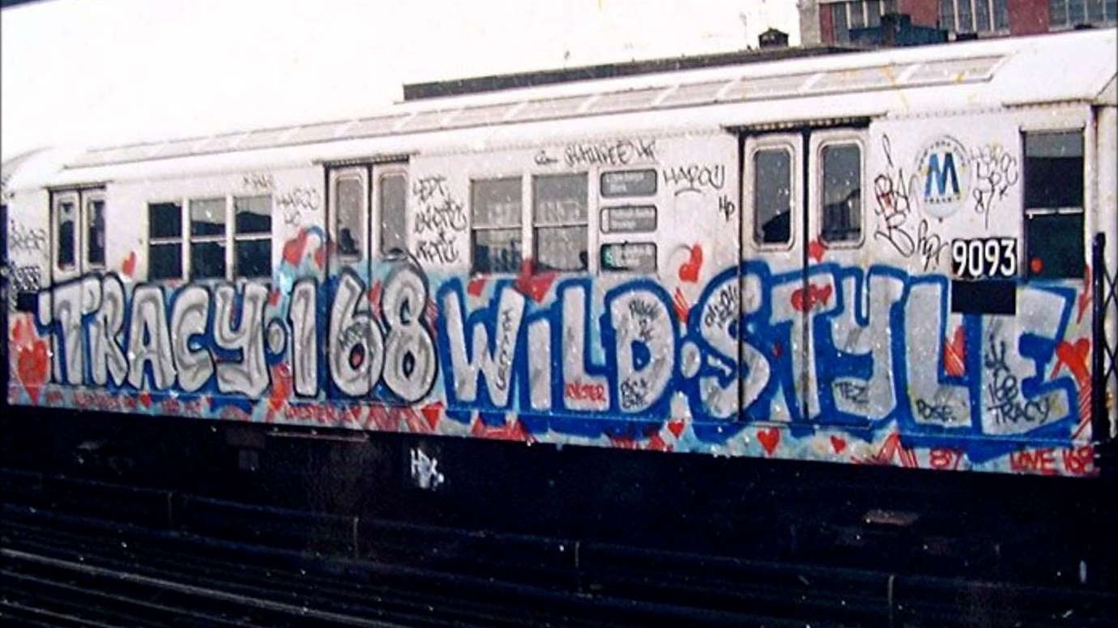
(L, Angelo, 2018).
With graffiti came a sense of belonging for a lot of people, a place for them to feel like they were a part of something. Not only a movement but a culture, allowing all different types of people to join the culture and bond over the same outlet of art. With this brought people together learning new things that came along with new individuals joining the graffiti culture, people were discovering different music, clothing styles, photography and delving more into the art world. With this being said I want to draw alight to an artist by the name of “Dash Snow” who is a very big influence to myself. 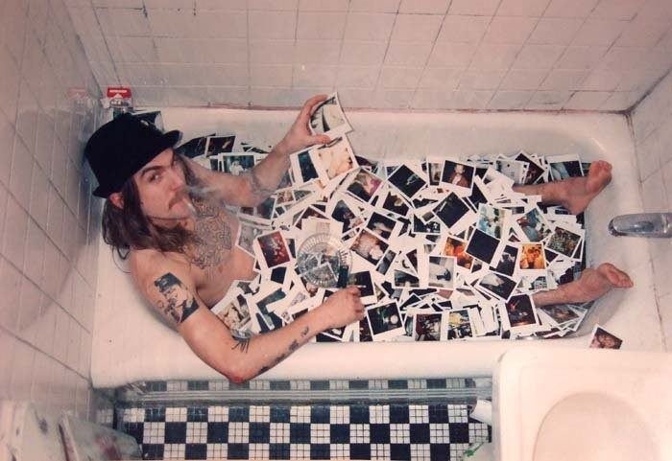
(Gavin, F, 2009).
“Dash Snow was an American artist multi-media artist, known for work that embodied a rebellious, drug-fueled lifestyle. Working with photographs, collages, sculptures, and even his own semen, he created work that captured the hedonistic world of both himself and his social circle of artists”. (Artnet, 2024). Yet, before all this he would be known in the streets of New York as “how at 15 he helped found Irak NY, a graffiti operation”. (Feuer, A. and Salkin, A, 2009) Snow went under the alias of “Sace” where he would paste his name all over not only New York but America.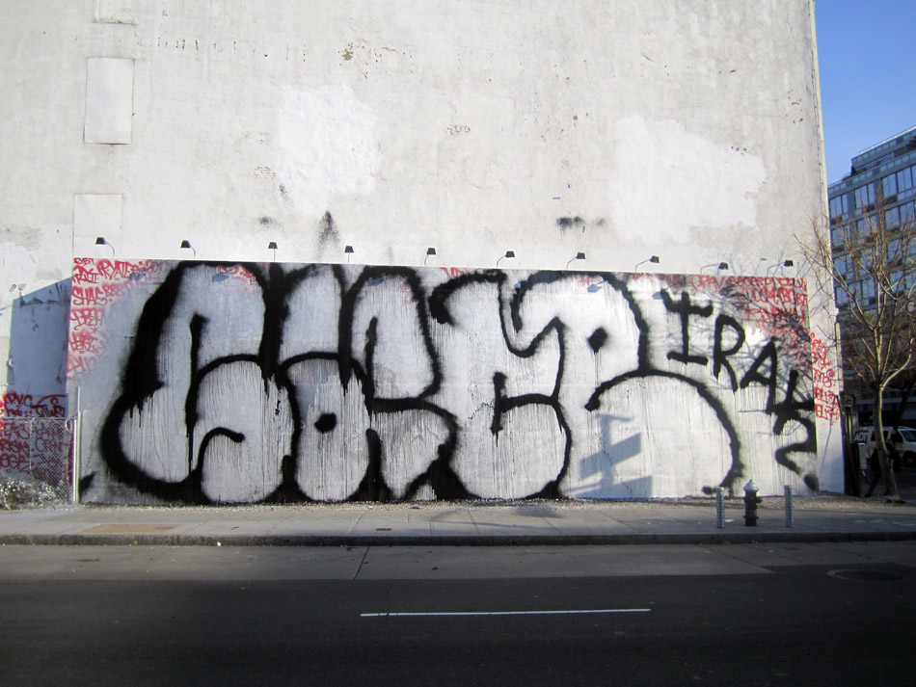
(Grayson, K, 2010).
Which leads me to believe that graffiti not only being an art form in itself but can also drive people to new paths within the artworld. For Snow, his graffiti would be considered amazing work by the people who understood it, and with graffiti in the public eye it can be considered a lot of negative things. When Snow broadened his artistic outlets, this didn’t change “The art world was not yet settled on whether Mr. Snow was an important artist, a young talent with promise or a reckless pretender.” (Feuer, A. and Salkin, A, 2009). This would all be due to his graffiti lifestyle, with Snow being a young kid on the streets of New York at a strange time in the city, on his graffiti missions he would see a lot of things that would be out of the ordinary to most. This then drove Snow to document the things he did and saw around the city, capturing thousands of pictures that would then be used in his later work creating a whole artistic style and a career path that originated from graffiti. Unfortunately Snow’s career would come to an end early, as he died from an overdose at the age of 27 yet his graffiti, photography and artwork all have left great impact within the art world.
Another artist that comes to mind when talking about graffiti is David Choe.
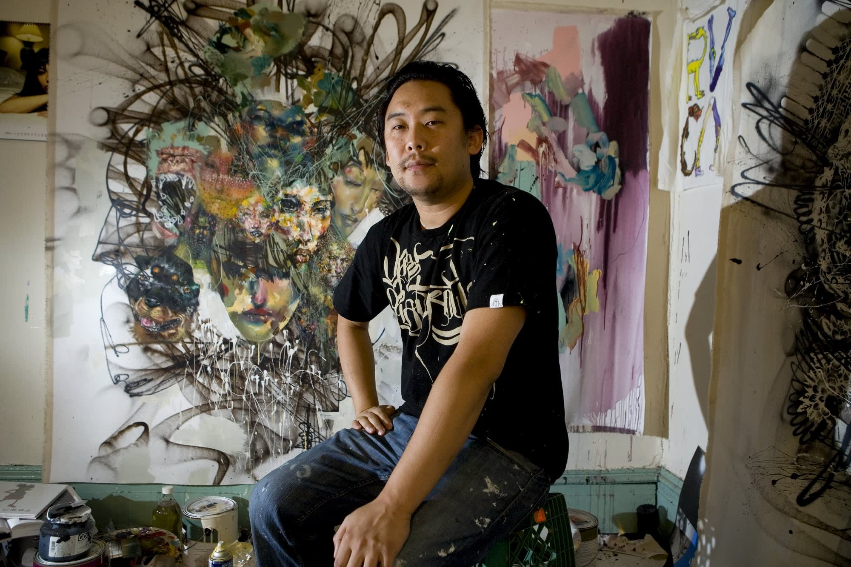
(Emmiemartin, 2017).
Choe being an American artist started his career within the graffiti world. Choe wouldn’t conform to the normal graffiti style, instead of trying to perfect letter work and get his name around a city as much as he could like other artists, Choe would focus on using graffiti as a way to portray his illustrations.
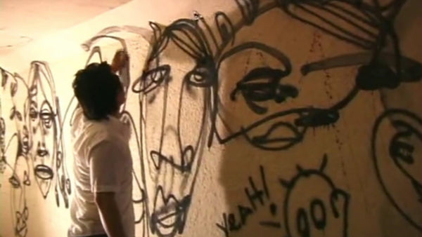
(L, Angelo, 2020).
With this Choe gained a lot of popularity within the urban artworld and would later be asked to paint the offices of Facebook in their early years. “Upon completing the murals, Parker offered Choe either $60,000 in cash or the equivalent in Facebook stocks. Of course, no one knew at the time whether or not Facebook would succeed, but Parker suggested that Choe take the stocks, which he did.” (Leatham, T. and Leatham, T, 2022). Which would go from kickstarting Choe’s career to throwing it into the deep end as “his stock options were worth $200 million”. (Emmiemartin, 2017). Gaining Choe a lot of attention from the public eye. After this Choe lead a successful career within the artworld, now working on other things such as music, acting and much more.
With all this being said, I want to bring alight to graffiti not being turned a blind eye to, as it holds its own artistic values but also can be a gateway to many paths within the art and design world.
I now want to take a look at my second word, which being “tattooing”. This alongside graffiti is another artform that can be considered out of the ordinary yet is a passion of mine. Tattooing itself can offer a wide range of different artistic styles and is quite versatile. I want to take a look into the different styles of modern age tattooing and how the artform and evolved and changed over the years whilst also looking how the artform has allowed people to experiment and express themselves freely.
“In the late 19th and early 20th centuries, tattooing became a common practice among sailors, soldiers, and other military personnel. It was during this time that iconic designs such as anchors, eagles, and pin-up girls emerged.” (TEAM, Z, 2024). 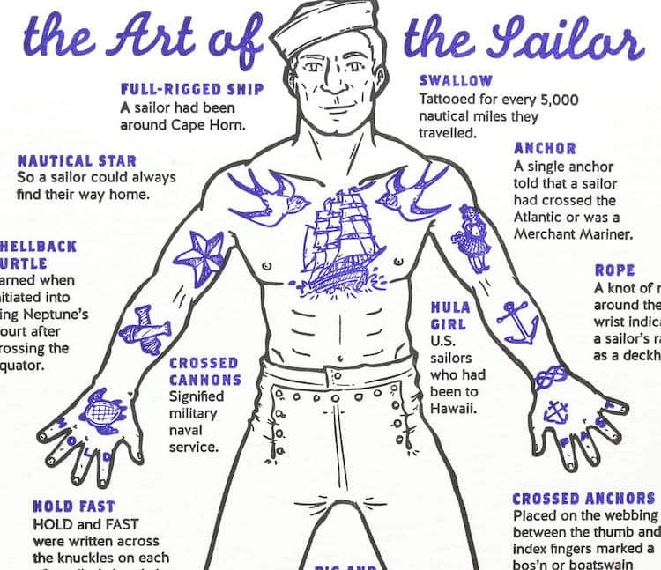 (Emmiemartin, 2017).
This tattooing style still holds its value till today and is labelled American traditional style. As seen in the above photo. Back then most tattoos would have meaning behind them and would be earned or gotten for significant meaning such as a girlfriend or their mother. Whilst there is what we call American Traditional there is also Japanese traditional. “Japanese tattooing is unique because the designs are used for storytelling. It's an essential part of Japanese culture and has gained popularity all over the world.” (Molenaar, N, 2023).
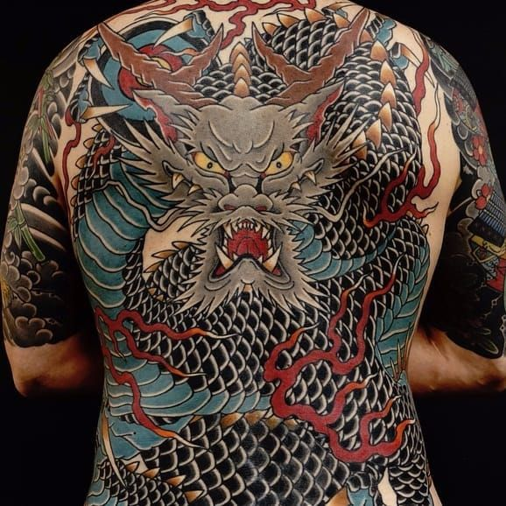
(Tattoodo, 2016).
Similar to the American traditional style, with the bold lines and packed full of colour, these tattoos would tell stories and use common characters from Japanese culture, such as the oni mask, which would be gotten as a tattoo for “Warding off bad luck or omens” (Kimono, E, 2022). These tattoos today as well as the American traditional can be seen by numerous of people, and have become a common style within the tattoo world, whilst they may of not lost their meaning you definitely do not need to meet a certain demographic or be from a certain culture to get them. These tattoos being widely worn by so many people allow people to express themselves by wearing art upon their skin, whether it has meaning behind it or not.
Even though Japan has a rich tattoo culture, they are not very accepting of the idea. “In Japan, showing your ink will see you banned from certain places like pools, onsens (bath houses), gyms and many ryokans (Japanese inns).” (Moss, T, 2017). This is due to the culture in Japan, and it is taken very seriously. Within Japan tattoo culture is associated a lot with criminal lifestyle, which being the Yakuza. The Yakuza is a criminal organisation within Japan that commonly wear the traditional Japanese style, yet also cover up. This brings me to my next point being the tattoo culture within prison. “Outlaws and inmates in many cultures often elect to mark themselves with designs that document their crimes, sentences, and beliefs.” (Brady, C, 1993). Prison inmates tend to mark themselves with tattoos with meaning, their criminal activity being the common factor, this follows the old belief of tattooing meaning the tattoos they get will have some kind of meaning or relation to an event. This practice of tattooing is very common within the Russian imprisonment system. Russian inmates would tend to tattoo themselves within prison to tell a story about their either past or current life attached to the criminal world. The eight point star would be a common tattoo seen amongst these inmates, placed upon the knees with the meaning “I will never get on my knees in front of anyone.” (News, C, 2023). This being a protest towards either the imprisonment system or other inmates.
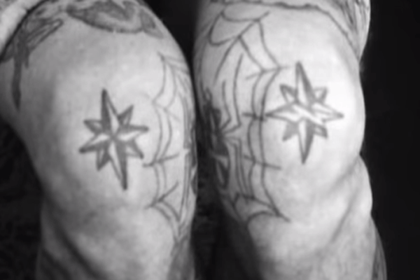
(News, C, 2023).
As we go further within time the tattoo world is evolving, allowing artists to step outside of this set style that has been popular for so long, and develop their own drawings that people will tend to get. This is labelled as flash and was popularized by artist Sailor Jerry.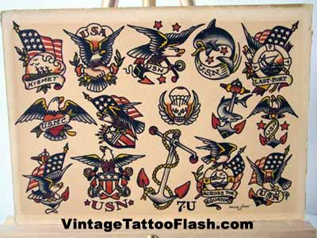
(TattooNow, 2019).
Who would sell his flash to other artist to use as reference to tattoo people. This would also be done by artist Ed Hardy who’s flash work became popular in the tattoo world, allowing his flash to be used amongst other artist who would then later develop a career as an artist. Nowadays, flash can be considered anything drawn by the artist themselves and tends to be asked for by people if they like that particular artists style.
Looking back on where tattoo cultured developed and how the idea of flash came into play, we can conclude that tattooing as an artform is not only for artists to display their work but also for people to display their work permanently on their skin allowing them to express themselves, similar to graffiti, where people found an artform that allowed them to express themselves through the means of letter styles and street art.
This brings me to my final word that I will be talking about, expression. This is something that both graffiti art, and tattoo art have in common, it is an artform that revolves around express but I think that all art can be boiled down to expression. I am going to be looking at different forms of expression through art to then lead me to my question for the end of this essay.
“One view of emotional expression in art is that it is preceded by a perturbation or excitement from a vague cause about which the artist is uncertain and therefore anxious. The artist then proceeds to express feelings and ideas in words or paint or stone or the like, clarifying them and achieving a release of tension.” (Dewey, J, 1926). This is stating that artists hold this idea within them, that sometimes cannot be put into a way of explaining until they have expressed their emotions or ideas through the form of art, reaching some clarity on whatever they had within them. I feel like this isn’t always the case with art, there can be art created without said purpose, yet I feel like we always have some passion or expression when creating no matter what it is, as artists hold this desire and love for the form of creation. Whether being something made for commission or something personal there will always be some level of expression of themselves through the word published. I think this is important when creating as if there is no expression within your work there may not be point in the art at all yet expressing yourself isn’t always easy. “In order for emotions to move through us freely, they must be accepted and expressed. Doing so enlivens us and fuels our creativity.” (Ruopp, S, 2020). This being said, expression can be used to help us get that drive for us to create but not only that but it can help us let out whatever suppressed emotion we may be holding onto. Art should be seen as an outlet, not something to be judged at all times, something that allows people to express their emotional views in a form that lets them. With this being said creativity should never be seen as a competition, yet something that is an expression of one’s self.
Researching my three words, I have found that both graffiti and tattoo culture is an artform that relies on self-expression and emotion and how a person can portray inner thoughts within the art world. Both being very different forms of art, they also can go hand in hand, as they both take a craft to learn and develop a style that sticks within each culture, but also allow anyone to pick up the trade and have their own input and ideas to help further the scene. Both also being somewhat black sheep of the art world, they hold a value that even through to some it may not be considered a normal route of art although the history and values that these art trades have can create amazing paths for people. These words allowed me to look into my third word, the idea of expression through art and understand it more. Which leads me to my question that I will be exploring within my next study year, “How can expression and emotion help create art?”.

Bibliography
Masterworks (2022) What is graffiti art?, Masterworks. Available at: https://insights.masterworks.com/art/history/what-is-graffiti-art/ (Accessed: 10 April 2024).
L, Angelo. (2018) A history of graffiti - the 60’s and 70’s, sprayplanet. Available at: https://www.sprayplanet.com/blogs/news/a-history-of-graffiti-the-60s-and-70s (Accessed: 10 April 2024).
Gavin, F. (2009) In memorium: Dash snow, Dazed. Available at: https://www.dazeddigital.com/artsandculture/article/4062/1/in-memorium-dash-snow (Accessed: 10 April 2024).
Artnet (2024) Price database, Artnet. Available at: https://www.artnet.com/artists/dash-snow/ (Accessed: 10 April 2024).
Feuer, A. and Salkin, A. (2009) Terrible end for an enfant terrible, The New York Times. Available at: https://www.nytimes.com/2009/07/26/nyregion/26dash.html (Accessed: 10 April 2024).
Grayson, K. (2010) Streets: Dash snow tribute (New York) " arrested motion, ArrestedMotion. Available at: https://arrestedmotion.com/2010/11/streets-dash-snow-tribute-new-york/ (Accessed: 10 April 2024).
Feuer, A. and Salkin, A. (2009) Terrible end for an enfant terrible, The New York Times. Available at: https://www.nytimes.com/2009/07/26/nyregion/26dash.html (Accessed: 10 April 2024).
Emmiemartin (2017) How this graffiti artist made $200 million overnight, CNBC. Available at: https://www.cnbc.com/2017/09/07/how-facebook-graffiti-artist-david-choe-earned-200-million.html (Accessed: 10 April 2024).
L, Angelo. (2020) Spray Planet Artist Feature: David Choe, sprayplanet. Available at: https://www.sprayplanet.com/blogs/news/spray-planet-artist-feature-david-choe (Accessed: 10 April 2024).
Leatham, T. and Leatham, T. (2022) David Choe, the graffiti artist that got rich from Facebook, Far Out Magazine. Available at: https://faroutmagazine.co.uk/david-choe-got-rich-from-facebook/ (Accessed: 10 April 2024).
Emmiemartin (2017) How this graffiti artist made $200 million overnight, CNBC. Available at: https://www.cnbc.com/2017/09/07/how-facebook-graffiti-artist-david-choe-earned-200-million.html (Accessed: 10 April 2024).
TEAM, Z. (2024) The evolution of tattoo art: A walk back through history, ZOOTATTOO AUSTRALIA. Available at: https://www.zootattoo.com.au/blogs/news/the-evolution-of-tattoo-art-a-journey-through-history#:~:text=The%20Rise%20of%20Modern%20Tattoo,and%20pin%2Dup%20girls%20emerged. (Accessed: 12 April 2024).
Emmiemartin (2017) How this graffiti artist made $200 million overnight, CNBC. Available at: https://www.cnbc.com/2017/09/07/how-facebook-graffiti-artist-david-choe-earned-200-million.html (Accessed: 12 April 2024).
Molenaar, N. (2023) Japanese tattoos and their meanings, Tattooing 101. Available at: https://tattooing101.com/learn/styles/japanese-tattoos-and-their-meanings/ (Accessed: 12 April 2024).
Tattoodo (2016) A guide to the mythological creatures of Japanese irezumi, Tattoodo. Available at: https://www.tattoodo.com/articles/an-intro-to-the-mythological-creatures-of-japanese-irezumi-10835 (Accessed: 12 April 2024).
Kimono, E. (2022) The Japanese oni mask & its meaning, Eiyo Kimono. Available at: https://eiyokimono.com/a/blog/oni-mask-meaning#:~:text=Oni%20mask%20tattoos%20can%20represent,and%20keeping%20them%20at%20bay (Accessed: 12 April 2024).
Moss, T. (2017) Visiting Japan with tattoos, Tara Moss. Available at: https://www.taramoss.com/visiting-japan-tattoos/ (Accessed: 12 April 2024).
Brady, C. (1993) NCJRS Virtual Library, FROM PUNISHMENT TO EXPRESSION: A HISTORY OF TATTOOS IN CORRECTIONS | Office of Justice Programs. Available at: https://www.ojp.gov/ncjrs/virtual-library/abstracts/punishment-expression-history-tattoos-corrections#:~:text=The%20tattoo%20became%20the%20badge,crimes%2C%20sentences%2C%20and%20beliefs. (Accessed: 13 April 2024).
News, C. (2023) 12 Russian prison tattoos and their meanings, Corrections1. Available at: https://www.corrections1.com/corrections/articles/12-russian-prison-tattoos-and-their-meanings-208QsTK7AMv7ZXOI/ (Accessed: 13 April 2024).
News, C. (2023) 12 Russian prison tattoos and their meanings, Corrections1. Available at: https://www.corrections1.com/corrections/articles/12-russian-prison-tattoos-and-their-meanings-208QsTK7AMv7ZXOI/ (Accessed: 13 April 2024).
TattooNow (2019) Sailor Jerry Tattoo flash sheet 7U, Vintage Tattoo Flash. Available at: http://www.vintagetattooflash.com/sailor-jerry-collins-flash/item1674.html (Accessed: 15 April 2024).
Dewey, J. (1926) Art as expression, Encyclopædia Britannica. Available at: https://www.britannica.com/topic/philosophy-of-art/Art-as-expression (Accessed: 22 April 2024).
Ruopp, S. (2020) The importance of expressing emotion through art, Arts Academy in the Woods. Available at: https://www.artsacad.net/the-importance-of-expressing-emotion-through-art/ (Accessed: 23 April 2024).

