

Methods and Search Strategy Academic Poster

Student name:SHABANA SHARIF
Student ID:2026633

Module name: POSTER
Module code:

The Impact of Social Isolation on the Mental Health of Older Adults in the UK: A Systematic Review of Qualitative Evidence
01 Introduction and Research Aim  A methods chapter explains how evidence was located, appraised, and synthesised. This poster outlines the search strategy, screening/selection, quality assurance, analysis, and ethics used in my qualitative-evidence review.  Aim: To examine how digital exclusion intersects with social isolation to affect the mental health and care experiences of UK older adults (≥60), and to identify effective inclusion responses (cf. Chapter 1). | 02 Search Strategy  A search strategy is a transparent, planned set of steps (databases, terms, limits) used to retrieve relevant studies and reduce bias (Booth et al., 2016; Page et al., 2021). I combined controlled vocabulary and keywords across four domains, population, phenomena, digital context, and setting, tailored to each database, then applied English/peer-review and date limits (2015–2025).
03 Searching for Information  Databases: MEDLINE (PubMed), CINAHL, PsycINFO, Scopus, Web of Science Core Collection, ASSIA, SocINDEX.  Process:  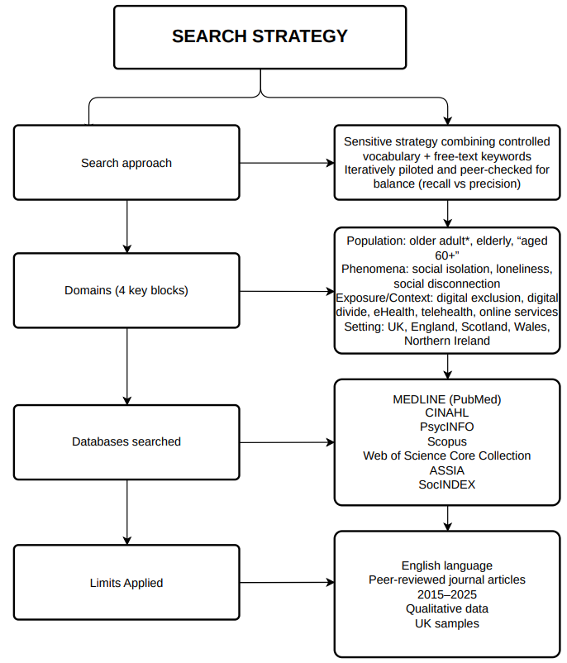  Core string (MEDLINE, adapted): (“Aged”[MeSH] OR “older adult*” OR elderly OR “aged 60+”) AND (“social isolation” OR lonel* OR “social disconnect*”) AND (“digital divide” OR “digital exclusion” OR eHealth OR telehealth OR “online appointment*” OR “patient portal*” OR “remote consultation*”) AND (UK OR England OR Scotland OR Wales OR “Northern Ireland”). | 04 Picture / Graph / Visual Aid / Statistics  Study selection (2015–2025): Identified = 7,207; Duplicates removed = 1,245; Screened = 5,962; Full-text assessed = 512; Excluded at full-text = 468; Included = 44 (PRISMA-aligned; Page et al., 2021).  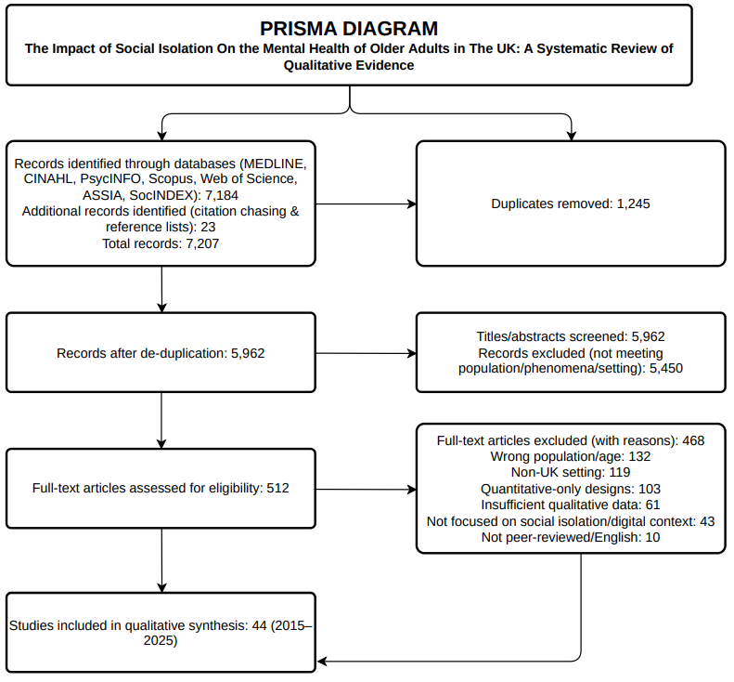
05 Research Validation and Analysis
Research validation ensures credible, dependable findings via transparent appraisal, audit trails and reflexivity; analysis applies thematic synthesis to code and integrate patterns across studies (Creswell & Poth, 2018; Thomas & Harden, 2008).
Validation (credibility & rigour): Dual checks on a sample; documented reasons for exclusion; critical appraisal with JBI qualitative checklist; reporting checks via COREQ; sensitivity analyses; confidence in findings graded using GRADE-CERQual (Lockwood et al., 2015; Tong et al., 2007; Lewin et al., 2018).
Analysis: Line-by-line coding of qualitative data; thematic synthesis in three stages—free codes → descriptive themes → higher-order analytical themes (Thomas & Harden, 2008); reported using established thematic analysis principles (Braun & Clarke, 2006).
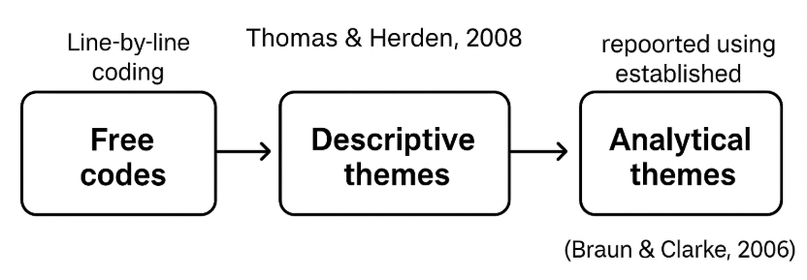

06 Inclusion Criteria  Empirical, peer-reviewed qualitative or mixed-methods (qual component) studies; UK samples of older adults (≥60) or carers/providers reporting older adults’ perspectives; address social isolation/loneliness in relation to digital access/use/exclusion; mental-health outcomes or care experience; English; 2015–2025. | 07 Exclusion Criteria  Quantitative-only; editorials/commentaries; non-UK samples; populations <60 where older-adult data not separable; studies on general ageing without a digital/isolational focus; usability studies lacking mental-health relevance.
08 Ethical Considerations
Ethics in secondary research is the responsible use of existing published data, respecting original consent and confidentiality, ensuring accurate attribution, and minimising harm through transparent, honest reporting (Creswell & Poth, 2018).

References
- Booth, A., Sutton, A. & Papaioannou, D. (2016) Systematic Approaches to a Successful Literature Review. 2nd edn. London: SAGE.
- Braun, V. & Clarke, V. (2006) ‘Using thematic analysis in psychology’, Qualitative Research in Psychology, 3(2), pp. 77–101. https://doi.org/10.1191/1478088706qp063oa
- Creswell, J.W. & Poth, C.N. (2018) Qualitative Inquiry and Research Design: Choosing Among Five Approaches. 4th edn. Thousand Oaks, CA: SAGE.
- Lewin, S., Booth, A., Glenton, C., et al. (2018) ‘Applying GRADE-CERQual to qualitative evidence synthesis findings’, Implementation Science, 13(Suppl 1), 2–10. https://doi.org/10.1186/s13012-017-0688-3
- Lockwood, C., Munn, Z. & Porritt, K. (2015) ‘Qualitative research synthesis: methodological guidance for systematic reviewers utilizing JBI methods’, International Journal of Evidence-Based Healthcare, 13(3), pp. 179–187. https://doi.org/10.1097/XEB.0000000000000062
- Page, M.J., McKenzie, J.E., Bossuyt, P.M., et al. (2021) ‘The PRISMA 2020 statement: an updated guideline for reporting systematic reviews’, BMJ, 372, n71. https://doi.org/10.1136/bmj.n71
- Thomas, J. & Harden, A. (2008) ‘Methods for the thematic synthesis of qualitative research in systematic reviews’, BMC Medical Research Methodology, 8, 45. https://doi.org/10.1186/1471-2288-8-45
- Tong, A., Sainsbury, P. & Craig, J. (2007) ‘Consolidated criteria for reporting qualitative research (COREQ): a 32-item checklist for interviews and focus groups’, International Journal for Quality in Health Care, 19(6), pp. 349–357. https://doi.org/10.1093/intqhc/mzm042

