Effective team working and communication
(BMSW4002_LON)
Lecturer: Anita Nan

Anderson Calle
2133889
University of Wales: trinity saint David


Table of contents
Introduction 1
Models’ communication 1
Communication skills 3
Communication in the workplace 5
Methods of communication in a company 5
Communication technology 5
References 6

Introduction

In this report will do a reflection about the different topics I saw in the module of effective team working and communication. The purpose of this report is to discuss several aspects that involves communication. To develop this report, I need to understand the definition of communication: Communication is the process to transmit or exchange information, feelings or any opinion through speaking, writing or any other methods between people.

Models’ communication

Models of communications are models used to explain ideas or concepts in an easy way during the process of communication.

I saw at class three models of communication: Shannon and Weaver

Model Shannon and Weaver which has 5 elements: sender (who transmit the message), encoder (is the message sent), channel (can be any electronic device), decoder (interpret the message) and receiver (the person who will get the final massage) in between is include the noise, due to this noise the receiver cannot get the message clearly. This model is more focus on the electronic communications. (businesstopica, 2018)


Image 1 Shannon and Weaver model: communicationtheory.org

Example seen at class Maria and Pedro: Maria phone call to his husband Pedro when he is working, in a building site, to tell him in his way home see if he brings her a chicken, when Pedro arrives to home, he goes straight to the kitchen then Maria asked Pedro for the chicken then he says he Understood that wait for her in the kitchen.
Most probably due to the noise in the building site Pedro could not get the message clearly and he did not bring the chicken.

At my workplace is catering, customers used to book a room for their meetings room.
Those booking goes through the receptionist and then they pass the information to us so we can set all the stuff inside the room. The communication between receptionist and us is by walkie talkie.

One day the receptionist changed the room but due the walkie talkie it was not working properly our supervisor did not get the message clearly and she the update the info with the wrong room, so as we continue with the plan we set all in the initial room, then the customer came very upset to the reception and said what is going on with the room he asked for to be ready, time later the receptionist came to us very upset as well and said why the room was not been ready, so we told her we set everything where she said that they said the due to that mistake then we moved all to the new room.

Berlo’s model communication

Berlo’s theory is a method where the sender creates a message and wanted transmitted, which encode and uses a channel to reaches a receptor and decode the message, the different with Shannon and Weaver is Berlo does not have noise and feedback. (Anon., 2015)

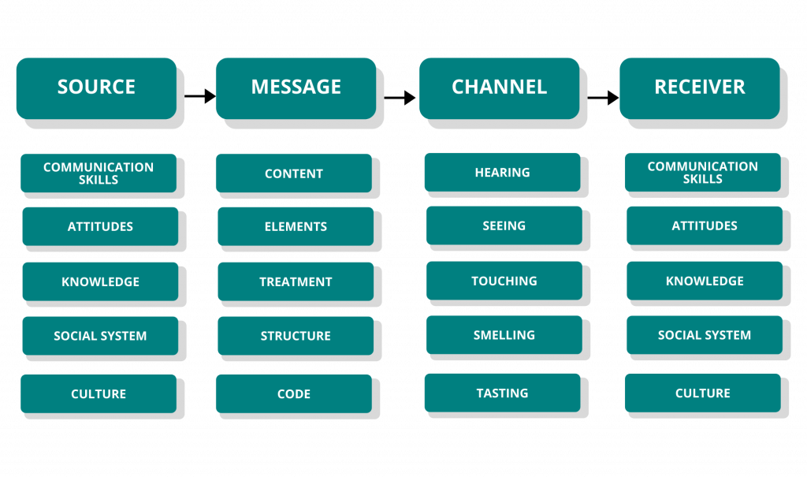
Image 2 Berlo’s model: elcomblus.com

At class the lecturer gave me an example about a teacher who works in a university and has a high level of vocabulary lives next to a little village. One day that teacher provoked a fire at his home.

Because his house was burning, went to the little village screaming that his house was in fire but using a high level of vocabulary that the people who lives in the village couldn’t understand and help him, because there’s a lack of feedback, I can say this is a clear Berlo’s model.

Berlo example at workplace: our manager wanted to transmit by email a relevant message that next day we will have an VIP customer so we can understand how important was that we needed to prepare everything at the room looking after every detail to provide to the customer an amazing experience.

Schramm model communication

Schramm model focus on the level of knowledge between the sender and receiver, according to how the sender transmit the message, the receptor will understand it better and give feedback conforming to the level of knowledge between each other.

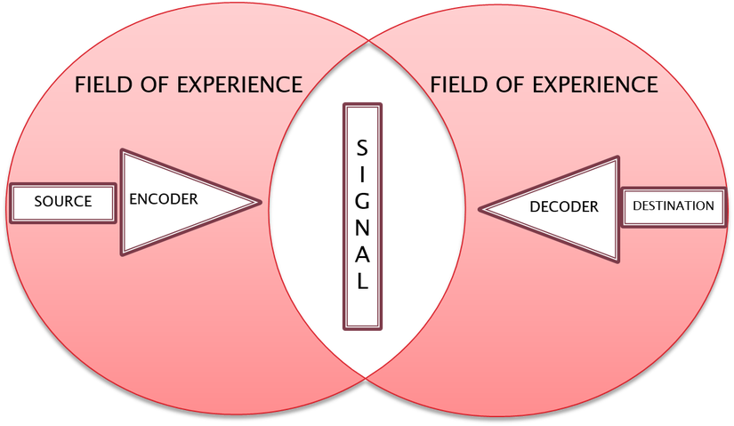

Image 3 Schramm model: studymasscommunication.wordpress.com

In the example before about the teacher as he is using a high level of vocabulary in a little village where the people do not have the same education as him, could not understand what he was trying to communicate them and not help him.

Here is an example with IT team at workplace.
My workmates and I we had a problem with the booking system, and we call the IT team, they explains us how to fix it by ourselves but everything faster and with an IT vocabulary that we could not understand then, because our of lack of experience with that problem our feedback was he needs to explain it again and slowly because we were missed since the beginning or come and fix it by themselves.

Communication skills

The communication skills are all this ability that allow us to transmit and link with other people efficiently. (Rojas, 2015)

There main communication skills are:

Verbal which can be divided in two speaking or written is about how I can talk, which kind of vocabulary I use, the volume of my voice. I have to say using a right verbal skill needs to be clear, specific, keeping eye-contact, with sincerity and put empathy

In writing I can see many types of written like letters, memos, reports many of them we will need to use a formal writing to communicate the message. A good structure must include words (accurate, brief and clear), sentences (simple structure, one idea, link sentences, be clear, punctuate), paragraphs (read in “chunks”, theme, importance of paragraphs, flowing) and positive and sincere tone.

Non- verbal is about how we communicate no using words, but through our body language, face expression, visual contact, gestures, and signs. This non-verbal communication can provide more information than verbal because conscious or unconscious we use more non-verbal skill.

A good way to transmit non-verbal communication is keeping our eye-contact with the person who is talking to, another right way is manage a proper body language like do not have cross arms it could mean you are in defensive mood or mistrust or our face gesture that needs to be controlled, also give space and not being too close to that person that just met, shaking hands is a right way to touch the other person, when is time to talk the silence when the other person is trying to communicate is a very essential key to let conversation to flow.

This is an example that the lecturer showed at class about how everything changes with a not right body language: A Day with the chief - Mark has been the top salesman in his company and because this, the company rewarded Mark with a free trip Mark to head office in California to meet the executive chief Alana who has very bad feedback along to the head company employees.

Mark is nervous to meet his boss because don’t know how she is going to react, for the Mark’s surprise she was receiving with a big and friendly smile offering something to drink. The meeting was keep going good and Mark felt more relax he start to loss his right body language and telling her everything what was wrong in London office. Suddenly Alana told him with a gruff voice “my secretary will show you out “

Listening
Is an essential key of communication that shows to the speaker that the listener understood the theme. Active listening and empathetic listening are important to develop a good relationship.

Active listening let us understand more about what that person is talking about through the body language, the speed of voice and the tone. Also, the exchange of opinion with no interruption will let the conversation flow better. The key points to develop the active listening are pay attention, show that you are listening, provide feedback, defer judgment, respond appropriately.

Empathetic listening is the ability to understand the other person through emotions and be in the “shoes of the person” in connexion about their feelings and judge. To provide an essential empathetic listening be non-judgmental, listen carefully, understand emotions, control your words, following this you will show kind, caring and be supportive to the other person.

Case study at class Max the multitasker: Max was good on organise and planning events, so he decided to start a business by himself which he had plenty of satisfied customers. One of these customers was Tamara who decide to hire Max again to organise her parent’s weddings,
Max accepted despite he was busy.

Due to Max has expenses could not afford somebody who help him, so he was in the role of secretary and receptionist. Tamara call Max to let him know due to some issue with her father’s health the wedding needs to be earlier that the date agreed, Max accepted the new date with no problems.

When the day came Tamara and all the guests arrive to the venue the found that another party was celebrating, Tamara upset call to Max to know what was wrong, and he apologised and said due to extremely busy diary and organising everything by himself he forgot to write the new date, Max offered Tamara organise the wedding at half price after her father come out form hospital but Tamara angry refuse and she will tell all her friends what happened.

Communication in the workplace

Methods of communication in a company

A successful company has different methods of communication:

Internal communication - pretend to keep coordinate and informed to all member teams. Internal can be oral (telephone, meetings, intercoms) or written (electronic mail, reports, newsletters)
External communication - to announce other out of the company about the activities in the business. Can be oral (presentations, conference) and written (press release, business letters).
Informal communication - it is referring about communication that does not follow any rules.
Formal communication - these methods use a correct and professional structure, follow a rule according to who is send the message and about

Advantages and disadvantages of technology communication

The technology has been helpful tool that has save for companies a lot of money, time and improve the communication between workers. Nowadays an employee, student or anyone should know how to use it. Now in my case I will analyse how technology has affect me in my student environment I will mention some advantages and disadvantages of the E- learning.

Advantages E- Learning from anywhere: since covid appear most of us stayed at home for long periods but because the technology some of the lessons has been continue without affect in the learning, flexible hours: basically, I can choose when to study, save time and money do not is necessary to move and spend money in a bus or train and maximize the learning of the new E-learning tools and the disadvantages focus more on theory than practice, requires that the student has self – motivation, lack of social communication, not everyone is capable to understand how it works.

CONCLUSION

To conclude I can say that technology has brought full of advantages to the students in terms of save time, chance to study at any moment but, in my opinion if I have choice I would prefer the traditional method because I like physically interactions see the person who is talking not through an screen because I feel that I have many questions to do and at the moment of the receive the answer it is not clear and develop a responsibility to assist to class.

References

Anon (2015) Management study guide [Online] Available at: https://www.managementstudyguide.com/strategies-to-improve-communication.htm (Accessed: 23 October 2022)

Businesstopice (2018) bussinesstopide [Online] Available at: https://www.businesstopia.net/communication/shannon-and-weaver-model-communication (Accessed: 25 October 2022)

Campbell, A. C. (2022) Better up [Online] Available at: https://www.betterup.com/blog/why-communication-is-key-to-workplace-and-how-to-improve-skills#:~:text=Communication%20in%20the%20workplace%20is,individuals%2C%20teams%2C%20and%20organizations (Accessed: 30 October 2022)

Gandhi, Y. (2021) Analytic steps [Online] Available at: https://www.analyticssteps.com/blogs/what-are-types-communication-technology (Accessed: 1 November 2022)

Herrity, J. (2018) Top 10 communication skills for a career success [Online] Available at: https://www.indeed.com/career-advice/resumes-cover-letters/communication-skills (Accessed: 30 October 2022)

Kashyap, V. (2021) Spiceworks [Online] Available a: https://www.spiceworks.com/hr/engagement-retention/guest-article/effective-communication-in-the-workplace-how-and-why/ (Accessed: 1 November 2022)

Rojas, N. (2015) 10 must – have communication skills for a business success [Online] Available at: https://www.salesforce.com/ca/blog/2015/06/10-communication-skills-for-business-success.html (Accessed: 28 October 2022)

