SQL Injection

A problem facing database-enabled sites is that of malicious commands being sent to the server in place of legitimate data.

For example, imagine a database set up as follows:

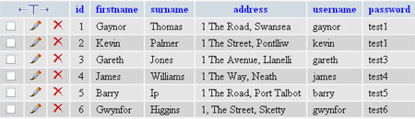

Suppose we write a simple PHP interface to allow the customer to type in their name and password and retrieve their account details:

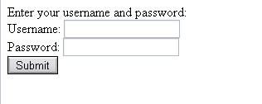

<html>
<head>
<title>Untitled</title>
</head>
<body>
Enter your username and password:
<form action="getdetails.php" method="post">
Username: <input type="text" name="username"><br>
Password: <input type="text" name="password">
<br><input type="Submit" value="Submit">

</form>
</body>
</html>
The form data is sent to a second PHP page to interrogate the data:

<?include "conninfo.php";

$username=$_POST["username"];
$password=$_POST["password"];

$query="SELECT * FROM people WHERE username='$username' AND password='$password'";

$result=mysql_query($query);?>
<br><br>

<?$numrows=mysql_num_rows($result);

if ($numrows>0){?>
Thank you for logging in. Here are your details:<br><br>
<?

while ($r=mysql_fetch_array($result))
{
echo $r["id"]." ";
echo $r["firstname"]." ";
echo $r["surname"]." ";
echo $r["address"]." ";
echo $r["username"]." ";
echo $r["password"]."<br>";
}
}
else
{
echo "Sorry, no records found";
}
?>

Providing the user enters the correct username and password, they can see their details:

For example:

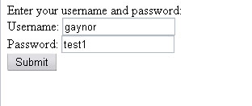

The PHP completes the string as:

SELECT * FROM people WHERE username='gaynor' AND password='test1'

…and retrieves the data:

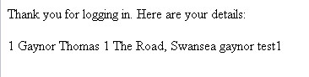

However, with some simple changes to what is entered in the form, it is possible to retrieve different data.

Consider the following:

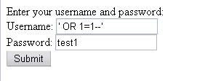

Now the string is created as follows, effectively bypassing the username checking mechanism:

SELECT * FROM people WHERE username='' OR 1=1--'' AND password='test1'

Now we can retrieve all the people who happen to have the password test1:

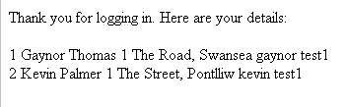

Even worse, we can also bypass the password:

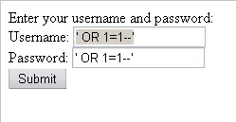

…which creates the string as:

SELECT * FROM people WHERE username='' OR 1=1--'' AND password='' OR 1=1--''

…giving the following result:

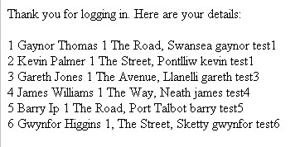
Other SQL injection commands are possible, including “DROP tables” which would be disastrous.

Code must be constructed carefully to avoid SQL injection.

One method is to strip out potentially dangerous characters when the data received, before passing it into the string:

For example,

$username=$_POST["username"];
$password=$_POST["password"];

$username=str_replace("'"," ",$username);
$password=str_replace("'"," ",$password);

$query="SELECT * FROM people WHERE username='$username' AND password='$password'";

