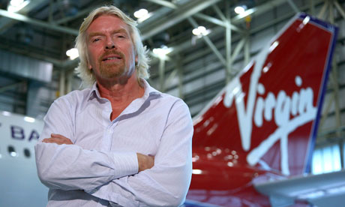
Sir Richard Branson
  - What Makes a great LEADER?
Sarah Rees |Leadership and Management Skills For The Workplace | 4/12/2020

Leader – Richard Branson
This essay is based on leadership and leadership styles I have chosen to base this essay on Sir Richard Branson as my case study and I will illustrate what Branson’s leadership styles are. I will critically compare different theories to see what theories fit within Branson’s leadership styles. I chose to do Richard Branson as he is a very successful English Business tycoon worth over £4 Billion and has made all his money from scratch having nothing at the start. Norris, (2020) reports that Branson attributes his success to luck, speed, and hard work which includes long nights and weekends. Branson never allowed inexperience to discourage him from being a daring entrepreneur rather than a suits and ties business man, although Branson has virgin airways and trains he has no technical abilities to fly or drive any of these but has the skill to lead people to run many successful businesses.
Early Life and Influences
Sir Richard Branson was born on 18th July 1950 in Surrey, England. Branson is most famously known for owning the Virgin group of businesses. Branson is married to Joan Templeman and has three children. His father Edward Branson worked as a Barrister, and his mother Eve Branson was a flight attendant. Branson, R. (2018). Branson struggled as a child with dyslexia and had a hard time at school. Luebering (2020) states that Branson had a business mind at a young age, when he dropped out of school at age 16, he entered into his first successful business venture he started publishing his own magazine ‘Student’. To expand and support his magazine Branson formed Virgin mail order records which took off and led on to him opening the first British discount record store in 1971 these are just a few of his early enterprises. According to Wachman, (2012) Branson’s virgin investment group consists of about 400 operations, a tangled web of enterprises owned via a complicated series of offshore trusts and overseas holding companies. Although Branson has a few large companies wholly owned by himself Virgin Atlantic Airlines, Virgin money, and Virgin trains all have other major shareholders. I have attached a timeline of Branson’s. businesses and key dates in the appendices for your perusal.
Schurenberg, (2020) reveals the inspiring story that gave Branson the inspiration to make a big success of himself and the belief that he can do anything. Branson’s boyhood inspiration was a man named Douglas Bader, a battle of Britain hero, who was a friend of the family and according to Branson he’s probably the most determined man of the 20th century. Bader lost both of his legs in the 1930’s in a flying accident. Bader not only learned to walk on artificial legs, without so much as a walking cane, he also learned to play scratch golf and to fly fighter planes, he did this well enough to become a top British ace. When Bader was finally shot down over German-Occupied France. He lost one of his prosthetic legs. After his captors allowed a replacement to be air dropped to him, he rewarded their chivalry by promptly climbing out of the third-floor window of his prison hospital and escaping. It may not be exactly a straight shot from Bader’s tin knee to the virgin group boardroom, but every founder needs inspiration and Branson took his from his boyhood idol.

LEADERSHIP
According to Moore, (2017) Leadership is about influencing people by what you say or do. Good leadership is influencing someone to do something well or better, Great leadership is when you influence someone to be the very best they can be and Fowler, (2017) suggests that Leadership is about supporting and enabling a team to be the best they can be, they need to trust their leader, or they will never follow their leader. If nobody is following you, then you’re not a leader.
Branson states that “What leadership boils down to is people” and “whatever your style, whatever your method, you need to believe in yourself, your ideas and your staff. Nobody can be a successful leader alone and you cannot be a great leader without great people to lead” Half, (2016).
Richard Branson is an exceptional business leader; this can be clearly seen by the distance he has come in the business world. He is a fun, friendly, competitive, an adventurer, hard negotiator, opportunist, and a workaholic. These qualities can be associated with the trait theory of leadership these are also some of the main characteristics of a successful leader. Trait theorists believe personality can be understood through the approach that all people have certain traits or characteristic ways of behaving. Lumen, (2020). Branson has a good relationship with his employees and treats them with respect, like he does his own family. Dearlove, (2007).
Nice, (2007) suggests that feedback and new ideas of employees are always welcomed, and he usually gives his employees the freedom to use their initiative and to be creative. There are no hierarchy structures within his organisations for employees and they can work on a more flexible basis and work independently without higher employees interference. These factors can clearly indicate that Branson’s form of leadership is of a democratic and participative nature and generally makes final decisions by himself. NCE, (2009).
Participative/Democratic leadership is one of the leadership styles identified in Kurt Lewin’s leadership styles model. Lewin’s theory found that participative leadership also known as democratic leadership is typically the most effective style, these leaders offer guidance to group members, but also participate with the group and takes on board all the input from other group members. The leader encourages the group members to participate but retain the final say. Group members feel engaged in the process and are more motivated and creative, but this also gives them the feeling of being important and pushes commitment to the goals of the group. Cherry, (2020). Branson works in this way and encourages his employees to express their ideas, Branson states that “it’s a shame that people shut down ideas because they are worried about being crushed by people who are supposedly better educated than them and says this is all about fear of failure in my opinion, entrepreneurial drive beats a fancy degree anytime” Connley, (2017).
However, looking at lewin’s leadership styles and the stories and information I have researched on Branson, I can see that although Branson’s style is mainly Democratic, I see a side that uses the laisses-faire style within Branson for example Mutuku, (2018) claims Richard Branson manifests all the features of a successful leader and as CEO of the Virgin Group he demonstrates laissez-faire leadership styles to enhance the teamwork within the organization. Branson tends to spend a lot of time in the early days of a new business, helping the management set up a business plan and plan the way forward, when it’s done he takes a step back and lets management drive the business forward. In Branson’s own words he suggests the use of laissez-faire leadership style by quoting “The company must be set up so that it can continue without me”. So once the setup Has been achieved Branson allows the laisses-Faire approach to allow management and staff to just get on with it and he believes this gives them a chance to exploit their capabilities in enhancing performance. I agree with this and feel at times Branson does use laisses-faire approach in his business.
I believe Richard Branson also falls into the Transformational leadership category as well. Indeed, (2020) describes this leadership style as a style that focuses on clear communication, goal setting and high employee motivation. A transformational leader is driven by a commitment to organizational objectives. This style of leading is best for teams that can handle many delegated tasks without constant connection supervision which Branson clearly states is how his businesses are run. Transformational leaders are big picture thinkers with strong connections to their teams, which can boost company morale and retention.
How well leadership is conducted is linked to the degree of motivation and this will impact how people behave and how effective productivity will be. There are two motivating factors, extrinsic and intrinsic. Extrinsic motivations are known to influence people to behave in the short term, but long term it can also demotivate people. Ted Sapountzis explains that it is not possible to provide rewards for every task that is done well. When good performances closely linked with rewards, extrinsically motivated employees won’t take on extra responsibilities unless they can see a payoff, therefor focusing on intrinsic motivation would encourage the right employee behaviour in an organisation. Most recognition programs for employees include external motivators such as cash bonuses or extra paid leave days. Some employees are better motivated by being recognized as a valuable company resource. Branson follows this belief at virgin. Staff at virgin have shared their stories about receiving calls from Branson personally, thanking them for their hard work and also some staff received the same thank you message in the form of a handwritten and signed letters. People appreciate recognition for what they do. Intrinsically motivated employees have tremendous pride in the work that they do and feel heartened when their bosses or clients acknowledge how much effort and energy they give to their work. Haun, (2019).
Different motivation factors produce different organisational behaviour. These behavioral factors are a significant aspect in the relationship between an employee and the leader and the concept of the psychological contract. This is not a form of written document, the psychological contact covers expectations of rights, duties and obligations which do not form part of a formal agreement, but they still have an important influence on peoples actions and behaviours. Mullins, (2010). In 2014 Branson introduced an amazing new policy for his personal staff at virgin, offering them the opportunity of unlimited holidays instead of a fixed number of days a year. This was providing they felt 100% comfortable, and they were up to date with their work and their absence would not affect their careers or the business. Branson believes that in this modern world, our jobs sometimes infringe on our personal lives. This shows that Branson highly values his employees at virgin. We can presume that the underlying psychological contract here shows that virgin is prepared to support the health and well-being through this holiday benefit and in return would expect loyalty and commitment to the aims and objectives of the business. These benefits both the business and the employees as a healthy workforce are a productive workforce. Cooper, (2014).
Motivation
Although Branson has no hierarchical structure in business, his personal life growing up tends to follow a hierarchical structure. Maslow’s hierarchy of needs could shed some light on how Branson’s life has taken structure around Abraham Maslow’s Humanistic Psychology a theory of human motivation. The higher levels can only be reached once the lower levels have been met. When a person fulfills all the levels, they satisfy the necessities for reaching self-actualization. Branson’s benchmarks in life to reach self-actualization are -Branson left school at 16 and moved to London to make a living and survive on his own in order to meet his psychological needs. When he started out with record sales via mail order and expanding into owning store, along with launching virgin records and his own recording studio he reached his safety needs. As Branson’s career continued to progress, he married Joan Templeton and they had two children together this would fulfill his social needs. With the first three levels of the pyramid complete Branson was able to focus on the higher levels. After subsequent years of success with virgin airways, trains, virgin mobile and more, Branson fulfills achievements and recognition this would give him a further on the hierarchy and I believe has reached self-actualization as his empire has continued to grow further, he has accomplished so much in business and has made so many personal achievements to develop his full potential which reaches Maslow’s final level of self-actualization. Singh, (2018).
Motivation also plays a big factor in change management and Branson knows any change or restructuring can be a difficult process even if everything is done right. Branson, (2011) states that When leading your company through restructuring, you will need to take a cold, hard look at the business and work out if you will be able to empower your staff to do what needs to be done as it is difficult to change a company’s existing culture. In 2007 when Branson relaunched the combined company of NTL, Telewest and virgin mobile into virgin media which created the largest virgin company in the world. The new merger between these totaled a huge 10 million customers and 13,000 employees so the “small is beautiful” business plan was no longer viable. Branson had to inspire all employees to think like entrepreneurs, the scripts for customer service went in the bin and they were told to solve problems with one call if possible and to issue perks where they deemed necessary. The lesson Branson learned was to avoid taking on someone else’s legacy if the people your responsible for no longer have enthusiasm and determination needed to relaunch the company. You’re better off finding a new team to launch your business. Branson believes that “every success story is a tale of constant adaption, revision and change because a company that stands still will soon be forgotten. Trying to provoke positive change is a principle we’ve embedded across the virgin family”. Heivly, (2020). Many companies have had to embrace change due to the current situation of COVID-19, Branson claims the pandemic is the most challenging crisis he has ever faced and from a business perspective the damage to many businesses is unprecedented and the length of the disruption remains unknown. He also declares that he is working with the virgin company teams to look after the people and protect as many people as possible. Branson insists that he is pouring his own wealth into virgin Atlantic as there is no money coming. However, he has asked the government to bail them out with £500 million and has asked staff to take 8 weeks unpaid leave. With all the wealth that Branson has along with the company people feel this is a bad move by Branson as so many people and businesses are suffering at present, it has caused people to think differently of him and they have made a huge public outcry and a signature campaign calling for Branson to be stripped of his knighthood. Ranosa, (2020).
Although Branson deals well with change throughout his empire, I feel on this occasion Branson has not dealt well with the tough changes that has had to be made with no flights operating and keeping the business afloat. People see his wealth alongside so many people suffering and feel he is all out for himself and money and does not care about the people as he claims to do so. I Think Branson should have gone about change in a more appropriate manner.
My Leadership Styles
While working on my case study on leadership and different leadership styles it has prompted me to look further at the leadership styles and the pros and cons that each hold, it has also prompted me to research my own leadership style.
A leadership style is the approach a leader takes in providing direction, implementing plans, and motivating people. Lumen, (2020) reports that Kurt Lewin a psychologist determined back in 1939 that there were 3 basic leadership styles: Autocratic, Democratic and Laissez-Faire. I needed to look at certain points in my life where I have been in a leadership role or look at a situation that I believe my leadership skills would have worked out better for that situation than the leader. In order to get more of a true reading of what leadership style I am and not just what I believe I took two questionnaires the leadership styles questionnaire and the conceptualizing leadership questionnaire. I will examine my situation before checking these results to see if I have a true picture of what sort of leader, I am to what I believe myself to be.
Firstly, I want to look at a time when I was 19, I was running my own café. The business failed within a year, for many reasons the business failed but from what I have learned about leadership skills I see how I could have changed a lot. I believe that in this situation my style was laissez-faire as Harness, (2018) states laissez-faire style leader is a leader that takes a hands-off approach. Allows staff to make their own decisions, and results in unmotivated employees. I allowed staff to take breaks whenever they wanted, employed too many friends and family, staff were saying when they could work, and too many free meals were given out to friends and family. I took a laid-back approach as they were friends and family and give no authority just to be the popular person in a way and this didn’t do the business any favors. Li, (2018) States that the downside to Laissez-Faire is that doing nothing is as bad as doing something wrong and leaders can lose the organizations important opportunities by being uninvolved and indecisive resulting in poor crisis management. I can clearly see now as I’ve matured and learned more about leadership and management why taking a democratic leadership approach in this situation would have benefited not only the business but it would have benefited myself in decision making, I would have had more control and staff would have been more motivated. Autocratic leadership would not have worked for me as it means there is much more authority and more demand style command’s, that Leadership would not fit with my personality and I’m not bossy in any way and I would worry too much that I may offend people.
Another occasion I want to reflect on would be when I played ladies darts. We were a fairly strong team, and the captain would just ask us who we would like to partner up with each week and that’s the order we would play in. As at this time of my life I was still under the laissez-Faire stage of leading I would just go with the flow even though I knew deep down that we should have teamed up with our strongest players at the top for a better chance of winning the majority of games which would have given us more weekly wins as apposed to mixing stronger and weaker players. I wish that I had more of a democratic leader within me back then, McGraw, (2010) demonstrates how democratic leadership encourages team members to take a more participative roll in decision making process. Team members are encouraged to share ideas and opinions. Change management would also play a part in this situation because instead of plodding along with the same formation week in, week out if I had suggested change then it may have helped the team connect and they may have bought into my vision that the change could work for the team.
So many of my life situations have been based around Laissez-Faire characteristics and this means there are some disadvantages to me that may have held me back in life such as being too laid back, indecisive and I may have uninvolved myself in many opportunities because of this attitude.
When partaking in the questionnaires I was surprised that the results showed that I were in the low range for Laissez-Faire and my highest result showed the I were in the high range category for Democratic Leadership. I think this leadership style suits me better as I would still have the support and opinions of a group which would allow me to be less indecisive with the participation of the group but still allowing me to make the final decisions.
The Results of my conceptualizing leadership questionnaire shows I scored highest in skill emphasis and then process emphasis. Skill emphasis means that these leaders are competent and know the means of carrying out their responsibilities and know what they need to do and how to do it. Even without the natural abilities of a leader they are still able to learn with practice, instructions, and feedback from others. Process emphasis means the leader is able influence others to achieve its goals in a way that is more cohesive and coherent. Before taking this questionnaire, I believed that relationship emphasis would have been my highest score as it is centered on the communication between leader and followers and is more of a collaboration and authority and influence are shared. I believe that relationship emphasis leads back to my old leadership style of Laissez-Faire and as my results say my Laissez-faire is on the low range it reflects that my relationship emphasis was lower than expected and my results show over all that democratic is more suited to my leadership style. I believe my leadership style has changed since my studies in leadership and management, as I now understand this topic more and know what qualities a leader requires to succeed and has changed my overall outlook and the way I think about leadership and management issues, again I believe this has influenced my answers in my questionnaires to the way I think about management issues now.
While researching leadership styles I believe that I also fit into the transformational leadership style. Mindtools, (2020) reports about the transformational leadership style which was created by James McGregor Burns in 1978, and it specifies that this style is a process where leaders and their followers (staff) raise one another to higher levels of morality and motivation working with teams for creating a vision, identifying needed change and working in tandem with a committed team. So, this style fits with my characteristics well.
While doing this case study I not only learned a lot about Richard Branson I have learned a lot about myself and the management skills I possess.

Appendices
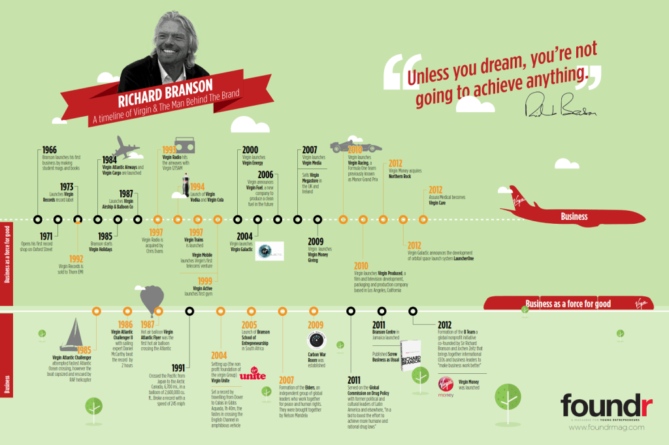
Chan, N. (2014).

REFERENCES
Branson, R. (2011). NBC News Entrepreneur by Richard Branson. Available at: https://www.nbcnews.com/id/wbna41228550 (Accessed 13th November 2020).
Branson, R. (2018). Who is Richard Branson? Available at: https://www.biography.com (Accessed 9th November 2020).
Chan, N. (2014) A Timeline of Richard Branson’s Success. Available at: https://foundr.com/wp-content/uploads/2014/11/Branson-Final_27_sept_001.png (Accessed 17th November 2020).
Cherry, K. (2020). Leadership Styles and Frameworks, you should Know. Available at: https://www.verywellmind.com/leadership-styles-2795312 (Accessed 10th November 2020).

Connley, C. (2017) Richard Branson says he looks for these 2 things in employees. Available at: https://www.cnbc.com/2017/11/30/richard-branson-says-he-looks-for-these-2-things-in-employees.html (Accessed 8th November 2020).
Cooper, C. (2014). Branson unlimited holiday plan for virgin blazes trial others should follow. Available at: https://www.lancaster.ac.uk/lums/news/archive/comment/branson-unlimited-holiday-plan-for-virgin-blazes-trial-others-should-follow/ (Accessed 13th November 2020).
Dearlove, D. (2007, p.163). Business the Richard Branson Way. Capstone, Chichester, uk.
Fowler, A. (2017). What does Leadership mean to you? Available at: https://www.nhsconfed.org/news/2017/01/what-does-leadership-mean-to-you (Accessed 9th November 2020).
Half, R. (2016). 9 Leadership Sills from Sir Richard Branson. Available at: https://www.roberthalf.co.uk/advice/people-management/9-leadership-skills-sir-richard-branson (Accessed 10th November 2020).
Harness, J. (2018). Characteristics of Laissez-Faire Management. Available at: https://bizfluent.com/info-8399492-characteristics-laissezfaire-management.html (Accessed 17th November 2020).
Haun, R. (2019). How to motivate employees the right way. Available at: https://excelbizsolutions.com.au/how-to-motivate-employees-the-right-way/ (Accessed 11th November 2020).
Heivly, C. (2020). Richard Branson’s 1 Rule for Embracing change. Available at: https://www.inc.com/chris-heivly/richard-branson-s-one-rule-for-embracing-change.html (Accessed 14th November 2020).
Indeed, (2020) Common leadership styles. Available at: https://www.indeed.com/career-advice/career-development/10-common-leadership-styles (Accessed 6th November 2020).
Li, M. (2018). Laissez-Faire Leadership: Why Doing Nothing is as Bad as Doing Something Wrong. Available at: https://fisher.osu.edu/blogs/leadreadtoday/subs (Accessed 17th November 2020).
Luebering, J. (2020). Biography Richard Branson. Available at: https://www.britannica.com/biography/Richard-Branson (Accessed 8th November 2020).

Lumen, (2020) Trait Theorists. Available at: https://courses.lumenlearning.com/psychology2x4master/chapter/trait-theorists/ (Accessed 10th November 2020).
Lumen, (2020). Leadership styles. Available at: https://courses.lumenlearning.com/wm-organizationalbehavior/chapter/leadership-styles/ (Accessed 16th November 2020).
McGraw, I. (2010). Democratic Leadership Style. Available at: https://acnotes.com/acqnote/careerfields/democratic-leadership-style (Accessed 18th November 2020).
Mindtools, (2020). Transformational Leadership. Available at: https://www.mindtools.com/pages/article/transformational-leadership.htm (Accessed 18th November 2020).
Moore, J. (2017). What does leadership mean to you? Available at: https://www.nhsconfed.org/news/2017/01/what-does-leadership-mean-to-you (Accessed 9th November 2020).
Mullins, L. (2010, p.14). Management and Organisational Behavior. 9th edn. Pearson. Essex.
Mutuku, C. (2018). Leadership of Richard Branson as an Historical Entrepreneur. Available at: https://m.grin.com/document/429852 (Accessed 8th November 2020).
NCE (Small Firms Association National Centre of Excellence), (2009), Leadership. Available at: http://www.centreofexcellence.ie/sectors/SFA/SFANCEDocLib.nsf/441763b04b0320b68025722e003fb55a/bc12f53469df45728025722e003f060f/$FILE/Leadership.pdf (Accessed 9th November 2020).
Norris, E. (2020). How Did Richard Branson Make His Fortune? Available at: https://www.investopedia.com/ask/answers/032615/how-did-richard-branson-make-his-fortune.asp (Accessed 3rd November 2020).
Ranosa, R. (2020). Richard Branson: I’m Working day and night to look after people. Available at: https://www.hcamag.com/nz/news/general/richard-branson-im-working-day-and-night-to-look-after-our-people/220518 (Accessed 14th November 2020).
Schurenberg, E. (2020). Sir Richard Branson’s Inspiration. Available at: https://www.inc.com/magazine/201303/eric-schurenberg/sir-richards-inspiration.html (Accessed 8th November 2020).
Singh, V. (2018). Richard Branson: How the Virgin Group CEO Ascended the Hierarchy of success. Available at: https://medium.com/@vishakh87341484/richard-branson-how-the-virgin-group-ceo-ascended-the-hierarchy-of-success-978ecaad9738 (Accessed 8th November 2020).
Skippritchard, (2016). Pros and Cons of Leadership Styles. Available at: https://www.skippritchard.com/pros-and-cons-of-leadership-styles/ (Accessed 16th November 2020).
Wachman, R. (2012). Virgin brands: What does Richard Branson really own? Available at: https://www.theguardian.com/business/2012/jan/08/virgin-brands-richard-branson-owns (Accessed 8th November 2020).

