Academic and Employability Skills

Assignment 1
ACE TERM 1 G10
Module code: BMSW4001
Lecturer: Timothy Hopkins
Student: Persida Cristiana Caragea
Student Number: 2014043

Slide 1
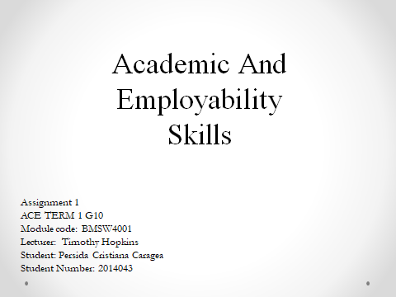
Slide 2

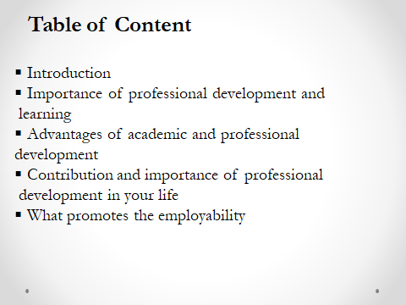
Slide 3
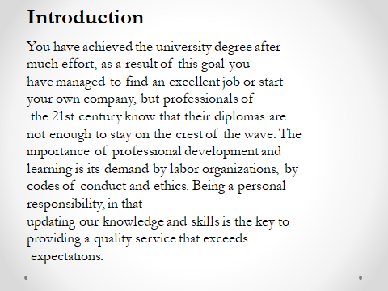
Slide 4
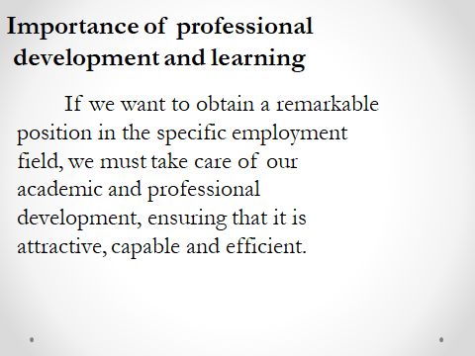
Slide 5
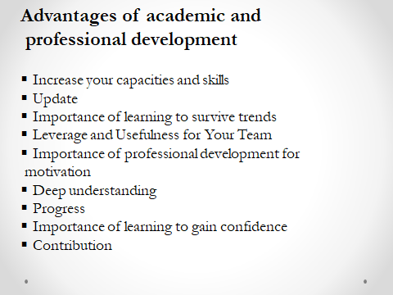
Slide 6

Slide 7
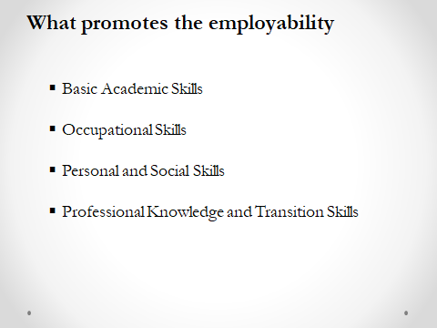
Slide 8


