What it means to be a professional.
To some people, being a professional means dressing smartly in the workplace, or doing a good job. Whereas others may consider it as having certain degrees or qualifications. Although, professionalism does mean all of these things, it also takes into consideration so much more (Mind Tools Content Team , n.d.). To be an accounting professional, it means for an individual to perform what is considered accounting functions such as audits or analysing financial statements. Accountants are able to be employed by either an accounting firm or a large company with their own internal accounting department. Or they could be a individual practice (Kagan, 2019).
Back in April 2018, the International Ethics Standards Board for Accountants (IESBA) released a newly written and revamped Code of Ethics for all Professional Accountants and renamed it as “International Code of Ethics for Professional Accountants (Including International Independence Standards)”. And the Code became effective from June 2019 onwards. The Code focuses on multiple key principles, such as integrity, objectivity, professional competence and due care, confidentiality and professional behaviour (Diane Jules, 2018). Accountancy is known to be a trusted and respected profession and it is vital for all AAT members behave both professionally and ethically, comply with all ATT regulations alongside the relevant legislation and to keep their skills and competence up to date, with regular training. The AAT also investigates complaints and any allegations of misconduct which are made against AAT members and carry out regular monitoring AAT licensed members. AAT also expects its members to constantly show the highest levels of professionalism, in both professional and personal lives. Both clients and employers rely on the AAT to be able to take steps to consider whether or not a member is, and continues to be a person fit to be a member. AAT members must be fully aware of the obligations of which they are required in the sense of the relevant legislation, regulations, policies and by laws (AAT, n.d.).
The ACCA Code of Ethics and Conduct is binding of all its members and students, alongside any partners within any ACCA practice. It’s based on the IESBA Code and the fundamental principles are the same. The Code is set out into 4 parts. Part A is applicable to all professional accountants, Part B is applicable to professional accountants working within a public practice, Part C is applicable to a professional accountant working within a business and Part D is applicable to all professional accountants working within the United Kingdom, who are also insolvency practitioners. Majority of accountants will find that the whole Code applies to them.
Part A determines the fundamental principles of the professional ethics for any accountants and provides them with a conceptual framework which professional accountants must apply to be able to identify any threats to compliance within the fundamental principles, evaluate the significant factors of the threats which have been identified and the ability to apply safeguards when required to be able to eliminate the threats, or at least be able to reduce them to what is considered to be an acceptable level.
Part B and C are describing how the conceptual framework can be applied in specific situations. They are able to provide examples of safeguards which are appropriate to address the threats to be compliant with the fundamental principles. These parts also describe situations in which safeguards aren’t able to be applied to address the threats.
If accountants fail to comply with the Code, they are liable to receive disciplinary action. There have been two committees which have been appointed by the council to enforce these standards; these are known as the Disciplinary Committee and the Appeal Committee. These committees are able to enforce their powers using bylaws (ACCA, n.d.).

Group Dynamics
Kurt Lewin was a social psychologist born in 1890 and died in 1947, his work covered studies of multiple leadership styles and the effects they have, group decision making, the development of force field theory and many more (British Library , n.d.). It is well known that Kurt Lewis had a huge impact on the generation of researchers and thinkers which are concerned about group dynamics. Kurt Lewin looked into the nature of the group task, to be able to determine the uniformity of specific groups’ behaviour. Brown argued that the two key theories merged out of the field theory which are vital for an appreciation of group process; interdependence of fate and task interdependence. Interdependence of fate is the argument which groups come into being a psychological sense, not because their members ae similar to each other but that the group exists because those involved realise that their fate depends solely on the fate of the group overall. The other being task interdependence which is considered to be a pretty weak form of interdependence in multiple groups, as argued by Lewin. A highly important factor is that the interdependence in the goals of the group members, also known as the groups task is that members of the group are solely dependent on one another for achievement which then as a result creates a powerful dynamic (Smith, 2001).
There are multiple factors which have a knock on effect for group dynamics. The success, or sometimes failure of a group is dependent on multiple factors, the resources of group members, the structure, group processes, and the group tasks.
The first factor being the members resources, such as knowledge, abilities and personality characteristics such as their social skills, and independence are the resources which each member of that group brings with them. The group success depends on these resources being useful to the task.
A group can be formed from 2 people, to a very large number. Smaller groups within the range of 2 to 10 people are considered to be more effective as each of its members are able to take part and then engage with each activity. Larger groups can waste more time on deciding on their processes and then deciding who should participate next.
Group norms are what define the standard of boundaries which are considered to be acceptable, and unacceptable behaviour. These are typically created to assist in group survival and make members behaviours more predictable, avoid any situations which are seen as embarrassing and express the group values.
The cohesiveness of the group signifies the bonding of the group members or also known as its unity, the feelings towards one another and desire to remain a part of the group. There are multiple factors which influence the amount of the group cohesiveness, such as the group agreeing on goals, the frequency of interaction, personal attractiveness and inter group competition. The more difficult it is to be able to achieve group membership, the more cohesive the group will then be. However, highly cohesive groups can also be vulnerable to groupthink. Groupthink commonly occurs amongst these groups when the members put pressure on one another to come to a decision.
The decision making process of the group is the superior component as the group generates more information as well as knowledge, creates diverse alternatives, increases the acceptance of a solution and increase the chance of legitimacy. Decisions take a long time, and the minority gets dominated and the pressure is applied to obey to group decisions, and no one is responsible for these decisions (Your Article Library , n.d.).
Teamwork is very important in the workplace, as it is the key to success of all businesses. To be sure to have a meaningful and lifelong career, it is important to have the skill to be able to work well alongside others. Teamwork brings new ideas to a group, and businesses are forever requiring fresh ideas to enable them to succeed in the competitive world. Each individual has a unique perspective which will benefit the business overall. Teamwork enables a quick and efficient way to solve problems, as brainstorming is a brilliant chance for the members of the team to be able to exchange ideas and come together to create a new and innovative way of doing things. Alongside this, teamwork is a support system to enable teams to ensure deadlines are met and the work is constantly to a high quality standard. When one member of the team falls behind, there is always someone there to assist them to pick up the pieces. When the workload of a group is divided up between its members, it gets done faster which overall makes the business operate at a much more efficient rate. And finally, teamwork builds morale. When a members work is appreciated and contributes to something which reaches the desired results. This also builds confidence and trust within the team (Career Training, 2015).
There are two common teamwork theory which allows us to understand the dynamics of a group as well as assisting us to work in teams. The first was developed by Bruce Tuckman in 1965, his original idea identified that there are four stages for all groups to pass through when transitioning from being newly formed, to high performing. In 1977 he revised the model, to include a fifth stage. These stages are Forming, Storming, Norming, Performing and Adjourning.
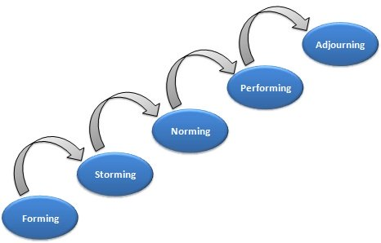
Figure 1 - Bruce Tuckman Team Development Model
Within the Forming stage, the members of the group meet one another and learn about the tasks they are required to perform. Team members then try and figure out how and where they will fit in and understand what is expected of them personally. This stage is vital for the project manager to be able t provide structure for the team.
During the Storming stage, interpersonal issues such as conflict arise. Within this stage it is awfully common for the members of the team to challenge one another, including the project manager. Team members also question each other on what they are doing and how they are doing it.
As the conflicts begin to settle and become less intense, the members start to understand and accept one another, this represents that the team is moving into the Norming stage. This is the point where the team comes together and is able to then focus on the task and its objectives.
In the Performing stage, the members are now comfortable with one another and the group norms have been accepted. All issues such as interpersonal and structural have been settled and focus is now on supporting task performance. Once the team is performing at a high level, you are able to focus on leadership activity.
While the project comes to an end, the team moves into Adjourning stage. This is the point when the group has become very close and majority of the members will feel as though they are at a loss. Due to this, this stage is also known as the Mourning stage (Project Management , n.d.).
The second teamwork theory which assists us to understand group dynamic and improve team performance was created by Dr Meredith Belbin. Belbin identified nine team roles. Each team role is associated alongside typical behaviour and interpersonal strengths. The team roles are organised into categories Action Oriented, People Oriented and Thought Oriented.
Action Oriented Roles.
The Shaper are those people who are willing to challenge the team to improve, they are dynamic and most commonly extroverted people who also enjoy to stimulate other people, question the group norms and find the best approach for tackling problems.
The Implementer are those who get things done. They take the teams initial ideas as well as concepts and turn them into plans and actions. These people are usually conservative, disciplined displaced and someone who works systematically and efficiently alongside being very organised.
The Completer-Finisher are a person who oversee the projects and ensure they are completed properly and to a high standard. They make sure there are no errors and pay specific attention to the smallest of details. However, they can worry when it isn’t necessary and sometimes find it hard to delegate jobs.
People Oriented Roles.
The Coordinator are those who take on the more traditional role of being a team leader and can often sometimes be referred to as the chairman of the group. The role of the coordinator is the guide the team and ensure they see the groups objectives.
The Team Worker provides support and ensures people within the team are working together effectively and efficiently. The person given this role fill the roles of the negotiator and are flexible as well as diplomatic and perceptive.
The group member who is the Resource Investigator is seen to be innovative and curious. They are constantly exploring new options and develop contracts and negotiate for resources on the behalf of the team.
Thought Oriented Roles.
The group Plant is the creative one, who is known to be the innovator and is responsible for coming up with new ideas for the group and new approaches. Plants are more often than not introverts and prefer to work alone, away from the team.
The Motor-Evaluator are best known for analysing and evaluating the ideas which have come from other people, most likely the Plant. These people carefully and efficiently look at the advantages and disadvantages of all options, prior to coming to a final decision.
The group Specialist have specific (specialist) knowledge and is required to ensure the job gets done. They are proud of their abilities alongside their skills and work hard to keep up their professional status (Mind Tools Content Team , n.d.).

Project.
There are five set steps to project management; project initiation, project planning, project execution, project performance and project closure.
The first step of the project and the overall goal of the phase is to be able to determine the overall project at a broad level. This phase usually begins using a business case and when the research for the project takes place.
The second phase is project planning and is key for successful project management, while focusing on developing a roadman which everyone in the group will follow. This phase usually begins by setting goals using S.M.A.R.T (Specific, Measurable, Attainable, Realistic and Timely) and C.L.E.A.R (Collaborative, Limited, Emotional, Appreciable and Refinable).
The third phase is Project Execution and where the deliverables are developed and then completed. This usually feels as though it’s the main part of the project due to the fact a lot is happening in this time, such as meetings and project reports. There is usually a meeting at the beginning of this phase to inform those of what their responsibilities in the project will be.
Phase four is the Project Performance stage and is all about focusing on measuring the progression and performance, whilst ensuring that everything happens and lines up correctly with the project plan. They usually use key performance indicators to be able to determine if the project is on track.
The final stage is Project Closure and is usually when the project is completed and any external contractors etc who are hired specifically for that project are let go. The team members which are valued are recognised and those who participated are thanked for their efforts (Eby, 2018).
During my time within college I worked within a group to plan the College Christmas Fair, and all proceeds raised were donated to a charity of our choice, Paul Sartori. Planning and reviewing throughout the project was vital for us. We didn’t use a gantt chart to mark milestones, but many teams find it useful.
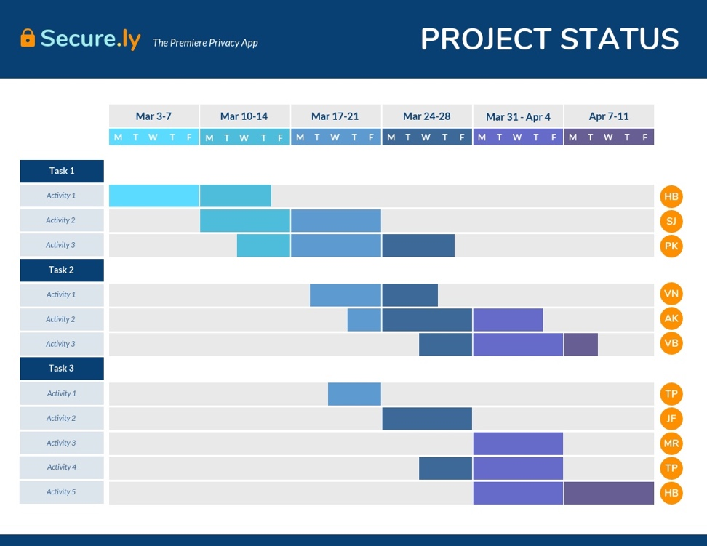
Figure 2 - Example Gantt Chart
Figure 3 - Project Plan
There are many problem solving techniques which can be used in a group, a very popular one being the fishbone technique, which also referred to as the cause and effect diagram. The first step is to identify the problem. The second is to collect data to determine the cause of the problem. Next is to draw the fishbone diagram and include the possible course and the four standard problem sources which are machinery and equipment, materials, methods and people. The fourth step is brainstorm each problem and think of any possible hypothesis related to that source. Then for each cause try and identify the root of each. Then to end it for each possible cause check the validitally of each cause.
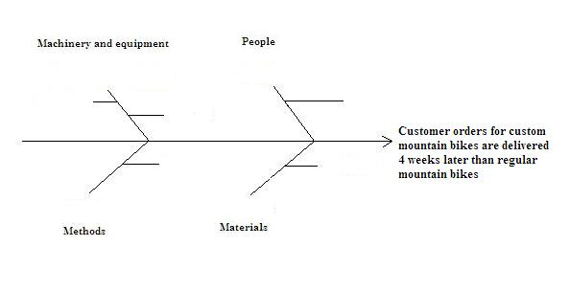
Figure 4 - Example Fishbone Diagram

CPD.
Continuing Professional Development (CPD) is important for all professionals as it refers to the process of tracking and documenting an individual’s skills, their knowledge and experiences which are gained both formally and informally and any initial training. It is a record of what experience is gained, learnt and then applied (Jobs.ac.uk, n.d.).

Bibliography
AAT, n.d. Professional Standards. [Online]
Available at: https://www.aat.org.uk/about-aat/professional-standards
[Accessed 30 April 2020].
ACCA, n.d. ACCA code of ethics and conduct. [Online]
Available at: https://www.accaglobal.com/gb/en/about-us/regulation/ethics/acca-code-of-ethics-and-conduct.html
[Accessed 30 April 2020].
British Library , n.d. Kurt Lewin. [Online]
Available at: https://www.bl.uk/people/kurt-lewin
[Accessed 30 April 2020].
Career Training, 2015. Reasons Teamwork Is Important In The Workplace. [Online]
Available at: https://www.yti.edu/blog/reasons-teamwork-is-important-in-the-workplace.asp
[Accessed 30 April 2020].
Diane Jules, D. D. I. a. R. E. P. B. B. &. I. S. C. M., 2018. The International Code of Ethics for Professional Accountants: Key Areas of Focus for SMEs and SMPs. [Online]
Available at: https://www.ifac.org/knowledge-gateway/building-trust-ethics/discussion/international-code-ethics-professional?fbclid=IwAR0V7m7g61Gwmv0o3zRSEX1rPPLyHIdHt9kRZVo5twq1751BJL2zCxef2Bg
[Accessed 30 April 2020].
Eby, K., 2018. Demystifying the 5 Phases of Project Management. [Online]
Available at: https://www.smartsheet.com/blog/demystifying-5-phases-project-management
[Accessed 30 April 2020].
Jobs.ac.uk, n.d. What is CPD. [Online]
Available at: https://career-advice.jobs.ac.uk/career-development/what-is-continuing-professional-development-cpd/
[Accessed 1 May 2020].
Kagan, J., 2019. Accountant. [Online]
Available at: https://www.investopedia.com/terms/a/accountant.asp
[Accessed 30 April 2020].
Mind Tools Content Team , n.d. Belbins Team Roles. [Online]
Available at: https://www.mindtools.com/pages/article/newLDR_83.htm
[Accessed 30 April 2020].
Mind Tools Content Team , n.d. Professionaism - Developing This Vital Characteristic. [Online]
Available at: https://www.mindtools.com/pages/article/professionalism.htm
Project Management , n.d. Teamwork Theory: Stages of Group Development. [Online]
Available at: https://www.project-management-skills.com/teamwork-theory.html
[Accessed 30 April 2020].
Smith, 2001. Kurt Lewin: groups, experiential learning and action research. [Online]
Available at: https://infed.org/mobi/kurt-lewin-groups-experiential-learning-and-action-research/
[Accessed 30 April 2020].
Your Article Library , n.d. Group Dynamics. [Online]
Available at: http://www.yourarticlelibrary.com/management/group-dynamics-its-characteristics-stages-types-and-other-details-management/5363
[Accessed 30 April 2020].

