Module Name: International Meetings Management for the Hotel Industry
Module Code: BMIH6007
Event- Winter: Childhood Christmas Memories

Student Name: Alina Maria Butarita
Student ID: 2207461
Module Lead: Kathryn Flynn

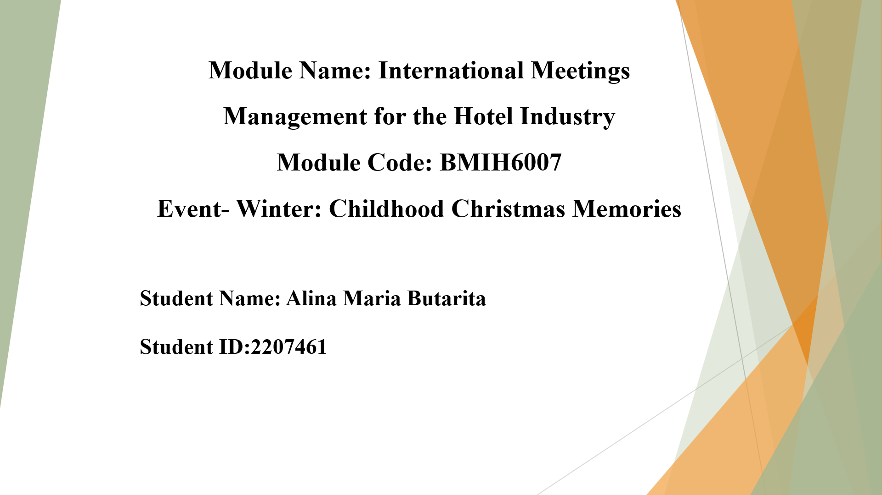
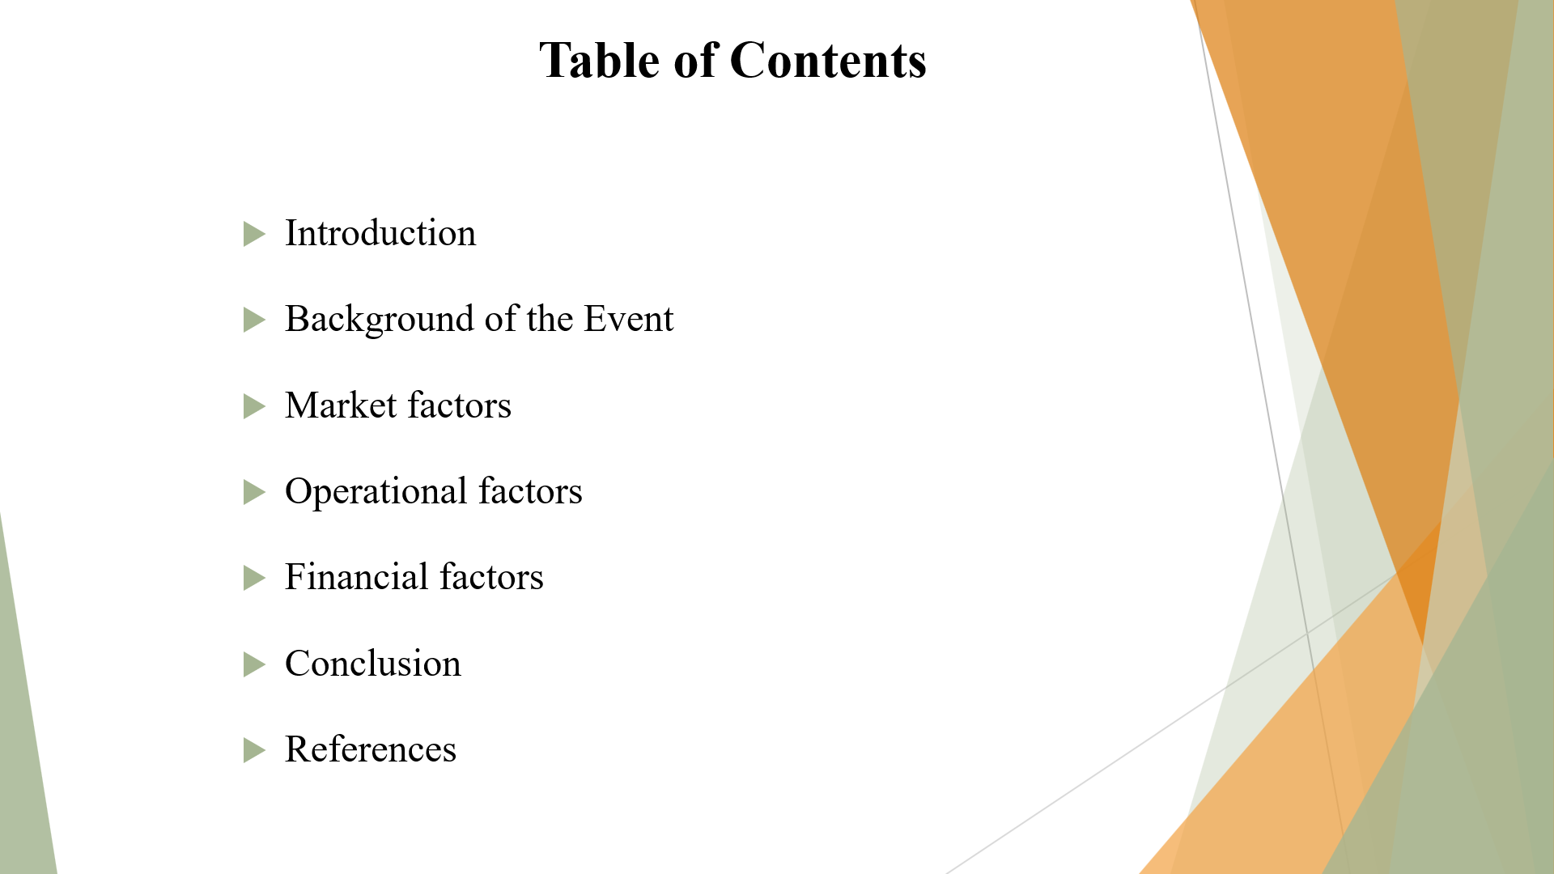

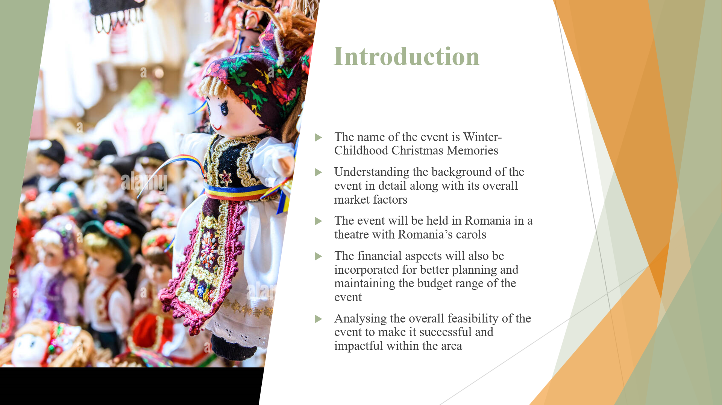
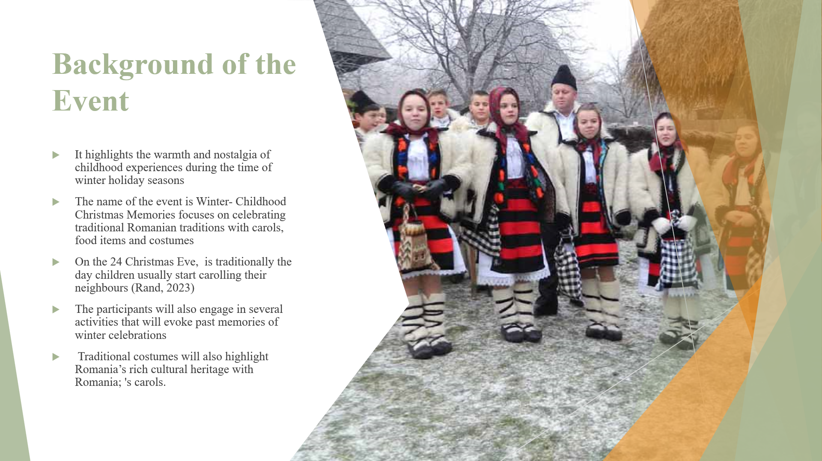
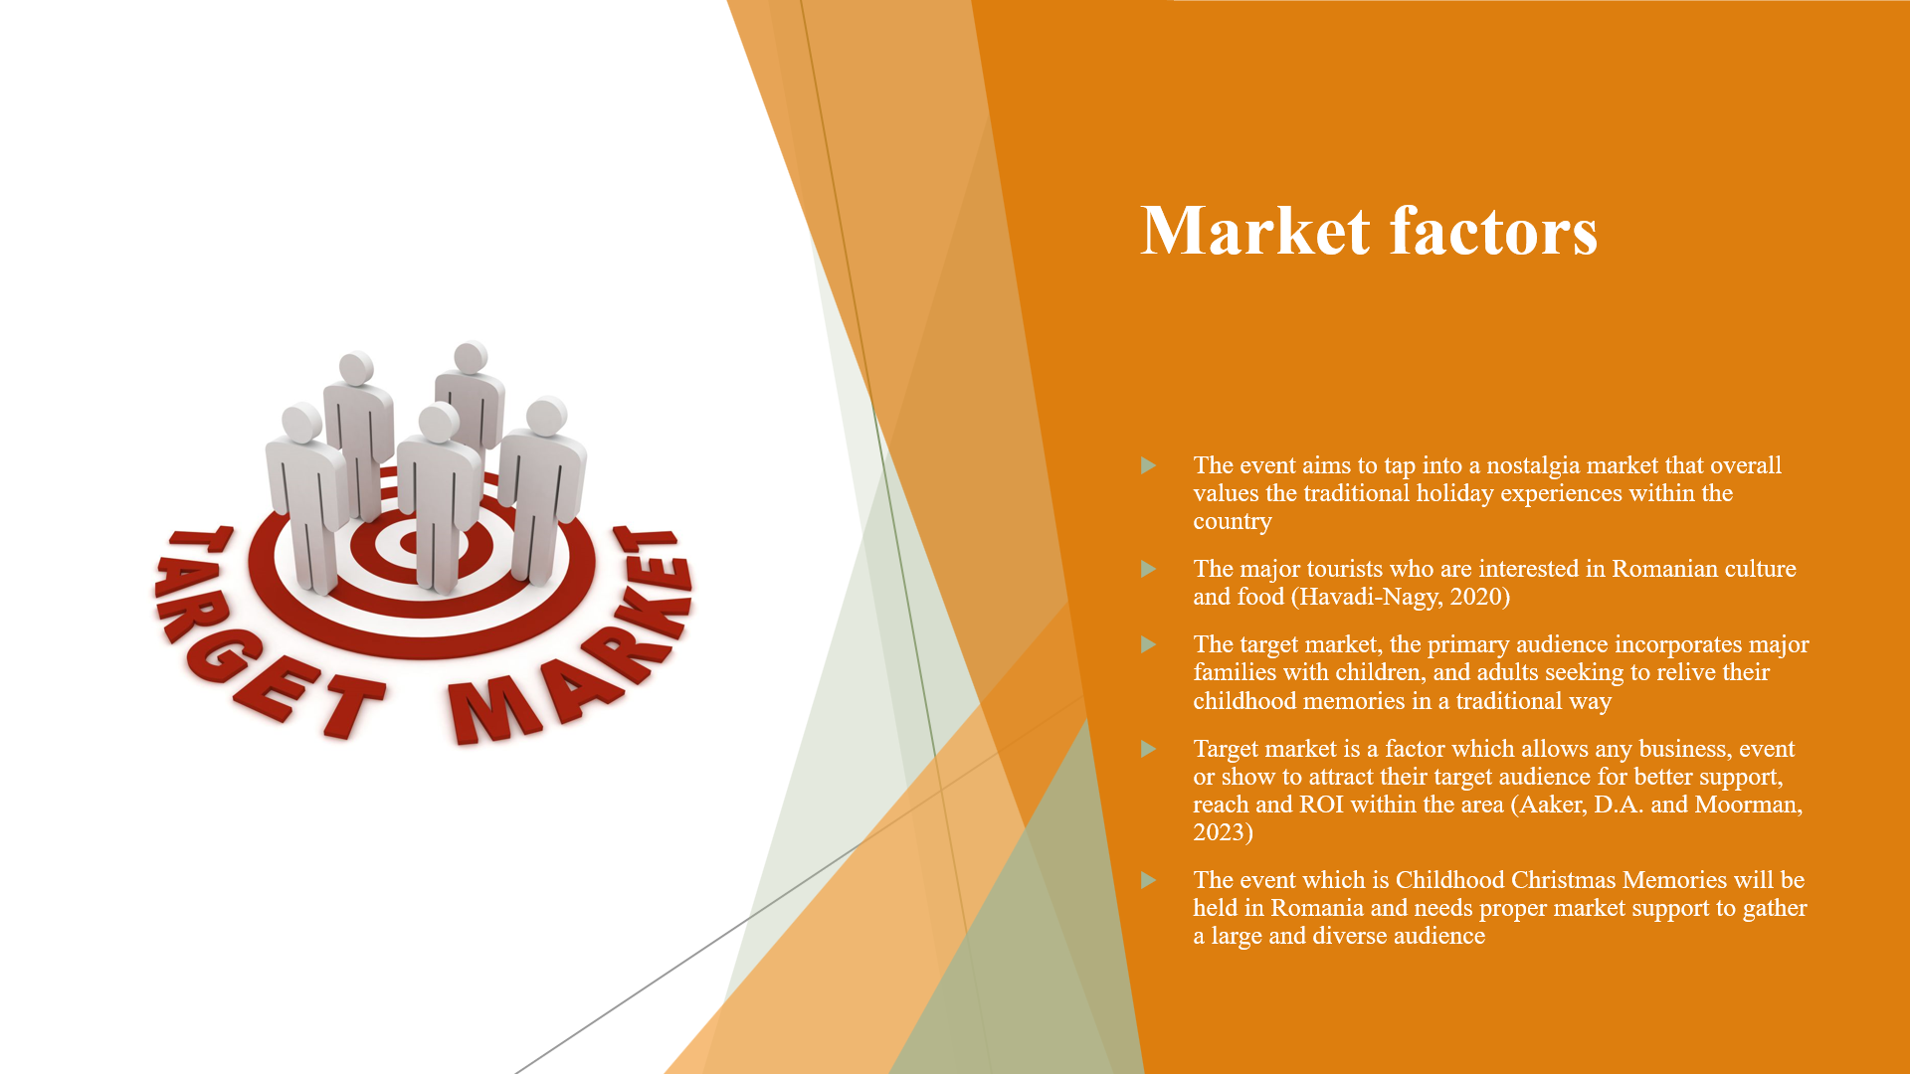
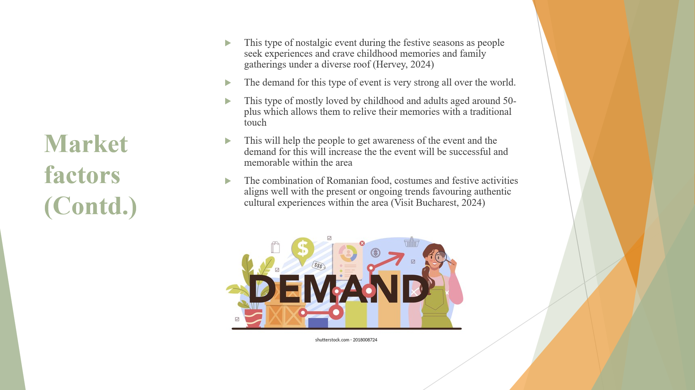
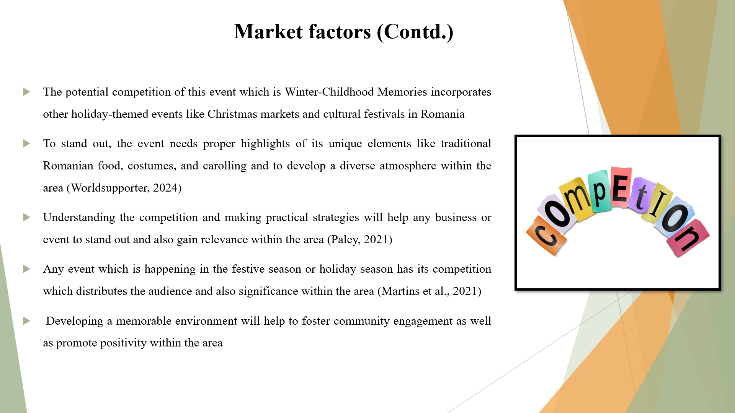
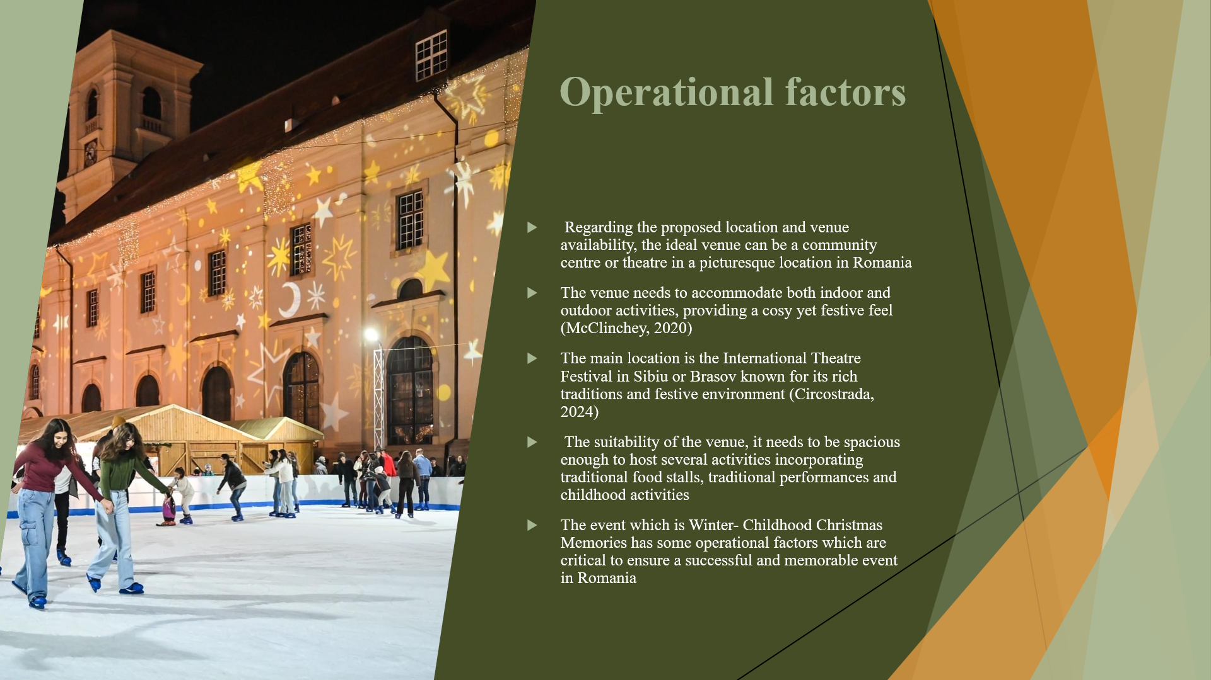
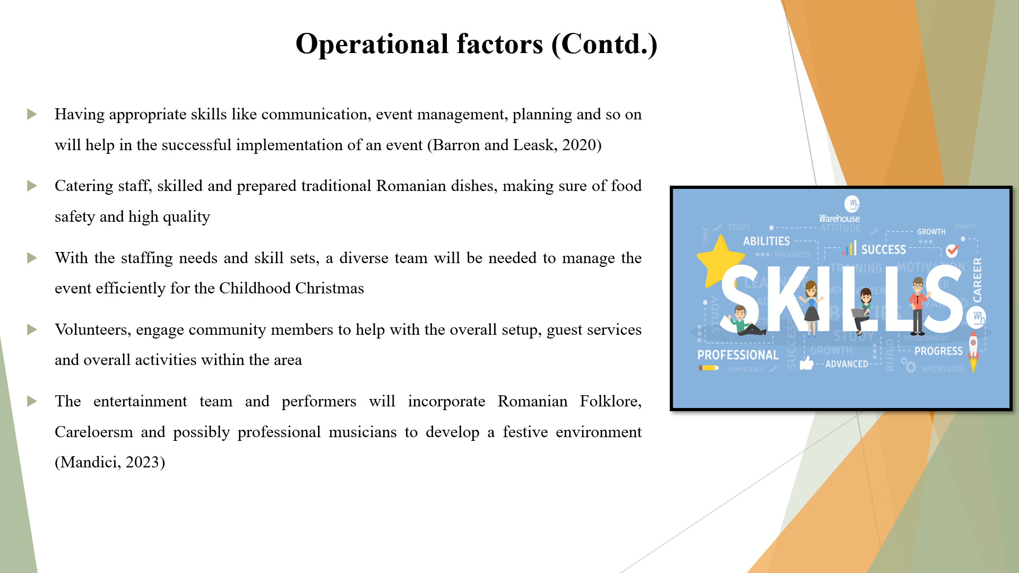
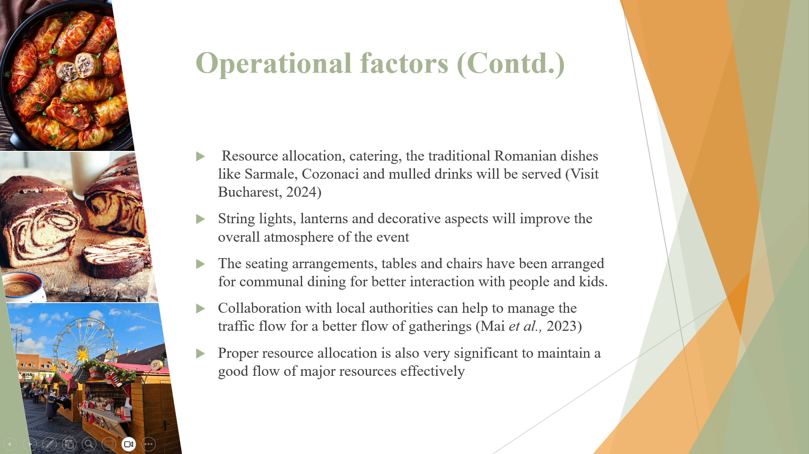
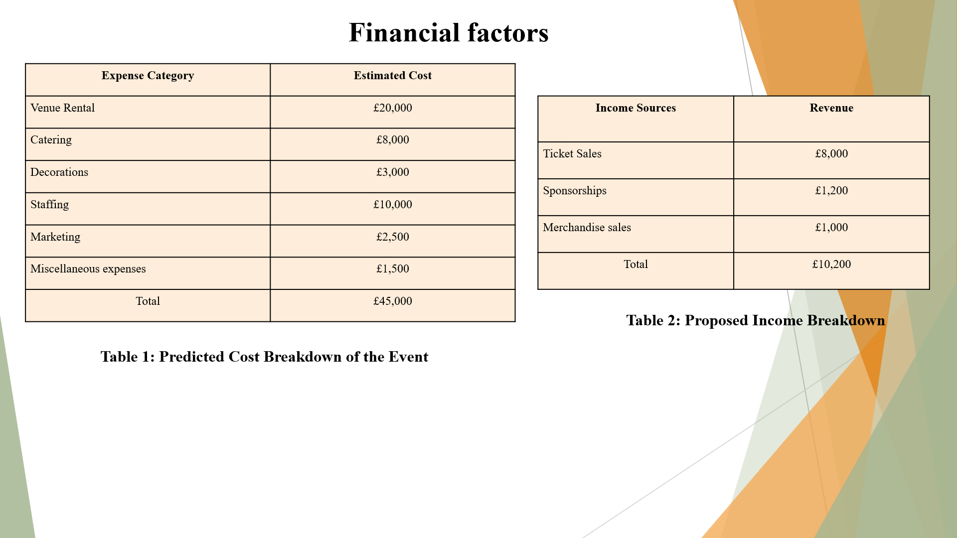
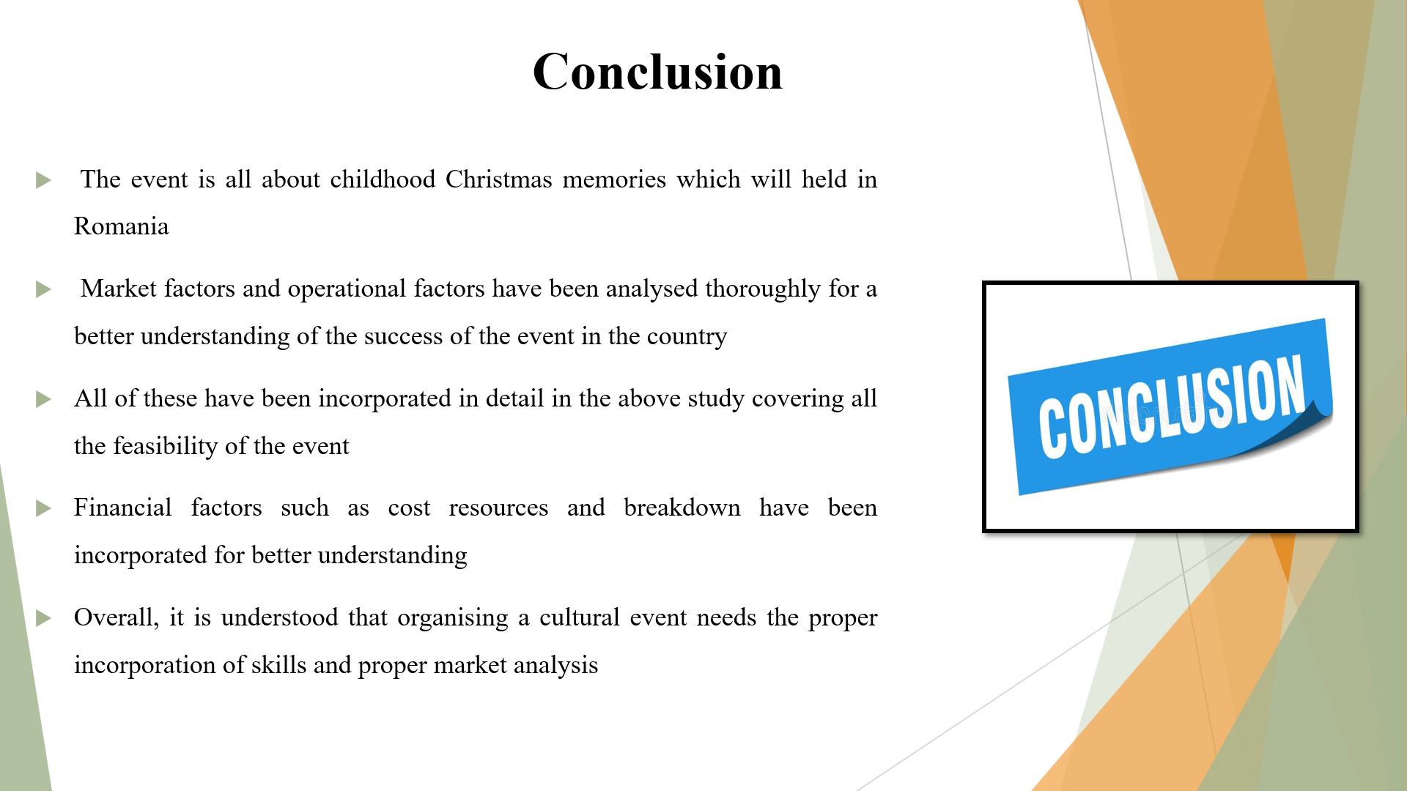
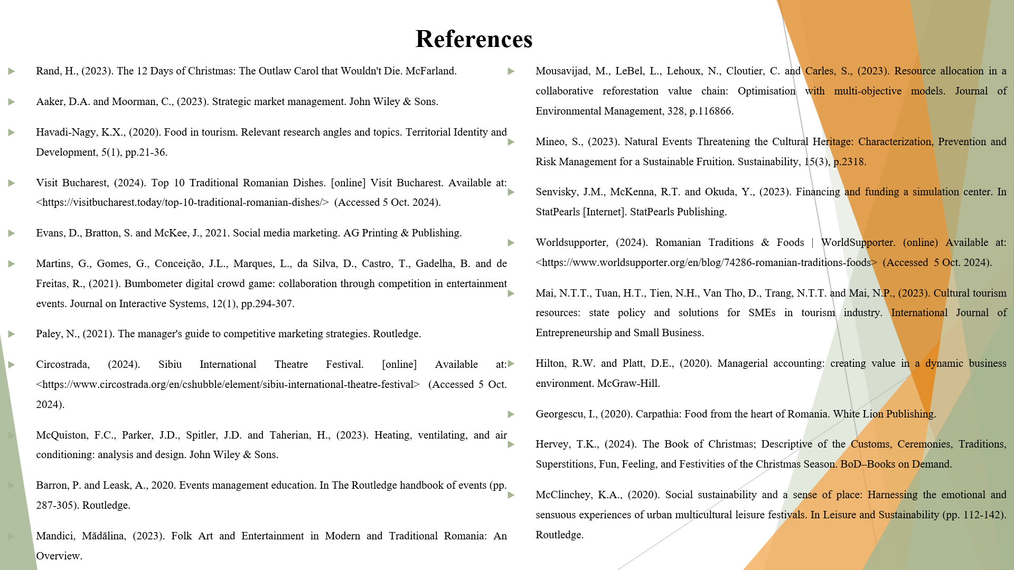


References

Rand, H., (2023). The 12 Days of Christmas: The Outlaw Carol that Wouldn't Die. McFarland.
Aaker, D.A. and Moorman, C., (2023). Strategic market management. John Wiley & Sons.
Havadi-Nagy, K.X., (2020). Food in tourism. Relevant research angles and topics. Territorial Identity and Development, 5(1), pp.21-36.
Visit Bucharest, (2024). Top 10 Traditional Romanian Dishes. [online] Visit Bucharest. Available at: <https://visitbucharest.today/top-10-traditional-romanian-dishes/> (Accessed 5 Oct. 2024).
Evans, D., Bratton, S. and McKee, J., 2021. Social media marketing. AG Printing & Publishing.
Martins, G., Gomes, G., Conceição, J.L., Marques, L., da Silva, D., Castro, T., Gadelha, B. and de Freitas, R., (2021). Bumbometer digital crowd game: collaboration through competition in entertainment events. Journal on Interactive Systems, 12(1), pp.294-307.
Paley, N., (2021). The manager's guide to competitive marketing strategies. Routledge.
Circostrada, (2024). Sibiu International Theatre Festival. [online] Available at: <https://www.circostrada.org/en/cshubble/element/sibiu-international-theatre-festival> (Accessed 5 Oct. 2024).
McQuiston, F.C., Parker, J.D., Spitler, J.D. and Taherian, H., (2023). Heating, ventilating, and air conditioning: analysis and design. John Wiley & Sons.
Barron, P. and Leask, A., 2020. Events management education. In The Routledge handbook of events (pp. 287-305). Routledge.
Mandici, Mădălina, (2023). Folk Art and Entertainment in Modern and Traditional Romania: An Overview.
Mousavijad, M., LeBel, L., Lehoux, N., Cloutier, C. and Carles, S., (2023). Resource allocation in a collaborative reforestation value chain: Optimisation with multi-objective models. Journal of Environmental Management, 328, p.116866.
Mineo, S., (2023). Natural Events Threatening the Cultural Heritage: Characterization, Prevention and Risk Management for a Sustainable Fruition. Sustainability, 15(3), p.2318.
Senvisky, J.M., McKenna, R.T. and Okuda, Y., (2023). Financing and funding a simulation center. In StatPearls [Internet]. StatPearls Publishing.
Worldsupporter, (2024). Romanian Traditions & Foods | WorldSupporter. (online) Available at: <https://www.worldsupporter.org/en/blog/74286-romanian-traditions-foods> (Accessed 5 Oct. 2024).
Mai, N.T.T., Tuan, H.T., Tien, N.H., Van Tho, D., Trang, N.T.T. and Mai, N.P., (2023). Cultural tourism resources: state policy and solutions for SMEs in tourism industry. International Journal of Entrepreneurship and Small Business.
Hilton, R.W. and Platt, D.E., (2020). Managerial accounting: creating value in a dynamic business environment. McGraw-Hill.
Georgescu, I., (2020). Carpathia: Food from the heart of Romania. White Lion Publishing.
Hervey, T.K., (2024). The Book of Christmas; Descriptive of the Customs, Ceremonies, Traditions, Superstitions, Fun, Feeling, and Festivities of the Christmas Season. BoD–Books on Demand.
McClinchey, K.A., (2020). Social sustainability and a sense of place: Harnessing the emotional and sensuous experiences of urban multicultural leisure festivals. In Leisure and Sustainability (pp. 112-142). Routledge.

