UNIVERSITY OF WALES TRINITY SAINT DAVID
CLOUD COMPUTING

Walmart Sales Forecasting
Big Data – Assessment 2

AUTHOR: CLAUDIU OCTAVIAN ALBUS
STUDENT ID: 1809254

London
2021
Table of Contents

- Abstract _____________________________________________________1
- Introduction__________________________________________________1
- Literature Review_____________________________________________2
- Methods_____________________________________________________7
- Data preparation_____________________________________________15
- Modelling___________________________________________________19
- Evaluation__________________________________________________22
- Results_____________________________________________________26
- Conclusions_________________________________________________27
- Bibliography________________________________________________28

Abstract

This paper is presenting how the sales forecasting is one of the key components for the retail companies, having a major impact on them.
It will be described how one of the leading retail stores in the United States, Walmart, is facing several issues related to its incapability to predict efficiently the demand for its products, and how this may conduct to another problem such as the possibility to remain out of stock for some of their items.
The objective is to support the company to forecast the sales accurately by developing a predicting model.

Introduction

Being involved in the retail business, a company that can take the right decision at the right time could maximize its profits. This advantage would not be possible without being able to precisely predict the demand and supply.
In the same context, Walmart, the leading retail store in the United States, is facing some issues due to an unexpected high demand and this has led to a high reduction of stocks. However, the company is looking forward to find the optimal solution to be able to predict accurately its sales, which will make the business more profitable.
The current project aims to analyze the previous data from Walmart stores that will help to develop a sales predicting model regarding indicators for the key performance to measure the inflation, such as: the consumer price index (CPI), the unemployment rate and so on.

Literature Review

The major goal of the network planning for the retail stores is to maximize the profits by understanding certain processes and where to spend profitably. To be efficient, the organization should be able to understand the customers behavior for each store from a specific area and to use the different variations of the allocation options (Anita, 2015).
There are several other challenges regarding the planning of the retail network, some of which are the failure of the retailers to evaluate properly the potential of the market. Also, the retailers do not take into account the seasonal periods, which may vary for each type of product (Anita, 2015).
The total sales for a particular item can be considered a result of estimating the highest possible volume of sales over a given period and under certain assigned conditions. The potential of the market depends on the customers’ behavior, the competitors, and the given support for the facilities. Those factors are affecting the future of the sales for a specific shop, from a specific location (Anita, 2015).

Forecasting
The forecasting process is a collection of methods used to predict the sales, being initiated after the objectives are determined. In case the methods were not used previously, it is preferable to be checked first before use, and then the data can be processed and interpreted (Anita, 2015).
Forecasting approaches consists of three main categories, such as: qualitative, quantitative, or a hybrid between the previous two. Qualitative methods often use human intelligence or may instruct a professional structure using human inputs. Quantitative approaches include statistical, space models and deep learning techniques. Also, there are statistical approaches using classic regression or time-series models. (B Abraham, 2009).

Data Mining
Data mining or information exploration is a mechanism by which computational tools and knowledge-based approaches are used to evaluate data and exploit trends that have value from a large volume of data (Dalia, 2015).
This concept is used to identify interactions, habits or correlations between dataset features that can be converted into helpful information about historical patterns and trends about the future (Dalia, 2015).

CRISP Model
In the current context of the Walmart case, the sales history is available for 45 stores. In this case, the statistical methods can be chosen to build an efficient sales forecasting model.
The major aim is related to the forecasting issue, that means the CRISP (Cross Industry Standard Process) model, will be used to build the predicting model. The following figure shows the steps of the process:
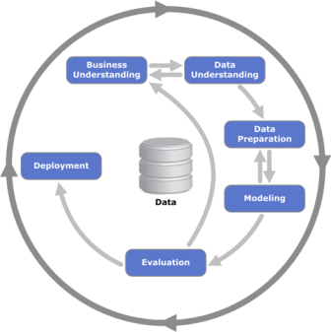
Figure 2 : CRISP Data mining

Phases
1) Business understanding phase - It is concentrating on the goals of the project from the company viewpoint, then translates this information into a description of the data mining task and a preliminary strategy to achieve the objectives.
2) Data understanding phase – Begins with the original data collection and continues with activities to get familiar with the data, to recognise the quality concerns, to uncover the information from the data or to identify interesting subsets to shape theories for hidden patterns.
3) Data preparation phase – This phase includes the activities needed to create the final data collection from the original raw data.
4) Modelling phase - Different methods are chosen and implemented and their parameters are adjusted to the optimum values. Usually, there are many approaches for the same form of data mining issue. Few approaches have unique data structure characteristics.
5) Evaluation phase – It is necessary for this model to be analysed in more depth and to review the measures taken to ensure that they meet the business standards. A decision on how to use the results of data mining should be made at the end of this process.
6) Deployment phase - Even if the purpose of the model is to improve the understanding of data, the knowledge gained must be organized and presented in such a way that it can be used further. (Óscar, 2009).

Random Forest
Random Forest is a group of unassembled categories or regressions trees. This category is developed based on a random collection of the training datasets and the characteristics chosen during the induction process. Each tree in this classification algorithm is expanded to the maximum size without pruning. Random Forest usually demonstrates a consistency gain over a single tree classifier or a Classification and Regression tree (CART). This classifier is designed to minimize the total error rate and to concentrate on the precision of the forecast (Ankur, 2015).

Methods

Data preparation
The first thing to do when working with data is to understand it from the beginning. This understanding process provides a comprehensive description of the data. By using descriptive statistics approaches, it can be obtained helpful information about the quality, the structure, and the distribution of the data.

Import Data
Because the historical data file has a CSV file extension, it will be used Knime CSV READER NODE to import the specific dataset.
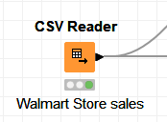
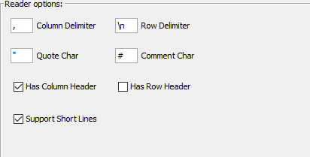
Figure 3:CSV READER NODE Figure 4: CSV READER Node
Settings

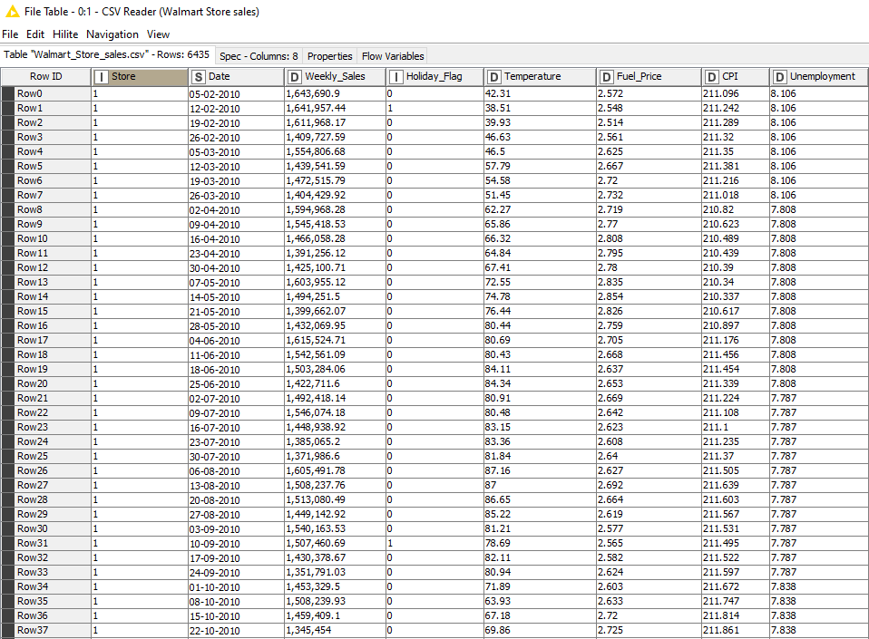
Figure 5: First Rows of Walmart Stores Data

Dataset dimension
When the dataset is read from the input file, the data structure can be observed in the table. The data set contains 8 columns and has 6436 rows. Most rows are numerical data, except for the column called ‘Date’, which contains the dates on which the sales were made.

Values
For a better statistical view, the Data Dictionary can be examined in depth. In the following print screen, the related figures can be observed:
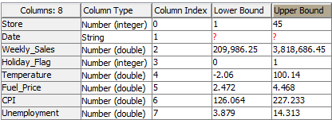
Figure 6: Data dictionary
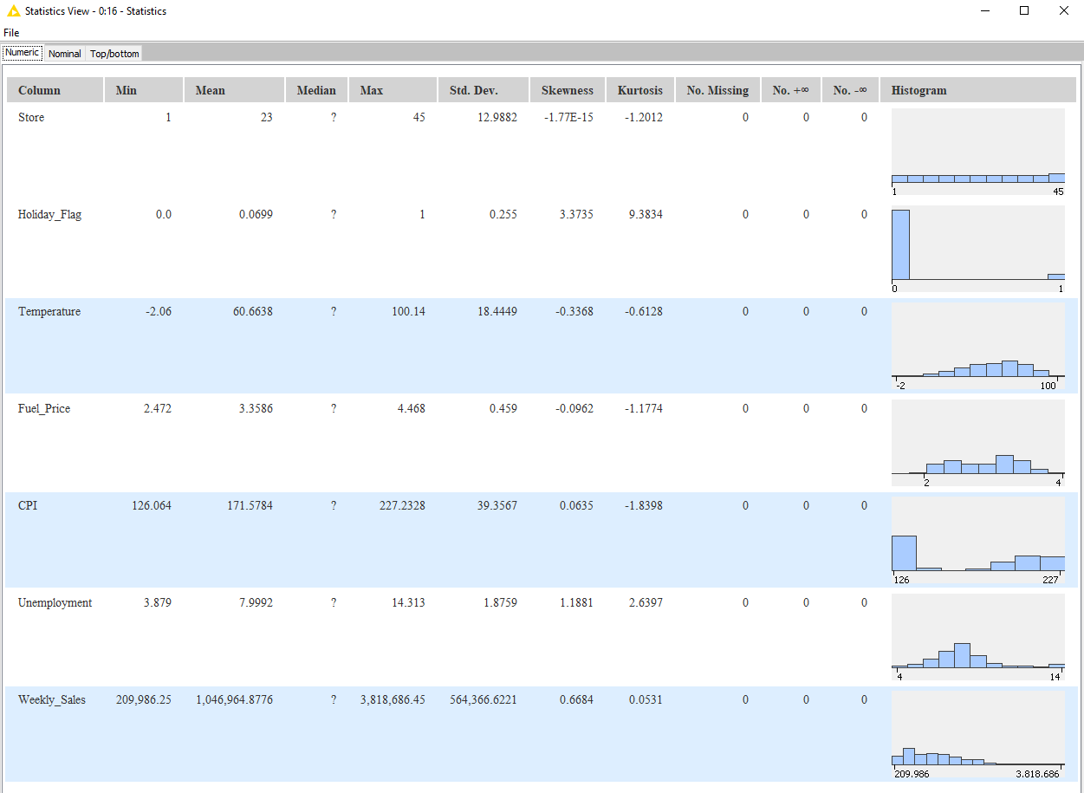
Figure 7: Statistics View

From figures 6 and 7, we observe that the wide range of data values range is quite different from one column to another. This will lead to the execution of the next step called Data Standardization, to commit an equal impact for each feature within the machine learning algorithms.

Data Representation
After grouping according to the representativity of each store, it can be observed that all 45 Walmart stores have 143 observations each. Which means the data is correctly balanced, and every store is having higher ponderation in terms of its population amount in the dataset. The following print screen shows up the count of rows grouped by store:
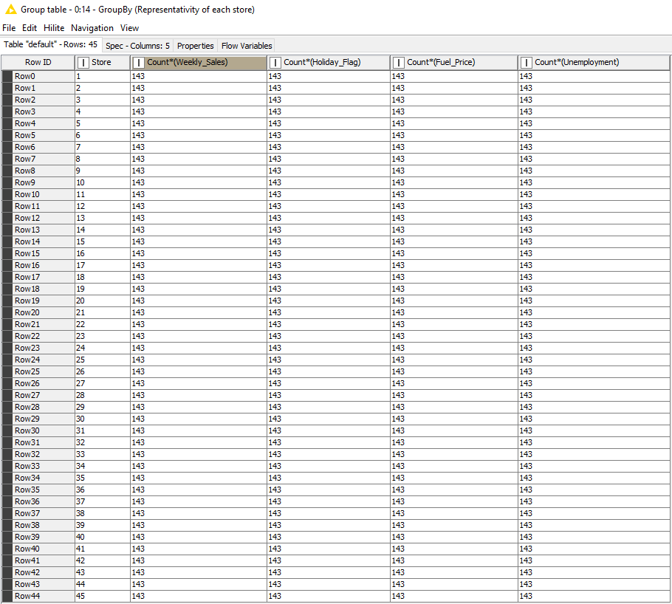
Figure 8: Count of rows Grouped by Store

Time Series Data
In this case, the ‘Date’ column follows the same time periods for the weekly sales data. Having time series data available, means that the time series forecasting model can be developed further.

Sales grouped by date
Using the node called ‘GroupBy’ within Knime platform, it can be performed a group by request. The following figure represents the node settings:

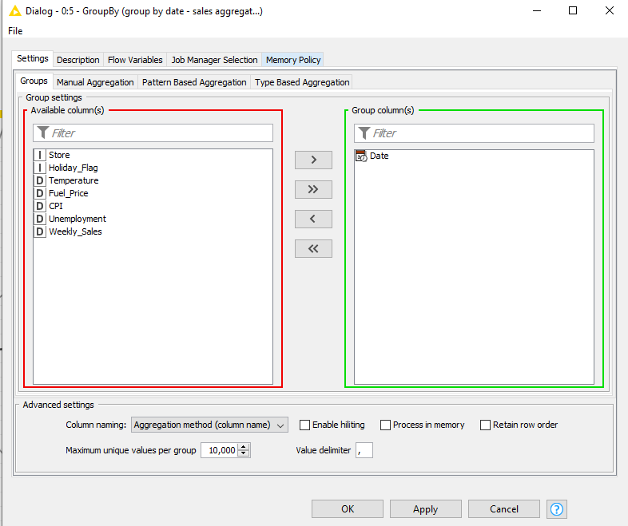
Figure 9: Setting the feature to group the data

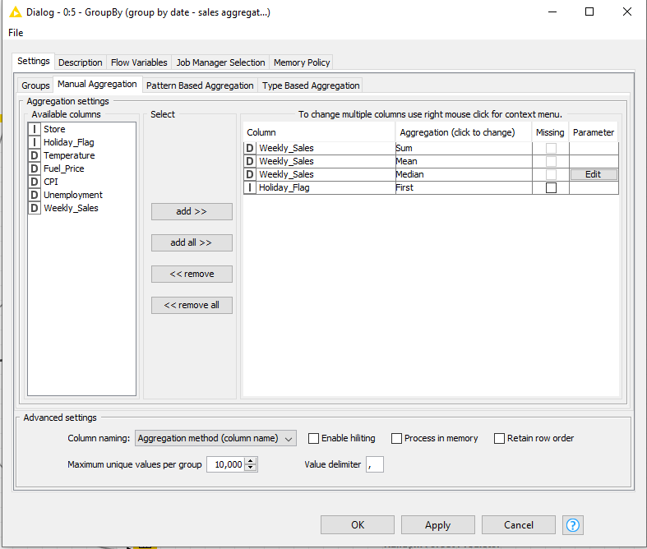
Figure 10: Setting the aggregate methods to perform on the data already grouped

In the next print screen are presented the statistic sales grouped by date:
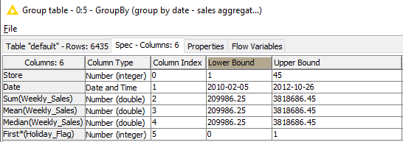
Figure 11: Statistics sales Grouped by Date
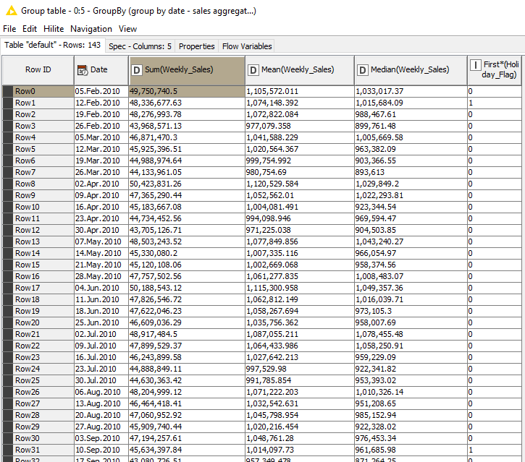
Figure 12: Sales Grouped by Date

As shown in the figure 11 and 12, for a given date, the gap between the lower sales and the maximum sales amount is important.

Sales grouped by store
In the same manner, the sales can be calculated being grouped by store. As shown in the following print screen, the results are retrieved from the model:
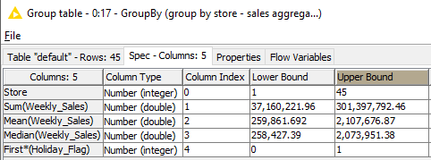
Figure 13: Statistics sales grouped by store
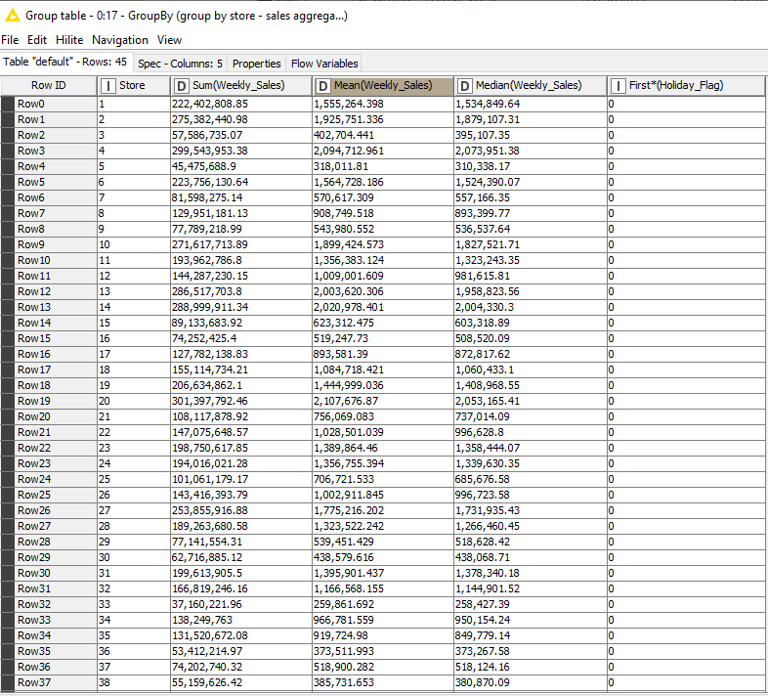
Figure 14: Sales grouped by store
The sales amount for each store can vary from one store to another. An example can be observed in the Figure 13, the aggregate method ‘Sum (Weekly_Sales)’ is calculating the sum of sales for the whole historical dataset per store. The amount varies from a store with less sales from another one with higher sales, the difference being substantial. So that means that some stores are more profitable than the others.

Data preparation

In this section, it will be presented all the data operations that were performed to make the dataset prepared for the machine learning algorithms.

Missing Values
Handling missing values is a mandatory prerequisite that aims to avoid breakdowns while data is manipulated, because of a non-handled null value.
In the Walmart dataset, the statistics can be checked to verify if there are missing values within the data. To achieve this, the statistics node is used, and the results can be viewed, as follows:
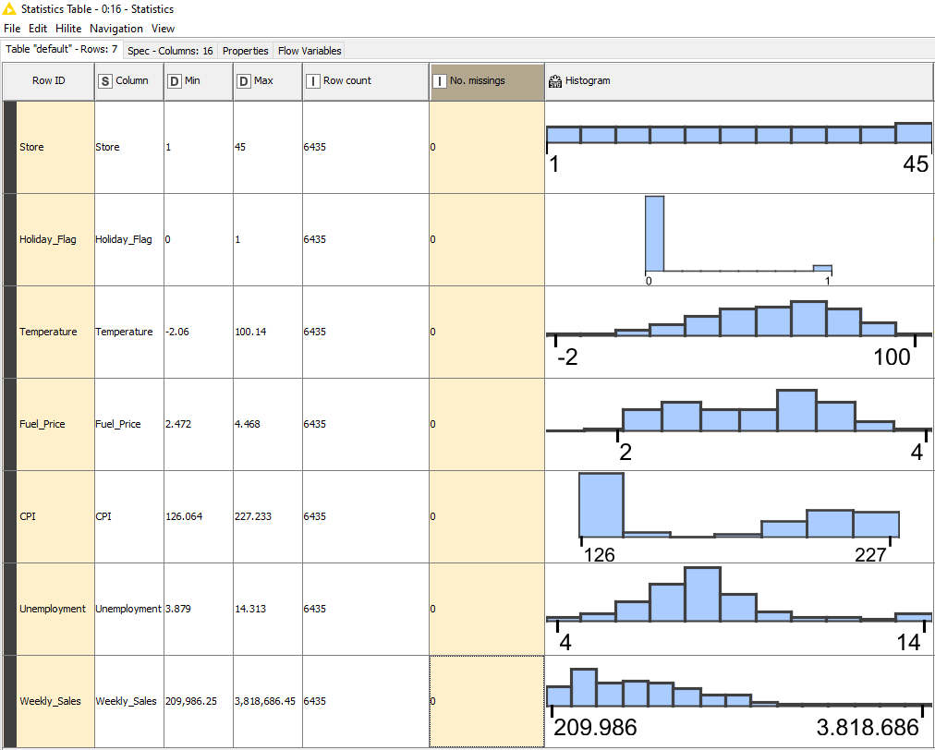
Figure 15: Statistics: No missing values

It can be noticeable from the above figure that the dataset does not include any null value within the columns. In the present case, there is no handling technics to be implemented to address the missing values.

Standardization
Machine Learning algorithms can be affected by the magnitude and the shape of the data feed to it. Data is always scaled when the underlying algorithm calculates distances. There is no side effect on algorithms, like decision trees, where there is no distance.
It will be applied Min-Max Scaling on numerical features to balance the effect of each attribute on the forecasting model. Min-Max Scaling is a transformation approach performed on a given column where its values are between zero and one. It consists of calculating the subtraction between the column’s original value and the minimum value of the column. Also, the substruction between the maximum value of the column and the minimum value of the column. Both results being divided in the end to obtain the result.

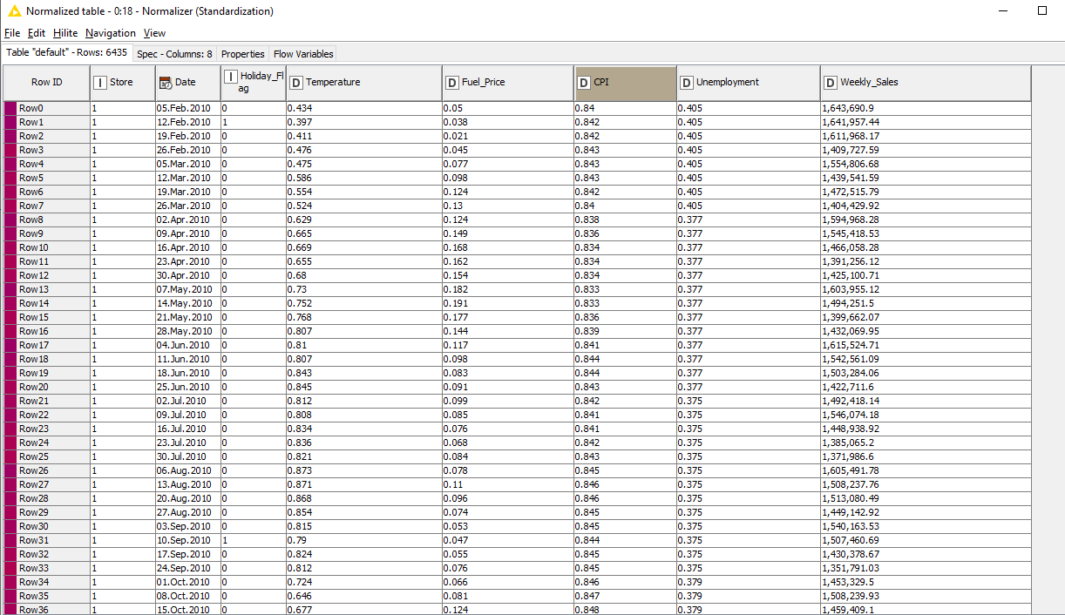
Figure 16: Sample Data with applied Min-Max Scaling

Data Partitioning
In order to develop predicting models, using data is essential, but to measure the accuracy of the results, a testing set must be performed. For this reason, it should be included partitioning data within the test and the training set, by applying the Pareto rule, which means the training set will choose randomly 80% of the whole data where the test will take part.

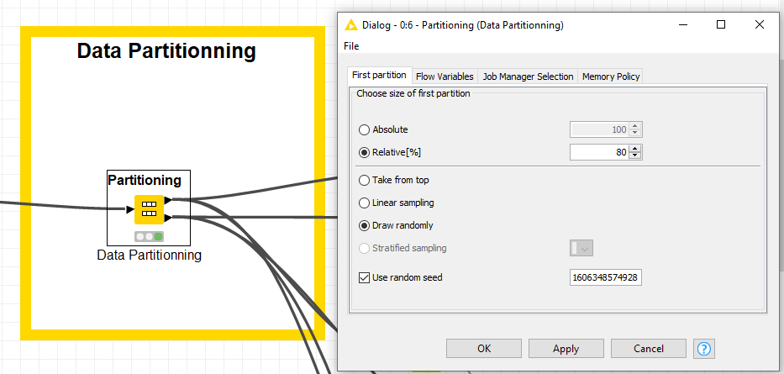
Figure 17: Data partitioning settings with Pareto principle

To be noted that if is needed to generate the same random subsets, it should be fixed a random seed value. Otherwise, each time when the node will be executed again, the generated data could be different.

Modelling

Model selection
To build a good predicting model, performing experiments is vital to the process, because the learning algorithm could adapt better on a dataset, but could also be a worst algorithm for another dataset. Therefore, data mining and knowledge discovery represent an empirical science.
It was chosen for the experiments three algorithms to build the models and after that the best was selected to proceed further.
The next print screen shows a part from the Knime workflow:
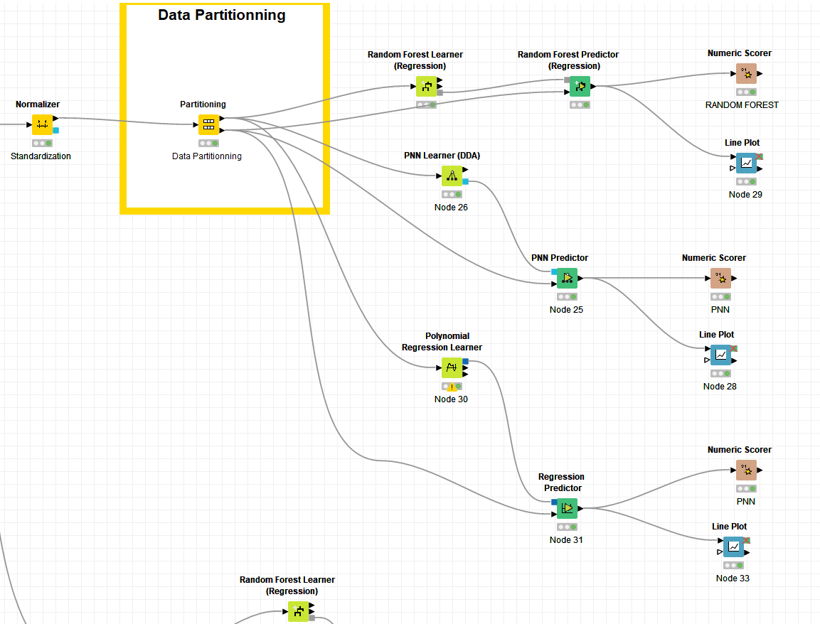
Figure 18: Overview caption of model training step

Polynomial Regression Model
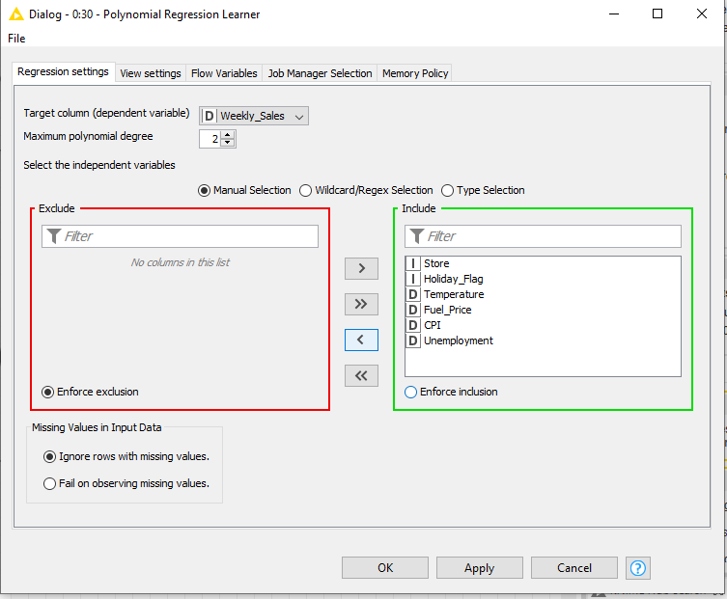
Figure 19: PRL model settings
Polynomial Regression model coefficients
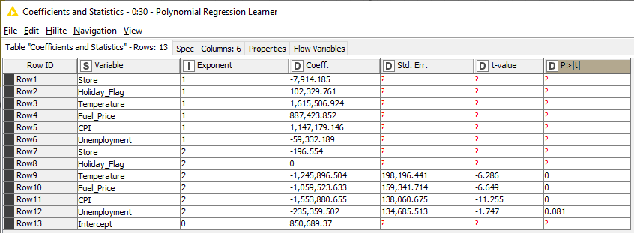
Figure 20: PRL coefficients and Statistics

Probabilistic Neural Network
The PNN model uses 5148 classes which mean that the model consists of 5148 rules:
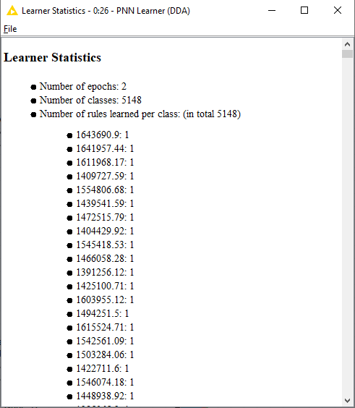
Figure 21: PNN Learner model

Random Forest
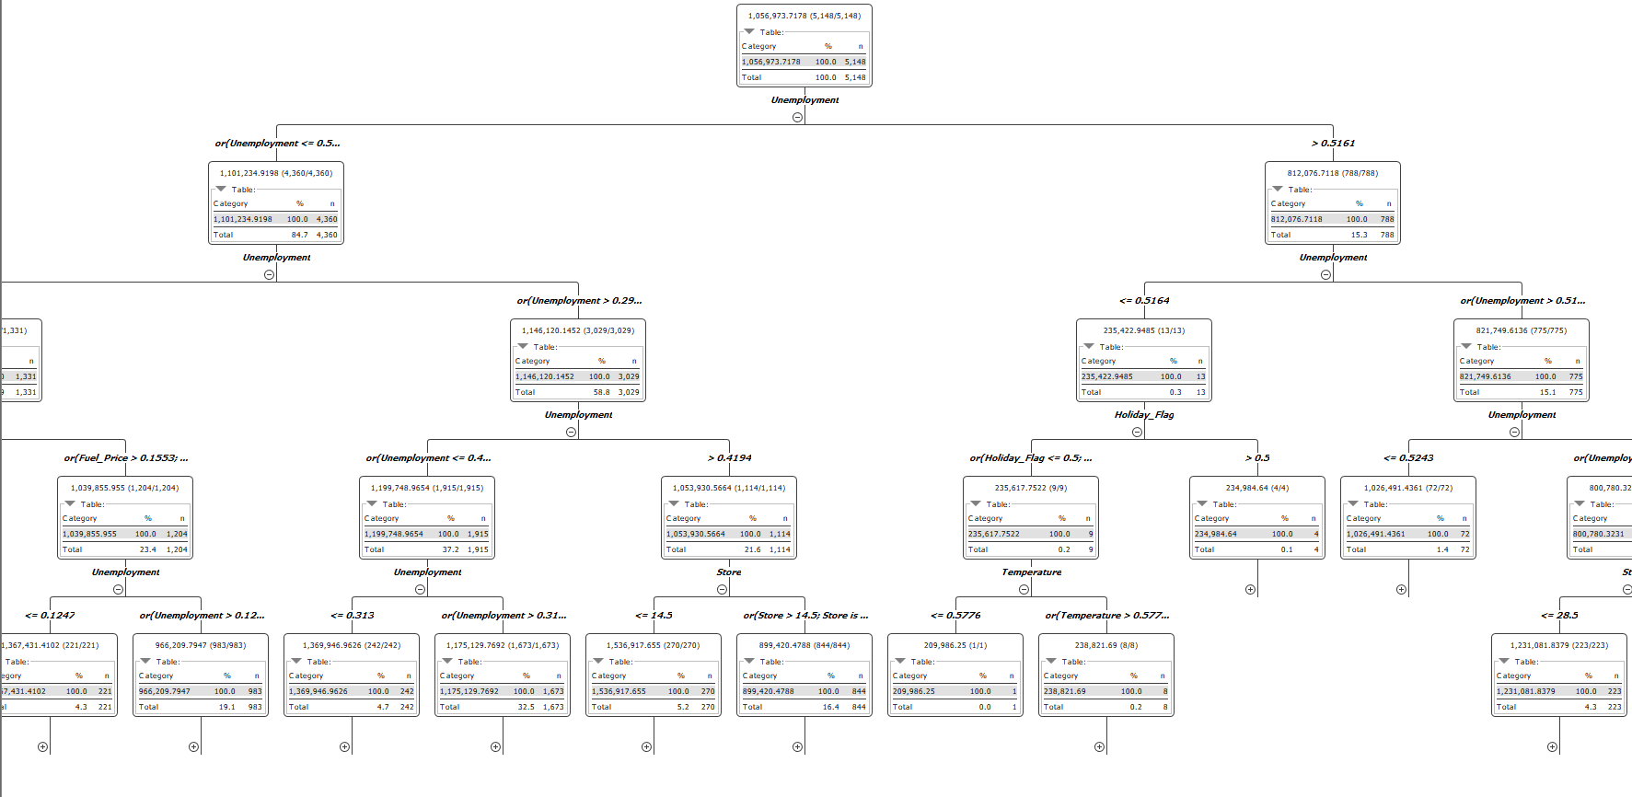
Figure 22: Decision trees

Evaluation

During the evaluation of the models, for each of the three model candidates, it is necessary to perform predictions on the test set, and because the actual values of the weekly sales are already available, it can be compared the predicted value with the actual one and calculate the error. The best model is the one with the less error value (Sonar, 2019).
For regression problems, the standard metric model used to measure the error rate is Root Mean Squared Error (RMSE). The best model is the one with less RMSE value.
RMSE measures the average error performed by the model within predictions. Mathematically, the RMSE is the square root of the Mean Squared Error (MSE), which is the average squared difference between the observed actual outcome values and the values predicted by the model (Sonar, 2019).
MSE = ((observed - predicted) ^2) and RMSE = sqrt (MSE). The lower the RMSE, the better is the model.

Models evaluation
Polynomial Regression
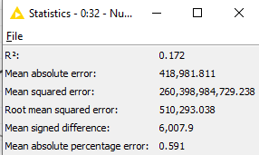
Figure 23: Polynomial Regression
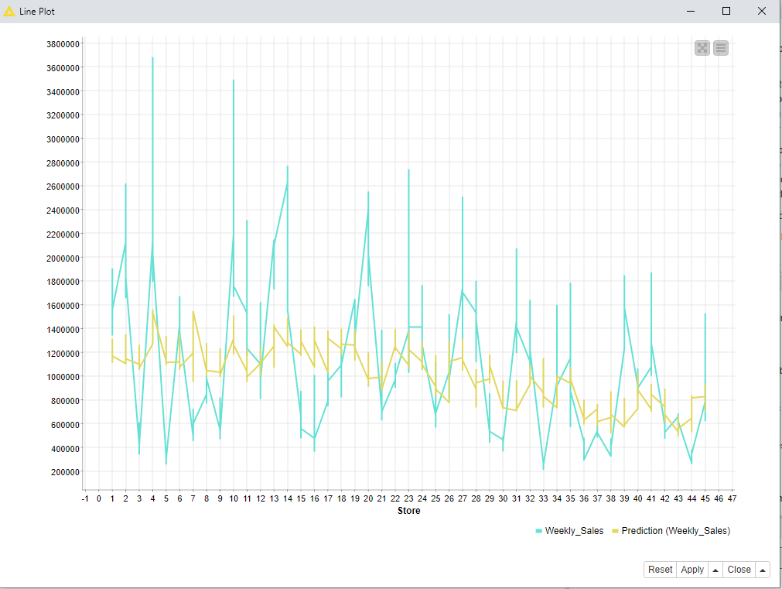
Figure 24: Polynomial Regression - Line plot
Probabilistic Neural Network

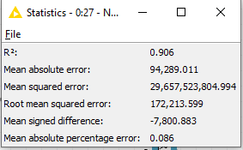
Figure 25: Probabilistic NN
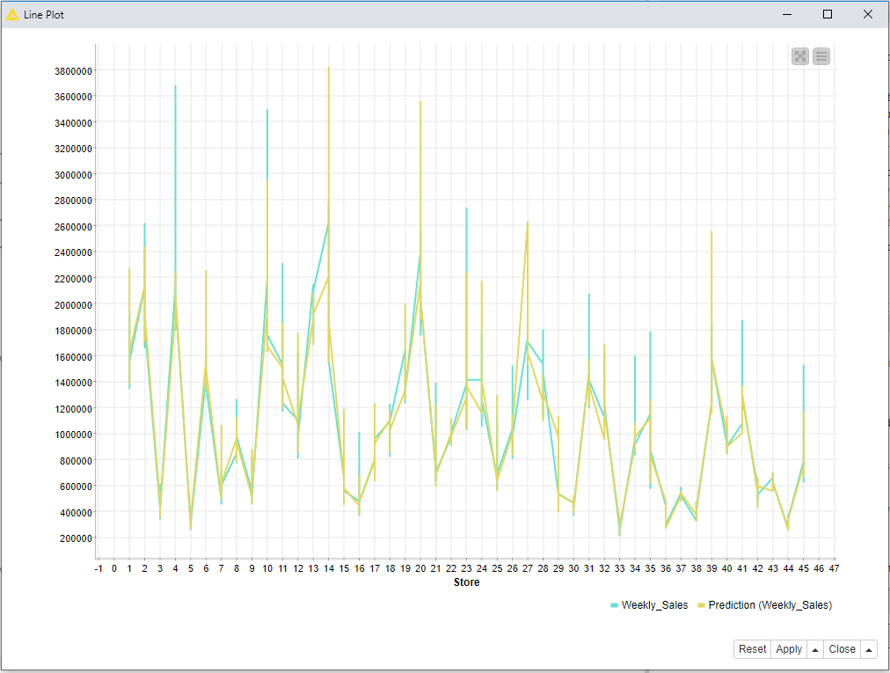
Figure 26: Probabilistic Neural Network - Line Plot

Random Forest
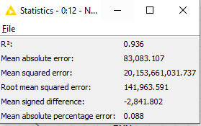
Figure 27: Random Forest
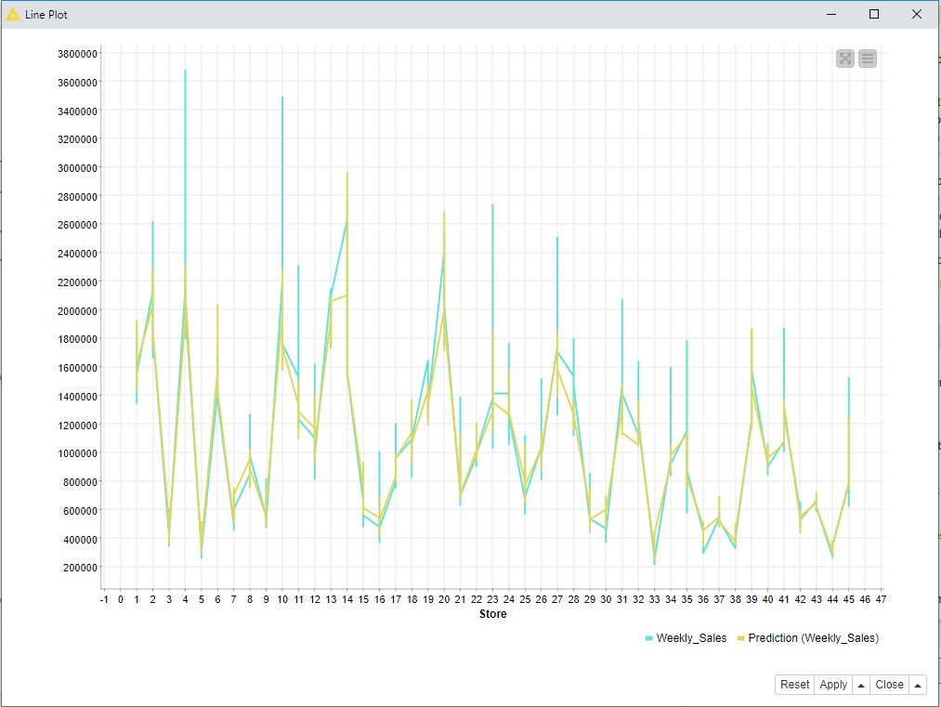
Figure 28:Random Forest - Line Plot

Results

After applying the knowledge discovery process, it has been shown that the competent model chosen for the Walmart issue is the Random Forest.
For a future evaluation of this model, using a plot is the key to perform the prediction for the weekly sales for each store. The results conclude that the holiday peaks along with the sales have doubled compared to the other months.
Even though it has a higher RMSE than the Random Forest, Probabilistic Neural Network has less Mean Absolute Error. That means it could also be used for the sales forecasting.

Conclusions

This paper is associated with the performance of the data mining methods and machine learning algorithms within the Walmart dataset and the study was conducted to assess their precision.
Random Forest is proving to be a suitable model for forecasting sales data, being known for its performance in working with a variety of variables. There are many algorithms that can provide results with high accuracy, but the algorithm chosen in this case is called Random Forest, which provides precise and adequate results.
The knowledge discovery is an experimental science for the Walmart case, and the current study concludes that the deployment of the Random Forest model is the most suitable.

Bibliography

- Anita S. Harsoor, Anushree Patil, (2015). Forecast of sales of Walmart store using big data applications, Volume: 04 Issue: 06, Available at: https://pdfs.semanticscholar.org/ed03/e6a1f4fb6fe0b185938e45ef69dc64b4bb69.pdf. [Accessed 23.11.2020]
- Ankur Jain, Manghat Nitish Menon, Saurabh Chandra, (2015). Sales Forecasting for Retail Chains, Available at: https://cseweb.ucsd.edu/classes/wi15/cse255-a/reports/fa15/004.pdf. [Accessed 02.12.2020]
- B Abraham, J Ledolter, (2009). Statistical methods for forecasting, p.2-5.
- Dalia Sami Jasim, (2015). Data Mining Approach and Its Application to Dresses Sales Recommendation, Available at: https://www.researchgate.net/profile/Dalia_Jasim/publication/293464737_main_steps_for_doing_data_mining_project_using_weka/links/56b8782008ae44bb330d2583/main-steps-for-doing-data-mining-project-using-weka.pdf. [Accessed 29.11.2020]
- JG Santaella Colón, (2019). Data Mining Techniques and Machine Learning Model for Walmart Weekly Sales Forecast, Available at: http://prcrepository.org:8080/xmlui/bitstream/handle/20.500.12475/174/FA-19_Articulo%20Final_Jose%20Santaella.pdf?sequence=1&isAllowed=y. [Accessed 30.11.2020]
- Óscar Marbán, Gonzalo Mariscal and Javier Segovia, (2009). A Data Mining & Knowledge Discovery Process Model, Available at: https://cdn.intechopen.com/pdfs/5937/InTechA/_data/_mining/_amp/_knowledge/_discovery/_process/_model.pdf. [Accessed 02.12.2020]
- Sonar Prashant Shantilal, Manish Gangil, (2019). Warehouse Sales Forecasting using Ensemble Techniques, Available at: http://www.rjetm.in/RJETM/Vol02_Issue04/Warehouse%20Sales%20Forecasting%20using%20Ensemble%20Techniques.pdf. [Accessed 03.12.2020]
- Vijayalakshmi Murlidharan, Bernard Menezes, (2013). Frequent pattern mining-based sales forecasting, Available at: https://link.springer.com/article/10.1007%2Fs12597-012-0119-9. [Accessed 23.11.2020]

