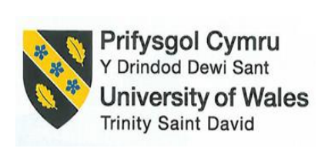

Financial Management for the Hotel Industry (BMIH5007)
Assessment 1: Business Report - Comparison of Two Hospitality Organisations

Student Name: Badrul Jamal
Student Number: 2126642
Tutor’s Name: Tristan Hawkins

Table of Contents
Introduction 1
Overview of The Companies 2
Mandarin Oriental Hotel Group 2
Premier Inn 3
Total Revenue of the Companies 4
Comparison of Total Revenue 6
Market Position of the Companies 8
Market Size in UK 8
The Comparison of The Market Position of the Companies 9
Growth Potential 10
Growth Potential of Mandarin Oriental Hotel Group (MOHG) 10
Growth Potential of Premier Inn 10
Financial Commitment to CSR 11
Recommendations 12
Recommendations for Mandarin Oriental Hotel Group (MOHG) 12
Recommendations for Premier Inn 12
Conclusion 13
References 14

Introduction
Two prominent hotel chains, Mandarin Oriental Hotel Group (MOHG) and Premier Inn, are thoroughly examined in this report. The report examines their financial standing, market share, growth prospects, and CSR initiatives. Both organisations have room for growth and longevity because of their unique strategies in their respective markets.

Overview of The Companies

Mandarin Oriental Hotel Group
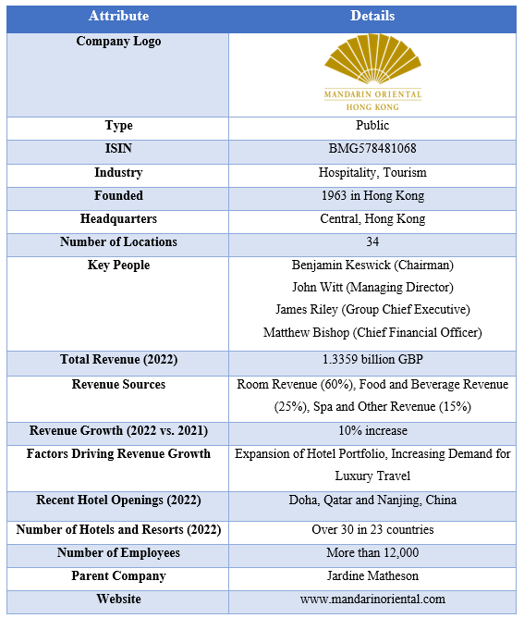
Figure: Overview of The Mandarin Oriental Hotel Group
Source: (MOHG, 2023).
Hong Kong has its first Mandarin Oriental hotel in 1963. The firm operates 34 hotels and resorts in 23 countries from its Central headquarters in Hong Kong. They earned 1.3359 billion GBP in 2022, up 10% from 2021 (MOHG, 2023). The hotel's major income sources are rooms (60%), food and drinks (25%), and spa and other services (15%). The company's success may be due to its ability to meet increased luxury travel demand by adding hotels.

Premier Inn
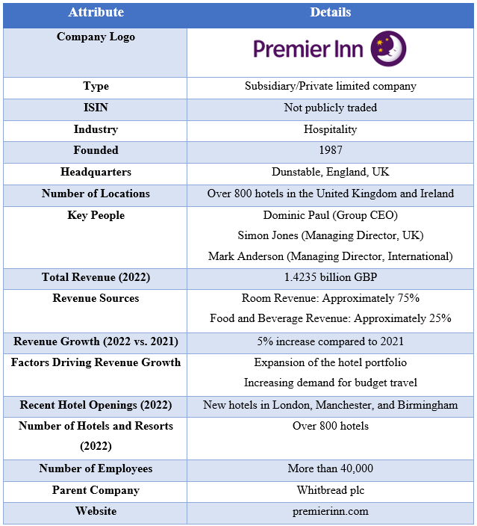
Figure: Overview of The Mandarin Oriental Hotel Group
Source: (Premier Inn, 2023).
Premier Inn is Whitbread plc's fully owned subsidiary and the UK and Ireland's biggest budget hotel chain. Since 1987, approximately 800 hotels have offered affordable pricing and outstanding standards (Premier Inn, 2023). Premier Inn, 2023 reported 1.42 billion British pounds in revenue in 2022, with 75% from hotel charges and 25% from food and drink. Premier Inn's revenue will climb 5% in 2022 due to hotel portfolio expansion and increasing demand for cheap holidays.

Total Revenue of the Companies
Total Revenue of Mandarin Oriental Hotel Group (MOHG)
Total Revenue in FY23: Revenue for Mandarin Oriental Hotel Group in FY23 was US$1,568.1 million, a considerable rise from FY22 that demonstrates the company's capacity to respond to market fluctuations (MOHG, 2023).
Sources of Revenue: In FY23, the most significant contributor to income was hotel management fees, which accounted for US$60 million, up 57% year-over-year (MOHG, 2023). Due in part to the company's hotel holdings, EBITDA hit US$77 million despite disruptions in the tourism industry (MOHG, 2023). The Americas, Europe, the Middle East, and Africa (EMEA) also showed improvement, with RevPAR increases. Problems arose in Asia because of protracted travel bans.
Revenue Trends: Revenues increased strongly in FY23. When borders were opened worldwide, tourism took off, and hotels were packed (MOHG, 2023). Demand for high-end lodgings pushed average room rates to all-time highs. As a result of increased revenue per available room in both EMEA and the Americas compared to the prior year, total revenue increased. New hotels and luxury apartments are only two examples of strategic growth that have helped.
Factors Driving Revenue Growth: The easing of travel restrictions, rising demand for high-end lodging, and a dedication to providing exceptional service all played significant roles in the company's financial success. This excellent performance resulted from the enormous growth in RevPAR over the previous year from both EMEA and the Americas.
Factors Influencing Revenue Decline: Revenue was negatively impacted because hotel recovery was slowed by continuing travel restrictions in Asia, particularly China and Japan. Net profit was affected by non-trading factors such as a loss on the reassessment of an investment property. One factor that impacted financial outcomes was a decline in other operational income.

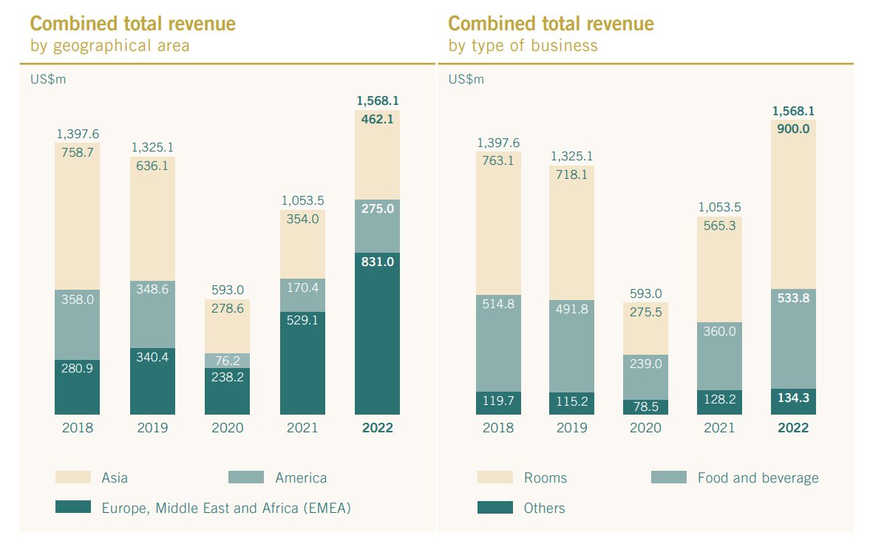
Figure: Combined Total Revenue
Source: (MOHG, 2023).
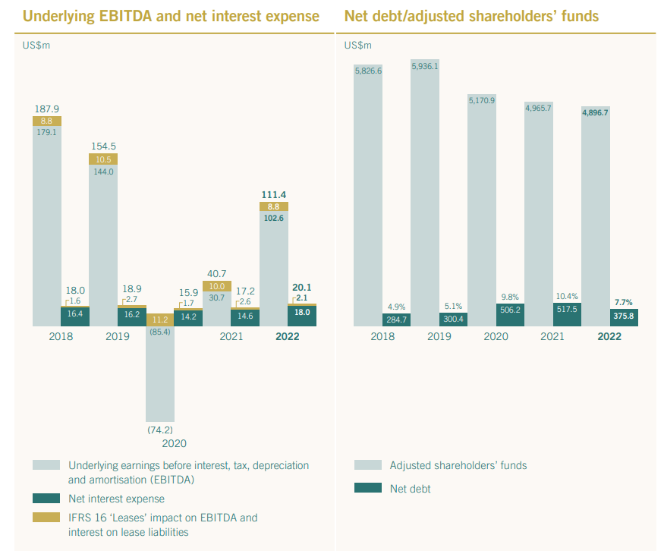
Figure: EBITDA & Net debt of the Company
Source: (MOHG, 2023).

Total Revenue of Premier Inn
Total Revenue in FY23: The UK branch of Premier Inn had robust growth and recovery in FY23, with a total statutory revenue of US$ 3051.67 million (Premier Inn, 2023).
Sources of Revenue: The hotel's leading sources of income are room rentals and food and drink (F&B) sales, with room rentals being the most important by far.
Revenue Trends: Compared to FY22, total statutory revenue increased by 50% in FY23. Compared to FY20, this indicates a strong recovery, with growth of 22% (Premier Inn, 2023).
Factors Driving Revenue Growth: Increased occupancy rates because of the lifting of pandemic restrictions, a notable 54% growth in Average Room Rates (ARR), expansion with over 1,700 new rooms, strengthened relationships with Travel Management Companies (TMCs), flexible pricing strategies, operational efficiencies, and capitalising on market opportunities due to reduced hotel supply are all key drivers.
Factors Influencing Revenue Decline: Due to difficulties in the UK pub restaurant market, such as price constraints and rising inflation, F&B sales fell somewhat, staying 4% below pre-pandemic levels (Premier Inn, 2023).

Comparison of Total Revenue
Comparison of total revenue for both companies are as follows:
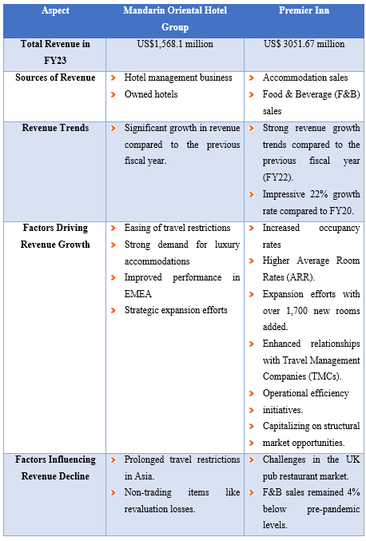

Market Position of the Companies

Market Size in UK
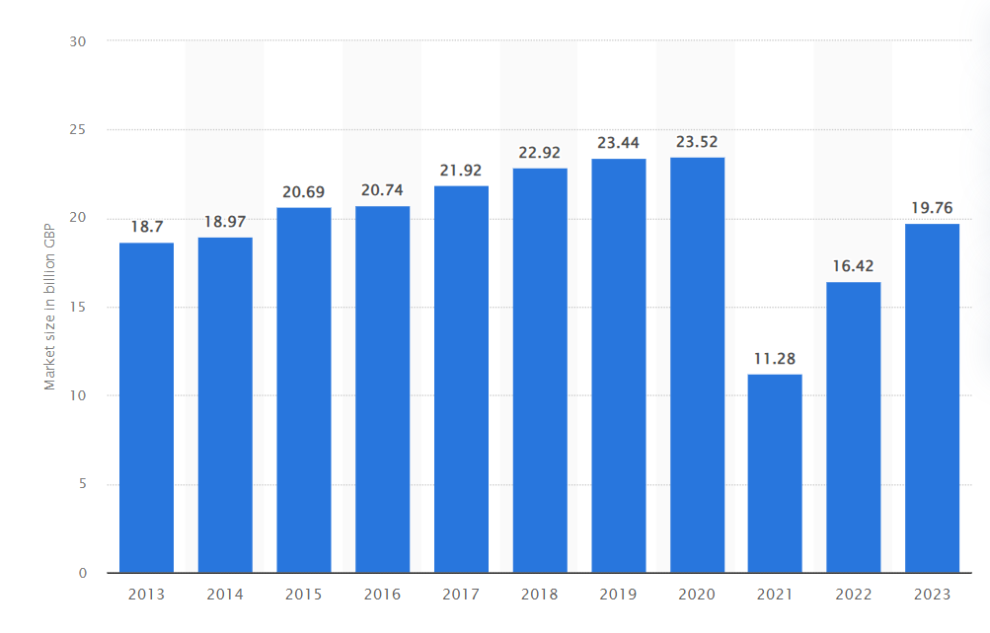
Figure: EBITDA & Net debt of the Company
Source: (Statista, 2023).
There is a wide variety of hotels in the United Kingdom, from 5-star luxury chains to well-known national budget hotel chains. There will be a significant rise in market value from the previous year's predicted £11.28 billion to 2022's estimated £16.42 billion (Statista, 2023). According to forecasts, the market size for this sector will increase to over £19.76 billion by 2023 (Statista, 2023). Despite these encouraging signs, the market has not reached its pre-pandemic levels (Statista, 2020).

The Comparison of The Market Position of the Companies
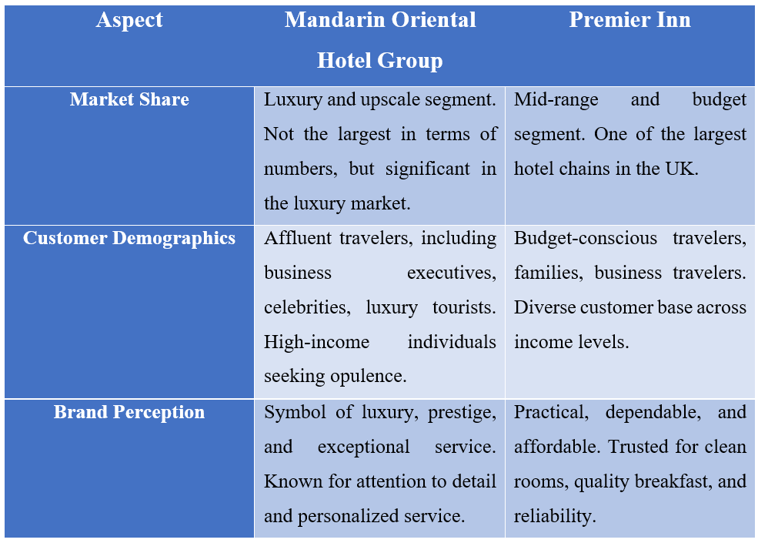
Mandarin Oriental Hotel Group
Market Share: Simply put, the Mandarin Oriental Hotel Group competes in the high-end and luxury hotel market. Luxury-seeking business and leisure travellers are the usual guests. Despite not having the highest market share in hotels or rooms, it controls a significant portion of the luxury hotel market worldwide. It stands apart from the crowd because of the value it places on privacy and high-end service.
Customer Demographics: Affluent and sophisticated travellers, such as corporate executives, celebrities, and luxury travellers, make up most of Mandarin Oriental's clientele. These clients have deep pockets and expect a higher price for first-rate treatment. Guests are well-off and eager to splurge throughout their stay.
Brand Perception: Luxury, sophistication, and first-rate service are the hallmarks of the Mandarin Oriental brand. In the hotel sector, it is often used to represent luxury and grandeur. Customers see Mandarin Oriental establishments as places to go for luxurious pampering and unforgettable adventures in the local culture. One of the brand's selling points is the care and consideration given to each customer.

Premier Inn
Market Share: The mid-range and cheap hotel market is where Premier Inn competes. It has an extensive and well-respected network of hotels throughout the United Kingdom, making it one of the country's most prominent hotel brands. Premier Inn has a sizable share of the budget-friendly, handy hotel market (Statista, 2023).
Customer Demographics: Budget-conscious travellers, families, business travellers, and anyone needing reliable and economical lodgings are all part of Premier Inn's target market. The company serves many customers from low to high disposable incomes (Lock, 2022). Business and leisure travellers have praised the hotel's reasonable prices and reliable service (Sweney, 2023).
Brand Perception: A practical and reputable hotel brand, Premier Inn is well-known. The words "comfortable," "convenient," and "affordable" are often connected with it. Premier Inn is well-liked by guests due to its convenient location, convenient booking procedure, and high-quality rooms and breakfast (Sweney, 2023).

Growth Potential

Growth Potential of Mandarin Oriental Hotel Group (MOHG)
MOHG has a clear plan for international growth within the luxury hotel segment of the market. The company is now present in 23 countries with 36 hotels and 7 residences under management, and it has a further 10 hotels and 7 residences in the pipeline (MOHG, 2023). The rising need for opulent lodging and individualised service experiences is fueling the growth of the luxury hotel market (Ghandour et al., 2015). MOHG is well positioned to take advantage of the expanding luxury travel market because of its emphasis on privacy and personalised service. Intense rivalry in the luxury travel segment and economic volatility influencing the high-end travel segment pose potential growth impediments (Bowie and Buttle, 2013).

Growth Potential of Premier Inn
Premier Inn operates approximately 800 hotels in the UK and Ireland, with another 50 hotels in the pipeline, all emphasising domestic growth within the budget segment (Premier Inn, 2023). Due to its attraction to frugal travellers and families, the budget hotel market offers room for growth (Moyer et al., 2014). Premier Inn's efforts, such as increasing room supply, fortifying links with Travel Management Companies (TMCs), applying flexible pricing methods, and seizing market possibilities, have been critical factors in the company's recent revenue growth. Maintaining consistent quality and service needs to be improved as the brand increases, as market saturation in specific locations might be an obstacle to growth in this segment. Shifts in the hospitality market and the United Kingdom might also impact growth.

Financial Commitment to CSR
Mandarin Oriental Hotel Group
MOHG has demonstrated a commitment to CSR initiatives, focusing on sustainability, community engagement, and ethical business practices.
Sustainability Practices: By incorporating environmentally friendly practices into the business, MOHG has made significant strides towards sustainability. Energy-efficient lighting, water conservation, and trash reduction programmes are just a few of the green practices implemented at several of its properties. The corporation encourages responsible environmental stewardship by supporting sustainable hotel materials and products (Brigham and Daves, 2018).
Community Engagement: Different programmes help MOHG interact with local communities. It often partners with local organisations to promote philanthropic endeavours, educational initiatives, and community development (Bloom and Van Reenen, 2010).
Ethical Business Practices: Fair employment, diversity and inclusion, and responsible sourcing are just a few of the ethical business practices that MOHG prioritises. To maintain high levels of integrity and accountability, the company's Code of Conduct underlines its commitment to ethical behaviour in all facets of its operations.
Philanthropic Initiatives: MOHG is also well-known for the charitable work it does, especially in the areas of healthcare, education, and cultural preservation. The organisation's charitable efforts are consistent with its goal of making a positive difference in people's lives (Brealey et al., 2020).
Premier Inn
Although Premier Inn's emphasis differs from MOHG's since it is in the affordable hotel market, it has demonstrated a commitment to CSR efforts.
Sustainability Practices: Premier Inn has implemented energy-efficient technology, water-saving measures, and waste-reduction programmes at all properties to lessen its negative environmental impact (Eun et al., 2021). The company aims to provide low-priced lodgings with as little environmental effect as possible.
Community Engagement: Premier Inn may not participate in high-profile charity activities, but it does help local communities by providing jobs and bolstering local companies. To meet community needs, it often partners with local nonprofits and charities (Block et al., 2019).
Ethical Business Practices: Premier Inn emphasises ethical business practices by encouraging equal employment, diversity, and inclusion among its staff. A responsible supply chain employs ethical sourcing practices.

Recommendations

Recommendations for Mandarin Oriental Hotel Group (MOHG)
Recommendations for Mandarin Oriental Hotel Group is given below:
Expand in Emerging Markets: The rising demand for luxury vacations is an excellent opportunity for MOHG to continue its strategic development in new regions. Opening new properties in regions like Asia and the Middle East might be a part of this strategy.
Enhance Sustainability Initiatives: MOHG must adopt eco-friendly technology and practices throughout its properties to keep up with global sustainability trends. Attracting ecotourists requires a focus on sustainability (Block et al., 2019).
Diversify Revenue Streams: Despite the hotel's significant room revenue, MOHG should look towards expanding its food and beverage and spa offerings to enhance total revenue (Anilkumar, 2023).
Strengthen Community Engagement: By giving back to local communities, a company may increase its popularity and attract more loyal customers (Petty et al., 2015).

Recommendations for Premier Inn
Recommendations for Premier Inn is given below:
Domestic Growth: Expand the presence inside the local market, especially in the United Kingdom and Ireland, by building additional reasonably priced hotels in strategic locations nationwide (Brigham and Houston, 2021).
Quality Assurance: To keep customers' faith in the company as it grows, it must provide the same high level of service in all its locations (Bekaert and Hodrick, 2012).
Sustainability Integration: Premier Inn should do more to attract environmentally aware tourists by including sustainability programmes like energy efficiency and waste reduction in its low-cost hotel strategy (Shapiro and Hanouna, 2019).
Collaborate with Local Businesses: Enhance Premier Inn's presence in the communities around its service regions by forging stronger ties with the local business community (Madura, 2020).

Conclusion
Two prominent hotel chains, Mandarin Oriental Hotel Group (MOHG) and Premier Inn, are thoroughly examined in this report. We have examined their financial standing, market share, growth prospects, and CSR initiatives. Both organisations have room for growth and longevity because of their unique strategies in their respective markets.

References
Anilkumar, R. (2023). Premier Inn owner Whitbread profit beats expectations, raises dividend. Reuters. [online] 25 Apr. Available at: https://www.reuters.com/business/retail-consumer/premier-inn-owner-whitbread-posts-annual-profit-above-pre-pandemic-levels-2023-04-25/ [Accessed 9 Oct. 2023].
Bekaert, G. and Hodrick, R.J., 2012. International financial management. Pearson Education Ltd.
Block, S.B., Hirt, G.A. and Danielsen, B.R., 2019. Foundations of financial management. McGraw-Hill.
Bloom, N. and Van Reenen, J., 2010. Why do management practices differ across firms and countries?. Journal of economic perspectives, 24(1), pp.203-224.
Bowie, D. and Buttle, F., 2013. Hospitality marketing. Taylor & Francis.
Brealey, R.A., Myers, S.C. and Allen, F., 2020. Principles of corporate finance. McGraw-hill.
Brigham, E.F. and Daves, P.R., 2018. Intermediate financial management. Cengage Learning.
Brigham, E.F. and Houston, J.F., 2021. Fundamentals of financial management: Concise. Cengage Learning.
Eun, C.S., Resnick, B.G. and Chuluun, T., 2021. International financial management. McGraw-Hill.
Ghandour, R., Bilal, J. and Mudassar, H., 2015. Relationship between Service Quality, Customer Retention and the role of Social Media-Case study Premier Inn Hotel (UK). Journal of Organizational Studies and Innovation, 2(4), pp.1-12.
Lock, S. (2022). Most popular hotel brands in the UK 2019. [online] Statista. Available at: https://www.statista.com/statistics/951262/most-popular-hotel-brands-uk/ [Accessed 9 Oct. 2023].
Madura, J., 2020. International financial management. Cengage Learning.
MOHG (2023). Financial Report of MOHG FY23. [online] https://mandarinoriental.com. Available at: https://photos.mandarinoriental.com/is/content/MandarinOriental/corporate-22arMOIL [Accessed 9 Oct. 2023].
Moyer, R.C., McGuigan, J.R. and Rao, R.P., 2014. Contemporary financial management. Cengage Learning.
Petty, J.W., Titman, S., Keown, A.J., Martin, P., Martin, J.D. and Burrow, M., 2015. Financial management: Principles and applications. Pearson Higher Education AU.
Premier Inn (2023). FY23 Results Premier Inn UK drives significant profit uplift versus FY22 and FY20 Strength of operating model underpins long-term growth opportunities in UK and Germany Increased dividend plus £300m share buy-back in H1 FY24. [online] Available at: https://cdn.whitbread.co.uk/media/2023/04/Final-FY23-RNS-Final-Combined.pdf [Accessed 9 Oct. 2023].
Shapiro, A.C. and Hanouna, P., 2019. Multinational financial management. John Wiley & Sons.
Statista (2020). Hotel industry in the United Kingdom (UK). [online] Statista. Available at: https://www.statista.com/topics/3146/hotel-industry-in-the-united-kingdom-uk/#topicOverview [Accessed 9 Oct. 2023].
Statista (2023). Hotel industry market size UK 2022. [online] Statista. Available at: https://www.statista.com/statistics/1364712/hotel-industry-market-size-uk/ [Accessed 9 Oct. 2023].
Sweney, M. (2023). Premier Inn owner surpasses pre-Covid profits as travellers seek deals. The Guardian. [online] 25 Apr. Available at: https://www.theguardian.com/business/2023/apr/25/premier-inn-whitbread-pre-covid-profits-deals [Accessed 9 Oct. 2023].

