Essay for Contemporary Human Resources in Practice Assignment 1 2019 – The Future of the HR Profession



NOVEMBER 2019

MODULE NAME: Contemporary Human Resources in practice (M6X00873)
Name: Sam Thomas
Student Number: 1706610

Critically evaluate the role of HR professionals in the future of work and identify the skills they will need to acquire in order to remain relevant in a world dominated by AI.

Introduction
It is more apparent than ever that we live in a society heavily influenced by technology and the increasing need for new advancements in AI both for businesses and people in every day life. In such a fast pace environment within which we currently live, it is more important than ever that people adapt in order to keep up with the changes. However, it is debated as to the extent that technology will affect workers, with some claiming it will only be lower skilled jobs that will be affected. However, the more pessimistic opinion is that we ‘will neither need nor want professionals to work in the way they did in the twentieth century and before’ (Suskind & Suskind, 2015, p. 1). One key area that will be affected is Human Resource Management. HRM is defined as ‘all those activities associated with the management of employment relationships in the firm’ (Boxall and Purcell 2003:1). Throughout this essay, I will look to evaluate the role of the HR professional and how it will change in the coming years if technology continues to grow as expected. I will discuss topics such as VUCA, how AI is potentially coming for jobs, Megatrends that are currently affecting the business world (e.g. Globalisation) alongside other various topics that could become an issue for people in the HR world and beyond.
Main Body
Artificial Intelligence is shaping the world as we know it, with scientists and entrepreneurs such as Elon Musk and Stephen Hawking warning of the threats AI could bring to not just businesses but humanity as we know it. A definition of AI is “The theory and development of computer systems able to perform tasks normally requiring human intelligence, such as visual perception, speech recognition, decision-making, and translation between languages”- English Oxford Learning Dictionary.
As mentioned, the world of work is rapidly changing due to AI and therefore it is very important that HR professionals adapt to that. This everchanging environment is often described using the concept of VUCA. VUCA is often portrayed in a table with 4 separate headings: Volatility, Uncertainty, Complexity and Ambiguity. The four terms are linked when applied in practice; “The more complex and volatile an industry is, for example, the harder to predict and therefore more uncertain it will be”- Kraaijonbrink (2015), What Does VUCA Really Mean? An example of this appears in the Harvard Business Review.
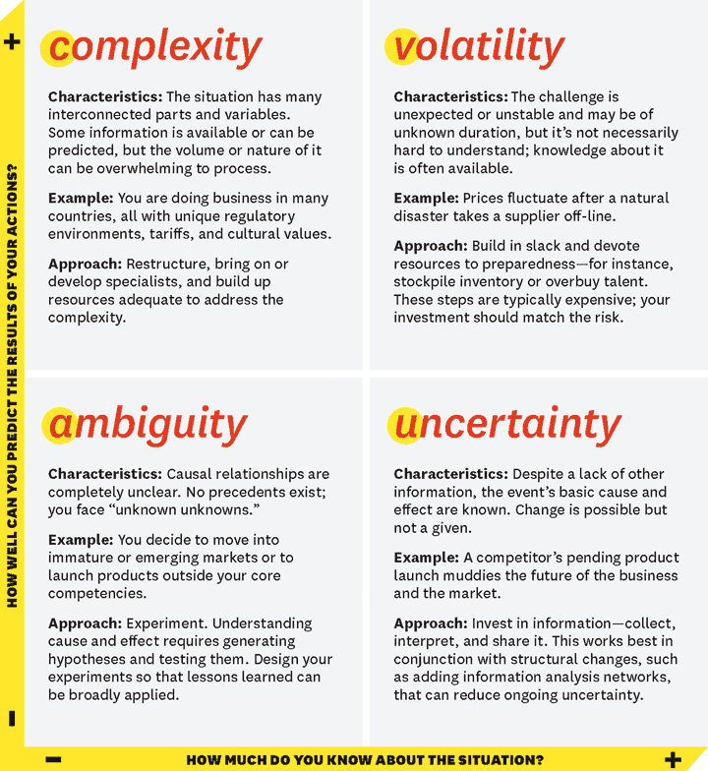
Bennett and Lemoine (2014). What VUCA Really Means for You.
The concept of VUCA is important to an organisation and it applies to the rise of technology, with many people claiming it is near impossible for an organisation to plan for a VUCA world. Linking to the key question, it appears it would be very important that an organisation gains the skills needed to understand how to survive in a VUCA environment. The title of complexity uses the example of a business operating in many different countries which is an example of globalisation. This links in with AI as the rise in technology will make Globalisation easier to adapt to for a business.
Alongside the need to adapt to a VUCA world, there are other reasons why the way in which HR Management operates, needs to change. ‘HRM covers activities such as human capital management, knowledge management, organization design and development, resourcing, performance management, learning and development, reward management, employee relations and employee well-being’ (Armstrong, 2016, p.6). The world of HRM can also be heavily influenced by the concept of Global Megatrends. A definition of Megatrends is as follows. ‘An important shift in the progress of a society or of any other particular field or activity; any major movement’- Lexico. There are considered to be many different Megatrends that affect modern society, however, there are 5 key megatrends that are mentioned often. The 5 key Megatrends are Globalisation, Mobility, Millennials and changing demographics, New Behaviours and Technology. Each of these trends affect the way in which HRM operates for different reasons, however, they all link together and contribute to the changing environment. Firstly, Globalisation. A definition of Globalisation is ‘the spread of products, technology, information, and jobs across national borders and cultures. In economic terms, it describes an interdependence of nations around the globe fostered through free trade’- Investopedia. Globalisation affects the way in which a business is able to operate. It allows companies to both develop products and sell products in countries that were potentially unattainable prior to Globalisation. This in turn means a change in the way a HR Professional can go about their job. ‘The global corporation operates with resolute constancy—at low relative cost—as if the entire world (or major regions of it) were a single entity; it sells the same things in the same way everywhere’ (Levitt 1983). With Globalisation comes a wider workforce, all potentially from different countries across the globe, who may in turn have different cultural beliefs, religious beliefs or standards which they usually adhere to in other jobs. This means that as professionals within the HR department, it is their responsibility to make sure they adapt in order to take in to account how best to deal with a multi-cultural workforce. ‘Companies need to consider a diverse range of practical adjustments to be able to hire, train, retain and support a workforce that's often spread throughout several countries, which often have varying cultural identities’ (Natter 2018). The rise in globalisation will force HR professionals to adapt to include people with varying cultural identities whilst also giving them a wider recruitment pool when looking to employ new staff. Globalisation may also lead to communication issues. If all HR related work was to be done solely within the UK, it may make it harder for HR staff to communicate with workers operating in other countries due to problems such as language barriers. This may lead companies in to spreading their HR duties across all countries in which they operate.
The second Megatrend is Mobility. Mobility is closely linked to Globalisation and refers to the mobility of workers and how it is becoming more convenient than ever to both work in different countries and to work from home due to technological advancements. It is commonly accepted that the increase in mobility by a company could lead to higher productivity through freedom for staff. ‘they may be looking for skilled and already-trained employees to be transferred to positions in the new overseas location. In this case, the willingness of workers to become mobile could be a key factor to productivity’ (Natter 2018). This would improve productivity in many ways, one way in which it could be improved is that if someone is suffering from illness, it may be to the extent that a person is unable to come in to a physical workplace, however they may feel well enough in order to work from home. This means that for a company they can keep their workforce running as efficiently as possible and this means there is less issues for a HR professional to deal with in terms of disciplining for repeated illness etc.
The concept of mobility in a workforce can also be linked to the third megatrend which is New Behaviours. One key area which encompasses both of the two megatrends is the idea of flexible working. One definition of flexible working is ‘a way of working that suits an employee’s needs, e.g. having flexible start and finish times, or working from home’ -GOV.UK. The CIPD definition of flexible working is ‘“Flexible working” describes a type of working arrangement which gives a degree of flexibility on how long, where, when and at what times employees work’ (CIPD, 2012). As mentioned in the YouTube video by Jacob Morgan, the way in which we work is changing rapidly, and hence is ‘forcing organizations to rethink and reimagine the way we work’- (Morgan, 2016). This means that a company will need to adapt in order to allow flexible working times alongside the ability to work from home, as with the rise in the younger, more tech savvy generations beginning to increase in the workforce, companies must stay up to date or face being left behind by competitors who meet the demands of their staff. Work is no longer a place you go to; it is something you can carry with you in your pocket (Morgan, 2016). This statement further proves the interlinks between new behaviours and mobility, as the new expectations of the workforce is to be able to be more mobile, flexible and to have more convenience when joining a company. This is an important factor for HR professionals, as they may need to re-design training for newcomers to the workforce to allow for greater flexibility, for example training to complete work from laptops. A positive for HR however is that if flexible working was to be introduced, less time would need to be sent in the production of rotas for staff.
The fourth megatrend is the rise in millennials and the changing demographics both within the consumer base and the workforce. The issue of changing demographics is a huge issue faced by HR and one which is growing in size every day. We are living in a society with an ageing population. It is projected that, by 2025, more than 20 per cent of Europeans will be aged 65 or over (European Commission, 2013). This is an issue for HR as it is important due to the rise in technology that staff members are upskilled in order to keep up with the advancements needed to improve. However, an ageing workforce might lead to resistance from older generations, who are reluctant to change methods they are accustomed to. E.g. Baby boomers: born between 1946 and 1964 and Gen X: born between 1965 and 1980 (Cotton, 2019). However, as the older generation moves out of the workforce, it will lead to it being even more dominated by millennials and Gen Z. It is generally accepted that Millennials are those born between 1981 to 1996, although this is debated. The increase in millennials brings about more issues for HR to deal with, as a recent report found that 57% of the millennial workforce expect to move job within two years, while 40% will move within one year (InstituteLM). This is a problem as a key area for HR is employee retention, as companies want to reduce their staff turnover, however the shifting in attitudes from this generation will make it harder for HR to keep their staff, especially given that by 2020, millennials will comprise more than 50% of the UK workforce. (InstituteLM). This means it is highly important that the HR department work on improving things such as employee engagement and ensuring that people are happy within their jobs.
The final megatrend is Technology. This is because the rapid rise in technology is making other megatrends such as globalisation grow. Many factors fall into Technology such as Big Data, Wearable Devices, the Internet of Things and Cloud computing. (Morgan, 2016). Technology entering the workforce can be an issue that affects the way HR operates. Implementing Technology in to places of work will cause resistance to change, especially in older generations. Some people would argue that there is worry for some workforces that allowing technology to progress at its current rate will leave them jobless and so it is not in their best interest to work with it and help it develop. Technical changes can be seen specifically as threats by employees who envision that their roles within the company will be replaced by a machine or computer that can do the job cheaper or faster (Bradley, J). The problem for HR is to motivate employees to want the change, and to adapt to it to make both themselves and the company more efficient. However, this is easier said than done as People resist being controlled. And so, 70% of all corporate change efforts fail (Bregman, 2009). Overall, it is apparent that HR professionals must learn to adapt to gain the skills to deal with these 5 megatrends, whilst dealing with the resistance to change from staff and the growing need for technology within businesses.
Alongside megatrends, there are other areas that need to be addressed by HR professionals, such as the skills that will be needed for the future of work and the way in which the size and shape of organisations are changing due to things such as the gig-economy. Definition of the gig-economy is as follows; ‘a free market system in which temporary positions are common and organizations contract with independent workers for short-term engagements’ (Rouse, 2019). Examples of work within the Gig economy include Uber, Deliveroo and other roles that involve self-employment or employment through technological advancements. ‘In the UK it's estimated that five million people are employed in this type of capacity’ (Wilson, 2017). This shows the shift in job roles, as even 10 years ago these jobs may not have been possible. The increase in technology however will soon enough see even these jobs left in the past due to advancements such as driverless cars. Alongside this, the changes in our work environment is highlighted by Frey and Osborne. They declared that a lot of jobs we currently take for granted are susceptible to computerisation (Frey and Osborne, 2016). This means there will be change in the workforce as we know it. This means the skills needed by modern workers will be vastly different to what was needed previously.
Another model that shows the changes is Atkinsons flexible firm model. The model was first introduced in 1986 by Jon Atkinson. An example of the model is given below. 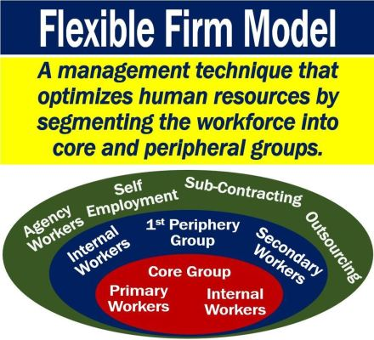
What is the Flexible Firm Model? (Market Business News)
The model splits workers in to 3 sections, the first being the core group which is employees vital to the organisation and difficult to replace, then the periphery group is those that have skills which are easily replaced, are only needed at certain times or that are only needed to complete certain tasks, potentially ones that could be replaced by technology. The third group are those external workers, these workers are described as being not core to the business, although important to its running – Oxford Reference. The rise in technology is shifting the model, this is because digital technology is making it easier for companies to get existing jobs done with less people. This means that those workers on the periphery will see their jobs at risk, whilst the core group of essential workers will either shrink or see their job roles change. The internal workforce will become less important as we move towards a project based model of organising work. However, it can be argued that in the upcoming ‘Workforce 4.0’, some jobs will remain within the core group such as those that require emotion or creativity as it is currently not expected by all that robots will be able to emulate that.
The changes in the world of work as we know it is also illustrated in David Ulrich’s model. Ulrich’s model is designed in order to organise HR functions in to four segments. The usefulness and relevance of the model in todays working environment is debated however it is still used and well respected in the HR world.
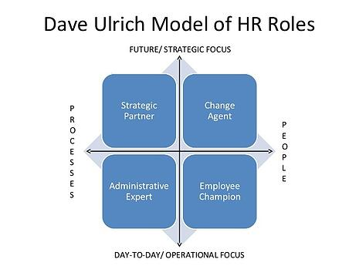
Shingal (2019). David Ulrich’s HR Model.
The model is used to distinguish between roles for HR professionals and to organize HR functions. Ulrich designed this in order to attempt to keep functions within the HR department simple, as it is split between the four sections. However, this model is also subject to change due to new job roles potentially not fitting solely in one category, alongside some roles being made redundant due to technology.
Conclusion
In conclusion, it is clear that the role of the HR Professional is changing at a rapid rate, which is set to continue as technology and AI gets set to takeover. It is vital that those working in HR consider the changes that are being brought by megatrends such as Globalisation providing a more diverse workforce than ever, mobility making it easy to work on the go, alongside the changing demographics we are seeing in the workforce. HR professionals must also use current models such as Ulrich’s model and adapt their thinking to compensate for the changing work environment. HR professionals must predict the skills that will remain relevant in the future of work whilst also upskilling current workforce in order to not be left behind.

References
Armstrong's Handbook of Strategic Human Resource Management (6 ed.). London: Kogan Page.
Bennett and Lemoine (2014). What VUCA Really Means for You. Available at: https://hbr.org/2014/01/what-vuca-really-means-for-you (Accessed on 3rd November 2019).
Boxall and Purcell 2003:1
Bregman, 2009. How to Counter Resistance to Change, Harvard Business Review. Available from: https://hbr.org/2009/04/how-to-counter-resistance-to-c.html (Accessed on 5th November 2019).
CIPD, 2012. Flexible working provision and uptake. London: Chartered Institute of Personnel and Development.
Cotton, 2019. Available from: https://www.businessleader.co.uk/2020-workforce-to-be-dominated-by-millennials/57878/ (Accessed on 5th November 2019).
English Oxford Learning Dictionary. Available at: https://www.forbes.com/sites/bernardmarr/2018/02/14/the-key-definitions-of-artificial-intelligence-ai-that-explain-its-importance/#20a974534f5d (Accessed on 4th November 2019).
European Commission 2013. Ageing – Policy. Public Health. Available online at http://ec.europa.eu/health/ageing/policy/index_en.htm [Accessed 5 November 2019].Google Scholar.

Frey and Osborne, 2017. The future of employment: How susceptible are jobs to computerisation? Technological Forecasting and Social Change. Vol 114, January 2017, pages 254-280. (Accessed on 10th November 2019).
GOV.UK. Available from: https://www.gov.uk/flexible-working (Accessed on 4th November 2019).
Institute of Leadership and Management. Available from: https://www.institutelm.com/resourceLibrary/workforce-2020-managing-millennials.html (Accessed on 5th November 2019).
Institute of Leadership and Management. Available from: https://www.institutelm.com/resourceLibrary/workforce-2020-managing-millennials.html (Accessed on 5th November 2019).
Investopedia. Available from: https://www.investopedia.com/terms/g/globalization.asp(Accessed on 4th November 2019).
Jeremy Bradley. "Challenges Faced by Human Resource Managers Because of Technical Changes." Small Business - Chron.com. Available from: http://smallbusiness.chron.com/challenges-faced-human-resource-managers-because-technical-changes-61058.html. (Accessed 5th November 2019).
Kraaijonbrink (2015), What Does VUCA Really Mean? Available at: https://www.forbes.com/sites/jeroenkraaijenbrink/2018/12/19/what-does-vuca-really-mean/#312b470f17d6 (Accessed on 3rd November 2019).
Levitt 1983, The Globalization of Markets. Available from: https://hbr.org/1983/05/the-globalization-of-markets(Accessed on 4th November 2019).
Lexico. Available from: https://www.lexico.com/en/definition/megatrend(Accessed on 4th November 2019).
Morgan,2016. [video] Available from: https://www.youtube.com/watch?v=LrhmHbDLM8o (Accessed on 4th November 2019).
Morgan,2016. [video] Available from: https://www.youtube.com/watch?v=LrhmHbDLM8o (Accessed on 4th November 2019).
Morgan,2016. [video] Available from: https://www.youtube.com/watch?v=LrhmHbDLM8o (Accessed on 5th November 2019).
Natter 2018. Effects of Globalisation on Human Resource Management. Available from: https://smallbusiness.chron.com/effects-globalization-human-resources-management-61611.html (Accessed on 4th November 2019).
Natter 2018. Effects of Globalisation on Human Resource Management. Available from: https://smallbusiness.chron.com/effects-globalization-human-resources-management-61611.html (Accessed on 4th November 2019).
Oxford Reference. Available from: https://www.oxfordreference.com/view/10.1093/oi/authority.20110803095823783 (Accessed on 5th November 2019).
Rouse, 2019. WhatIs.com. Available from: https://whatis.techtarget.com/definition/gig-economy (Accessed on 5th November 2019).
Shingal, 2019. David Ulrich’s HR Model. Available from: https://blog.mettl.com/talent-hub/managing-hr-roles-david-ulrich-model (Accessed on 6th November 2019).
Susskind, R. & Susskind, D. (2015). The Future of the Professions: How Technology Will Transform the Work of Human Experts. Oxford: Oxford University Press.
What is the flexible firm model? (Market Business News) Available from: https://marketbusinessnews.com/financial-glossary/flexible-firm/ (Accessed on 5th November 2019).
Wilson, 2017. BBC.co.uk. What is the Gig-economy? Available from: https://www.bbc.co.uk/news/business-38930048 (Accessed on 5th November 2019).

