

REPORT
Case Study: The Seacrest Lodge

Student Name: VICTORIA CHILIANU
Student ID Number: 2208500
The Module Title: Financial Management for the Hotel Industry BMIH5007
Lecturer’s Name: TRISTAN HAWKINS
Word count: 2184

Executive Summary
Seacrest Lodge, long a seaside resort icon, is struggling financially and operationally. The entity’s financial health, operational efficiency, and market position are examined in this study, showing diminishing revenue, assets, and liabilities. A strong turnaround plan to revive the entity’s attractiveness, financial stability, and market competitiveness is needed.
Financial Health: Financial statements show a liquidity constraint, with liquid assets decreasing and equity falling sharply, indicating financial losses and undermining shareholder trust. Another alarming pattern in the income statement is declining revenue versus growing operating expenditures, resulting in considerable losses.
Market Position: Modern resorts are increasing competition for the entity, requiring a strategic repositioning. Market research, a solid marketing and branding strategy, and service and facility upgrade to match client expectations are needed.
Financial and cash flow management: A comprehensive audit to discover financial mismanagement, then efforts to stabilise cash flow, restructure debt, and better manage obligations.
Operational streamlining and cost reduction: Eliminating inefficiencies, negotiating better supplier conditions, and using technology to boost efficiency.
Brand Revitalisation and Market Repositioning: Market research to guide service changes, a strong marketing plan to revitalise the brand, and product improvements to improve the visitor experience.
Long-Term Growth and Improvement: Property and equipment to update facilities, dynamic pricing to maximise revenue, and stakeholder involvement to support the turnaround approach.

Table of Contents

Executive Summary 1
Introduction 3
Financial Statements Analysis 4
Balance Sheet Assessment 4
Analysis of Liabilities and Equity 5
Analysis of Income Statement 5
ARR and Occupancy Rate 6
Balance Sheet Revelations 7
Reflection of the key issues 7
Risk management process for the context of declining profits 7
Seacrest Lodge’s Turnaround Strategy 9
Financial Health Objectives 9
Development Strategies 10
Conclusion 11
Recommendations 12
References 13
Appendices 14

Introduction
The luxury that is a hallmark of Seacrest Lodge is being tested to the limit by an array of problems. The resort's ideal setting and luxurious facilities made it a popular choice for those looking to unwind in style. But times have changed, and the once-bustling sanctuary for leisure, today faces several formidable challenges. The lodge's income and clientele have been steadily declining, according to the accounts. There are more fundamental problems that need fixing right now, as seen by the steep fall in customer satisfaction and the troubling drop in occupancy rates.
The already difficult situation for Seacrest Lodge is made much worse by the cutthroat nature of the coastal resort industry. The advent of modern, ultra-modern resorts in the area has completely transformed the holiday scene. Customers' tastes and expectations have shifted due to these new competitors' strong marketing, cutting-edge facilities, and novel services. This revitalised and dynamic competitive zeal appears to be rendering Seacrest Lodge's previously exclusive charm obsolete.
The lodge's market position has taken a hit, and its operational sustainability and prospects are in jeopardy, due to the change in customer behaviour and market dynamics. A strong and comprehensive turnaround plan is urgently required to stem the immediate financial loss and bring the lodge's services up to date with what the market wants. The goal is to re-establish Seacrest Lodge as a premier venue for leisure and elegance, and getting there requires a close look at its current financial, operational, and market situation. This case study will lay the groundwork for an in-depth analysis of the difficulties Seacrest Lodge is facing, as well as possible solutions that can help it recover and thrive in the face of intense competition.

Financial Statements Analysis
As shown by Schroeder et al. (2022, ch. 6, p. 218) the financial situation of a company can guides and establish the current accounting problems. These processes subsequently lead to effective decision-making regarding the resolution of economic gaps. Therefore, the financial statements of The Seacrest Lodge for the previous three years will be evaluated below.
Table 1. Seacrest Lodge Balance Sheet (£)
Asset/Liability | 2021 | 2022 | 2023
Cash and Equivalents | £100,000 | £80,000 | £20,000
Accounts Receivable | £50,000 | £40,000 | £30,000
Property and Equipment | £2,000,000 | £2,000,000 | £1,800,000
Total Assets | £2,150,000 | £2,120,000 | £1,850,000
Accounts Payable | £30,000 | £40,000 | £50,000
Long-term Debt | £1,500,000 | £1,500,000 | £1,500,000
Total Liabilities | £1,530,000 | £1,540,000 | £1,550,000
Equity | £620,000 | £580,000 | £300,000

Table 2. Seacrest Lodge Income Statement (£)
Item | 2021 | 2022 | 2023
Revenue | £1,200,000 | £1,100,000 | £950,000
Operating Expenses | £900,000 | £950,000 | £1,100,000
Net Income | £300,000 | £150,000 | -£150,000

Table 3. ARR and Occupancy Rate of Seacrest Lodge
 | 2021 | 2022 | 2023
Average Room Rate (ARR): | £260 | £240 | £210
Occupancy Rate: | 65% | 60% | 50%

Balance Sheet Assessment
As highlighted by Damodaran (2022a, ch. 3, p. 27) in his valuation work, analysis of the balance sheet can point to various issues in a business (see Appendix 1). A thorough examination is necessary due to concerning patterns shown by Seacrest Lodge's balance sheet (Table 1), which provides a key picture of its financial health. An important finding is the steepest decline in liquid assets, which have drastically decreased from £100,000 in 2021 to a worrying £20,000 in 2023. This drastic reduction not only indicates a serious shortage of funds but also limits the Lodge's capacity to pay for urgent expenses or make smart investments in recovery efforts.
In 2023, property and equipment value declined sharply from £2,000,000 to £1,800,000. Customers have voiced their worry about the Lodge's amenities and facilities seeming antiquated, and this depreciation reflects both that and the natural wear and strain on assets.
This will show the operational performance of the business was reduced drastically due to the poor management of the assets along with liabilities in the journey of right management. Due to that, the level of the equity has been reduced effectively and failure of the right alignment of assets as well as liabilities ultimately reduces the operational efficiency.

Analysis of Liabilities and Equity
Accounts due on the liabilities side of the balance sheet rise steadily from £30,000 in 2021 to £50,000 in 2023 (Tabel 1). There may be inefficiencies in maintaining vendor relationships and payment cycles, or rising operational expenses might be the cause of this trend. This rise has two major consequences: first, it will put pressure on the Lodge's working capital and cash flows. Second, it may cause important suppliers and partners to lose faith in the lodge and its business practises.

Analysis of Income Statement
Griffin and Mahajan (2019, pp. 144-148) indicate that an income statement indicates the performance of a business during a period. Seacrest Lodge's revenue statement provides a detailed account of the resort's declining financial health (Table 2). From £1,200,000 in 2021 to £950,000 in 2023, the Lodge's income stream has shrunk significantly during the last three years. This shrinkage is an indicator of more serious problems, such as an ageing clientele, flawed pricing tactics, or even a disappearing presence in the market, rather than just a reflection of revenue loss.
The net income has plummeted from a respectable £300,000 profit in 2021 to a troubling loss of £150,000 in 2023 as a result of falling sales and rising costs. The critical need for a thorough examination of financial control methods, revenue management, and cost centres is highlighted by this sudden turnaround in profitability. Moreover, a PESTLE Analysis (see Appendix 2) must be conducted by the business twice a year, to ensure that the external aspects that could impact the organisation are closely evaluated.
The level of the net income has been reduced continuously for having the same service provider in the same industry during a specified accounting period. Due to this, the respective business has failed to offer their services in a unique way as well as facing difficulties in creating competitive advantages.

ARR and Occupancy Rate
The Seacrest Lodge has the lowest occupancy rate took in 2023 due to a lower level of positive brand awareness (Table 3). Hence, it leads to ways in which the customer database decreases in size as customers may switch preferences.
The level of the ARR, and occupancy rates are continuously decreasing. Due to this, the entity has to face a difficult situation to survive in the market and face problems to bring development over time.

Balance Sheet Revelations
According to Hasanaj and Kuqi (2019, p. 17), the balance sheet represents the business's situation at a specific date. The balance sheet of Seacrest Lodge is equally revealing, highlighting concerns across assets, liabilities, and equity (Table 1). The Lodge's ability to meet short-term obligations and invest in crucial recovery initiatives is at risk due to the severe liquidity crunch indicated by the dramatic decrease in cash and equivalents from £100,000 in 2021 to £20,000 in 2023.
The value of property and equipment, which dropped from £2,000,000 in 2021 to £1,800,000 in 2023, is not just a reflection of physical wear, but also a service offering that is being less competitive. In a rapidly evolving market, the failure to modernise and innovate could be a pivotal factor in the Lodge's declining appeal.
Simultaneously, a financial rehabilitation plan is imperative. This plan should address liquidity management, asset optimisation, debt restructuring, and equity restoration. It involves not only immediate cash flow stabilisation but also a long-term strategy for asset maintenance, debt servicing, and capital structure optimisation.

Reflection of the key issues
Poor customer experience and reputational management:
In his article, Thomas (2020) states that the business has been facing difficulties from poor consumer services which ultimately reduce the brand image of the market dropping the level of return on investment as well as raising the issues of unemployment. Due to that, this business has been showing that the entity has failed to give high-quality services to the people at their pricing policy.

Risk management process for the context of declining profits
Financial hedging:
The article (BBC, 2020) reported that hedging can create a barrier against the potential resources in the flow of revenue during the enhanced cost which makes a stable situation in profit margin along with credit more economical performance even in volatile market situations. Seacrest Lodge can try to utilise the system of financial ageing as the risk management process regarding the reductions of profitability. This involves utilising several economic instruments like futures contracts and swaps to prevent any kind of adverse fluctuations in financial variables like commodity prices.
Diversification:
Another relevant risk management strategy is diversification which an entity can utilise to maintain a proper revenue stream during that time. Businesses can try to innovate their services like accommodations event hosting tours Spa treatments and other aspects that target different consumer segments based on geographical can reduce the chances of potential risk in revenue in the context of different markets or consumer bases. That impact of reductions in the specific sectors as well as the vulnerability of the profits in a specific time.

Seacrest Lodge’s Turnaround Strategy
A well-planned and multi-faceted turnaround strategy is required to turn around Seacrest Lodge's deteriorating fortunes. The Ansoff Matrix framework will be used to help plan and evaluate business growth initiatives (see Appendix 3). This tool will help the company to conceptualise the level of risk associated with different growth strategies. Reviving Seacrest Lodge's operational, financial, and market position is the overarching goal.

Financial Health Objectives
Financial Audit:
Analysing the financial accounts in detail to find financial mismanagement, revenue leakages, and inefficient costs. Examining the income statement for clues about falling revenues and rising expenses and the balance sheet for details about assets, liabilities, and equity are all part of this process.
Management of Cash Flow:
Dirman (2020, pp. 17-25) notes that the valuation of the business can be impacted if there is a significant amount of debt. Action planning for immediate cash flow stabilisation. Improving collection methods, maximising working capital, and strategically managing payables are all part of this process, which aims to provide liquidity for important operations and strategic projects.
Long-term Loan conditions:
This may need exploring other financing alternatives with more advantageous terms, renegotiating terms with creditors, or consolidating debts.
Review of supplier contracts:
The company must ensure that purchases are in line with operational requirements and budget capacity, so it must negotiate better terms and combine suppliers for better prices.

Development Strategies
Implementation of social media marketing:
The respective entity has to be suggested to utilise the methods of social media marketing that are ultimately useful for increasing brand awareness, and consumer outreach as well as other aspects for meeting the operational goal of increasing sales.
Focusing on customer feedback:
The Seacrest Lodge needs to bring interchanges in the operational activity by focusing on customer feedback and making improvements according to it. The business can easily access customer preferences which ultimately increases brand reputation as well as overall revenue.
Integrating technology:
It will use technology to streamline processes, increase consumer engagement, and improve the overall guest experience. Among these measures is the acquisition of state-of-the-art property management software, CRM, and other technical resources that may improve productivity and customer satisfaction.

Conclusion
A company in trouble would have falling revenues, rising costs, and dwindling assets. The comprehensive research highlights the need for a multi-faceted strategy to tackle the financial issues, revitalise the Lodge's allure, and put it in a strong position for a successful recovery in the cutthroat resort industry.
Seacrest Lodge's turnaround plan aims to address the lodge's complex difficulties with a comprehensive framework that includes specified goals and strategies. If the entity is to emerge from its present turmoil and into a future defined by financial stability, operational excellence, market relevance, and sustainable expansion, it must adhere to this ambitious strategic plan. Thorough preparation, steadfast dedication, and teamwork from everyone concerned are essential for the effective execution of this approach.

Recommendations
Revitalise the brand and reposition it in the market:
Researching the market thoroughly to learn about the latest trends, consumer tastes, and the competition. Using these findings to adjust Seacrest Lodge's services and to meet customer needs.
A strong marketing and branding plan must be created to reposition Seacrest Lodge in the industry. This entails revitalising the brand's reputation, developing hyper-specific advertising campaigns, and making better use of digital marketing platforms to raise awareness and participation.
Improving facilities, customising services, and guaranteeing quality at every customer touchpoint will redefine the visitor experience. The key to making Seacrest Lodge stand out in a crowded industry is to provide guests with experiences they will never forget.
Long-Term Growth and Improvement
Hsiao et al. (2018, pp. 1-13) stated that improvement involves more than just architectural renovations, but also incorporating environmentally-friendly methods and technology that meet changing consumer tastes and regulations. Strategic investment in property and equipment to upgrade facilities will increase Seacrest Lodge's appeal.
The sweet spot between room rates and occupancy must be found with a dynamic pricing strategy. Developing ways to diversify revenue streams such as organising events, providing customised packages, and adding more services.
Communicate openly and consistently with all parties involved, including workers, clients, financiers, and debtors. The company must involve all these parties in the recovery effort so that they better understand the overall picture.

References
Aguilar, F.J. (1967) Scanning the Business Environment. New York: MacMillan Co.
BBC (2020) ‘UK hospitality industry calls for 'urgent' support’, 6 July. Available at: UK hospitality industry calls for 'urgent' support - BBC News (Accessed: 26 February 2024).
Damodaran, A. (2012a) Investment valuation: Tools and techniques for determining the value of any asset. 3rd edition. New York: John Wiley & Sons.
Damodaran, A. (2012b) Investment valuation: Tools and techniques for determining the value of any asset. 3rd edition. New York: John Wiley & Sons.
Dirman, A. (2020) ‘Financial distress: the impacts of profitability, liquidity, leverage, firm size, and free cash flow’, International Journal of Business, Economics, and Law, 22(1), pp. 17-25. Available at: https://www.ijbel.com/wp-content/uploads/2020/08/IJBEL22_205.pdf (Accessed: 19 February 2024).
Griffin, P.A. and Mahajan, S. (2019) ‘Financial Statement Analysis. Finding Alphas: A Quantitative Approach to Building Trading Strategies, pp. 141-148’, Online Library: Wiley. Available at: https://doi.org/10.1002/9781119571278.ch19 (Accessed: 18 February 2024).
Hasanaj, P. and Kuqi, B. (2019) ‘Analysis of financial statements’, Humanities and Social Science Research, 2(2), p. 17. Available at: https://doi.org/10.30560/hssr.v2n2p17 (Accessed: 18 February 2024).
Hsiao, T.Y., Chuang, C.M. and Huang, L. (2018) ‘The contents, determinants, and strategic procedure for implementing suitable green activities in star hotels’, International Journal of Hospitality Management, 69, pp. 1-13. Available at: https://doi.org/10.1016/j.ijhm.2017.10.005 (Accessed: 19 February 2024).
Peterdy, K. (2024) ‘Ansoff Matrix’, Corporate Finance Institute. Available at: https://corporatefinanceinstitute.com/resources/management/ansoff-matrix/ (Accessed: 20 February 2024).
Schroeder, R.G., Clark, M.W. and Cathey, J.M. (2022) Financial accounting theory and analysis: text and cases. 11th edition. Hoboken, NJ: John Wiley & Sons.
Thomas, D. (2020) ‘Hospitality worst-hit as unemployment rises again’, BBC, (15 December). Available at: Hospitality worst-hit as unemployment rises again - BBC News (Accessed: 26 February 2024).

Appendices

Appendix 1

The Balance Sheet
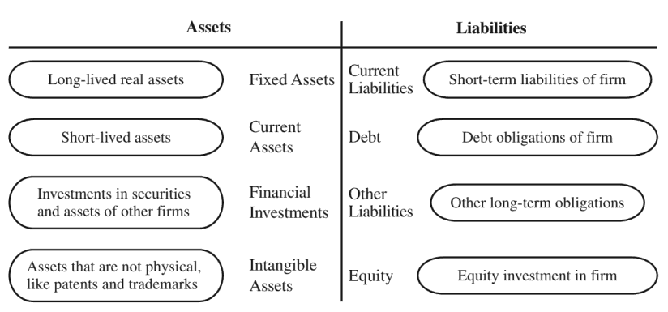

(Damodaran, 2022b, ch. 3, p. 28)

Appendix 2

Pestel Analysis
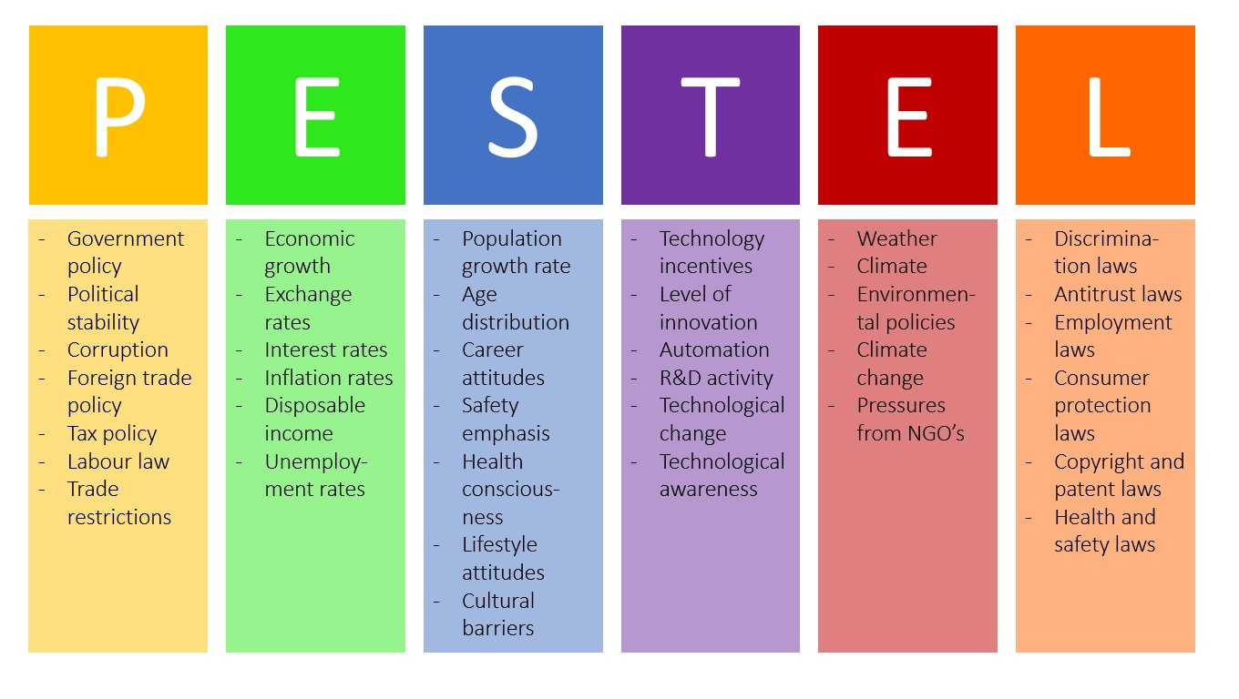(Aguilar, 1967)

Appendix 3

The Ansoff Matrix
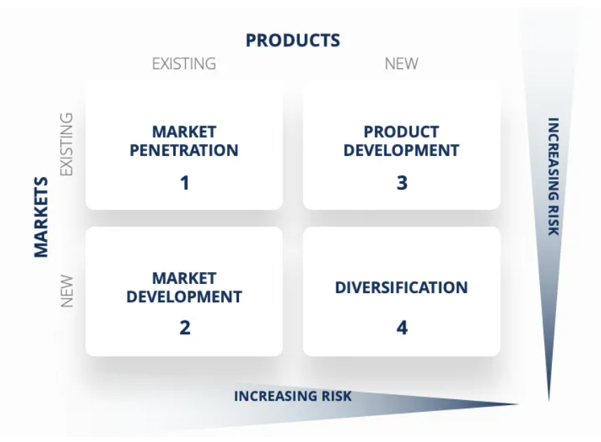
(Peterdy, 2024)

