Developing Relationships and Workplace Achievements
BMSW-5102 T2G1
Shamima Akther Supa-1916787
Lecturer- Gregory Cowan

Table of Contents
Introduction………………………………………………………………………3
Critical evaluation development vehicles……………………………………..3
Effectiveness for the evaluation of development vehicles…………………...5
A professional development plan……………………………………………….7
Models for personal development………………………………………………9
Methods for developing a plan…………………………………………………10
Theories for development of the plan …………………………………………..13
Conclusion…………………………………………………………………………14
Reference List …………………………………………………………………….15

Introduction
The study initiated in providing a clear vision reading the use and essentiality of training and development that is required within Unilever. Unilever is one of the renewed organisations that are based in London, England. The organisation has one of the best training and development spectrums within its premises. The total revenue that has been gained in 2020 was €17.655 billion (Source: Unilever.com, 2021). With 155,000 employees working across the world, the organisation has been one of the best in bringing up the customers with the best personal care products. In addition to that, the products that the organisation sells include food, beverages, cleaning agents and personal care products. It consists of a total of 400 brands under their name, with a proclamation to prominent brands Knorr, Dove, Axe, and Lipton. In the year 2019, it was listed to be the fourth largest FMCG Company worldwide in terms of sales (Statista.com, 2021).

Figure 1: Logo of Unilever
(Source: Unilever.com, 2021)

Critical evaluation development vehicles
Unilever is one of the reputed organisations in a global context that formulates the ways organisations new development vehicles. Strategically Unilever focuses on providing better prospects and good quality products and services to people around the globe. As opined by Maity (2019), the need for evaluation tends to be focused more on previous development within individuals. In Unilever, the most important development vehicle that is used in understanding the market and evolving the organisation according to the need provided.
The development vehicles that Unilever initiate in bringing up within their organisation and that will be helpful in satisfying the development needs of the individual employees are as follows:
Embracing digital revolution
Unilever has been an initiative in acting better prospects for employees in creating associative strategies in development for the individual employees. Embracing the digital revolution is one of the development vehicles that Unilever uses. As opined by Gilani and Cunningham (2017), initiating better prospects within the organisation, improving technological aspects proves to be voluntary. In Unilever, delivering strategic growth opportunities has been worked upon for a long time. It has led to various obligations and finally led to increasing the service to a better front. In addition, technology and automation have been united within the organisation to bring up human support. It would be helpful to the employees in getting back with a human touch for their day-to-day needs. It has resulted in 1 million interactions translating to an estimated 300,000 hours freed up annually for employees and HR (Source: Unilever.com, 2021).
Promoting a positive physical and mental health environment
It can be said that with the proclamation of variations maven took into consideration, Unilever has initiated in creating better prospects in bringing upon a positive physical and mental health environment. As opined by Papa et al. (2018), creating a better environment for employees tends to be one of the important and validated development vehicles the organisation can initiate. In the case of Unilever, creating and promoting a better environment for work helps in empowering the employees to be the best version of them. In order to evaluate better versions of people, it is important to focus on the ways organisations are keeping the workplace (Unilever.co.uk, 2021). Hence, focusing on the environment, Unilever tends to initiate and develop their business by means of work safety and effectiveness.

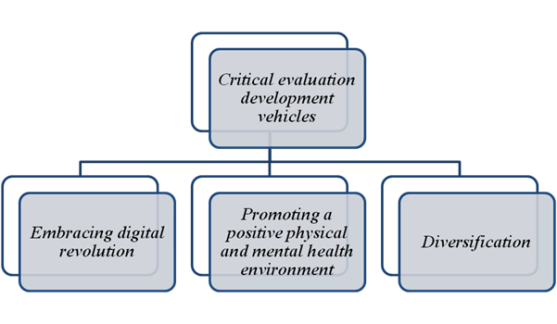
Figure 2: Critical evaluation development vehicles
(Source: Created by author)
Diversification
Diversification is the key to evaluation within organisational premises as a diversified environment tends to focus on differences and validations. Diversification is the process through which intuition needs to be made in order to bring together people from different universities. As opined by Arasanmi and Krishna (2019), diversification leads to intuitive proclamation within an organisation, and that might be initiated to create better prospects. In the case of Unilever, the mode of catering workplace with different diversity states upon the ways employees would be able to have developed from both professional and personal front. In order to have access to building strategic talent pools in supporting a diversity and inclusion (D&I) workforce (Source: Unilever.com, 2021).

Effectiveness for the evaluation of development vehicles
Evaluation of development vehicles is in evaluating various prospects that could be incorporated within organisation development. As stated by Block et al. (2020) it is important to create ways organisations might take their part in inciting development vehicles. The effectiveness of providing the development vehicles is incredible. The need for provision strategies lies within the ways organisations might take their turn. The reasons behind the need for Effectiveness for the evaluation of development vehicles are as follows:
Planning for future endeavours
It is essential to have the basics of development vehicles within organisations as it helps in planning for future tech endeavours. It can be said that by means of development vehicles, organisations are able to initiate better prospects that would be evaluated in the near future. As opined by Handley et al. (2018), understanding the present state of the organisations by developing vehicles help in bringing up the prospects of the paintings that need to be done later. It is associated with the fact that employee satisfaction lies within the aeration related to profiling with the basis of the ways organisations might take their turn. Hence, it can be said that inciting better intuition in creating associative evidence to evaluate evidence care is necessary.
Focusing on the Strengths and Weaknesses
It is essential to evaluate the ways intuitive proclamation needs to be assisted. It is required to evaluate development vehicles as it would be helpful in bringing both strengths and weaknesses of the organisation. It is important to initiate organisations with their own strength and weakness and with better development vehicles; it gets a better turn to evacuate better prospects. As stated by Holland (2019), undergoing butter analysis on the strength and weaknesses to proper variations being achieved. Hence, it can be said that leveraging strengths and validating plans to close capability gaps helps in creating a higher level of awareness within organisations.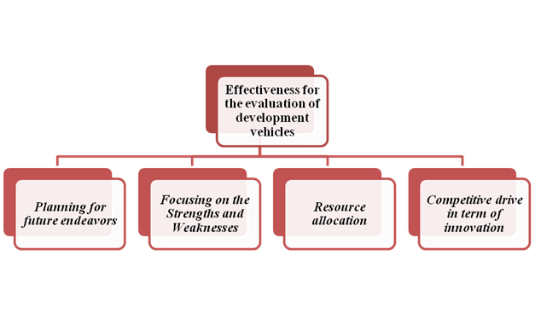
Figure 3: Effectiveness for the evaluation of development vehicles
(Source: Created by author)
Resource allocation
It is essential to evaluate better resource allocation strategies within the accessible provinces in order to have proper diversification. As opined by Elia et al. (2017), it can be said that the validations with inclusive spectrum take place by means of proper resource allocation. In association with the betterment of the organisations taking place, it is important to initiate development vehicles. It is needed to animate in bringing up the strategies that are required in order for testing betterment in resource segregation. This is because the proclamation gives initiative that takes a better turn in evaluating different prospects related to inclusive association with development vehicles.
Competitive drive in terms of innovation
In case of creating better prospects, that might take its turn in evaluating better prospects in the competitive ruling of innovation. As stated by Block et al. (2020), it is necessary to evaluate better prospects that are related to the ways organisational development could be achieved. In association with the ways, evaluation can be restrained and shall be more focused on the validations. In addition, it is important to initiate betterment within the organisation in the provision to evaluate development vehicles. It can be said that the evaluation tends to be important to initiate greater prospects within the company. It can be achieved as it helps in uniting better innovation and validating positive prospects.

A professional development plan
Type | Evaluation | Induction | Ongoing professional development | Resulting professional development
Goal | Helping people to improve their health and wellbeing | ● Creating better products and services  ● With the assistance of advanced technical people  ● Improvement of employee retention | Bringing up with getting back the improvement taken into consideration regarding product and services | Focusing on bringing up with quality products and services at reasonable prices
Strategies | ● Initiating betterment in the products of products and providing services  ● Creating a workplace with innovation and advanced technologies  ● Initiating transition diversity in the workplace | ● Improving the quality of the products and services  ● Creating a place with better technological terms  ● Recruiting people from various diversity and culture | ● By initiating proper quality control for the products  ● By evaluating workplace strategic analysis  ● By use of better perspectives in bringing down intuitive culture | ● Best quality products  ● The great working environment for employees  ● Better diversity specification in the workplace
Table 1: Professional development plan for Unilever
(Source: Created by author)
From the above table, it can be seen that proper professional development for Unilever has been made based on the prospects that need to be focused on. In addition, an overall assertion related to diversification takes place in creating better prospects focusing on the goals and strategies the organisation creates. Hence, it can be said the above goals for helping people to improve their health and wellbeing can be sustained and gained with proper strategies and planning.

Models for personal development
Boud Reflection Model
According to the Boud Reflection Model, the model initiates in focusing on learning by reflecting on one's practice. It initiates in bringing up with the provision on reflecting on one’s own practice. As opined by Liu et al. (2021), profiling to the activities that need to be focused more into with proclamation of improving the skills that are incorporated shall have refrained. It is essential to evaluate the ways an improvement on the existing skills needs to be focused more. It can be said that the emotions of a person related to the experiences at work are based on the reflective self-analysis that the model provides where the work experience must be more focused.
SMART
Objectives | Specific | Measurable | Achievable | Relevant | Time-bound
Initiating innovation | In bringing betterment through innovation | It is measurable by means of best ways of bringing different technology through innovation | It can be achievable by means of proper timing and resources | Its impact initiates in creating better innovation ringing organisation | 6 months
Creating a better work culture | Bringing together the initiation better workplace by means of better initiatives | It is measurable by means of analysing the workplace properly | It can be achievable by means of better strategic management | The impacts are evaluated by means of having better prospects in the working culture | 5 months
Initiation to diversification | Bringing together people from different cultures and diversities | It is measurable by means of annoying the ways people from different diversities take part in the workplace | It can be achievable by means of better strategic management and time | The impacts of the objective need to be affirmative | 4 months
Table 2: SMART Table
(Source: Created by author)
Analysis
From the above table, it can be seen that the initiation to a validated objective shall be taken into consideration by means of the ways self-development could be done. It has been seen that a total of three objectives are redefined, and those can be taken forward for the development purpose of self-evaluation. The objective needs to be specific along with the ways they could be measurable along with that being achievable and relevant with a specific time-bound.

Methods for developing a plan
Setting goals
In order to have proper planning for the development purposes, it is essential to evaluate the goals that are required to get initiated. Setting up goals is related to the ways personal development can be profiled (Michael, 2019). Hence, with the help of goal setting, the first step to personal development can be taken forward.
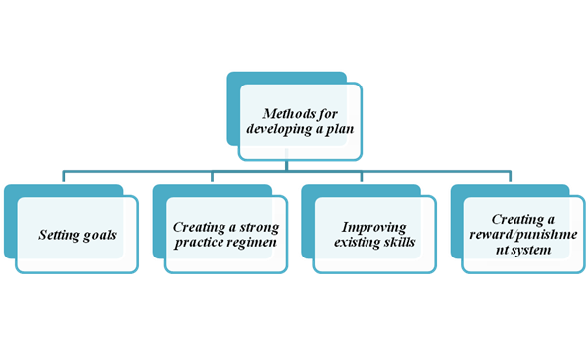
Figure 4: Methods for developing a plan
(Source: Created by author)
Creating a strong practice regimen
In order to evaluate the ways development plan shall be restrained, initiating to get back with string practice is important. As opined by Numonjonov (2020), it can be said that profiling with a proclamation to evidential usage and essentiality of strong practices. It is necessary to innate better prospects as per the personal plan that needs to be developed.
Improving existing skills
The stepping forward that needs to be made in terms of personal man shall evaluate better prospects in order to understand and improve the existing skills. As opined by Rieckmann (2018), it can be said that improving the existing skills would be helpful by means of becoming prompt in the skills that shall be evaluated better. Hence, exhibiting skills need to be improved better than the things that are required to be initiated later.
Creating a reward/punishment system
In order to get back with the system of the personal development plan, one of the methods that can be formulated is creating a reward/punishment system. It would be helpful in bringing down the way in which if a positive aspect is achieved, rewards shall be proclaimed, and if any negative evidence is regarded, the punishment shall be initiated.

Theories for development of the plan
Freud's psychosexual stage theory
According to Freud's psychosexual stage theory, there are a total of 5 stages in human life, and this initiates the way development takes place. The first stage is also called the oral stage that takes place in terms of the age group 1 to 3. The second stage is also called the anal stage that takes place in between the 3 to 6 (Harvey et al. 2017). The third stage initiates between the ages 3 to 6 and is called the phallic stage, and the fourth stage inmates to be Latency stage that takes place in between the 6 years to puberty, and the last stage is the Genital that takes place in between puberty to adulthood.
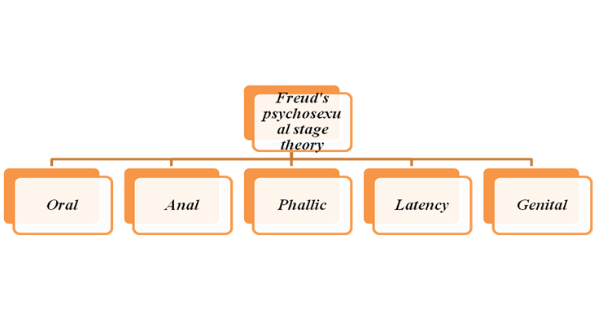
Figure 5: Freud's psychosexual stage theory
(Source: Harvey et al. 2017)
Erik Erikson's stages of psychosocial development
According to Erik Erikson's stages of psychosocial development, psychological development takes place by means of eight different stages (McLeod, 2018). In responding to personal development, psychosocial development initiates in the first stage that is Trust vs Mistrust that initiates psychological acceptance to the overall personality. The next sites to be Autonomy vs Shame and Doubt following with the sage named Initiative vs Guilt. Industry vs Inferiority and Identity vs. Confusion are the next two stages of the theory props by Ericson. Intimacy vs Isolation, Generatively vs Stagnation and Integrity vs Despair is the next three stages used to be the 6th, 7th and 8th stages.
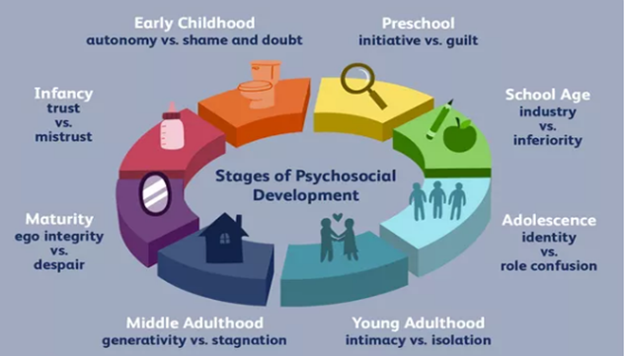
Figure 6: Erik Erikson's stages of psychosocial development
(Source: McLeod, 2018)

Conclusion
From the above, it can be concluded that despite Unilever bringing one of the most validated organisations of all time and ruling the global market for the last 92 years, there have been times when the organisation needed training and development. The study focused on the importance of training development an organisation gets into in order to meet up with the expectations. In the study, an overall justification has been provided, and a critical evaluation of development vehicles has been made. In addition, the need for it has also been invited, focusing on a professional plan being taken into consideration. The professional plan has been developed focusing on the objectives of the company and inciting betterment for the development occurring within the organisation. In addition, the accessibility tends to focus more on the ways organisations take into consideration the validations required. Appropriate models, methods and theories have been used in the story to evaluate the importance of professional development in order to access betterment in career.

‘

Reference List

Arasanmi, C.N. and Krishna, A., 2019. Employer branding: perceived organisational support and employee retention–the mediating role of organisational commitment. Industrial and Commercial Training.
Block, P., Hoffman, M., Raabe, I.J., Dowd, J.B., Rahal, C., Kashyap, R. and Mills, M.C., 2020. Social network-based distancing strategies to flatten the COVID-19 curve in a post-lockdown world. Nature Human Behaviour, 4(6), pp.588-596.
Elia, V., Gnoni, M.G. and Tornese, F., 2017. Measuring circular economy strategies through index methods: A critical analysis. Journal of Cleaner Production, 142, pp.2741-2751.
Gilani, H. and Cunningham, L., 2017. Employer branding and its influence on employee retention: A literature review. The Marketing Review, 17(2), pp.239-256.
Handley, M.A., Lyles, C.R., McCulloch, C. and Cattamanchi, A., 2018. Selecting and improving quasi-experimental designs in effectiveness and implementation research. Annual review of public health, 39, pp.5-25.
Harvey, F., Present and Critically Assess the Main Contributions of Freud’s Theory of personality to Sociological Analysis. Volume 22 Summer, p.16.
Holland, B., 2019. Factors and strategies that influence faculty involvement in public service. Building the Field of Higher Education Engagement: Foundational Ideas and Future Directions.
Liu, M., Kitto, K. and Shum, S.B., 2021. Combining factor analysis with writing analytics for the formative assessment of written reflection. Computers in Human Behavior, 120, p.106733.
Maity, S., 2019. Identifying opportunities for artificial intelligence in the evolution of training and development practices. Journal of Management Development.
McLeod, S., 2018. Erik Erikson's stages of psychosocial development. Simply Psychology, 3.
Michael, A., 2019. A handbook of human resource management practice.
Numonjonov, S.D., 2020. Innovative methods of professional training. ISJ Theoretical & Applied Science, 1(81), pp.747-750.
Papa, A., Dezi, L., Gregori, G.L., Mueller, J. and Miglietta, N., 2018. Improving innovation performance through knowledge acquisition: the moderating role of employee retention and human resource management practices. Journal of Knowledge Management.
Rieckmann, M., 2018. Learning to transform the world: Key competencies in Education for Sustainable Development. Issues and trends in education for sustainable development, 39, pp.39-59.
Statista.com, 2021. Unilever - Statistics & Facts. Available at: https://www.statista.com/topics/1397/unilever/#dossierKeyfigures [Accessed on: 12.12.2021]
Unilever.co.uk, 2021. Available at: https://www.unilever.co.uk/our-company/purpose-values-principles/ [Accessed on: 12.12.2021]
Unilever.com, 2021. UNILEVER. Available at: https://www. unilever.com /our-company/at-a-glance/ [Accessed on: 12.12.2021]

