BMSW 4005 Task 2-Portofolio of work
Certificate in High education skills for the Workplace Professional and Career development

Student Name: Visan Bianca Elena
Student ID:

Table of Content:
Job Advertise ___________________________________________________________ page 02
Cover Letter ____________________________________________________________ page 03
CV ____________________________________________________________________ page 04
References _____________________________________________________________ page 05
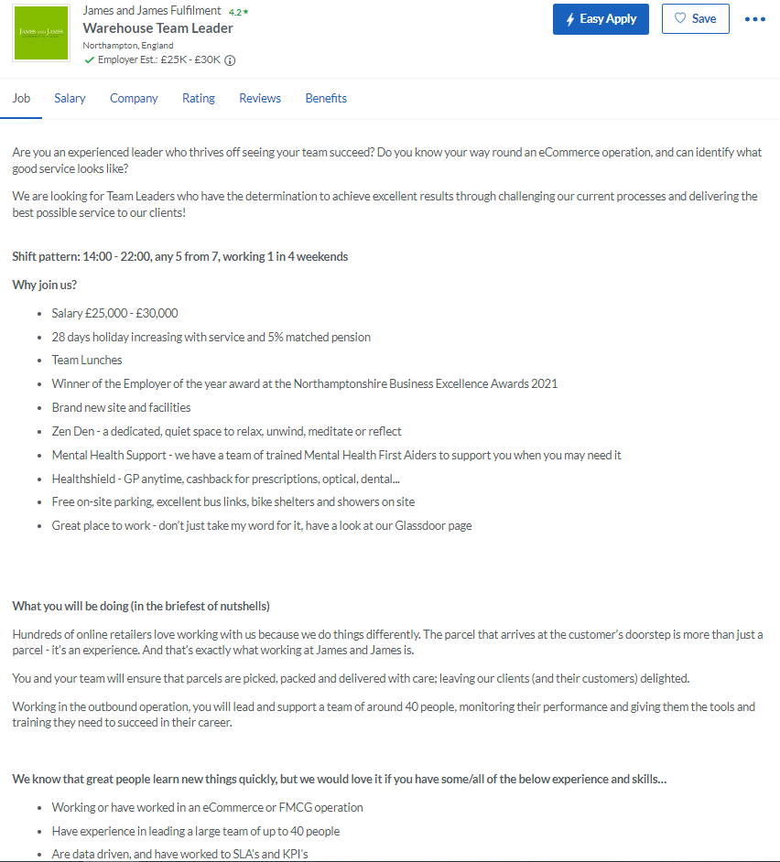
(Glassdoor, 2022)
16 of June 2022
Rhosili Rd, Northampton NN4 7JE
To: James and James Fulfilment
, Recruitment Department
Dear Recruitment Office team,
First I want to thank you for the opportunity to apply for the job role of Team Leader for warehouse operative, as an experienced team leader I believe that I am the perfect candidate foe the role, as I have experience as a warehouse operative and experience as a team leader in a warehouse working in a fast environment for DHL Sainsbury’s been very dedicate to improve the organization by keeping the time motivate; help to drive thru and develop and always push my limits in order to achieve with the team the best results possible. Knowing all about warehouse operative work by been previously a worker in multiple warehouses, I am not required to be spent time on trainings for the warehouse departments of the operation by already knowing to operate with license all the warehouses machines. Also I have strong communication; team work and leadership skills achieved at the previous job as an experienced teal leader. Hoping to see you soon, and ready for the interview booking.
Thank you,
Visan Bianca Elena

Skills:
Communication
Decision Making
Teamwork
Problem Solving
MS Office
Leadership
Management
Planning and organization
Time Management

Contacts:
- 10 Sandy Lane, Rugby,
CV21-2UR
- 07305151414
- Biancabebelo46@gmail.com

Education:
Certificate of higher education skills for workplace and health and social care at University of Wales Trinity Saint David (2021-2023 United Kingdom)
SCF Training rich Truck Licence
SCF Training counter balance Truck Licence
SCF Training PPT Truck Licence
SCF Training LLOP Truck Licence

Work History:
DHL Sainsbury’s Daventry Good In team leader 2020-Current
Working in a fast environment as a team leader I am motivating my team, help with all the queries and training needs; working together in accomplish all the warehouse demands in the Goods In department exploding our potential at maximum.
DHL Sainsbury’s Daventry Warehouse Operative 2018-2020
As a warehouse operative I had been trained to the following operational machines : rich truck; ppt; llop in order to assisting with loading and unloading stock; staking moving and loading or picking items from the racking, ensuring that all the operational task are well done in high performance.
Tesco Grocery Daventry Warehouse Operative 2016-2018
Assisting to delivery of Goods and supplies, ensuring that all the damage or missing items are reported working by the Heath and Safety rules, Load raking with goods; keep records of stock and pack orders.

Professional Summary:
Hard worker always dedicate for improvements with self drive to development as an experienced team leader with a large work experience in the warehouses in both operational and team leader always ready to help my team to perform at the maximum potential and to work together to accomplish all the operational and business need in order to grow and succeed, working for more then three years and with high understands about the business needs and business culture.
Visan Bianca Elena

References
Glassdoor, 2022. Warehouse Team Leader. [Online]
Available at: https://www.glassdoor.co.uk/job-listing/warehouse-team-leader-james-and-james-fulfilment-JV_IC3253297_KO0,21_KE22,48.htm?jl=1007897782854&utm_campaign=google_jobs_apply&utm_source=google_jobs_apply&utm_medium=organic
[Accessed 15 06 2022].

