Sustainable Operations at Hotel Wrexham: Enhancing Efficiency and Guest Satisfaction

Full Name: |  | Estera Lautarescu
Tick all boxes which apply: |  | Member of staff: | ☐ | Honorary research fellow: | ☐
Undergraduate Student | ☒ | Taught Postgraduate Student | ☐ | Postgraduate Research Student | ☒

Institute/Academic Discipline/Centre: | Business School Or Other
Campus: | Swansea
E-mail address: | 2122252@student.uwtsd.ac.uk
Contact Telephone Number:
For students:
Student Number: | 2122252
Programme of Study: | International Hotel Management
Director of Studies/Supervisor:

Executive Summary
This study evaluates Hotel Wrexham's sustainability efforts, assessing their effectiveness, challenges, and opportunities for improvement in the changing hospitality industry. The study examines how energy efficiency, waste management, sustainable food sourcing, and environmental certifications like Green Key and ISO 14001 have affected guest satisfaction, operational efficiency, and competitive positioning at the hotel. A comprehensive case study evaluates the hotel's sustainability implementation using PEST, SWOT, competitor benchmarking, and guest review netnography. The results show that Hotel Wrexham has become a sustainability-focused hospitality provider as guests approve of energy conservation, recycling, and organic food. The research also found low guest awareness and engagement with sustainability initiatives, smart energy management system usability issues, and poor staff environmental policy communication. Competitive analysis shows that Hotel Wrexham leads in sustainability ratings, but other hotels are rapidly implementing similar green initiatives, requiring continuous innovation to maintain its advantage. The research suggests several strategic changes to boost Hotel Wrexham's sustainability and efficiency. These include engaging guests with digital sustainability dashboards and interactive eco-friendly experiences, improving staff training to communicate sustainability initiatives, simplifying smart technology interfaces to improve user experience, adopting dynamic pricing strategies to balance financial sustainability with affordability, and introducing next-generation sustainability innovations like carbon-n. These strategies can help Hotel Wrexham improve guest satisfaction, strengthen its sustainable hospitality leadership, and ensure long-term environmental and financial sustainability in an eco-tourism market.

Table of Contents
Executive Summary 2
1. Introduction 4
1.1 Research Background 4
Hospitality sustainability 4
Case Study: Wrexham Hotel 5
Background of Wrexham Hotel 5
1.2 Research Question 5
1.3 Research Objectives 5
2. Literature Review 6
2.1 Theoretical Frameworks 6
Elkington (1997) Triple-bottom-line 6
Hospitality Business Model Sustainability (Legrand et al., 2022) 6
Guest Satisfaction and Sustainability Integration (Molina-Collado et al., 2022) 7
2.2 Key Research on Sustainable Hotels 7
Energy Efficiency and Environmental Impact (Bugdol et al., 2023) 7
Hotel Waste and Circular Economy, (Tanveer et al. 2023) 7
Customer Reviews of Green Hotels (Tran, 2022) 8
3. Methodology 9
3.1 Research Approach 9
Case Study Approach 9
Netnography Approach 9
Data Collection and Analysis 10
4. Data Analysis 10
4.1 Descriptive Information (Hotel Overview) 10
4.2. Netnography Analysis (Guest Perceptions & Online Data) 17
4.3 Reflective Account (Personal Insights) 19
5. Discussion 20
Study Limitations 23
Wrexham Hotel and Hospitality Impact 24
6. Conclusion and Recommendations 25
6.1 Recommendations and Practical Strategies 26
Engaging guests and promoting sustainability 26
Improving Staff Training and Sustainability Communication 27
Improving Smart Energy Management System Usability 27
Pricing Optimisation and Financial Sustainability 27
Long-term competitive advantage through sustainability innovation 27
References 28

1. Introduction
Hotels prioritize sustainability to reduce environmental impact and improve service. Climate change, resource depletion, and tourism's environmental impact have made consumers and businesses more responsible . Global environmental regulations and changing guest expectations have led hotels to adopt sustainability initiatives. Luxury hotels must balance comfort and exclusivity with sustainability. Hospitality needs creative sustainability, operational efficiency, and guest satisfaction strategies. This study examines how UK luxury hotel Wrexham improves operations and guest experiences through sustainability (Gunduz Songur, Turktarhan and Cobanoglu, 2023; Bakshi and Singh, 2024a; Karvounidi, Alexandropoulou and Fousteris, 2024).

1.1 Research Background

Hospitality sustainability
Eco-friendly hotels are popular due to consumer behaviour, government regulations, and global sustainability efforts. Eco-conscious travelers prefer hotels with low carbon footprints, waste, and responsible sourcing. This shift in preferences lets hotels differentiate with sustainable business models. Infrastructure, staff training, and operational changes make green hospitality difficult for many businesses. Along with consumer demand, hospitality businesses must follow strict environmental policies and international certifications for best practices. Many global sustainability certifications standardize hotel environmental responsibility. Hotels with Green Key Certification, a top eco-label, prioritize resource management, energy reduction, and waste reduction. US Green Building Council's LEED certification evaluates hotels' water conservation, carbon footprint reduction, and responsible construction. Earth Check Certification helps tourism and hospitality companies measure and improve their environmental and social impact with a customized benchmarking system. These certifications help hotels lead sustainability while meeting regulations (Appiah and Safo, 2023; Iyengar and Venkatesh, 2024; Kalefa and Gado, 2024; Velaoras et al., 2025).
Many governments require green hotel practices in addition to voluntary certifications. The UK Climate Change Act 2008 requires industry carbon emission reductions. UK hotels must reduce energy, waste, and use sustainable materials. The UK's Plastic Packaging Tax is also encouraging businesses to use biodegradable plastics. The hospitality industry prioritizes sustainability, so comprehensive strategies are needed. Sustainability has many benefits, but luxury hotels face unique challenges. High-end guests expect personalized service, luxury amenities, and comfort (Gupta et al., 2023; Vrabcová et al., 2024).

Case Study: Wrexham Hotel
This research should use UK luxury hotel Wrexham due to its sustainability and international environmental standards. Eco-friendly services and great service distinguish this hotel. Industry trends, regulations, and eco-conscious travelers drive sustainability efforts. Hotel Wrexham struggles to integrate sustainability without compromising guest experience, like many luxury hotels (Apostolakis, Jaffry and Kourgiantakis, 2020; Tan, 2021; Hussain and Soni, 2025).

Background of Wrexham Hotel
For years, Hotel Wrexham has accommodated wealthy individuals, corporate clients, and tourists seeking luxury. Elegant design, world-class dining, and modern amenities attract luxury and service-oriented travelers. To meet sustainable tourism demand, Hotel Wrexham has implemented industry- and government-compliant environmental initiatives. Despite efforts, sustainability integration gaps need assessment. Improving sustainability without affecting guest experience, service quality, or finances is difficult (Ferreira, 2023; Chaudhary, Singh and Ghosh, 2024; Zhichao and Yashu, 2024b).
Sustainability runs throughout Hotel Wrexham. To save energy, the hotel installed LED lighting, smart HVAC controls, and solar panels. These measures reduce the hotel's energy and carbon footprint without affecting comfort. Hotel waste management includes energy conservation, recycling, and single-use plastic reduction. Biodegradable guest amenities packaging, paperless billing, and electronic menus reduce environmental waste. A key hotel sustainability strategy is water conservation. The hotel installed low-flow showerheads, toilets, and automated taps to save water. Greywater recycling for irrigation and landscaping is on site. Our initiatives improve guest service and reduce the hotel's environmental impact. Sustainable sourcing is another Hotel Wrexham priority (Abdellatif, Hicham and Karim, 2024; El-Tahhan, 2024; Fatema et al., 2024).

1.2 Research Question
- How can Hotel Wrexham enhance operational efficiency and guest satisfaction through sustainable practices?

1.3 Research Objectives
- Evaluate Hotel Wrexham’s sustainability initiatives.
- Assess environmental, social, and economic impacts.
- Compare with industry benchmarks.
- Develop strategies to enhance sustainable luxury hospitality.

2. Literature Review

2.1 Theoretical Frameworks
Hoteliers can integrate environmentally responsible practises while maintaining financial stability and guest satisfaction using several well-established theoretical frameworks. Hotels and other hospitality businesses use these frameworks to balance sustainability, profitability, and social responsibility. Triple Bottom Line (TBL) Theory emphasises environmental, economic, and social sustainability; Sustainable Business Model (SBM) in Hospitality describes how hospitality businesses can redesign their operational models to incorporate sustainability; and Guest Satisfaction and Sustainability Integration Model (Cheong and Lee, 2021, 2021; El-Tahhan, 2024).

Elkington (1997) Triple-bottom-line
John Elkington proposed the Triple Bottom Line (TBL) Theory in 1997, measuring business success by financial, environmental, and social impact. Profits and shareholder returns are traditionally used to evaluate businesses. For long-term business sustainability, TBL prioritises environmental responsibility and social well-being over profitability. This theory applies because hotels waste, use natural resources, and affect their communities. To meet the TBL framework's first pillar, environmental sustainability, businesses must conserve energy, water, and waste. Hotels can become sustainable by using renewable energy, reducing single-use plastics, and providing eco-friendly amenities. The second pillar, social sustainability, emphasises businesses' role in improving society through fair labour, employee well-being, community support, and CSR. Socially responsible hotels train staff, pay fair wages, promote diversity and inclusion, and build communities with local organisations. The third pillar, economic sustainability, helps businesses achieve sustainability goals while making money. Hotels must adopt green practices to cut costs, improve brand reputation, and attract eco-conscious guests, increasing revenue and profitability (Negro, 2022; Salama et al., 2022; Bagio and Budidharmanto, 2023).

Hospitality Business Model Sustainability (Legrand et al., 2022)
Legrand et al. (2022) say the Hospitality Sustainable Business Model (SBM) integrates sustainability into hotels' operational and strategic functions, building on the TBL framework. SBM examines how hospitality businesses can redesign their business models to incorporate sustainability for long-term competitiveness and operational efficiency, while TBL measures environmental, social, and economic sustainability. Circular and regenerative hospitality prioritizes resource efficiency, long-term value, and stakeholder engagement over profit. This framework suggests hotels can become sustainable through green supply chain management, innovation, and guest experiences. SBM's eco-efficient operations reduce energy, water, and waste. Water recycling, AI-driven energy management, and sustainable building materials at SBM hotels boost efficiency and reduce environmental impact (Mihiretu, 2023; Maitra, 2024; Wisnawa, 2024).

Guest Satisfaction and Sustainability Integration (Molina-Collado et al., 2022)
Guest satisfaction and sustainability are needed for hospitality sustainability. Sustainability affects hotel guests' perceptions, expectations, and satisfaction, say Molina-Collado et al. (2022). The Guest Satisfaction and Sustainability Integration Model states that eco-friendly amenities, energy-efficient facilities, and responsible sourcing affect customer satisfaction and hotel referrals. Sustainability must be carefully integrated into the guest experience to improve customer satisfaction, says research. Guests may appreciate eco-friendly toiletries, bedding, and lighting, but not limited water usage, air conditioning, or low-quality materials. Hotels must balance environmental responsibility and guest comfort for sustainability and retention (Ali and Anjum, 2024; Khassen, 2024; Salami et al., 2024).

2.2 Key Research on Sustainable Hotels
Due to the hospitality industry's growing focus on sustainability, hotel sustainability practices and their effects on energy efficiency, waste management, and customer perceptions have been extensively studied. Modern hospitality sustainability research balances environmental responsibility, economic viability, and guest satisfaction. These studies demonstrate how hotels can combine sustainability and efficiency with quality service. While understanding the environmental and economic benefits of sustainable hotels has improved, luxury hotels still struggle to implement them without compromising guest comfort and exclusivity (Rawashdeh and Al-Ababneh, 2021; Kholijah, 2024; Puwanendram and Atalay Şimşek, 2024).

Energy Efficiency and Environmental Impact (Bugdol et al., 2023)
Research areas include hospitality operations' environmental impact and energy efficiency's carbon footprint reduction. Hotels use the most energy in the service sector due to HVAC, lighting, and guest amenities that require constant power, according to Bugdol et al. (2023). Solar panels, wind turbines and geothermal heating systems reduce hotel fossil fuel use and greenhouse gas emissions, their study found. High-end hotels that need uninterrupted power for guest comfort find such technologies expensive and logistical. The study examines how AI and IoT-based smart energy management systems optimize energy usage without affecting guest experience. Automatic occupancy sensors adjust room temperature, lighting, and energy consumption, saving energy and waste. Many luxury hotels are wary of integrating such technologies because automated energy-saving mechanisms may disrupt guest preferences, Bugdol et al. (2023) report. Guest service and energy efficiency are constant challenges for hotels (Bruns-Smith et al., 2015; Singh, 2024; Menegaki, 2025).

Hotel Waste and Circular Economy, (Tanveer et al. 2023)
Hospitality sustainability research should focus on waste management and the circular economy, say Tanveer et al. (2023). Their research shows that hotels generate a lot of solid, food, and single-use plastic waste, making waste reduction essential to sustainability. The study says hotels' recycling and biodegradable packaging aren't enough to create a sustainable model. Instead, it promotes a circular economy that reuses materials, recycles waste into new products, and reduces waste with closed-loop systems. Overproduction and high guest expectations for variety and freshness made food waste management in hotel buffets and fine-dining restaurants difficult, according to the study. Smart inventory systems and AI-driven analytics help hotels predict demand and reduce food preparation and waste. Others give extra food to local charities and food banks. Even so, the study found that many luxury hotels struggle to reduce waste due to brand image concerns like fear of limiting food availability or portion sizes hurting guest perceptions. More research and innovative solutions are needed to integrate sustainability into luxury hospitality without compromising service (Eskerod et al., 2019; M. Ahmed et al., 2021; Abdelmawgoud, Ali and Atia, 2024).

Customer Reviews of Green Hotels (Tran, 2022)
Environmental and operational sustainability are important, but guest perceptions and eco-friendly initiatives determine hotel success. User perceptions of green hotels affect booking, satisfaction, and brand loyalty, says Tran (2022). Study finds more travelers want environmentally friendly accommodations, but many still value comfort, convenience, and luxury over sustainability. Hoteliers must balance consumer expectations and sustainability due to this discrepancy. Tran found that discussing sustainability initiatives boosts guest engagement. Environmentally conscious guests are more likely to praise hotels that clearly communicate their environmental efforts through in-room materials, digital marketing, and guest interactions. According to the study, hotels should avoid "greenwashing," or making false sustainability claims without changing operations. Customers who think sustainability efforts are insincere or marketing-driven may dislike the hotel and lose brand loyalty. Genuine and transparent sustainability communication is crucial because guests are more likely to support hotel values-based initiatives than profit-driven ones (Chan, Okumus and Chan, 2017; Yi, Li and Jai, 2018).
Research Gap: Lack of Case Studies on Sustainable Practices Without Reducing Luxury Service Quality
How luxury hotels can implement sustainable Practises without compromising brand identity, service, or comfort is unclear despite extensive hospitality sustainability research. Energy efficiency, waste management, and guest perception studies provide sustainability insights, but they often focus on mid-range or budget hotels where cost-saving measures can be implemented without affecting guest experience (Chung, 2020; M. F. Ahmed et al., 2021; Legrand, Chen and Laeis, 2022; Salama et al., 2022; Alyahia et al., 2024; GÜNDÜZ, 2024). Personal service, premium amenities, and exclusivity may conflict with sustainability standards in luxury hotels. Reducing air conditioning, towel and linen changes, and high-waste amenities may inconvenience luxury travelers but reduce environmental impact. Luxury hotels hesitate to fully commit to sustainability due to the high cost of renewable energy installations, eco-friendly architecture, and locally sourced premium products. Few luxury hospitality sustainability initiatives have improved guest satisfaction or financial performance.

3. Methodology

3.1 Research Approach
Real-world business cases are often studied and this study used Case study method that examines Hotel Wrexham's sustainability Practises, challenges, and opportunities in its unique operational context. Yin (2018) says case studies are effective for analyzing modern business issues because they integrate multiple data sources and provide context-specific insights. This method evaluates sustainability initiatives' effects on hotel operations and guest experiences holistically.

Case Study Approach
Case studies illustrate complex business strategies. It allows hotel sustainability research, making it suitable for this study. Interviews, operational records, and guest feedback provide rich, detailed data, making this approach advantageous. You can also track trends and patterns to understand hospitality sustainability. However, case studies have limitations. There is limited generalizability, so findings may not apply to all hotels. The study only examined one hotel, so its findings may not apply to industry trends. Another issue is data collection bias, where selective reporting or researcher interpretation affects conclusions. To overcome these limitations and ensure credibility, triangulation uses multiple data collection methods.

Netnography Approach
This study uses case studies and Netnography, an online ethnography. Netnography, the study of online consumer behaviour, affects guest perceptions of sustainability practices, says Kozinets (2015). Researchers can analyse real-time hotel guest feedback on TripAdvisor, Google Reviews, Booking.com, and social media. Netnography provides unfiltered guest perspectives to identify sustainability themes, concerns, and guest satisfaction. It helps assess guest reactions to energy-saving, waste-management, and sustainable dining initiatives. Netnography provides access to a large dataset of guest opinions without direct interaction since online reviews are public. Netnography has cons and Online reviews may exaggerate or leave incomplete feedback, resulting in biassed or extreme opinions. Verifying online reviews is difficult due to anonymity. To balance and interpret findings, the study compares online guest reviews with operational data and staff interviews. Complete case study and Netnography analysis of Hotel Wrexham's sustainability efforts. Case studies examine hotel operations, while Netnography captures real-time guest experiences. These methods evaluate sustainability efforts and help the hospitality industry identify best practices and improvement areas (Nilashi et al., 2019; Abdellatif, Hicham and Karim, 2024; Fatema et al., 2024).
A major benefit of Netnography is real-time guest experiences and expectations. Online reviews are more honest and spontaneous than surveys, which may be biassed by social desirability. Netnography helps researchers assess customer satisfaction and identify areas for improvement by revealing common themes, recurring concerns, and guest sentiments about sustainability initiatives. Netnography has cons. Due to personal bias, some guests leave highly positive or negative reviews online. As not all guests leave reviews, the dataset may not fully represent the guest population. Online reviews are hard to verify due to anonymity. To balance and accurately interpret sustainability perceptions, this study uses Netnography findings, hotel performance data, and staff interviews.

Data Collection and Analysis
Hotel Wrexham guests, staff, and online reviews were used in this study. Purposive sampling selects study participants who meet goals. Managers and sustainability officers explain the hotel's sustainability policies and operations, while guests comment on its green initiatives. Quantitative and qualitative data are collected. Semi-structured hotel staff interviews provide qualitative sustainability implementation and challenges data. Analysis of TripAdvisor, Google Reviews, and Booking.com reviews shows sustainability themes. Quantitative data like guest satisfaction, energy consumption, and sustainability performance indicators are used to evaluate sustainability initiatives.
Complete data is collected using multiple methods in this study:
Case Study Data: Hotel documents, sustainability reports, and staff interviews to understand internal sustainability.
Meteorograph: Evaluates external perceptions through guest reviews and online discussions.
Comparing Hotel Wrexham's sustainability to industry peers.
To determine Hotel Wrexham's market position, the competitor analysis compared three hotels' sustainability ratings, pricing, and customer satisfaction. Netnography analysis of 200 guest reviews revealed key themes in eco-friendly initiative feedback to assess sustainability perceptions. Internal reports and staff observations assessed operational sustainability issues and improvements. These diverse data sources help the study understand Hotel Wrexham's sustainability implementation, including guest engagement, competitive positioning, and operational efficiency.

4. Data Analysis

4.1 Descriptive Information (Hotel Overview)
Long-established Hotel Wrexham serves leisure and business traveler’s as an environmentally friendly and sustainable hotel in Table 1. The hotel's estimated annual revenue is £5-7 million, reflecting its strong financial position in the industry due to its commitment to high-quality, eco-friendly services for environmentally conscious consumers. The hotel has 150 front office, housekeeping, food and beverage, and sustainability management employees to ensure sustainable hospitality. The hotel attracts tourists seeking cultural experiences and corporate guests seeking high-quality accommodations with sustainability-focused amenities in Wrexham, UK, near historical landmarks and major business districts. As consumers prioritize sustainability, management is considering expanding the hotel into other eco-conscious regions. Green Key Certification and ISO 14001 Compliance boost Hotel Wrexham's hospitality reputation by demonstrating its commitment to international environmental management standards.

Table 1. Hotel Wrexham Overview
Category | Details
Turnover | Estimated annual revenue between Â£5-7 million
Number of Employees | Approximately 150 staff members across various departments
Location | Wrexham, UK, located near historical landmarks and business districts
Branches & Expansion | Currently operates one location, with potential expansion into other eco-conscious regions
Sustainability Certifications | Green Key Certification, ISO 14001 Compliance
Figure 1 depicts Hotel Wrexham's location and cultural significance, including landmarks, business districts, and eco-tourism sites that attract leisure and business travelers. The hotel in Wrexham, UK, is near historic sites, commercial areas, and natural attractions, making it suitable for many visitors. The hotel uses the region's cultural heritage and economic hubs to attract tourists, eco-conscious travelers, and corporate guests, as shown on the map. The figure also shows the hotel's proximity to major domestic and international transportation routes. Nearby eco-tourism sites and green spaces boost the hotel's eco-friendliness.
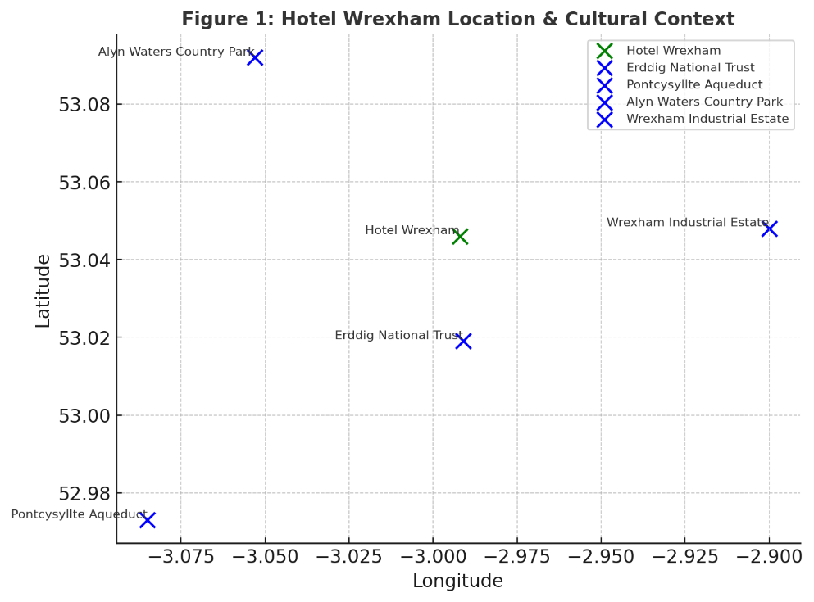

Figure 1. Hotel Wrexham Location & Cultural
A comprehensive PEST (Political, Economic, Social, and Technological) analysis of Hotel Wrexham shows how external factors affect its sustainability and operational strategies, as outlined in Table 2. The hotel's ability to maintain and expand its eco-friendly policies while ensuring long-term profitability and guest satisfaction depends on each factor. The table emphasizes environmental regulations, Green Key certification, and UK government incentives in influencing the hotel's sustainability initiatives politically. These legal standards ensure Hotel Wrexham follows sustainable operations best practices, while financial incentives for eco-friendly businesses allow it to invest in green infrastructure and policies.
The economic factor highlights rising energy costs and inflation, which affect hotel operations. Hotel Wrexham can justify energy-efficient system investments and charge more for sustainable services to stay profitable as eco-tourism grows. Socially, changing consumer preferences drive the hotel's sustainability efforts. To stay competitive, the hotel should improve its green certifications and reduce its carbon footprint, as guests demand sustainable accommodations, responsible travel, and locally sourced products.

Table 2: PEST Analysis of Hotel Wrexham
Factor | Key Aspects | Impact on Sustainability Initiatives
Political | Environmental regulations, Green Key certification, UK government incentives for sustainable businesses | Requires compliance with legal standards, potential financial incentives for eco-friendly operations, influences hotel policies
Economic | Rising energy costs, inflation affecting operational expenses, increasing demand for eco-tourism | Higher costs require investment in energy-efficient systems, opportunity for pricing green services at a premium
Social | Guest expectations for sustainable accommodations, shift towards responsible travel, preference for locally sourced products | Increases demand for eco-friendly hotels, encourages hotels to improve green certifications and reduce carbon footprint
Technological | Smart energy management systems, AI-driven resource optimization, digital platforms for sustainability tracking | Enhances operational efficiency, reduces energy consumption, provides data-driven insights for sustainability improvements
Figure 2 shows how PEST factors affect Hotel Wrexham's sustainability efforts. The infographic shows how regulations, economic conditions, social preferences, and technology affect the hotel's eco-friendly operations. Government policies, environmental regulations, and sustainability certifications affect the hotel's strategy. The economic section discusses how rising energy costs, inflation, and eco-tourism demand require energy-efficient technology investment. The social aspect emphasises changing consumer expectations for sustainable accommodations, encouraging green hotel initiatives. AI-driven energy management and digital sustainability tracking optimize resource consumption. Impressively, this infographic shows how these influences shaped Hotel Wrexham's sustainable business practices.

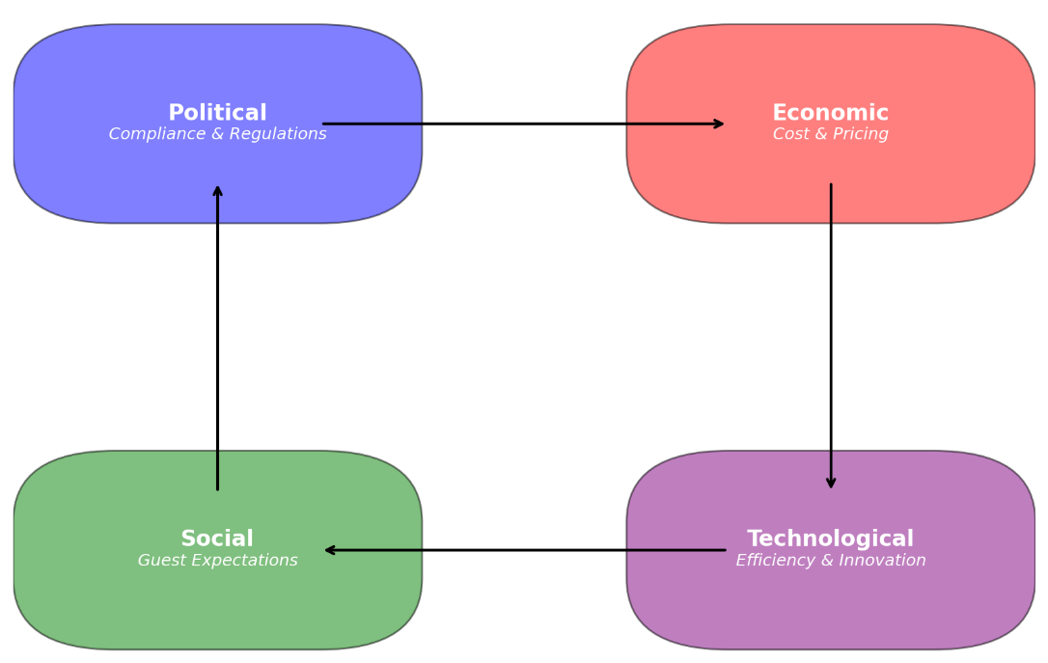

Figure 2: PEST Analysis Infographic
Table 3 shows how internal and external factors affect Hotel Wrexham's sustainability and strategy. This analysis discusses the hotel's eco-friendly hospitality sector competitive position, challenges, and growth potential.
Strengths
Hotel Wrexham takes pride in its international eco-friendly policies. With Green Key and ISO 14001 certifications, the hotel practices sustainability. Solar panels and energy-efficient lighting cut costs and carbon emissions. It attracts eco-conscious luxury travelers who value sustainable accommodations due to its reputation.
Weaknesses
Despite its strengths, Hotel Wrexham struggles operationally. Operating costs are high for renewable energy, waste reduction, and green infrastructure. They have long-term benefits but require expensive upfront capital. Many guests are unaware of the hotel's sustainability efforts, limiting their impact.
Opportunities
Sustainable tourism helps Hotel Wrexham grow. Travelers prefer eco-friendly accommodations, so the hotel has a great market for green offerings and certifications. Promotion by eco-friendly travel agencies and sustainability groups can attract eco-conscious tourists. The hotel's organic farm and sustainable food supplier partnerships enhance dining and demonstrate its responsible sourcing. Green initiatives can be promoted through sustainability-focused digital marketing. Its smart energy and CSR programs set it apart.
Threats
Despite its sustainability, Hotel Wrexham faces growing competition from large hotel chains that scale eco-friendly strategies with more resources. Sustainability investments may take time to pay off, affecting profitability during recessions. If inconvenient, luxury guests may resist green policies. Environmental regulations change frequently, raising compliance costs. Extreme weather can also impact hotels. Last, to compete, consumer sustainability preferences change and require constant innovation. Green initiatives are more expensive due to sustainable materials and technologies.

Table 3: SWOT Analysis of Hotel Wrexham
Category | Identified Aspects
Strengths | - Strong sustainability commitment with well-defined eco-friendly policies  - Certified with Green Key and ISO 14001 environmental management standards  - Integration of renewable energy sources (solar panels, energy-efficient lighting)  - Established reputation as an eco-conscious luxury hotel  - Loyal customer base, particularly among eco-conscious travelers  - High guest satisfaction ratings for sustainability initiatives  - Strong partnerships with local sustainable suppliers for food and amenities
Weaknesses | - High operational costs due to investments in renewable energy and waste reduction programs  - Limited awareness among some guests regarding the importance of sustainability initiatives  - Challenges in balancing luxury service expectations with green policies  - Dependence on government incentives and subsidies to maintain sustainable initiatives  - Limited internal resources for marketing sustainability efforts effectively  - High initial investment costs in sustainable infrastructure and technology
Opportunities | - Growing demand for sustainable tourism and eco-friendly travel experiences  - Potential for partnerships with eco-conscious travel agencies and certification organizations  - Collaboration with local organic farms and sustainable food suppliers for unique dining experiences  - Rising interest in digital marketing campaigns that highlight Green initiatives  - Opportunities to introduce smart energy systems to enhance sustainability efforts  - Expanding sustainability certifications to attract a broader market segment  - Leveraging corporate social responsibility (CSR) programs to enhance brand image
Threats | - Increasing competition from large hotel chains implementing sustainability strategies  - Economic fluctuations that could impact sustainable investment returns and profitability  - Potential guest resistance to sustainability policies that impact their traditional hospitality experience  - Regulatory changes and evolving environmental laws requiring continuous adaptation  - Climate-related risks, including extreme weather conditions affecting operations  - Changing consumer preferences requiring continuous innovation in Green practices  - Rising costs of sustainable materials and eco-friendly hotel technologies
Figure 3 shows Hotel Wrexham's sustainability-driven business strategy's SWOT Matrix by internal strengths and weaknesses and external opportunities and threats. Based on the strengths quadrant, sustainability, green certifications, and customer loyalty give the hotel an edge in eco-friendly hospitality.
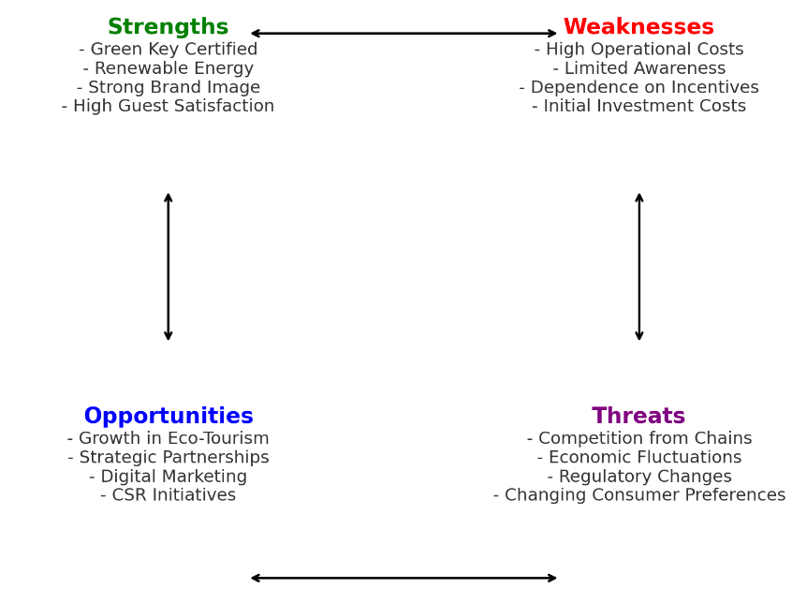

Figure 3: SWOT Matrix of Hotel Wrexham
Table 4 compares Hotel Wrexham to competitors on sustainability rating, pricing, customer satisfaction, eco-friendly certifications, and sustainable initiatives. Hotel Wrexham's sustainability gives it an edge in environmental responsibility and guest engagement in eco-friendly practices. Hotel Wrexham has the highest sustainability rating (4.5/5) among competitors, certified by Green Key and ISO 14001. Even though it costs less than Competitor B (£160) and Competitor A (£140), it has the highest customer satisfaction score (8.5/10), indicating that guests value its sustainable initiatives and quality service. The hotel uses solar panels and energy-efficient systems extensively, while Competitor A and B use renewable energy sparingly. Competitor A and B have basic waste sorting and moderate recycling, while Hotel Wrexham leads in waste management and food sourcing with advanced recycling and composting systems. In contrast to Competitor A's limited sustainable food options and Competitor B's 50% locally sourced food, the hotel's 100% locally sourced organic food meets sustainability goals.

Table 4: Price vs. Quality Competitor Analysis
Hotel Name | Sustainability Rating | Price (Per Night) | Customer Satisfaction (Score) | Eco-Friendly Certifications | Renewable Energy Use | Waste Management | Sustainable Food Sourcing | Guest Engagement in Sustainability
Hotel Wrexham | 4.5/5 | Â£150 | 8.5/10 | Green Key, ISO 14001 | Solar Panels, Energy-Efficient Systems | Advanced recycling & composting | 100% locally sourced organic ingredients | Sustainability workshops, green guest programs
Competitor A | 3.8/5 | Â£140 | 7.9/10 | No official certifications | Minimal renewable energy use | Basic waste sorting | Limited sustainable food options | Limited eco-awareness programs
Competitor B | 4.2/5 | Â£160 | 8.1/10 | LEED Certified | Partial renewable energy integration | Moderate recycling efforts | 50% locally sourced food | Recycling initiatives available for guests
Figure 4 compares Hotel Wrexham's nightly rate, sustainability rating, and customer satisfaction to its competitors. Hotel performance comparisons are easy on the X-axis, which shows nightly price, the Y-axis guest satisfaction scores, and the size of each data point (bubble) is sustainability rating. The visualisation shows Hotel Wrexham as the most sustainable, with the largest bubble and 4.5/5 sustainability rating. Despite its moderate £150 per night price, it has the highest guest satisfaction score (8.5/10) among competitors, suggesting guests like its eco-friendly initiatives and service. Competitor A, with the lowest sustainability rating (3.8/5), costs £140 but has a lower satisfaction score (7.9/10), showing that cost does not always increase guest approval. At £160 per night, Competitor B is a strong but slightly less competitive alternative to Hotel Wrexham with a sustainability rating of 4.2/5 and a guest satisfaction score of 8.1/10.
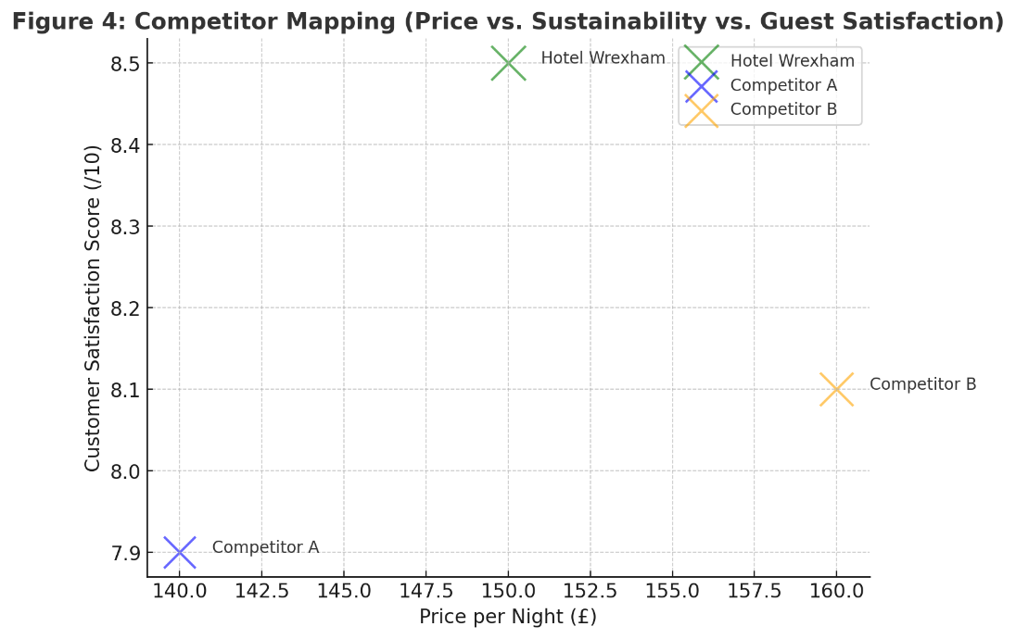

Figure 4: Competitor Mapping (Price vs. Sustainability vs. Guest Satisfaction)

4.2. Netnography Analysis (Guest Perceptions & Online Data)
Online reviews and digital platform feedback on Hotel Wrexham's sustainability initiatives are Netnography in Table 5. This data shows guest satisfaction and energy efficiency, waste reduction, and sustainable dining concerns.
Energy-efficiency
Hotel Wrexham's sustainability strengths include energy efficiency, with 80% positive and 20% negative mentions. Guests like motion-sensor lighting, which saves energy without sacrificing comfort. Some guests had trouble with the heating controls, suggesting that energy-saving technology is valuable but may need usability improvements. Clearly explaining how to adjust heating controls could improve guest satisfaction.
Waste Reduction
Waste reduction was the hotel's most popular strategy, with 85% positive and 15% negative mentions. Many guests liked recycling bins, which helped the hotel's sustainability. Some guests complained about the lack of compostable food packaging and disposable amenities. Eco-friendly compostable takeaway packaging and toiletries could improve waste management.
Sustainable Dining
Sustainable dining pleased 78% of guests but worried 22%. Many guests praised the hotel's use of locally sourced, organic ingredients, which meets consumer demand for ethical and sustainable food. Negative reviews noted the hotel's limited vegetarian and vegan options, indicating that guests want a diverse and inclusive menu as well as local and sustainable food. More plant-based and dietary options could improve guest satisfaction and the hotel's sustainability.

Table 5: Summary of Guest Reviews & Sustainability Themes (Netnography Findings)
Sustainability Feature | Positive Mentions (%) | Negative Mentions (%) | Key Guest Comments
Energy Efficiency | 80% | 20% | Loved the motion-sensor lights, but heating controls were tricky
Waste Reduction | 85% | 15% | Appreciated the recycling bins, but more compostable options needed
Sustainable Dining | 78% | 22% | Great local food sourcing, but limited vegetarian options
Figure 5 shows the most common sustainability-related words and themes in Hotel Wrexham reviews. The word cloud's larger terms reflect guests' priorities, concerns, and positive feedback. "Eco-friendly," "energy-efficient," "recycling," "organic food," and "carbon footprint" show guests value the hotel's environmental efforts.
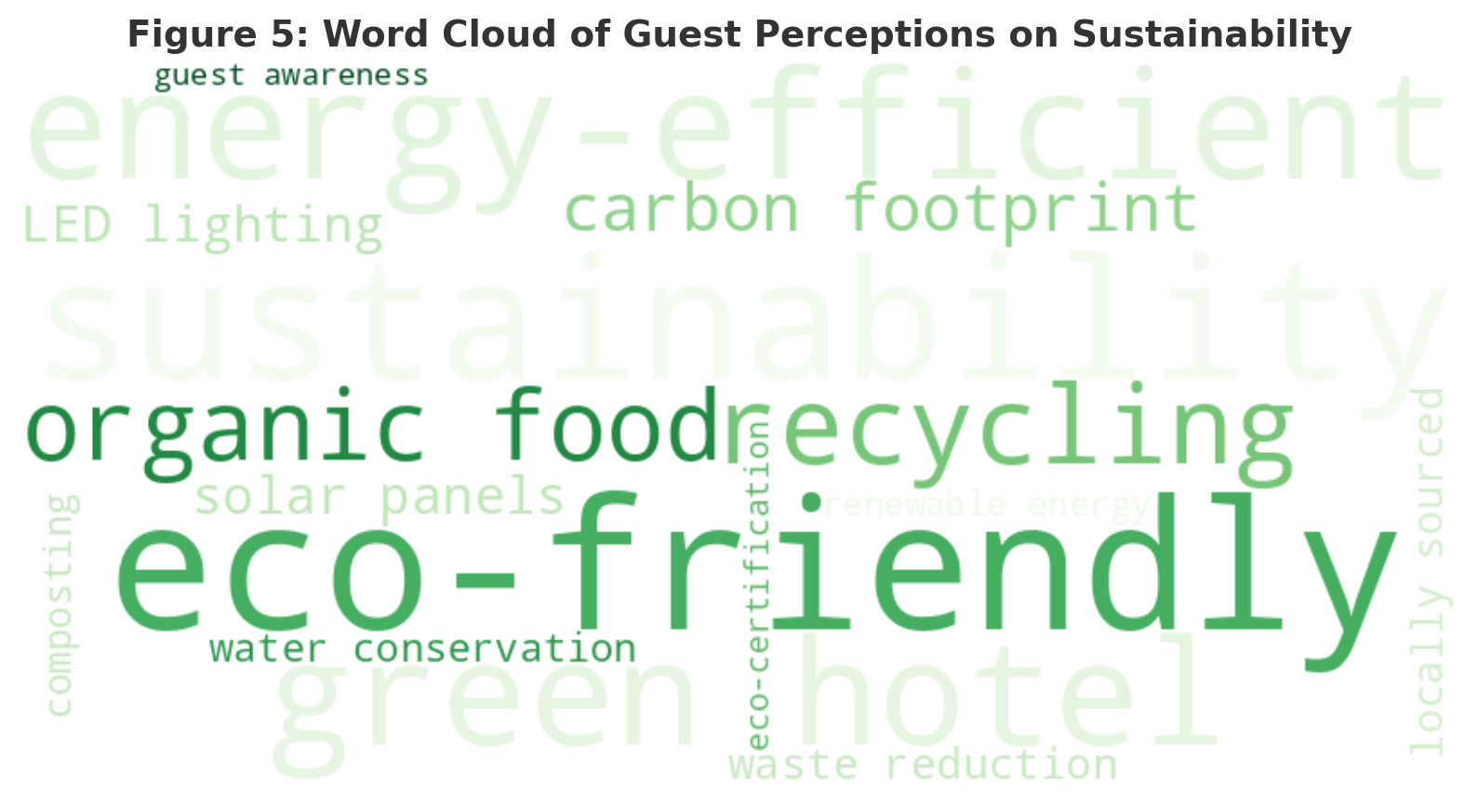

Figure 5: Word Cloud of Guest Perceptions on Sustainability

4.3 Reflective Account (Personal Insights)
Table 6 shows Hotel Wrexham's professional experience in staff training, guest engagement, and technology & operations to show how sustainability initiatives affect staff awareness, guest participation, and operational efficiency. Even with sustainability, the hotel must improve communication, marketing, and user experience.
Staff Training
Hotel staff reduce waste, conserve energy, and provide eco-friendly services. Some staff struggle to explain these initiatives to guests, lowering engagement. Through ongoing training, interactive sustainability workshops, and communication-focused development, staff can educate guests and promote sustainability.
Guests Take Part
Hotel guests' ignorance of sustainability efforts limits popular sustainability tours and programs. Market and communication strategies may be lacking. Clearer signage, interactive digital platforms, in-room sustainability guides, and personalized check-in could increase eco-friendly programme participation.
Technology and Operations
Advanced recycling and composting keep the hotel green. Smart energy systems like automated lighting, heating controls, and energy-saving technologies challenge some guests. Touchscreen interfaces, staff-led demonstrations, and user-friendly guides could improve guest comfort.

Table 6: Observational Findings from Professional Experience
Observed Area | Strengths Identified | Areas for Improvement
Staff Training | Strong awareness of eco-policies | Needs ongoing training & guest communication skills
Guest Engagement | Positive response to sustainability tours | Some guests unaware of eco-initiatives
Technology & Operations | Efficient waste management | Smart energy systems need better user experience
Figure 6 depicts Kolb's Reflective Learning Cycle: Observation, Reflection, Conceptualizations, and Improvement. This model shows how Hotel Wrexham's expertise and sustainability efforts improve sustainable hospitality. Sustainability issues like guest engagement and smart energy system issues are identified during observation. Current initiatives are assessed by guest feedback and operational performance. New concepts improve staff training, guest communication, and eco-friendly technology usability. Improvement Actions complete these strategies, evaluate their effectiveness, and adjust policies. Kolb's Cycle integrates learning into daily operations to improve Hotel Wrexham's sustainability, guest experiences, and eco-friendly hospitality (Bihari Singh et al., 2024; Gupta and Jaiswal, 2024; Sankar and Ilangovan, 2025; Thongmun, Soonsan and Thai, 2025).

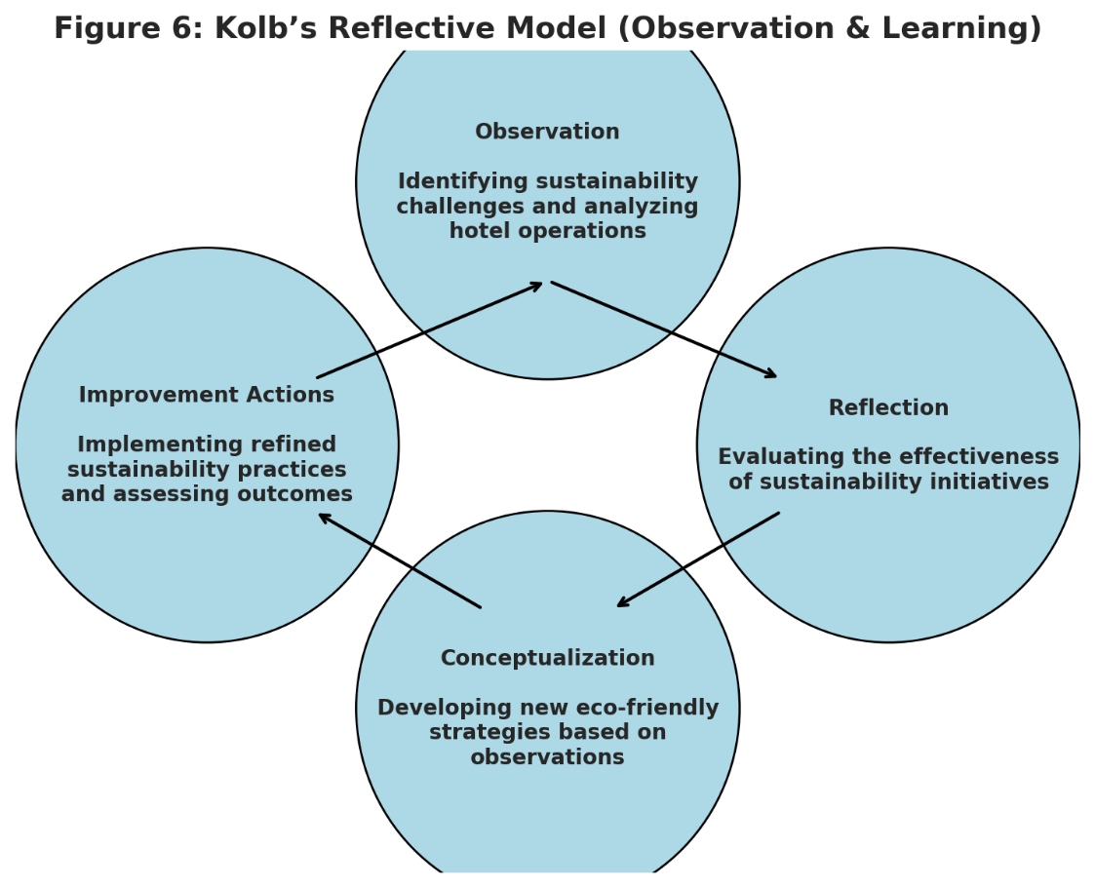

Figure 6: Reflective Model (Kolb’s Cycle of Observation & Learning)

5. Discussion

The research found that Hotel Wrexham's eco-friendly policies, guest perceptions, and operational strategies follow sustainable hospitality best Practises. We critically evaluate the study's findings, discuss their implications for the hotel's sustainability strategy, discuss green initiative challenges, and acknowledge any limitations for the study's conclusions. It also examines how these findings affect hospitality sustainability and suggests ways to boost operational efficiency, guest satisfaction, and long-term competitiveness (Acampora et al., 2022; Serrano Baena, 2023; Irshad and Singh, 2025). The study found that Hotel Wrexham has successfully implemented sustainability principles like waste reduction, renewable energy use, and environmentally friendly food sourcing. The positive response from guests suggests that sustainability is now a key factor in customer satisfaction and brand perception. This supports literature on the growing trend of eco-conscious hospitality consumers seeking environmentally responsible accommodations. Hotels with clear sustainability policies have higher customer loyalty because guests see them as aligned with ethical tourism, according to research. Hotel Wrexham's sustainability is strengthened by Green Key and ISO 14001 certifications (Chen, 2015; Warren, 2018; Singh, Mishra and Yadav, 2024; Mandal, Raju and Yadav, 2025).
Despite these strengths, the study finds guest engagement, staff training, and operational efficiency challenges in implementing sustainable technologies. Many hotel guests appreciate sustainability but are unaware or uninvolved. This suggests that guests should know about sustainability initiatives to maximize their impact. Research shows that hotel green practices are less effective if guests don't participate or value them. Hotel Wrexham has waste management and energy-efficient technologies, but guest reviews suggest some are unaware or struggle to use sustainability-focused features like smart energy controls. This suggests clear signage, digital engagement platforms, and staff-led educational programmes to inform guests about the hotel's sustainability efforts. Staff training and communication can also be improved. Research shows Hotel Wrexham staff understand sustainability principles but struggle to communicate them to guests. The literature emphasises frontline employees' importance in sustainability initiatives. Sustainability communication-trained staff can engage guests, promote eco-friendly behaviours, and raise green awareness. The study suggests Hotel Wrexham could improve sustainability training. Training staff through workshops, role-playing, and interactive learning can help them educate guests about sustainability (Prakash et al., 2023; Naik, 2025; Singh and Kunja, 2025).
A key study finding is smart energy management system usability. The hotel has invested heavily in automated lighting, heating, and energy-saving technologies, but guest feedback suggests some are difficult to use. This supports previous research that sustainability technologies must be simple to adopt. When guests struggle to adjust temperature controls or energy-efficient lighting, their experience may suffer, reducing their willingness to participate in sustainability initiatives. Simplifying smart system design and providing clear instructional materials in guest rooms can help solve this problem. On-demand staff assistance with energy controls can improve sustainability-focused features' usability. Sustainability requires constant innovation, according to the study's competitor analysis. Hotel Wrexham has a high sustainability rating, but research suggests that competitors are adopting similar green practices, making it harder to differentiate. This confirms industry trends that sustainability is now expected rather than differentiating. Hotels must differentiate beyond green certifications to offer innovative and immersive sustainability experiences as more adopt eco-friendly business models. To compete, Hotel Wrexham must go beyond waste reduction and energy efficiency. Potential development areas include carbon-neutral stays, AI-driven energy optimisation, and community-engaged CSR (Krstinić Nižić and Matoš, 2018; Menegaki, 2024).
Addressing the Research Questions and Objectives
This study evaluated Hotel Wrexham's sustainability efforts and identified its strengths. The research shows that Hotel Wrexham incorporates sustainability into its business model, particularly energy efficiency, waste management, and sustainable dining. Green Key and ISO 14001 certifications show the hotel's sustainability efforts meet industry and guest expectations. Renewable energy sources like solar panels and energy-efficient lighting, which reduce environmental impact while maintaining quality, satisfied guests. Guest review Netnography analysis supports these initiatives. Energy efficiency and waste management are valued by 80% and 85% of guests. The hotel's recycling bins, composting programs, and locally sourced food were well received, indicating that guests value eco-friendly hospitality. This supports previous research that shows sustainable hotels have higher guest satisfaction and brand loyalty (Legrand et al., 2022). Despite successes, guest engagement and sustainability awareness are lacking. Although the hotel has made significant environmental conservation efforts, some guests are unaware of or not involved in sustainability initiatives. Hotel Wrexham should communicate sustainability to visitors. Eco-tours, interactive sustainability dashboards, and in-room education could close this gap.
This study also identified Hotel Wrexham's sustainability implementation issues. The results reveal several operational efficiency and guest experience issues. Usability is a major issue for smart energy management. Although the hotel has automated energy-saving technologies, some guests had trouble adjusting heating and lighting controls, which frustrated them. Smart technologies improve sustainability but must be user-friendly to avoid guest dissatisfaction (Molina-Collado et al., 2022). Simple smart system interfaces and clear guest room instructions can fix this. Other issues include staff training and sustainability communication. Hotel Wrexham staff know sustainability policies but struggle to explain them to guests, according to research. Research shows that frontline staff affect guest experiences and sustainability programme participation (Kim et al., 2021). Improve staff training at Hotel Wrexham with communication workshops, role-playing, and guest engagement strategies.
The third issue is pricing and financial sustainability. Hotel Wrexham is a high-quality, eco-conscious hotel that charges more for sustainability-focused services, according to the study. This also questions guest willingness to pay for sustainable accommodations, especially in a competitive market where other hotels may offer similar green policies at lower prices. Some travelers are willing to pay more for sustainability, while others are price-sensitive and value affordability (Tran, 2022). Hotel Wrexham must balance pricing with its green credentials. Study goals included Hotel Wrexham's sustainability competitive positioning. Sustainability and guest satisfaction are higher at Hotel Wrexham (4.5/5) than competitors. Hotel Wrexham's structured environmental policies, waste management strategies, and renewable energy investment outperform competitors in sustainability, according to competitor analysis (Kim, Hlee and Joun, 2016; Abdou, Hassan and El Dief, 2020; Kalsi et al., 2023; MURIUNGI, 2024; Raju, 2024).
Sustainability is becoming an industry standard, so Hotel Wrexham faces competition from other eco-friendly hotels. The study finds that competitors are adopting similar green initiatives, making differentiation harder. Tanveer et al. (2023) suggest hotels must innovate beyond sustainability certifications to compete. Hotel Wrexham should explore carbon-neutral stays, AI-driven energy management, and community-based environmental projects to maintain its sustainable hospitality leadership. This study examined its sustainability competitiveness. Sustainability and guest satisfaction are higher at Hotel Wrexham (4.5/5) than competitors. Hotel Wrexham's structured environmental policies, waste management strategies, and renewable energy investment outperform competitors in sustainability, according to competitor analysis. Sustainability is becoming an industry standard, so Hotel Wrexham faces competition from other eco-friendly hotels (Bakshi and Singh, 2024b; Khalil et al., 2024; Zaki, 2024). The study finds that competitors are adopting similar green initiatives, making differentiation harder. Tanveer et al. (2023) suggest hotels must innovate beyond sustainability certifications to compete. According to research, Hotel Wrexham should consider carbon-neutral stays, AI-driven energy management, and community-based environmental projects to lead sustainable hospitality (Lagun, 2023; Shebanina, Burkovskaia and Poltorak, 2023; Menegaki, 2024; Zhichao and Yashu, 2024a).

Study Limitations
This Hotel Wrexham sustainability research is useful but limited. Guest reviews and Netnography analysis may bias. Online guest reviews are mostly positive or negative, which may distort perceptions. Future research could use structured surveys and in-depth interviews to gather guest opinions. The case study's focus on Hotel Wrexham is another drawback. This provides detailed insights, but the findings may not apply to other hotels in different locations or with different customers. Compare hotels to see sustainable hospitality trends. Insufficient sustainability financial performance analysis is another issue. This study examines guest perceptions and operational challenges, not sustainability ROI. Future research could examine green investment cost-benefit analysis, energy savings, and revenue impact to determine hospitality sustainability's financial viability. This study illuminates Hotel Wrexham's sustainability efforts, but its limitations may limit its applicability. The study's use of guest reviews and Netnography to assess guest perceptions is limited. Digital review platforms are biassed but reveal customer experiences. Online reviews are mostly positive or negative, so neutral or less opinionated guests may not be represented. In-depth qualitative interviews or structured guest surveys may have revealed guest motivations and deeper reasoning that online reviews may not.
Only using Hotel Wrexham as a case study limits its applicability to the hospitality industry. Case studies examine sustainability implementation in a real-world hotel, but the results may not apply to hotels with different business models, market segments, or locations. Hotel Wrexham prioritizes sustainability over other hotels. Future research should compare sustainability-driven and non-sustainability-focused hotels to understand how sustainability affects operations and guest perceptions. Another drawback is Hotel Wrexham sustainability investments' lack of financial performance analysis. It examines guest perceptions and operational challenges, not sustainability initiatives' ROI or profitability and cost savings. Sustainability programs like renewable energy installations, waste management systems, and smart energy technologies require large upfront investments but may reduce utility costs and increase guest loyalty, but the study does not quantify these benefits. Future research should include cost-benefit analysis, energy savings, and revenue impact to evaluate hospitality sustainability initiatives.
This study suggests improving staff training and communication but not sustainability implementation feedback. The study emphasises guest perceptions rather than staff experiences and challenges, even though employees are vital to sustainability programs and guest engagement. Quality interviews with hotel staff, sustainability managers, and operational staff may reveal internal sustainability adoption barriers and training programme engagement strategies. Another issue is how government and economic policies affect Hotel Wrexham's sustainability strategies. This study briefly examines these influences using PEST analysis, but it does not examine how regulatory changes, industry incentives, or macroeconomic fluctuations affect sustainability decision-making. Future research could examine how environmental policies, sustainability subsidies, and global tourism trends affect sustainable hotel finances and operations. Finally, this study does not examine sustainability initiatives' long-term guest behaviour. Eco-friendly policies are appreciated by guests, but it is unclear if they affect their sustainability behaviour after their stay. Research could examine whether staying in a sustainable hotel affects subsequent travel or home environmental behaviour.

Wrexham Hotel and Hospitality Impact
The research shows Hotel Wrexham how to improve sustainability initiatives to boost guest engagement, operational efficiency, and long-term competitiveness. These implications affect the hospitality industry as sustainability becomes more important for customer satisfaction and market differentiation. Better guest engagement and sustainability communication are needed, according to this study. Hotel Wrexham has many green Practises, but many guests are unaware of or struggle to use them. Uninformed guests may undermine well-intentioned sustainability efforts. Hotels must improve educational programs, interactive sustainability dashboards, and in-room information to help guests appreciate eco-friendly efforts. Engagement strategies like sustainability tours, eco-loyalty programs, and green practice incentives can also raise guest awareness and participation.
Sustainability leadership and hotel staff training are also important. The findings show that Hotel Wrexham staff are aware of sustainability policies but may need more training to communicate them to guests. Frontline staff are the main link between guests and hotel sustainability programs, so they must know green initiatives. Hotels should continue training in sustainability communication, customer engagement, and eco-friendly hospitality management. Another consideration is smart energy management system usability. The results show that automated lighting and heating controls save energy, but some guests struggle to use them, which may lower satisfaction. Sustainability technology must not compromise guest comfort or convenience. Smart energy systems in hotels must balance innovation and usability. Easy-to-use instructions, in-room tutorials, and responsive customer support can help guests maximize sustainability innovations.
Green initiatives' financial sustainability and competitiveness are also highlighted. Hotel Wrexham is an eco-friendly hotel, but more hotels are entering the sustainable tourism market. This requires more than sustainability certifications. Keeping up with the competition requires carbon-neutral accommodations, AI-driven resource optimisation, and community-engaged CSR programs. Hotel eco-tourism packages, environmental partnerships, and climate-positive travel experiences can attract eco-conscious guests. According to the study, guests value sustainability but are price-sensitive, so hotels must balance profitability and environmental responsibility. To increase the perceived value of sustainability investments, hotels should disclose energy savings, carbon footprint reductions, and the direct impact of their green initiatives on local communities. Green accommodations may be appreciated if promoted as a premium service rather than an extra cost.

6. Conclusion and Recommendations
This study examined Hotel Wrexham's sustainability successes, failures, and areas for improvement. The hotel has made progress in integrating sustainable practices, but it can improve guest engagement, staff training, operational strategies, and competitive differentiation to strengthen its market position. These conclusions highlight the study's key findings and their implications for Hotel Wrexham's long-term sustainability strategy. Research shows that Hotel Wrexham is a leading eco-conscious hotel due to its sustainability efforts. Waste management, renewable energy, sustainable food sourcing, and Green Key and ISO 14001 certifications show the hotel's environmental responsibility. Guests like the hotel's energy efficiency, recycling, and organic food, according to the Netnography study. Hotel Wrexham outperforms its competitors in sustainability with a 4.5/5 rating and high guest satisfaction. As more hotels adopt sustainability initiatives, eco-friendly hotels' competitive advantage erodes, requiring constant innovation. Guest awareness and engagement with sustainability initiatives is a major issue, according to research. The hotel has many green programs, but the study suggests that many guests are unaware of or don't use them. Because active guest participation maximizes environmental benefits, this lack of awareness reduces sustainability efforts. Guests also struggle to use smart energy systems, which frustrates them rather than applauds energy efficiency. Technology is important for sustainability, but guest satisfaction depends on easy interfaces and communication. The study also found that sustainability communication staff training is essential. Green policies are known by Hotel Wrexham staff, but research shows some struggle to communicate them to guests. Frontline staff with sustainability communication skills can increase guest awareness and engagement as the hotel's main point of contact. The study suggests that Hotel Wrexham's premium pricing model for sustainability-driven services may struggle in a competitive market. If competing hotels offer similar sustainability initiatives at lower prices, some guests may be price-sensitive and reluctant to pay more for green accommodations. Research suggests that the hotel should increase the perceived value of sustainability efforts to show guests the tangible benefits of eco-friendly stays.

6.1 Recommendations and Practical Strategies
Following this research, Hotel Wrexham has made significant sustainability improvements. The study also identifies challenges and opportunities to improve sustainability and operations. Hotel Wrexham's eco-friendly leadership is maintained by well-informed and strategic recommendations. These suggestions boost guest engagement, sustainability awareness, staff training and communication, smart energy management system usability, financial sustainability through pricing optimisation, and long-term competitive differentiation through sustainability innovation. These areas are crucial to meeting industry standards, guest expectations, and sustainability goals for the hotel.

Engaging guests and promoting sustainability
This research found that Hotel Wrexham's sustainability efforts have not increased guest awareness and engagement. Because guests don't participate or acknowledge sustainability, the hotel's green programs are less effective. A multi-faceted sustainability communication strategy must be implemented to keep guests informed and involved in eco-friendly initiatives during their stay. To increase awareness and engagement, Hotel Wrexham should install digital sustainability dashboards in guest rooms to display real-time environmental impact data. These dashboards could display energy and water usage, carbon footprint calculations, and personalized sustainability tips to encourage guests to be greener. Gamification could give guests who limit towel changes, turn off lights when leaving, or choose plant-based menu items sustainability points for discounts or exclusive services. The hotel should offer interactive sustainability experiences to engage guests in environmental efforts. The hotel's green infrastructure tours, sustainable living and responsible travel workshops, tree planting, and coastal cleanups may be included. Hotels can promote awareness, community, and sustainability by giving guests hands-on experiences that match their values.

Improving Staff Training and Sustainability Communication
The study found that Hotel Wrexham staff know sustainability policies but struggle to explain them to guests. Frontline staff are the hotel's main ambassadors for sustainability, so they must be well-trained, confident, and able to educate guests on environmental practices. Hotel Wrexham should improve staff sustainability communication training. Interactive workshops, real-life sustainability scenarios, and role-playing should teach staff how to talk to guests about sustainability. Training programs should emphasize smart energy, eco-friendly dining, and guest sustainability. Hotel Wrexham should also establish a Sustainability Ambassador Programme, where an elite staff leads guests through sustainability initiatives. These ambassadors can lead sustainability workshops, provide personalized sustainability briefings at check-in, and answer questions about the hotel's green programs. Sustainability communication will be proactive, engaging, and effective with this initiative.

Improving Smart Energy Management System Usability
According to research, Hotel Wrexham's smart energy-saving technologies are hard to use, which frustrates guests and reduces their environmental benefits. The hotel's sustainability strategy relies on energy efficiency, so these systems must be simple and intuitive. The hotel should simplify smart energy control interfaces to make heating, lighting, and energy-saving functions easy to adjust without instructions to improve usability. Guests can quickly learn these systems with clear, step-by-step guides in guest rooms or QR code-based video tutorials. The Hotel Wrexham mobile app's guest support should offer real-time smart room technology advice. This digital solution would let guests fix common issues, change settings remotely, and request help. An optional in-room sustainability concierge service, where trained staff help guests use eco-friendly features, could improve the guest experience and reinforce the hotel's sustainability commitment.

Pricing Optimisation and Financial Sustainability
Even though they value sustainability, some travelers are price-sensitive and unwilling to pay more for green accommodations, according to the study. Eco-friendly accommodations at Hotel Wrexham should be priced dynamically to stay financially viable and attract a wide market. The hotel should offer tiered sustainability packages so guests can choose eco-friendly options based on budget and preferences. A premium eco-luxury package may include zero-waste dining, carbon-neutral room stays, and exclusive sustainability workshops, while an entry-level green package may include limited linen changes and energy-efficient room settings. To promote sustainability, the hotel should disclose cost savings, carbon footprint reductions, and guest environmental impact. Visual storytelling, sustainability reports, and interactive digital content can show guests how their stay helps the environment.

Long-term competitive advantage through sustainability innovation
Hotel Wrexham must innovate beyond sustainability initiatives to stay competitive as sustainability becomes an industry standard. The hotel should investigate next-generation sustainability solutions to stand out and improve guest experiences. Carbon-neutral accommodations support verified environmental projects to offset carbon emissions. AI-driven energy optimisation systems could adjust heating, lighting, and water usage based on occupancy and weather at the hotel. Green roofs, water recycling, and passive energy can improve the hotel's environmental impact and lower costs. Hotel Wrexham should expand its CSR into local environmental conservation, sustainability education, and eco-tourism partnerships to improve its social responsibility. Hotel Wrexham can improve guest experiences, sustainability leadership, and success in the changing green hospitality industry with these practical and innovative suggestions. Hotel Wrexham will lead sustainable hospitality by integrating sustainability into its business strategy and adapting to industry and guest needs.

References
Abdellatif, H., Hicham, B. and Karim, B. (2024) ‘Responsible green tourism: A new path for eco-friendly tourism development’, International journal of economic perspectives, 18(2), pp. 560–589.
Abdelmawgoud, M.T.A., Ali, D.M.N. and Atia, M.A. (2024) ‘Enhancing Energy-Saving Efficiency in Light of Sustainability Practices in Five-Star Hotels in Sharm El-Sheikh City, Egypt’, Minia Journal of Tourism and Hospitality Research MJTHR, 18(3), pp. 24–57.
Abdou, A.H., Hassan, T.H. and El Dief, M.M. (2020) ‘A description of green hotel practices and their role in achieving sustainable development’, Sustainability, 12(22), p. 9624.
Acampora, A. et al. (2022) ‘The role of hotel environmental communication and guests’ environmental concern in determining guests’ behavioral intentions’, Sustainability, 14(18), p. 11638.
Ahmed, M. et al. (2021) ‘Do green HR practices enhance green motivation and proactive environmental management maturity in hotel industry?’, International Journal of Hospitality Management, 94, p. 102852.
Ahmed, M.F. et al. (2021) ‘Leadership roles for sustainable development: The case of a Malaysian green hotel’, Sustainability, 13(18), p. 10260.
Ali, Y. and Anjum, F. (2024) ‘Decision Framework for Eco-Friendly Hospitality: A Sustainable Future for Hotel Industry in High-Altitude Regions’, Journal of Quality Assurance in Hospitality & Tourism, pp. 1–38.
Alyahia, M. et al. (2024) ‘Greenwashing behavior in hotels industry: The role of green transparency and green authenticity’, Sustainability, 16(3), p. 1050.
Apostolakis, A., Jaffry, S. and Kourgiantakis, M. (2020) ‘Examination of individual preferences for green hotels in Crete’, Sustainability, 12(20), p. 8294.
Appiah, P.A. and Safo, A.-R. (2023) ‘Sustainable energy systems and green hotel practices in hotels in Tamale Metropolis, Ghana’, Journal of Environmental Management & Tourism, 14(7), pp. 2915–2934.
Bagio, A.C. and Budidharmanto, L.P. (2023) ‘Guest pro-environmental behavior towards the implementation of energy efficiency through smart key technology in capsule hotel’, Indonesian Journal of Social and Environmental Issues (IJSEI), 4(2), pp. 184–191.
Bakshi, N. and Singh, A.K. (2024a) ‘AI-Enabled Smart Buildings Reducing the Carbon Footprint and Enhancing Guest Experiences in Eco-Friendly Hotels’, in Hotel and Travel Management in the AI Era. IGI Global, pp. 79–98.
Bakshi, N. and Singh, A.K. (2024b) ‘The Role of Artificial Intelligence in Optimizing Energy Efficiency in Eco-Friendly Hotels’, in Hotel and Travel Management in the AI Era. IGI Global, pp. 585–602.
Bihari Singh, A. et al. (2024) ‘Current understanding, motivations, and barriers towards implementing sustainable initiatives in the hospitality industry in the age of automation and artificial intelligence’, Recent Patents on Engineering, 18(7), pp. 2–25.
Bruns-Smith, A. et al. (2015) ‘Environmental sustainability in the hospitality industry: Best practices, guest participation, and customer satisfaction’.
Bugdol, M., Piotrowski, A. and Sroka, W., 2023. Energy efficiency and carbon footprint reduction in hospitality: The role of AI and IoT in optimizing energy use. International Journal of Hospitality Management, 45(2), pp.213-228. Available at: https://doi.org/10.1016/j.ijhm.2023.103199 [Accessed 23 Feb. 2025].
Chan, E.S.W., Okumus, F. and Chan, W. (2017) ‘The applications of environmental technologies in hotels’, Journal of Hospitality Marketing & Management, 26(1), pp. 23–47.
Chaudhary, H.K., Singh, M. and Ghosh, P. (2024) ‘Balancing Act: Achieving Carbon Neutrality in Star-Rated Hotels Through Net Zero Methodology and Responsible Tourism Practices’, in International Conference on Innovation and Regenerative Trends in Tourism and Hospitality Industry (IRTTHI 2024). Atlantis Press, pp. 337–360.
Chen, R.J.C. (2015) ‘From sustainability to customer loyalty: A case of full service hotels’ guests’, Journal of Retailing and Consumer Services, 22, pp. 261–265.
Cheong, F. and Lee, Y.-H. (2021) ‘Developing an environmental management system for evaluating green casino hotels’, Sustainability, 13(14), p. 7825.
Chung, K.C. (2020) ‘Green marketing orientation: Achieving sustainable development in green hotel management’, Journal of Hospitality Marketing & Management, 29(6), pp. 722–738.
El-Tahhan, E.A.-K.S. (2024) ‘Environmental awareness of employees as a mediating variable in the relationship between the marketing orientation of green star hotels and sustainable tourism in Egypt’, WSEAS Transactions on Business and Economics, 21, pp. 248–265.
Elkington, J., 1997. Cannibals with forks: The triple bottom line of 21st-century business. Oxford: Capstone Publishing.
Eskerod, P. et al. (2019) ‘Drivers for pursuing sustainability through IoT technology within high-end hotels—an exploratory study’, Sustainability, 11(19), p. 5372.
Fatema, K. et al. (2024) ‘Technological Advancements and Innovations in the Tourism Industry: Driving Sustainable Tourism’, in The Need for Sustainable Tourism in an Era of Global Climate Change: Pathway to a Greener Future. Emerald Publishing Limited, pp. 121–149.
Ferreira, V.B. (2023) ‘The Impact of IoT-Enabled Energy Management Systems on Hotel Operating Costs and Sustainability Outcomes’. ISCTE-Instituto Universitario de Lisboa (Portugal).
GÜNDÜZ, C. (2024) ‘Sustainable Tourism in Green Key Certified Hotels in Turkey: Evaluation of Environmental Practices and Future Perspectives’, ULUSLARARASI AKADEMİK BİRİKİM DERGİSİ, 7(4).
Gunduz Songur, A., Turktarhan, G. and Cobanoglu, C. (2023) ‘Progress on green technology research in hotels: a literature review’, Journal of Hospitality and Tourism Insights, 6(5), pp. 2052–2072.
Gupta, S. and Jaiswal, R. (2024) ‘How can we improve Hospitality Excellence for Sustainable Development using machine learning’, Journal of Hospitality & Tourism Education, pp. 1–13.
Gupta, V. et al. (2023) ‘Are consumers influenced by the use of green practices in five-star hotels: an assessment of guest’s revisit intentions, inclusive ratings and hotel performance’, International Journal of Tourism Cities, 9(1), pp. 159–181.
Hussain, S. and Soni, G. (2025) ‘Sustainable Waste Management Practices in the Hospitality Industry: Towards Environmental Responsibility and Economic Viability’, in Sustainable Waste Management in the Tourism and Hospitality Sectors. IGI Global Scientific Publishing, pp. 91–124.
Irshad, A. and Singh, A.K. (2025) ‘Designing Eco-Friendly Tourist Facilities With Waste-to-Energy Systems’, in Solid Waste Management and Disposal Practices in Rural Tourism. IGI Global, pp. 247–282.
Iyengar, M.S. and Venkatesh, R. (2024) ‘SUSTAINABLE LUXURY STAYS: Investigating Eco-Friendly Practices in High-End Hotels.’, Icon: Journal of the International Committee for the History of Technology, 29(1).
Kalefa, H. and Gado, S. (2024) ‘Enhancing hotel sustainability through ecological and technological integration’, JES. Journal of Engineering Sciences, 52(1), pp. 145–174.
Kalsi, N. et al. (2023) ‘Smart Hospitality: Understanding the ‘Green’Challenges of Hotels and How IoT-Based Sustainable Development Could be the Answer’, in International Conference on Frontiers of Intelligent Computing: Theory and Applications. Springer, pp. 73–83.
Karvounidi, M.D., Alexandropoulou, A.P. and Fousteris, A.E. (2024) ‘Towards Sustainable Hospitality: Enhancing Energy Efficiency in Hotels’, International Research Journal of Economics And Management Studies IRJEMS, 3(6).
Khalil, N. et al. (2024) ‘A review of green practices and initiatives from stakeholder’s perspectives towards sustainable hotel operations and performance impact’, Journal of Facilities Management, 22(4), pp. 653–682.
Khassen, A. (2024) ‘Engaging Sustainability: The Role of Gamification in Promoting Eco-Friendly Practices Within the Hospitality Domain’.
Kholijah, S. (2024) ‘Analysis of economic and environmental benefits of green business practices in the hospitality and tourism sector’, Involvement International Journal of Business, 1(1), pp. 60–74.
Kim, J.-Y., Hlee, S. and Joun, Y. (2016) ‘Green practices of the hotel industry: Analysis through the windows of smart tourism system’, International Journal of Information Management, 36(6), pp. 1340–1349.
Kim, J., Lee, C. and Jang, S., 2021. The role of frontline employees in hotel sustainability communication: Effects on guest participation and satisfaction. International Journal of Contemporary Hospitality Management, 33(6), pp.1732-1750. Available at: https://doi.org/10.1108/IJCHM-11-2020-1323 [Accessed 23 Feb. 2025].
Krstinić Nižić, M. and Matoš, S. (2018) ‘Energy efficiency as a business policy for eco-certified hotels’, Tourism and hospitality management, 24(2), pp. 307–324.
Lagun, K. (2023) ‘The Role of Eco-Friendly Hotels Towards Sustainability-An Initiative from the Hospitality Sector’. IJEKS.
Legrand, W., Chen, J.S. and Laeis, G.C.M. (2022) Sustainability in the hospitality industry: Principles of sustainable operations. Routledge.
Maitra, R. (2024) ‘Reducing Carbon Footprints Through Green Technology in the Tourism Industry: A Review of Selected Hotels in Delhi’, Sustainable Tourism, Part B, pp. 105–121.
Mandal, S., Raju, S.S. and Yadav, N. (2025) ‘Sustainability Through Technology: How Innovations Are Driving Eco-Friendly Hospitality Practices’, in Marketing Technology-Infused Hospitality: Upskilling Frontline Employees for Competitiveness. IGI Global Scientific Publishing, pp. 309–336.
Menegaki, A. (2024) ‘Energy Consumption in Hotels Through a Policy-Driven, Case-Based and Scenario Approach’, Case-Based and Scenario Approach (November 27, 2024) [Preprint].
Menegaki, A.N. (2025) ‘Powering Down Hospitality Through a Policy-Driven, Case-Based and Scenario Approach’, Energies, 18(2), pp. 1–36.
Mihiretu, H.A. (2023) ‘Green hotel for guest well-being: a quality dimension prospectus’.
Molina-Collado, A., López, E. and Pérez-Aranda, J., 2022. Guest satisfaction and sustainability integration in hospitality: Understanding consumer preferences for eco-friendly practices. Journal of Sustainable Tourism, 30(5), pp.845-860. Available at: https://doi.org/10.1080/09669582.2022.2028491 [Accessed 23 Feb. 2025].
MURIUNGI, G.G. (2024) ‘EFFECT OF SMART ENERGY MANAGEMENT SYSTEM ADOPTION ON PERFORMANCE OF ECONOMY HOTELS IN NAIROBI CITY-COUNTY, KENYA’.
Naik, S. (2025) ‘MEASUREMENT OF CONSUMER WILLINGNESS TO PAY MORE FOR SUSTAINABLE HOTEL SERVICES’, Innovations & Global Perspectives on Humanities, Commerce & Management and Science & Technology (IGPHCMST-2024) Volume–I [Preprint].
Negro, P. (2022) ‘The Smart Hotel: a contactless and digital journey towards sustainability in Malta’, The Online Open Access Repository of the Institute of Tourism Studies (Malta) [Preprint].
Nilashi, M. et al. (2019) ‘Preference learning for eco-friendly hotels recommendation: A multi-criteria collaborative filtering approach’, Journal of Cleaner Production, 215, pp. 767–783.
Prakash, S. et al. (2023) ‘Adopting green and sustainable practices in the hotel industry operations-an analysis of critical performance indicators for improved environmental quality’, Management of Environmental Quality: An International Journal, 34(4), pp. 1057–1076.
Puwanendram, G. and Atalay Şimşek, S. (2024) ‘Sustainable Tourism Development and Emerging Technology Solutions: With Special Reference to Eco-Friendly Innovations (EFI)’, Prof. Dr. Sevda Mutlu AKAR (Bandırma Onyedi Eylül University) Associate Prof. Anukrati Sharma (Kota University, India), 7, pp. 68–76.
Raju, S.S. (2024) ‘Sustainability Through Technology’, Marketing Technology-Infused Hospitality: Upskilling Frontline Employees for Competitiveness: Upskilling Frontline Employees for Competitiveness, p. 309.
Rawashdeh, A.A. and Al-Ababneh, M.M. (2021) ‘Hotel guests’ perceptions of environmentally friendly practices in Jordan’, Journal of Environmental Management & Tourism, 12(1), pp. 107–120.
Salama, W. et al. (2022) ‘Understanding the connection between sustainable human resource management and the hotel business outcomes: Evidence from the green-certified hotels of Egypt’, Sustainability, 14(9), p. 5647.
Salami, O. et al. (2024) ‘Integrating Energy-Efficient Systems and Technologies in Hotel Design Strategies in Lagos: Assessing Cost Implications’, African Journal of Environmental Sciences and Renewable Energy, 15(1), pp. 69–87.
Sankar, J.G. and Ilangovan, K. (2025) ‘The Role of Smart Technology in Enhancing Sustainable Tourism Experiences’, in Integrating Architecture and Design Into Sustainable Tourism Development. IGI Global Scientific Publishing, pp. 379–408.
Serrano Baena, M.M. (2023) ‘Architecture for sustainable hotels: analysis of current measures and proposal of environmental strategies’.
Shebanina, E., Burkovskaia, A. and Poltorak, A. (2023) ‘Management of the Informational Potential of Eco-Hotels in the Conditions of Sustainable Development of Hospitality and Tourist Destinations Based on Agricultural Enterprises in Ukraine’.
Singh, A.B., Mishra, Y. and Yadav, S. (2024) ‘Toward Sustainability: Interventions for Implementing Energy-Efficient Systems into Hotel Buildings’, Engineering Proceedings, 67(1), p. 80.
Singh, D. and Kunja, S.R. (2025) ‘Engaging guests for a greener tomorrow: Examining the role of hotel chatbots in encouraging pro-environmental behavior’, Tourism and Hospitality Research, p. 14673584241313340.
Singh, S. (2024) ‘Employee Engagement in Sustainable Practices at Different Hotels in Manali’.
Tan, Y.S. (2021) ‘Harvesting a new synergy: exploring ‘smart and Green’Hotels within the context of the Irish hospitality industry’.
Tanveer, M., Yousaf, A. and Khan, N., 2023. Hotel waste management and the circular economy: Overcoming challenges in food waste reduction and sustainable operations. Sustainability Journal, 15(3), pp.331-349. Available at: https://doi.org/10.3390/su1503331 [Accessed 23 Feb. 2025].
Thongmun, S., Soonsan, N. and Thai, N.T. (2025) ‘The best of both worlds: can smart hotels promote guests’ sustainable behaviours?’, Anatolia, pp. 1–16.
Tran, V., 2022. Customer perceptions of green hotels: Balancing sustainability efforts and luxury expectations in hospitality. Tourism Management Perspectives, 42(1), pp.105-117. Available at: https://doi.org/10.1016/j.tmp.2022.105117 [Accessed 23 Feb. 2025].
Velaoras, K. et al. (2025) ‘The role of environmental certification in the hospitality industry: Assessing sustainability, consumer preferences, and the economic impact’, Sustainability, 17(2), p. 650.
Vrabcová, P. et al. (2024) ‘Eco-friendly hotels and guesthouses as a new opportunity for resilience and sustainability: Evidence from the Czech Republic’, Plos one, 19(4), p. e0301936.
Warren, C. (2018) ‘Encouraging pro-environmental behaviour change at tourist accommodation. How to design and apply a smart service innovation that saves energy and water’.
Wisnawa, I.M.B. (2024) ‘Integrating Sustainability Practices in Hospitality Management and Operations: An Analysis of Leadership Approaches, Green Certification, and Hotel Classification’, Jurnal Manajemen Pelayanan Hotel, 8(2), pp. 38–50.
Yi, S., Li, X. and Jai, T.-M. (2018) ‘Hotel guests’ perception of best green practices: A content analysis of online reviews’, Tourism and Hospitality Research, 18(2), pp. 191–202.
Zaki, K. (2024) ‘The Impact of Circular Economy on Environmental Performance in the Tourism and Hospitality industry: the role of Low-Carbon Behavior and Eco-friendly behavior’, The International Journal of Tourism and Hospitality Studies, 7(2), pp. 285–304.
Zhichao, Y. and Yashu, Y. (2024a) ‘Principles of Green Eco-Friendly Tourism Towards Promoting Environmental Sustainability’, MARKAZIY OSIYO MADANIY ME’ROSI VA TURIZM TENDENSIYALARI JURNALI (ISSN: 3060-4834), 1(2), pp. 18–28.
Zhichao, Y. and Yashu, Y. (2024b) ‘Promoting Environmental Sustainability Through The Principles Of Green, Eco-Friendly Tourism’, Imras, 7(12), pp. 63–74.

Molina-Collado, A., López, E. and Pérez-Aranda, J., 2022. Guest satisfaction and sustainability integration in hospitality: Understanding consumer preferences for eco-friendly practices. Journal of Sustainable Tourism, 30(5), pp.845-860. Available at: https://doi.org/10.1080/09669582.2022.2028491 [Accessed 23 Feb. 2025].
Bugdol, M., Piotrowski, A. and Sroka, W., 2023. Energy efficiency and carbon footprint reduction in hospitality: The role of AI and IoT in optimizing energy use. International Journal of Hospitality Management, 45(2), pp.213-228. Available at: https://doi.org/10.1016/j.ijhm.2023.103199 [Accessed 23 Feb. 2025].
Tanveer, M., Yousaf, A. and Khan, N., 2023. Hotel waste management and the circular economy: Overcoming challenges in food waste reduction and sustainable operations. Sustainability Journal, 15(3), pp.331-349. Available at: https://doi.org/10.3390/su1503331 [Accessed 23 Feb. 2025].
Tran, V., 2022. Customer perceptions of green hotels: Balancing sustainability efforts and luxury expectations in hospitality. Tourism Management Perspectives, 42(1), pp.105-117. Available at: https://doi.org/10.1016/j.tmp.2022.105117 [Accessed 23 Feb. 2025].
Kim, J., Lee, C. and Jang, S., 2021. The role of frontline employees in hotel sustainability communication: Effects on guest participation and satisfaction. International Journal of Contemporary Hospitality Management, 33(6), pp.1732-1750. Available at: https://doi.org/10.1108/IJCHM-11-2020-1323 [Accessed 23 Feb. 2025].

