
APPENDIX GA36c

LEVEL 6 ASSESSMENT SPECIFICATION

Student name: | Georgina Jones | Student ID number: | 1702648
Programme: | Primary
Module: | Principles of Pedagogy
Module code: | M6X01438/C | Contribution to Overall Module Assessment (%): | 100%
Lecturer: | Siân Brooks | Internal Verifier: | Siân Brooks
Assignment Title: | ‘Describe a learning event which has happened during your recent school experience. Reflect upon what took place, connecting events to theories of learning and teaching. Make recommendations about how you could improve your own practice in the light of this. Produce a poster to illustrate how you would develop the elements of an effective learning environment.’ | Word count (or equivalent): | 5,000 or equivalent.
Submission deadline: | 17/10/18 (23.59) | Return date of provisional marks & written feedback: | 14/11/18
Submission method: | All written assessments, where practical and possible, must be submitted via Turnitin unless otherwise instructed by the Lecturer. (Please DO NOT put this assessment specification into Turnitin or it will match many similarities with other students’ submissions.)  Alternative submission method (if applicable):  Late submission of the assessment will result in a late penalty mark. Penalties for late submission: Up to one week late, maximum mark of 40%. Over one week late, 0%. Only the Extenuating Circumstances Panel may approve a change to submission dates.
Academic honesty / referencing: | Academic honesty is required. In the main body of your submission you must give credit to authors on whose research and ideas your work is based. Append to your submission a reference list that indicates the books, articles, etc. that you have used, cited or quoted in order to complete this assessment.

Module Learning Outcomes
(from module syllabus)
1. understand, synthesise and evaluate the main theories that underpinning learning, behaviour and assessment in the primary school
2. reflect critically on how learning theories inform the planning and provision of high quality learning environments, demonstrating a clear understanding of how theory and practice are interrelated
3. organise knowledge and learning through the use of a range of information sources, and present work appropriately.

‘Describe a learning event which has happened during your recent school experience. Reflect upon what took place, connecting events to theories of learning and teaching. Make recommendations about how you could improve your own practice in the light of this. Produce a poster to illustrate how you would develop the elements of an effective learning environment.’

Introduction
In accordance with the BERA (British Educational Research Association) guidelines, I have a responsibility to the: pupils, staff, school and community to provide an unprejudiced, ethically correct and mindful assignment based upon my observations. Following these guidelines, the specific location, school name, teachers’ names and pupils’ names have all been redacted and replaced with a pseudonym. This has been done to protect the identity and provide anonymity. (BERA, 2018) Due to this the following children I observed will be referred to as; child A and child B. Furthermore, I supplied the school with a consent form and received written consent from the headmaster (Figure 1) allowing for the photography or recording of the learning event or anything I deemed important to the assignment. It should be noted that due to ethical concerns, any recording or photo evidence containing a reference to any of the young learners or the school will be blurred or edited to protect their identity.
The significant learning event to which I refer in this essay was observed during a placement I did with a primary school in South Wales. The said school was described in the most recent Estyn report, as having a population of 384 pupils and a 94.6% attendance rate. At 33.6%, the school had an above average take up rate for free school meals and was classed ‘green’ in the support category. (Reference not added as schools identity would be compromised.)

Observation
The learning event I observed took place after lunch within the indoor environment of the classroom. The event emanated from work produced by pupils in a pervious lesson. The teacher began the lesson by wheeling out a whiteboard filled with words and images based on the topic of ‘electricity and it’s uses’, produced by the students in a previous ‘over to you’ session; this is shown in Figure 2. The aim of the activity was to access pervious knowledge of the topic and help them to expand their understanding of electricity and link it to the real world by using the ideas and knowledge from the whiteboard visual aid, group discussions, questioning and real-life applications.
After a brief refresher using the whiteboard the young learners were given the question, “What might you know about the uses of electricity?” They then went into their ‘buzz’ groups. At this point I sat just on the periphery of the groups; this was done so as not to cause a disturbance or make any of the young learners feel too nervous or uncomfortable in the presence of an unknown adult as this could possibly lead to my observation results being detrimentally affected. I focused my attention on one of the groups, observing their conversation and interactions with the teacher and each other. The transcription of my selected learning event is detailed in Figure 3.
I recorded my learning experience using the written observation method. I selected this method as I felt that it would allow me to quickly and more accurately record any observations that might present themselves in the moment. I was careful to ensure the clarity and order of these note would enable me to easily make sense of them and help me to easily reflect accurately on the learning event. As well as the written observation method, I also utilised photographic recording to log my observations as shown in Figure 2. This was a useful method for recording the illustrative work on the whiteboard and also allowed me to easily recall and reflect on key moments during the observation. Despite the advantages of these observation methods, both techniques demonstrated drawbacks. For instance, with the written observation method became a balance between observing the group and writing in my notebook. Writing removed my full focus from the group and may have resulted in me missing key events, whilst observing meant that I had to stop taking notes, hence missing the opportunity to record key events. The written observation method is definitely a skill that requires practice in order to maximise its benefit. The downfalls to photographic recordings were that despite having the consent (Figure 1) of the school, images had to be cropped or blurred to protect the identity of the school and its pupils. While this in itself was not an issue it was time consuming and it affected the quality of the information the photo provided. The act of taking the photos invariably resulted in some of the pupils noticing and taking an interest in being photographed and hence would becoming distracted; this could, if not perused with care, reduce the effectiveness of the learning event.
In hindsight, I would have considered using audio recording as this would have enabled me to capture the detail of all discussions and to replay them to help reflect on the experience with more clarity. (Wilson, 2009) The audio recording method of observation would have complemented the photographic recordings, as the audio recording could be aligned to the photos, matching up what was being said to elements in the photo, such as, facial expressions or body language.
I could have used video recording, as it would have combined the visual benefits of the photographic method and the audio effect of the recording. (Wilson, 2009) However, I decided against this as I realised that combing through all the footage would be very time consuming and that the act of making a video and wielding a camera would have caused disruption in the class and would have resulted in focus being taking away from the learning event and in turn detrimentally affecting my observation results. (Wilson, 2009) In addition to these drawbacks, several of the children in the class were not allowed to be recorded on photo or video, making this recording method more problematic than the other methods.
From all of the observations I made during my placements, I selected one, for this study, that stood out as an excellent example of Constructivism; specifically, social constructivism, Vygotsky’s theory, with links to exploratory talk.
The constructivist theory was originally established by Jean Piaget and was the underpinning influential theory in Lev Vygotsky’s, social constructivism theory, which specifically looked at the importance of social interactions in children’s cognitive development; this contrasted with Jean Piaget’s view that cognitive development was established by the independent learning. From the learning experience I chose, it can be seen how Child A and Child B discuss what their understanding is of the topic, in this case, ‘electricity and its uses’ and build upon it. In the transcript of the converstation between Child A and Child B, detailed in figure 3, Child B show an understanding of some of the real life applications of electricity when stating “like in our bee bots,” although Child B does not seem to quite grasp the full knowledge of other applications of electricity. The new piece of information about batteries and their use in “toys and cars” didn’t fit with child B’s previous knowledge creating confusion. The teacher and Child A help Child B develop their understanding and knowledge by using the white board as a visual aid and through exploratory talk. Child A and the teacher, the more knowledgeable individuals, guide Child B, helping them to create links between the new knowledge and the previous knowledge. This can be seen when Child A explains how, “miss said there were batteries in cars yesterday, remember?” Here Child A challenges Child B’s thinking; this is done via recalling information using short term memory. Child A helps Child B to reconstruct and reapply their concepts, in this case the discovery by Child B that electricity not only makes Bee bots work but that the electricity comes from batteries used to make other toys work (batteries illustrated on white board in figure 2) and that bigger batteries are used to make cars work. The teacher also had a part by initially leading the group with a question: “Who here can tell me anything they might know about electricity?” The teacher then uses questions and prompts like, “how do bee bots work?” and “batteries?” This three part exchange is referred to as an Information, Response and Feedback exchange (IRF), a technique pioneered by Sinclair and Couthald that they believed to be how classroom talk was laid out . This where the teacher initiates conversation using a question that in turn causes a response and this response results in a form of feedback. (Mercer and Hodgkinson, 2008) This kind of exchange is useful for the teacher to gauge the level of understanding from their pupils, without taking over the conversation entirely.

Theory

Jean Piaget, a swiss biologist, developed the theory of cognitive constructivism. His work is considered to be a significant and influential piece of research in the understanding of learning in the classroom. Piaget held the opinion that a child’s age could directly impact on their learning development and that a child should have a complete understanding before moving on to higher development stages. (Edwards and Mercer, 1987) Piaget produced four developmental stages as guild lines; these are referred to as: the sensorimotor stage, the preoperational stage, the concrete operational stage and the formal operational stage. (Hattie, 2012) These stages focus from the sensory stage in young infants to the final stage where complex thought is formed and carried through adulthood. However, these four developmental stages have been heavily critiqued and as many, like, Vygotsky, believed that a child could be balanced on more than one development stage and age should not be factored into the child’s cognitive development.
Piaget believed that learning should not be an entirely teacher led practise, where the pupils are fact fed, but rather it should be an independent process that comes from the active learning of the young learner, in the form of open ended questions and exploration of their environment to allow for internalisation and reconstruction of their previous understanding. (Grigg, 2015)
Piaget’s work on constructivism subsequently influenced Russian psychologist Lev Vygotsky, whom pioneered Social Constructivism. While Vygotsky agreed with several arguments made by Piaget, he strongly held the perspective that children learn and develop their cognitive abilities not by independent learning, as Piaget believed, but through dialogue, language and social interactions. (Russel, 2015) Vygotsky believed that social interactions were the key to understanding language, signs and symbols in early years, via peers or parental guidance. He, unlike Piaget, saw that this early years speech was an attempt at communication made by the child. He determined the term, egocentric speech, first referred to by Piaget as speech spoken aloud by children, not as an attempt to socialise but was more for themselves in that it was actually the child’s attempt at creating inner speech from outer speech. (Fosnot and Perry. 2005) This shows one of Vygotsky’s main concepts of internalisation. Here we see how children go from outer speech, where they constantly vocalise sounds in an attempt to imitate them or vocally communicate, to inner speech. Here we can see the begins of the transition to thought, done without the need to vocalise. This internalisation of speech can now be used by the child and allows for them to problem solve and make sense of the world around them.
Vygotsky saw language as a cultural tool enabling children to produce cognitive development through social interactions, such as, discussions with fellow peers and even teacher initiated talks. (Hattie, 2012) Piaget, on the other hand was against teacher involvement as it was in contradiction of his belief that children are independent individuals and learn by exploring their environment and making their own sense of what they are learning and what applications there could be in the real life world. However, Vygotsky’s theory encourages teacher engagement to further understanding and scaffold learning of their pupils.
Scaffolding was a term used by, American psychologist, Jerome Bruner, who after following Vygotsky’s work used the term to explain the support given to the learner by an adult, such as, a parent or teacher, through means of dialogue and give the support needed to understand more challenging tasks. (Smidt, 2009) The level of involvement by the adult is reduced depending on if the learner’s grasp of the topic becomes more steadfast and requires the scaffolding to be removed accordingly. This fits with Vygotsky’s opinion that the scaffolding being provided helps the learner stretch their knowledge and allows them to understand something that they would have struggled to or never been capable to sufficiently comprehending unaided.(Mercer, 1995)
The opinion of talk in classrooms has changed over time, from being extensively dissuaded to commonly used as a tool in children’s cognitive and social development and understanding. Talk is frequently used in: problem solving, sharing ideas, evaluating and challenging peers hypothesises. There are three types of talk: disputational, cumulative and exploratory. It should be noted that talk does not fall into one category. Disputational talk comprises of the learners forming their own opinion, often creating a challenging and argumentative environment. Cumulative talk invokes a more positive environment where people simply agree with an opinion without challenging or assessing it. Exploratory talk is produced amongst learners who feel comfortable with each other to share concepts and thoughts, that might be wrong or vague, without feeling worried about being judged. A summary of Douglas Barnes and Frankie Todd’s description of exploratory talk, is a combination of hesitation and questions which allow the learners to test ideas, self-reflect on them and see the general consensus of the group. (Barnes and Todd, 1977) Peers are critical but constructive when discussing each other’s ideas; this social technique can be useful between pupils in problem solving and promotes teamwork.(Mercer and Hodgkinson, 2008) The teacher can observe or involve themselves in these talks to check if understanding is happening.
Vygotsky introduced a model that incorporated dialogue, scaffolding and social interactions between individuals to promote understanding. This model is termed as The Zone of Proximal Development (ZPD). The model is made up of a more knowledgeable other, who has full unaided mastery over the topic and a less knowledgeable other, who lacks the knowledge and understanding of the topic. This more knowledgeable other could be an adult or more “capable peer” (Vygotsky, 1978, p86) and provides the scaffolding and social interaction that the less knowledgeable other needs to comprehend and further their understanding. This showed Vygotsky’s understanding of the adult’s role in leading their pupils understanding, using language and social interaction. The ZPD represents three main ideas: What can be done unaided, what they can not do unaided and what with hep from a more knowledgeable other could be attained. (Russel, 2015)
Studying the above theories, I believe that my learning event was best represented by Vygotsky’s theory of Social Constructivism with links tying in exploratory talk and the overall importance of Scaffolding. Looking at my learning event I can see how exploratory talk was present within the group, through a mix of teacher-peer led and peer- peer led talk, which unconsciously resulted in scaffolding being present to provide cognitive support for Child B, from the teacher (The MKO), who guided the conversation onto the topic of batteries, without influencing how Child A and Child B chose to probe into the topic. During the learning event it was observed that peers can also provide scaffolding; this was observed from Child A during the learning event, when they explain to Child B how batteries make cars work and that there are in fact batteries in cars. Child A further guides Child B’s understanding as they begin to comprehend the concept by using the visual aid of the board to explain that “the one on the board is for smaller things.” My learning event displayed the importance of dialogue and social interaction in developing ideas and cognitive abilities, a concept that runs throughout Vygotsky’s theory, unlike Piaget who focused upon the independent learning of the child.
Based upon what I have witnessed and learnt throughout my learning event and subsequent research, I have formed the conclusion that in my own approach to teaching, I shall focus upon stimulating dialogue and social interactions that provided scaffolding, as and when required, to provide guidance and further the understanding of my future classes. I aim to promote stimulating dialogue by using more open ended high level questions that promotes a higher level of thinking through, discussions and speculation. This is argued against by Dillon in 1994, whom proposed these higher level questions would only serve little stimulation to the learners or the teacher and a more effective and stimulating method would be to use a range of techniques that encourage think time, to allow the learners to produce their own questions. (Mercer and Hodgkinson, 2008) For my approach to work it is important that I create an environment that makes the learners feel safe and comfortable to contribute to exploratory talk, giving all the chance to share ideas and opinions without being worried about being judged and potentially allowing a consensus to be reached. (Mercer,1995) To summarise, I will promote learning in the classroom by using aspects of Vygotsky’s theory and push for Social interactions that encourage dialogue and scaffolding.

Poster/Learning Environment

The ideal learning environment should be one of the main areas focused on when planning the development of young learners. It must be able to promote a positive atmosphere, foster engagement and further learning. This section will be focuses upon my ideal learning environment with links made to my poster. (Figure 4)
My ideal learning environment poster (Figure 4) is constructed for a foundation phase class, around year 1 to year 2. My learning environment is a combination of indoor and outdoor learning. I have brought the outdoor environment into my learning environment as it is rich in adventurous experiences, caters to a range of needs and inspires creativity, imagination, physical and social development. (Bilton, 2010) Outdoor learning offers the chance for many children, who due to where they live or their family routine, do not get an opportunity to experience nature. (White, 2014) It’s important to implement the outdoor in education as it provides them with space to take risks, experience nature, make links in their learning to the real world and socialise through means of talk and play. Play is significant to both the indoor and outdoor environment. There is a range in types of play, from active to constructive to make believe. All of these promote stimulation, socialisation, can help with general problem solving and allow for the development of dialogue and fine and gross motor skills. It should be noted that there is no one definition of play. Vygotsky, saw play as a way of socialising and establishing mental pathways allowing for more complex thinking. (Palaiologou, 2010) While Piaget argued that play was nothing more than children at play. (Samuelsson and Carlsson, 2008) It is exceedingly important for teachers to link play into learning environment, indoor and out, as play has the capabilities of creating connections in learning. (Tovey, 2007)
Looking at my poster, in the outdoor environment, I have attempted to engage active learning through play by including areas of outdoor continuous provision. These include, an art corner, the sand and water area and the greenhouse. I added the art corner as art is an extremely useful tool regarding creativity and general wellbeing. It can give children the chance to express themselves and any feelings that they may feel are being pent up. This allows for self-reflection and looking after of their general state of wellbeing. The sand and water play area are have been introduced, specifically outside because it offers space and the chance for messy play. I believe it is important for these natural and versatile materials to be used in the learning environment, as children not only enjoy to play with them, they also get offered a chance to interact and explore the world around them. (white, 2014)
I chose to give my learning environment a green house, where the children could grow their own fruit, vegetables or plants because I think that this will can be encourage healthy eating and tackle issues like obesity. I see the green house being used in a range of ways. I believe that it will encourage children in to taking an interest and wanting to investigate their natural environment. I think by giving children the choice of the food they want to plant and letting them take are of the plants will give them a sense of accomplishment and ownership. They also might be more inclined to try new fruits and vegetables. This idea is supported by Jane white. White, an early education associate and advisors for several landscape and equipment companies, believes that all children have the right to new experiences and outdoor play. She see how the environment meets the multi-sensory needs of children and allows them to gain an understanding of nature and the earth itself. (White, 2014)
Looking at my outdoor and indoor environment in my poster, I have added role play areas. I consider these not only to be sources of play but when planned correctly they can be beneficial to: a child’s wellbeing, language, social and cognitive development. These go from general, shop or doctor areas to specially topic related. I saw amazing examples of this in my observation. For example, one class was studying the Blitz and had created a bunker. The teacher decided to give the bunker a multipurpose however. As well as adding costumes and other essentials, they also filled it with pillows and topic related books. I thought this was an excellent use of the resource. In another class, the children were given the chance when learning about transport to select a vehicle. The class agreed on a bus and the teacher made not only a bus, but a bus station which encourage the use of math when buying tickets and working out on maps how long until they reached their stop. Finally, I witnessed an excellent piece of role play that was produced from a lesson involving a piece of writing , where the pupils had to imagine they were astronauts in space. Despite this only being a way to produce pieces of creative writing, the teacher saw how excited and engaged the children were in the task and decided to replace one of their role play areas with a rocket and a couple of alien and astronaut costumes. This is further supported by Michelle Ceynar Rosel, who sees role play as an outstanding discussion technique used to engage all the participants and can be used to discus light topic like space to more sensitive issues, such as, bullying. (Rosel, 2005)
In my poster I have added, interactive white boards with an ICT corner with computers and iPads. Digital technology and ICT skills have become a major part of todays society, with most of the foundation phase learners being knowledgeable about technology by the time they enter school. This makes having ICT provisions in a classroom not just a want but a necessity. The use of technology, such as, iPad or computers is a statutory requirement and can, when used correctly, be used throughout the curriculum to support a range of subjects. (Simpson and Toyn, 2011) During my observation I witnessed how technology was used throughout the working day by pupils and staff alike. I saw how the staff often captured moments of learning and achievement made by the students using iPads. I saw that the pupils were frequently given the opportunity to use technology and expand their ICT skills, via, answering questions using the interactive whiteboards. I saw at one point during a math lesson how some of the pupils were grouped up and allowed to use the computers to practice number squares and design posters.

Conclusion
To conclude, my learning event presents in line with Les Vygotsky’s theory of Social Constructivism. Highlighting the importance of social interaction and the use of language as a tool in cognitive development. In my learning event, we can see how exploratory talk and scaffolding from peers and adults, play a part in a child’s understanding and development by challenging ideas and resulting in the reconstruction of knowledge.
I also understand now that the learning environment can posse an impact on a child’s development and should be carefully planned to include qualities that promote: wellbeing, creativity, communication and social development. This can be done through well planned: role play areas, outdoor play and learning, ICT skills and types of provision to engage learning in both indoor and outdoor settings.
My learning event and subsequent research, has provided me with a better sense of knowledge and understanding for what I would like to push for in my lessons, in this case, the importance of social interactions and use of exploratory talk to develop knowledge and further understanding. I now have a developed sense of how I would plan my ideal learning environment to engage and develop future young learners.

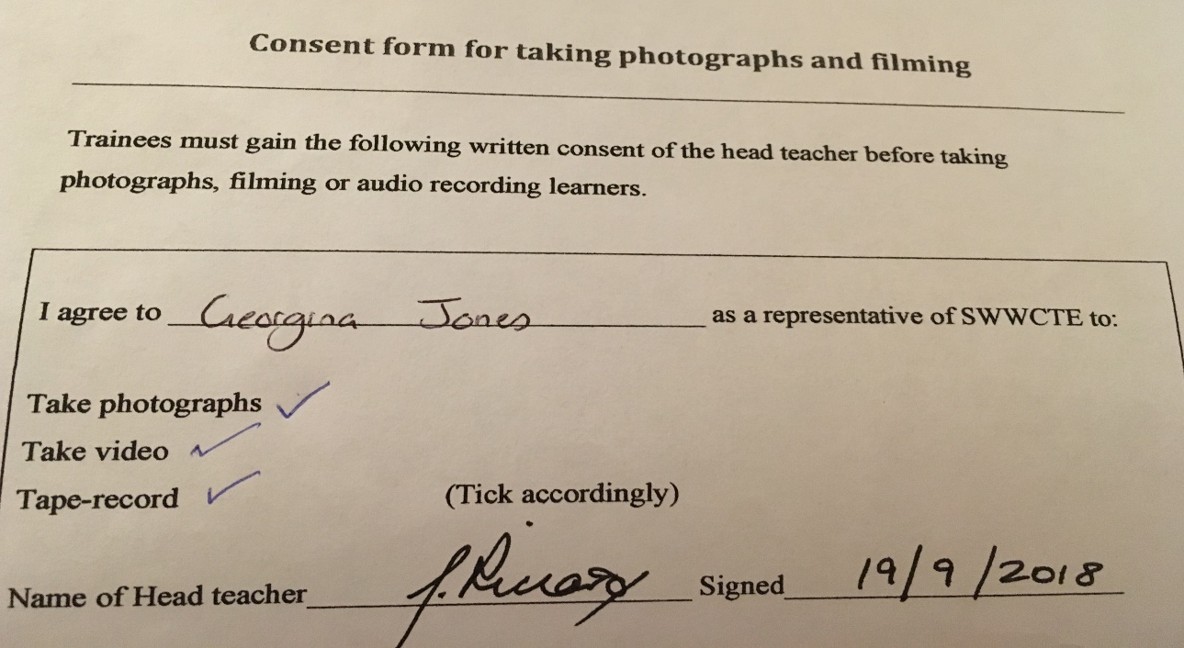
Appendix

Figure 1, shows the consent form signed by the headmaster, giving me permission to take photos and recordings of those allowed in my given class.

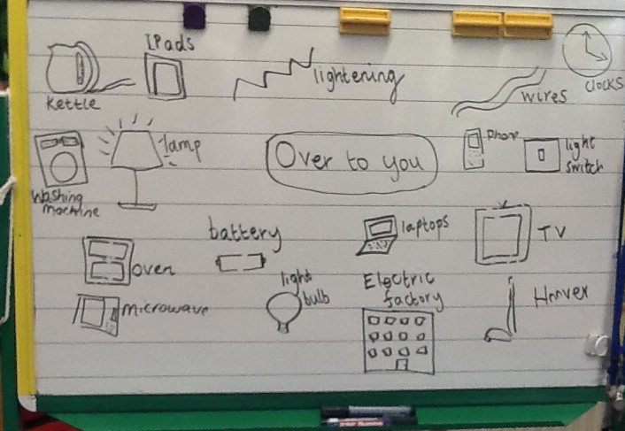
Figure 2 shows an image of the whiteboard from the previous over to you session containing the children’s ideas. This was used to help review the previous lesson.
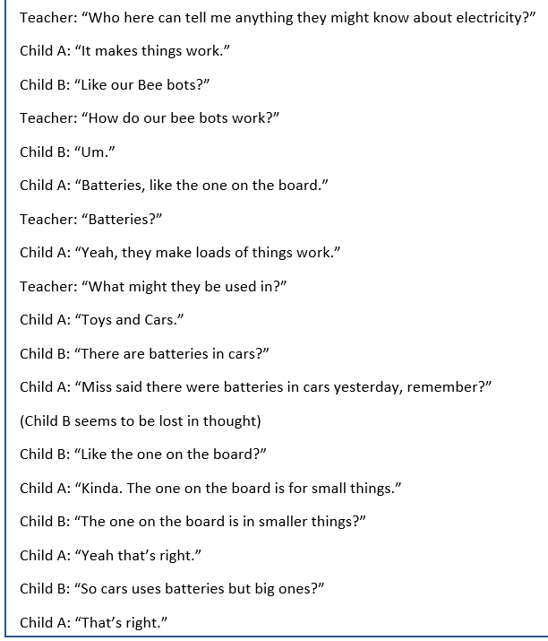

Figure 3 is the transcript of the discussion after the over to you review session. This is where the pupils were placed into small buzz groups to discuss their
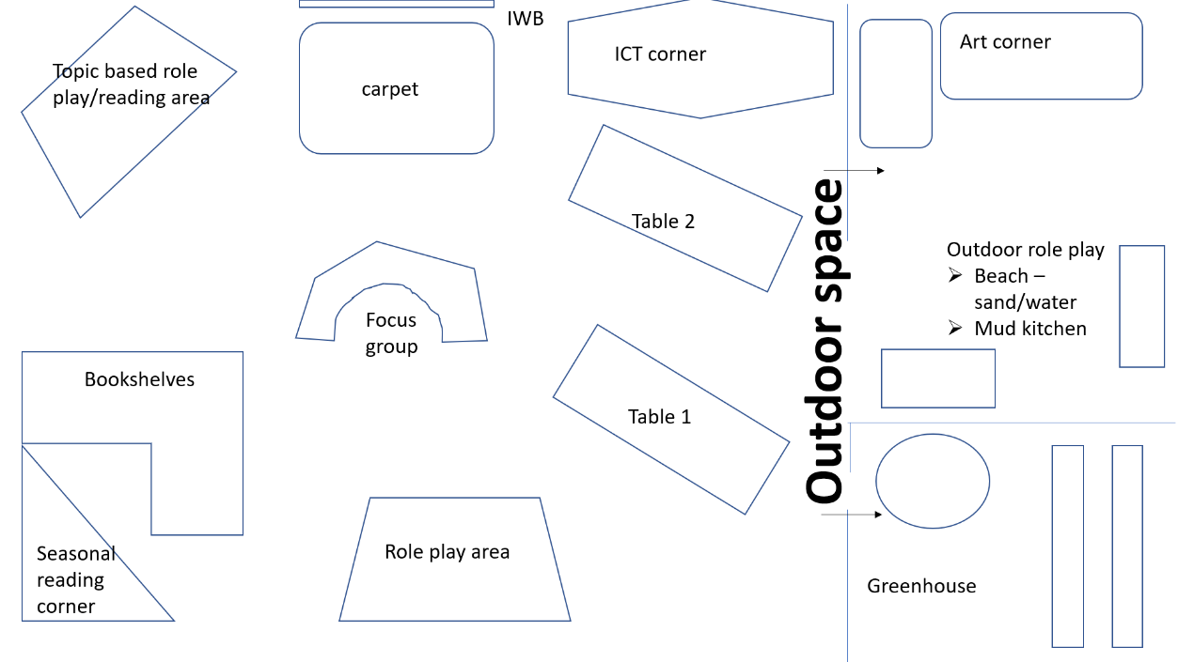
Figure 4 – Poster of my ideal learning environment
Reference

Barnes, D and Todd, F. (1997) Communicating and learning in small groups. Routledge

Bilton, H. (2010) Outdoor learning in the early years. Management and innovation. Third edition. Routledge

British Educational Research Association [BERA] (2018) Ethical Guidelines for Educational Research, fourth edition, London. https://www.bera.ac.uk/researchers-resources/publications/ethicalguidelines-for-educational-research-2018 (Accessed: 2nd October 2018)

Edwards, D. and Mercer, N. (1987) Common knowledge. The development of understanding In the classroom. Methuen & Co

Fosnot, C.T. (2005) Constructivism: Theory, Perspectives and Practice, second edition, Teachers Collage Press
http://faculty.arts.ubc.ca/emeyers/LIBR535/readings/Fosnot&Perry_2005.pdf (Accessed: 9th October 2018)

Grigg, R. (2015) Becoming an outstanding primary school teacher. 2nd edition. Routledge

Hattie, J. (2012) Visible learning for teachers. Routledge

Mercer, N. (1995) The Guided Construction of Knowledge. Talk amongst teachers and learners. The Cromwell Press.

Mercer, N and Hodgkinson, S. (2008) Exploring talk in school. SAGE publications.

Palaiologou, I. (2010) The early years foundation stage. Theory and practice. SAGE publications
Rosel, M.C. (2005) The Pedagogical Value of Experimental Participation Paired With Course Content. Psychology Learning and Teachings. SAGE publication
http://journals.sagepub.com/doi/pdf/10.2304/plat.2004.4.1.55
(Accessed: October 13th 2018)

Samuelsson, I.P and Carlsson, M.A. (2008) The Playing Learning Child: Towards a pedagogy of early childhood. Routledge
https://www.tandfonline.com/doi/pdf/10.1080/00313830802497265?needAccess=true [Accessed: October 12th 2018]

Simpson, D and Toyn, M. (2011) Primary ICT across the curriculum. Learning matters.

Smidt, S. (2009) Introducing Vygotsky. Routledge

Tovey, H. (2007) Playing Outdoors. Spaces and Places, Risk and Challenge. Open university Press

Vygotsky, L. (1978) Mind in society: The development of higher Psychological processes. Harvard University Press

White, J. (2014) Playing and learning outdoors. Second edition. Routledge

Wilson, E. (2009) School based research. A guide for education students. SAGE publications

