LAB IMPLEMENTATION REPORT: ENTERPRISE NETWORK SECURITY
Course Module: ACCA7032 Enterprise Network Security
Platform Infrastructure: Check Point GAiA R81.20 Architecture
Deployment Scope: Management Station (A-GUI), Security Management Server (A-SMS), and Multi-Homed Security Gateway (A-GW)

SECTION 1: HYPERVISOR VIRTUALIZATION BLUEPRINT & RESOURCE ALLOCATION
To architect a scalable, isolated enterprise sandbox, independent virtual security appliances were built inside an Oracle VM VirtualBox hypervisor framework. This configuration mirrors real-world production networks by ensuring strict resource isolation and distinct broadcast domains across various functional zones.
1.1 Compute & Architecture Profiling
Independent virtual machine profiles were generated to ensure adequate computational boundaries for security inspections, cryptographic handshakes, and database activities.
- Management Workstation (A-GUI) Profile: Windows 10 Enterprise container initialized to handle GUI-driven administration utilities and remote API execution loops.
- Security Management Server (A-SMS) Profile: Oracle Linux (64-bit) baseline template provisioned with 8192 MB (8 GB) vRAM and a dedicated storage pool to prevent database bottlenecks during policy generation.
- Security Gateway (A-GW) Profile: Optimized 64-bit network appliance instance tuned for high-throughput packet classification and security acceleration.

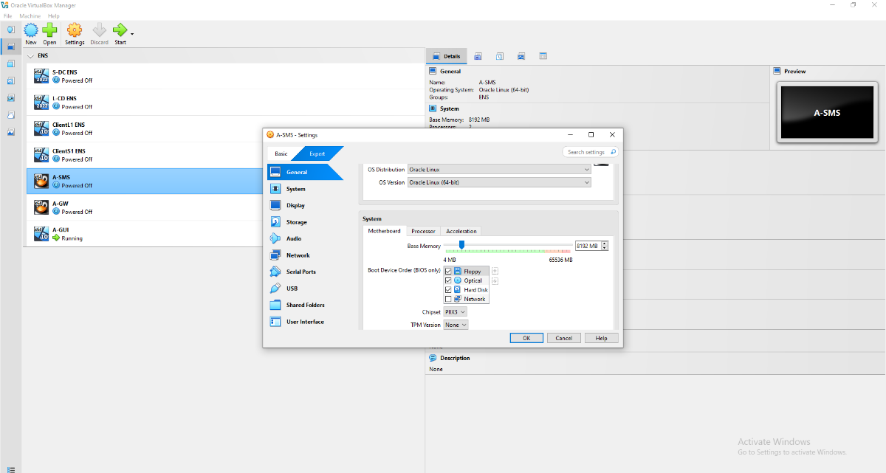
A-SMS Base Memory Resource Allocation

- Visual Briefing: The VirtualBox configuration canvas showing the system profile properties for the A-SMS appliance, verifying the registration of a 64-bit operational profile alongside an 8192 MB RAM allocation.

1.2 Enterprise Network Interface Mapping
To maintain crisp isolation between data-transit areas and highly privileged configuration pathways, network adapters were explicitly mapped to internal software switches.
1.2.1 A-GUI Workstation Network Mapping
The administrative endpoint dictates system properties across three discrete hardware segments:
- Adapter 1: Anchored to the internal private management broadcast zone named IntCP to lock down administrative access.
- Adapter 2: Bound to Network Address Translation (NAT) parameters to support isolated sandboxed system properties.
- Adapter 3: Routed through a Bridged Adapter linked directly to the bare-metal network interface card to fetch system components from local file systems.
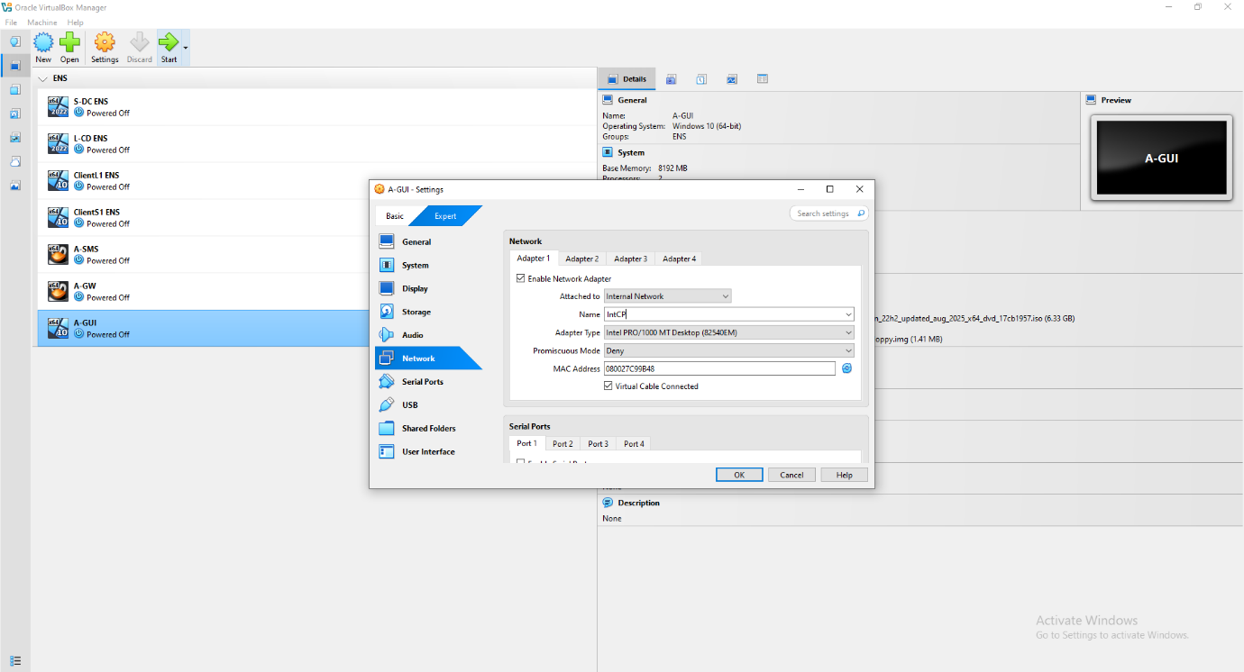
A-GUI Adapter 1 Network Settings

- Visual Briefing: VirtualBox network setup panel for the A-GUI station, showing Adapter 1 bound to the internal software broadcast segment named IntCP.
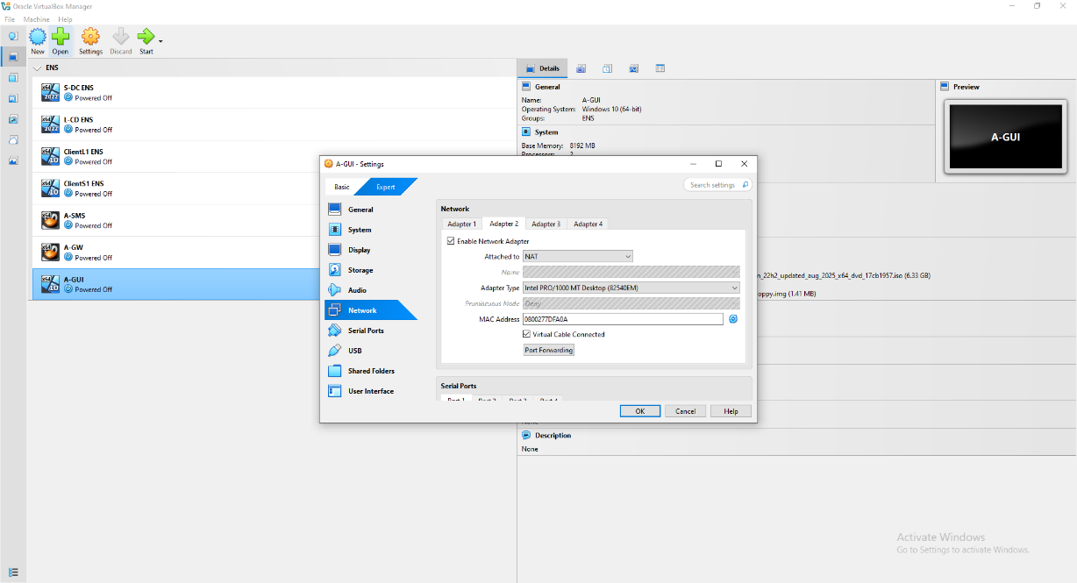
A-GUI Adapter 2 NAT Settings

- Visual Briefing: Virtual network panel verifying Adapter 2 configured under standard NAT parameters.
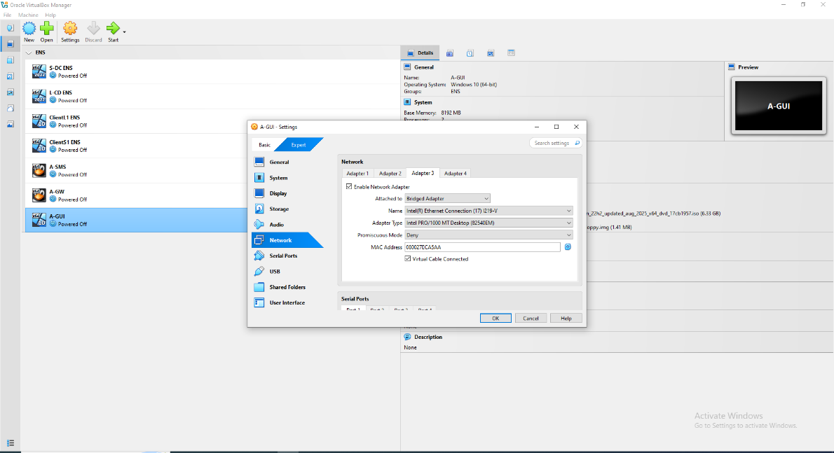
A-GUI Adapter 3 Bridged Adapter Settings

- Visual Briefing: Hypervisor settings menu mapping Adapter 3 directly to a physical hosting card using a bridged adapter framework.
1.2.2 Security Gateway (A-GW) Perimeter Boundary Matrix
The firewall perimeter gateway acts as a multi-homed stateful core inspector. Four independent physical interfaces were mapped to separate internal production servers, cross-datacenter lines, management networks, and untrusted zones:
- Adapter 1: Tied to the Internal Network IntCP (Dedicated Management Plane).
- Adapter 2: Anchored to the Internal Network IntSwa (Internal Production Core Network).
- Adapter 3: Linked to the Internal Network ExtLCD (Cross-Datacenter Interconnect Segment).
- Adapter 4: Assigned to NAT parameters (Simulated Untrusted Public Internet Segment).
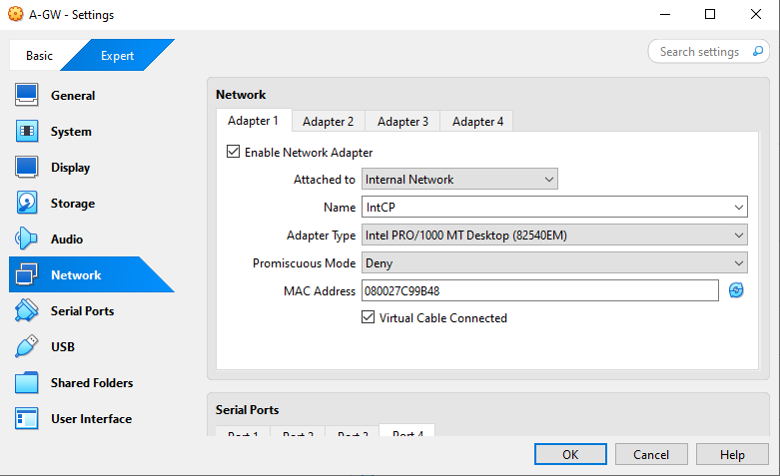
A-GW Adapter 1 Network Configuration

- Visual Briefing: Virtual configuration screen showing A-GW hardware Adapter 1 linked directly to the private management loop segment (IntCP).
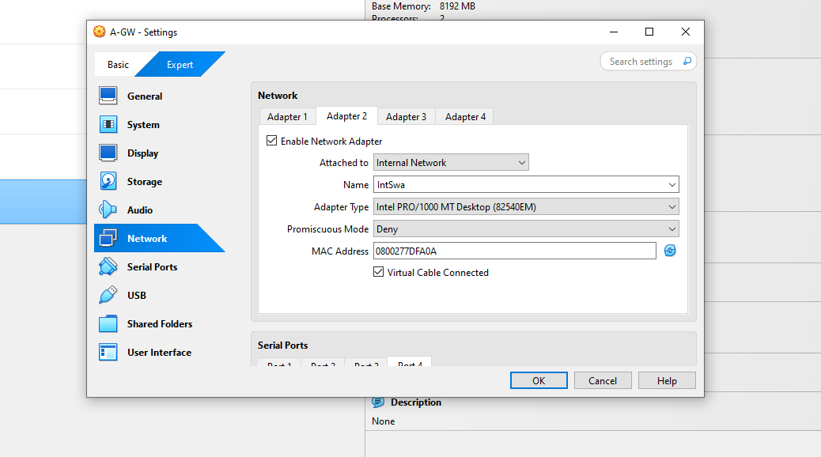
A-GW Adapter 2 Network Configuration

- Visual Briefing: Network interface settings page attaching Adapter 2 to the internal private infrastructure zone labeled IntSwa.
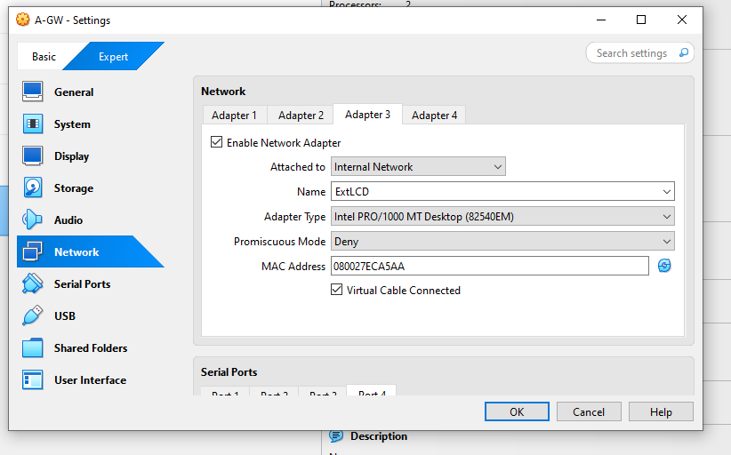
A-GW Adapter 3 Network Configuration

- Visual Briefing: Interface configuration matrix linking Adapter 3 to the secondary remote interconnect node labeled ExtLCD.
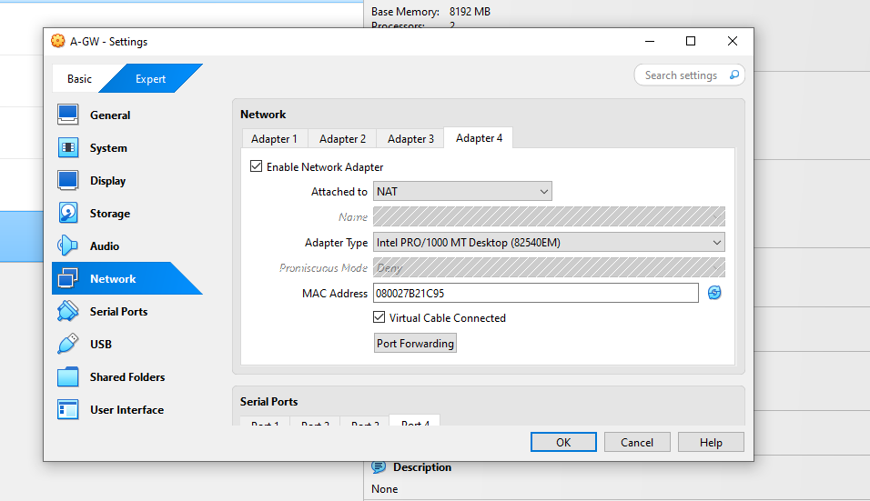
A-GW Adapter 4 NAT Network Configuration

- Visual Briefing: Network properties mapping Adapter 4 directly onto a public internet segment using an internal NAT structure.
1.2.3 Security Management Server (A-SMS) Network Mapping
- Adapter 1: Securely tied to the private management Internal Network loop IntCP.
- Adapter 2: Assigned via standard NAT configuration routes for system tool updates.
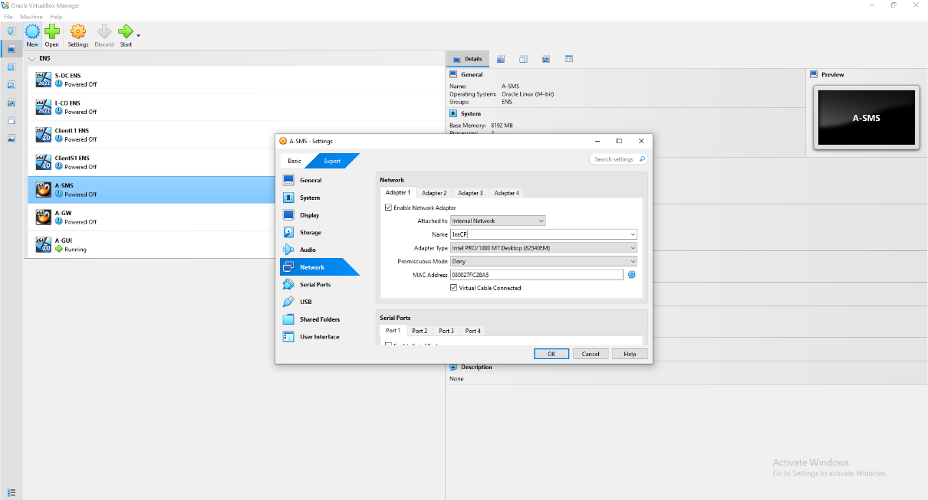
A-SMS Adapter 1 Network Configuration

- Visual Briefing: Property window confirming the A-SMS primary adapter linked to the private administrative data network switch (IntCP).
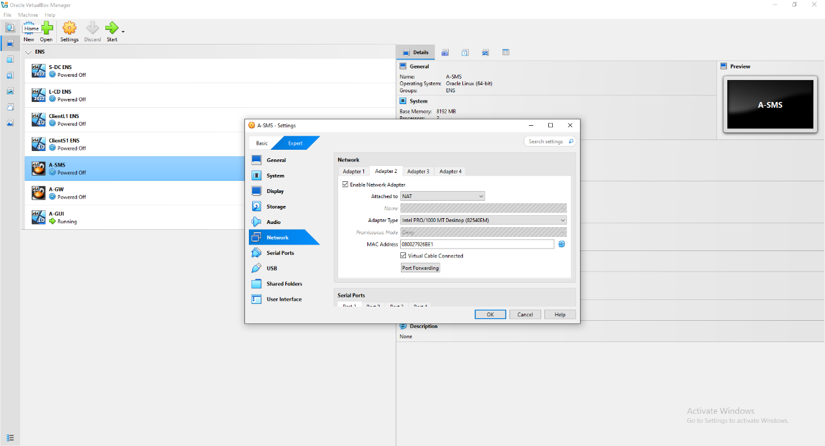
A-SMS Adapter 2 NAT Configuration

- Visual Briefing: Hardware configuration panel verifying the deployment of the server's backup interface under standard NAT parameters.

SECTION 2: OPERATING SYSTEM BASELINE DEPLOYMENT
Once the hypervisor frameworks were locked down, the specialized Check Point GAiA R81.20 microkernel engine was deployed to initialize hard perimeter defenses.
2.1 Boot Loader Initialization & Installation Localization
Booting from the official Check Point installation media spins up an advanced, hardened Linux-based architecture specifically tuned for high-velocity packet routing.
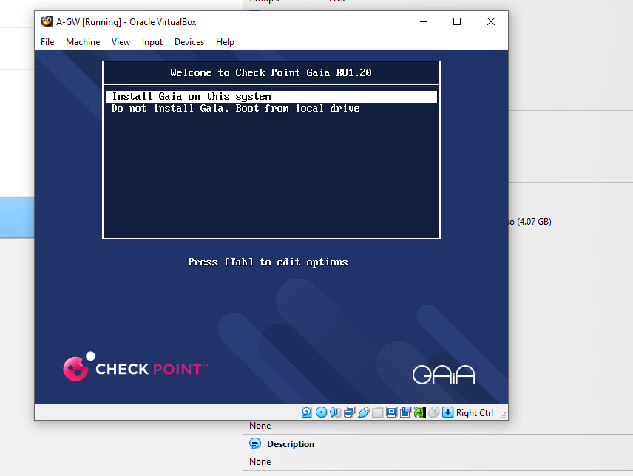
A-GW Gaia ISO Grub Boot Menu

- Visual Briefing: Text-mode boot installation dashboard for the R81.20 GAiA kernel, selecting the "Install Gaia on this system" initialization step.
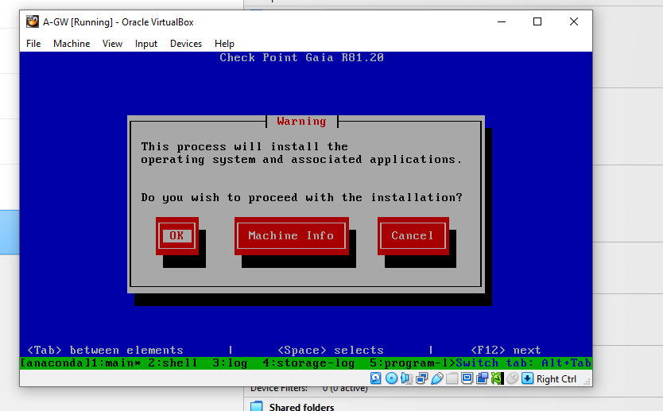
A-GW Installation Initialization Wizard Prompt

- Visual Briefing: System greeting box requiring explicit administrative authorization approval to continue with formatting and image extraction loops.
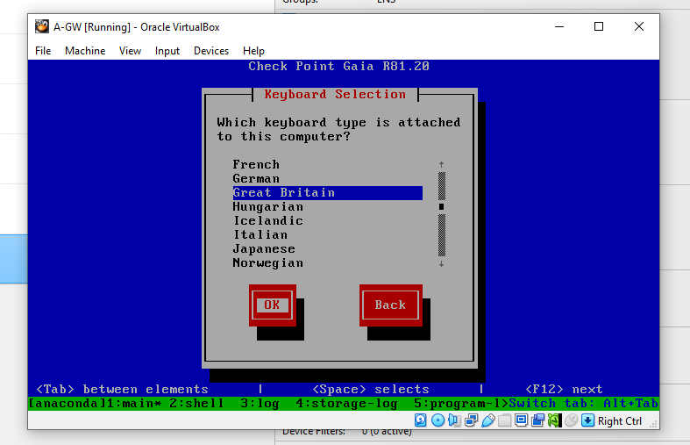
A-GW Keyboard Layout Locale Configuration

- Visual Briefing: System localization options window, setting the hardware character mapping arrays to match a standard Great Britain alignment grid.

2.2 Storage Partition Allocation Profiling
Check Point GAiA architectures separate active configuration boundaries from live logging repositories using discrete logical volume spaces. This layout model ensures that unexpected log data surges cannot fill up the primary file system and crash the firewall engine.
2.2.1 A-GW Storage Topography (85 GB Base Allocation)
- System-swap Space: 8 GB (10%)
- System-root Partition: 15 GB (18%)
- Logs Storage Drive: 15 GB (17%)
- Backup & Upgrade Mirror Pools: 47 GB (55%)
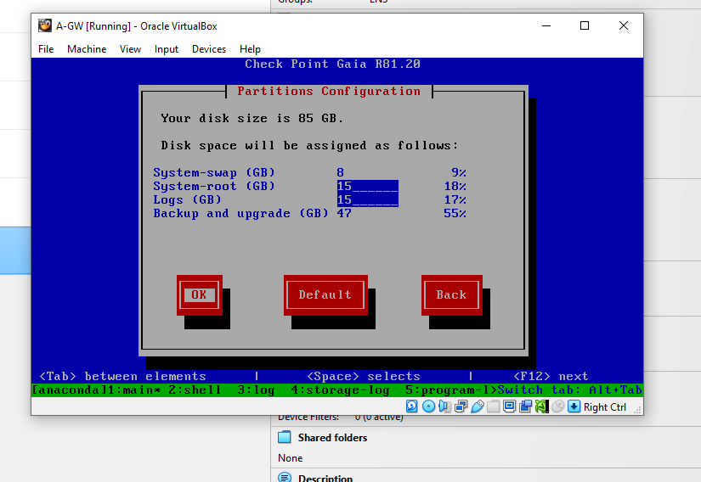
A-GW Dynamic Partition Configuration Profile Table

- Visual Briefing: Partition mapping panel detailing logical volume distribution limits across the A-GW host disk.
2.2.2 A-SMS Storage Topography (82 GB Base Allocation)
- System-swap Space: 8 GB (10%)
- System-root Partition: 15 GB (19%)
- Logs Storage Drive: 15 GB (18%)
- Backup & Upgrade Mirror Pools: 44 GB (53%)
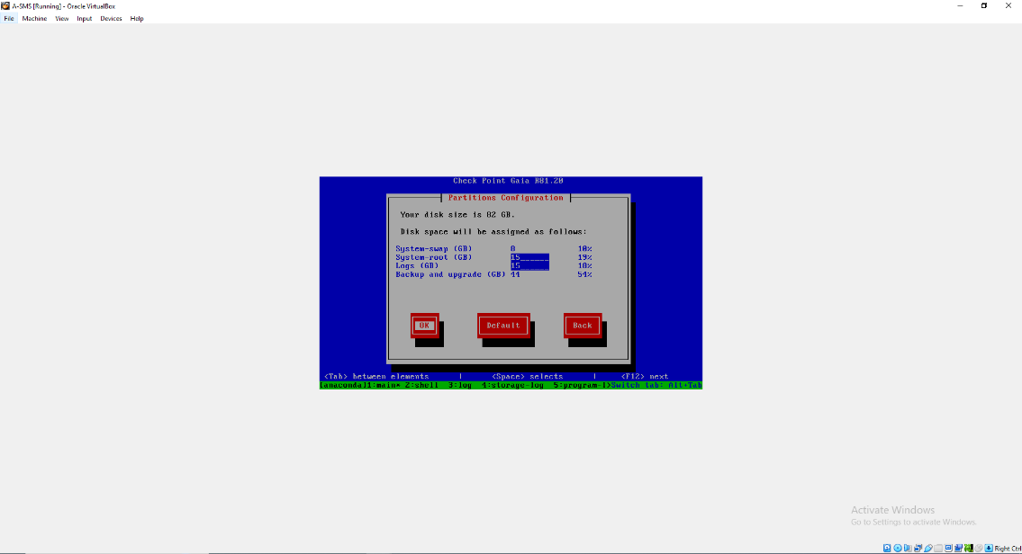
A-SMS Storage Volumes Layout Configuration

- Visual Briefing: Logical partition setup workspace charting storage bounds and snapshot tracking volumes for the A-SMS engine disk.
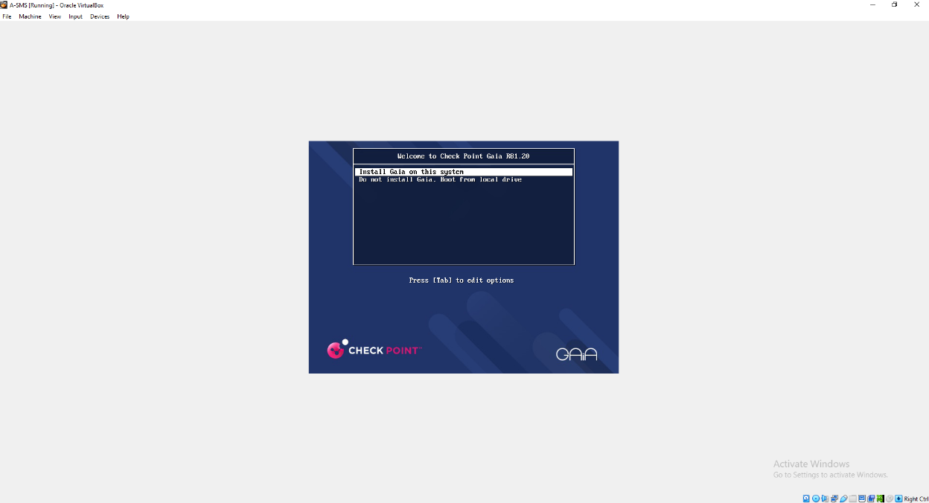
A-SMS Installation Boot Selection Screen

- Visual Briefing: Initial text startup boot wizard profile for the management server container, selecting installation variables.
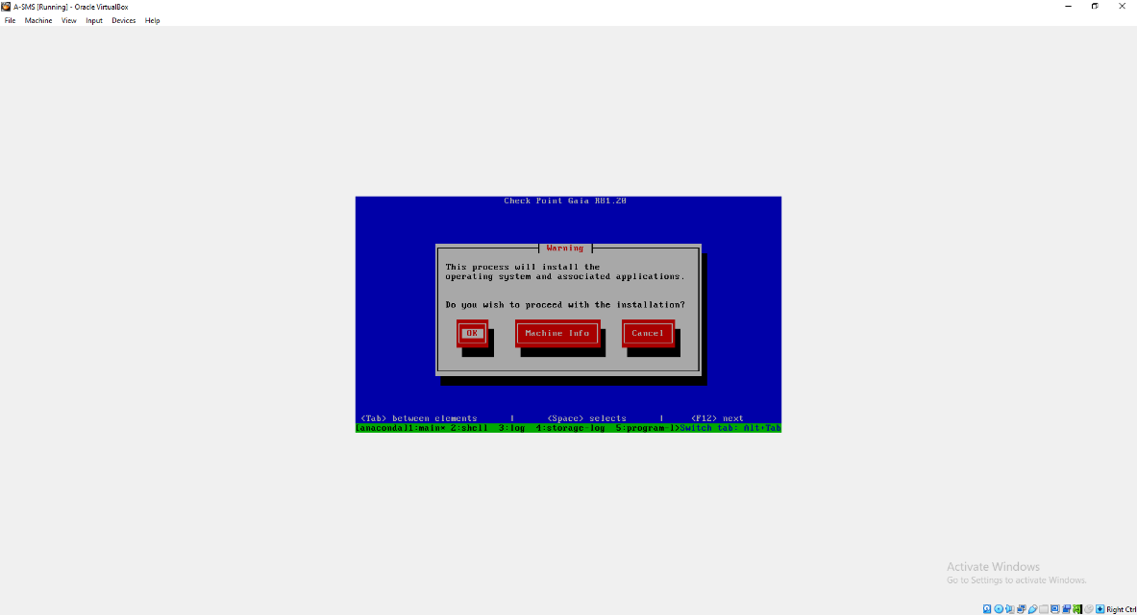
A-SMS Installation Initialization Warning

- Visual Briefing: Alert message diagnostic layout window requiring deployment verification clearance prior to running disk format commands.
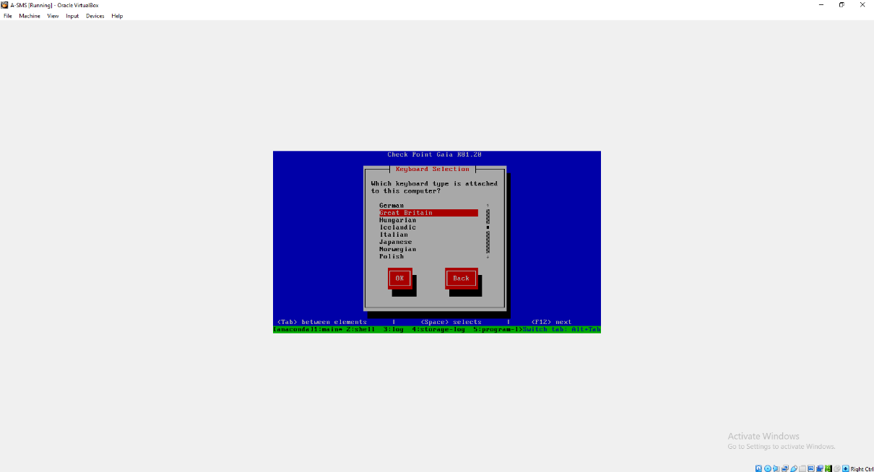
A-SMS Keyboard Layout Locale Selection

- Visual Briefing: Regional localization setup pane aligning text interpretation entries with a standardized Great Britain schema.

2.3 Identity Authentication & Administrative Access Control
To shield root configuration channels across local text prompts, standard administrative passwords were configured across all backend platforms.
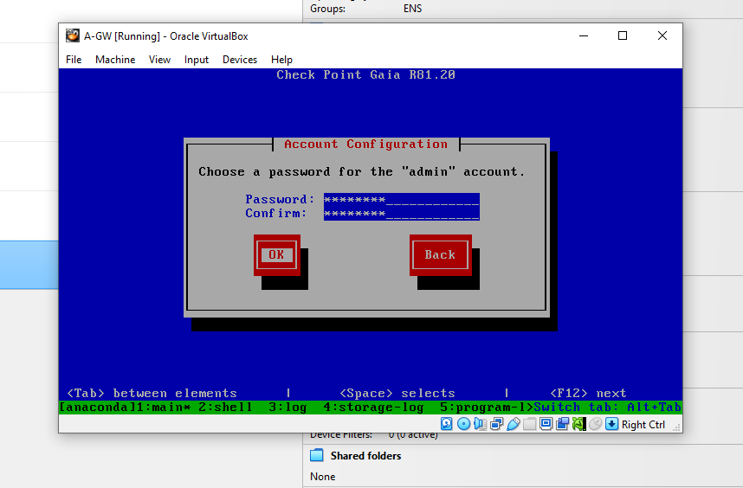
A-GW Root Account Admin Password Setup

- Visual Briefing: Credentials registration screen masking password entries for the default master security administrator profile "admin" on the gateway.

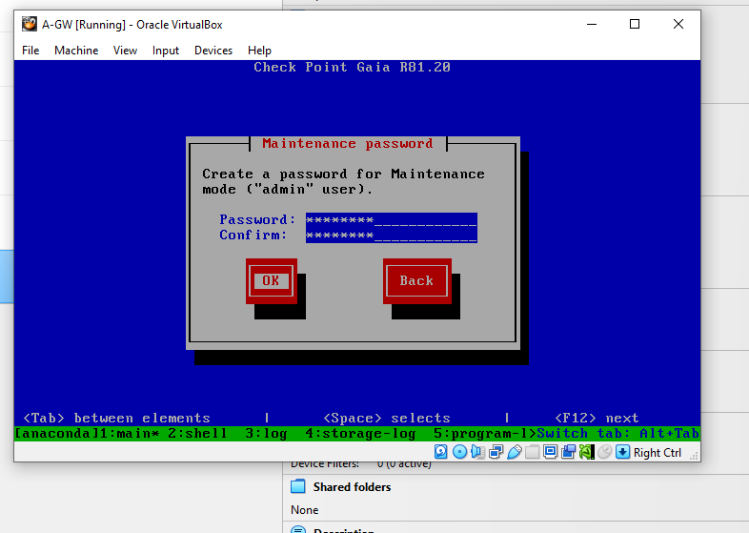
A-GW Maintenance Mode Recovery Credentials

- Visual Briefing: Offline protection setup wizard registering specialized fallback passwords for low-level system diagnostic sessions.
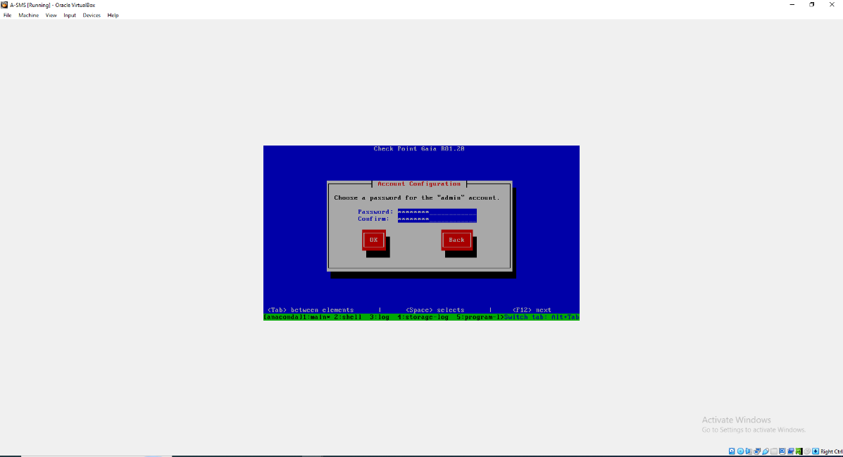
A-SMS Account Configuration Administrator
- Visual Briefing: Access control prompt setting up primary access keys for the central management server's administrative profile.

2.4 Management Interface Binding & Network Definition
During installation, a primary network port must be selected to allow administrative connections over terminal prompts and the Gaia Web UI portal.
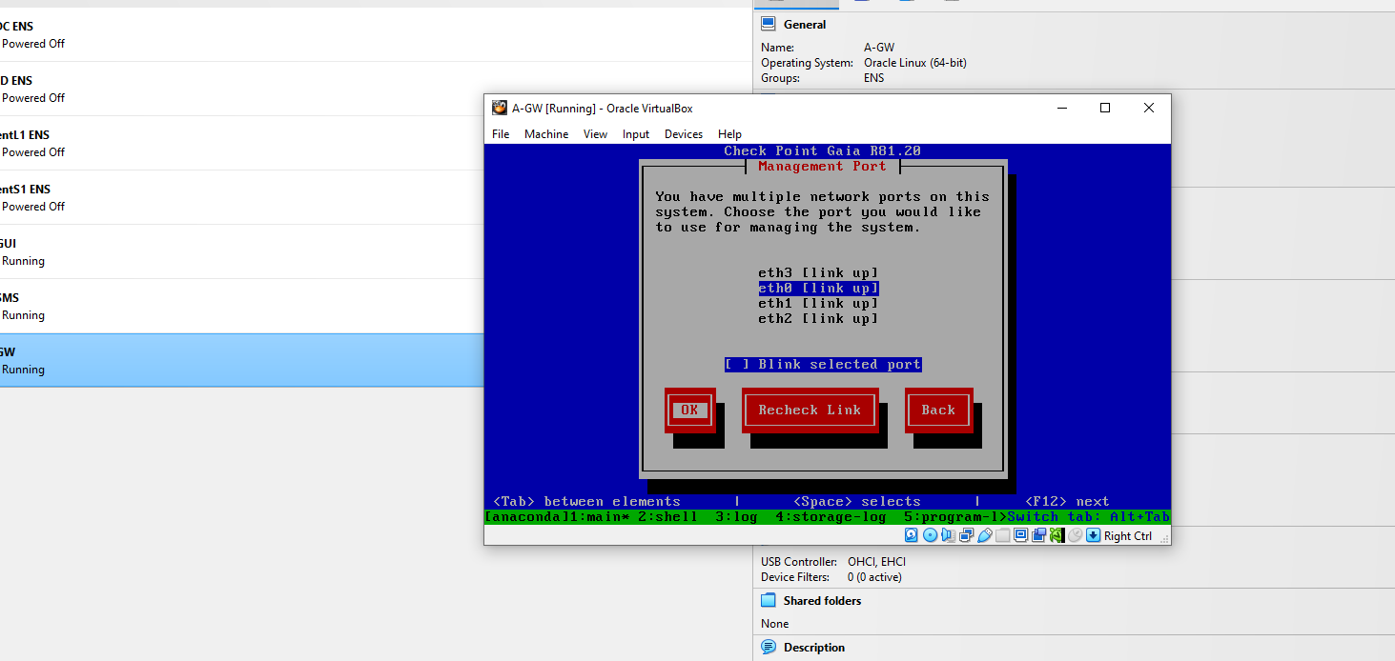
A-GW Multi-Port Detection Access Matrix
- Visual Briefing: Connection port scanning dashboard showing physical line states, with port eth0 chosen to manage incoming configuration requests.
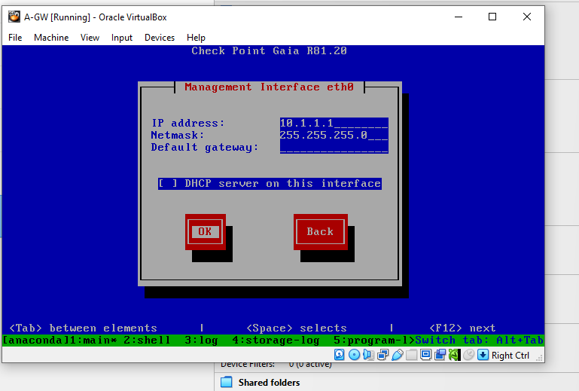
A-GW Static IP Operational Matrix Assignment

- Visual Briefing: Core network configuration menu assigning static IP 10.1.1.1 alongside netmask 255.255.255.0 to interface port eth0.
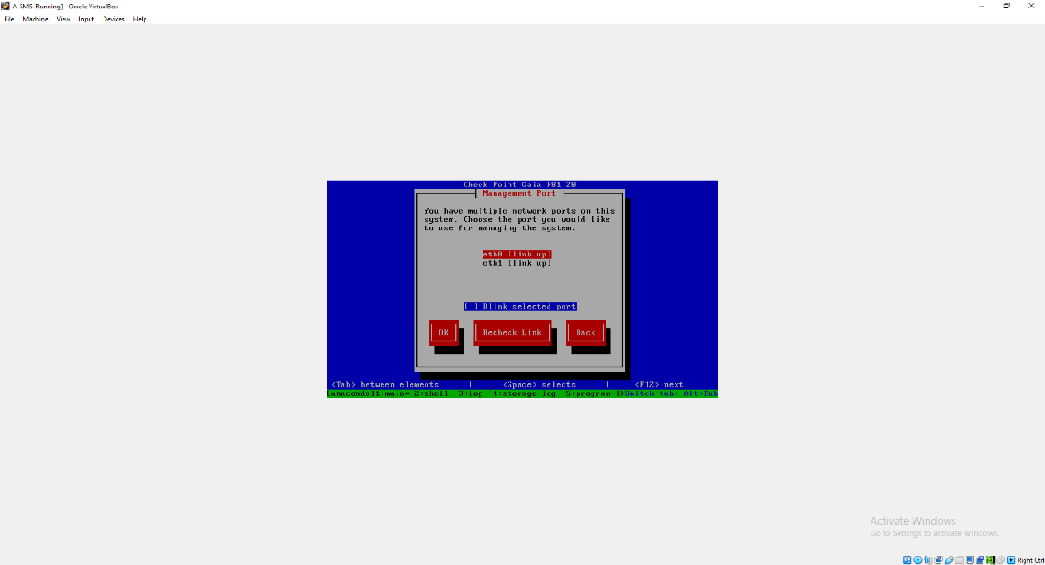
A-SMS Management Port Hardware Selection List

- Visual Briefing: Active adapter tracking prompt mapping available interface lines, showing port eth0 highlighted.
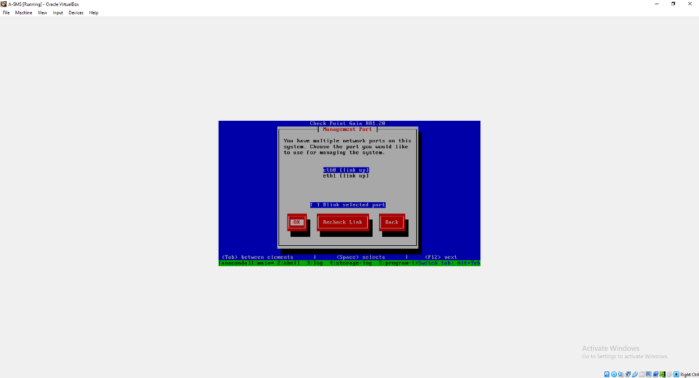
A-SMS Management Port Selection Step Confirmation

- Visual Briefing: Layout step confirming interface eth0 as the primary operational route for server management.
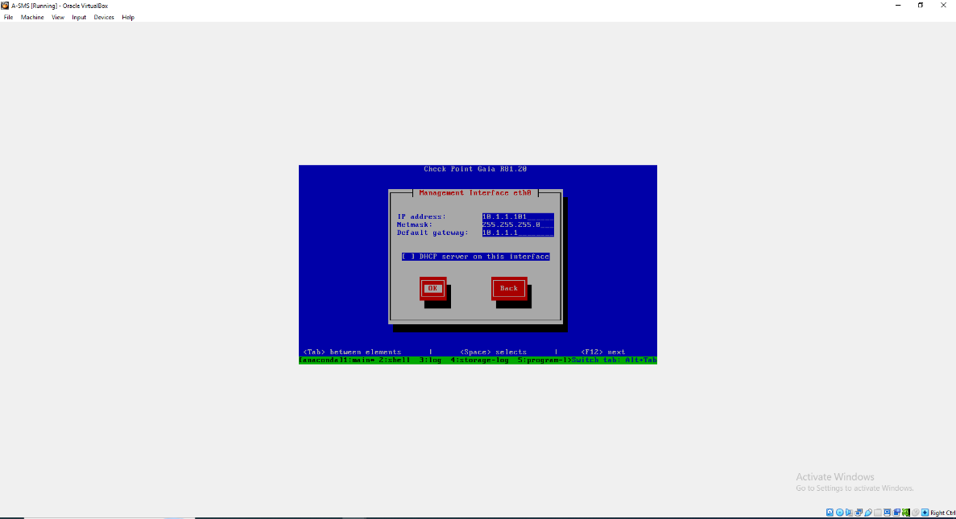
A-SMS Management Interface Network Matrix Assignment
- Visual Briefing: Interface configuration wizard assigning static IP 10.1.1.101 and netmask 255.255.255.0 to interface port eth0, and directing default gateway paths back through the gateway at 10.1.1.1.

2.5 Disk Write Compilation & Extraction Progress Loops
With baseline network entries verified, system variables were written to the active disk partitions.
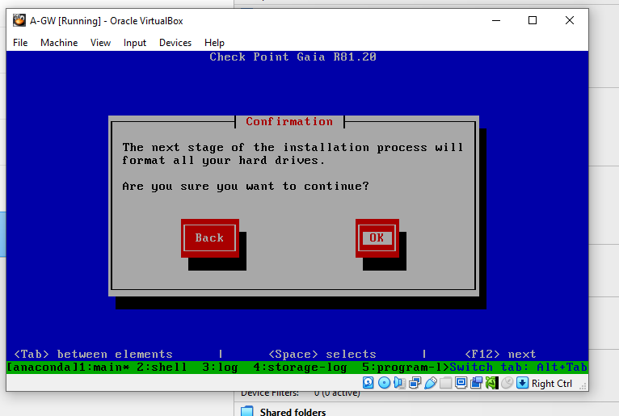
A-GW Final Storage Allocation Warning Confirmation
- Visual Briefing: Terminal warning validation prompt confirming the final formatting of targeted volume spaces.
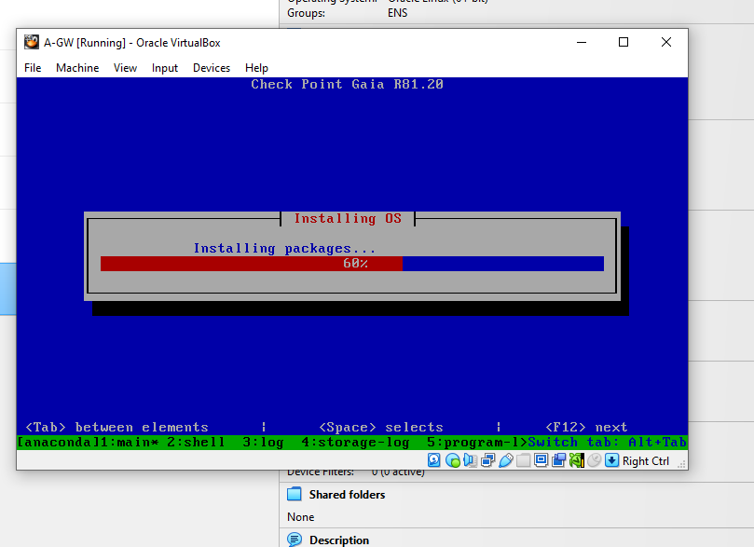
A-GW Core Package Extraction Phase Progress Bar

- Visual Briefing: Progress status interface tracking active operating system installation metrics at 60% completion.
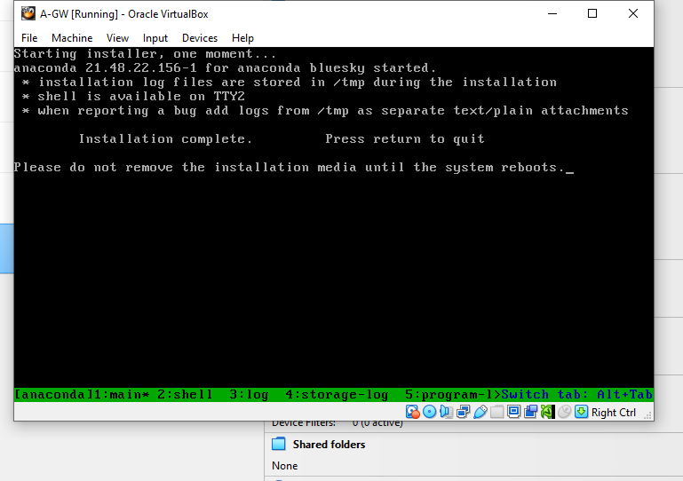
A-GW Text Mode Installation Finish Screen

- Visual Briefing: Text configuration screen noting a successful software setup cycle and requesting an appliance reboot.
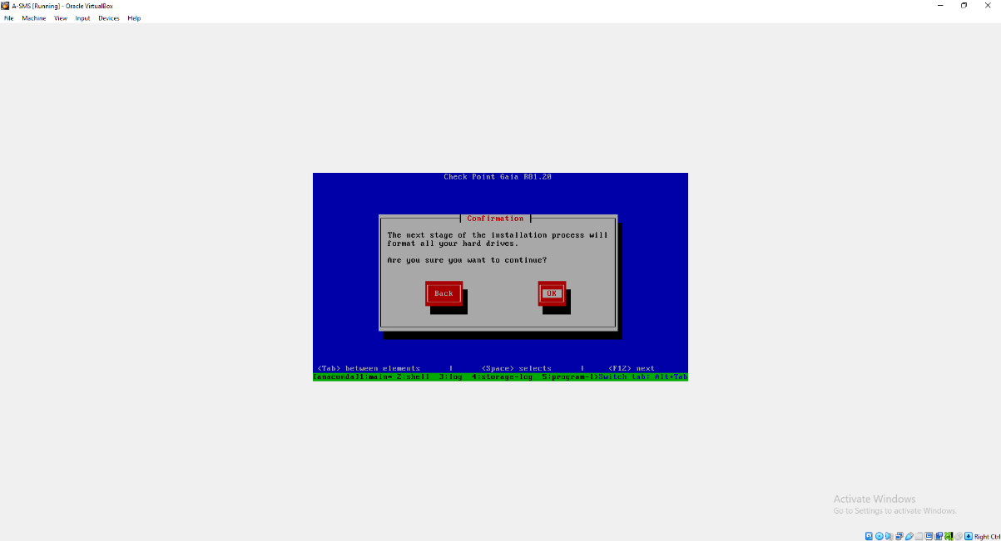
A-SMS Storage Partition Confirmation Alert Box

- Visual Briefing: Administrative pop-up message box requesting final verification to build the management server file system tables.
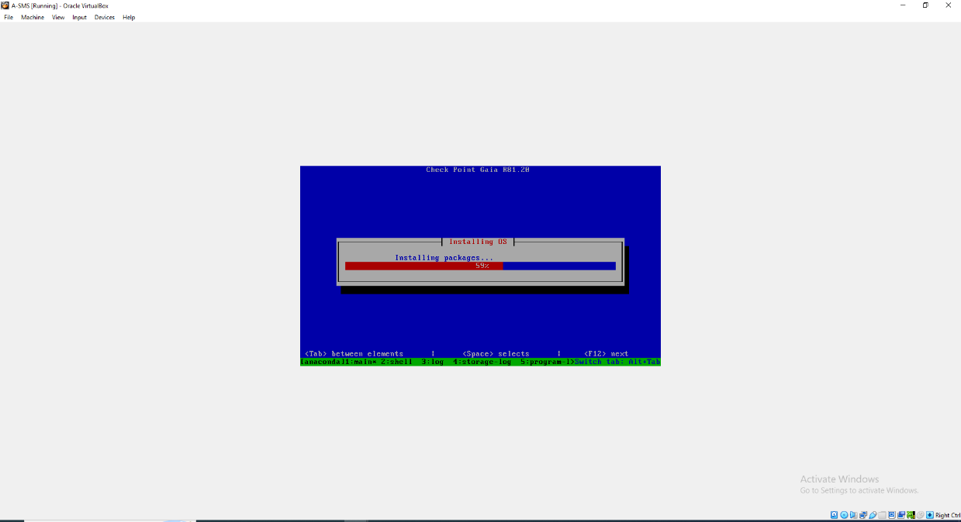
A-SMS Operating System Package Expansion Phase Tracker

- Visual Briefing: Operational status screen charting management package expansion matrices at 59% completion.
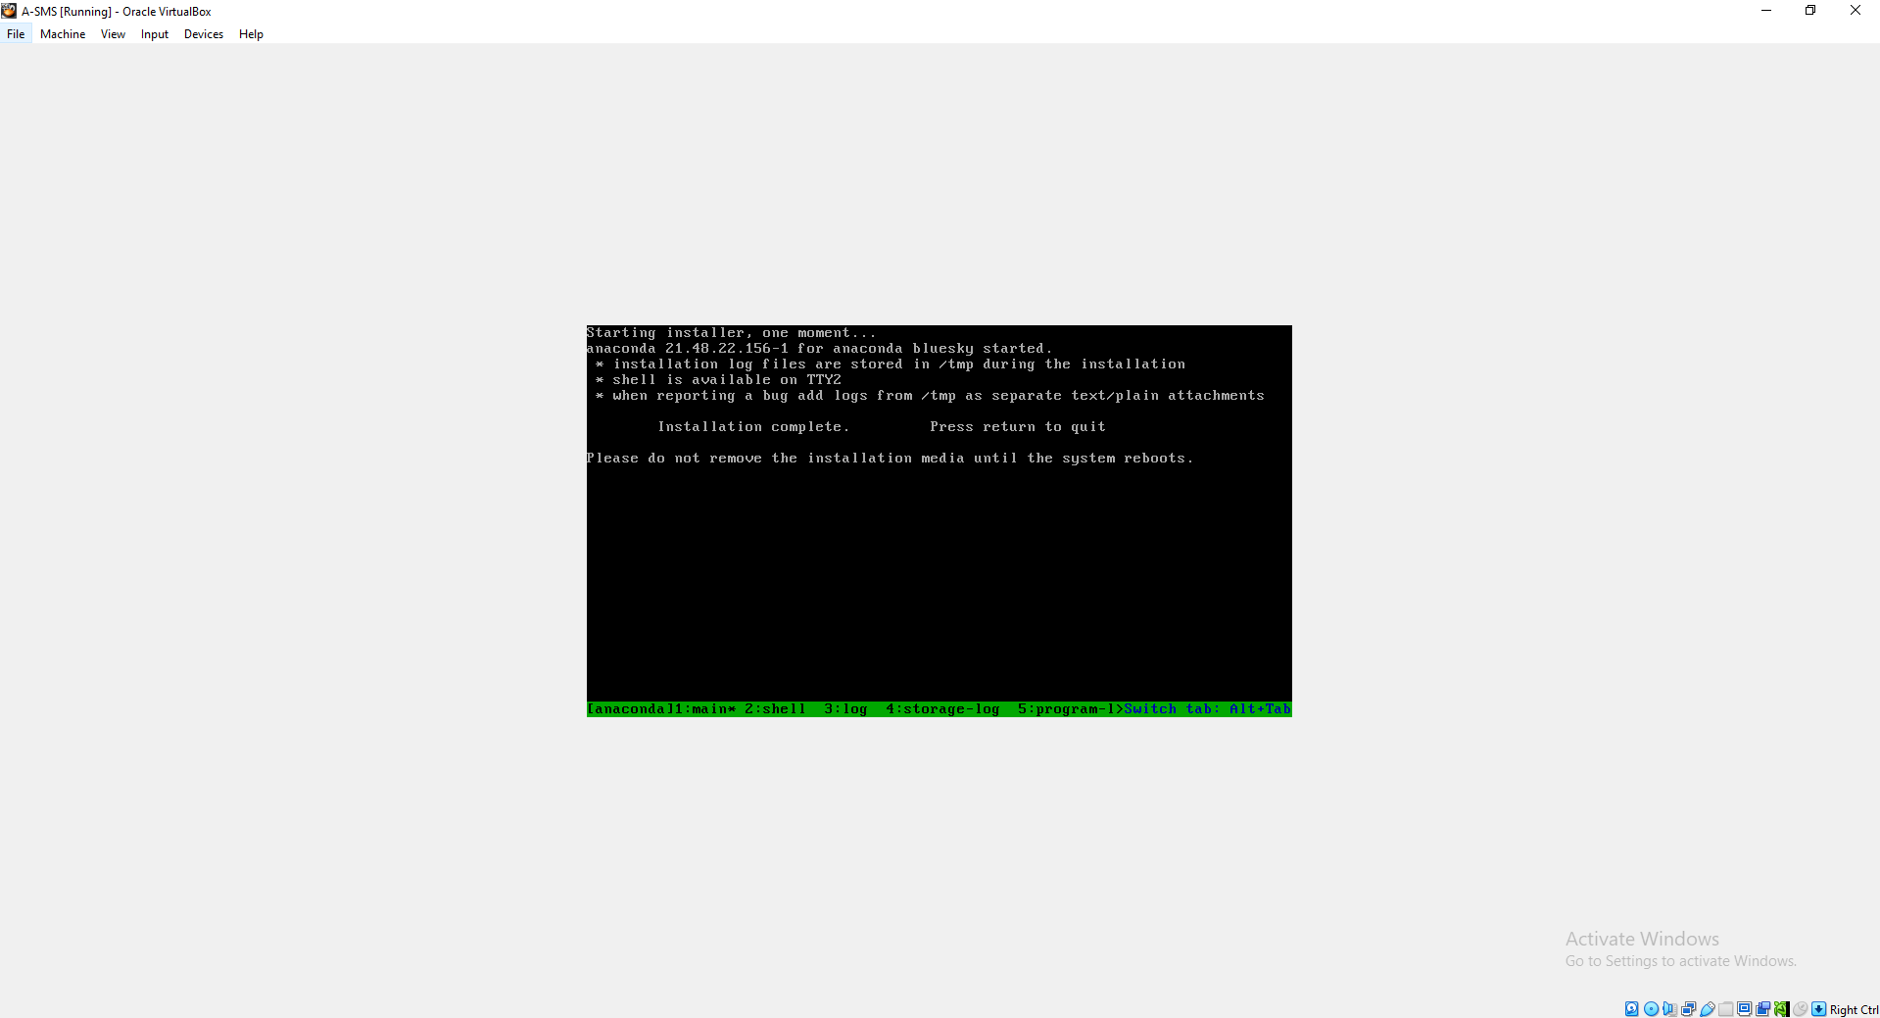
A-SMS Text Mode Installation Lifecycle Complete Screen

- Visual Briefing: Final text deployment dashboard confirming successful operating system setup and requesting a system reboot.
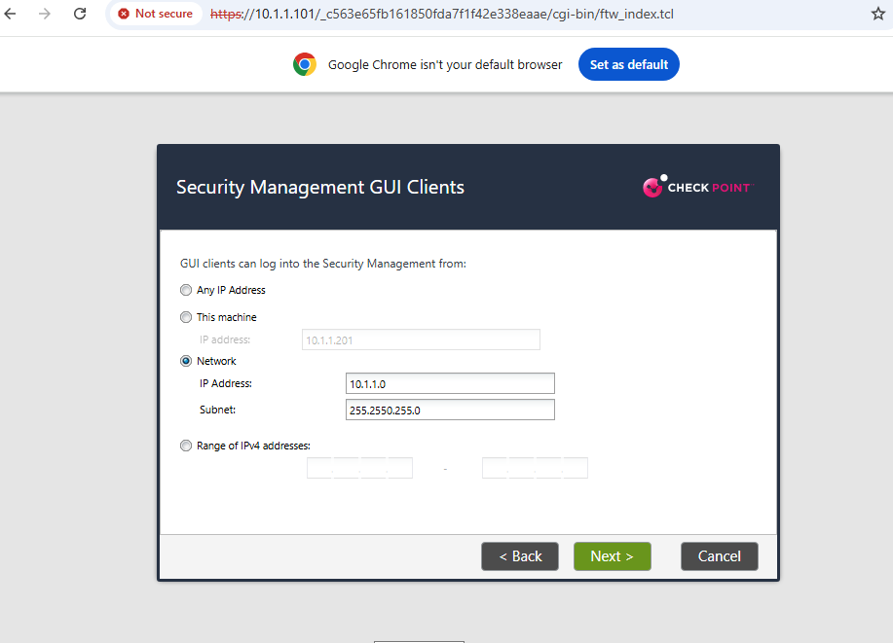
A-SMS Hypervisor view of Text Installation Complete
Visual Briefing: Hypervisor view showing the A-SMS virtual engine console confirming installation completion and prompting a reboot.

2.6 A-SMS Terminal Hardening & Session Security Tuning
Following a clean reboot of the management server appliance, its command-line interface was accessed to establish strict timeout parameters.
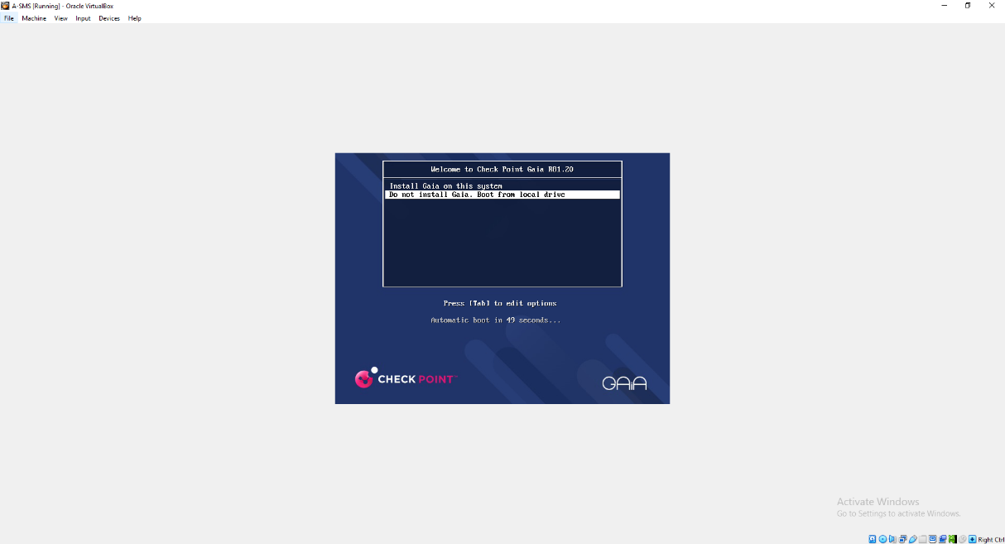
A-SMS Post-Install Boot GRUB Menu

- Visual Briefing: Text-based GRUB execution screen booting the server instance straight from its local disk image tables.
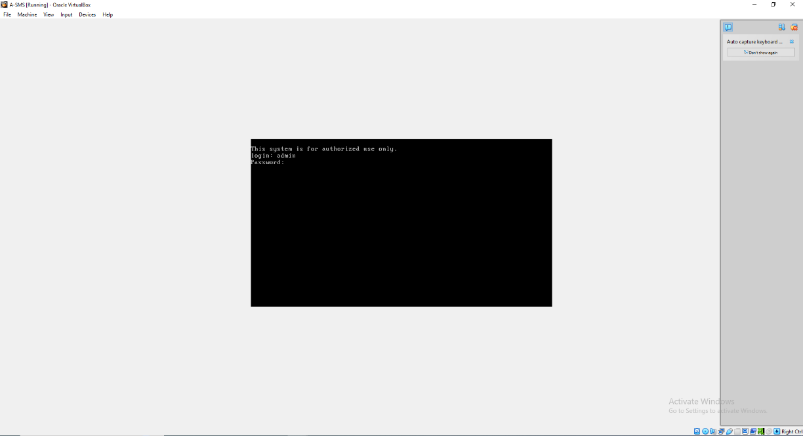
A-SMS Command Line Interface Login Prompt

- Visual Briefing: Hardened terminal login banner requesting secure account profiles for user authentication.
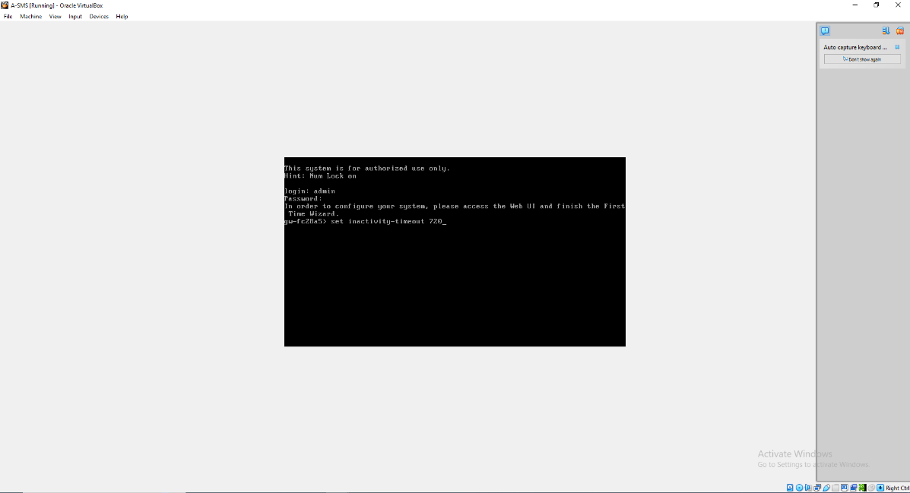
A-SMS CLI Inactivity Timeout Hardening Command

- Visual Briefing: Active terminal shell executing set inactivity-timeout 720 to widen administrative terminal durability rules.
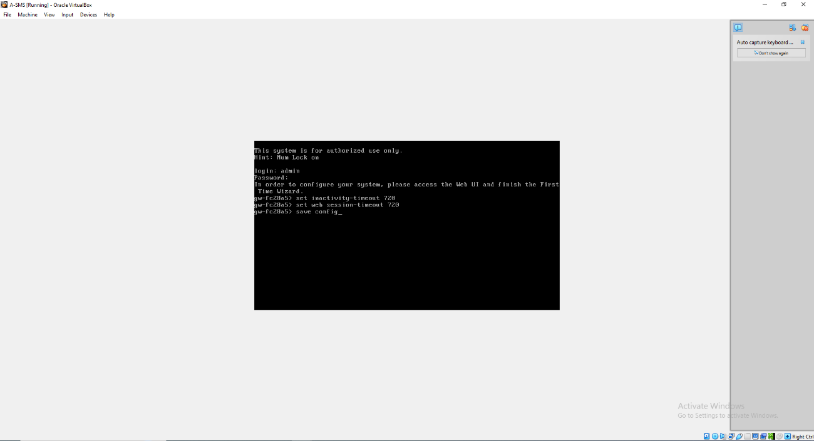
A-SMS CLI Session Timeout Configuration and Save Loops

Visual Briefing: Command terminal window running set web session-timeout 720 followed by save config to commit parameters to non-volatile configuration files.
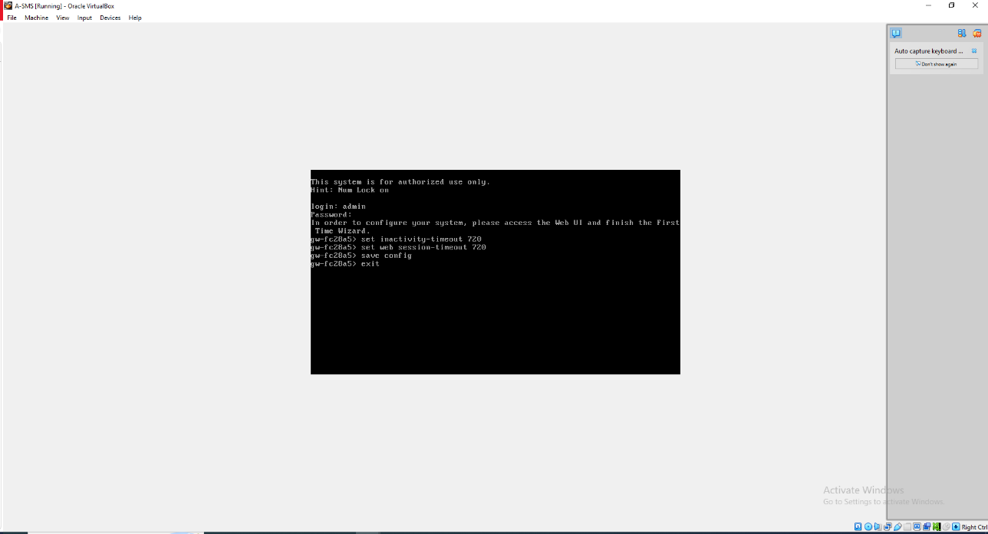
A-SMS Hardened Session Exit Script Execution

- Visual Briefing: Terminal control prompt executing an exit script parameter to safely terminate the active root terminal block.

SECTION 3: MANAGEMENT WORKSTATION ENGINEERING & APPLICATION SETUP
To manage the backend security clusters, the Windows 10 A-GUI workstation was engineered to host the centralized Check Point SmartConsole management application framework.
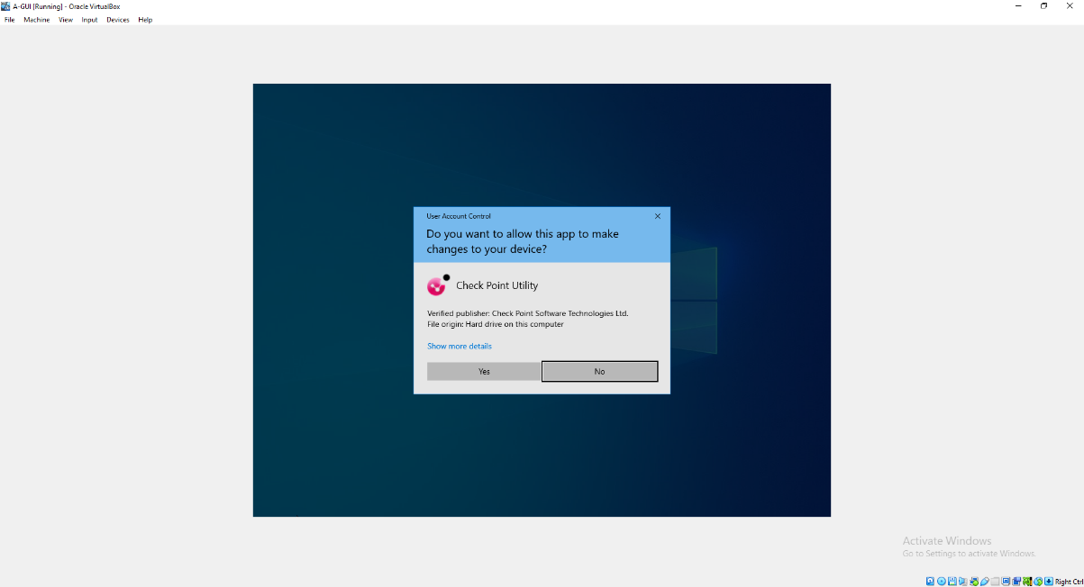
A-GUI UAC Executive Privilege Elevation Notification

- Visual Briefing: Windows User Account Control privilege elevation challenge window, confirming Check Point Software Technologies as a trusted cryptographic author.
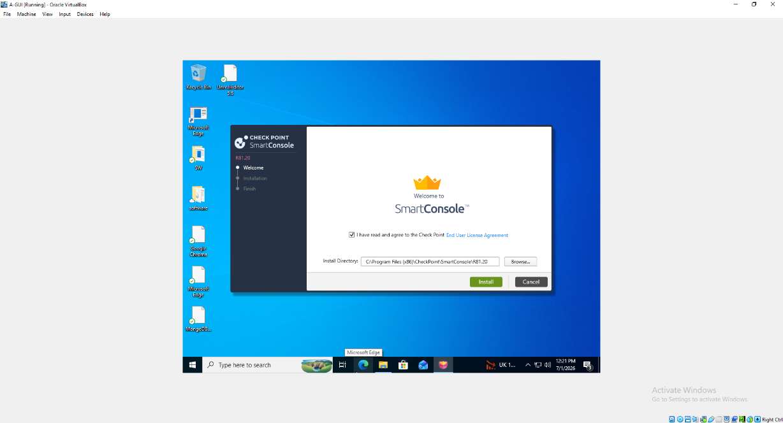
SmartConsole R81.20 Directory Path Mapping Wizard

- Visual Briefing: Central application setup wizard tracking default installation target paths for Check Point SmartConsole R81.20.
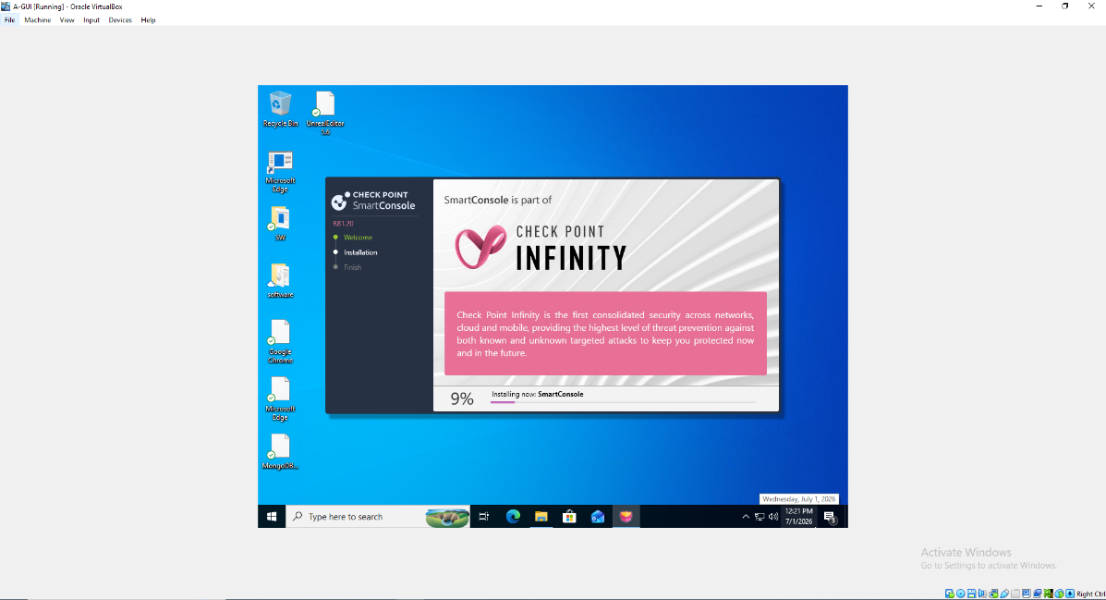
Check Point Infinity Software Package Deployment Progress

- Visual Briefing: Active installation bar dashboard detailing package extraction metrics (9%) under the global Check Point Infinity deployment framework.
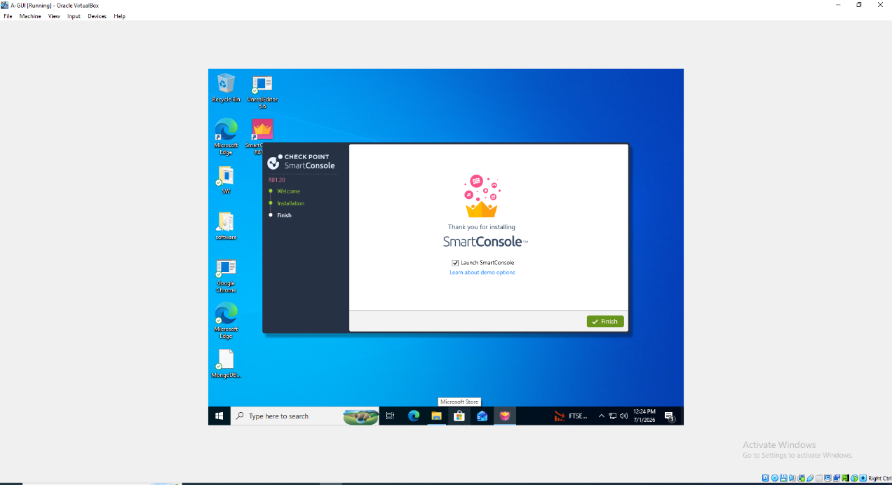
SmartConsole Installation Complete Dialog UI

- Visual Briefing: Final configuration summary panel marking a successful software installation lifecycle and providing a toggle to launch SmartConsole.

SECTION 4: GAIA PORTAL WEB INTERFACE FIRST-TIME WIZARDS
Following the base network installations, advanced appliance configurations were completed over secure HTTPS terminal streams using web utility interfaces.
4.1 Security Gateway (A-GW) Configuration Wizard
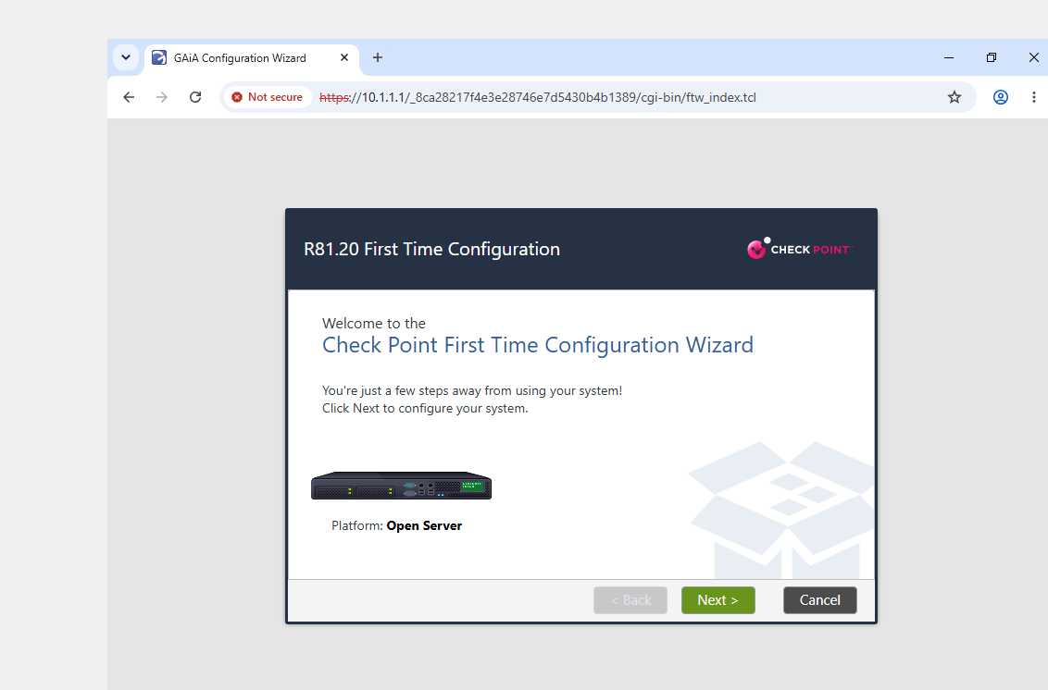
Gaia Web First-Time Configuration Launch Portal

- Visual Briefing: Secure login screen initialized at https://10.1.1.1 launching the official Check Point First Time Configuration Wizard process.
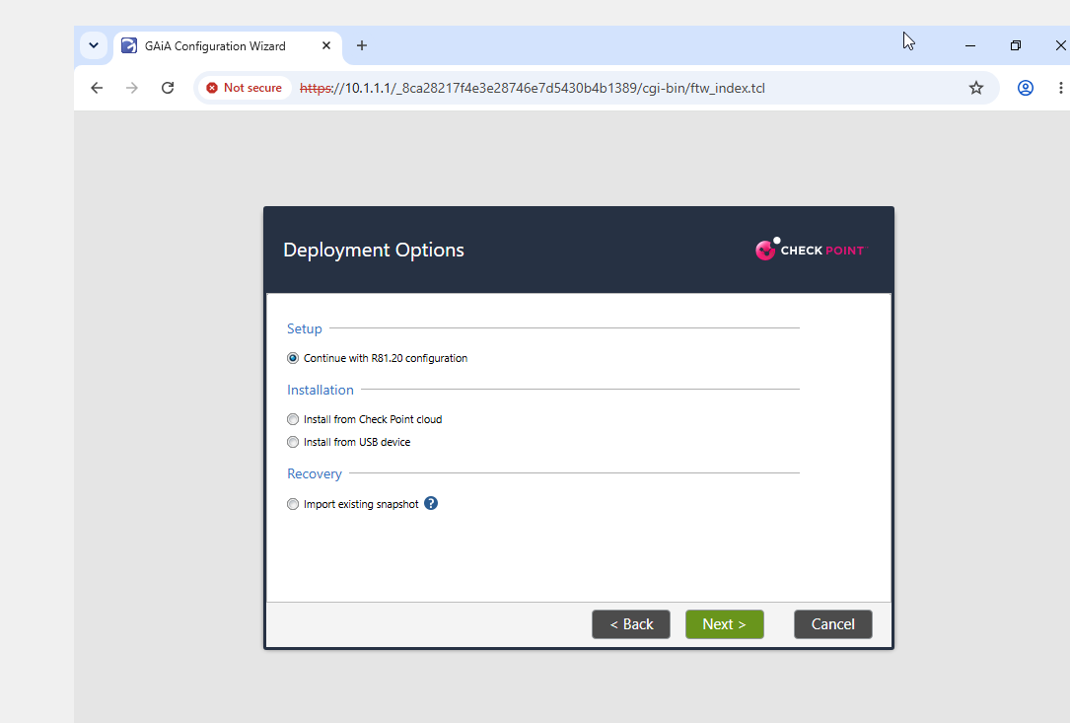
Gaia Wizard Deployment Option Selector Panel

- Visual Briefing: Deployment options toggle menu, configuring the system to continue with specialized automated R81.20 layout definitions.
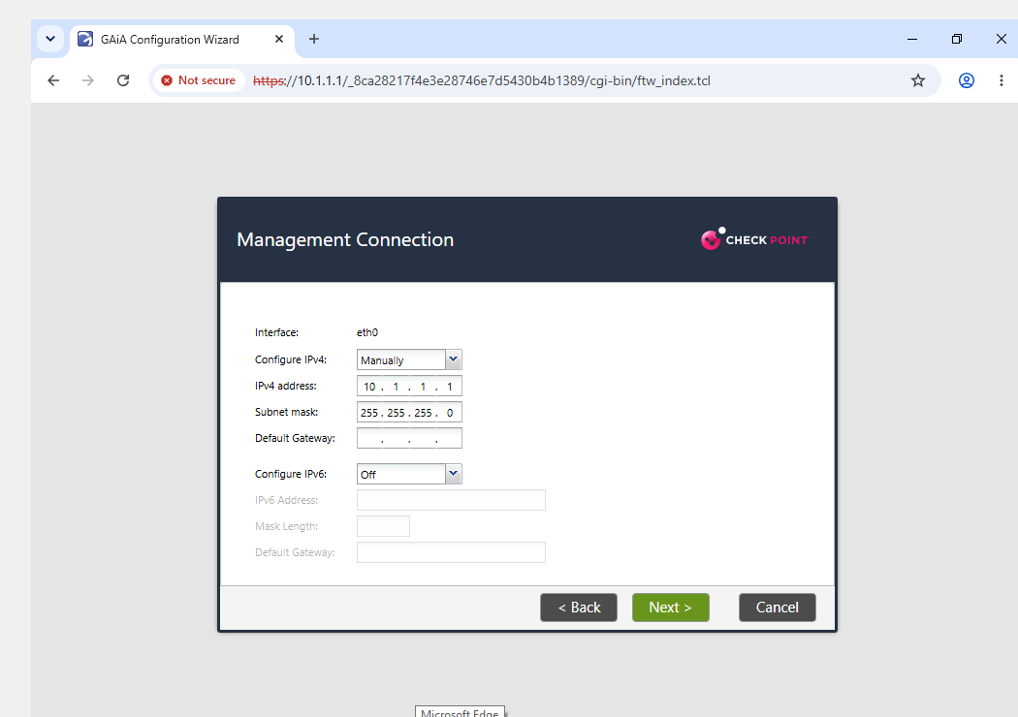
Gaia Management Network Link Properties Check

- Visual Briefing: Network interface check page verifying the gateway's manual configuration properties on port eth0 (10.1.1.1/24).
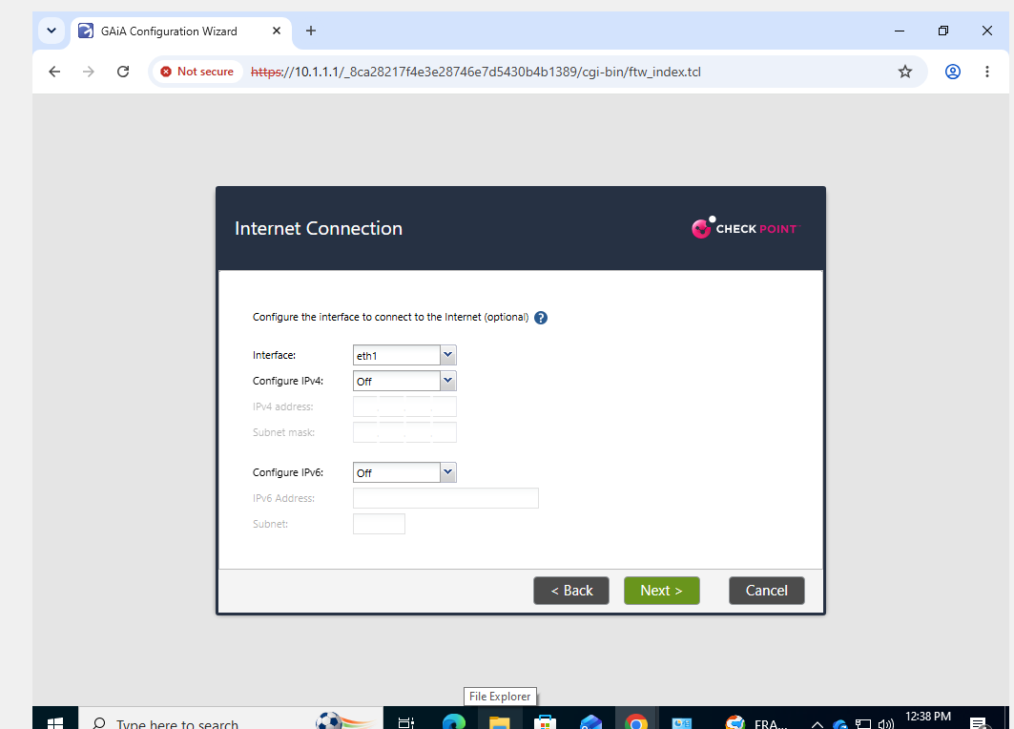
Gaia Internet Interface Initial Status Setting

- Visual Briefing: Gateway interface status window tracking dynamic assignments, leaving interface port eth1 unconfigured during the initial baseline phase.
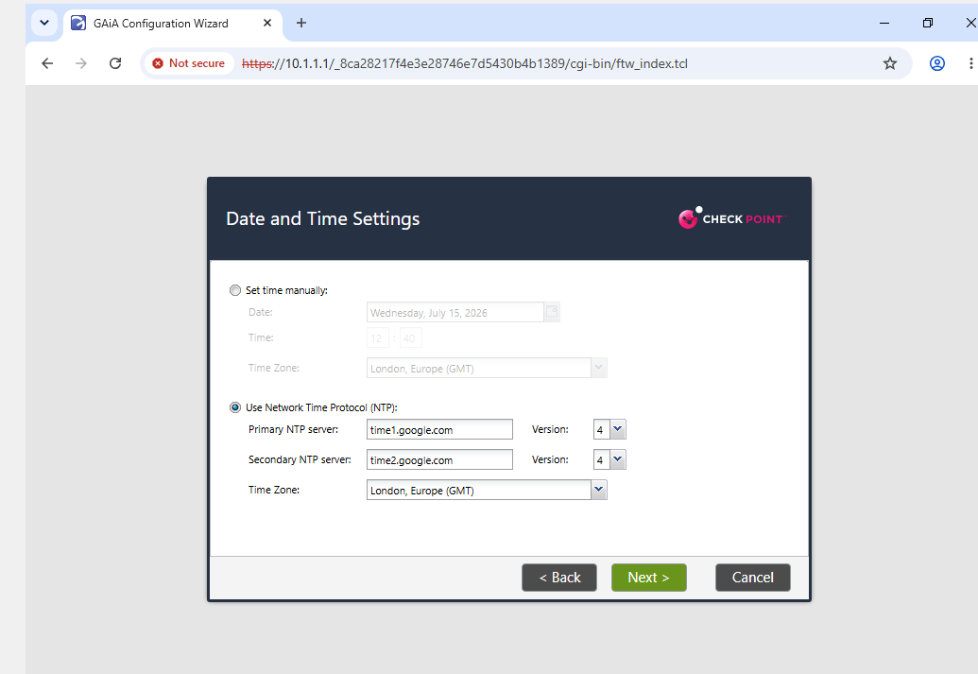
Gaia Network Identity Host Mapping Panel
- Visual Briefing: Domain parameters page configuration, writing the appliance Host Name to A-GW, setting the network Domain label to swansea.acca, and setting up static upstream lookup roots (192.168.1.1, 8.8.8.8, 4.2.2.2).
Gaia NTP Synchronization Time Engine Layout
- Visual Briefing: Date and time synchronization workspace mapping Network Time Protocol properties outward to public pools (://google.com, ://google.com) localized to a GMT time zone model.
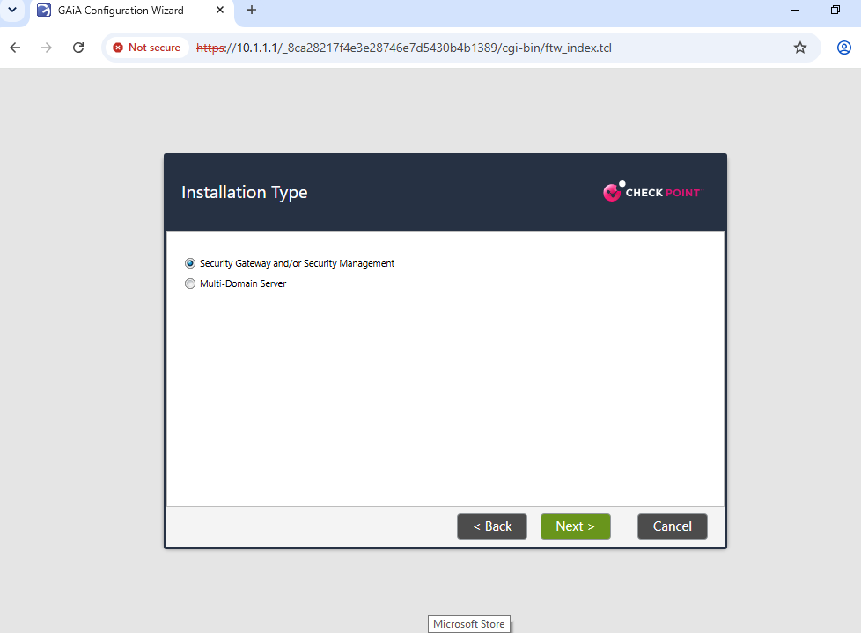
Gaia Installation Functional Profile Definition Type

- Visual Briefing: Installation type selector switch grouping configuration rules under specialized Security Gateway and/or Security Management frameworks.
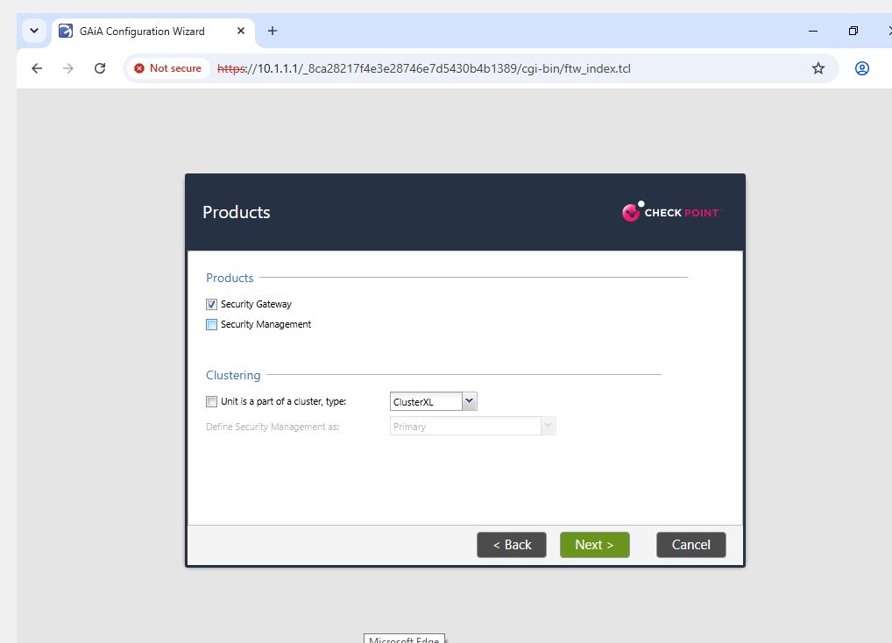
Gaia Product Selection Separation Setting Checkbox

- Visual Briefing: Role selection step checking the Security Gateway appliance feature role while explicitly clearing any management database flags.
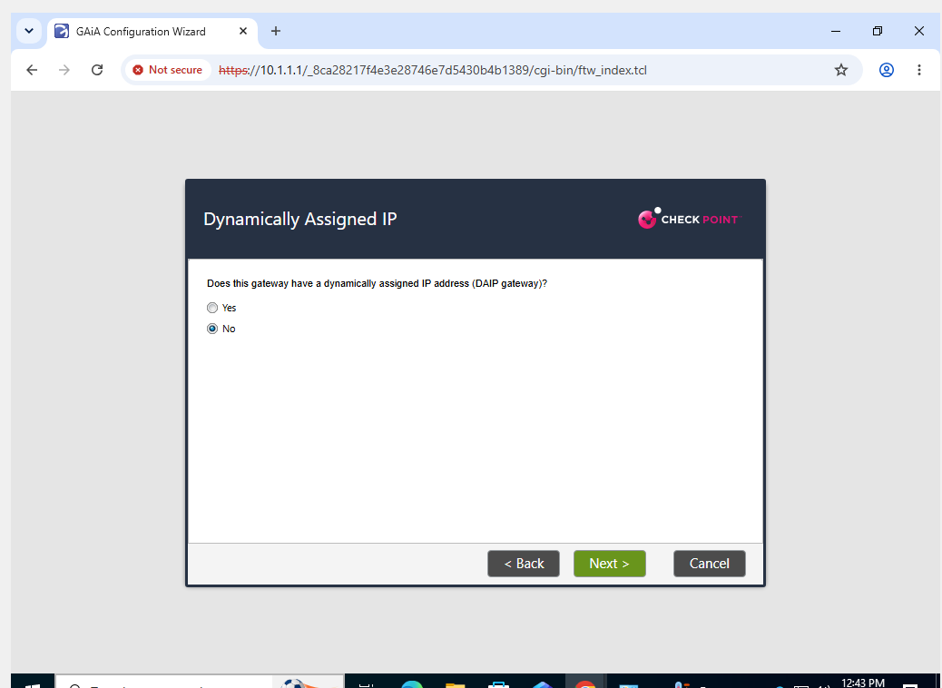
Gaia DAIP Configuration Selection Switch

- Visual Briefing: Network classification switch setting the gateway option to "No" to reject dynamic allocations and preserve stable static routing tables.
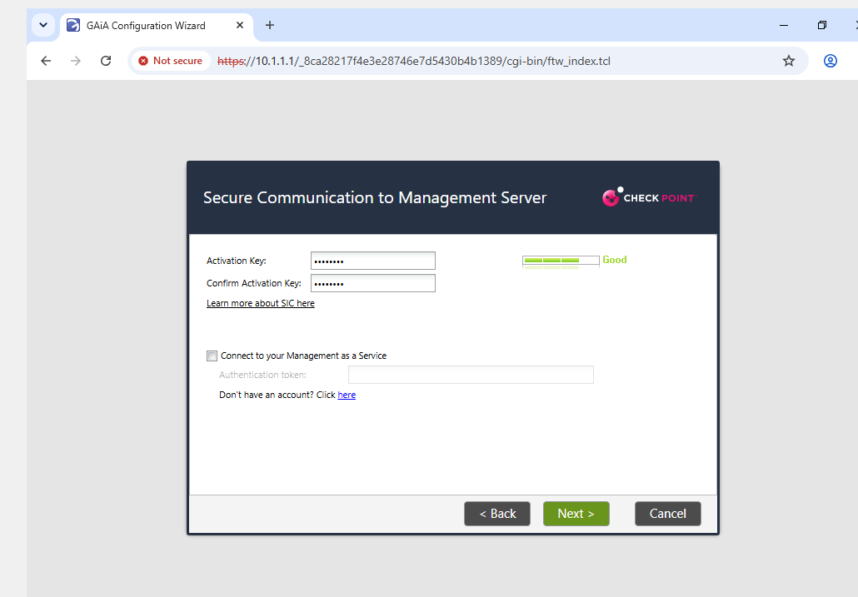
Gaia SIC Secure Access Token Entry Box

- Visual Briefing: Security trust field registering a strong secure internal communication access token string used to authorize connections with the main management server.
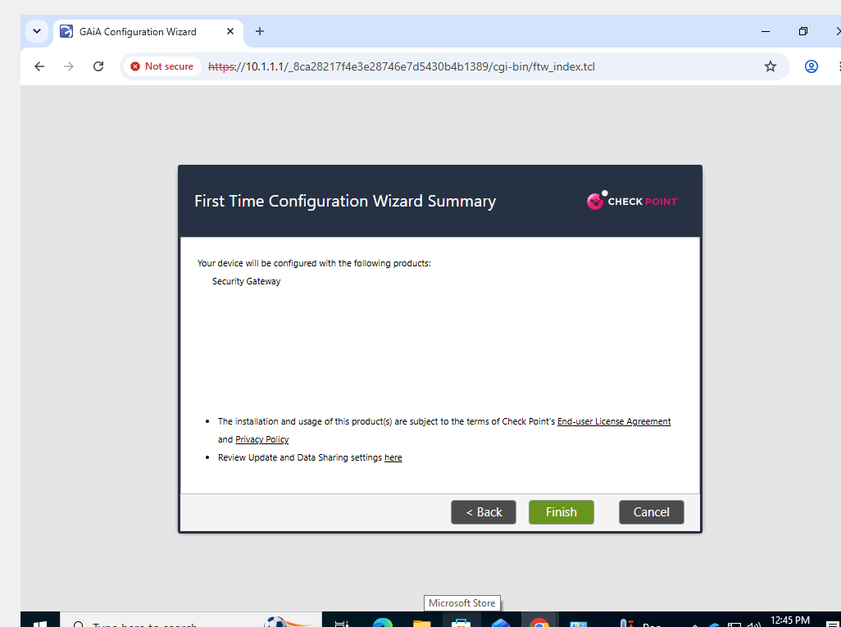
Gaia Compilation Summary Checklist Window

- Visual Briefing: Summary canvas listing parameters written to the Security Gateway image directories.
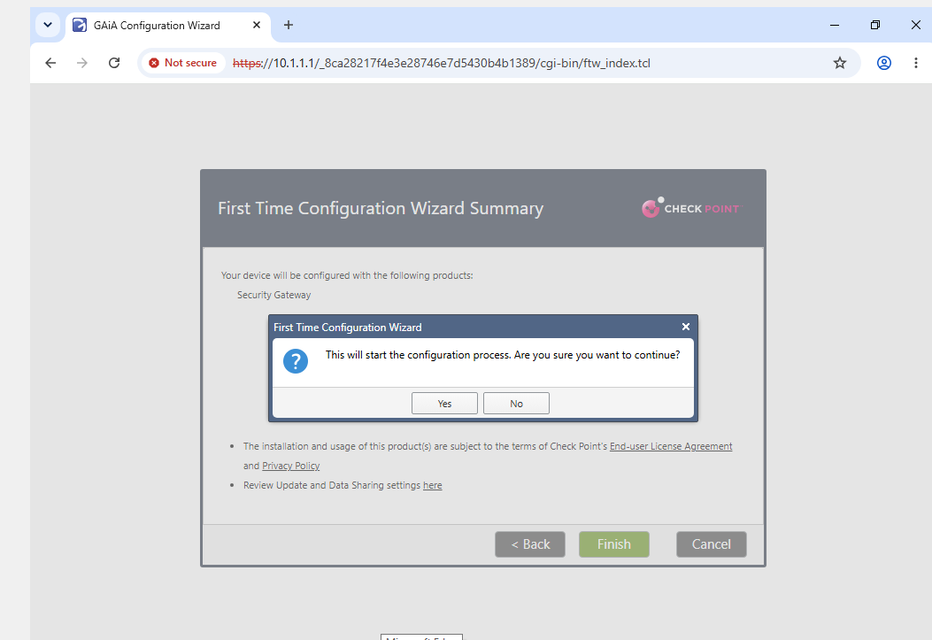
Gaia Wizard Installation Launch Verification Prompt

- Visual Briefing: Confirmation message prompt requiring final verification authorization before writing variables to the appliance configurations.
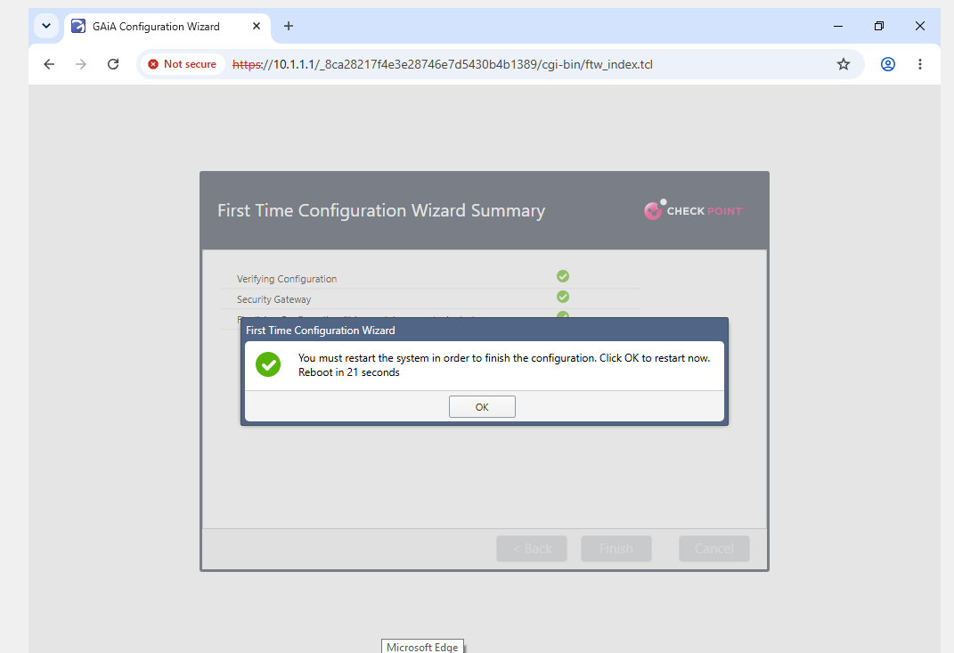
Gaia Wizard Completion Notification and Reboot Alert

- Visual Briefing: Step validation panel displaying active green checkmarks alongside an automated 21-second post-wizard system reboot countdown alert.

4.2 Security Management Server (A-SMS) Configuration Wizard
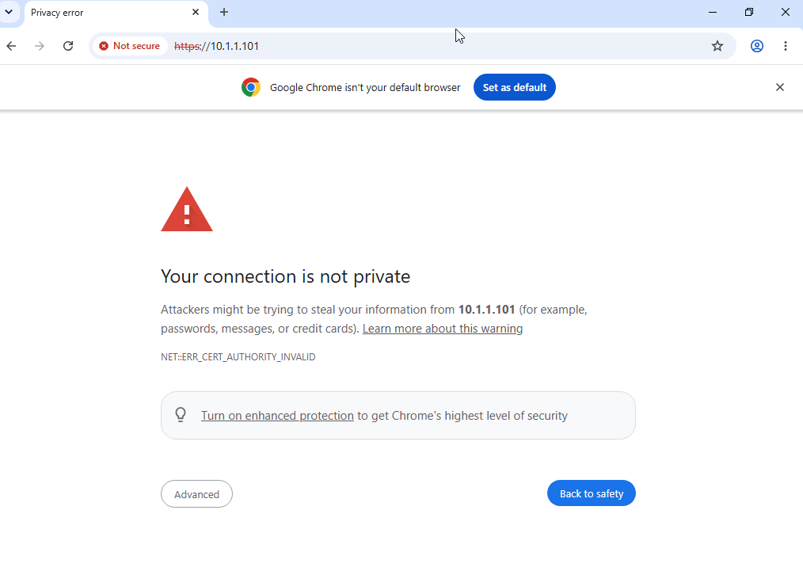
A-GUI Browser Certificate Authorization Alert

- Visual Briefing: Connection security warning layout screen at address location https://10.1.1.101 alerting the administrator to self-signed appliance certificates.
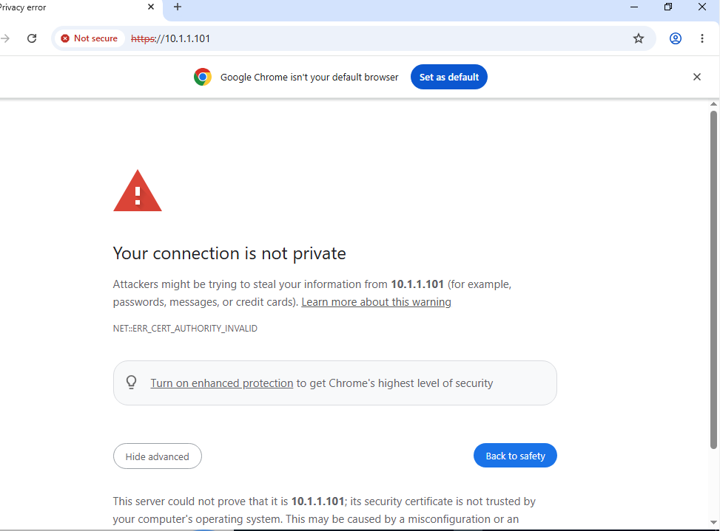
A-GUI Advanced Certificate Security Exception Access Path

- Visual Briefing: Advanced configuration sub-panel allowing the user to bypass the browser exception threshold and navigate to the web console setup.
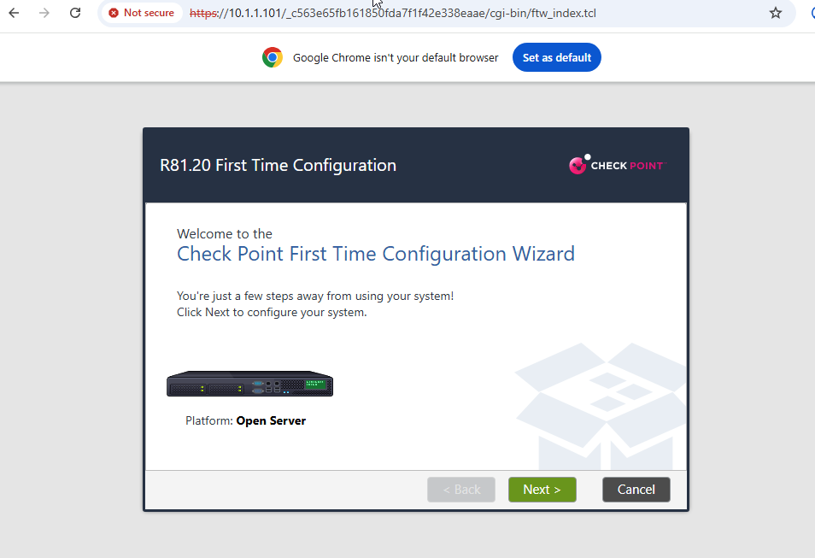
A-SMS Gaia Web First-Time Configuration Launch Portal

- Visual Briefing: Opening configuration welcome page for the A-SMS appliance First Time Configuration Wizard process.
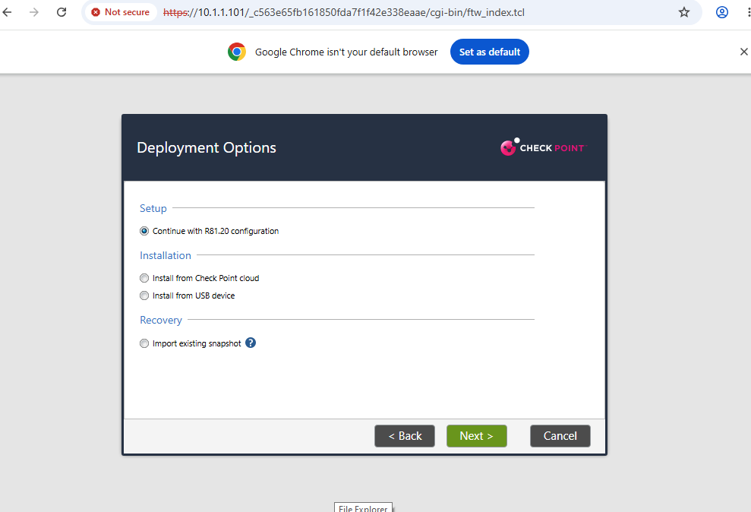
A-SMS Gaia Wizard Deployment Option Selector Panel

- Visual Briefing: Setup options menu selecting standard automated configuration paths for the management server image.
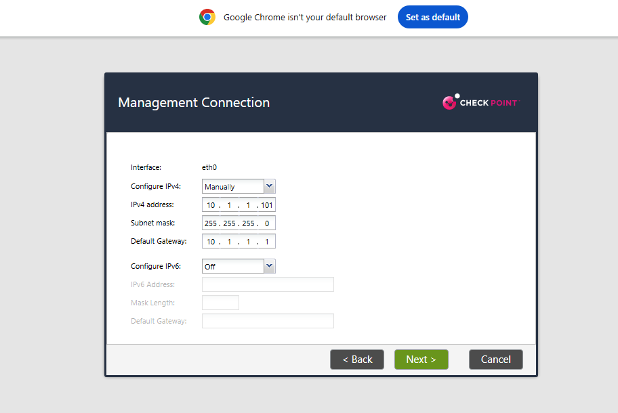
A-SMS Gaia Management Network Link Properties Check

- Visual Briefing: Network interface connection manager confirming static IP settings on port eth0 (10.1.1.101/24) routing through default gateway interface 10.1.1.1.
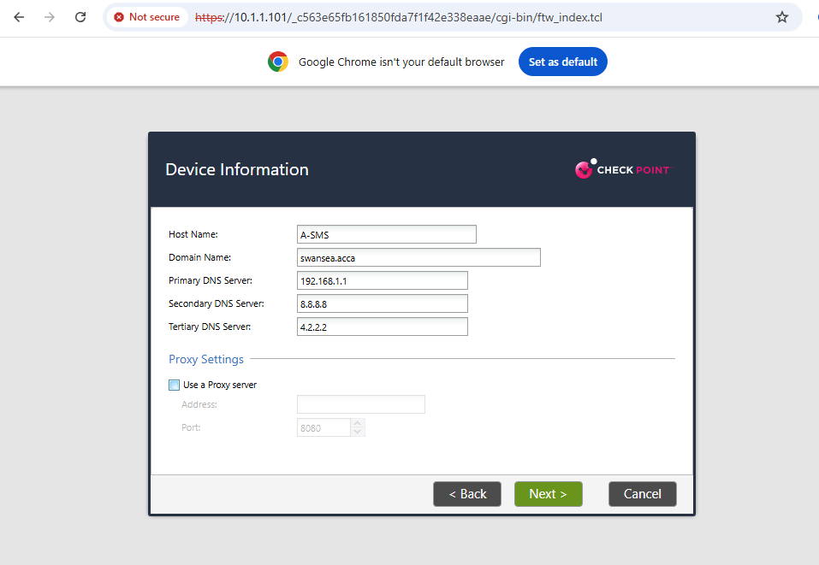
A-SMS Network Identity Host Mapping Panel

- Visual Briefing: Domain information settings page defining the platform Host Name as A-SMS, naming the local Domain to swansea.acca, and setting active lookup DNS targets (192.168.1.1, 8.8.8.8, 4.2.2.2).
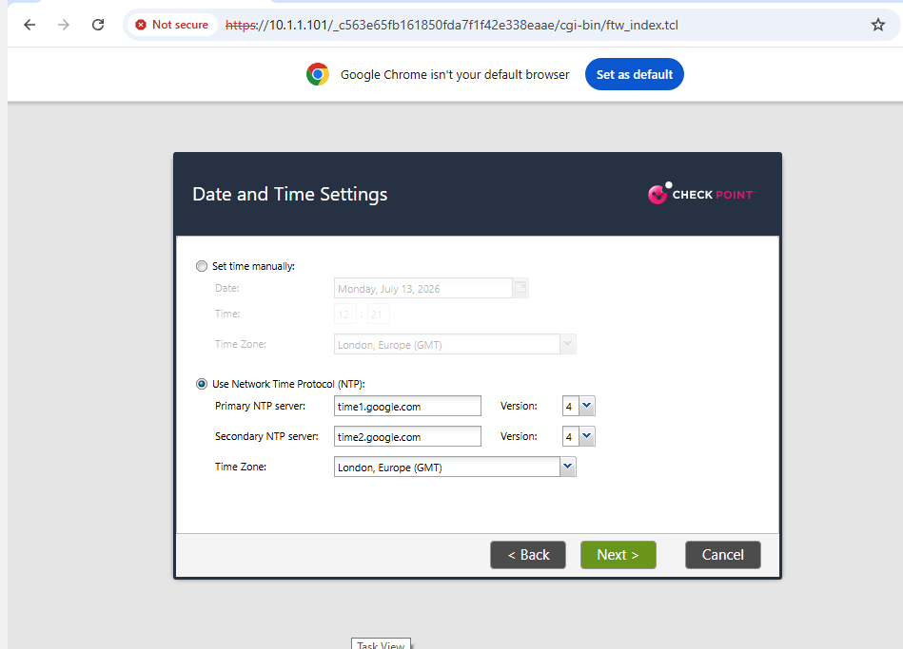
A-SMS NTP Synchronization Time Engine Layout

- Visual Briefing: Network Time Protocol properties window mapping background tracking routines to server instances ://google.com and ://google.com.
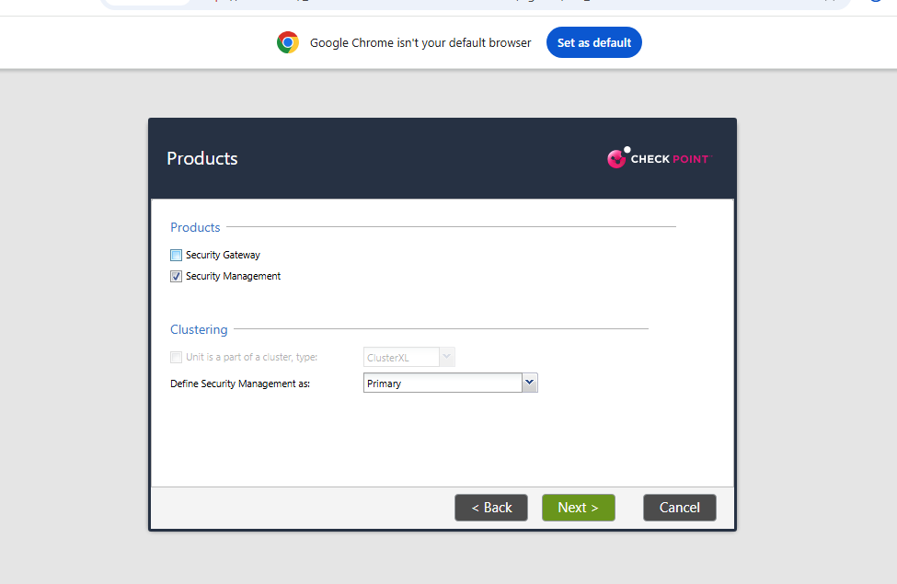
A-SMS Product Selection Separation Setting Checkbox

- Visual Briefing: Product allocation panel customizing the node's function by selecting Security Management and defining its rank structure as a Primary security management engine.
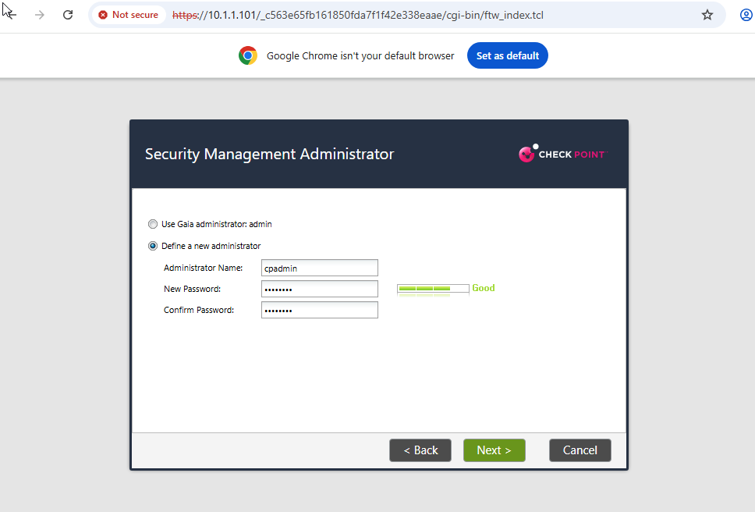
A-SMS Security Management Administrator Account Configuration

- Visual Briefing: Administrative account wizard workspace switching setup parameters to "Define a new administrator" to build a custom security profile named cpadmin.
A-SMS Security Management GUI Clients Restriction Entry

- Visual Briefing: Access limitation panel changing permissions from "Any IP Address" to an explicit network block configuration to allow SmartConsole clients to connect only if originating from within the management network block 10.1.1.0 / 255.255.0.0.
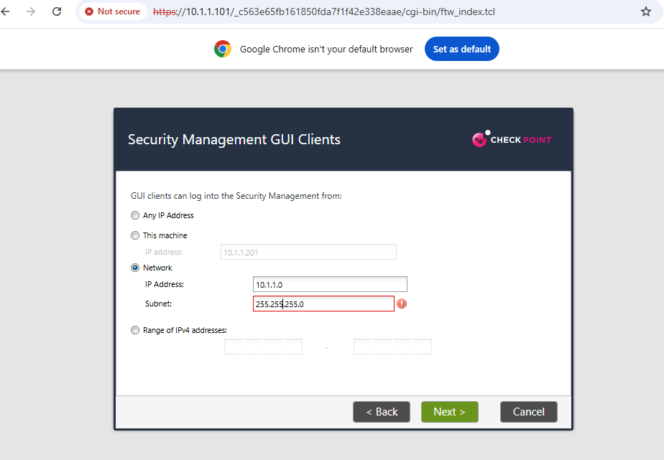
- A-SMS GUI Subnet Input Verification Typo Error

- Visual Briefing: Structural verification warning marker showcasing an invalid input error (255.2550.255.0) safely caught by validation rules, forcing the user to correct the octet schema back to standard parameters (255.255.255.0).
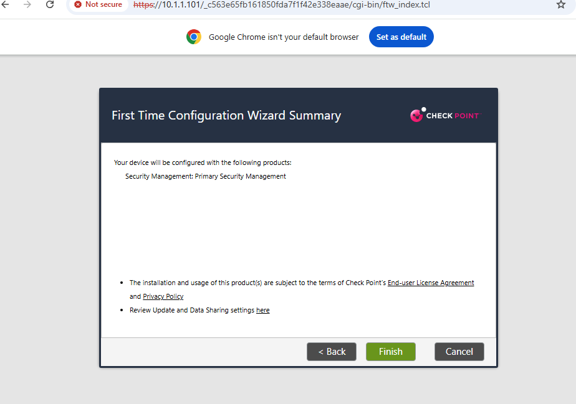
A-SMS First Time Configuration Wizard Summary Layout

- Visual Briefing: Configuration review panel listing variable parameters written to the primary management server files.
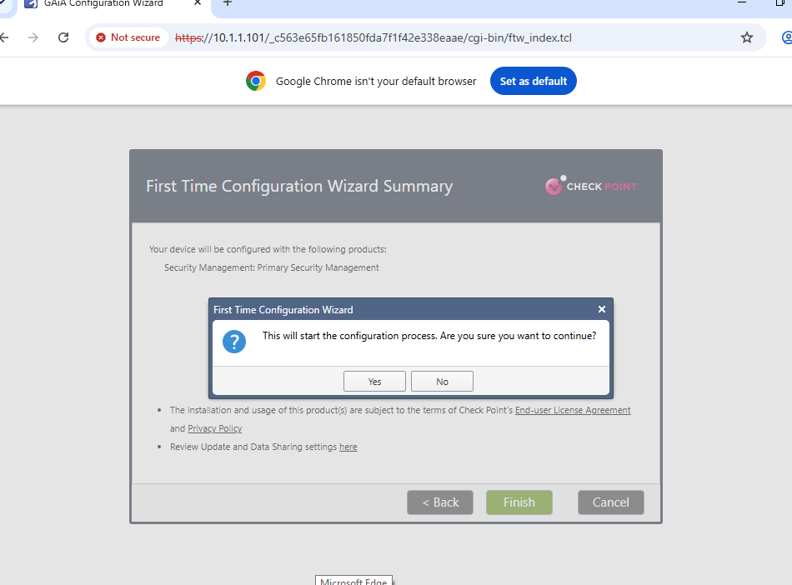
A-SMS Configuration Execution Confirmation Popup

- Visual Briefing: Dynamic prompt window requesting administrative confirmation authorization before compiling initialization variables.
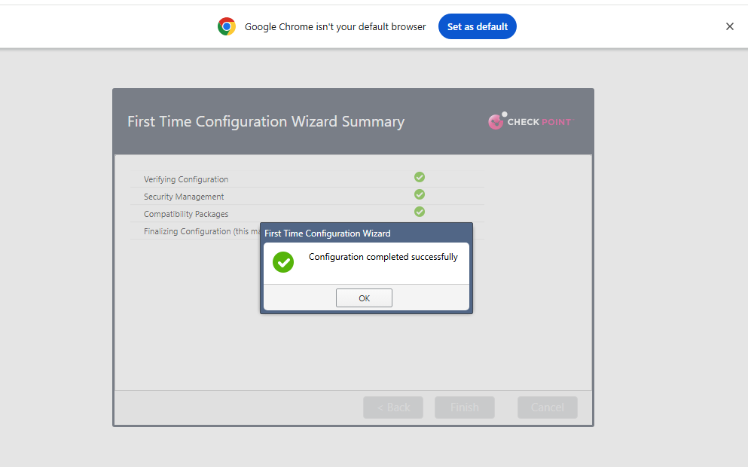
A-SMS Configuration Completed Successfully Dialogue

- Visual Briefing: Configuration complete status popup window tracking green verification flags across the security server application tables.

SECTION 5: ADVANCED GAIA WEB INTERFACE PORTAL CHECKS
With initialization wizard parameters written, live interface matrices were configured inside the GAiA Portal cockpit environments.
5.1 Security Gateway (A-GW) Advanced Multi-Homed Network Interface Engineering
To route and inspect traffic across multiple segments, the firewall's network interfaces were mapped out to separate internal production servers, datacenter links, and external untrusted networks.
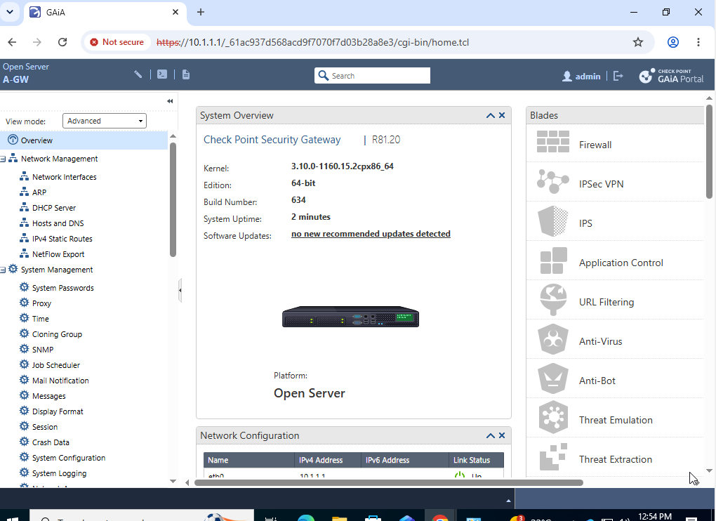
Gaia Live Management Dashboard Operational Summary View

- Visual Briefing: Live Gaia administrative portal dashboard for A-GW, illustrating the platform running kernel version 3.10.0-1160 under a standard 64-bit architecture structure.
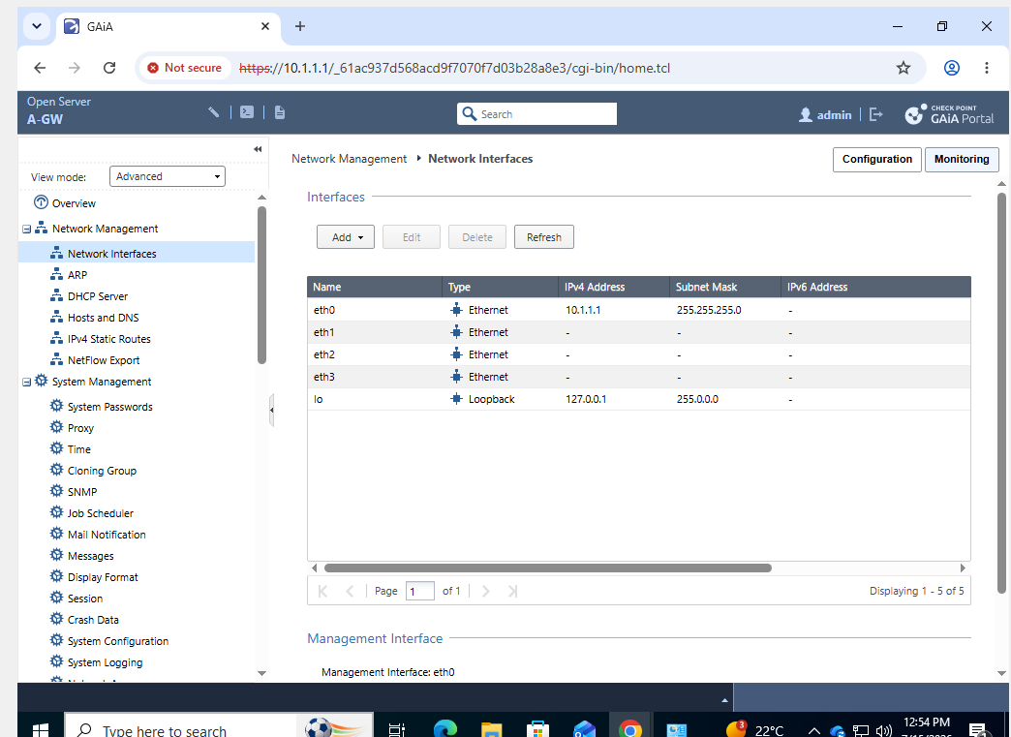
Gaia Portal Network Interfaces Baseline Matrix Grid

- Visual Briefing: Network interface management console tracking physical interface states, showing only interface port eth0 active and running on IP address 10.1.1.1.
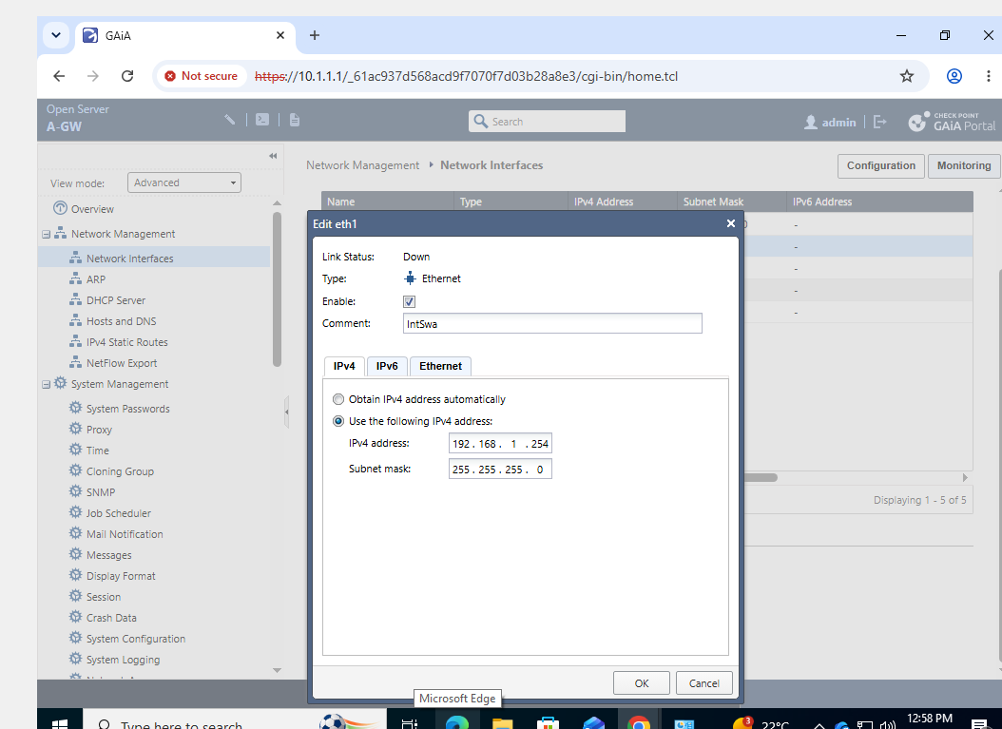
Gaia Portal Interface eth1 Private Intranet Modification Window

- Visual Briefing: Editing configuration window adjusting interface port eth1 properties, assigning static IP address 192.168.1.254/24 commented to protect internal production database assets (IntSwa).
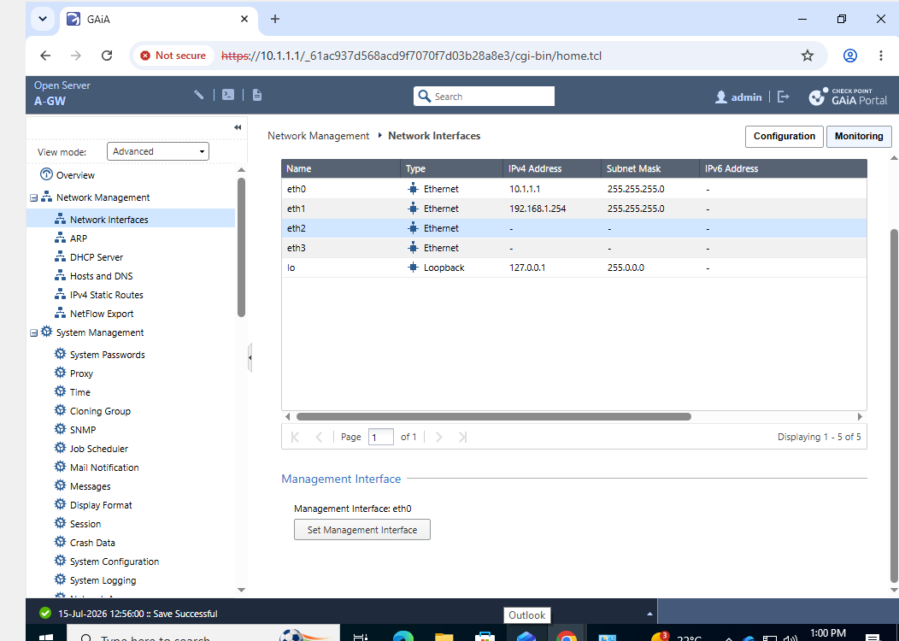
Gaia Portal Network Interfaces Post-eth1 Update Configuration Status

- Visual Briefing: Network physical interfaces summary table verifying interface port eth1 successfully configured and running online.
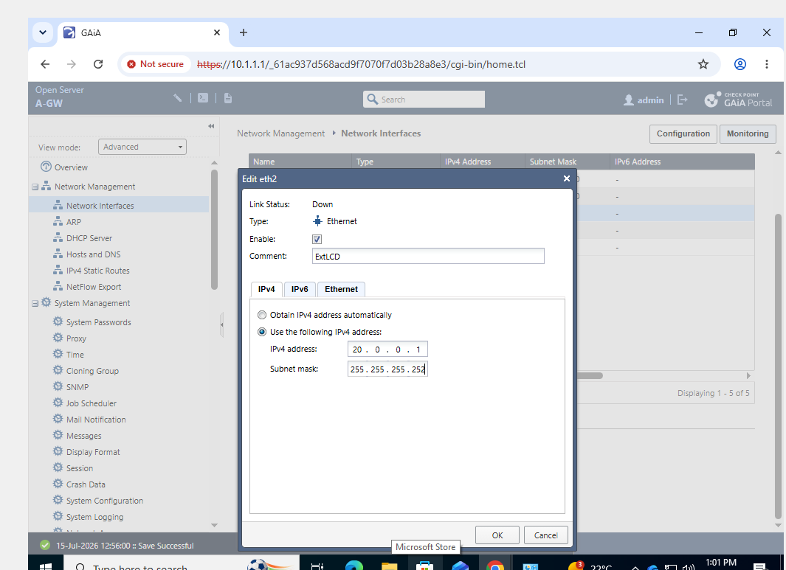
Gaia Portal Interface eth2 Datacenter Interconnect Configuration Dialog

- Visual Briefing: Advanced setup properties box for interface port eth2, assigning a static point-to-point network mapping IP address 20.0.0.1 and netmask 255.255.255.252 commented as cross-datacenter link (ExtLCD).
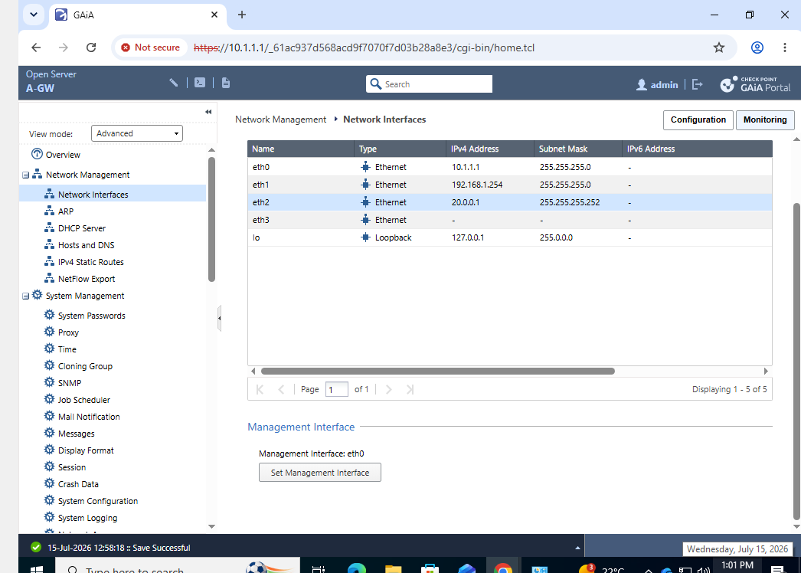
- Gaia Portal Network Interfaces Dashboard Post-eth2 Commit

- Visual Briefing: Interfaces list index verifying that ports eth0, eth1, and eth2 are written to active system storage maps.
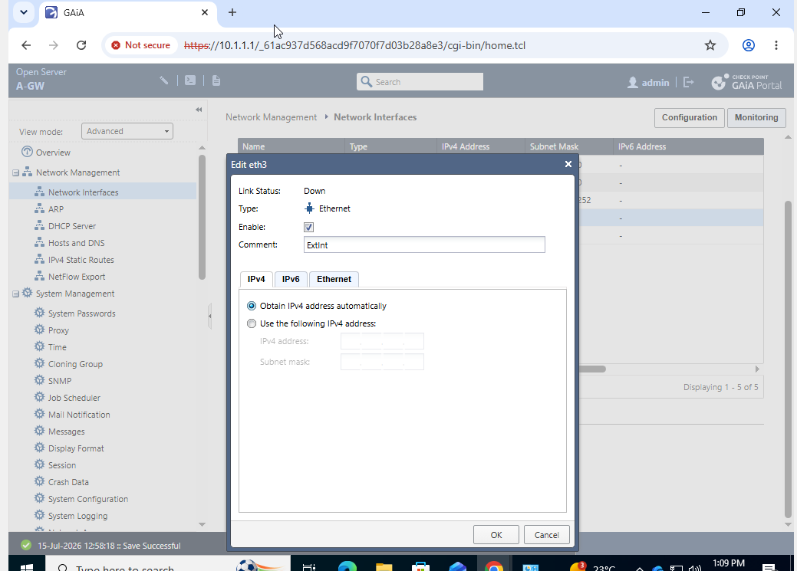
Gaia Portal Interface eth3 External Dynamic Internet Assignment Window

- Visual Briefing: Interface layout canvas for interface port eth3 commented as external link (ExtInt), using dynamic routing parameters to fetch an external public address profile automatically via DHCP.
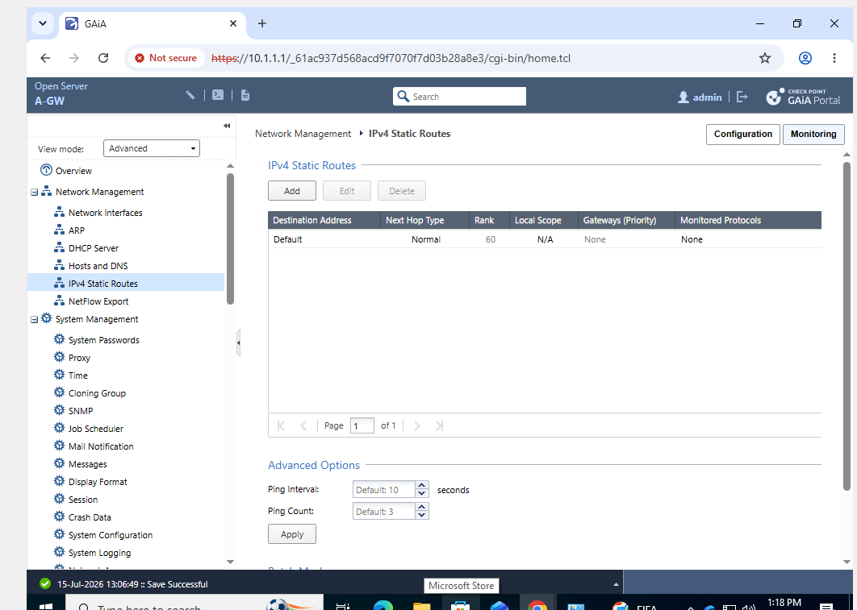
Gaia Portal IPv4 Static Routes Table Core Window

- Visual Briefing: Routing properties manager confirming the live entry configurations for default static network routing tables, with rank indicators set to value 60.

5.2 Security Management Server (A-SMS) System Health Audit
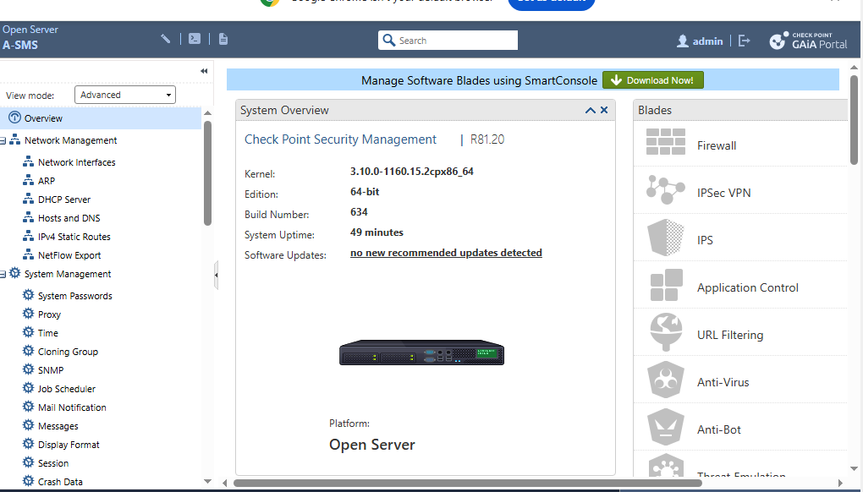
A-SMS Gaia Web Portal Operational Overview Dashboard

- Visual Briefing: Central Gaia system overview layout window for the A-SMS appliance, confirming active platform configuration baseline rules under module version R81.20.
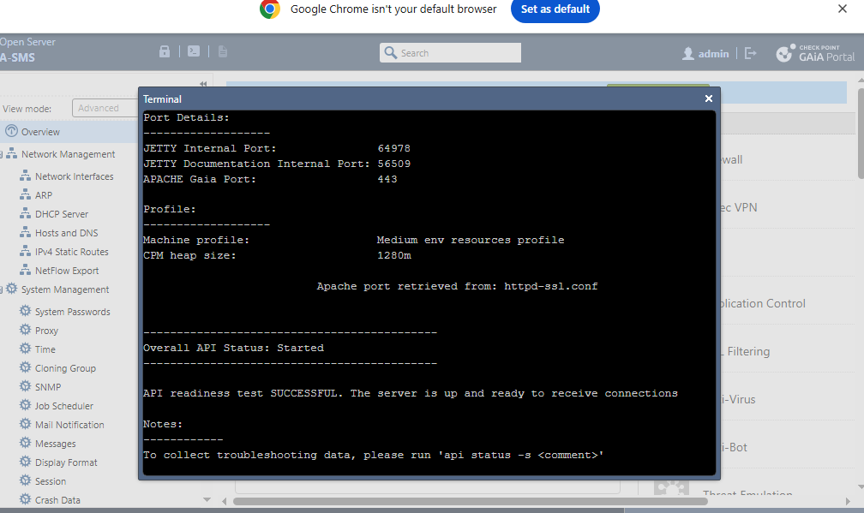
- A-SMS Management Portal Terminal API Readiness Test

- Visual Briefing: Internal management command prompt running terminal state tests. The check panel validates: Overall API Status: Started, and confirms API readiness test SUCCESSFUL. The server is up and ready to receive connections.

SECTION 6: CENTRALIZED SMARTCONSOLE NODE SECURITY MANAGEMENT INTEGRATION
With all nodes online, the final task focused on using the A-GUI workstation to authenticate into the Security Management Server (A-SMS) to build security objects and establish cryptographically trusted links to the gateway (A-GW).
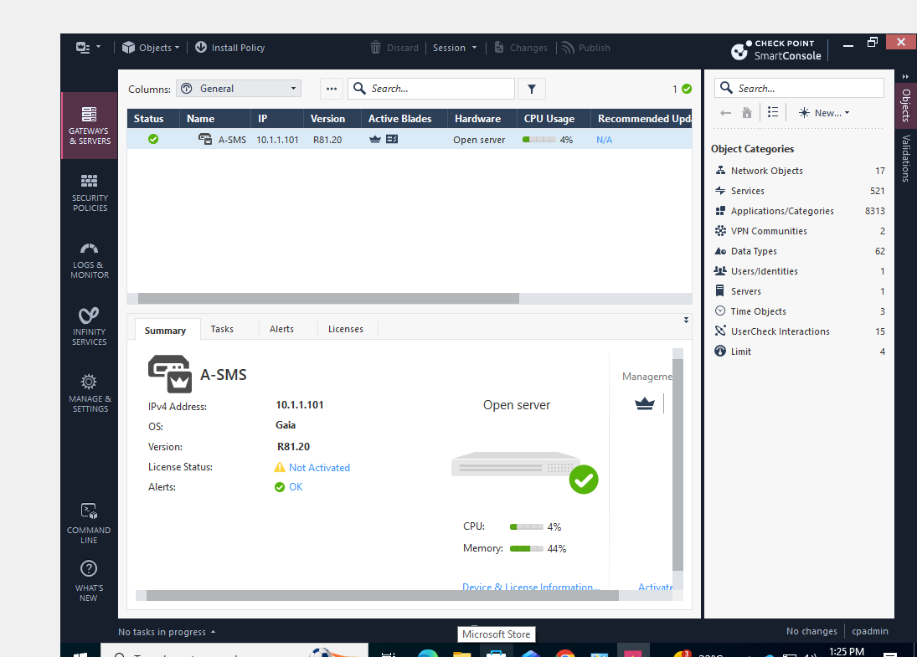
- SmartConsole Core Dashboard Gateways and Servers Operational Grid

- Visual Briefing: SmartConsole main administrative workspace view confirming successful authorization into the primary management server at host IP address 10.1.1.101.
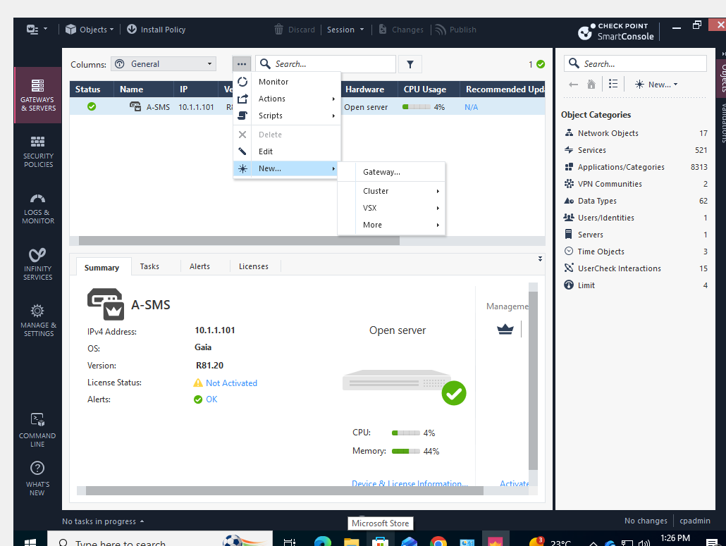
- SmartConsole Object Right-Click Context Menu Options

- Visual Briefing: Contextual menu control panel navigating through configuration dropdown choices: selecting New Object to deploy a standalone gateway profile structure.
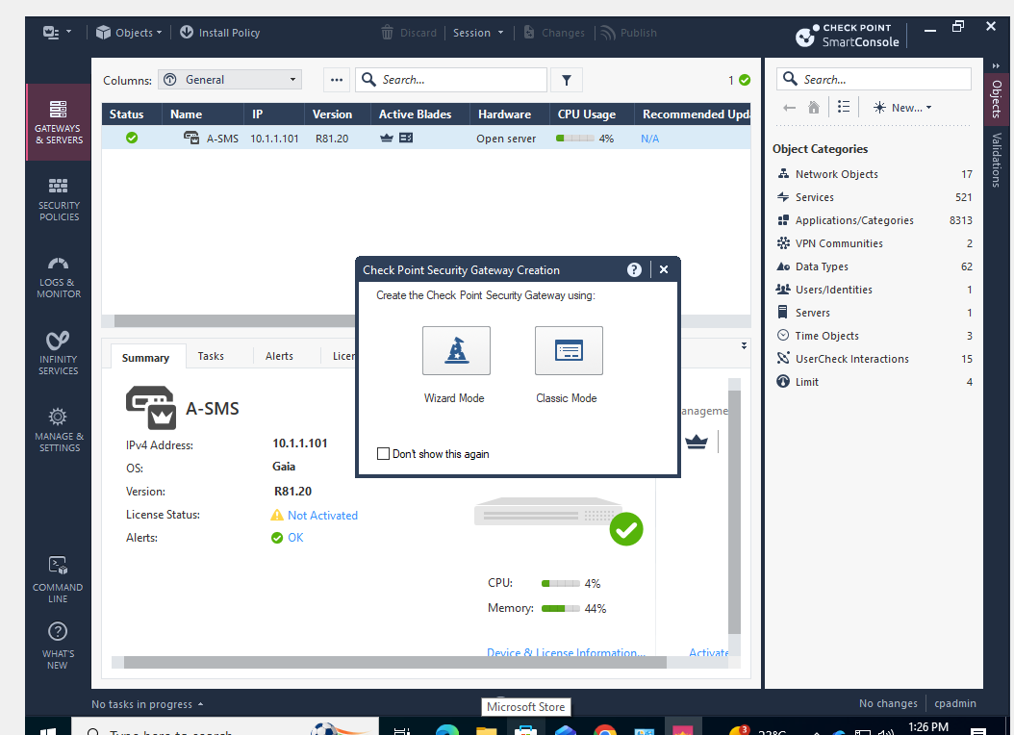
- SmartConsole Check Point Gateway Object Creation Mode Selection Panel

- Visual Briefing: Network object initialization modal prompt offering choices between Wizard Mode setup tracking lines or manual Classic Mode mapping vectors, with Wizard Mode selected.
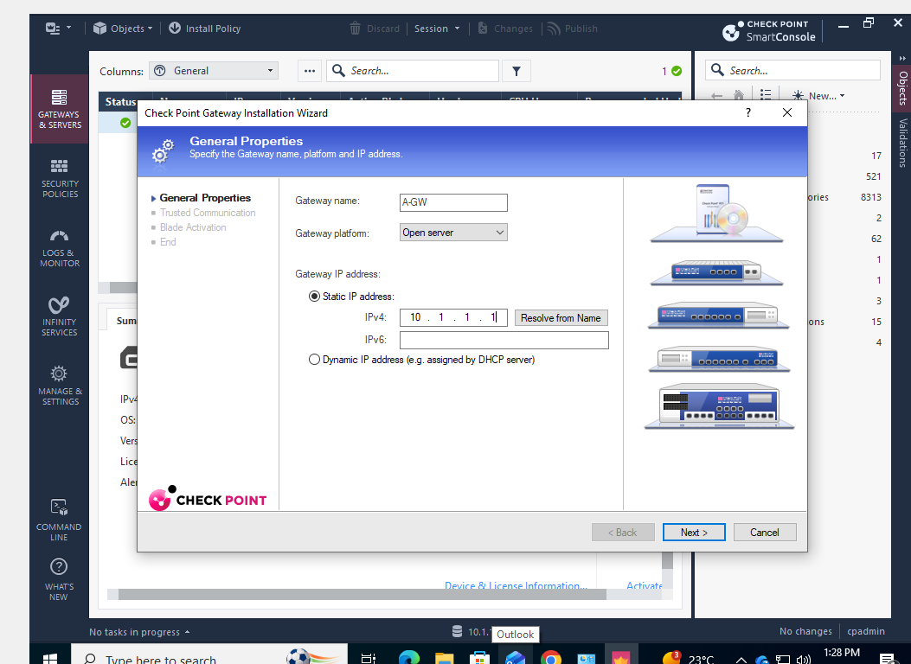
- SmartConsole Gateway Creating Wizard General Properties Dialog

- Visual Briefing: Network object definition panel naming the node identifier to A-GW, setting its platform footprint parameters to Open Server, and pinning its static target IP to 10.1.1.1.
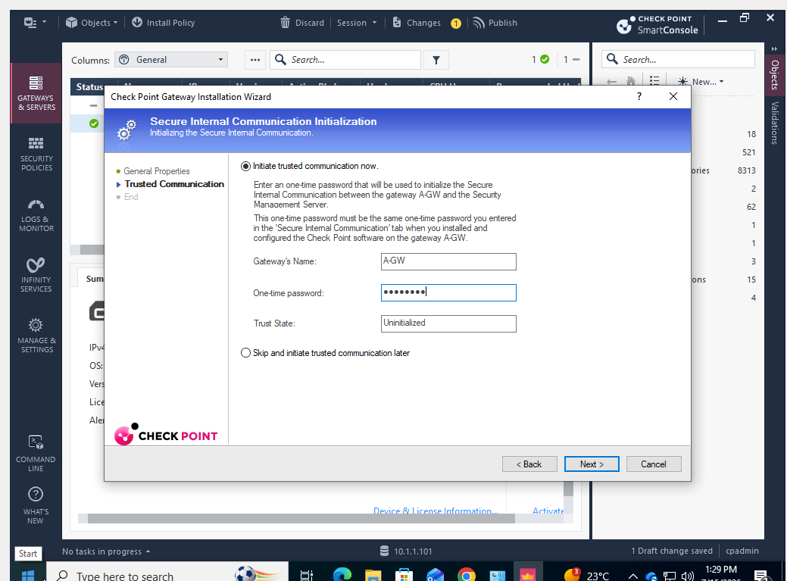
- SmartConsole SIC Cryptographic Handshake Initialization Box

- Visual Briefing: Trusted Communication wizard step where the shared one-time activation passkey is entered to coordinate a cryptographically secure handshake with the remote appliance.
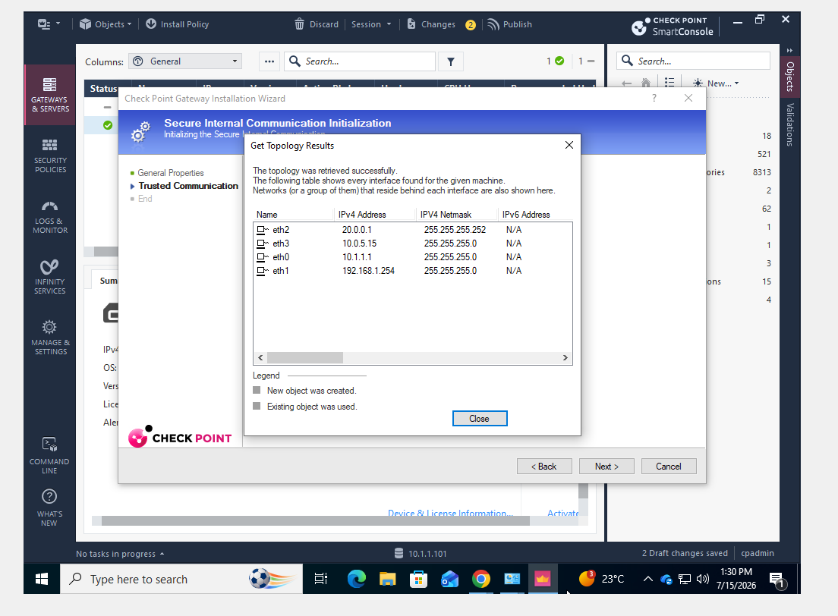
SmartConsole Secure Interface Topology Fetch Verification Popup

- Visual Briefing: Topology fetch reporting page showing a successful interface scan across the secure internal communication link, displaying multihomed firewall connections (eth0, eth1, eth2, eth3) verified straight from the gateway's live configuration.
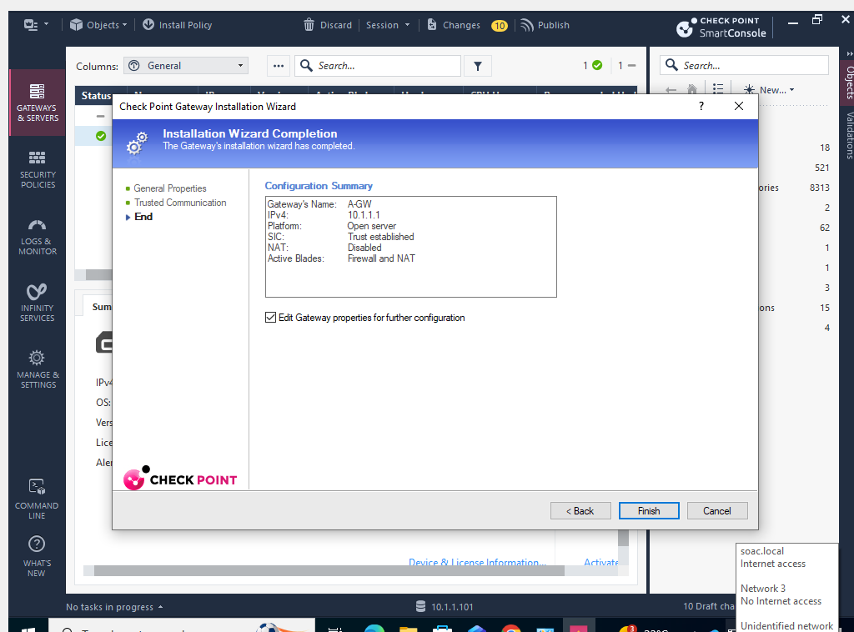
- SmartConsole Gateway Installation Wizard Completion Overview

- Visual Briefing: Final configuration summary screen for the creation wizard, verifying that the cryptographic handshake has successfully run and completed with a status of "Trust established".
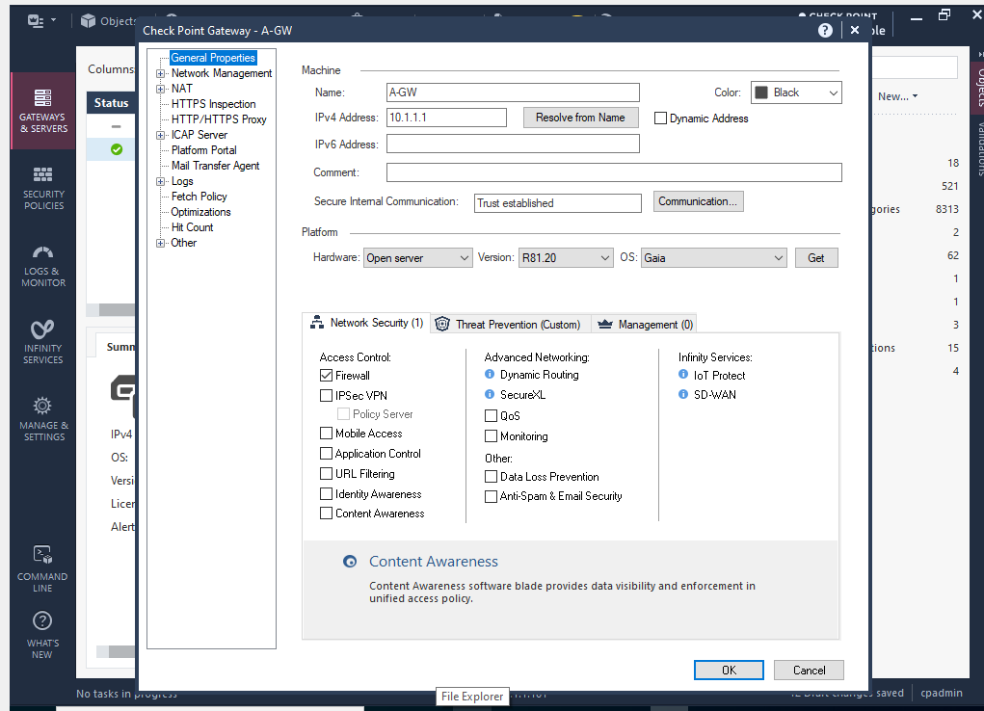
SmartConsole Gateway General Properties Profile Properties Panel

- Visual Briefing: Unified properties summary dashboard for the gateway profile (A-GW), confirming active communication states matching the live R81.20 architecture platform variables.
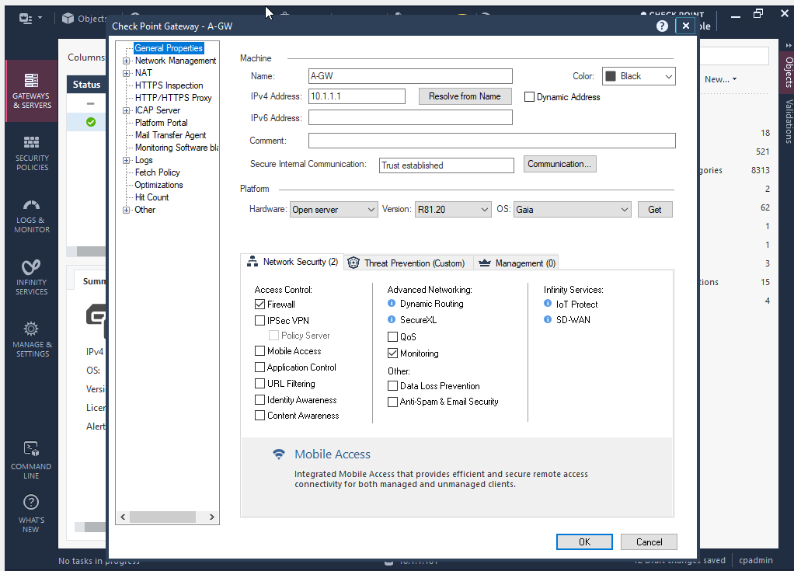
SmartConsole Gateway Properties Security Blade Feature Checklist Summary

- Visual Briefing: Firewall inspection blades activation dashboard, demonstrating the manual activation of the Monitoring checkpoint inspection feature blade checkbox to finalize setup.
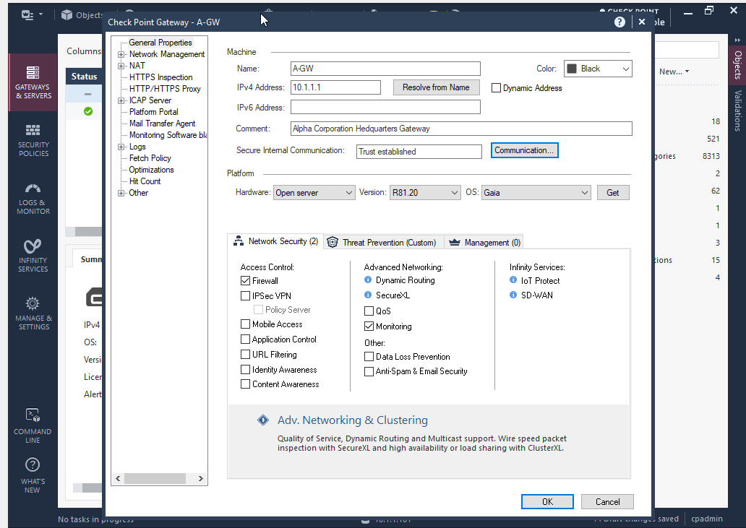
SmartConsole Gateway Properties Object Comment Injection

- Visual Briefing: Advanced object configuration pane where a custom tag comment note is injected, defining the appliance comment classification string as: Alpha Corporation Headquarters Gateway.

SECTION 7: PHASE PROGRESSION LOG ANALYSIS (LAB SUBMISSION APPROVED)
By evaluating the step-by-step implementation milestones captured in these snapshots, the deployment successfully matches the security design requirements for ACCA7032 Enterprise Network Security:
- Multi-Homed Interface Separation Complete: The Security Gateway perimeter boundary node (A-GW) has been configured with its multihomed interface layout, successfully bridging the management link (eth0), internal server network (eth1), cross-datacenter interconnect line (eth2), and dynamic outbound internet access port (eth3).
- Hardened Management Restriction Enforced: Centralized management console connection lines are locked to an explicit 10.1.1.0/24 subnet restriction boundary entry, shielding the primary management server from unauthorized configuration calls outside the secure management segment.
- SIC Trust Infrastructure Active: Secure Internal Communication channels have successfully completed their handshake routines, verified by green status indicator lamps and real-time topology mapping verified straight within SmartConsole. The enterprise architecture setup is complete and ready for firewall access rules and traffic inspection policies.

