

Fighting Game in Esports & What Sets Them Apart From Each Other

by
Calum Case

Supervisor: Adam Head

May 2023

Contents
1. List of Abbreviations 2
2. Introduction 3
3. Background Research 4
3.1 Literature Review 4
3.2 E-Sports 4
3.3 Spectators 4
3.1.1 Downloadable Content 4
3.1.2 Online Gameplay 4
3.4 Types of Fighting Games 5
3.4.1 Sub-Genres 5
3.4.2 Street Fighter 6
2.4.3 Super Smash Bros. 7
3.4.4 Tekken 10
3.4.5 MultiVersus 12
3.4.6 Independent Fighting Games 14
4. Discussion 15
4.1 The Appeal of Each Fighting Game Sub-Genre 15
4.2 Video Games Mods 16
4.2.1 Super Smash Bros. & Project M 16
4.2.2 MultiVersus 17
4.2.3 Rivals of Aether 17
4.3 Findings 17
4.3.1 Analysis 17
4.3.2 Evaluation 18
5. Conclusion 18
6. References 19
7. Bibliography 23

1. List of Abbreviations
DLC – Downloadable Content
FPS – Frames Per Second
Indie games – Independent games
MV – MultiVersus
Rivals – Rivals of Aether
ROA- Rivals of Aether
SF – Street Fighter
SFV – Street Fighter V
SSB – Super Smash Bros.
SSBB – Super Smash Bros. Brawl
SSBM – Super Smash Bros. Melee
SSBU – Super Smash Bros. Ultimate
Smash 4 / SSB4 – Super Smash Bros. For 3DS, Super Smash Bros. For Wii U

2. Introduction
In this written report, we will be discussing fighting games in esports and their differences between them. Other topics will be discussed too such as: The history of competition dating back to gladiator fights. One of the main topics is Esports, this will be discussed in detail throughout this paper covering topics such as the history of certain games. The subject of spectators will also be talked about as spectators are a big factor in Esports and this paper will discuss why people like to watch Esports as a spectator.
Downloadable Content will also be covered, this is an interesting topic to discuss with fighting games and Esports as the introduction can really make or break a video game’s competitive play base and the game’s life cycle. This paper will discuss certain cases that stand out with Downloadable content with cases such as player banning certain Downloadable fighters.
Online game modes in fighting games have also been talked about due to it being a common way for players to compete in online tournaments. There will be some additional detail regarding online as there are different ways online game modes have been developed that can affect the overall experience drastically known as a delay based netcode and rollback netcode being the topic of discussion, a comparison will also be made for these two types of online developed modes.
After the online section, the report will then talk about the sub-genres in fighting games as this is one major difference with most fighting games that are available and are supported in Esports. This section will discuss what are the sub-genres and will also list some examples of games that fall under each sub-genre.
After the sub-genres, a list of games will then be discussed in detail. Each game is unique and each deliver something different when playing and spectating. These games include Street Fighter series, Super Smash Bros. Series, Tekken Series, MultiVersus and Independent fighting games with Rivals of Aether being discussed in detail. Topics such as the history of each game series, what genre each game series is, the popularity of the games, how each series is represented in Esports, the present stage of each series, what does the future have for them, what makes them unique and final the Downloadable Content are all talked about in detail for each game series mentioned.
Modding will also be discussed in detail as video game mods have been used in Esports before with fan made game overhauls being as popular as the original game without mods. This part will also discuss where modding has been disallowed and allowed in some cases as well as comparing two cases of a game series using mods to greatly benefit the players.
After the modding section, the findings will be discussed with the research that was conducted for the paper. This will include an analysis with a comparison of all the discussed games to see what game series are currently in a stable safe spot and we will also discuss the games that are not as successful as others and in some cases the game even getting shut down making it unplayable.
Finally, an evaluation will also be conducted of everything that was found while conducting the research for this topic.

3. Background Research

3.1 Literature Review
The history is competitive sports/games goes back a long time, back to when gladiators were fighting and competing. The earliest battle took place in 215 BC during the first Punic War with the Rome against the Carthage [1]. Outside of the war there were the gladiator games, this was an event that was created by the Etruscans with warriors fighting to their deaths to honor their “warlike” spirit. This became a common practice for the foreseeable 800 years with the Romans as part of a funeral that takes place [2].

3.2 E-Sports
E-sports, also known as electronic sports, is a term used to describe competitive video games. These video games can range from first person shooters to racing games. There are professional players from all over the world behind each of these games and each of them are dedicated to becoming the best with most being signed by organizations to sponsor the player to give them an income to play Sports a viable living option to the professional players. Early E-sports was with the video game known as proto-Pong and this is considered one of the earliest competitive video games made [3].
E-sports is now popular at the global scale with video games having big leagues for their games such as the Overwatch League and EA’s FIFA Nations Cup being a popular e-sport for those who are involved and the viewers.

3.3 Spectators
Spectators are watching an event take place and e-sports is an easy sport to spectate due to how accessible it is to watch esport events via livestreams on websites such as YouTube, Twitch and sometimes esports is even shown on TV. Spectators can also attend certain esports events whether it is to compete in the tournament as this is common in the fighting game esport community or players showing up in person to spectate the game and support their favorite players [4].

3.1.1 Downloadable Content
Downloadable content (abbreviated to DLC) is content that can be downloaded to a video game and fighting games are no exception. DLC is common amongst fighting games as fighting games add new characters via DLC. This has been proven to be both a positive and a negative, it is a positive as it keeps players returning to play the new DLC release and to keep community interest with the game, but in some cases having DLC can impact the game in a negative way. Some fighting games have had DLC that adds new characters to the game that are unbalanced and could potentially hurt the competitive players due to the DLC being too strong in the game, there have been various cases where a DLC fighter have been banned from tournaments due to how strong they can be. While this can be fixed with balance patches that tone the fighter down, Super Smash Bros. For 3DS and Wii U (abbreviated for Smash 4) had a notorious case with its final fighter Bayonetta. This fighter was overturned and was too strong in the game, tournaments banned the character while Nintendo had moved on from giving the game balance adjustments [5].

3.1.2 Online Gameplay
Fighting games are expected to feature an online mode where players can play the game with other players around the world. However, this comes with its own issues as there are many distinct types of ways a fighting game is played online. There are two common ways fighting games are made for online play, they are delay-based netcode and rollback netcode, while the differences are small, they can make a substantial impact on how competitive players play fighting games online.
Rollback netcode is a type of online play that will reduce latency a game has during online play [6]. This makes the online game a lot more responsive and is the preferred way that fighting game players want their online games developed. Games such as: Guilty Gear Strive, MultiVersus, Street Fighter 5 and Skullgirls all use rollback netcode for their online mode benefiting the players and the game itself [7]. Some players have added rollback netcode to the game by themselves, Super Smash Bros. Melee a game that is over 20 years old game now has an online mode thanks to the community creating a online mode for the game known as Slippi [8].
Delay-based netcode is the alternative method fighting games are developed for online play. This method of online play is less efficient as it can cause more lag to the game and more drops in the game’s frame rate resulting in specific butting commands not being reliable online with delay based netcode [9]. Some fighting games have first used the delay based netcode but due to demand from the players have changed to the more efficient rollback netcode.

3.4 Types of Fighting Games
This section will cover the various fighting games that are available to play. Topics such as the history of each game, popularity, the e-sports representation, the present and future, what makes each covered fighting game unique and DLC. The games that will are covered and discussed are Street Fighter series, Super Smash Bros series, Tekken series, MultiVersus and Independent fighting games. The topic of sub-genres will also be discussed the several types of fighting games such as 2D and platform.

3.4.1 Sub-Genres

3.4.1.1 2D
2D fighting games are your traditional fighting games that are typically 2D with no 3D movement with the only way of movement is forward and back with vertical movement in the air [10]. These types of games tend to be played on a flat stage with walls on each side of the screen. A few examples of 2D games are Street Fighter and Guilty Gear.
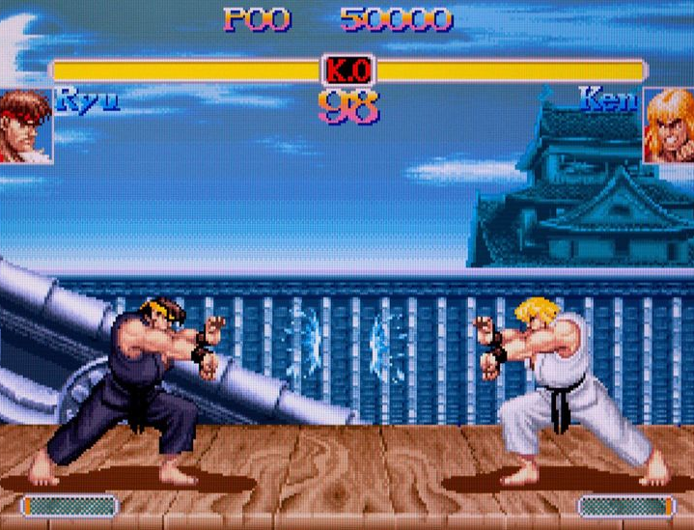
Figure 1 Example of a 2D fighter (Street Fighter II)

3.4.1.2 Platform
Platform fighters are like 2D fighting games with the addition of more movement options and the stages introducing platforms. A few examples of a platform fighter are Super Smash Bros series of games and MultiVersus.
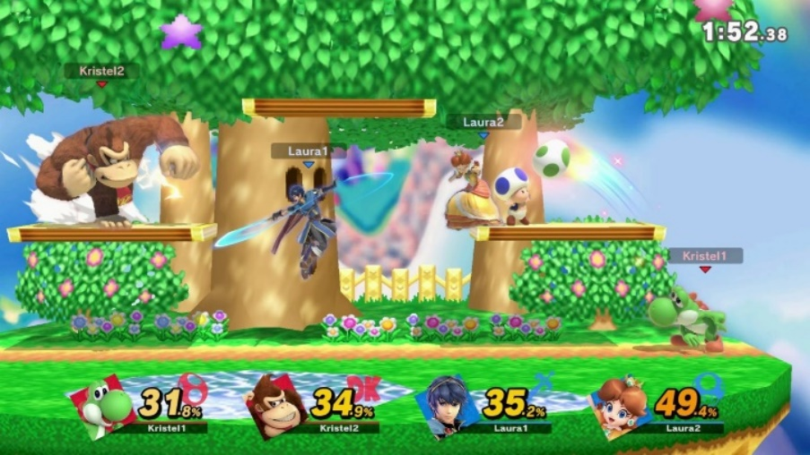
Figure 2 Screenshot example of a platform fighter (Super Smash Bros. Ultimate)

3.4.2 Street Fighter
Street Fighter (abbreviated to SF) is one of the oldest fighting game series that is still receiving new releases while keeping a sizable player base too. The very first Street Fighter game was released in arcades in 1987. After the first release the series did receive a sequel known as Street Fighter II: The World Warrior. Street Fighter 2 went on to become one of the best-selling fighting games of all time, selling over twenty million units [11].
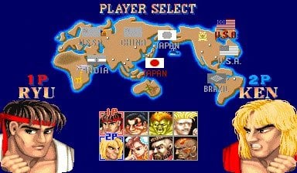
Figure 3 Image of the character selection screen seen in Street Fighter II
Street Fighter 2 also received several spinoff titles that included fan favorites such as Street Fighter II Turbo: Hyper Fighting and Super Street Fighter II – The New Challengers. As the series grew new entries were also released Street Fighter III, Street Fighter IV and Street Fighter V have all been released with various spinoff titles for each big entity with rereleases of the older game being released for modern platforms too [12]. This is good because it allows players the option to play the older titles in the series in the most efficient way possible.
SF is a traditional 2D fighting game. This style of fighting game is popular as most other fighting games in and out of the esports picture tend to be played as a traditional 2D fighting game.
SF is one of the most popular fighting games esports in the world currently. The series has its own league named the Street Fighter League that has become wildly successful [13].
The future of the series is with the next entry in the series, Street Fighter 6. The game is near to release, and Capcom have started to conduct public beta tests and release a demo before the game released in June [14].
Due to DLC being a more modern practice, the older SF games were not able to have DLC, this started with SF III: 3rd Strike with simple recolors of the fighters and music [15]. As new entries were released, Capcom decided to release new DLC characters, this can be seen with SFV as the game received a big number of DLC characters (seen below with images of the roster before DLC and after DLC.
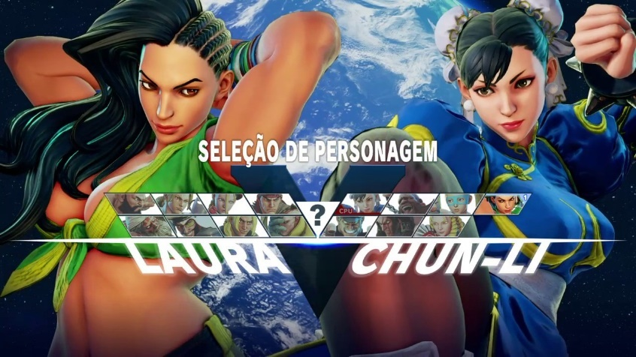
Figure 4 Image of the roster in Street Fighter V with no DLC
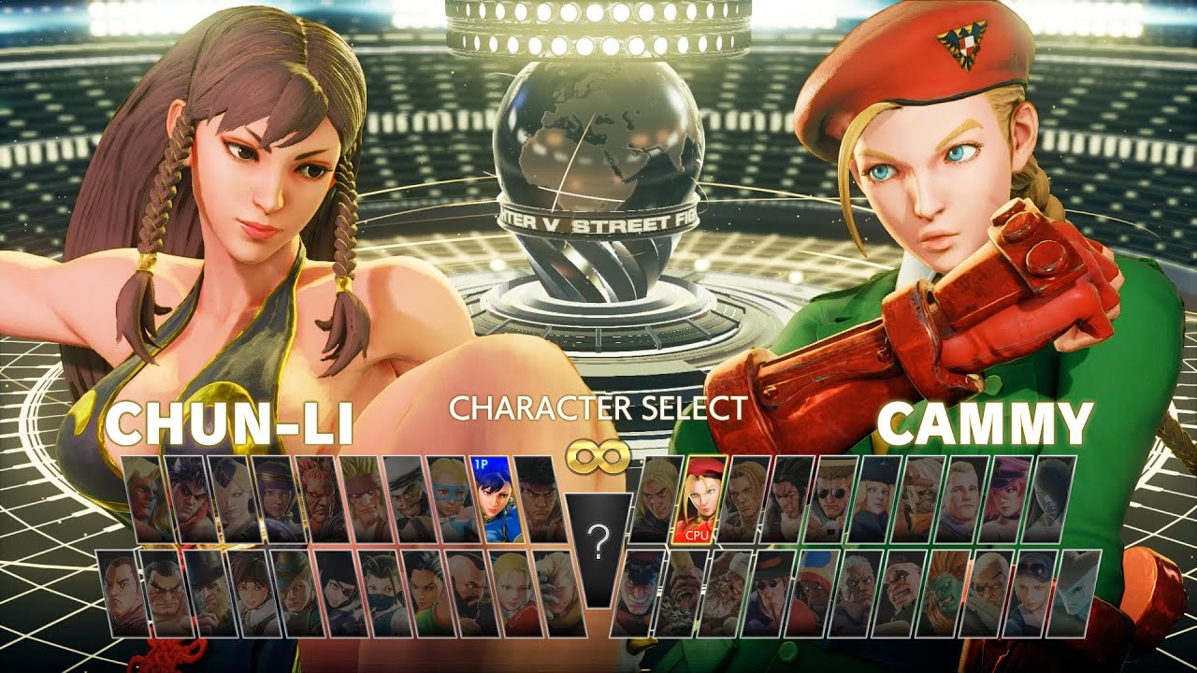
Figure 5 Image of Street Fighter V with all its DLC purchased.

2.4.3 Super Smash Bros.
Super Smash Bros is known as a platform fighter that is not common amongst other fighting games. A platform fighter has the players fight typically on a floating platform with the goal being to knock your opponent off the stage. Unlike most other fighting games, you have a life system unlike the usual life meter that fighting games tend to offer. The series was also developed as a party game with casual players in mind and no competitive aspects specifically developed, this results in the game being played in a unique way with the competitive players [16].
Super Smash Bros has a rich history with the first entry dating back to the Nintendo 64 with a total of 8 characters (seen below) selling a total of 5.5 million units as of December 2014 [17].
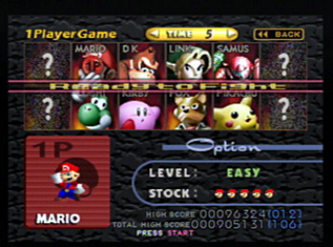
Figure 6 Image of the roster from the first Super Smash Bros game
The first game was successful, and a sequel was quickly made for Nintendo’s upcoming GameCube console. The sequel, Super Smash Bros. Melee (abbreviated to SSBM) was released early into the GameCube’s life and became the bestselling game for the GameCube with a total of 7.41 million units [17]. SSBM is still being played to this day with a thriving community that has researched 20 plus years into the game to find optimal combos and techniques to outplay their opponents. The next game in the series is Super Smash Bros Brawl, released on the Wii and became one of the best-selling games for the system with a total of 13.32 million units. [18]. The next two games were released near each other due to them being similar, Super Smash Bros for 3DS and Wii U released in 2014. The 3DS version of the game sold 9.64 million [19] and the Wii U version sold 5.38 million units [20]. Finally, the latest game in the series, Super Smash Bros Ultimate (abbreviated to SSBU), was released for the Nintendo Switch with the biggest roster in the series with a total of eighty-one unique characters (see figure 3 below). This game sold a total of 30.44 million units, the third biggest selling game for the Nintendo Switch [21].
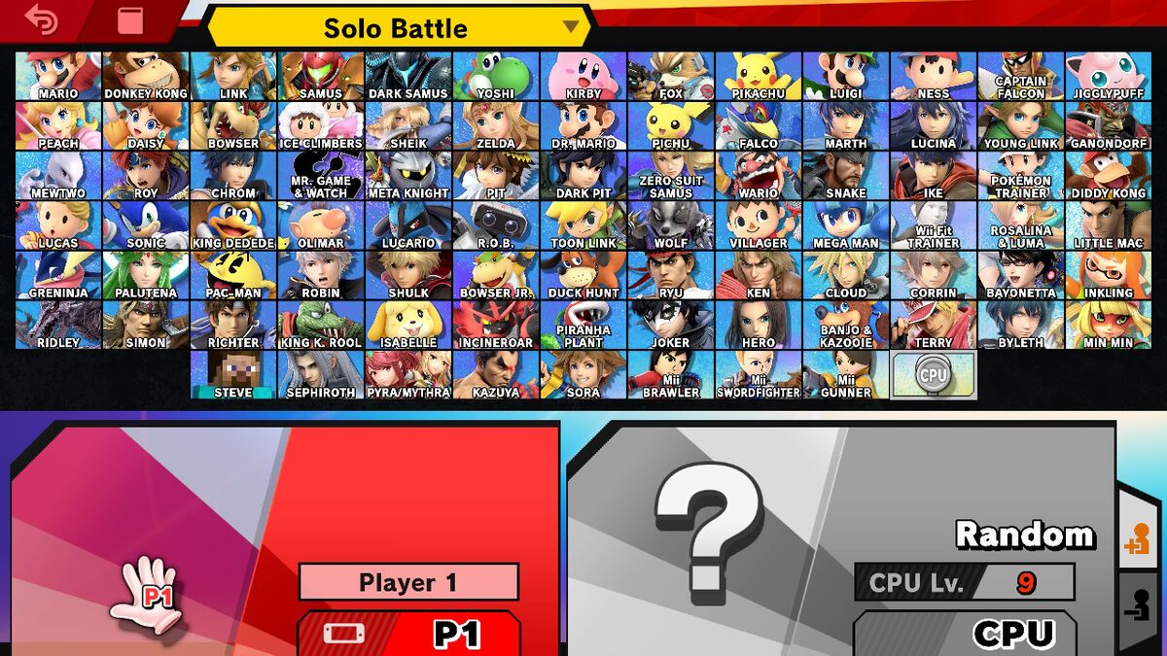
Figure 7 Image of the character selection screen from Super Smash Bros. Ultimate with all the DLC shown.
The Super Smash Bros. games are simple in playstyle when compared to other fighting games. Unlike traditional fighting games, Smash does not utilize long and complex command inputs to execute moves but rather only uses a few buttons for all its attack options. This can be seen below:
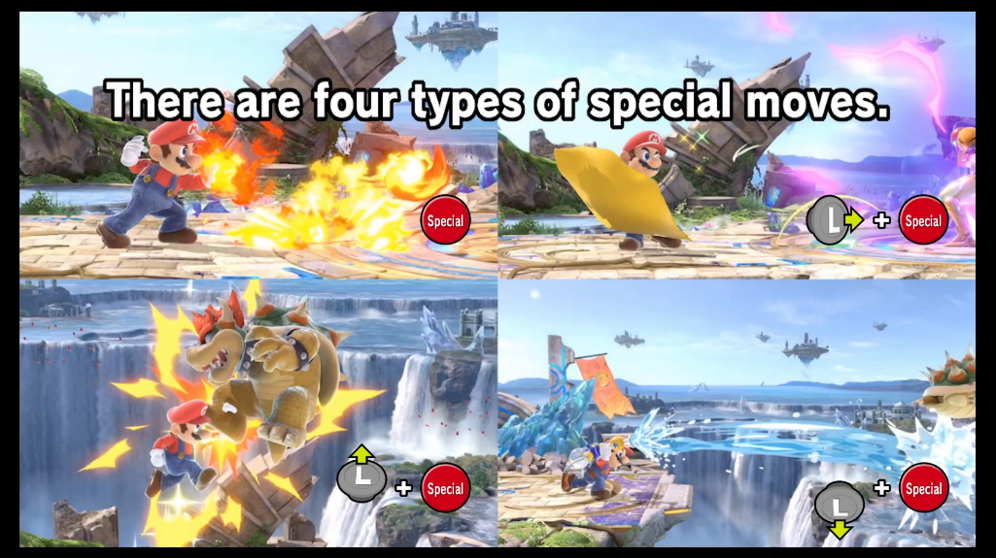
Figure 8 Image of a section of the How to Play video found in SSBU.
Super Smash Bros has had DLC for three of its latest games being the 3DS, Wii U and Ultimate on the Nintendo Switch. The 3DS and Wii U titles share the same DLC and were received poorly due to certain fighters being unbalanced resulting in professional players leaving the game. This DLC is now unavailable to download due to Nintendo shutting down their online stores for the Wii U and 3DS [22].
SSBU also had post launch content made in the format of two Fighters Pass.’ Each fighter’s pass contained new fighters with casual players enjoying the added content due to the characters being highly requested fighters. On the other hand, the competitive players noticed that the new fighters were too strong in the game resulting in certain characters being banned from tournaments due to how strong they were and Nintendo having no interest to balance the game after finishing created content for the game [23].

3.4.4 Tekken
Tekken is a fighting game that was developed and released by Namco first for arcades and was soon ported to Sony’s PlayStation. The first Tekken game on PlayStation was well received by players and a sequel was developed by Namco and released shortly after the first Tekken game was released.
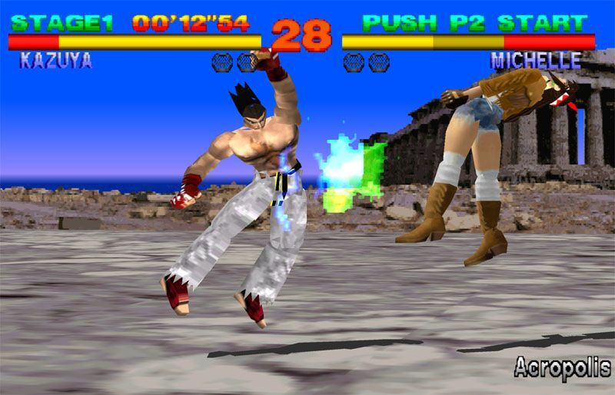
Figure 9 Image of the first Tekken on PlayStation
Tekken has been a mainstay on consoles since it released on PlayStation as there have been entries on PlayStation 2, PlayStation 3, PlayStation 4, soon PlayStation 5, PlayStation Portable, Xbox 360, Wii U, Xbox One, Xbox Series X and Series S and PC. The latest entry in the Tekken series Tekken 8 is currently in development.
Tekken is a 2.5D fighting game, like a traditional 2D fighting game. However, the players can move in the Z axis resulting in Tekken games having a 2.5D aspect to the gameplay. The stages are fully 3D, and most stages can be interacted with due to them being in a 3D space.
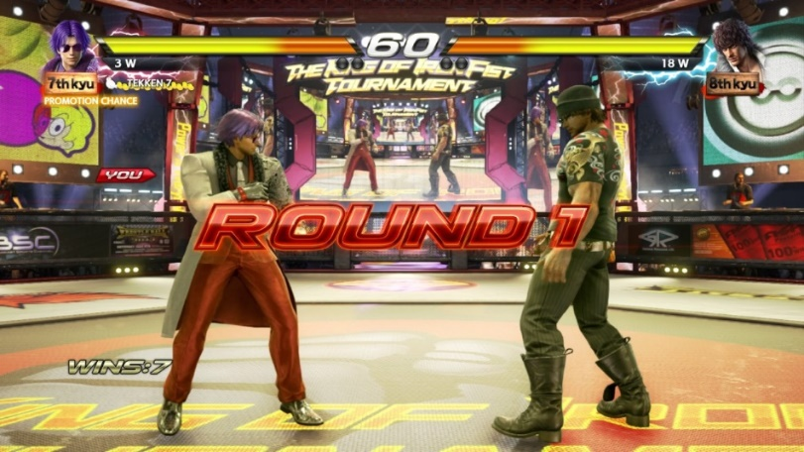
Figure 10 Image of Tekken 7 to show the 3D stages.
Tekken is a popular fighting game series with casual and especially competitive players. The s-sports community for Tekken is well received by its players and the viewers of the game. The latest Tekken game Tekken 7 is one of the biggest fighting games in e-sports currently. With the support of the developer (Namco) the e-sports has been able to host tournaments with big prize pools with the total amount currently at $1,290,688 have been given away as prize money [24].
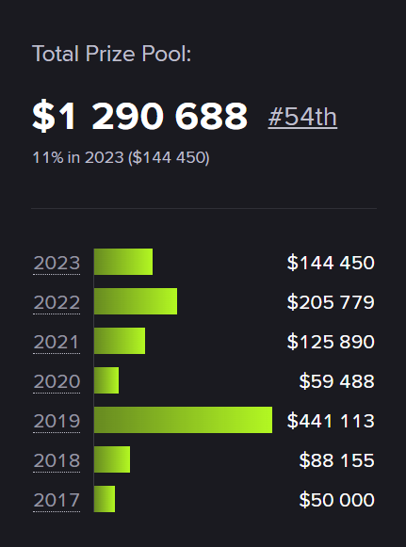
Figure 11 Total money made during Tekken 7's e-sport history dating from 2017 to present day.
Tekken also has a tournament series named the Tekken World Tour that happens yearly that had players from around the world competing in various tournaments (see figure below) in a year to earn points. The players with the most points are invited to the Tekken World Tour Finals to determine who the best player is from that respectful year [25].
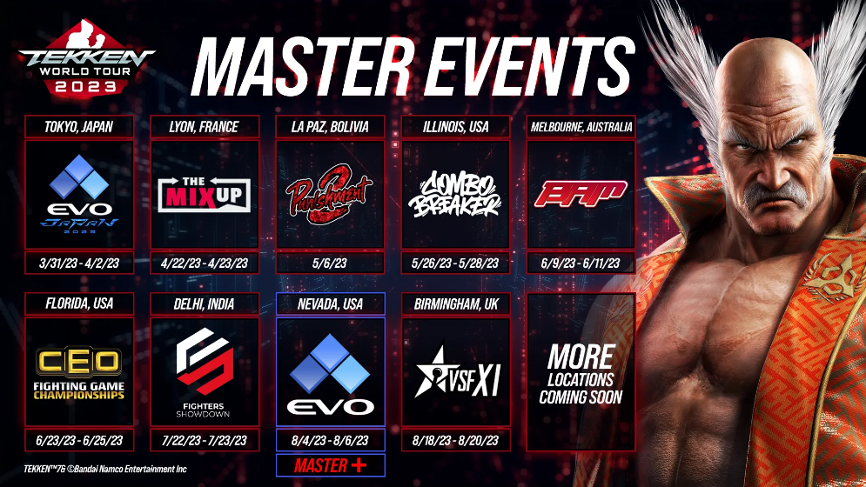
Figure 12 Image of the upcoming Tekken World Tour 2023 and its various locations that qualify for the Tekken World Tour.
Currently, the Tekken series has the upcoming Tekken World Tour 2023 that will be beginning soon along with the next entry in the Tekken series Tekken 8 being developed.
Tekken stands out from every other fighting game in the E-sports scene due to how the game is played and the sub-genre. Tekken players usually use a controller known as a box controller. A box controller is a box that emulates the buttons and sticks that are usually seen on arcade cabinets. This is how most professional players play the game.
Tekken has received DLC in the way of new characters, this can include popular requested characters, crossover characters and brand-new original characters. While most DLC fighters were balanced upon release, Tekken has however fallen into the trap of releasing a DLC fighter that is unbalanced. This was apparent with the release of Leroy Smith in Tekken 7. It was apparent that Leroy Smith had little to no weakness in the game and this made the character difficult to beat resulting in players not being happy with the character. This was brought to the attention of the developers Bandai Namco, and they had quickly released an update to Tekken 7 to balance Leroy Smith to make him a balanced character to use and to fight against. The community was satisfied with this balance change to Leroy Smith [26].

3.4.5 MultiVersus
MultiVersus (abbreviated as MV) is a free to play fighting game that is available on PlayStation, Xbox, and PC platforms. The game had microtransactions and a battle pass system to monetize the game, however it was announced that the game will shit down and relaunch in 2024 as the game was released with an “open beta” title [27].
This game is a crossover platform-based fighting game like Super Smash Bros with characters from Warner Bros appearing in the title, including but not limited to: Batman, Shaggy, Gizmo and Bugs Bunny to name a few.
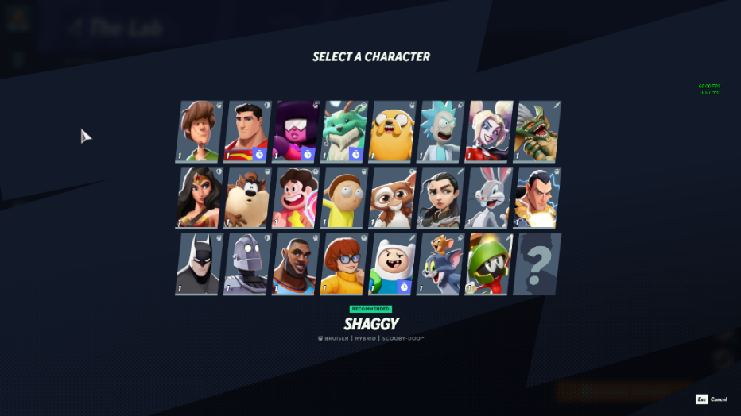
Figure 13 MultiVersus Roster
When the game first released, the reception of the game was positive, and the game had an all-time high of 153,000 players during its peak [28]. However, the game is in a strange spot as it has been announced to shut down in the summer of 2023 and the player count has decreased dramatically since its launch in 2022 now sitting at roughly around 100 players daily [28].
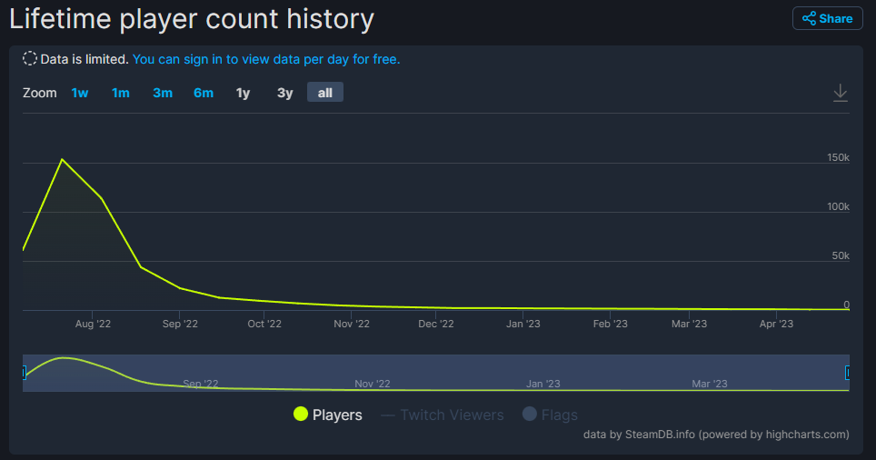
Figure 14 MultiVersus player count as seen on Steamdb. This shows the numbers from its release to the present day.
E-sports for MultiVersus at the start of the game’s life was strong as there were big tournaments with big cash prizes. The earliest tournaments dates to the game’s open beta with a big tournament taking place at EVO Championship Series (EVO is a tournament that is organized once a year featuring the biggest fighting games with the best players from each game being invited to compete in the years biggest tournaments for their game of choice respectively). EVO 2022 was the first tournament to host a MV tournament, featuring over two hundred players reaching the cap of 212 with players from other games competing in the first MV tournament [29]. This tournament had a huge cash prize with over $100,000 in the prize pool to give out to the players.
As the game went into 2023, tournaments were not as common due to the player count rapidly falling and lack of added content or updates from the developers.
The game (as of April 2023) is in a strange spot as it has been announced that the game will shut down in the summer to prepare for a relaunch in 2024. The player count has been falling fast, only resulting in a few hundred players playing the game each day.
MultiVersus is a unique game as it is like that of Super Smash Bros games being a platform fighter with the characters crossing over. The thing that sets MV apart is the game being free to play and available on multiple devices whereas Nintendo’s SSB series is limited to their hardware only. MV also features a battle pass system that has players completing challenges in the game to unlock new cosmetics for their roster (such as a new look for a character) and other cosmetics to make their account stand out from other players [30]. Another thing MV has over the Super Smash Bros series is their online. MV utilizes the more stable and reliable rollback netcode making for more reliable and a higher quality online mode, compared to Super Smash Bros. Ultimate’s delay based netcode the difference is quite a big one when compared to eachother [31].
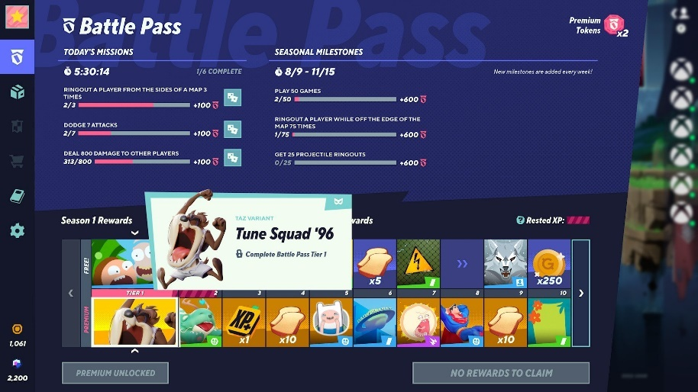
Figure 15 Image of the battle pass system seen in MultiVersus.
MultiVersus did not have traditional DLC as it was a free to play game with free content available. There was an option for users to purchase the added content to obtain it faster with the battle pass. The game also had post launch characters added to the game too, characters such as Rick Sanchez [32] and Morty Smith [33] from the Rick and Morty show, and Space Jam’s LeBron James all being added shortly after the games launch [34]. The final character to release for MultiVersus was Marvin the Martian in late November 2022 with the game not receiving a new character until the game relaunches in 2024 [35].

3.4.6 Independent Fighting Games
As independent games have grown into each genre, there are a few fighting games that have been made by indie developers. There are many titles that include Slap City, Brawlout, Fight of Animals, however the focus of one will be covered and that title is Rivals of Aether.
Rivals of Aether is an indie fighting game developed with competitive players in mind, released on PC in early 2017 [36] and later releasing on Nintendo Switch in 2020 [37]. Rivals of Aether is a sprite-based platform fighting game that is designed to appeal to the fans of the sub-genre with a sequel currently in development that moves away from sprites to 3D models [38]. The series also includes a couple crossover characters from other indie games including Yacht Club Games’ Shovel Knight and Moon Studios GmbH’s Ori.
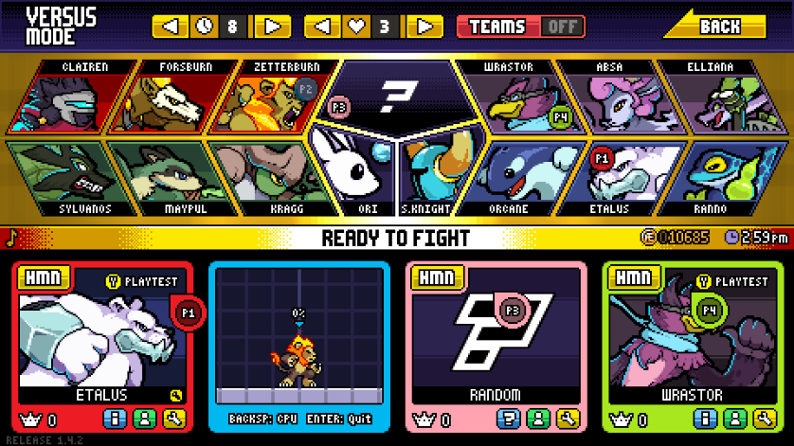
Figure 16 Rivals of Aether roster
This game was developed by a team of people who originally had created a now defunct modified version of Super Smash Bros. Brawl titles Project M, the aim of the mod was to make SSBB faster and to add the movement from previous games into the then latest Super Smash Bros game [39].
While indie games are not represented that much within e-sports, Rivals has become popular with competitive players having its own player base and competitive community. Rivals has an active championship series named the Rivals Championship Series that is ongoing [40].
The future of the game/series is a promising one as there is still support for the original Rivals game whilst a sequel to the game is being actively developed.
Rivals is unique as it has a system that allows users to create custom fighters and stages via the Steam Workshop. This program by Steam allows users to upload their custom creations to a supported game, Rivals of Aether fully supports the Steam Workshop feature [41]. This system allows users to download custom fighters and stages to their copy of Rivals, while this is not supported in tournament play due to custom characters being unbalanced, there have been cases where a custom fighter has made its way into the game via official DLC due to the popularity of the custom character.

4. Discussion

4.1 The Appeal of Each Fighting Game Sub-Genre
There have been several fighting games that have been discussed all with their own unique twist to make them each stand out as different fighting games and the type of fighting games were also discussed. 2D, 2.5D and platform fighters were the topic. Each sub-genre has its own way to stand out and appeal to players.
2D fighting games are the most traditional fighting games and the type of video game that mode fighting game competitive players tend to enjoy more due to how simple the games can become with the 2D sub-genre. This however is hard to track due to player counts statistics also counting players who are casually enjoying the game, this can be seen below with player stats showing that platform fighters are the most popular fighting game with Ubisoft’s Brawlhalla.
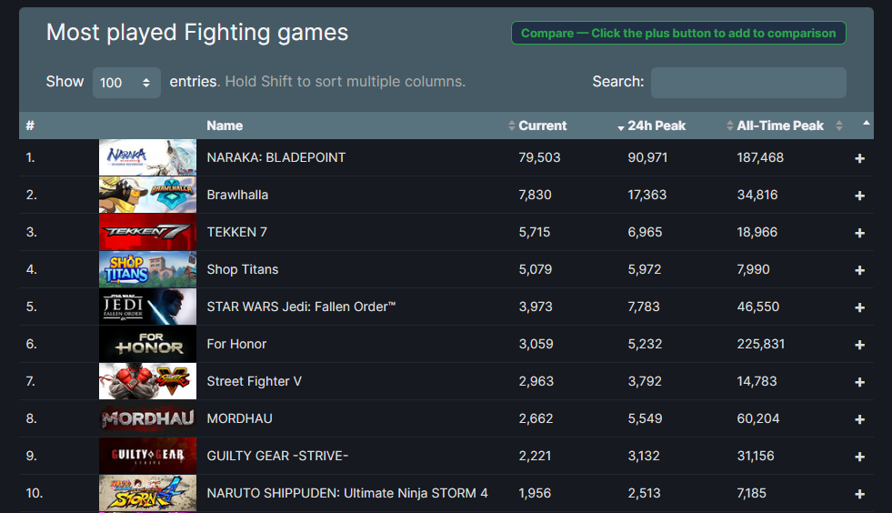
Figure 17 Player counts for fighting games on Steam.

4.2 Video Games Mods
Video game modifications have been around for a long time, this is also seen in fighting games in some cases. Some games mentioned have had a big history with mods while others have not.

4.2.1 Super Smash Bros. & Project M
Super Smash Bros has a lot of gameplays altering modifications known as modpacks that have been released for most of their games. These can range from balance changes towards certain fighters, new mechanics for fighters, new alternative colors and skins for fighters and gives the game new functionality. This can be seen with Project M, a modpack developed for Super Smash Bros. Brawl on the Nintendo Wii. This modpack overhauled the game by adding new fighters, new stages, redesigned fighters and had a growing competitive scene that at certain times was more popular than the original Super Smash Bros. Brawl game. This got shut down by Nintendo in late 2015 with all downloads for the mod being taken offline [42].
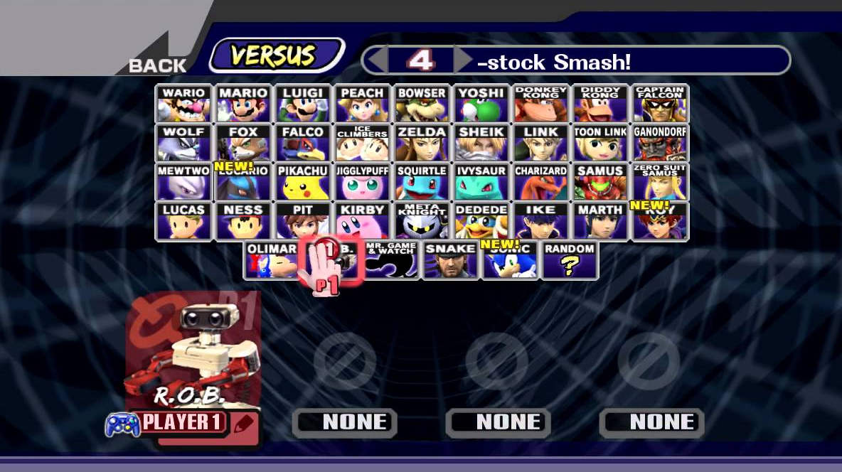
Figure 18 Image of Project M's Roster
The Super Smash Bros series has had a rich history with mods with players adding in the basics that other fighting games have present such as a traditional training mode. While Super Smash Bros does feature a training mode, it has limited options that do not benefit players as much as training mode in other fighting games. An example of how limited Super Smash Bros is with training mode is the lack of view of hitboxes on the fighters moves and attacks meanwhile other fighting games have the ability to display hitboxes in their training mode. Modders have created a competitive friendly training mode for almost all Super Smash Bros games that offer these quality-of-life features to players.

4.2.2 MultiVersus
While MultiVersus has not been released for a long time, it did however have a small modding community that helped players with quality-of-life mods like Super Smash Bros. However, the publisher of the game, Warner Bros did not support the mods that were being created for the game. This was apparent when an update was pushed to MultiVersus that made modding the game impossible and the website hosting the mods, GameBanana issues a statement saying that Warner Bros filed a DMCA on all their MultiVersus mods [43].

4.2.3 Rivals of Aether
Rivals of Aether has a unique aspect of supporting the modders of their game. This can be seen with their collaboration with Valves’ Steam Workshop. Users can create and upload their own fighters and stages with no issue. Some fighters in Rivals of Aether started out as Workshop creations. Some custom fighters have also been allowed to be used in competitive tournaments too known as a sub community RoA Extended Workshop.

4.3 Findings
Below will discuss the findings with an analysis and evaluation of the findings being conducted.

4.3.1 Analysis
After conducting research for each game and the various aspects of all the games that were discussed. It was found out all the games covered (Street Fighter, Super Smash Bros, Tekken, MultiVersus and Rivals of Aether) are all unique and each have their redeeming qualities that make them enjoyable to play in and to compete in esports tournaments with.
Street Fighter is the most grounded competitive fighting game with its 2D fighting game style and massively popular esports community with developed endorsement with things like the Street Fighter League. This added with a new SF game releasing soon means that the Street Fighter community will likely grow, and the competitive player base will potentially grow soon thanks to the release of Street Fighter 6.
Super Smash Bros was found to be in a strange spot as the series is a popular one with many players form around the world competing in tournaments for their latest game and the older Super Smash Bros Melee title. The fans have taken over the esports scene for Super Smash Bros due to Nintendo trying to stay away from the competitive scene as much as possible even resulting in some tournaments being shut down due to a Nintendo DMCA claim [44]. There are players coming and going as the latest entry has become stale due to the game being released in 2018 and the DLC being unbalanced for the game and ruining some players motivation to compete due to how poorly balanced certain DLC fighters were.
Tekken is in a similar spot to Street Fighter as it has a popular player base both casual and competitive with the developers Bandai Namco supporting the competitive scene with their own League named the Tekken World Tour. Players enjoy how different Tekken is to other fighting games with its 2.5D gameplay being the main difference with the other games that have been discussed. Tekken will potentially introduce new players as Tekken 8 is in active development and is due to be released soon.
MultiVersus unfortunately stands out for the wrong reasons due to the game being shut down and going offline, meaning players cannot play online until the game relaunches in 2014. With the player count shrinking each day too, MultiVersus is in a problematic situation when compared to other fighters discussed. Due to the game being shut down, there is no motivation to play the game competitively right now.
Rivals of Aether, while smaller than the other fighting games discussed, is in a comfortable spot when it comes to the game’s life and the players. ROA developers are hard at work developing the next entry in the Rivals series and there are also players creating their own characters and stages with the Steam Workshop.

4.3.2 Evaluation
To evaluate, it is apparent that there are some esport fighting games that are in a stable state with funding from developers and a big community playing their games and there are also games on the opposite side that used to be popular but now are on the brink of shutting down for the foreseeable. It is still apparent that all the games discussed are/were popular and all had a great community with competitive players with the strive to become the best despite each game having something different about them.

5. Conclusion
To conclude, we have discussed various things such as the history of competing and why do people compete along with the spectators and why do people spectate within esports. The report went on to discuss several fighting games, those being Street Fighter, Super Smash Bros, Tekken, MultiVersus and Rivals of Aether. Those games were discussed in detail and discussed topics such as, their sub-genre of fighting game, the sub-genres include 2D, 2.5D and platform fighting games. Alongside the sub-genres the history of each game was introduced in detail as this would mention things like the series’ origins and their first title leading up to their latest title and any substantial information was also included such as MultiVersus’ open beta and Street Fighter’s 6 prerelease open beta and demo. The esports side of the game went into detail and talked about what each game has in terms of its esports such as Street Fighter and Tekken’s developer funded leagues and the rough history of Super Smash Bros’ esports and Nintendo’s disapproval of it, meanwhile MultiVersus had a strong start with a slow decent into shutdown and Rivals of Aether has been consistently supported with its fans.
The present of each game was also talked about to see where each game was currently, Street Fighter, Tekken and Rivals of Aether are in a stable spot with their esports and player base with each series having new games in development with the earliest releasing in June 2023. However, on the opposite side there is MultiVersus and Super Smash Bros. MultiVersus has had no new content for a period and no major tournaments, this has resulted in players not playing the game and the player count has been slowly shrinking to the point of the player count being under 100 according the SteamDB. Super Smash Bros has a tough time getting off the ground due to Nintendo being against Super Smash Bros tournaments. The attempts that have been made are more appealing to the casual players of the game. This has resulted in a split with Nintendo and the Super Smash Bros players as the majority do not endorse what Nintendo do to the Super Smash Bros esports community and the competitive community in general.
As mentioned above Street Fighter, Tekken and Rivals of Aether have a strong future with their own competitive scenes receiving support from their developers and new players keep playing the game competitively. The games also have brand new entries being developed on with Street Fighter 6, Tekken 8 and Rivals 2 with Street Fighter 6 already having playable demos available to download and play.
MultiVersus has a strange future as the game is getting shut down in the summer of 2023 and a relaunch planned in 2024. Super Smash Bros is community driven and thus will not slow down for the foreseeable unless Nintendo intervenes and shut tournaments down for the game as they have demonstrated before.
Downloadable content is also discussed due to most video games adopting the practice and fighting games are no exception. DLC for fighting games is both a good and bad thing due to certain DLC fighters being unbalanced such as Super Smash Bros. For Wii U’s Bayonetta and Tekken 7’s Leroy Smith.
After discussing the game in detail, a discussion was then made talking about the findings of the conducted research with an analysis and evaluation.

6. References

[1] | R. Dunkle, Gladiators, Violence and Spectacle In Ancient Rome, New York: Pearson Education Limited, 2008.
[2] | P. Gregory Aldrete, "Public Entertainment in Ancient Rome and the Origin of Gladiator Games," 6 October 2020. [Online]. Available: https://www.wondriumdaily.com/public-entertainment-in-ancient-rome-and-the-origin-of-gladiator-games/#:~:text=The%20purpose%20of%20gladiator%20games,became%20institutionalized%2C%20which%20Romans%20imitated.. [Accessed 4 April 2023].
[3] | P. '. Chaloner, "From Arcades to esports: Where it all began," in This Is Esports (And how to spell it), London, Bloomsbury Publishing PLC, 2020, pp. 24-27.
[4] | Video Games as a spectator sport, 2013.
[5] | I. Khan, "Smash 4 has a problem -- and it's Bayonetta," ESPN, 22 Feburary 2018. [Online]. Available: https://www.espn.co.uk/esports/story/_/id/22543852/smash-4-problem-bayonetta. [Accessed 20 April 2023].
[6] | Sony, "Why is Rollback Netcode Better for Fighting Games," Sony, 17 Feburary 2021. [Online]. Available: https://compete.playstation.com/en-gb/all/articles/why-is-rollback-netcode-better-for-fighting-games?validatedAge=true. [Accessed 20 April 2023].
[7] | C. S. Nathan Lyttle, "17 Best Fighting Games with Rollback Netcode," TheGamer, 21 August 2022. [Online]. Available: https://www.thegamer.com/fighting-games-best-greatest-rollback-netcode/#brawlhalla-free-to-fight. [Accessed 21 Augest 2022].
[8] | Slippi.gg, "Slippi.gg," Slippi, [Online]. Available: https://slippi.gg/.
[9] | Qualbert, "Guilty Gear & Rollback Netcode Explained," Qualbert, 23 December 2022. [Online]. Available: https://www.qualbert.com/guilty-gear-and-the-importance-of-rollback-netcode/#:~:text=What%20is%20Delay%2DBased%20Netcode,seems%20closer%20to%20local%20play.. [Accessed 20 April 2023].
[10] | Pro Fight Stick, "2D vs 3D Fighting Games: which one is better?," Pro Fight Stick, 21 April 2023. [Online]. Available: https://www.profightstick.com/2d-vs-3d-fighting-games-which-one-is-better/. [Accessed 21 April 2023].
[11] | Street Fighter, "Street Fighter," VGSales, 1 May 2023. [Online]. Available: https://vgsales.fandom.com/wiki/Street_Fighter#cite_note-9. [Accessed 1 May 2023].
[12] | Capcom, "Street Fighter History," Captom, 1 May 2023. [Online]. Available: https://www.streetfighter.com/en/35th/history.html. [Accessed 1 May 2023].
[13] | Capcom, "Street Figher League," Capcom, 1 May 2023. [Online]. Available: https://www.streetfighterleague.com/. [Accessed 1 May 2023].
[14] | Capcom, "Street Fighter 6," Capcom, 1 May 2023. [Online]. Available: https://www.streetfighter.com/6/en-us/. [Accessed 1 May 2023].
[15] | PS Deals, "Street Fighter® III: 3rd Strike: Online Edition DLC Pack," PS Deals, 1 May 2023. [Online]. Available: https://psdeals.net/us-store/game/725341/street-fighter-iii-3rd-strike-online-edition-dlc-pack. [Accessed 1 May 2023].
[16] | Playing with the script: Super Smash Bros. Melee, 2015.
[17] | Nintendo, "Nintendo software and hardware sales data from 1983 to present," 23 October 2021. [Online]. Available: https://www.installbaseforum.com/forums/threads/nintendo-software-and-hardware-sales-data-from-1983-to-present.170/.
[18] | Nintendo, "Top Selling Title Sales Units (Wii)," Nintendo, 30 September 2022. [Online]. Available: https://www.nintendo.co.jp/ir/en/finance/software/wii.html. [Accessed 30 September 2022].
[19] | Nintendo, "Top Selling Title Sales Units (3DS)," Nintendo, 30 September 2022. [Online]. Available: https://www.nintendo.co.jp/ir/en/finance/software/3ds.html. [Accessed 30 September 2022].
[20] | Nintendo, "Top Selling Title Sales Units (Wii U)," Nintendo, 30 September 2022. [Online]. Available: https://www.nintendo.co.jp/ir/en/finance/software/wiiu.html. [Accessed 30 September 2022].
[21] | Nintendo, "Top Selling Title Sales Units (Nintendo Switch)," Nintendo, 31 December 2022. [Online]. Available: https://www.nintendo.co.jp/ir/en/finance/software/index.html. [Accessed 31 December 2022].
[22] | Nintendo, "Notice of End of Purchases in Nintendo eShop for Wii U and Nintendo 3DS – Update March 2023," Nintendo UK, 16 Feburary 2022. [Online]. Available: https://www.nintendo.co.uk/Support/Purchasing/Download-games/Nintendo-eShop/Notice-of-End-of-Purchases-in-Nintendo-eShop-for-Wii-U-and-Nintendo-3DS-Update-March-2023-2174073.html. [Accessed 31 March 2023].
[23] | K. Shepard, "Long-Hated Steve From Minecraft Is Being Banned In Competitive Smash Bros.," Kotaku, 3 March 2023. [Online]. Available: https://kotaku.com/super-smash-bros-tournament-ban-steve-minecraft-glitch-1850185818. [Accessed 3 March 2023].
[24] | Esports Charts, "Tekken," Esports Charts, 1 May 2023. [Online]. Available: https://escharts.com/games/tekken. [Accessed 1 May 2023].
[25] | Bandai Namco, "Tekken World Tour," Bandai Namco, 1 May 2023. [Online]. Available: https://tekkenworldtour.com/. [Accessed 1 May 2023].
[26] | Pro Fight Stick, "Leroy Smith: How a broken character almost ruined Tekken 7," Pro Fight Stick, 2023. [Online]. Available: https://www.profightstick.com/leroy-smith-how-a-broken-character-almost-ruined-tekken-7/. [Accessed 1 May 2023].
[27] | T. Franzese, "MultiVersus to shut down in June ahead of relaunch in 2024," Digital Trends, 27 March 2023. [Online]. Available: https://www.digitaltrends.com/gaming/multiversus-beta-shut-down-2024/. [Accessed 27 March 2023].
[28] | SteamDB, "SteamDB (MultiVersus)," SteamDB, 26 April 2023. [Online]. Available: https://steamdb.info/app/1818750/charts/. [Accessed 23 April 2023].
[29] | Start.gg, "MultiVersus Open Beta $100,000 Evo Tournament," Start.gg, 5 August 2022. [Online]. Available: https://www.start.gg/tournament/multiversus-open-beta-100-000-evo-tournament-1/details. [Accessed 29 April 2023].
[30] | T. Morgan, "Face-Off: MultiVersus vs Super Smash Bros Ultimate," EuroGamer, 5 August 2022. [Online]. Available: https://www.eurogamer.net/digitalfoundry-2022-face-off-multiversus-vs-super-smash-bros-ultimate#:~:text=The%204K%20resolution%20favours%20MultiVerse,more%20inventive%2C%20and%20more%20busy.. [Accessed 20 April 2023].
[31] | J. Green, "MultiVersus has one huge advantage over Super Smash Bros," VG247, 1 September 2022. [Online]. Available: https://www.vg247.com/multiversus-has-one-huge-advantage-over-super-smash-bros. [Accessed 18 April 2023].
[32] | J. Green, "‘MultiVersus’ Rick Sanchez DLC fighter release date," NME, 5 September 2022. [Online]. Available: https://www.nme.com/guides/gaming-guides/multiversus-rick-and-morty-dlc-release-date-3289532. [Accessed 15 April 2023].
[33] | J. Ramuz, "Morty Is Out Now In MultiVersus!," EarlyGames, 25 August 2022. [Online]. Available: https://earlygame.com/gaming/morty-multiversus. [Accessed 19 April 2023].
[34] | M. Stewart, "LeBron James, Rick and Morty Confirmed For MultiVersus," GameInformer, 22 July 2022. [Online]. Available: https://www.gameinformer.com/2022/07/22/lebron-james-rick-and-morty-confirmed-for-multiversus. [Accessed 19 April 2023].
[35] | C. Faulkner, "‘MultiVersus’ adds Marvin the Martian to its roster," NME, 21 November 2022. [Online]. Available: https://www.nme.com/news/gaming-news/multiversus-adds-marvin-the-martian-to-its-roster-3353068. [Accessed 20 April 2023].
[36] | Steam, "Rivals of Aether," Valve, 28 March 2017. [Online]. Available: https://store.steampowered.com/app/383980/Rivals_of_Aether/. [Accessed 20 April 2023].
[37] | Nintendo, "Rivals of Aether," Nintendo, 24 September 2020. [Online]. Available: https://www.nintendo.com/store/products/rivals-of-aether-switch/. [Accessed 20 April 2023].
[38] | Rivals of Aether, "Rivals 2 Official Announcement Trailer," Rivals of Aether, 1 April 2022. [Online]. Available: https://youtu.be/vxp6LpkIEPw. [Accessed 20 April 2023].
[39] | Project M, "Project M," Project M, 30 April 2023. [Online]. Available: https://projectmgame.com/. [Accessed 2023 April 2023].
[40] | Start.gg, "Rivals Championship Series - Season 7," Start.gg, 31 Jan 2023. [Online]. Available: https://www.start.gg/league/rivals-championship-series-season-7/details. [Accessed 16 April 2023].
[41] | Valve, "The Steam Workshop for Rivals of Aether," Valve, 20 April 2023. [Online]. Available: https://steamcommunity.com/workshop/about/?appid=383980. [Accessed 20 April 2023].
[42] | J. Muncy, "Project M, Super Smash Bros. Fan Mod, Closes Its Doors," Wired, 2 December 2015. [Online]. Available: https://www.wired.com/2015/12/project-m-closed-super-smash-bros/. [Accessed 15 April 2013].
[43] | GameBanana, "New MultiVersus mods are now banned on GameBanana," GameBanana, 22 October 2022. [Online]. Available: https://gamebanana.com/threads/222685. [Accessed 1 May 2023].
[44] | T. Salaun, "Smash fans outraged as Nintendo shuts down Big House with cease & desist," Dexerto, 19 Novemver 2020. [Online]. Available: https://www.dexerto.com/smash/smash-fans-outraged-as-nintendo-shuts-down-big-house-with-cease-desist-1457908/. [Accessed 14 December 2022].

7. Bibliography
[1] H. McCullough, “From Zelda to Stanley: Comparing the Integrative Complexity of Six Video Game Genres,” View of from Zelda to Stanley, https://press-start.gla.ac.uk/index.php/press-start/article/view/127/94 (accessed May 2, 2023).
[2] H. Juho and S. Max, “What is esports and why do people watch it? - proquest,” What is eSports and why do people watch it?, https://www.proquest.com/docview/1879627794 (accessed May 2, 2023).
[3] D. Y. Jin, Global Esports: Transformation of Cultural Perceptions of Competitive Gaming. New York, NY: Bloomsbury Academic, 2022.
[4] H. Z. Chen and J. F. Huang, “Analytic Network Process Decision-making to downloadable content system,” Applied Mechanics and Materials, vol. 284–287, pp. 3352–3356, 2013. doi:10.4028/www.scientific.net/amm.284-287.3352
[5] G. min read and 2018 Jimmy Donnellan·August 23, “Fighting game DLC is the worst in the industry,” Cultured Vultures, https://culturedvultures.com/fighting-game-dlc-is-the-worst-in-the-industry/ (accessed May 2, 2023).
[6] M. R. Skolnik and S. Conway, “Tusslers, Beatdowns, and brothers: A sociohistorical overview of video game arcades and the street fighter community,” Games and Culture, vol. 14, no. 7–8, pp. 742–762, 2017. doi:10.1177/1555412017727687
[7] “Street Fighter and The King of Fighters in Hong Kong: A Study of Cultural Consumption and Localization of Japanese Games in an Asian Context,” Game Studies, https://www.gamestudies.org/0601/articles/ng (accessed May 2, 2023).
[8] V. Firoiu, W. F. Whitney, and J. B. Tenenbaum, “Beating the world’s best at Super Smash Bros. with Deep Reinforcement Learning,” arXiv.org, https://arxiv.org/abs/1702.06230 (accessed May 2, 2023).
[9] J. Codsi and A. Vetta, “A case study in learning in metagames: Super smash bros.. melee,” Proceedings of the AAAI Conference on Artificial Intelligence and Interactive Digital Entertainment, vol. 17, no. 1, pp. 2–9, 2021. doi:10.1609/aiide.v17i1.18884
[10] J. Taelman, “Playing with the script: Super smash bros.. melee - universiteit utrecht,” Playing with the script: Super Smash Bros. Melee From a casual game to a competitive game, https://studenttheses.uu.nl/bitstream/handle/20.500.12932/19654/Taelman_Joeri_Thesis_final.pdf?sequence=2 (accessed May 2, 2023).
[11] B. Niklas, T. Koch, and S. B. Pongratz, “User Entrepreneurship in the esports Industry An exploratory Case Study of the Game Series “Super Smash Bros.,” Jonkoping University, https://www.diva-portal.org/smash/get/diva2:1433731/FULLTEXT01.pdf (accessed May 2, 2023).
[12] R. Rogers, Understanding ESPORTS: An Introduction to the Global Phenomenon. S.l.: LEXINGTON BOOKS, 2021.

