
Student Name: Teodora Gogonea
Student ID: 2440666
Module Code: LCLM4001
Lecturer: Tim Hopkins

Through My Own Eyes:
My Journey as a Student

Table of Contents
1. Introduction 3
2. Description of Experiences 3
3. Personal Reflectio 5
3.1 Evaluation 5
3.2 Analysis 5
4. Conclusion 6
- References……………………………………………………………………………………………………………..…………………7

- Introduction

Reflection involves critically thinking about experiences to gain deeper understanding and improve future actions (University of Sussex, n.d.). For university students, it supports academic growth and personal development by fostering critical thinking and self-awareness. Reflection helps connect theory to practice, recognise strengths and weaknesses, and make better learning decisions. It also aids in managing challenges and adapting to higher education demands, building resilience and a proactive mindset. Ultimately, reflection enhances academic success and prepares students for future challenges (University of Sussex, n.d.).

- Description of Experiences

- Critical Thinking

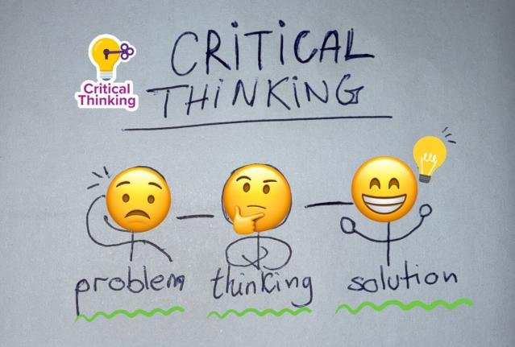Notebook (Source: Author)
As a student, I see critical thinking as the ability to break down and make sense of complex information, so I can form well-reasoned opinions and decisions. It’s not just about spotting errors—instead, it’s about examining evidence, spotting any gaps or weaknesses, and thoughtfully weighing multiple viewpoints before deciding what to believe or argue (University of Edinburgh n.d) (Sunderland Library Guides n. d. )
In Week 8 we looked at a series of images - taken from TV broadcast of important information during the Pandemic. We had to examine them to see differences between them, and ask questions about why they were different. This was an example of us needing to use critical thinking in life.

At university, this is especially important. It helps me move beyond just memorising material—I can evaluate the quality of sources, decide if their arguments are solid, and build my own insights supported by evidence. The University of Edinburgh emphasises that success at higher levels depends on this kind of analytical approach; purely descriptive work isn’t enough—you need to think deeply, construct your own argument, and justify it. From my point of view, Critical Thinking is crucial when it comes to being a university student , as we use it every day , specially when we have research or exams.
- Note-Taking

We looked at different kinds of note taking in Week 2. We looked at Linear, Diagrammatic, Tabular, Cornell notes. (See Image 1, example of Linear notes on left hand page.)
I understand note-taking as more than just jotting down what’s said—it's about staying engaged and filtering information into something useful later. When I take notes, I lean in mentally, pick out the most important ideas, structure them clearly, and make them my own so they're easier to understand and recall later (scholarly.so n.d.).
A well-organized set of notes provides a roadmap for studying. They help me stay focused during lectures, guide my revision by highlighting connections between ideas, and act as personalized study tools when I'm preparing for exams (York University n.d.)

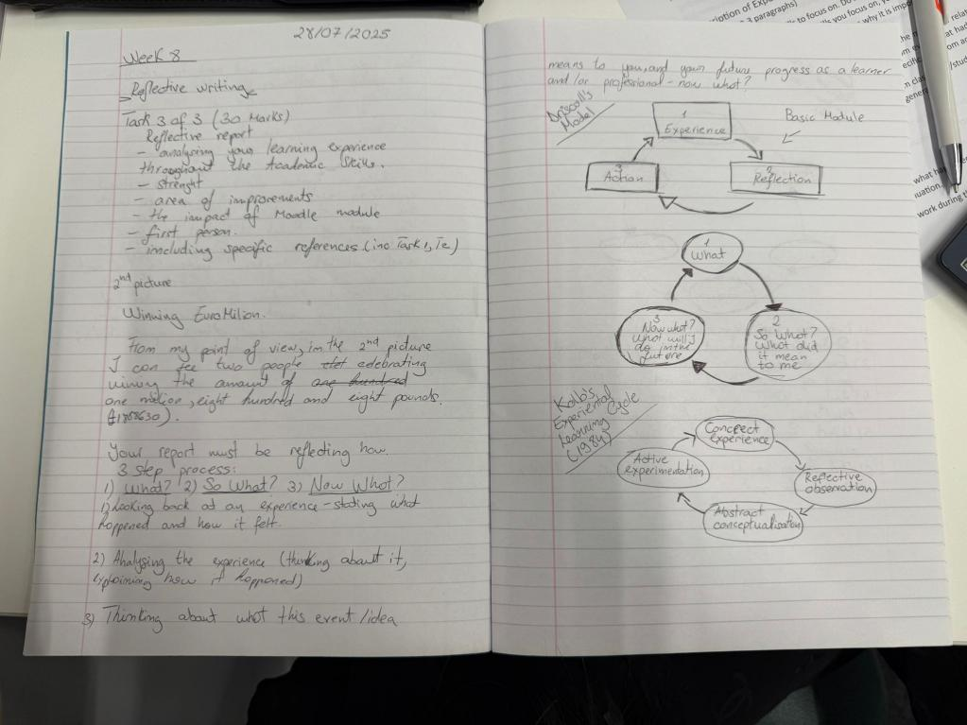
Linear Note-taking - Picture of my Academic Skills Notebook

- Personal Reflection

  - Evaluation

Attending my first university exams was both challenging and eye-opening (Academic Skills & Digital Skills ). The transition from classroom learning to independent revision made me realise that academic success relies not only on understanding content but also on using effective study skills. Two skills that particularly supported me were critical thinking and note-taking.
Initially, I underestimated the value of note-taking. However, as lectures progressed and the volume of information increased, I began to structure my notes more purposefully—using headings, summaries, and highlighting key concepts.
Critical thinking also played a crucial role. Rather than memorising facts, I began to question ideas, evaluate arguments, and consider multiple perspectives. This allowed me to write exam responses that demonstrated analysis and insight, rather than simply recalling information. As a result, I felt more confident applying my knowledge in unfamiliar contexts.
Overall, my first exam experience taught me that mastering academic skills is essential for university success. Critical thinking and note-taking not only improved my academic performance but also deepened my engagement with the subject. .

  - Analysis

Reflecting on my journey as a university student so far, I have experienced both encouraging successes and difficult setbacks. Achieving this gave me a sense of accomplishment and reassurance that my study methods and commitment are effective. I’ve found that staying organised, managing my time, and using skills like critical thinking and structured note-taking have significantly contributed to this success.
However, despite these achievements, I have also faced ongoing challenges—especially with attendance. Like many students, I am balancing part-time work with my academic responsibilities. Although working is necessary to support myself financially, it has occasionally led to me missing lectures or falling behind on coursework. This has impacted my ability to engage fully with certain topics and has increased stress during peak assessment periods.
Missing classes has also affected my learning consistency. While I try to catch up independently, I sometimes find it difficult to fully grasp concepts without direct teaching. This creates a cycle where I must invest more time catching up, which in turn affects my work–study balance. I recognise that this is an area that requires improvement. Going forward, I aim to manage my schedule more strategically—such as negotiating more flexible shifts with my employer or using recorded lectures and learning resources more effectively when absences are unavoidable.
Critical thinking has made me realise that success at university is not just about passing exams but about managing one’s overall academic experience. Maintaining attendance, staying mentally engaged, and looking after personal wellbeing are all essential for long-term success. I feel proud of the progress I’ve made so far, but I also acknowledge that sustainable improvement depends on more consistent time management and self-discipline.
In addition, Note-taking is useful in my personal life as well , as it is helping me to keep notes of my daily and work tasks. This way I avoid error making as being late or not fully achieving my tasks.

- Conclusion

The Academic Skills module has played a vital role in shaping my development as a university student. It has helped me build a strong foundation in essential skills like critical thinking and note-taking, both of which significantly improved my performance during my first exams. These tools not only enhanced my ability to understand and apply academic content but also boosted my confidence and engagement.
Through reflective activities, I became more aware of the challenges I face—particularly balancing part-time work with academic responsibilities. This awareness has motivated me to improve my time management and seek more effective ways to stay on top of my learning.
Overall, this module has taught me that academic success involves more than passing exams; it’s about continuous self-improvement and finding balance. I now feel more equipped to take responsibility for my learning and to grow personally and academically throughout my university journey.

6.References:
1.University of Edinburgh (2024) Critical thinking. Available at: https://www.ed.ac.uk/students/academic-life/study-support/supporting-taught-postgraduates/developing/critical-thinking (Accessed: 11 August 2025).
2. University of Sussex (2024) Reflective thinking. Available at: www.sussex.ac.uk (Accessed: 04 August 2025)
3.University of Sunderland (2025) Why critical thinking is important. Available at: https://libraryguides.sunderland.ac.uk/being-critical (Accessed: 11 August 2025).
4.Scholarly Blog (n.d.) The importance of note-taking for students: A comprehensive guide. Available at: https://scholarly.so/blog/the-importance-of-note-taking-for-students-a-comprehensive-guide (Accessed: 11 August 2025).
5.Scholarly Blog (n.d.) The benefits of note taking in college. Available at: https://scholarly.so/blog/the-benefits-of-note-taking-in-college (Accessed: 11 August 2025).
6.University of York (n.d.) Note-Taking Strategies. Available at: https://www.yorku.ca/scld/learning-skills/reading-and-notes/note-taking/ (Accessed: 11 August 2025).
7.SMU Journal (n.d.) Exploring the benefits and methods of note-taking for university students. Available at: https://www.thesmujournal.ca/university/exploring-the-benefits-and-methods-of-note-taking-for-university-students (Accessed: 11 August 2025).

