Module Title: BA (Hons) International Hotel Management
Module Code: BMIH5006
Lecturer’s Name: Lisa-Marie Bassler
Student Name: Antonela Costiuc
Student Number:2117337

Greener practices of The Savoy Hotel

Acknowledgment
I confirm that I have not used any AI tools in the research and creation of this assignment. I confirm that I have not presented any AI generated material as my own work. I confirm I have copies of my drafts, notes, and other resources I used, which I may be asked to provide in evidence.

Executive Summary
Among London’s most famous hotels is the Savoy Hotel and this hotel reputation and its luxurious status cannot overshadow its concern for environmental issues. The report will look green practices that is vital to the Savoy, focusing on water conservation. The report establishes that integrating effective water controls as an important factor in mitigating environmental effects and satisfying more consumer expectations of sustainable hospitality. The report makes special emphasis on explaining particular actions, such as the use of water-efficient equipment, efficient watering systems, and communication campaigns. Implementation issues; cost factors and operational issues are discussed, and suggestions provided to build on The Savoy sustainable luxury hospitality advantage.

Table of Contents
Executive Summary 2
1 Introduction 4
2 Main Findings 5
2.1 Greener Practice Initiative 5
2.2 Benefits to the Hotel in Terms of Sustainability 6
2.3 Potential Challenges in Implementation 7
2.4 Environmental Benefits of the Initiative 8
3 Conclusion/Recommendations 8
4 References 10

Introduction
With increased consciousness, the hotel and hospitality sectors are implementing certain “Greener Practices,” that aims at the increased sustenance of the environments, a decrease in the effects hotel commutations impose on the surrounding environment. Greener means management practices that are intentionally used to preserve unprotected natural resources, minimize recycle and hazardous waste, and improve energy and water usage (Andeobu et al., 2023). Such activities can entail activities such as adopting the use of renewable energy, reflecting on waste management and recycling program, and ordering environmentally friendly products. An example of greener practice includes; energy efficient lighting and appliances are used that dramatically reduces electricity consumption and therefore lessens the carbon imprint.
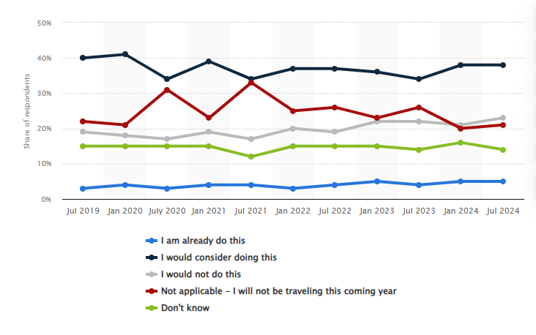
Figure 1: Share of travelers choosing eco-friendly hotels to reduce their environmental impact in Great Britain from July 2019 to July 2024
Source: Statista (2024)
Showing an astonishing level of success since its opening in 1889, The Savoy Hotel is one of the most antique, luxurious, and majestic hotels in the center of London (The Savoy Hotel, 2024). This luxurious five star hotel and resort has elegant Art Deco and Edwardian architecture with 267 guest rooms and suites, excellent dining and stunning views over the River Thames. Today, referred as The Savoy hotel enjoys reputation of hosting the royalty, world leaders, and celebrities, The Savoy is a perfect example of traditional English hotel with elements of contemporary luxury.
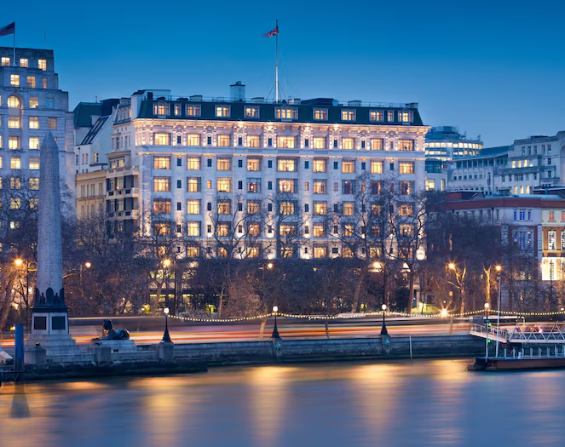
Source: The Savoy Hotel (2024)

Main Findings

Greener Practice Initiative
Water management is recognized as a critical part of sustainability concern and eco-tourism (Zhang et al., 2024). Due to the fact that Savoy is a luxury hotel that customers from different backgrounds visit, it is comparatively easy to ensure that efficient measures taken to conserve water also work to meet the environmental goal. Water conservation initiative has one of its main objectives to decrease the amount of water used in the hotel greatly and educate the employees and customers on how not to waste water. Implementing of water-saving technologies main goal is to ensure that the Savoy Hotel employs superior technologies that meet the firm’s water conservation needs for its facilities. This includes fitting guest and public restroom’s fixtures comprising taps, showerheads and flush valves with low flow shower heads and latrine fixtures without compromising the comfort of the guests. Moreover, landscaping of the hotel will be done using smart irrigation systems with sensors that change the watering schedule according to the currents weather conditions. Such an approach ensures that water is only used only where it is needed and this in turn helps the hotel gardens be healthier.
Guest education and participation in water conservation program is very crucial. Awareness creation will be conducted at The Savoy since guests will need to be informed on the general power of water. This will involve having in-room literature and poster advertising the facility policies such as reuse of towels and linen. The hotel can also bring programs, where customers get reductions on charges or complimentary solutions, depending on the involvement in the conservation program throughout their stay at the hotel facility. For efficient operation of the water conservation plan The Savoy will require each employee of the hotel to undergo a training on the working of the same (Ronconi et al., 2022). These sessions will bring out the importance of water management in operations and engage employees in cases that show opportunities where water may be spared. The staff is well motivated to buy into the sustainability goals that The Savoy seeks to achieve by developing top down ownership.
For example, Marriott International has put in place elaborate water saving measures which include fitting low flow showerheads and water-efficient faucets, fixtures and use of climate responsive irrigation. Marriott has targeted water reduction key performance indicators, the overall goal is to reduce the water usage by 15 percent by 2025 (Marriott International, 2024). This has not only an impact to the operational effectiveness but also the community water saving program. Likewise, InterContinental Hotels Group uses the Green Engage system, energy efficient, water saving and other environmental conservation measures (Scholz et al., 2020). This system helps the IHG hotels to get an effective management and monitoring of the resource utilizations to know where to make improvements. Measures such as using water-saving landscape designs and grey water reuse are among the measures that have been observed to deliver large improvements in water efficiency by IHG (InterContinental Hotels, 2024). Moreover, Hilton Hotels is also committed to sustainability through it travel with purpose; it has sustainable sourcing and reduced waste (Scanlon et al., 2023). Some of Hilton’s projects concerns the sustainability of water through integrating water-saving technologies and water-saving behaviors among the guest and personnel. These strategies mean that Hilton wants to lessen its water usage by half in all its hotels by 2030 (Hilton Hotels, 2024).

Benefits to the Hotel in Terms of Sustainability
With a focus on water saving, the hotel will be able to set up a goal to decrease its environmental impact, and become an example of a luxury hotel that cares about the environment. Reducing water consumption is an important advantage where significant savings of money may be drawn (Lakhiar et al., 2024). Through upgrades of water efficient fixtures and water efficient irrigation systems The Savoy can reduce its water bills and energy costs used in heating water. Today where environmental awareness is in the rise, and customers are willing to pay a bit more to get a service from hotels that cares for sustainability. The successful application of water recycling strategies has a function in the strengthening of the image that The Savoy Hotel has on being responsible and progressive (Parete et al., 2024). Costumers’ behavior tends to consider the values they cherish, and showing concern about the company’s approach to sustainable development may attract the audience focused on the environment.
The hotel replicates water conservation measures to meet the new standards of the growing environmental rules and laws (Reddy et al., 2023). There are also tendencies among local and national governments to introduce more severe requirements to the usage of water in hospitality, and by being ready to handle these concerns, The Savoy will be ready to conform and avoid sanctions. Moreover, water saving in the hotel may bring about the eco-labels including Green Key that helps guests choose a more eco-friendly hotel (Kizanlikli et al., 2023). In addition, the use of water saving measures also improves the image of an organization in the eyes of the guests. Some people love accommodation that makes conscious efforts to protect the environment and this may be a reason people will select The Savoy.

Potential Challenges in Implementation
A key problem in the water conservation initiative in that the investments into water-saving technologies and systems are relatively high and can be made only at the initial stage (Gunduz Songur et al., 2023). To install low-flow fixtures, smart irrigation systems and other green installations entail high costs, which may earn the management a lot of money yet they do not invest as required. Although such investments tend to result in long-term savings that can eliminate or reduce water bills and construction costs, they require capital, which can be costly and a limiting factor in a delicate niche market that centers on luxury often defined by the value of margins. Also, for implementation of the water conservation measures, several logistical drawbacks can be encountered. Scheduling the upgrade of primitive systems like irrigation systems or plumbing facilities entail some modification plans that needs to undertake in order to reduce interferences on daily practices (Ritzema et al., 2023). People actually spending their money to get services from the hotel have high expectations of getting good service and this is why if during the installation there are services disruptions then the hotel will risk being sued by its guests. Consequently, the improvement of the renovation program’s timeline and operational needs should be key factors to prevent negative effects.
It is also difficult to guarantee that the necessary education of new systems and water-saving procedures is provided to all employees. Seminars must be conducted to these employees to increase understanding of the need to save water and how to utilize relevant fixtures. It can be a lengthy process, and a clear commitment, especially in a big place of work such as The Savoy, there is likely to be high turnover and, therefore, training new people can be challenging implying deviation from the standardized learning curriculum (Nair et al., 2023). Furthermore, the particular supplier relationships for sustainably sourced materials can be a challenge for the day to day practice. Buying sustainable lighting products and other lighting technologies sometimes requires working with specified suppliers only (Lin et al., 2024). The supply variation, changes in suppliers’ capabilities, or higher demand for sustainable products can be problematic; inconsistencies become an issue affecting the hotel’s capability to properly implement its conservation measures.

Environmental Benefits of the Initiative
In the view of Santos et al., (2023), the key advantage of the water conservation initiative is the long-term preservation of a crucial material. Huge savings can be realized within The Savoy through use of water-efficient faucet designs, low flow showerheads and bells, and efficient irrigation systems. The initiative also intends to decrease the amount of wastewater produced by the hotel. Lesser water use means less wastewater produced, meaning less stress or stress on sewage and treatment systems of the local community. This makes a considerably beneficial effect as potential negative impact to water quality in rivers and streams in the vicinity of generating stations can be reduced lessening the adverse effect on aquatic life.
Likewise, water conservation measures are believed to also have a link to energy use. The deliver, treat, and heating processes use a lot of energy sources in getting water to the consumers (Tareemi and Sharshir, 2023). Besides benefitting from efficient water usage The Savoy also benefits from the fact that water consumes less energy in the water treatment processes and therefore less energy is used, meaning that there are fewer greenhouse gas emissions that come with energy use. Such a reduction helps the hotel to fit into its broader strategies of combating climate change by reducing emissions. The Savoy succeeds to set standards when it comes to responsible tourism by adopting and promoting water conservation (Quon and Jiang, 2023). The visitors of the hotel also look for green options, so client satisfaction is achieved since the hotel emphasizes sustainability.

Conclusion/Recommendations
It has been concluded that for The Savoy Hotel, a water conservation activities indicates that the process of improving the company’s position in sustaining its environment is rather important. Through the concept of adoption of water efficient technologies, participation of guests and staff and setting up of a comprehensive data collection method, the hotel’s intention is to lower their consumptive water use in the facility and hence lessen their impact on the environment. It contributes to preserving significant water usage and minimizing wastewaters and reduces energy use while supporting sustainable tourism practices.
The findings have suggested that to enhance the success of the water conservation drive at The Savoy Hotel, the firm must always assess its approaches toward the use of water as it saves the substance, and change the approach depending on the results obtained. Furthermore, developing cooperation with other environmental organizations of the area will also serve the purpose of strengthening the hotel’s professed sustainability and community impact. The following are recommendations that will make sure that The Savoy maintains optimum sustainability alongside becoming a model of responsible luxury accommodation. In this way, The Savoy Hotel can adopt those practices as a part of general environmental conservation measures promoted around the world successfully offering guests an attractive and environmentally friendly experience.

References
Andeobu, L., Wibowo, S. and Grandhi, S., 2023. Informal E-waste recycling practices and environmental pollution in Africa: What is the way forward?. International journal of hygiene and environmental health, 252, p.114192.
Gunduz Songur, A., Turktarhan, G. and Cobanoglu, C., 2023. Progress on green technology research in hotels: a literature review. Journal of Hospitality and Tourism Insights, 6(5), pp.2052-2072.
Hilton Hotels, 2024. Protecting And Preserving The Destinations Where We Operate. [Online] Available at https://esg.hilton.com/environment/ [Accessed on 28 Oct 2024].
InterContinental Hotels, 2024. IHG Green Engage™ system. [Online] Available at https://www.ihg.com/content/gb/en/support/green-engage [Accessed on 28 Oct 2024].
Kizanlikli, M.M., Margazieva, N., Asanova, K. and Gundogdu, I., 2023. An assessment of eco hotel practices and green marketing perceptions: An eco-labelling model proposal for hotels in Kyrgyzstan. Journal of Cleaner Production, 420, p.138438.
Lakhiar, I.A., Yan, H., Zhang, C., Wang, G., He, B., Hao, B., Han, Y., Wang, B., Bao, R., Syed, T.N. and Chauhdary, J.N., 2024. A Review of Precision Irrigation Water-Saving Technology under Changing Climate for Enhancing Water Use Efficiency, Crop Yield, and Environmental Footprints. Agriculture, 14(7), p.1141.
Lin, J., Shen, J. and Silfvenius, C., 2024. Human-centric and integrative lighting asset management in public libraries: insights and innovations on its strategy and sustainable development. Sustainability, 16(5), p.2096.
Marriott International, 2024. Marriott International, Inc. - Water Security 2022. [Online] Available at https://serve360.marriott.com/wp-content/uploads/2022/09/Marriott-2022-CDP-Water-Security.pdf [Accessed on 28 Oct 2024].
Nair, S.S., Marasini, R., Buck, L., Dhodapkar, R., Marugan, J., Lakshmi, K.V. and McGuigan, K.G., 2023. Life cycle assessment comparison of point-of-use water treatment technologies: Solar water disinfection (SODIS), boiling water, and chlorination. Journal of Environmental Chemical Engineering, 11(3), p.110015.
Parete, G., Bruno, M.F., Calabrese, P., Carlucci, R., Chiarulli, M., D'Onghia, G., Fiore, A., Fratino, U., Longo, C., Longo, F. and Scorrano, S., 2024. Climate impacts and adaptation strategies for coastal erosion, aquaculture, and tourism along the Adriatic side of Apulia region. Frontiers in Climate, 6, p.1378253.
Quon, H. and Jiang, S., 2023. Decision making for implementing non-traditional water sources: a review of challenges and potential solutions. npj Clean Water, 6(1), p.56.
Reddy, K.R., Kandou, V., Havrelock, R., El-Khattabi, A.R., Cordova, T., Wilson, M.D., Nelson, B. and Trujillo, C., 2023. Reuse of treated wastewater: Drivers, regulations, technologies, case studies, and Greater Chicago Area experiences. Sustainability, 15(9), p.7495.
Ritzema, H., Abdel-Dayem, S., El-Atfy, H., Nasralla, M.R. and Shaheen, H.S., 2023. Challenges in modernizing the subsurface drainage systems in Egypt. Agricultural Water Management, 288, p.108484.
Ronconi, R.A., Lieske, D.J., McFarlane Tranquilla, L.A., Abbott, S., Allard, K.A., Allen, B., Black, A.L., Bolduc, F., Davoren, G.K., Diamond, A.W. and Fifield, D.A., 2022. Predicting seabird foraging habitat for conservation planning in Atlantic Canada: Integrating telemetry and survey data across thousands of colonies. Frontiers in Marine Science, 9, p.816794.
Santos, E., Carvalho, M. and Martins, S., 2023. Sustainable water management: Understanding the socioeconomic and cultural dimensions. Sustainability, 15(17), p.13074.
Scanlon, N.L., 2023. Communicating Sustainability to Guests: Leading question: How should sustainability be communicated to guests?. In Critical Questions in Sustainability and Hospitality (pp. 255-263). Routledge.
Scholz, P., Linderová, I. and Konečná, K., 2020. Green management tools as a way to sustainable behaviour in the hotel industry: Case study from Czechia. Sustainability, 12(23), p.10027.
Statista, 2024. Share of travelers choosing eco-friendly hotels to reduce their environmental impact in Great Britain from July 2019 to July 2024. [Online] Available at https://www.statista.com/statistics/1340780/travelers-choosing-ecofriendly-hotels-uk/ [Accessed on 28 Oct 2024].
Tareemi, A.A. and Sharshir, S.W., 2023. A state-of-art overview of multi-stage flash desalination and water treatment: Principles, challenges, and heat recovery in hybrid systems. Solar Energy, 266, p.112157.
The Savoy Hotel, 2024. about Us. [Online] Available at https://www.thesavoylondon.com/ [Accessed on 28 Oct 2024].
Zhang, S., Zhang, Z., Yu, H. and Zhang, T., 2024. Assessment and Empirical Research on the Suitability of Eco-Tourism Development in Nature Reserves of China: A Multi-Type Comparative Perspective. Land, 13(4), p.438.

