Component 1: Coursework: Essay
Project Management (LCBB6006)
Ionut agrigoroaei (2247225)

Table of Contents
Table of Contents 1
I. Introduction 2
II. Aim, Objectives and Scope 2
1. Aim 2
2. Objectives 2
3. Scope 3
III. Project Outputs 3
IV. Activities Required to Deliver the Outputs 4
1. Initiation 4
2. Planning 4
3. Execution 4
4. Monitoring and Controlling 5
5. Closure 5
V. Work Breakdown Structure (WBS) 5
VI. Deliverables, Milestones and Timeline 0
VII. Resource Usage: Personnel and Materials 0
1. Personnel 0
2. Materials 0
VIII. Conclusion 0
References 1

Introduction
Simon (2018) explains that a project can be understood as a set of activities undertaken to achieve specific objectives related to change, and this definition clearly applies to the conservatory rebuild because it is a unique undertaking with a defined starting point and a fixed ten week completion period that aims to produce a tangible outcome in the form of a new conservatory, washroom, and pantry rather than an ongoing routine operation. In this context, project management can be understood, according to the Project Management Institute (2021), as the application of appropriate knowledge, skills, tools, and techniques to project activities in order to meet established requirements and achieve the intended results. Furthermore, Larson and Gray (2018) suggest that project management provides a structured framework that supports effective planning, execution, and control so that client expectations are met within agreed time, cost, and quality constraints. This project plan therefore begins by clearly defining the aim, objectives, and scope of the rebuild, after which it outlines the expected outputs and the sequence of activities needed to achieve them. It also includes a Work Breakdown Structure that divides the overall work into smaller and more manageable tasks, while identifying key deliverables, milestones, timelines, and the human and material resources necessary for successful completion.

Aim, Objectives and Scope

Aim
The aim of this project is to remove the existing thermally inefficient single pane conservatory and deliver a fully insulated and multifunctional replacement structure comprising a garden room, a small washroom and a pantry that complies with current UK Building Regulations, meets the client’s design brief, and is completed safely, on schedule and within the agreed budget.

Objectives
A project’s purpose can be understood as a set of clearly defined and shared objectives that reflect the needs and expectations of all stakeholders and guide the project towards its intended outcomes, and its importance lies in aligning different interests, supporting effective planning and execution, and determining overall success through the achievement of these objectives according to Wassenaer (2017). In line with the SMART framework proposed by Doran (1981), objectives should be specific, measurable, assignable, realistic, and time related, and in this project they include completing the demolition and safe clearance of the existing conservatory within one week, constructing a new insulated structure that meets Approved Document L standards within five weeks, installing compliant glazing elements such as skylights, windows, and doors by week seven, fitting out a washroom and pantry with full regulatory approval by week nine, and finalising all testing, documentation, and handover within ten weeks while remaining within the agreed budget.

Scope
According to Steyn (2023), the scope of a project refers to the defined objectives, expected deliverables, and the work required to achieve those deliverables, and it acts as a key document that guides all stages of planning and execution throughout the project. Its importance lies in establishing clear and measurable goals while ensuring that all stakeholders share a common understanding, which reduces the risk of confusion, miscommunication, and potential project failure that may result from unclear objectives or changes to the scope during the project lifecycle.
The scope of this project includes the demolition of the existing conservatory and the construction of a new structural frame, roof, and insulation, along with the installation of Velux skylights, a three pane window, and a garden door, as well as plumbing and electrical work for the washroom and pantry, internal finishes, and ongoing waste removal with final inspection and approval. The scope excludes wider garden landscaping and any structural changes beyond the conservatory footprint or permitted development limits, which require planning permission according to Planning Portal (2026), while the addition of enclosed facilities requires Building Control approval according to HM Government (2021).

Project Outputs
Project outputs refer to the tangible deliverables and direct results that are provided to the client upon completion of the work (). According to Doran (1981), the use of SMART criteria ensures that each deliverable is clearly defined, measurable, and completed within a set timeframe, which supports effective project control and evaluation. In this project, the outputs begin with the full demolition of the existing conservatory and removal of all waste by week one, followed by the construction of a new conservatory shell that includes an insulated wall, frame, and roof structure that meets Approved Document L by week six. By week seven, the installation of roof skylights, a garden facing window, and a functional door is completed. By week nine, internal features such as a washroom and pantry are installed. Final outputs include certification and documentation by week ten. According to Larson and Gray (2018), these outputs correspond to stages in the project life cycle and provide clear evidence that the project objectives have been achieved.

Activities Required to Deliver the Outputs
Project activities are organised according to the five stages of the project life cycle, namely initiation, planning, execution, monitoring and controlling, and closure, according to PMI (2021). This structured arrangement ensures that each activity is directly linked to a specific deliverable, which enhances coordination and clarity throughout the project, according to Larson and Gray (2018). It also supports the preparation of an accurate Work Breakdown Structure by providing a clear framework for identifying, grouping, and managing tasks in line with the overall objectives.

Initiation
During the initiation stage, the site is examined to assess the structural condition of the existing conservatory and identify any potential concerns. At the same time, permitted development status and Building Regulations requirements are confirmed with the local authority, according to Planning Portal (2026), to ensure legal compliance. Detailed design drawings and specifications are also finalised, including layouts for key features, so that a clear project foundation is established.

Planning
During the planning stage, a comprehensive schedule and Work Breakdown Structure are prepared to organise activities and allocate resources. Contractors are selected and appointed, while essential materials and long lead items are ordered in advance. Arrangements for site access and waste management are also made to support smooth project delivery.

Execution
During the execution stage, construction activities begin with demolition and continue with structural work, installation, and internal finishing, ensuring that the design is fully realised in practice.

Monitoring and Controlling
During this stage, work quality and progress are carefully reviewed against the plan, and any variations are managed to maintain alignment with project objectives.

Closure
During the closure stage, final inspections, remedial works, and documentation handover are completed to confirm compliance and formally deliver the project to the client.

Work Breakdown Structure (WBS)
A Work Breakdown Structure is described as a deliverable focused and hierarchical breakdown of the work that must be carried out by the project team in order to achieve the project objectives and produce the required outputs, as defined by PMI (2021). It organises and represents the full scope of the project in a structured way. In practical use, the Work Breakdown Structure divides the overall project into smaller and more manageable levels, moving from the complete project to major deliverables, then to activities, sub activities, and finally individual tasks, until each element is detailed enough to be estimated, assigned, and controlled effectively, according to Kerzner (2017).
For a Work Breakdown Structure to be effective, it must be both precise and easy to understand, according to PMI (2019). Precision is achieved by applying the one hundred percent rule, which requires that all work at each lower level fully represents the total work of the level above without any overlap or omission. Clarity is achieved by organising the structure around deliverables rather than roles, which helps users easily recognise the link between tasks and outputs.
A simple example shows this structure clearly, where the first level represents the overall project, followed by major deliverables, then activities, and finally detailed tasks, with each numbered code indicating the exact position of a task within the overall project framework.

WBS Code | Work Package / Sub-Activity | Task(s)
1.1 | Initiation & Design
1.1.1 |  | Site survey and structural assessment
1.1.2 |  | Regulatory / permitted development check
1.1.3 |  | Design drawings and specification (skylights, window, door, washroom, pantry)
1.2 | Demolition
1.2.1 |  | Disconnect existing services (gas, electric, water)
1.2.2 |  | Strip out glazing and frame
1.2.3 |  | Remove debris and dispose via skip
1.3 | Structural Construction
1.3.1 |  | Foundation and dwarf wall works
1.3.2 |  | Frame erection
1.3.3 |  | Roof structure installation
1.4 | Glazing & Openings
1.4.1 |  | Install two Velux roof skylights
1.4.2 |  | Install 3-pane garden window
1.4.3 |  | Install garden door
1.5 | Washroom & Pantry Fit-Out
1.5.1 |  | First-fix plumbing and drainage
1.5.2 |  | First-fix electrics
1.5.3 |  | Install toilet, basin and pantry shelving
1.5.4 |  | Second-fix and finishes
1.6 | Insulation & Internal Finishing
1.6.1 |  | Install wall and roof insulation
1.6.2 |  | Plaster and decorate
1.6.3 |  | Lay flooring
1.7 | Testing, Inspection & Handover
1.7.1 |  | Building Control inspection and sign-off
1.7.2 |  | Snagging and defect resolution
1.7.3 |  | Client handover and documentation

Deliverables, Milestones and Timeline
The Gantt chart and the accompanying table present the key milestones linked to each major work package, together with the corresponding deliverables and their target completion weeks within a ten week programme, assuming that the project begins at the start of the works. Each milestone represents the stage at which a deliverable is fully completed and formally approved, which enables progress to be measured in a clear and objective manner against the project plan, according to PMI (2021).
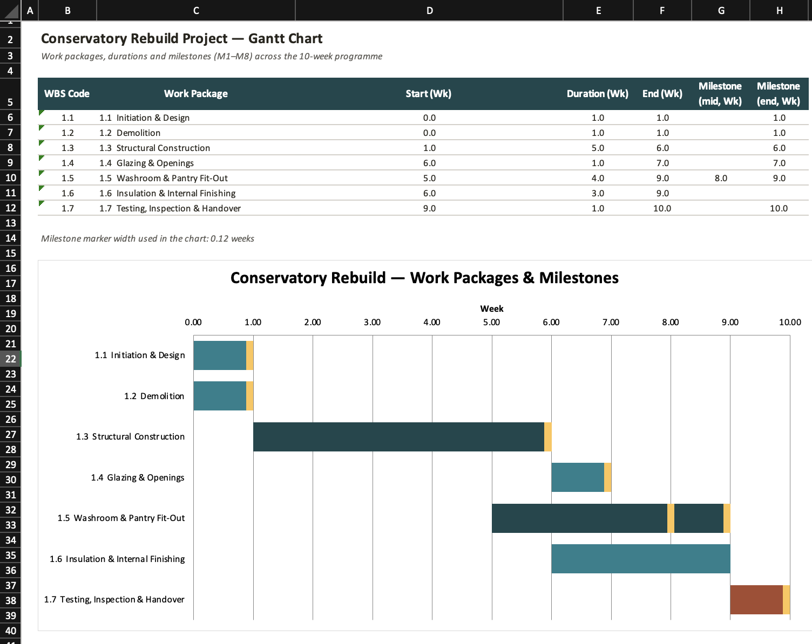

Resource Usage: Personnel and Materials
Delivering each task within the Work Breakdown Structure requires the careful allocation of appropriate personnel and materials to ensure that all activities are completed efficiently and to the required standard. Resources are assigned directly to the specific tasks identified in WBS Table, for example the glazier and the Velux units are linked to glazing tasks, while the plumber and sanitary equipment are allocated to washroom installation tasks, which supports effective coordination and accountability throughout the project.

Personnel
The project team includes a project manager who oversees scheduling, budgeting, coordination, and communication with the client throughout the project. A structural or building surveyor evaluates the existing structure and provides guidance on design aspects. Builders and general labourers carry out demolition, construction, insulation, and finishing work, while the glazier installs skylights, windows, and doors. The plumber is responsible for drainage and washroom fittings, and the electrician completes all electrical installations. In addition, a plasterer and decorator complete internal finishes, and a Building Control Officer inspects the work and confirms compliance with regulations.

Materials
A range of materials is required to support construction and finishing activities, including structural components for the frame and walls, roofing and insulation materials that comply with the legal requirements, glazing units such as skylights and windows, and a door set. Internal fittings include sanitaryware and pantry storage, supported by plumbing and electrical components. Finishing materials such as plaster, paint, and flooring are also needed, along with arrangements for waste removal through skip hire.

Conclusion
This project plan defines the aim, objectives, and scope of the conservatory rebuild and translates them into clear outputs, activities, a Work Breakdown Structure, milestones, and resource requirements. The work is organised through a clear and logical Work Breakdown Structure in which each code is linked to a specific deliverable, allowing the project manager to estimate, schedule, and control the ten week programme with greater accuracy and confidence. The milestone timeline also provides the client with clear points to review progress throughout the project. However, as is common in domestic construction projects, potential risks such as adverse weather conditions, delays in the supply of Velux units, and unexpected structural issues during demolition may affect progress. Effective communication among the contractor, glazier, plumber, and electrician, along with the inclusion of contingency measures, is essential to ensure that the conservatory, washroom, and pantry are completed safely, on time, and within budget.

References
Doran, G.T. (1981) ‘There’s a S.M.A.R.T. way to write management’s goals and objectives’, Management Review, 70(11), pp. 35–36.
HM Government (2021) Approved Document L: Conservation of Fuel and Power (2021 edition, incorporating 2023 amendments). Available at: https://www.gov.uk/government/publications/conservation-of-fuel-and-power-approved-document-l (Accessed: 11 July 2026).
Kerzner, H. (2017) Project Management: A Systems Approach to Planning, Scheduling, and Controlling. 12th ed. Hoboken, NJ: Wiley.
Planning Portal (2026) Conservatories: Planning Permission and Building Regulations. London: Planning Portal. Available at: https://www.planningportal.co.uk/permission/common-projects/conservatories (Accessed: 11 July 2026).
Project Management Institute (2019) Practice Standard for Work Breakdown Structures. 2nd ed. Newtown Square, PA: Project Management Institute.
Project Management Institute (2021) A Guide to the Project Management Body of Knowledge (PMBOK Guide). 7th ed. Newtown Square, PA: Project Management Institute.
Simon, P. (2018) Starting out in project management. . Third edition. Edited by R. Murray-Webster. Buckinghamshire, England : Association for Project Management.
Wassenaer, A. van (2017) A Practical Guide to Successful Construction Projects. 1st edn. Informa Law from Routledge. Available at: https://www.perlego.com/book/1568107 (Accessed: 14 July 2026).

