Construction Technology 1

Swansea Foreshore Ice-cream Parlour

Contents

- Preliminary Desk Top Study – Pages 3-5
- Further Site investigation – page 5-5
- Materials Used – Page 6-6
- The Site – Pages 7-9
- References – Page 9-9

Preliminary Desk Top Study

When in the planning stages of considering construction work whether it being a new build on a unused site or a new build on an existing site or even a refurbishment to a home, you should start of by carrying out a feasibility study and a preliminary desk top study on your site.

A feasibility study will tell you if your project is possible to be constructed and if the funding required to construct it is actually worth it by seeing if the out come will provide a good money generating service like the Tidal Lagoon concept. This concept has been giving the green light after the feasibility study as it was seen a possible and cost effective project, yet the government still haven’t exactly given a response to this. The project is fundamentally a sea wall the can be walked over by the public creating nice atmospheres for the public to enjoy, but at the same time under the wall are fans which when the tides come in and out will be spun creating electricity.

A preliminary site investigation is the process of gathering background information about site-specific characteristics that will need to be considered during planning (Designing Buildings Wiki, 2018).

Most researched sources of desk top studies include service records to see where utility cables are like electrical cables. Ordinance survey maps which help with telling how the coastal erosion is like, which is important in our buildings case as its right next to the see wall. They are also used for concealed mine shafts and drainage etc, all of which are important to be informed about when building on sites as the information will help for you to assess the area and build accordingly.

From research I done in the Swansea central library using old OS maps I had discovered that the area of our site used to be a canister works and had easy access to a rail way which is where the promenade is now back in the 1950’s. This shows me that the area is capable of have construction work carried out on the site.
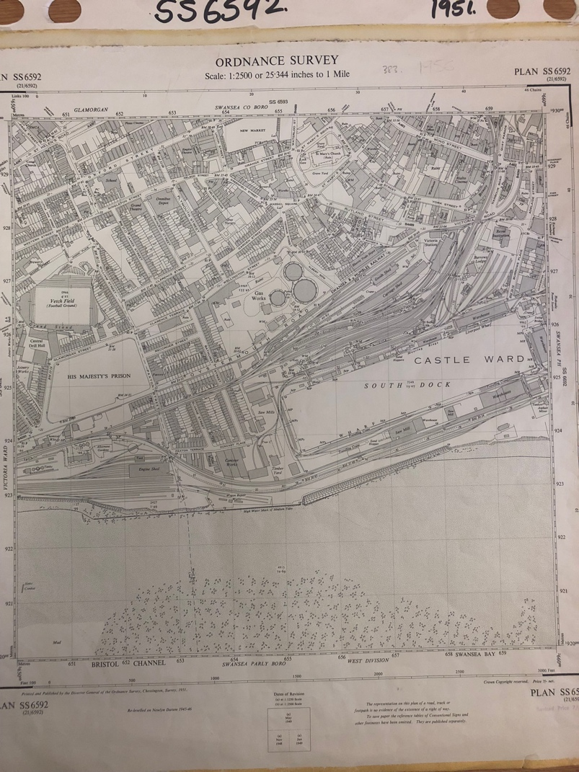

(OS map showing the site and surrounding area back in the 1950’s)

From my personal walk over inspection of the site that I conducted currently, I discovered that there are some sort of utility services under the site running parallel with the promenade but approximately 1m away from the promenade. So this could possible effect how I do my foundation as if I carry out my foundation for my building there the process of digging up the surface area could possibly result in these services being damaged. So in order to combat this ill have to not have my ice cream parlour that close to the promenade and find where they run exactly from recorded maps of the area.

There are some trees near by the site so on a further and more detailed investigation I would need to find out what type of tree they are and how close to a building they can be and if their roots and water intake would affect a buildings foundation and sub structure.

On site there is a large amount of top soil above the building level which may or may not be needed to flatted out and transported else where, however a further site investigation would generate that information if need be.

Further Investigation

In order to achieve I better understanding of the site provided and gain a more detailed site check I would need to do more which I haven’t been able to find out. Such as finding out what material and type of soil is the site on and if there is shrinkable clay etc or even if the ground is contaminated. Finding out the moisture of the land would be handy in addition as it would allow me to predict the type of concrete need to use in the foundations to dry faster for example.

Finding out how well the sea wall defence opposite the site on the promenade as if it isn’t maintained very well it would be advisable to the local authorities to take action and for us to tell the client as the building could be in future risk.

The exact location of the utilities below the surface is need to avoid any damage caused by the machinery being used during the construction process.

Need to ensure there aren’t any plats that can cause risk to foundations near by such as Japanese knot weed however it is very unlikely in this area and I can safely assume there isn’t any, however you will always need to check for various things like this just in case. As if by chance you discover some and it’s too late then it’s a costly process and a long one to fix this issue.

I would like to find out the sun rise in regards to that spot so I can position my building at the correct angle in order to achieve the maximum natural light into the building also creating a good atmosphere for the public.

Materials Used

Materials that are being used in this construction can be seen in drawings attached.

Deep strip foundations are being dug out at 600mm wide and either 1m/2m deep due to being so close to the see front. This will provide a sturdy and strong base for the construction of the parlour. Then the cavity wall is to be filled with some concrete but kept at 225mm below the damp proof course. Then damp proof membrane will be laid on top of the insulation above the sub floor and will lap with the dpc on the inner wall leaf and go through the block work and brick work. Above the dpm layer will be a small layer of latex smoothing compound to smooth out the floor in order to lay flooring coverings.

Walls are being made 300mm thick with a layer of brick, then a cavity with wall ties keeping the brick and block wall together followed by a wall of aerated blocks with thick thermal boards and plaster. This should create a good enough wall to with stand the conditions of a seafront which would occasionally consist of harsh winds, so the public when inside shouldn’t feel or tell if there is harsh conditions outside.

The front of house will have two glass walls which will only go from the foundation level to the floor of the first floor, so only the ground floor will have these glass walls because this is where all the public will be held create a nice view out to the seaside and promenade.

For the roof of the ice cream parlour/restaurant in order to protect it from weathering I’ve designed it by using a concrete deck base with the timber batons running around the edge. Followed by a vapour control layer on which the insulation rests on to level with the baton. On top of the insulation is a black sheathing felt and a solid permaphelt water check. The roof trim attaches to the water check and fascia board. Permaphlat is a mastic asphalt type of roofing which provides good durability and weather resistance and temperature stability, while all being easy to install. Polymer technology grants its positive outcomes. Due to the ease of installation and good protection and durability in changing weathering conditions makes it ideal to use.

The Site

The site of the ice cream parlour shown in the brief is very hard to organise due to the fact that it’s contains two car parks one from the Swansea council building and the other from the Marriot’s hotel. On top of that it’s right next to the public promenade which you cant close down to put a wall up.

What I’ve suggested is as shown on my existing site plan. The site will include part of both car parks providing we get permission to access and use of the area temporally. This could possible save us some money. Once the site walls are built up in the area shown on the drawing attached, we will be able to grant access to vehicle deliveries through the Swansea council archive car park. Once the deliveries are taken place we can store the materials required inside the site wall and up on scaffolding which will be constructed around the building. This is a very similar approach to what TRJ construction carried out during the construction of Prezzo back in 2017 in mumbles which isn’t actually far down the coast from this site on the same promenade. Which suggests to me this is the best way of organising the site.

This lay out will provide enough space to grant us use of some helpful machines such has compact cranes that we can set up in stationary positions around the site allowing us to transport the materials to the upper floors of the project with ease. This will reduce any harm to labourers and the public as the machines will be operated with ing the site and nothing will be held over the site walls.

Very small diggers will be required to carry out this work due to excavate the ground to create a flat surface in order to dig out the trenches required for the foundations. This is because we are using deep strip foundations to have the maximum support for the building we are carrying out.

With the space provided in the enclosed site walls we should have enough room to allow a storage facility for our employees to store there tools necessary for the job such as hammers, drills etc.

Also we will have to allow the labourers a place to use the lavatories so we will have to install a portable toilet in this area.

Due to the site being used for a lot of plant I’m sure it won’t leave enough space for our company’s labourers to park their vans so we will have to ask the Swansea council or Marriott hotel to use their spaces to allows the work staff to park their vehicles.

On the site plan shows the rough sketch of how it all will be set up and ho the promenade will still have access to the public. Also it shows what to chase up on in the further site investigation.

Health and safety

Health and safety is very serious to consider during the process of building and should be thought of widely through out the construction industry. This is because as an employer of a work force which is required to use machines you have a duty of care of the employees to make sure they are all safe and looked after.

This is done by making sure everyone has proper training in order to become usable on your sites. Id make sure everyone is CSCS card ready as a start. Hols tool box talks so everyone is completely competent of the basic requirements on site. Then for anyone using special machinery such as cranes for example make sure they are indeed well trained in that piece of equipment before allowing access to them using it.

Also make sure the site permitter wall is well labelled with live job, hard required, safety boots required, authorised personal only etc. This will ensure that the members of public won’t try to enter the site but to be extra safe on all entrances to the site have a key code system in place just to be safe allowing protection for the public. Make sure the signs include some sort of warning of high walls, machinery and plant in use so they know in is a dangerous place to enter and they could be seriously harmed.

References

Designing Buildings Wiki (2018) Desk Study [online] available at https://www.designingbuildings.co.uk/wiki/Desk_study [accessed 09 February, 2018]

OS map of Oystermouth Road in 1951. Ordinance Survey map, viewed December 2017.

