

LCMB7002
Financial Management

Assessment component: Financial Performance and Management
Strategic CFO Challenge

Title: Strategic CFO Challenge – Financial Analysis of Toyota Industries Corporation

Submitted by
Student Name: Ashraful Hoque
ID: 2522430
Submitted to-
Lecturers: Shengfeng Mei / Patrick Yeboah

Word Count: 5844

Submission deadline: 24th April 2026 by 2PM

Acknowledgement of AI Tool Use
In accordance with the UWTSD AI Use Acknowledgement Guidelines (February 2026), I declare the following uses of AI tools during the preparation of this assessment. All uses fall within the permitted categories of Research, Proofreading, and Creative as specified in the assessment brief.

1. Research Support
I acknowledge the use of Google Gemini (https://gemini.google.com/) on 2 March 2026 to support my research using the prompt(s):
1. Can you help me find the key financial ratios from Toyota Industries Corporation annual report 2025, specifically gross margin, operating margin, and ROE for each year from FY2021 to FY2025?
2. What was the cash flow from operations for Toyota Industries in FY2024 and FY2025 and why did it change so much?

I acknowledge the use of ChatGPT (https://chatgpt.com/) on 12 March 2026 to support my research using the prompt(s):
3. How do you calculate the cash operating cycle for a manufacturing company and what is considered a good benchmark?
4. What is the difference between capital rationing and capital budgeting and how does the profitability index help with project selection?

2. Proofreading Support
I acknowledge the use of Grammarly (https://www.grammarly.com/) on 18 March 2026 to check my work using the prompt(s):
5. Check the following paragraphs from my financial health check section for grammar, spelling mistakes and sentence flow.
6. Please review my investment appraisal section for any grammatical errors and suggest corrections.

I acknowledge the use of QuillBot (https://quillbot.com/) on 20 March 2026 to check my work using the prompt(s):
7. Check the readability and academic tone of my restructuring section and flag any sentences that sound too informal for a masters level report.

3. Creative Support
I acknowledge the use of Google Gemini (https://gemini.google.com/) on 15 April 2026 to create chart images using the prompt(s):
8. Create a professional line chart showing Toyota Industries net sales from FY2021 to FY2025 with data points at 2118.3, 2705.1, 3379.9, 3833.2, 4084.9 billion yen in dark navy colour on white background.
9. Create a horizontal bar chart comparing NPV of three investment projects: Project A at negative 8.68m, Project B at negative 8.30m, Project C, at negative 1.98m, with a break-even line at zero.
10. Generate a doughnut chart showing Toyota Industries segment revenue breakdown for FY2025 with Materials Handling at 68.2 percent, Automobile at 28.4 percent, Textile at 2 percent.

I acknowledge the use of Canva AI (https://www.canva.com/) on 17 April 2026 to edit and format chart images:
11. Resize and crop the chart images to fit A4 landscape format and remove extra whitespace around the edges.
I confirm that I have not presented any AI generated materials as my own work. I confirm I have copies of my drafts, notes, and other resources I used before, and after the use of AI tools which I may be asked to provide in evidence.

Table of Content | Page no
Table of content | 4
Table of table & figures | 5
1.Introduction | 6
2.Financial Health Check (Ratio Analysis) | 7
2.1-2.3 Profitability, Liquidity, Efficiency, Gearing, Investment Ratios | 8-12
2.4 2.4 Key Trends, Strengths & Threats | 12-13
3.Working Capital Management Analysis | 14
3.1-3.3 Cash Operating Cycle Assessment, Practical Strategies for Improving Liquidity & Short-term vs Long-term Financing Options | 14-16
4. Strategic Financial Restructuring Plan | 17
4.1-4.3 Recommended Financial Restructuring Options, What This Means for Shareholders, Debt, and Flexibility & International and Ethical Considerations | 17-19
5. Investment Appraisal and Capital Budgeting Decisions | 20
5.1 Project Details and Calculations (PBP, ARR, NPV, PI, IRR) | 20-23
5.2 Which Project, and Why? | 23
5.3 What If We Can Invest in More Than One? | 24
6. Conclusion | 25-26
References | 27-28
Appendices A - Detailed Ratio Calculations &  Appendix B- Investment Appraisal Workings | 29

Table of Tables
Table 1: Financial Summary of Toyota Industries Corporation (FY2021-FY2025)
Table 2: Profitability Ratios (FY2021-FY2025)
Table 3: Liquidity and Efficiency Ratios (FY2021-FY2025)
Table 4: Gearing and Investment Ratios (FY2021-FY2025)
Table 5: Estimated Cash Operating Cycle (FY2024 vs FY2025)
Table 6: Comparative Summary of All Three Projects
Table 7: Capital Rationing - Comparing Project Combinations

Table of Figures
Figure 1: Net Sales Trend (FY2021-FY2025)
Figure 2: Profitability Ratios Trend Chart
Figure 3: Segment Revenue Breakdown (FY2025)
Figure 4: Cash Flow Comparison (FY2024 vs FY2025)
Figure 5: NPV Comparison of Projects A, B, and C

1. Introduction
Toyota Industries Corporation, founded in 1926 by Sakichi Toyoda, is one of those companies that people outside the automotive world tend to overlook, despite it being a genuinely massive enterprise. With consolidated net sales reaching ¥4,084.9 billion in FY2025 and a workforce of nearly 80,000 employees, the firm operates across automobiles, materials handling equipment, and textile machinery (Toyota Industries Corporation, 2025). What makes it particularly interesting for a financial analysis is its hybrid identity: it manufactures car air-conditioning compressors, engines, and electronic components for electric vehicles while simultaneously being the world's largest producer of forklift trucks through its Materials Handling Equipment segment.
This report takes on the role of Chief Financial Officer and attempts to do something that, frankly, is easier said than done: to look at five years of financial performance, identify where the cracks are, and propose something constructive. The company has been navigating a period of considerable turbulence. There was the domestic engine certification scandal discovered in 2023, which led to production suspensions, reputational damage, and provisions exceeding ¥49 billion (Toyota Industries Corporation, 2025). At the same time, the firm posted record profits. It is actually that kind of tension, between the strong headline numbers and the messy operational risks lurking underneath, that makes digging into this analysis feel worth the effort.
The structure of this report follows a logical progression. In part 2, the report works through a thorough ratio analysis looking at profitability, liquidity, efficiency, gearing, and investment metrics from FY2021 through to FY2025. In part 3 there is working capital management. In part 4 proposes strategic financial options. In part 5 there are 3 hypothetical projects through the usual capital budgeting tools: Payback Period, ARR, NPV, Profitability Index, and IRR. The goal throughout is to be as rigorous as possible while still being upfront about where things get fuzzy. Because let's be honest, any analysis that relies on published financial statements is inherently working with information that is not quite complete.

2. Financial Health Check (Ratio Analysis)
Before getting into the ratio analysis proper, it is worth just pausing for a moment and looking at what the raw numbers themselves are actually saying. Sometimes the big picture gets lost once you start slicing things into percentages. Over the past five years, Toyota Industries has come close to doubling its net sales, going from ¥2,118.3 billion in FY2021 all the way up to ¥4,084.9 billion by FY2025. Operating profit moved in roughly the same direction, going from ¥118.1 billion up to ¥221.6 billion over that same five-year window. Though it's worth noting the pace of growth here has been slower than the topline, which tells you something about cost pressures eating into margins. On the surface, this looks like a company in excellent health. But the picture gets muddier when you look beneath the headline figures, particularly around cash flow volatility, comprehensive income swings, and the massive decline in total assets from ¥11,078.4 billion to ¥9,403.4 billion in a single year (Toyota Industries Corporation, 2025). That last point is mostly explained by the fall in fair value of investment securities, especially Toyota Motor Corporation shares, which dropped from ¥4,521.3 billion to ¥3,119.1 billion.

Table 1: Financial Summary of Toyota Industries Corporation (FY2021-FY2025)
Metric (¥ Billions) | FY2021 | FY2022 | FY2023 | FY2024 | FY2025
Net Sales | 2,118.3 | 2,705.1 | 3,379.8 | 3,833.2 | 4,084.9
Operating Profit | 118.1 | 159.0 | 169.9 | 200.4 | 221.6
Profit (Owners) | 136.7 | 180.3 | 192.8 | 228.7 | 262.3
Total Assets | 6,503.9 | 7,627.1 | 7,821.1 | 11,078.4 | 9,403.4
Total Equity | 3,236.0 | 3,928.5 | 3,837.4 | 6,045.7 | 4,904.6
Op. Cash Flow | 382.3 | 321.0 | 194.9 | 443.5 | 171.5
Source: Toyota Industries Corporation Annual Financial Report 2025.
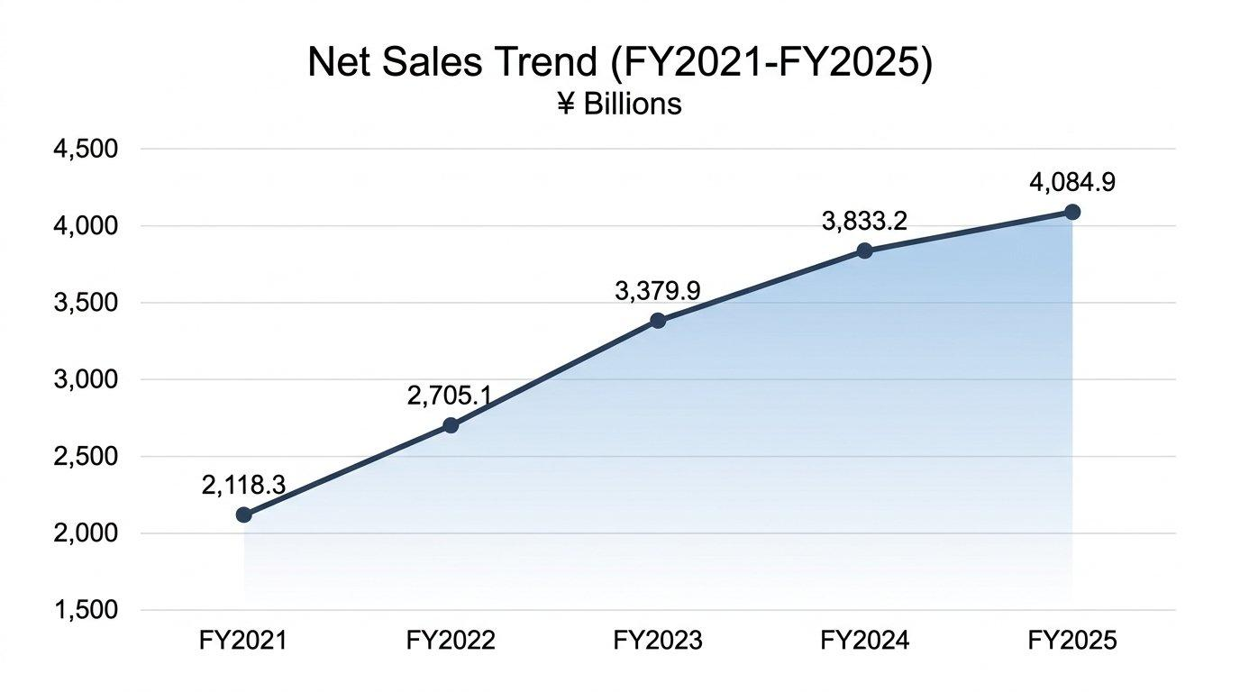
Figure 1: Net Sales Trend, FY2021-FY2025 (¥ Billions). Source: Author's compilation from Toyota Industries Corporation (2025).

2.1 Profitability Analysis
Profitability ratios paint a somewhat cautious picture. Gross profit margin has stayed fairly steady at around 23% throughout the period. It did nudge slightly from 23.5% in FY2024 down to 23.3% in FY2025, though honestly, that is more of a rounding difference than a real shift. This is not spectacular for a manufacturer, but it is consistent. Operating margin has bounced around a bit between 5.0% and 5.9% over this period, settling at 5.4% in FY2025. Not dramatic movement, but enough to notice. One could argue this is somewhat thin, especially for a company of this scale, but it reflects the capital-intensive nature of both automobile component manufacturing and materials handling equipment production.
Net profit margin has, well, technically improved, rising from 6.4% in FY2021 to 6.4% in FY2025. Which is to say it has basically stayed flat, even if the years in between saw some dips and recoveries. Return on equity attributable to owners of the parent has remained remarkably stable at around 4.8% to 5.0%, which is, to be candid, not particularly exciting. When you have a company sitting on ¥4.9 trillion in equity and only pulling a 4.8% return, something feels off. That either points to an overly cautious balance sheet or assets that just are not being put to work hard enough (McLaney, 2017). The enormous investment securities portfolio, which makes up over 40% of total assets, is probably the biggest culprit behind that dilution. Return on assets has similarly hovered around 2.5% to 2.8% across the period, which again reflects the bloated asset base.
Table 2: Profitability Ratios (FY2021-FY2025)
Ratio | FY2021 | FY2022 | FY2023 | FY2024 | FY2025
Gross Profit Margin | ~23.0% | ~23.2% | ~23.1% | 23.5% | 23.3%
Operating Margin | 5.6% | 5.9% | 5.0% | 5.2% | 5.4%
Net Profit Margin | 6.4% | 6.7% | 5.7% | 6.0% | 6.4%
ROE (Owners) | 4.82% | 5.03% | 4.97% | 4.63% | 4.79%
EPS (Yen) | 440.28 | 580.73 | 621.17 | 736.86 | 856.96
Source: Author's calculations based on Toyota Industries Corporation Annual Financial Report 2025.
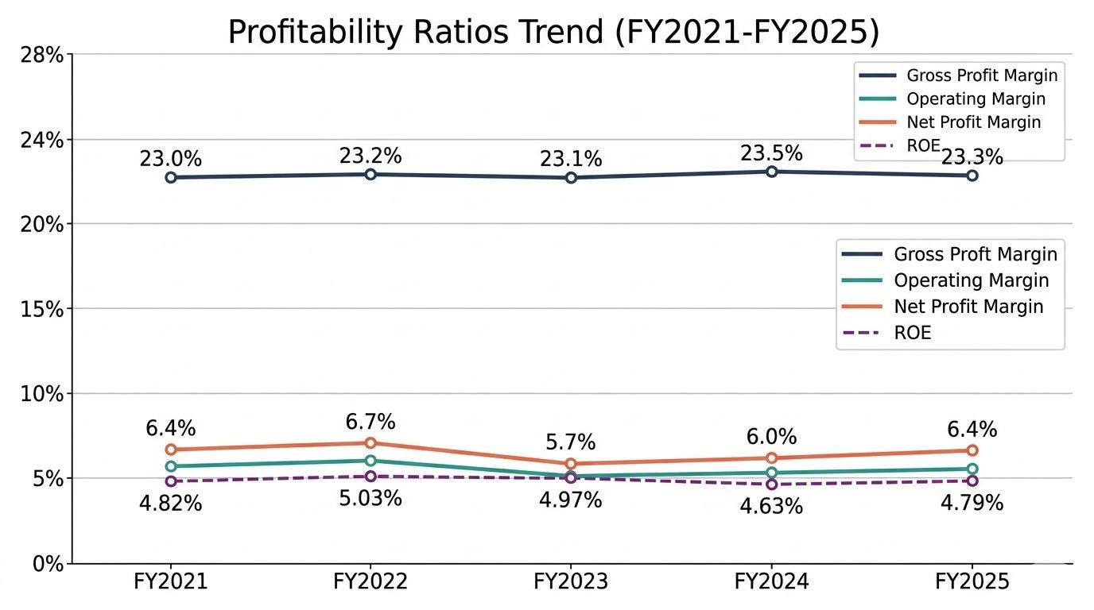
Figure 2: Profitability Ratios Trend, FY2021-FY2025 (%). Source: Author's calculations from Toyota Industries Corporation (2025).

On a brighter note, earnings per share has nearly doubled over five years, going from ¥440.28 up to ¥856.96. That is one trend that's genuinely hard to argue with. This reflects both profit growth and, in FY2025, the effect of a significant share buyback programme where the company repurchased ¥109.1 billion worth of treasury stock (Toyota Industries Corporation, 2025). Shareholders will probably like what they see there, though there is a catch. The share buyback shrinks the equity base too, and that could end up inflating ROE in future periods in a way that does not really reflect actual performance improvement.

2.2 Liquidity and Efficiency Analysis
Liquidity is perhaps the area where questions start to emerge. Current assets of ¥3,109.4 billion against current liabilities of ¥1,622.2 billion gives a current ratio of approximately 1.92, which is comfortable by most standards. Quick ratio, stripping out inventories of ¥619.8 billion, sits around 1.53. These are adequate, and there is no immediate liquidity crisis.
The cash position, though, has taken a noticeable hit. Cash and equivalents dropped from ¥496.8 billion at FY2024 year-end to ¥378.4 billion by FY2025. A 24% fall in your cash pile in a single year is not the kind of thing you can just shrug off, even for a company this size. Even more striking, operating cash flow dropped from ¥443.5 billion to just ¥171.5 billion. A big chunk of that is down to income tax payments, which jumped massively from ¥78.9 billion to ¥213.8 billion (Toyota Industries Corporation, 2025). That is a pretty remarkable swing in tax outflows. That is a remarkable swing in tax outflows, and it raises questions about the sustainability of prior-year tax positions, possibly related to the timing of gains on investment securities disposals.
Turning to efficiency ratios, these give you a sense of how disciplined the company is being with its day-to-day operations. They are not glamourous metrics, but they matter more than people tend to think. Trade receivables have remained broadly stable at around ¥628.5 billion, while payables have edged down slightly to ¥422.9 billion. Inventory turnover looks reasonably healthy on the surface. Inventories stayed more or less flat at ¥619.8 billion even though sales grew by 7%, which at first glance suggests the company is managing its stock well enough. That said, you would really need a more detailed product-by-product breakdown to say for certain, because aggregate numbers have a tendency to hide problems at the segment level (Atrill, 2020).
Table 3: Liquidity and Efficiency Ratios (FY2024-FY2025)
Ratio | FY2024 | FY2025
Current Ratio | 1.91 | 1.92
Quick Ratio | 1.53 | 1.53
Cash Ratio | 0.30 | 0.23
Inventory Turnover (times) | 4.73 | 5.06
Receivables Days | ~60 | ~56
Source: Author's calculations based on Toyota Industries Corporation Annual Financial Report 2025.
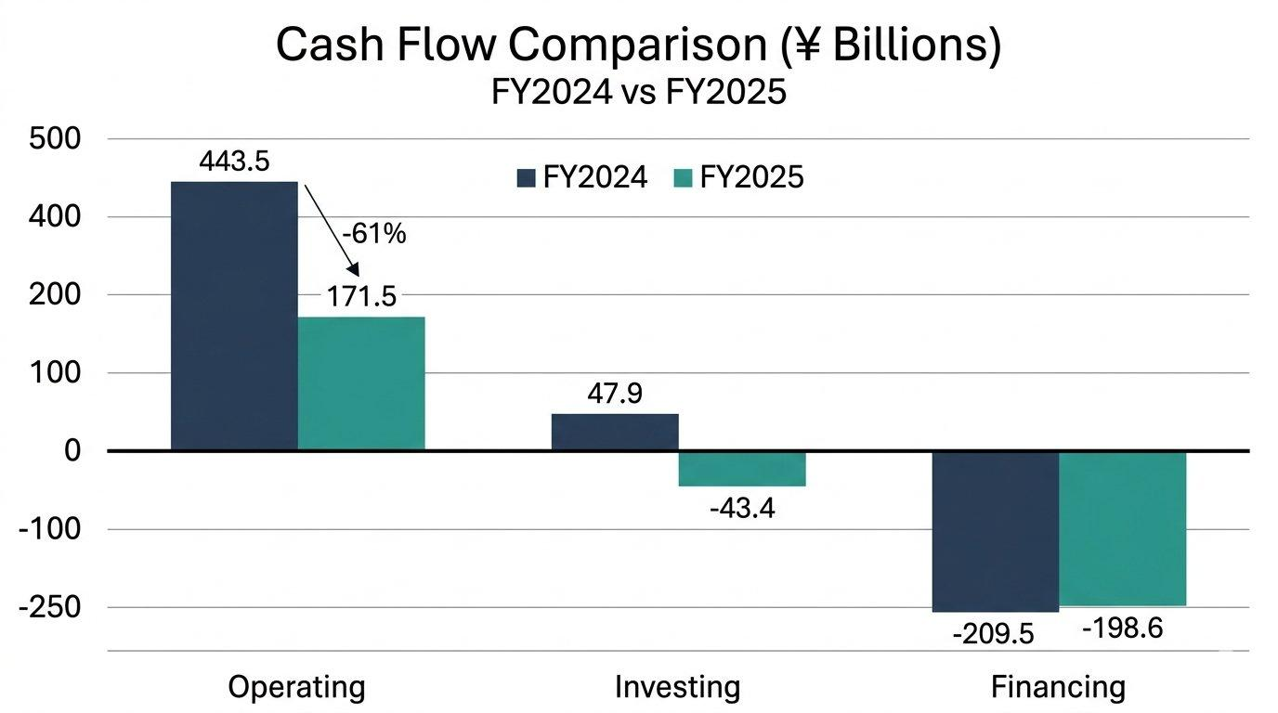
Figure 4: Cash Flow Comparison, FY2024 vs FY2025 (¥ Billions). Source: Author's calculations from Toyota Industries Corporation (2025).

2.3 Gearing and Investment Ratios
The gearing position of Toyota Industries is moderate but has shifted in interesting ways. By FY2025, total liabilities came in at ¥4,388.2 billion while equity sat at ¥5,015.2 billion, which works out to a debt-to-equity ratio of roughly 0.87. Not alarming by any stretch, but it's worth keeping an eye on the direction of travel. This is down from the previous year, primarily because liabilities fell by ¥536.9 billion, driven by a large reduction in deferred tax liabilities that accompanied the fall in investment securities valuations. Corporate bonds and loans total ¥1,730.0 billion, which represents a debt-to-total-capital ratio of about 25.6% if you exclude the investment securities distortion.
Interest cover, meanwhile, is in a very comfortable position and not something that keeps anyone up at night. With operating profit at ¥221.6 billion and interest expenses of just ¥11.1 billion, the interest coverage ratio comes out at over 19 times. That is, by any reasonable measure, very comfortable. You would have to imagine a fairly catastrophic scenario for that to become a problem. The credit ratings from S&P, Moody's, and R&I more or less confirm this picture of financial solidity (Toyota Industries Corporation, 2025). Nevertheless, the firm is carrying net debt that has been growing, with long-term loans of ¥779.7 billion and corporate bonds of ¥453.0 billion representing significant future obligations.
The equity ratio to total assets stands at 52.16%, which is actually quite strong for a manufacturing conglomerate. The price-to-earnings ratio of 14.83 times is reasonable and suggests the market is pricing in modest growth expectations rather than any premium for exceptional performance (Penman, 2013). Dividend yield has been respectable, with total dividends of ¥280 per share for FY2025. One thing that stands out, though, is that the company has already said there will be no dividends for FY2026. The reason is the pending tender offer from Toyota Fudosan, and if that goes through, it will quite fundamentally reshape the company's entire capital structure.
Table 4: Gearing and Investment Ratios (FY2024-FY2025)
Ratio | FY2024 | FY2025
Debt-to-Equity | 0.80 | 0.87
Interest Coverage | ~11.8x | ~19.9x
Equity Ratio | 54.57% | 52.16%
P/E Ratio | 21.24x | 14.83x
Dividend per Share (¥) | 200 | 280
Source: Author's calculations based on Toyota Industries Corporation's Annual Financial Report 2025.

2.4 Key Trends, Strengths and Threats
Several trends deserve attention. Firstly, revenue growth has been consistent and broad-based across all segments, with the Materials Handling Equipment segment (¥2,786.3 billion in FY2025) serving as the dominant revenue driver, accounting for 68% of consolidated sales. The Automobile segment, which brought in ¥1,160.2 billion in revenue, saw a genuinely impressive jump in profitability. Operating profit surged 147% year-on-year, which is partly a recovery effect following the partial resolution of the engine certification mess. So it looks dramatic, but some of that is just bouncing back from an artificially low base.
The key strength of the company is diversification. Unlike a pure-play EV manufacturer, Toyota Industries has multiple revenue streams and geographic spread, with Japan contributing ¥1,008.1 billion, the USA ¥1,415.2 billion, and other markets ¥1,661.6 billion in FY2025. This geographic balance provides a natural hedge against regional economic downturns, though it also increases exposure to currency risk, particularly the yen-dollar and yen-euro rates (Madura, 2018).
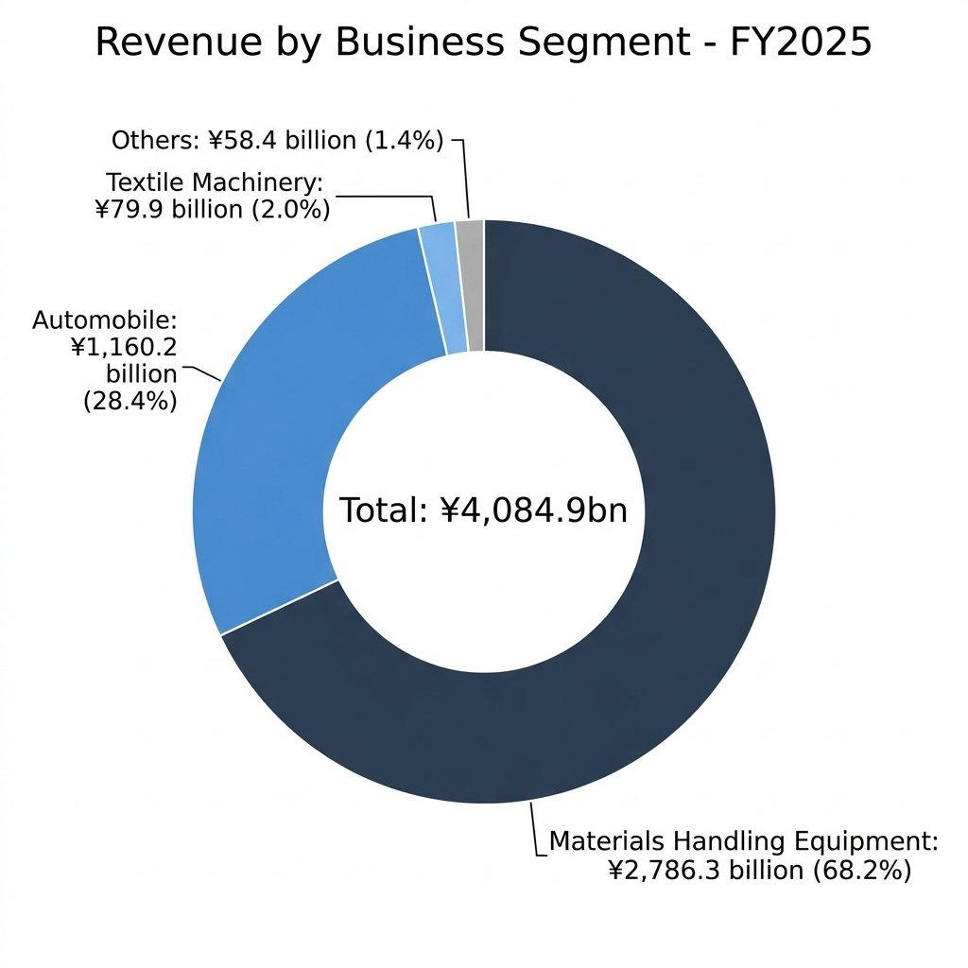
Figure 3: Business Segment Revenue Breakdown, FY2025. Source: Author's compilation from Toyota Industries Corporation (2025).
The primary threat, beyond the ongoing engine certification investigations and US class action lawsuit, is the extraordinary volatility in comprehensive income. To put the volatility in perspective, comprehensive income was ¥2,285.8 billion in FY2024. A year later, it swung to negative ¥938.1 billion. That is a swing of over ¥3.2 trillion in twelve months, which is the kind of number that makes you do a double take. A swing of over ¥3.2 trillion in a single year, driven almost entirely by the revaluation of FVTOCI financial assets, exposes how sensitive the company's reported equity is to stock market movements. This is not an operational problem per se, but it significantly complicates any assessment of financial health (Barth, Landsman and Lang, 2008).

3. Working Capital Management Analysis

3.1 Cash Operating Cycle Assessment
In Toyota Industries' case, the cycle runs through a fairly standard sequence: buying raw materials, pushing them through production, sitting on finished goods for a while, selling them off, and then waiting for customers to actually pay up. Each step along the way ties up cash. Each stage ties up cash, and the longer the cycle, the more working capital is required to keep operations running smoothly (Arnold, 2019).
Looking at FY2025 data, inventories stood at ¥619.8 billion against a cost of sales of ¥3,133.4 billion. That gives an approximate inventory holding period of around 72 days. Trade receivables of ¥628.5 billion set against net sales of ¥4,084.9 billion give you a receivables collection period of around 56 days, which is not unreasonable for a business of this scale and complexity. On the other side, trade payables of ¥422.9 billion against cost of sales imply a payables payment period of about 49 days. So when you add it all up, 72 days for inventory plus 56 days to collect minus 49 days of payables, the estimated cash operating cycle lands at roughly 79 days. Not terrible, but there's definitely room to tighten things up. This is not unusual for a diversified manufacturer, though it does suggest there is capital tied up in the cycle that could, at least in theory, be released.
Table 5: Estimated Cash Operating Cycle (FY2024 vs FY2025)
Component (Approx. Days) | FY2024 | FY2025
Inventory Holding Period | ~77 | ~72
Receivables Collection | ~60 | ~56
Payables Payment Period | ~55 | ~49
Cash Operating Cycle | ~82 | ~79
Source: Author's calculations based on Toyota Industries Corporation Annual Financial Report 2025.

3.2 Practical Strategies for Improving Liquidity
So what could Toyota Industries actually do to free up cash through better working capital management? A few options come to mind. The most obvious starting point is receivables. Sitting on ¥628.5 billion in trade receivables with a 56-day collection period means there is real money locked up waiting to come through the door. If you could shave just 5 days off that collection period, you are looking at freeing up somewhere in the neighbourhood of ¥56 billion in cash. That is not a trivial amount. One way to do this would be offering early payment discounts to bigger customers or leaning more heavily into factoring arrangements in the Materials Handling Equipment segment, which already manages ¥626.5 billion in lease investment assets, so the infrastructure for that kind of thing is partly there already (Brealey, Myers, and Allen, 2020).
A second strategy involves inventory optimization. On the surface, overall inventory looks stable enough. But when you break it down, finished goods and merchandise are sitting at ¥355.3 billion, work in process at ¥123.2 billion, and raw materials at ¥141.1 billion. What catches the eye is that finished goods climbed from ¥327.5 billion to ¥355.3 billion even while total inventory barely moved. That kind of shift hints at either overproduction somewhere or products that just are not moving off shelves as fast as they used to. The Textile Machinery segment, where sales fell a full 14%, seems like an obvious candidate for tighter demand forecasting and leaner inventory practices along the lines of just-in-time principles (Christopher, 2016).
Then there is the supplier side of the equation. Going back and trying to renegotiate payment terms is always worth exploring, even if it is not always a comfortable conversation to have. Extending the payables period from 49 to, say, 55 days would retain cash for an additional week across the supply chain. This must be balanced against supplier relationships, particularly given the automotive industry's emphasis on supply chain stability and the lesson from the engine certification scandal about the consequences of straining partner relationships.

3.3 Short-term versus Long-term Financing Options
Toyota Industries currently employs a mixed financing strategy. Short-term instruments include ¥60.7 billion in short-term loans, ¥173.6 billion in commercial paper, and ¥233.0 billion in long-term loans repayable within one year. Long-term Instruments include ¥779.7 billion in long-term loans and ¥453.0 billion in corporate bonds with maturities extending to 2039.
For a company of this size and credit quality, the current balance seems reasonable. Short-term financing has its advantages, mainly flexibility and, usually, cheaper rates. The commercial paper program can be rolled over efficiently. That said, the weighted average interest rate on short-term loans sits at 4.10%, which feels a bit on the high side. That probably reflects the borrowing conditions in some of the non-Japanese subsidiaries rather than anything specific to the parent company's creditworthiness. Long-term loans carry a weighted average of 2.56%, while corporate bond rates range from 0.080% on older yen-denominated issues to 5.929% on newer USD-denominated notes (Toyota Industries Corporation, 2025). With global monetary policy still uncertain and the costs of delisting likely to be considerable, having predictable financing costs seems like the sensible play rather than gambling on where short-term rates end up next year (Watson and Head, 2019).

4. Strategic Financial Restructuring Plan

4.1 Recommended Financial Restructuring Options
The elephant in the room, of course, is the pending tender offer from Toyota Fudosan at ¥16,300 per share, announced on 3 June 2025. This is not an ordinary restructuring scenario. If successful, this transaction will take Toyota Industries private, delisting its shares and making the Offeror and Toyota Motor Corporation the sole shareholders. The reasoning behind it, at least officially, is that going private would let the company make decisions faster, integrate more deeply with Toyota Group companies, and chase longer-term growth without constantly worrying about what the market thinks every quarter (Toyota Industries Corporation, 2025). Whether that actually plays out that way is another question entirely.
In this context, the recommended restructuring approach has three dimensions. For starters, the company really ought to look at selling off assets that are not central to its core business. Partial stake of AICHI Corporation to ITOCHU Corporation, which was completed in May 2025 with an expected gain of ¥9.1 billion. Logic behind it makes sense when you think about it. AICHI's aerial work platform business was profitable, yes, but it was never really at the heart of what Toyota Industries is trying to do. Bringing ITOCHU in as a partner adds distribution know-how and a different perspective on growth, which is exactly the kind of thing AICHI probably needs at this stage. You could make a similar case for the Textile Machinery segment, which managed only ¥2.5 billion in operating profit on ¥79.9 billion of sales. A 3.1% margin is, frankly, barely worth the management attention it consumes.
On the equity side, the company has already gone through a ¥109.1 billion share buyback in FY2025, and, as mentioned, there will be no dividends paid for FY2026 because of the tender offer. Once delisting actually happens, the whole capital structure changes. Without public shareholders breathing down management's neck for quarterly returns, there is a real opportunity to funnel free cash flow into R&D and capital investment instead. That lines up nicely with the ¥488.5 billion the company already poured into property, plant, and equipment in FY2025 alone. The push Towards electrification and logistics automation is not going away, so having more freedom to invest aggressively there could make a real difference.

4.2 What This Means for Shareholders, Debt, and Flexibility
How generous is the ¥16,300 per share tender offer, really? That is a question worth sitting with. Equity per share is ¥16,273, so the offer is essentially at book value, a price-to-book of roughly 1.0x. And if you assume FY2025 earnings carry forward, the implied P/E is about 19 times. Neither of those screams premium. You could argue shareholders are being asked to hand over their stakes without much of a sweetener, though the counter-argument is that the stock was trading at a P/E of 14.83 before the announcement, so the offer is still above where the market had priced it. For current shareholders, the premium over book value is negligible, though the offer does crystallize value that might otherwise remain unrealized given the highly illiquid cross-shareholding structure with Toyota Motor.
Debt structure will likely change post-delisting. Losing access to equity markets obviously means the company will have to lean harder on bank loans and the bond market for external financing. But with operating cash flows that have averaged over ¥300 billion a year, even if the year-to-year swings are quite large, and solid credit ratings, that probably is not going to be a dealbreaker. The bigger worry, if you ask me, is around discipline. Being private can absolutely speed up strategic pivots, but it also takes away the pressure that comes from public market scrutiny, and that pressure is not always a bad thing (Jensen, 1986).

4.3 International and Ethical Considerations
The international dimension is unavoidable. The international footprint is substantial. Toyota Industries has operations spread across more than 25 countries with 281 consolidated subsidiaries, which are a lot of moving parts to keep track of. Exchange rate risk is flagged repeatedly in the FY2025 annual report, and for good reason. A weaker yen did help boost reported sales figures in FY2025, which looks nice in the headline numbers, but it cuts both ways. Raw material imports get more expensive when the yen slides, and perhaps more subtly, the translation effect can make it look like the business is growing faster than it actually is in volume terms. You must be careful not to confuse currency tailwinds with genuine operational momentum.
The ethical dimension cannot be sidestepped either. There is really no way to sugarcoat it: the engine certification scandal was a serious governance and compliance failure. Full stop. The discovery of legal violations in domestic engine certification for forklifts, construction machinery, and automobiles, followed by a correction order from Japan's Ministry of Land, Infrastructure, Transport, and Tourism, raised fundamental questions about the company's internal controls (Toyota Industries Corporation, 2025). In response, the company has committed to three areas of reform, which they have labelled Culture, Mechanism, and Organization/Structure. Those are broad categories, and whether they translate into genuine change or just become corporate buzzwords remains to be seen. Whether these are substantive or merely cosmetic will only become apparent over time, but the estimated ¥63 billion in certification-related provisions suggests the financial impact has been significant.
From a corporate social responsibility perspective, the firm's environmental commitments must be weighed against the reality of its product mix. While the Electronics Parts and Others segment, which includes batteries and DC-DC converters for electric vehicles, grew 16% in FY2025, the company still manufactures diesel and gasoline engines. The shift towards a more sustainable product lineup is happening, sure, but it would be generous to call it anywhere close to finished (Eccles and Klimenko, 2019). There is still a long road ahead on that front.

5. Investment Appraisal and Capital Budgeting Decisions
Between three investment projects. Each one calls for an initial outlay of £50 million and is expected to generate cash inflows over a five-year period. For the purposes of the appraisal, a discount rate of 10% has been used, and depreciation is calculated on a straight-line basis down to zero. These are standard assumptions, though it's worth acknowledging that the choice of discount rate is always somewhat arbitrary, and even small changes can shift the results quite dramatically.

5.1 Project Details and Calculations
Project A has cash inflows of £10m, £12m, £14m, £10m, and £8m over Years 1 to 5. Project B is the simplest of the three, with a flat £11m coming in every single year. Predictable, if nothing else. Project C starts slowly with £5m and £10m in the first two years, peaks at £20m and £25m, then drops to £5m. Let us work through each appraisal technique systematically.

5.1.1 Payback Period (PBP)
For Project A, cumulative cash flows are: Year 1 (£10m), Year 2 (£22m), Year 3 (£36m), Year 4 (£46m), and Year 5 (£54m). The investment of £50m is recovered partway through Year 5. After Year 4, there is still £4m left to recover, and Year 5 brings in £8m, so the payback period works out to 4 + (4/8) = 4.5 years. Not exactly quick, but it gets there eventually.
Project B's cumulative cash flows build up steadily: £11m, £22m, £33m, £44m, and then £55m by the end of Year 5. The £50m investment gets paid back somewhere during that fifth year, giving a PBP of 4 + (6/11) = 4.55 years. So basically neck and neck with Project A on this metric.
Project C starts slow, with cumulative flows of just £5m after Year 1 and £15m after Year 2, but then it ramps up considerably to £35m and then £60m. The backloaded nature of these cash flows is what makes it interesting. The £50m is recovered in Year 4: £15m remains after Year 3, and Year 4 generates £25m, so PBP = 3 + (15/25) = 3.6 years. Project C has the shortest payback, despite its back-loaded cash flow profile.

5.1.2 Accounting Rate of Return (ARR)
Annual depreciation is £50m / 5 = £10m for all projects. To get the average annual profit, you take the average cash flow per year and subtract depreciation. The average investment is simply (£50m + 0) / 2 = £25m, assuming the asset depreciates all the way down to nothing.
Project A: Average cash flow = (10+12+14+10+8)/5 = £10.8m. Average profit = £0.8m. ARR = 0.8/25 = 3.2%.
Project B: Average cash flow = £11m. Average profit = £1m. ARR = 1/25 = 4.0%.
Project C: Average cash flow = (5+10+20+25+5)/5 = £13m. Average profit = £3m. ARR = 3/25 = 12.0%. Project C delivers the highest ARR by a considerable margin.

5.1.3 Net Present Value (NPV)
Using a 10% discount rate, with discount factors: Year 1 (0.909), Year 2 (0.826), Year 3 (0.751), Year 4 (0.683), Year 5 (0.621):
Project A: NPV = (10×0.909) + (12×0.826) + (14×0.751) + (10×0.683) + (8×0.621) - 50 = 9.09 + 9.92 + 10.51 + 6.83 + 4.97 - 50 = -8.68. NPV = -£8.68m (negative).
For Project B, the math is straightforward since every year is the same: NPV = 11 × (0.909+0.826+0.751+0.683+0.621) - 50 = 11 × 3.791 - 50 = 41.70 - 50 = -8.30. So another negative result, though marginally better than Project A.
Project C: NPV = (5×0.909) + (10×0.826) + (20×0.751) + (25×0.683) + (5×0.621) - 50 = 4.55 + 8.26 + 15.02 + 17.08 + 3.11 - 50 = 48.02 - 50 = -1.98. NPV = -£1.98m (negative).
All three projects have negative NPVs at a 10% discount rate, which in strict NPV terms means none should be accepted. This is an important finding. Project C, however, comes out as the least negative of the bunch. At -£1.98m it is not far off breaking even at all, and that probably warrants a closer look before writing it off completely.

5.1.4 Profitability Index (PI) and What It Tells Us
The PI is a fairly intuitive metric. You just take the present value of all future cash flows and divide it by the initial investment. Anything above 1.0 means the project creates value; anything below means it destroys it. Project A: 41.32/50 = 0.826. Project B: 41.70/50 = 0.834. Project C: 48.02/50 = 0.960. A PI greater than 1.0 indicates value creation; all three fall short, but Project C at 0.96 is very close to breakeven.

5.1.5 Internal Rate of Return (IRR)
The IRR is the discount rate at which NPV equals zero. Using interpolation to estimate the IRR for each project, you get roughly 4.5% for Project A, about 3.6% for Project B, and around 9.2% for Project C. None of the three clear the 10% hurdle, which is consistent with what the NPV analysis already told us. But Project C at 9.2% is tantalizingly close. If the discount rate were nudged down even half a percentage point, the picture would change entirely. And honestly, given Toyota Industries' solid credit profile and relatively low cost of debt, you could make a legitimate case for using a slightly lower rate (Brealey, Myers, and Allen, 2020).

Table 6: Comparative Summary of All Three Projects
Appraisal Metric | Project A | Project B | Project C
Payback Period | 4.5 years | 4.55 years | 3.6 years
ARR | 3.2% | 4.0% | 12.0%
NPV (@ 10%) | -£8.68m | -£8.30m | -£1.98m
PI | 0.826 | 0.834 | 0.960
IRR | ~4.5% | ~3.6% | ~9.2%
Source: Author's own calculations based on project data provided in assessment brief.
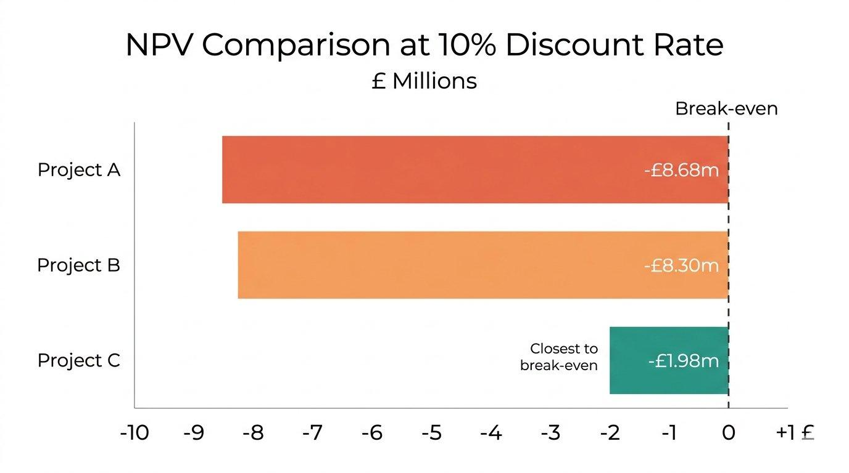
Figure 5: Net Present Value Comparison at 10% Discount Rate (£ millions). Source: Author's calculations based on assessment brief data.

5.2 Which Project, and Why?
If you had to pick one, and only one, Project C is the standout choice even though all three technically have negative NPVs. The numbers speak for themselves: shortest payback at 3.6 years, highest ARR at 12.0%, the least negative NPV at just -£1.98m, a PI of 0.960 that nearly breaks even, and an IRR of 9.2% that is practically knocking on the door of the hurdle rate. Beyond the raw numbers, there is a strategic argument too. Toyota Industries' profitability has been trending upwards, and the cash position, while weaker than last year, is still substantial enough to absorb a modest shortfall. The fact that Project C's biggest cash flows hit in Years 3 and 4 is also convenient timing, since that is roughly when the company might need liquidity for post-delisting restructuring.
However, one cannot ignore other risk factors, escalating tariff environment and Toyotas' significant US operations (¥1,415.2 billion in US sales), could materially affect any project's actual returns. Customer loyalty in the materials handling segment, where long-term relationships drive repeat purchases, should also influence project selection. A project that Strengthening customer relationships or addressing the certification trust deficit might generate qualitative benefits that the numbers alone do not capture (Drury, 2018).

5.3 What If We Can Invest in More Than One?
Now, if the capital budget is capped at £100 million, the question becomes which pair of projects makes the most sense. The possible combinations are A+B, A+C, or B+C, each costing exactly £100m. Doing all three would need £150m, which blows past the budget. Using the Profitability Index to rank them under capital rationing:
Table 7: Capital Rationing - Comparing Project Combinations
Project Combination | Total Cost | Total NPV | Weighted PI
A + B | £100m | -£16.98m | 0.830
A + C | £100m | -£10.66m | 0.893
B + C | £100m | -£10.28m | 0.897
Source: Author's own calculations based on project data provided in assessment brief.

B + C comes out on top with the least negative combined NPV at -£10.28m and the highest weighted PI at 0.897. If the company absolutely has to deploy the full £100m, this pairing destroys the least value of the available options. The logic is fairly straightforward. Project B gives you a steady, predictable cash stream that helps keep the lights on, while Project C brings the upside through those big Year 3 and Year 4 returns. One is the reliable workhorse; the other is the swing for the fences.
That said, it is worth questioning whether the company should invest at all when all projects destroy value at the required 10% rate of return. A genuinely strategic CFO might argue for returning the £100m to shareholders or deploying it in higher-return opportunities such as the logistics automation and electrification technologies that are central to the company's growth strategy. The capital budgeting framework is a useful tool, but it should inform rather than dictate decision-making (Pike, Neale and Linsley, 2018).

6. Conclusion
Toyota Industries Corporation is, in many ways, a company of contradictions. If you look at the standard metrics, Toyota Industries appears to be in pretty solid shape. Sales keep going up, profits are climbing, and the balance sheet is carrying a substantial amount of equity. Over five years from FY2021 to FY2025, net sales have nearly doubled, EPS has grown consistently, and debt levels have stayed manageable. On paper, at least, it looks like a well-run company. Yet beneath the surface, there are meaningful concerns: volatile comprehensive income driven by investment securities exposure, a sharp decline in operating cash flow in FY2025, the lingering effects of the engine certification scandal, and an ROE that barely exceeds 5%.
Looking at working capital, the cash operating cycle sits at around 79 days. That is acceptable, sure, but there is room to do better. Speeding up how quickly receivables get collected would be one lever to pull, along with tightening up inventory in the segments that are underperforming and maybe pushing payables periods out a bit where the supplier relationships can handle it. The financing mix is sensible but could benefit from greater long-term fixed-rate borrowing to provide certainty in an uncertain monetary environment.
The restructuring picture is really dominated by one thing: the Toyota Fudosan tender offer. If it goes through, the governance structure of the company will change in ways that are hard to overstate. Going private would bring some clear advantages, like quicker decision-making, lower compliance costs, and not having to worry about quarterly earnings pressure. But it also comes with real downsides. Reduced transparency is one, and then there is the risk that without public scrutiny, capital allocation might become less disciplined over time. It's a trade-off, and anyone who says it's straightforwardly good or bad probably has not thought about it carefully enough. The recommended approach is to use the transition period to divest non-core assets, particularly in the Textile Machinery segment, and redirect capital towards electrification and logistics automation.
Perhaps the most striking takeaway from the investment appraisal is that none of the three projects produces a positive NPV when you apply a 10% discount rate. That is a sobering result, and it should give pause before committing capital to any of them. If investment is required, Project C stands out as the single best option. And under capital rationing with a £100m ceiling, pairing B with C makes the most sense. But here is the thing, and this might be the most important point in the whole report: should the company even be investing in projects that destroy value at a 10% discount rate? The honest answer is probably not, at least not without a very compelling strategic reason. With the delisting on the horizon and deeper Toyota Group integration potentially opening opportunities that these standalone projects simply cannot match, there might be better places to put that £100 million. Capital budgeting frameworks are tremendously useful tools, but they should inform decisions rather than make them for you (Pike, Neale, and Linsley, 2018).

References
Arnold, G. (2019) Corporate Financial Management. 6th edn. Harlow: Pearson Education.
Atrill, P. (2020) Financial Management for Decision Makers. 9th edn. Harlow: Pearson Education.
Barth, M.E., Landsman, W.R. and Lang, M.H. (2008) 'International accounting standards and accounting quality', Journal of Accounting Research, 46(3), pp. 467-498.
Brealey, R.A., Myers, S.C. and Allen, F. (2020) Principles of Corporate Finance. 13th edn. New York: McGraw-Hill Education.
Christopher, M. (2016) Logistics and Supply Chain Management. 5th edn. Harlow: Pearson Education.
Drury, C. (2018) Management and Cost Accounting. 10th edn. Andover: Cengage Learning.
Eccles, R.G. and Klimenko, S. (2019) 'The investor revolution', Harvard Business Review, 97(3), pp. 106-116.
Jensen, M.C. (1986) 'Agency costs of free cash flow, corporate finance, and takeovers', American Economic Review, 76(2), pp. 323-329.
Madura, J. (2018) International Financial Management. 13th edn. Boston: Cengage Learning.
McLaney, E. (2017) Business Finance: Theory and Practice. 11th edn. Harlow: Pearson Education.
Penman, S.H. (2013) Financial Statement Analysis and Security Valuation. 5th edn. New York: McGraw-Hill Education.
Pike, R., Neale, B. and Linsley, P. (2018) Corporate Finance and Investment: Decisions and Strategies. 9th edn. Harlow: Pearson Education.
Toyota Industries Corporation (2025) Annual Financial Report 2025: For the Year Ended March 31, 2025. Kariya: Toyota Industries Corporation. Available at: https://www.toyota-industries.com/investors/annual_report/ (Accessed: 20 March 2026).
Toyota Industries Corporation (2025) 'Management's Discussion and Analysis of Financial Condition and Results of Operations', in Annual Financial Report 2025. Kariya: Toyota Industries Corporation, pp. 2-14.
Toyota Industries Corporation (2025) 'Consolidated Statement of Financial Position', in Annual Financial Report 2025. Kariya: Toyota Industries Corporation, pp. 15-16.
Toyota Industries Corporation (2025) 'Notes to Consolidated Financial Statements', in Annual Financial Report 2025. Kariya: Toyota Industries Corporation, pp. 22-98.
Watson, D. and Head, A. (2019) Corporate Finance: Principles and Practice. 8th edn. Harlow: Pearson Education.
Whittington, R., Angwin, D., Regner, P., Johnson, G. and Scholes, K. (2023) Exploring Strategy: Text and Cases. 13th edn. Harlow: Pearson Education Limited.

Appendices

Appendix A: Detailed Ratio Calculations
Detailed calculations for all financial ratios are available upon request. Key formulas applied include:
Gross Profit Margin = (Net Sales - Cost of Sales) / Net Sales × 100
Operating Profit Margin = Operating Profit / Net Sales × 100
Return on Equity = Profit Attributable to Owners / Equity Attributable to Owners × 100
Current Ratio = Current Assets / Current Liabilities
Debt-to-Equity = Total Liabilities / Total Equity
Interest Coverage = Operating Profit / Interest Expenses
Inventory Holding Period = (Inventories / Cost of Sales) × 365
Receivables Collection Period = (Trade Receivables / Net Sales) × 365
Payables Payment Period = (Trade Payables / Cost of Sales) × 365

Appendix B: Investment Appraisal Workings
Discount Factor Table at 10%: Year 1 = 0.9091, Year 2 = 0.8264, Year 3 = 0.7513, Year 4 = 0.6830, Year 5 = 0.6209.
The detailed NPV calculations, PBP workings, and IRR interpolation can all be found in the Excel file submitted alongside this report. All figures have been checked for accuracy, though inevitably there may be minor rounding differences depending on the number of decimal places used.
All figures referenced in the List of Figures have been inserted at the appropriate locations throughout this report.

