

Assessment 1 – Reading Task Template – Chloe Fenner
PART 1: Upload your photo of your A3 in-class notes here:
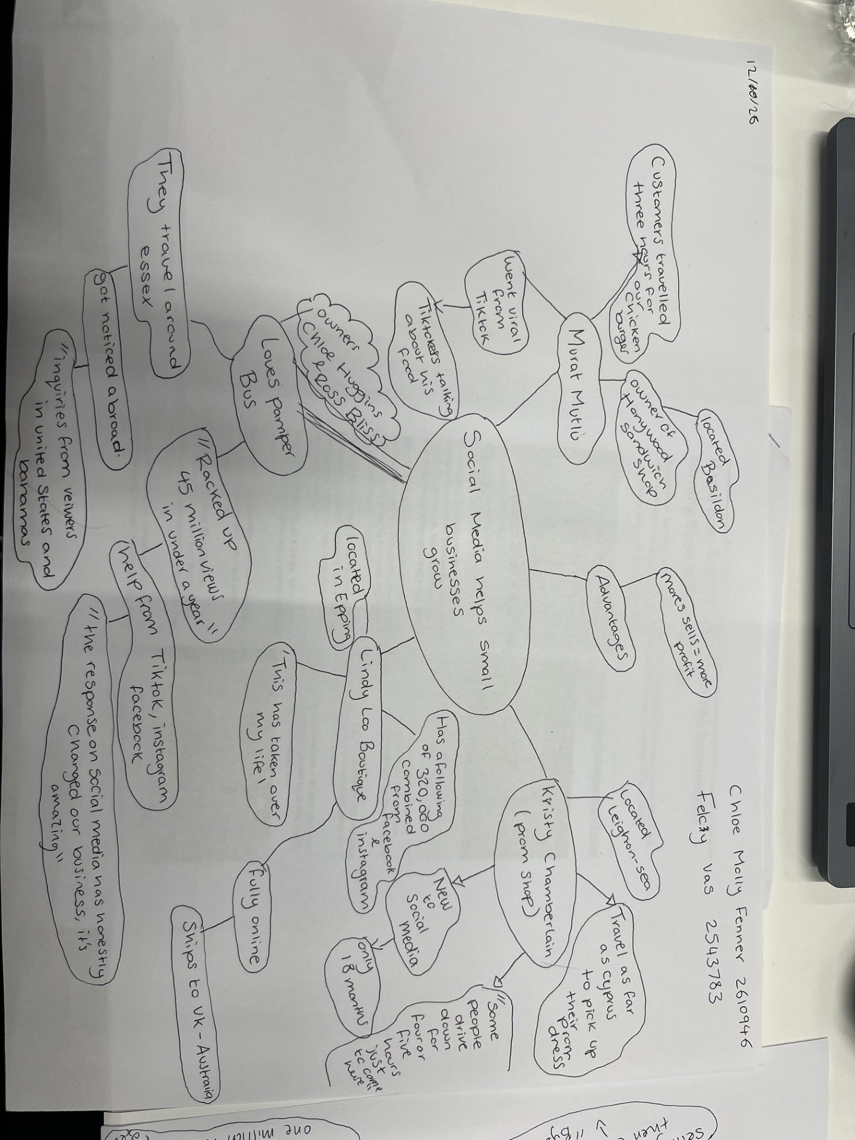

PART 2:
- Answer every question below in 1-3 full sentences.
- Use your own words. Do not use generative AI to answer these questions.
- Include a specific detail from the text when asked.
REMINDER
- The main idea is the overall message of the whole text.
- A key point helps to explain the main idea.
- A specific detail or example from the text shows that the key point is true.

- What is the main idea of the whole text?
I think the main idea of the text is to show the positive effects and benefits social media has on small businesses.

- What is one key point that supports the main idea, and which specific example from the text shows this?
In the text, it shows a variety of different small intrapreneur’s in different locations and how they have received a positive outcome from social media. For example, one of the business owners, Chloe Huggins and Ross Bliss from Thundersley, own Loves Pamper Bus, have received amazing advantages. In the text it says, “they racked up 45 million views in under a year, according to ross” from help from TikTok, Instagram and Facebook, Chloe quoted; “the response on social media has honestly changed our business, it’s amazing.”

- What is a different key point that supports the main idea, and which specific example from the text shows this?
Another example of how social media has helped small businesses, is owner of Krystalls Boutique a prom dress shop, Kristy Chamberlain. Kristy based in Leigh-on-sea, has had an increase of customers to her boutique with only been on TikTok for a short period of 18 months after being encouraged by her son. She has had customers travel far and wide for her dresses, found in the source, “teenagers travel from the Channel Islands and even Cyprus to pick out a frock.” And “some people drive down four to five hours just to come here.” Kristys explains “it’s amazing, really.” This highlights how a small part of advertising on a platform has engaged with so many people, they to travel to her shop.

- Which part of the text do you think is most important, and why?
I think the most important part of the text is showing how social media can change someone’s life and while highlighting all these different people around England, it brings forward an empowering and positive feel. I think this is very important to bring forward the good because sometimes social media can be used for the wrong things in a negative way. This helps us remember platforms such as TikTok, Facebook and Instagram can help us grow as individuals and bring our passions and ideas to life. Therefore, I feel this text has a really positive outcome and may have encouraged more small businesses or individuals to take the leap and start their journeys.

Reflection:
- What did you find difficult in this task (including in-class components), and why was it difficult?
I found note taking difficult in this sector at the start as sometimes I think you can get carried away and right down more then key phrases or points and make full sentences that are hard to remember.

- What helped you with this difficulty, and how did it help you?
It really helped going over mind maps and how you can divide them into different sections instead of something like bullet points. I really enjoyed making the mind maps and I think this is something I will use more of in the future. I also used the highlighting method in class to help take notes from the text, so it made it easier for me.

