Scott James (P146328)

Client: Richard Morse
Email: richardmorse@fishguardbayhotel.co.uk
cONSULTANCY PROJECT:
THE FISHGUARD BAY HOTEL
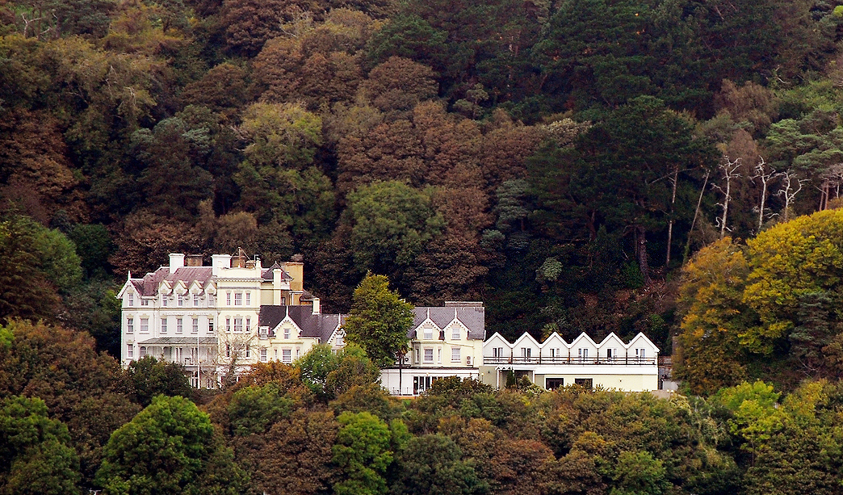
Contents Page
- Executive Summary ………………………………………………………….. 3
- Introduction …………………………………………………………………….. 3
- Visitor Profile and Target Market to Pembrokeshire ……….. 3
  - What is the visitor profile to Pembrokeshire? .................................................... 3
  - Why do People Visit Pembrokeshire? ……………………………………………………………. 4
  - Target Markets to Pembrokeshire ………………………………………………………………… 4/5
- Social Media …………………………………………………………………… 5
  - The importance of social media …………………………………………………………………... 5
  - Fishguard Bay Hotel – Instagram ………………………………………………………………… 5/6
  - St Brides Spa Hotel and Cliff Hotel & Spa – Instagram ………………………………… 6/7/8
  - Why is Twitter Important for a Small Organization? …………………………………….. 8
  - Fishguard Bay Hotel – Twitter …………………………………………………………………….. 8/9
  - Wolfcastle Country Hotel – Twitter …………………………………………………………… 9/10
  - The Fishguard Bay Hotel – Facebook ………………………………………………………… 10/11
  - The Cliff Hotel & Spa – Facebook ………………………………………………………………. 11/12
- Survey Results …………………………………………………………… 13 – 17
- Focus Group ………………………………………………………………… 17
  - Respondent 1 …………………………………………………………………………………………….. 17
  - Respondent 2 ……………………………………………………………………………………………..17/18
  - Respondent 3 …………………………………………………………………………………………….. 18
  - Respondent 4 ……………………………………………………………………………………………. 18
- Conclusion ……………………………………………………………………. 18
- Recommendations ……………………………………………………… 18/19
- Bibliography ………………………………………………………………… 19

- Executive Summary
Over the last seven years, Pembrokeshire has experienced steady growth in the tourism industry. Most of the additional spend is in the serviced accommodation section – hotels, guesthouses and B&BS (Tenby Observer, 2016). This growth is highlighted by the fact St Brides Spa Hotel in Saundersfoot was named best Hotel in Wales at the Visit Wales 2018 National Tourism Awards (Tenby Observer, 2018). However, a lot of this growth is down to the marketing strategy that they apply. This report will tackle the issue of the Fishguard Bay Hotel marketing strategy, and the consultant will investigate where they can improve moving forward. Apart of this report will be looking at the visitor profile and target markets to Pembrokeshire, as it provides additional background to the type of guests Pembrokeshire receives. Furthermore, the social media accounts of the Fishguard Bay Hotel will be investigated, where comparisons with local competitors will be included as part of the report. This is a great way of receiving an understanding on their activity use with social media and how it compares with its nearest competitors. A survey will be conducted in the report, where results from the local population of Fishguard and Goodwick will be included to gain their viewpoints and opinions. Lastly, a focus group will be organized which will encompass the views of the Fishguard Bay Hotel workers. This will give the consultant an inside understanding of where the staff believe is going wrong with the marketing strategy currently at the Fishguard Bay Hotel, and what they think can be implemented to improve it.
- Introduction
For the consultant growing up in Fishguard and Goodwick, the Fishguard Bay Hotel has always provided an iconic image and memories growing up. As you drive down the bypass into Goodwick, it’s the image that instantly catches your eye. The hotel is in a perfect location and is fortunate to have such an elegant appearance. Pembrokeshire is blessed to have many luring hotels and restaurants which have really come to the fore over the last decade. However, what catches your eye with these competitors is that they put a lot of time and effort into their marketing strategy, and it really has a positive effect on enticing people to visit from all over Wales, as well as the UK. The consultant has used the last few months putting what he’s learnt in University over the last three years into the consultancy project, where vital information obtained will hopefully help the new owners of the Fishguard Bay Hotel implement a compelling marketing strategy moving forward. This will help the new owners improve their marketing strategy, which will hopefully help solidify their position within Pembrokeshire.
- Visitor Profile and Target Market to Pembrokeshire
Although this survey was conducted and published in 2012, it provides a great insight into what is the visitor profile to Pembrokeshire, and what really motivates certain target markets to visit the county. A lot may have changed over the years, but these facts provide a great appreciation to what organisations can implement to achieve a variety of target markets to Pembrokeshire (Turner, 2018).
3.1 What is the visitor profile to Pembrokeshire?
Pembrokeshire year on year continues to attract a range of visitors. The survey conducts that south Pembrokeshire attracts a slightly younger profile compared to the west and the north. The market which remains pivotal to Pembrokeshire is the home market. Visitor origin has been split almost 50:50 between those from Wales and those outside Wales since 2007/8. Day trips also continue to account for a quarter of all visits with stating trips within Pembrokeshire account for approximately 70% (Turner, 2018).
3.2 Why do people visit Pembrokeshire?
The key for people visiting Pembrokeshire is the natural environment. The experience of gracing elements such as award-winning beaches, a range of natural attractions and walking routes is a huge pull for people wanting to visit the county. With the natural environment playing such a huge part in motivating people to visit Pembrokeshire, many of the activities are focused on enjoying the landscape. Over a quarter of visitors come to walk with one in ten coming to visit the beach. Ratings for country paths and the Pembrokeshire Coastal Path were also very high. The picture below highlights the main motivations for people visiting Pembrokeshire (Turner, 2018).
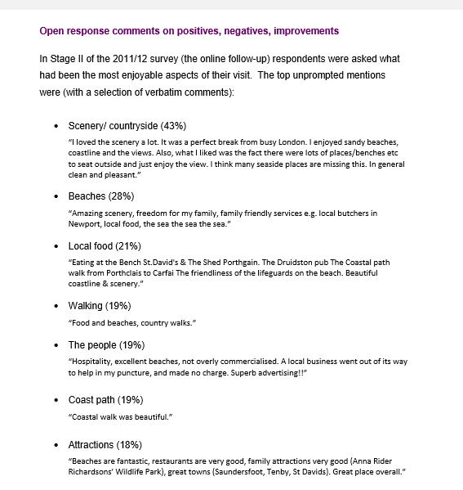
3.3 Target Markets to Pembrokeshire
Understanding the key target markets to the area is vital towards building a strong marketing strategy moving forward for the Fishguard Bay Hotel. It helps understand what is needed to entice different groups to an organization, and what can be implemented to motivate visitors to north Pembrokeshire. The consultant has got in touch with Pembrokeshire Tourism, where they have identified a portfolio of their main target markets to Pembrokeshire, and what really motivates them to the area:
- The Family Group
- The family market makes up 38% of all visitors who come to Pembrokeshire, with it going up to 50% in the summer season.
- The biggest proportion from outside of Wales live in South East England (21%) and the West Midlands (16%).
- The family market are influenced to coming to Pembrokeshire because of three main reasons: A previous visit; easy to get to; and quality beaches.
- They place the importance of family friendly places to visit, beaches and outdoor activities as the main factors. They are the segment most likely to be undertaking beach activities, visiting family attractions and taking boat trips.
- However, the family market are the largest segment that don’t intend to use the Coastal Path and are least likely to be eating and drinking out. A large factor for this is that the family market mainly stay in self-catering accommodation and rented caravans (Turner, 2018).

- The Older Couple
- The older couple independents (aged 45+ with no children) make up 47% of all visitors, with the percentage going up to 53% in the autumn.
- The proportion of the older couple come from the West Midlands (21%) and the South West (19%), and tend to visit Pembrokeshire for the National Park, to see the natural landscape, escape for peace and quiet or to use their own property.
- They scored the highest on the importance of walking, environmentally friendly facilities, gardens, history & culture, the National Park and nature. They are the most likely to be wildlife watching and visiting natural attractions.
- Much of the segment were staying near St David’s area, and are he more likely to be on a short break (Turner, 2018).

- The Younger Couple
- These are younger independents (up to 44 with no children) who make up 15% of all visitors, with the percentage going up to 19% in winter, and they are the segment which most likely to be their first visit to Pembrokeshire.
- 22% of visitors are in the 26 to 34 age bracket, and 22% are 34 to 44, so they are not particularly young.
- They are the biggest proportion that live outside of Wales who live in central London and the South East (both 17%) and are more likely to be on a short break.
- They place the importance of facilities open all year, nightlife and suitable eating out spots as their main motivation on visiting Pembrokeshire.
- They are the group most likely to be visiting historic sites and eating/drinking out and scored the highest for main activity of water sports and driving around/sightseeing from the car (Turner, 2018).

- Social Media
4.1 The Importance of Social Media
Social media has been a game changer in the new dawn of the marketing era. Social media has the capability to put customers at the centre of the organization and provide marketers within organizations a new set of tools to encourage them to interact with the brand. The potential to have customers engaging with organizations has been vital as it shows that customers can become partners driving the organizations forward. Social media also provides a golden opportunity for marketers to create a strong brand which will provide a sustainable competitive advantage and ultimately build a better organization (Smith, Smith and Zook, 2011).
4.2 Fishguard Bay Hotel – Instagram
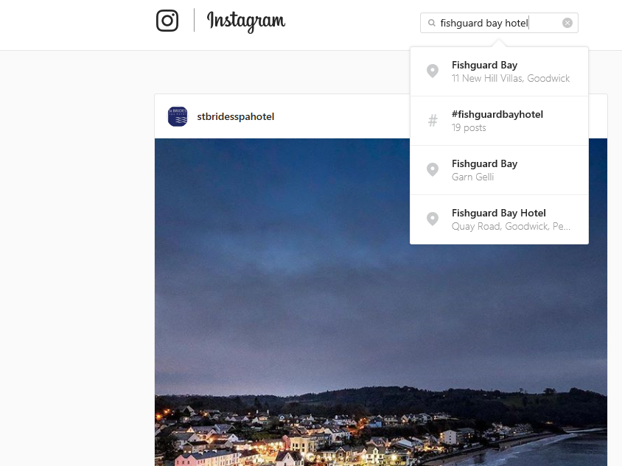
Instagram has provided a new opportunity for organizations to promote themselves using images. In today’s world, a large majority of organizations have Instagram accounts, as it’s the current marketing trend with a large majority of people, as it’s a way of marketing without the use of words, but instead with pictures.
Many organizations, big and small use Instagram to really be creative when it comes to selling their main attributes. The Fishguard Bay hotel do not have an Instagram account, and are lagging behind their main competitors when it comes to social media marketing. Instagram brings along many positive factors which could and should be utilized by the Fishguard Bay Hotel as it would create a lot more attention as Instagram is fast becoming the leading social media account.
4.3 St Brides Spa Hotel and Cliff Hotel & Spa Hotel – Instagram
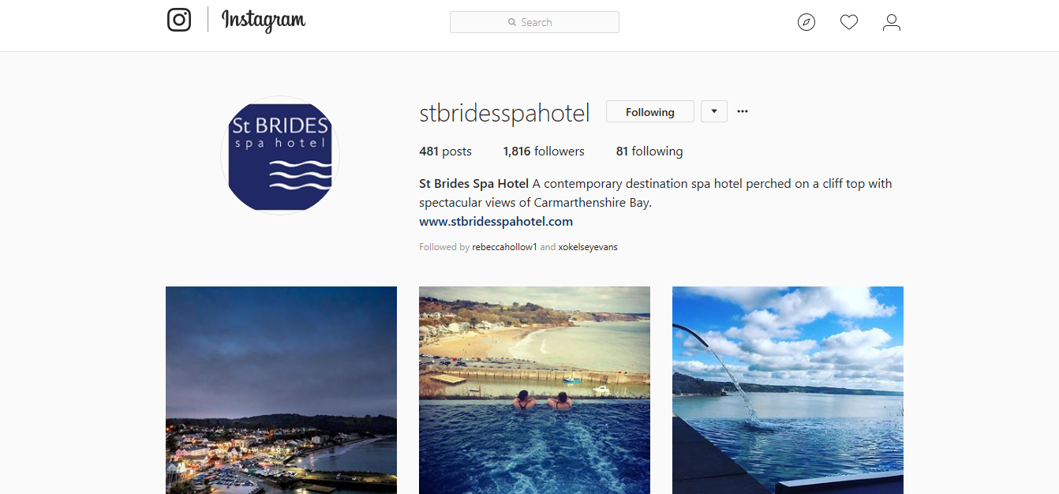
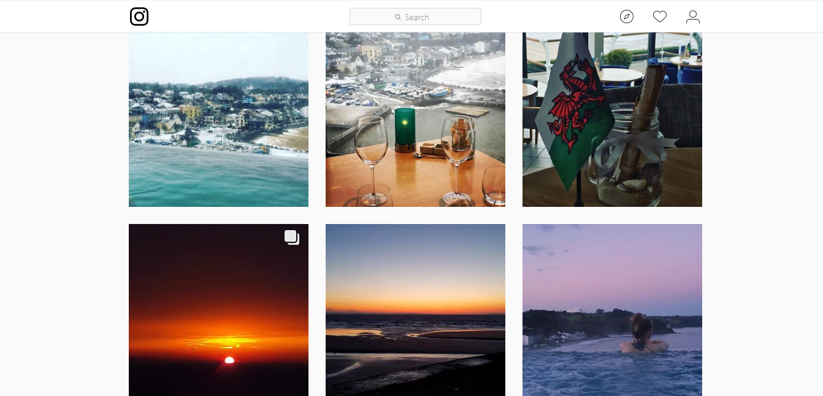

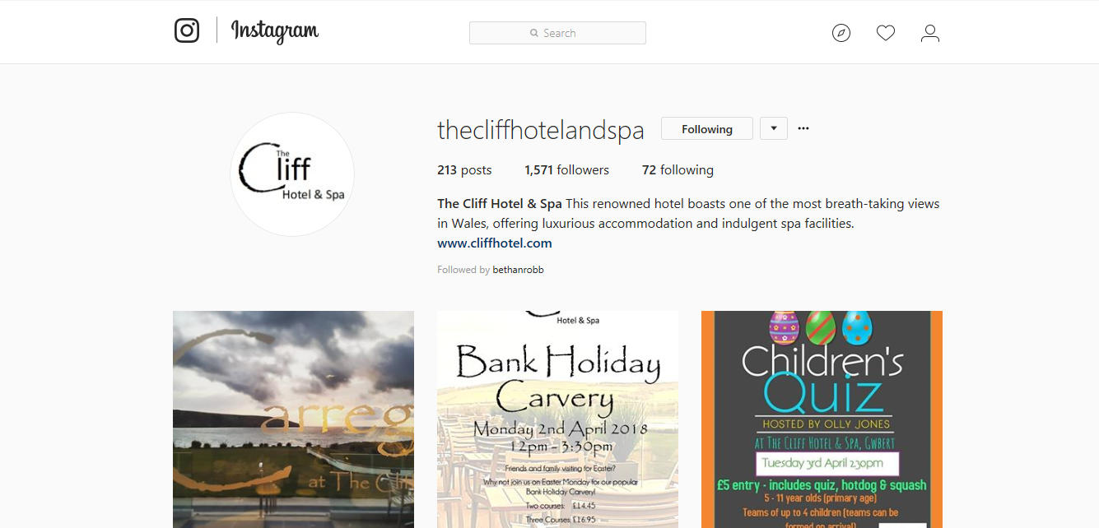
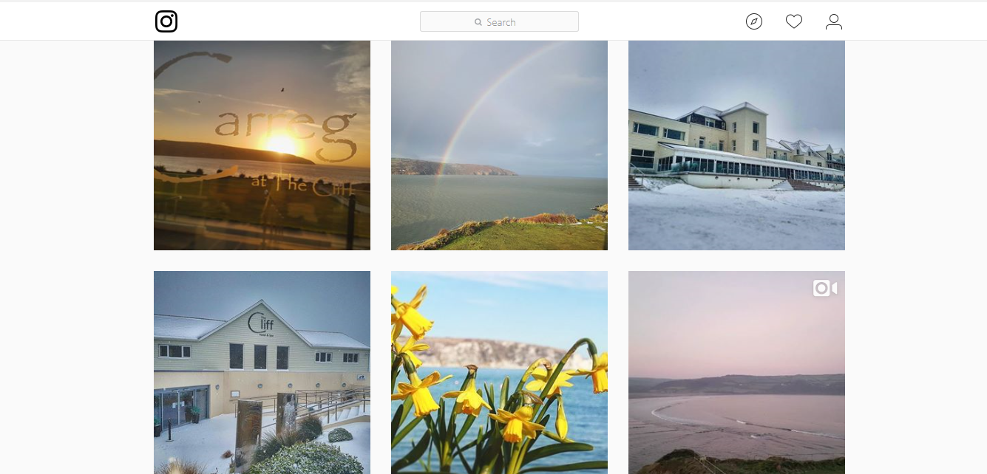
St Brides Spa Hotel and the Cliff Hotel & Spa are two hotels which are located both in West Wales and are in close proximity to the Fishguard Bay Hotel. From the following images, both hotels have an active Instagram account with over 1,800 and 1,500 followers respectively. As you can see, the two hotels use Instagram to promote what they have to offer and really sell their local area as it would certainly be a pull factor for potential customers.
Although these hotels are different in what they offer to the Fishguard Bay Hotel, the main aspect of delivering an active Instagram account should be the same. The Fishguard Bay Hotel is in a beautiful location, surrounded by woodland and sea. With a magnificent exterior to the hotel, Instagram would be perfect tool to promote all of the mentioned attributes, which would certainly be seen by a larger quantity of people. It’s a perfect opportunity for smaller organizations to show what they have to offer and to grow their brand (Steel, 2012).
4.4 Why is Twitter Important for a Small Organization?
Twitter offers a fast way of building a relevant audience for the type of organizations that is run. It gives a chance for organizations to interact and engage with the right customers and really build a relationship that Facebook and Instagram can’t achieve. If the engagement is there, people will be interested in what is being offered. As well as being a great technique of building a relationship with your customers, it’s also equally an efficient way of collecting customer feedback and gaining opinions about the organization. Also, if there’s anything specific to learn, Twitter offers the chance to ask the customers their opinions by conducting a poll through the site (Imarketingstrategy.com, 2017).
4.5 Fishguard Bay Hotel – Twitter
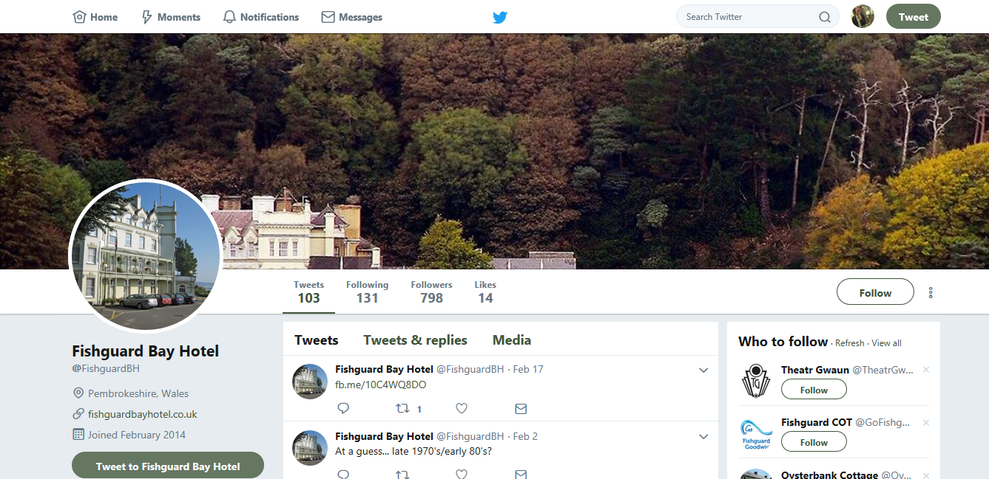
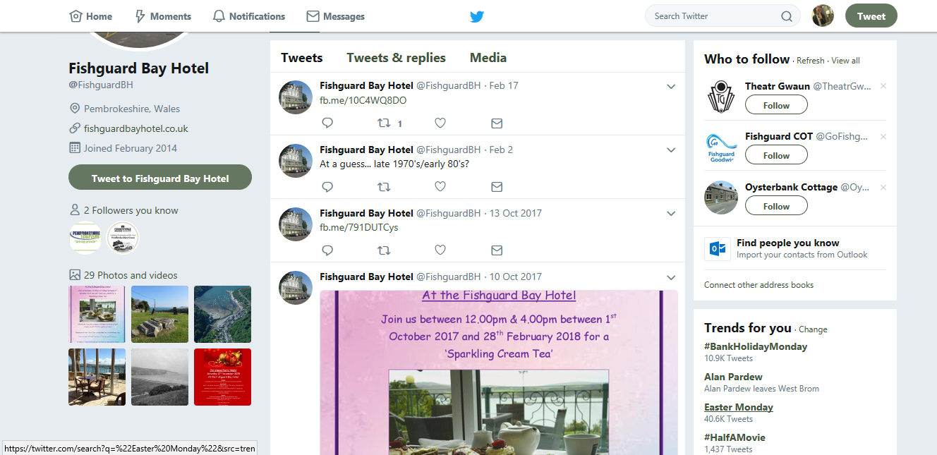

4.6 Wolfcastle Country Hotel – Twitter
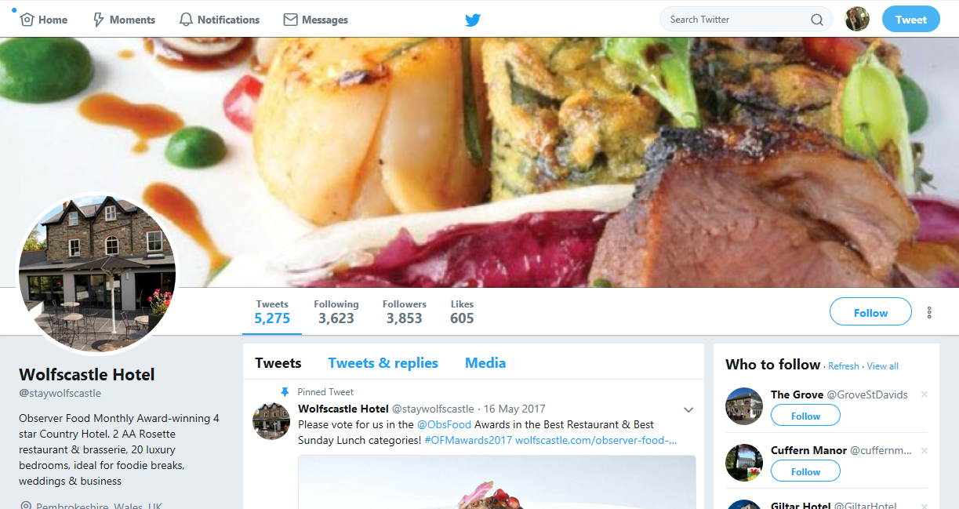

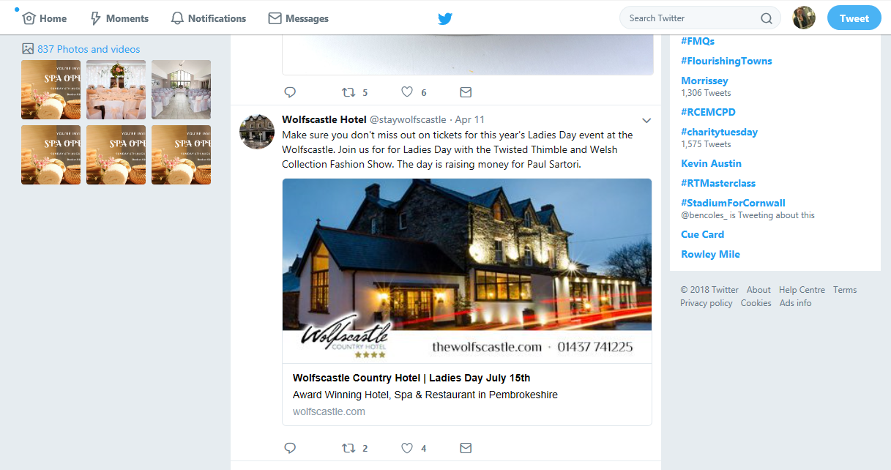
Comparing the two Twitter accounts, the difference between the both is distinguishable. At the time the consultant investigated the Fishguard Bay Hotel’s Twitter account, they only produced 103 tweets, with a large majority being links to pictures. There isn’t a lot of colour in the home page, and it wouldn’t jump out and excite someone who came across the page. They do share their beautiful location in the header and do have plenty of pictures which market their events and sell what they have got to offer.
Comparing with the Wolfcastle Country Hotel, instantly you notice how active their Twitter account is. With over 5,000 tweets, close to 4,000 followers and hundreds of pictures, they certainly use Twitter to their advantage. They market their events that they incorporate yearly through exhilarating posters that instantly appeal to people. They are famous for their Sunday Roasts, and they display that through their header. This would instantly attract people who would come across the page and would encourage people to venture to the Wolfcastle Country Hotel rather than the Fishguard Bay Hotel.

4.7 The Fishguard Bay Hotel – Facebook
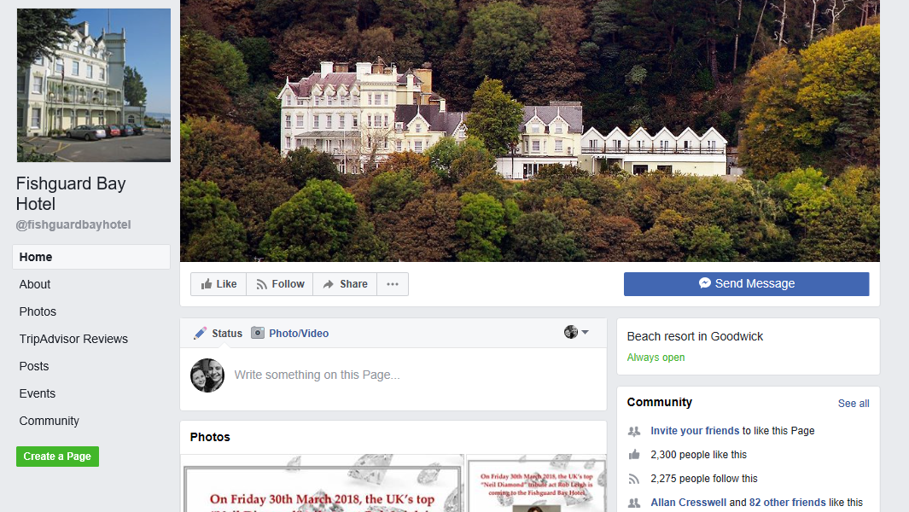
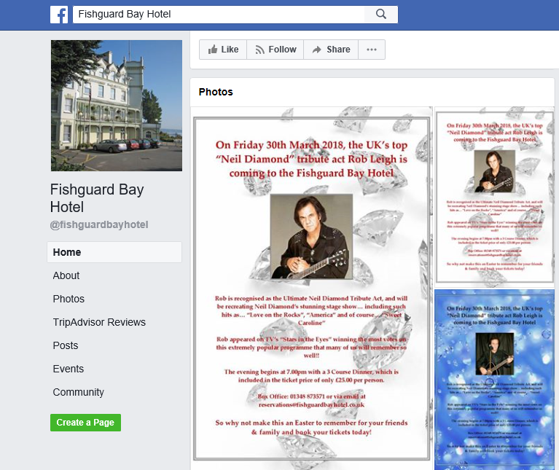
The Fishguard Bay Hotels Facebook account is a lot active than their other social media accounts. With close to 3,000 followers, they use their Facebook account to market their events throughout the year. They also use Facebook to show past images of Fishguard and Goodwick, which has been a big hit within the community. The Neil Diamond tribute act is one of many events that they have going on at the Fishguard Bay Hotel. However, they tend to only market these events on Facebook, where a lot more effort should be put into really selling the event through other ventures.

4.8 The Cliff Hotel & Spa Hotel – Facebook
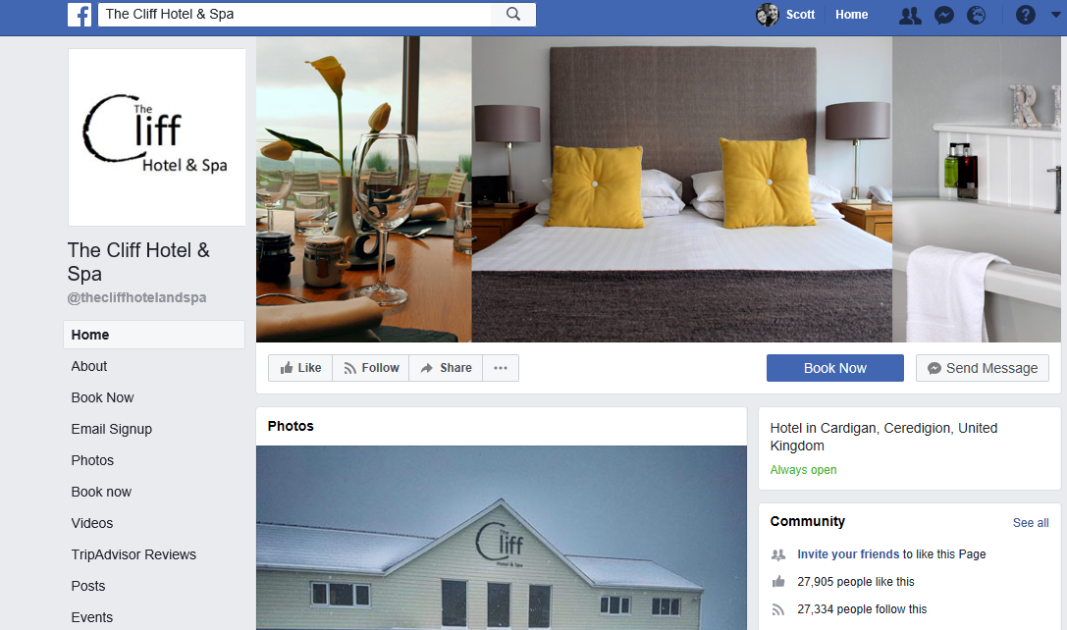
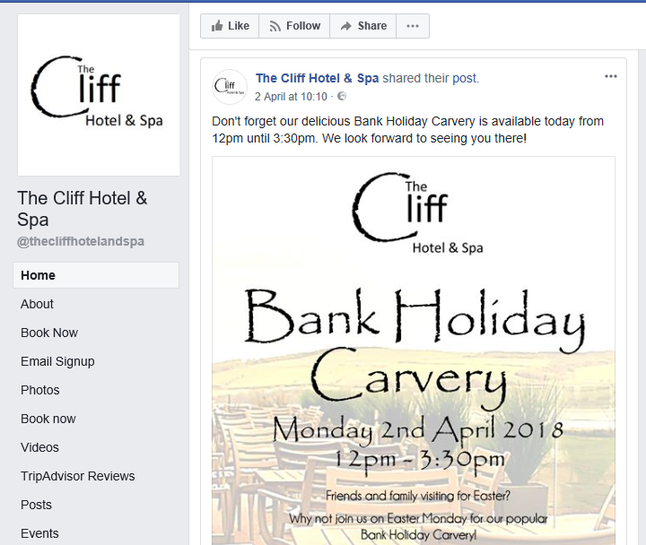
However, there is a stark contrast if you compare to a local competitor, like the Cliff Hotel & Spa. In a town with a similar population to Fishguard & Goodwick, the Cliff Hotel & Spa in nearby Cardigan have over 27,000 followers, which shows how far ahead they are when it comes to their social media accounts. When you look at their page, you instantly see how professional it’s set up, with a clear brand, a logo and images that would instantly persuade people to further investigate their Facebook page. This is something that the Fishguard Bay Hotel should aim towards.
Another difference between the two accounts is the way they set up their posters. It’s not a high priority, but the difference that a professionally set up poster makes is substantial when it comes to encouraging people to attend that particular event. It is certainly a page that the Fishguard Bay Hotel should be aspiring towards.
Example:

Cliff Spa Hotel & Spa Fishguard Bay Hotel
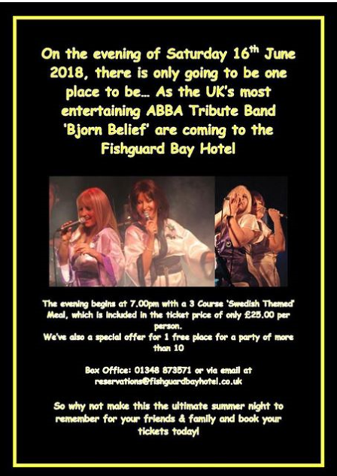
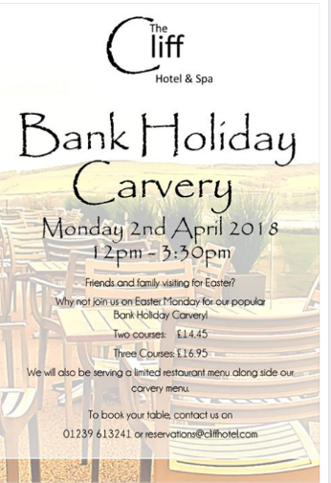

- Survey Results
The consultant conducted a survey through Survey Monkey which was published on social media to find out various perspectives on the Fishguard Bay Hotel. This survey was answered by 97 respondents from the local population of Fishguard and Goodwick, as well as the surrounding area. The sole purpose of this survey was to discover differing viewpoints and what the judgement was from the local population regarding various questions on the Fishguard Bay Hotel. This survey was also important as it gave a broader perspective on the marketing issues facing the Fishguard Bay Hotel, and also what they thought could be implemented to rectify the problem.
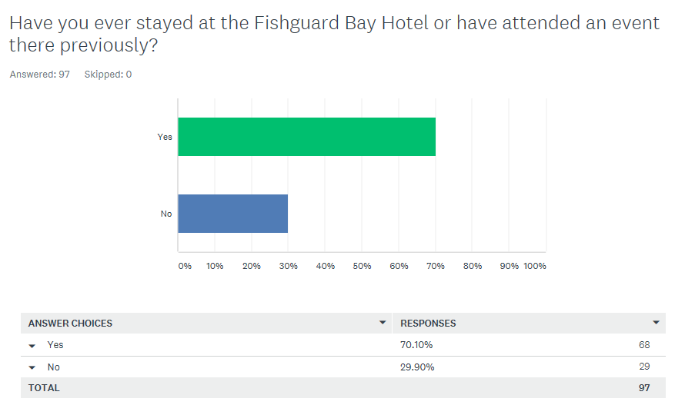
From the above table, it shows that out of 97 people who surveyed, that 68 of the correspondents answered they have previously stayed at the Fishguard Bay Hotel. That is a large majority of the people who answered this survey, which highlights that the Fishguard Bay Hotel has been visited by a large proportion of the local population. However, a large figure still answered that they haven’t visited the hotel, which is an exceedingly excessive number regarding the number of people who answered this survey.
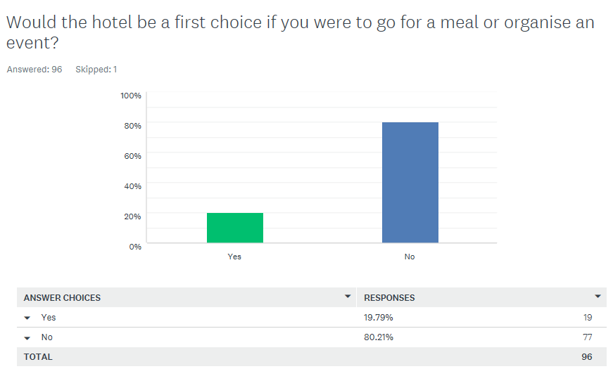
The second question that was asked was if the Fishguard Bay Hotel would be first choice if you were to go for a meal or to organise an event. Although the hotel has a lot of competition nearby, these results still came as a shock to the consultant. The Fishguard Bay Hotel is in a lovely location, and events especially should be in high demand throughout the year. However, these results reflect its popularity and that other options are deemed more viable in this current climate.
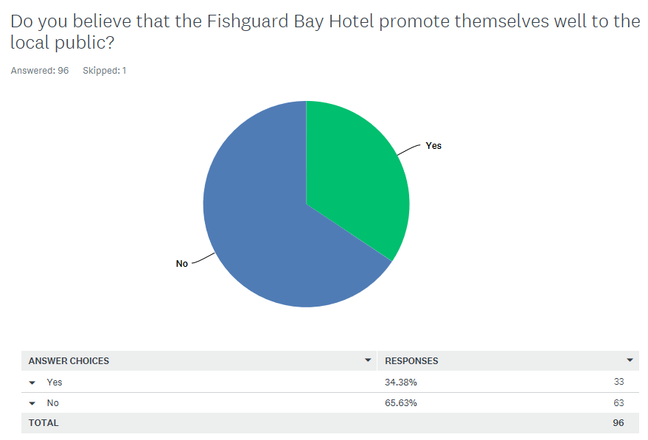
The consultant has lived in Fishguard for the best part of 18 years and has deemed that the Fishguard Bay Hotel do not promote themselves as effectively as other organizations within the area. So this question was interesting to see what the local population thought regarding this question. A staggering 65.63% believed that they do not promote themselves well to the local population, which is further emphasized by the next question.

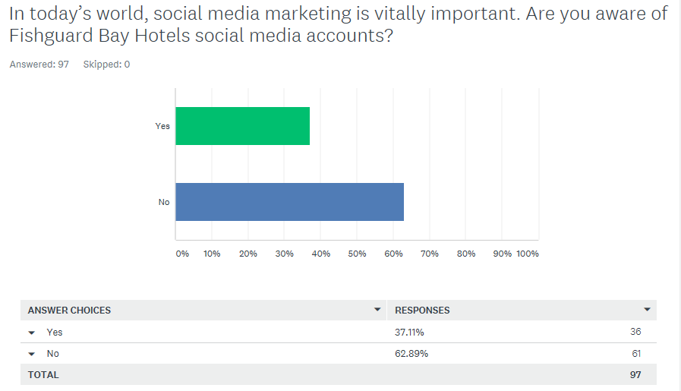
As mentioned, social media marketing is vitally important for the growth of an organization. A large majority of organizations have Instagram, Facebook and Twitter accounts where they promote their business. The outcome of this question was astonishing, as a mammoth 62.89% of the people who took part in the survey were not aware of Fishguard Bay Hotel’s social media accounts. This is highlighted by the inactivity of their social media accounts, where really, a strong effort should be put forward to produce an active and vigorous social media campaign.
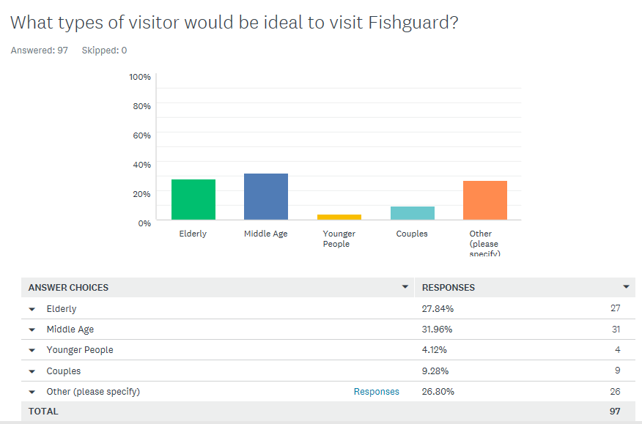
The Fishguard Bay Hotel commonly engage an elderly market to the hotel, due to coach trip offers and the design of the hotel. However, this question was put forward to see what markets people thought Fishguard could offer. From the above table, there is really a comparable list of results, which shows that people believe that Fishguard could entice all types of markets, not just the elderly market. This is something that the Fishguard Bay Hotel could contemplate when reasoning with their marketing strategy moving forward.
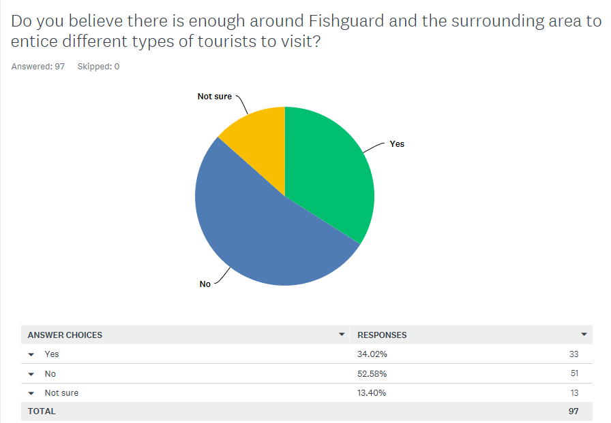
A big priority for people when visiting an area is what that area offers other than the accommodation. This question was put forward to see if people believe if Fishguard do offer enough to entice different types of tourists to the area. The outcome of the results was somewhat surprising, as a large majority of the people who took part in the survey believe that Fishguard do not offer enough to bring different target markets to the area. To a degree, this would impact on people visiting the Fishguard Bay Hotel as there has to be enough in the surrounding area to lure people to the hotel.
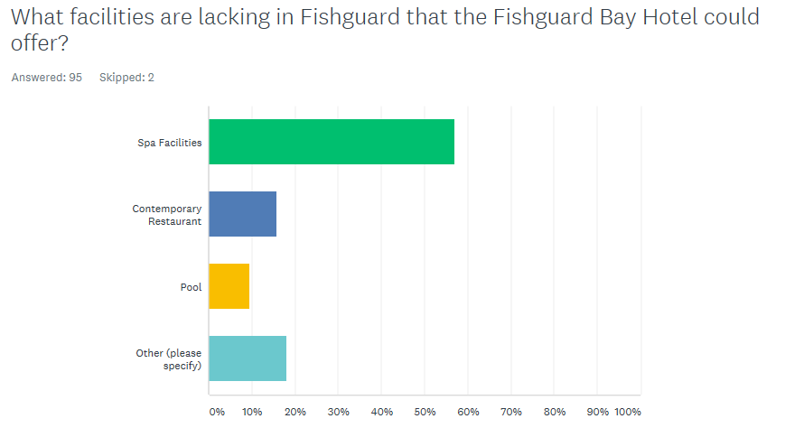
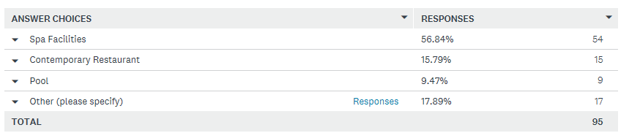
Other:
- More entertainment evenings
- Outdoor activities
- A good deal
- Gym facilities
- A family orientated restaurant
A lot of local competitors in the hotel industry offer a range of facilities that tempt visitors all year round. The Cliff Hotel & Spa and St Brides Spa Hotel offer spa facilities and a contemporary restaurant. The Wolfcastle Country Hotel offer a unique menu which attract the local population all year round, as well as take advantage of their tremendous event facilities. This question was to find out what people within Fishguard and the surrounding area would really like to see from the Fishguard Bay Hotel. Although the Fishguard Bay Hotel market themselves in a distinctive way. In today’s market, customers want to experience something unique and the above list show what could be contemplated for the future development of the Fishguard Bay Hotel.

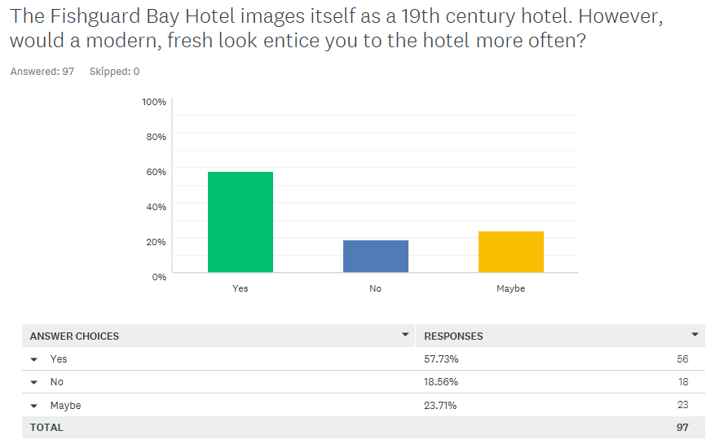
The Fishguard Bay Hotel market themselves as a 19th century hotel. However, today’s market has changed somewhat towards a modern, contemporary look. This question was put forward to see the perspective of the local population, and really find out if a modern, fresh look to the hotel would entice customers to visit regularly. As predicted a large majority of people would be more inclined to the hotel if they were to invigorate their appearance. However, a strong contingent was happy with the current layout of the hotel, with 23.7% being not sure.
- Focus Group
A focus group was vitally important for the consultant as it was an opportunity to receive opinions from people who work at the Fishguard Bay Hotel. The focus group was initially meant to be held with a few members of staff. However, getting the staff together wasn’t possible, so instead the consultant received views from the staff via email and Facebook. Although this wasn’t ideal, it still gave the consultant a great overview on where the staff believe where the Fishguard Bay Hotel are currently struggling and where they can possible improve their marketing strategy moving forward.
6.1 Respondent 1
Respondent one said that the Fishguard Bay Hotel could improve on their marketing strategy by updating their website, making it more attractive and appealing to all types of markets. They also included for there to be more advertising, with maybe a blog being introduced as a possible idea. An aspect that they mentioned was that the whole place needs a revamp. The building is dated, and although a lot of people enjoy that, so many people dislike it also. In conclusion, the first respondent has issued for the Fishguard Bay Hotel to get with the times with current markets and competitors, with that being by being more active with their social media and updating the appearance of the hotel.
6.2 Respondent 2
Respondent two mentioned that a big onus on improving their marketing strategy is by increasing deals locally. A lot of people love deals, and a way to engage the local population is to encourage them to stay as part of a deal, which could lead to a lot footfall from the local population, in terms of stays and utilizing other facilities of the hotel. The respondent also mentioned about improving their Facebook page. Mentioned as a scope to improve was getting back to people, as engagement with the customer is important for making the customer feel important, which will only be a positive for the hotel.
6.3 Respondent 3
The third respondent issued that an important aspect on getting the Fishguard Bay Hotel on the map was for the new owners to put money into refurbishing the hotel and then advertising the hotel as refurbished. The respondent mentioned that a local example of this being successful was the Royal Oak in Fishguard square. Once a pub down in the dumps, an input of money into the establishment and then advertising it as refurbished has brought many locals back to the pub where it’s currently enjoying a lot of footfall. Respondent three can’t see why not the Fishguard Bay Hotel can do the same.
6.4 Respondent 4
Respondent four implied that a lot more needs to be achieved to market the hotel, especially considering it’s located in such a beautiful location. The respondent issued that a lot more should be concentrated on marketing the local coastal path. With only ten National Parks in the UK, and only three in Wales, the Fishguard Bay Hotel should be thriving considering the proximity to the National Park.
- Conclusion
From the report, the consultant has found out a lot regarding the issues of marketing at the Fishguard Bay Hotel and what can possibly be done to deal with the problem. Looking at the social media accounts, the consultant was astounded by the lack of inactivity compared to their local competitors. This is somewhere where the consultant believes the Fishguard Bay Hotel can really improve on moving forward. An aim for the hotel should really be to increase their productivity on social media and getting on par with local organizations within Pembrokeshire. Secondly, the survey results were likewise an eye opener in terms of getting a viewpoint from the local population. A lot was repeated regarding improvement within the hotel. Although the consultant understands that is a long-term project due to the planning and funding having to be involved. Nevertheless, there were other aspects to the feedback where a lot issued improvement to social media and selling themselves to the local area. This was also repeated from the views received from the focus group. Some of the issues can be instantly rectified in the short term which will hopefully lead on to further improvements to the marketing strategy of the Fishguard Bay Hotel in the long term.
- Recommendations
- A lot needs to be done to fully change a marketing strategy of an organization, and the consultant knows that funding to improve the hotel is an objective moving forward. However, small aspects such as having a productive social media account and introducing special offers are aspects which can have an instant positive impact on the Fishguard Bay Hotel. This has the potential to gain more recognition for the Fishguard Bay Hotel and put them on the map.
- Visit Pembrokeshire have a website which the Fishguard Bay Hotel do not appear on. During 2018, the Visit Pembrokeshire website are aiming to reach one million unique users. To appear on the website, there’s no charge, no restrictions and they’re able to add web links, special offers, images and video clips. This would be great for the Fishguard Bay Hotel to start promoting themselves within Pembrokeshire, which would instantly lift their local profile.
- The consultant has briefly talked about branding being a huge importance towards an organization growing. As the consultant spent a lot of time looking at local competitors, one aspect that was noticed was that other competitors had branding and logos which made them stand out. For example, St Brides Spa Hotel have a logo which many instantly recognize. This is something where the consultant believes the Fishguard Bay Hotel can implement moving forwards. This will make them stand out and would really start growing the Fishguard Bay Hotel Brand.

- Bibliography
Imarketingfactory.com. (2017). The Importance of Twitter for Small Businesses. [online] Available at: http://www.imarketingfactory.com/twitter/ [Accessed 1 May 2018].
Smith, P., Zook, Z. and Smith, P. (2011). Marketing Communications: Integrating offline and online with social media. 5th ed. Kogan Page, p.4.
Steel, E. (2012). Instagram has marketers salivating. Financial Times. [online] Available at: http://infoweb.newsbank.com.ezproxy.uwtsd.ac.uk/resources/doc/nb/news/1435A3702BFCA690?p=UKNB [Accessed 5 Apr. 2018].
Tenby Observer. (2016). Steady growth for tourism industry. [online] Available at: http://www.tenby-today.co.uk/article.cfm?id=107622&headline=Steady%20growth%20for%20tourism%20industry&sectionIs=news&searchyear=2016 [Accessed 1 May 2018].
Tenby Observer. (2018). St. Brides Spa Hotel wins Best Hotel in Wales Award. [online] Available at: http://www.tenby-today.co.uk/article.cfm?id=116455&headline=St.%20Brides%20Spa%20Hotel%20wins%20Best%20Hotel%20in%20Wales%20Award&sectionIs=news&searchyear=2018 [Accessed 1 May 2018].
Turner, A. (2018). Promoting Pembrokeshire Word Document. [email]. C:\Users\P146328\Downloads\Promoting Pembrokeshire - Implementing a digital marketing strategy (1).doc
Wordount: 3938

