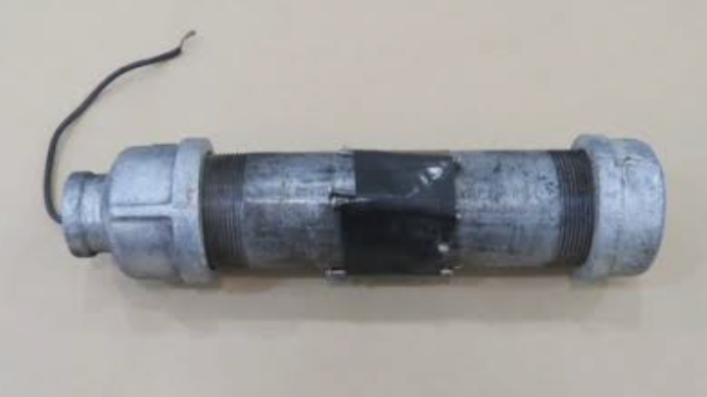  Figure 1 Pipe Bomb [11]  OME Identification  Lab Report | Rebecca Dingwall (2217521)  Data Capture & Evaluation ACDA 6021

Table of Contents
1. 1 Aim 2
1.2 Hypothesis 2
2. Theory 2
2.1 Pressure Data 2
2.2 Fragment Velocity 2
2.3 Fragment Spread, Mass and Depth Penetration 3
2.4 Mathematical Blast Prediction 3
3. In Practice 3
4. Trial Set Up 4
5. Results 6
5.1 Pressure data 6
5.2 Velocity data 7
7
5.3 FTIR analysis 8
6. Discussion 8
7. Conclusion 9
Bibliography 10

1. 1 Aim
This report covers how to identify an OME item using a variety of techniques, including blast pressure data and fragment velocity data alongside physical swab analysis of explosive residue to determine a result.

1.2 Hypothesis
It can be assumed that the OME item is of a relatively low mass due to the maximum NEQ allowed at the range where the test was conducted; so, this could be either a grenade or a pipe bomb, the assumed low budget given for the group for this range day a pipe bomb is the hypothesis due to its low cost production.

2. Theory
This section covers some of the techniques that are commonly used to capture data on explosives trials. Although traditionally from experience, the information required from the trials team covers what data is required to be collected, what the item is, and then from that information the most appropriate data collection method is chosen. The following section details what data is usually required and the options available to collect that data. It is important to note that this list is not exhaustive, and considerations must be made to the suitability of the method in each situation to collect the data as previously mentioned as all methods have their own benefits and drawbacks or strengths and weaknesses. Considerations must also be made to the other axillaries that each method requires, this could include specific oscilloscopes or Multi-channel Logic analyzers needed to record the data or specific software required to record or further analyse the data captured.

2.1 Pressure Data
The types of gauges used to gather pressure data can be either static pressure gauges or dynamic pressure gauges. Static gauges measure the change in pressure, so ambient pressure to the new pressure [1] no consistent monitoring. Dynamic pressure sensors measure a ‘live reading’ of changing pressures [2]. The internals of how these pressure gauges work, differ between manufacturer, some use resistance, some use a diaphragm, while others use piezoelectric. It is key to understand the right type of gauge required for a trial and using a simulated mathematical model to understand an estimate of pressure requiring to be recorded is important to reduce noise and select the correct gauge.

2.2 Fragment Velocity
To measure fragment velocity, there are a range of methods that could be used both contact and non-contact these include make or break foils, and less commonly wire nets, both contact methods work in a similar way, when a piece of fragment breaks through the foil or wires, this fragment will either short the circuit and that time is recorded or, the fragment makes contact and makes the circuit and this time is recorded [3]. For non-contact methods, high speed video, flash x-ray and heterodyne velocimetry [4] can all be used, these methods cost more and are more accurate and re-useable but arguably the data outputs from the HSV and flash x-ray are simpler to analyse.

2.3 Fragment Spread, Mass and Depth Penetration
To track fragments during an arena trial, witness boards are erected prior to the blast and the arena is documented. Witness boards are a known density material in multiple layers that catch the fragmentation from the blast. These boards are then collected and processed, layer by layer, each piece of fragmentation is carefully collected, weighed and coordinates and depth layer per fragment piece is documented and collated into a graph. This can also be used in conjunction with HSV to view and track trajectories and velocity.

2.4 Mathematical Blast Prediction
These mathematical methods are typically used to predict blast wave parameters, overpressure, and initial fragment velocity. These can be done either in excel for small simple calculations but is more commonly done on computational modelling programs due to their complexity.
- Kingery- Bulmash uses a set of phenological relationships to calculate blast wave parameters. It can provide data for incident pressure, reflected pressure, incident and reflected impulse, duration of positive pressure phase and the time of arrival of the shock wave and shock front velocity [5].
- Kinney-Graham is used to look at blast overpressure and uses a set of formulas based on scaled distances and TNT equivalents [6].
- Gurney Equation sates that the peak fragment velocity is a function of the Gurney velocity and the charge-to-metal weight ratio [7]. They are a range of formulae used to predict how fast an explosive will accelerate the material surrounding it upon detonation, this information used in conjunction with the above equations to predict fragment penetration [8].
Using these principles working backwards with pressure data, and time of arrival, it is possible to predict what type of explosive was used but given the scenario the group was given this would not likely be used in this situation. However, this could be relevant in a post blast analysis with other contributing data. This information and modelling would have been done to prior to the range day to predict the pressures and fragment spread of the OME item to ensure the safety of all those involved.

3. In Practice
In practice during this range day the techniques used were make foils, pressure gauges and frag packs. Although this wasn’t a full arena trial and the frag packs were not used and analysed in the traditional sense. The frag packs were used to hold the foils and collect fragments for further FTIR analysis and average mass not spread or depth. The arena was documented, distances cable and foil naming conventions used as seen in figure 4, the initials and numbers on each foil correspond to the cable.

4. Trial Set Up
For the set-up of the simplified arena, strawboard packs were mounted in portrait to the steel frames in a double layer. Figure 2 shows a simplified layout of the strawboard packs.

Strawboard: 105cm (H) x 80cm (W)
1 strawboard pack = 20 sheets, double layer= 40 sheets.

Arena dimensions:
Diameter: 1.5m
Horizontal ark: 113°
Vertical ark: 15°

OME item placement:
In the centre of the ark 0.5m from the ground to the centre of the charge. The charge was detonated vertically.

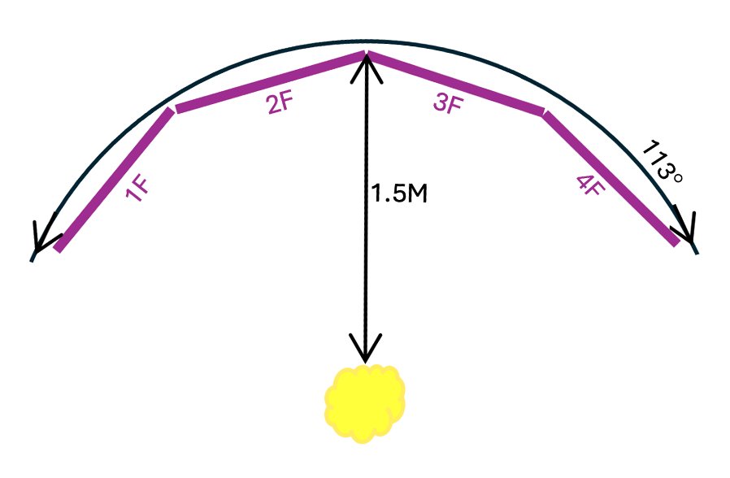

Figure 2 Simplified arena layout

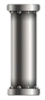
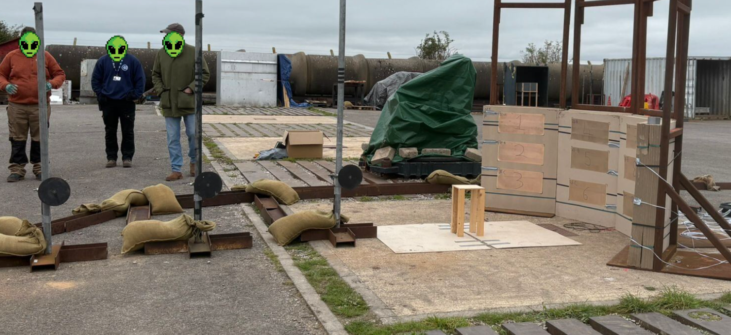
Figure 3 shows the set-up of the arena including the pressure gauges depicted by the green arrow with a digitally imposed pipe-like munition highlighted in yellow. The measurements of the pressure gauges from the ground is 0.5m in line with the centre of the charge. For an accurate measurement from charge centre to pressure gauge centre a laser could be used to gather more accurate results, due to the often-uneven ground on explosives ranges.
Figure 3 Wide angle of trial arena
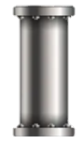
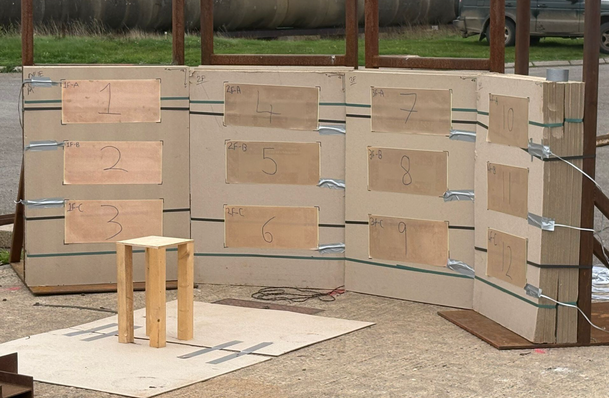
As seen in figure 4, for the set-up of the foils, each foil was labelled clearly, this labelling continues to the end of each cable, corresponding with the inputs to the junction box behind the frag packs, this then continues to the oscilloscope within the control room, it can also be seen in figure 4 that care was taken with cable management on the front of each pack to each foil. This was done in attempt to protect the cables to the foils as if these cables are impacted with fragmentation, it is possible to lose the data for that foil.
Figure 4 Close up of trial arena showing frag packs and make foils

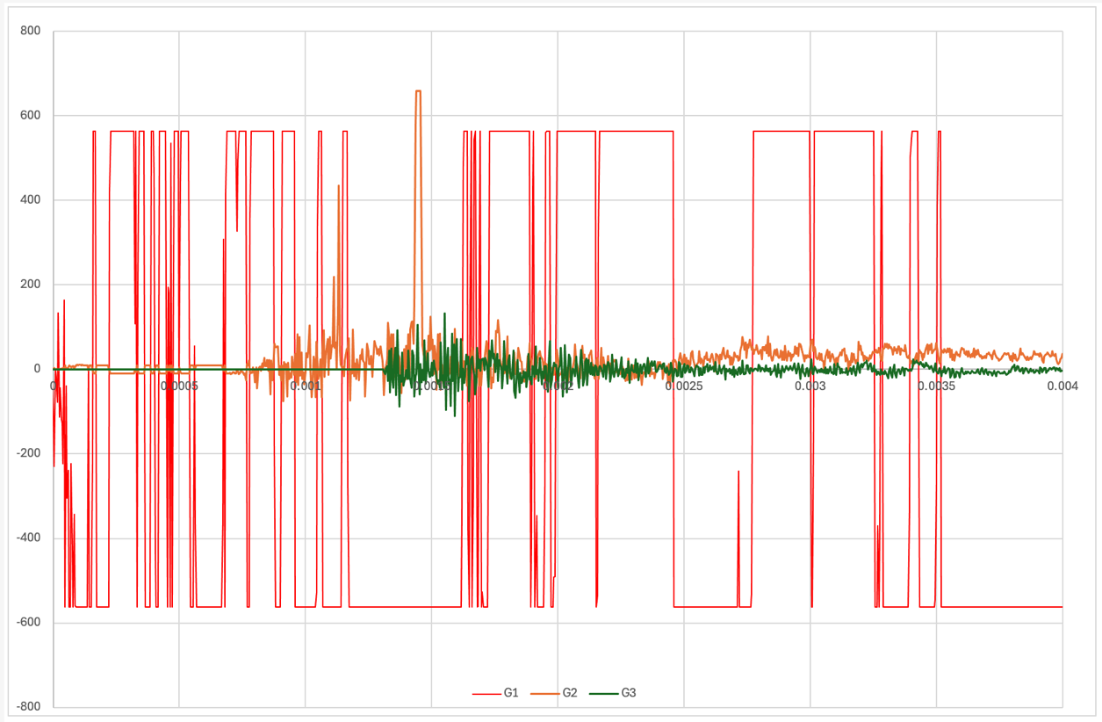
5. Results

5.1 Pressure data
Figure 5 Pressure data with noise
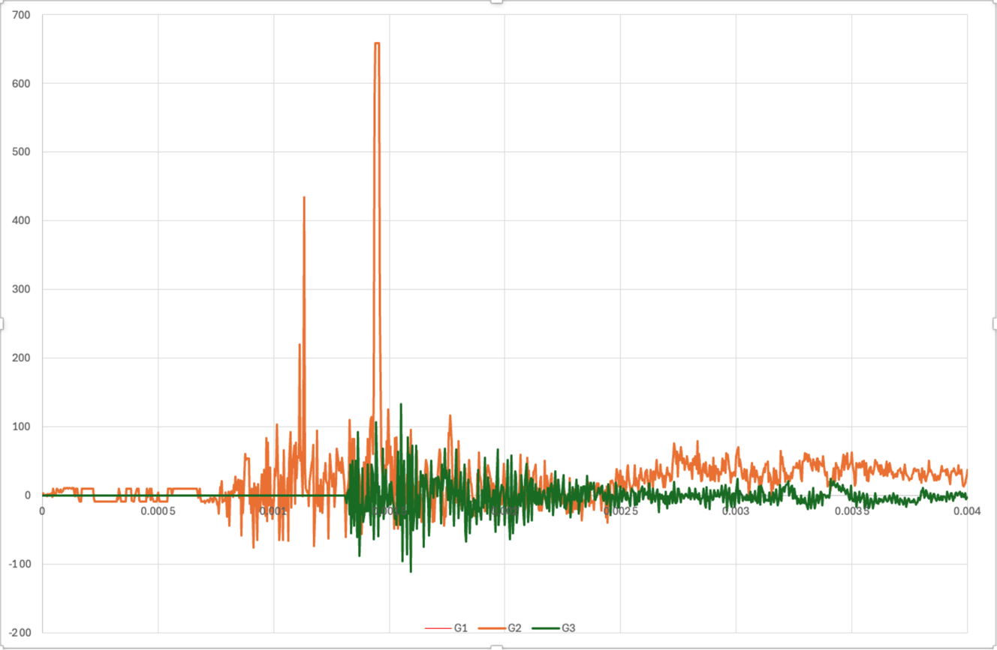
The pressure data seen in figure 5 demonstrates typical representative data collected while on trial, gauge 1 was hit with a large piece of fragmentation causing the red graph line as the gauges used were dynamic gauges giving a constant reading. Figure 6 shows this data cleansed of any noise, the orange line shows gauge 2, where the shock wave has travelled through the ground and up the stand of the more dense materials much quicker than what can be seen from the peak pressures, this noise can’t be cleansed from the data, but is expected when using pressure gauges due to mounting and sensitivity. The other spikes seen on the graph are likely to be reflections from the buildings, shipping containers and other large objects situated in the area.
Figure 6 Pressure data cleansed of noise

Gauge: | Distance | kPa
Gauge: | Distance | Peak 1 | Peak 2 | Peak 3
Gauge 1 | 0.009m | - | - | -
Gauge 2 | 2.075m | 219.47 | 434.58 | 658.5
Gauge 3 | 3.090m | 31.58 | 31.58 | 133.17
Table 1 Peak Blast Pressures

5.2 Velocity data
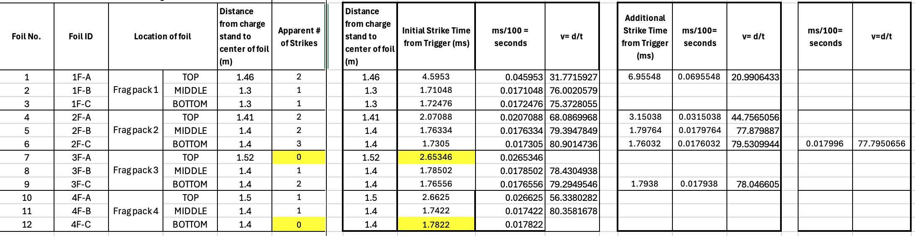
Table 2 Velocity Foil raw data
 | Fragment velocity averages m/s
 | Initial strike | Total strikes
Mean | 58.83 | 60.28
Median | 77.22 | 77.84
Range | 49.12 | 59.91
Table 3 Fragment Velocity Averages
It can be seen from the table that the average fragment velocity is 58.83 m/s using only the initial strikes for the measurements. It is sometimes possible to use additional strike times; however, this can sometimes skew the results due to the possibility of lightly caught fragments making contact with the foils and causing a false positive.

5.3 FTIR analysis
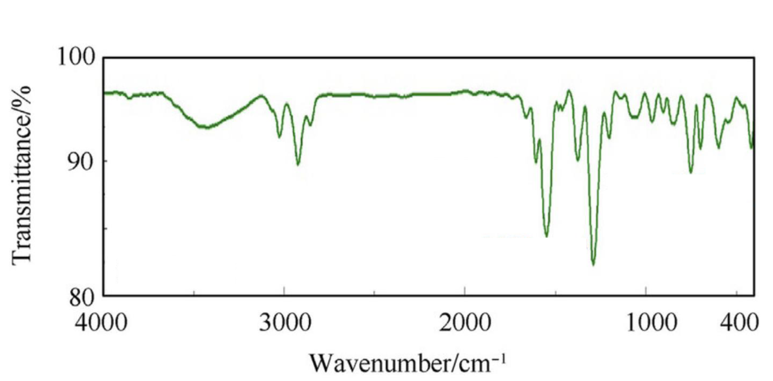
Figure 7 FTIR spectra of swab samples

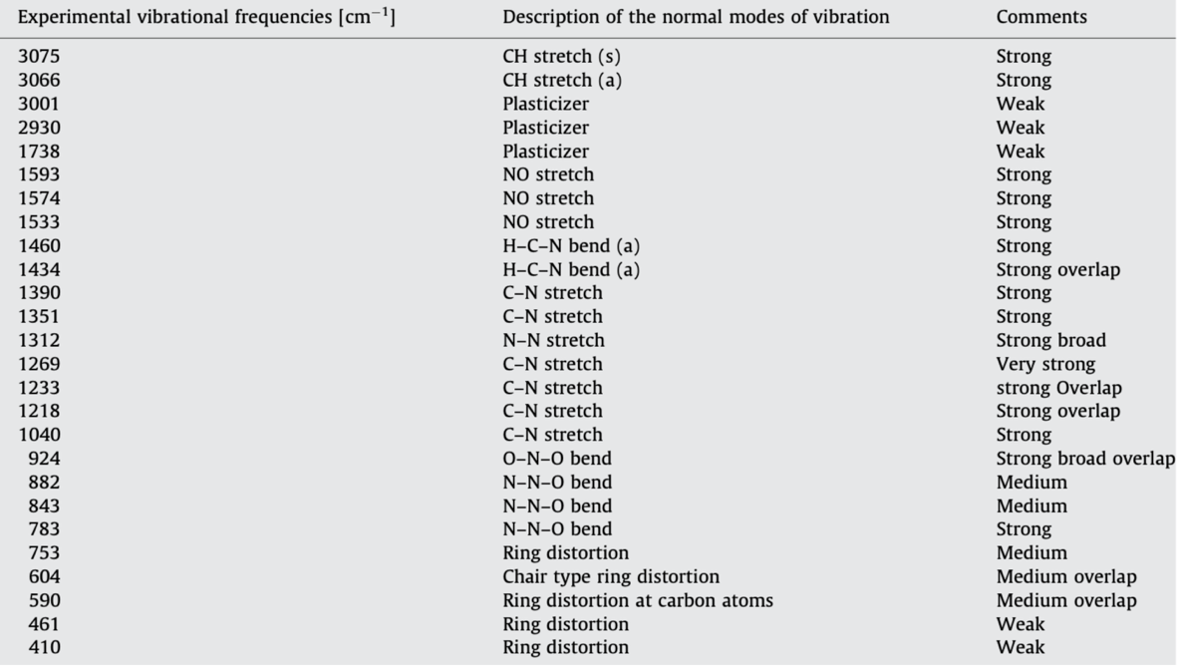
Figure 8 Swab Sample FTIR wavenumber, bond vibrations and strength

The FTIR output of the post blast swab samples have shown strong C-H stretch at 3066 - 3070 cm-1, a strong N-O stretch at 1593 cm⁻¹, a strong C-N stretch at 1040 cm⁻¹, and a very strong C-N stretch at 1269 cm⁻¹indicating characteristic absorption peaks for RDX [9] with peaks at around at 3000–2800 cm⁻¹, 1738.22 cm⁻¹, 1461.10 cm⁻¹, and 1171.97 cm⁻¹ that are thumbprints of diisooctylsebacate [10].

6. Discussion
The results of the FTIR analysis indicate C4 due to the RDX and diisooctylsebacate plasticiser, had the Kingery- Bulmash, Kinney-Graham and Gurney Equation been used, this could have indicated how many grams of C4 had been used, although other than gurney, the other models are for open air bursts as this item was known to be cased, gurney could have given a better match to the fragment velocities but this wasn’t needed due to the post blast scene assessment indicating a small amount of explosive, in a small naturally fragmenting OME item.

7. Conclusion
All the evidence gathered pre and post-trial indicates a small pipe bomb was the OME item that was detonated. Although there are some quicker and more practical ways of gathering this data, pressure gauges are always a benefit to any explosive trial, but highspeed video and computer modeling are much more practical ways to collect and validate fragment velocity data. The trials team setting up the trial consisted of poor communicators and the group was too large with only one item to gather data. This trial should be repeated with the earlier recommendations, a smaller team with an obvious task lead over seeing the whole team with at least 5 repetitions.

Bibliography

[1] | Supmea, “Static Pressure Vs. Dynamic Pressure Vs. Total Pressure,” Supmea, 17 07 2023. [Online]. Available: https://www.supmeaauto.com/training/static-pressure-vs-dynamic-pressure-vs-total-pressure#:~:text=Static%20pressure%20is%20the%20pressure%20exerted%20by,a%20fluid%20when%20it%20is%20in%20motion.. [Accessed 13 12 2025].
[2] | Meacon , “Static Pressure Vs. Dynamic Pressure Vs. Total Pressure,” Meacon , 17 07 2023. [Online]. Available: https://www.meaconsensor.com/training/static-pressure-vs-dynamic-pressure-vs-total-pressure#:~:text=Some%20common%20types%20of%20dynamic,when%20subjected%20to%20mechanical%20stress.. [Accessed 15 12 2025].
[3] | Z. Y. a. D. Shi, “Study on Fragment Velocity Measurement Technology of Prefabricated Fragment Warhead,” 2018 3rd International Conference on Materials Science, Machinery and Energy Engineering (MSMEE 2018), 2018. [Online]. Available: https://www.clausiuspress.com/conferences/AEASR/MSMEE%202018/G3998.pdf. [Accessed 15 12 2025].
[4] | P. Mercier, J. Bénier, P. A. Frugier, G. Contencin, J. Veaux, S. Lauriot-Basseuil and M. Debruyne, “Heterodyne velocimetry and detonics experiments,” SPIE, 2009. [Online]. Available: https://www.spiedigitallibrary.org/conference-proceedings-of-spie/7126/1/Heterodyne-velocimetry-and-detonics-experiments/10.1117/12.820433.short. [Accessed 15 12 2025].
[5] | UN, “Kingery-Bulmash Blast Parameter Calculator,” United Nations , [Online]. Available: https://unsaferguard.org/un-saferguard/kingery-bulmash. [Accessed 10 12 2025].
[6] | G. Kinney and K. Graham, Explosive Shocks in Air, New York: Springer, 2013.
[7] | D. Frem, “Estimating the metal acceleration ability of high explosives,” Chinese roots global impact , 05 07 2019. [Online]. [Accessed 13 12 2025].
[8] | UN, “Gurney Equations for Fragment Velocity,” United Nations, [Online]. Available: https://unsaferguard.org/un-saferguard/gurney. [Accessed 13 12 2025].
[9] | G. Li, M. Liu, R. Zhang, L. Shen, L. Yazhong and L. Yunjun, “Synthesis and properties of RDX/GAP nano-composite energetic materials,” Springer , 2016 05 16. [Online]. Available: https://www.researchgate.net/publication/277918877_Synthesis_and_properties_of_RDXGAP_nano-composite_energetic_materials#pf4. [Accessed 4 1 2026].
[10] | M. Khan, M. Ahsan, S. Farrukh and E. Pervaiz, “Free-Flowing Polymer-Bonded Powder Composition of Hexahydro-1,3,5-trinitro-1,3,5-triazine Using Solvent–Slurry Coating,” MDPI, 2024. [Online]. Available: https://www.researchgate.net/publication/379088902_Free-Flowing_Polymer-Bonded_Powder_Composition_of_Hexahydro-135-trinitro-135-triazine_Using_Solvent-Slurry_Coating. [Accessed 4 1 2026].
[11] | National Forensic Science Technology Center®, “A Simplified Guide to Explosives Analysis,” NFSTC Science Serving Justice®, [Online]. Available: https://www.forensicsciencesimplified.org/explosives/Explosives.pdf. [Accessed 10 12 2025].

