

Postgraduate/Distance Learning
Assignment coversheet & feedback form

THIS SHEET MUST BE THE FIRST PAGE OF THE ASSIGNMENT YOU ARE SUBMITTING (DO NOT SEND AS A SEPARATE FILE)

For completion by the student:
Student Name: Judith Dunkling

Module code: AHHI7016  Module title: Studying the Medieval: Manuscripts and Records | Student ID number: 1807205 |  |  | Educational support needs:  No
Module tutor: Professor Janet Burton

Assignment due date: 12 June 2020
If your module has multiple submissions please indicate which piece of work this is.

1st 2nd 3rd X 4th 5th 6th
I confirm that this is my original work and that I have adhered to the University policy on plagiarism.
Signed: J.M.T. Dunkling
Email submission: if you are submitting this form via email, please tick this box √□
(as a substitute for your signature) to confirm that you agree to the above declaration.
Assignment Mark
1st Marker’s Provisional mark
2nd Marker’s/Moderator’s provisional mark
External Examiner’s mark (if relevant)
Final Mark

NB. All marks are provisional until confirmed by the Final Examination Board.

For completion by Marker 1 :
Comments:

Marker’s signature: |  |  | Date:
For completion by Marker 2/Moderator:

Comments:

Marker’s Signature: |  | Date:
External Examiner’s comments (if relevant)

External Examiner’s Signature: |  | Date:

Assignment 3 (a): Comment on the significant features of a visual image
taken from a medieval book of hours, psalter, bible etc.

Commentary on ‘Cantors’ from the Ranworth Antiphoner in
the Church of St Helen, Ranworth, Norfolk

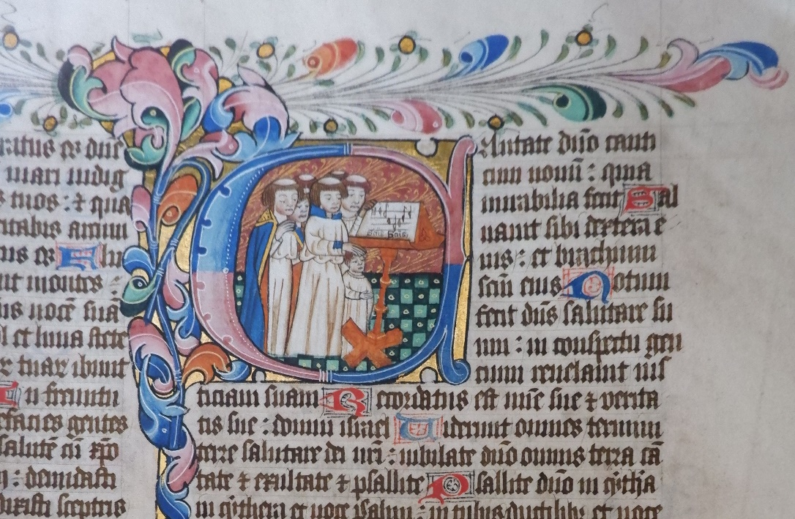
‘Cantors’ from the Ranworth Antiphoner. Photograph by Judith Dunkling, November 2019.
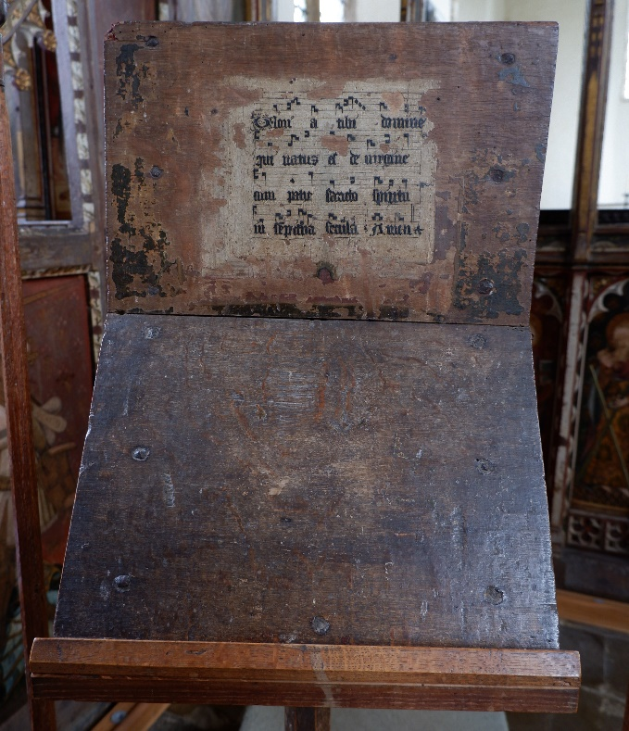
Fifteenth-century Music Desk in St Helen’s, Ranworth. Photograph by Judith Dunkling, November 2019.
The image selected is one that is colloquially known as ‘Cantors’ and which forms part of the Ranworth Antiphoner which is kept at St Helen’s Church, Ranworth in Norfolk. The Ranworth Antiphoner is a late medieval illuminated manuscript typical of its period. John Harthan describes illumination as being an art form in which books are decorated with colours, usually gold or occasionally silver. The term ‘illumination’ has its origins, Harthan states, in the Latin ‘illuminare’ which means to ‘brighten’ or ‘lighten up’.

Over the past century there has been some debate regarding the dating of the Ranworth Antiphoner. In 1937, F. Harrison wrote that the antiphoner may have been written around 1400, though the date may be a little earlier. By 2009, Richard Pfaff was putting forward an argument for the antiphoner being precisely dated to 1468 because of a reference it contains to the feast day of St Linus falling immediately before the First Sunday of Advent, which could only have happened in 1468 when brought together with other liturgical references contained within the book.

The primary purpose for an antiphoner was a private one, enabling the singing of the psalms during the daily offices of the Church. During the medieval period in monastic churches, and indeed later, the day would be punctuated by seven times of prayer or daily offices and these would be recited or sung antiphonally, meaning alternately between the priest and the choir. Typically, an antiphoner contains those portions of the daily or Divine Office which were sung. Michelle Brown writes that antiphoners were often written in large format, so that they could be clearly read and used by the choir singing the Office. Brown also states that usually an antiphoner would include decorated and historiated initials featuring saints and key points in the liturgical year of the church. The Ranworth Antiphoner follows this pattern and the volume contains at least eighteen pages that are illuminated with a large capital letter featuring a miniature illustration, with borders decorated in, what were for the time, conventional leaf forms. Harrison writes that in the Ranworth Antiphoner, in common with other antiphoners, the psalms are divided for daily recitation. Each division between the daily psalms is marked by an illuminated first letter decorated with subjects usually found in psalters. It is fortunate that the Ranworth Antiphoner has survived, despite being ‘lost’ for approximately three hundred years after the Reformation, before it was found in a bookseller’s catalogue in the twentieth century and restored to Ranworth Church. Comparatively few anthiphoners have survived in northern countries, which Harthan attributes to destruction at the time of the Reformation.

The selected image, ‘Cantors’, is an historiated initial. An historiated initial is a popular device within medieval manuscript illumination where a letter depicts within it an identifiable scene or figures, which can sometimes relate to the text. The illuminator has used one of the foundational principles of manuscript work at this time, by using a gold as a base for the initial, effectively highlighting the initial on the page and making it very clear as a place division. To the left of the initial, running vertically down the page and along the top border, is decorative leaf work in more subtly coloured red, blue and green. The colours red and blue are also used to form the letter ‘C’ as the historiated initial.

In the ‘Cantors’ image, the historiated initial is ‘C’ is picked out as it marks the opening of Psalm 98 in the psalter, which in Latin is Cantate Domine or O sing to the Lord a new song. Within the initial, the illuminator has aptly chosen to depict a group of seven monks singing as a choir at a music stand. The image is apt because of the words of Psalm 98 about singing to the Lord, as well as the singing or recitation of the psalms being part of the daily work of the religious. It can be seen that the figures portrayed are monks as they as shown with tonsured heads, in the typical western monastic pattern of the medieval period.

It is widely held that the Ranworth Antiphoner was made at the Premonstratensian priory at nearby Langley on the River Yare. As Langley held the patronage of St Helen’s, Ranworth, it is believed that the antiphoner may have been made especially for St Helen’s. Pfaff cites D.J.King in confirming this and argues that the antiphoner is a standard workshop production which includes the basic Norwich diocesan calendar for liturgical celebrations. There is also a visual clue in ‘Cantors’ that lends credence to its origins being within Langley Priory, which shows that the illuminator was simply portraying what he knew and familiar scenes from his daily round. That clue is that the monks portrayed in the image are wearing white habits, and these were the habits worn by the Premonstratensians who were known as the ‘White Canons’. As well as their white habits, the monk on the left is wearing an opulent blue and gold cope with red lining, a cloak worn by priests on ceremonial liturgical occasions. The monk in the centre is wearing blue cuffs and collar on his habit, again a liturgical marker of the season in the church’s year.

There is a rather humorous, even touching, moment portrayed where one of the monks has his hand on the head of a youngster who is too short to see the music stand. This is believed to be a young novice monk who is being encouraged in his endeavours by a pat on the head. To the immediate left of the stand, another monk is shown holding on to it and craning his head round as he tries to read the music. The monks are shown gathered around and singing from an antiphoner which has been placed on a wooden music stand. Coincidentally, the music stand illustrated is virtually identical a music stand that can be still be seen in St Helen’s today, a photograph of which is included above. Pfaff cites Charles Tracy as saying that this stand is a fifteenth century cantor’s desk which is likely to have been of local manufacture. Again, this is another example of the illuminator portraying that which he knew.

The decoration of what we must assume is a monastic church building shown behind the monks is also in keeping with a late medieval date for the antiphoner. They are shown standing on a black and green patterned, chequerboard tiled floor. The background is a richly decorated with a red leaf and branch design.

When the function of the Ranworth Antiphoner is considered, it can be demonstrated that the primary purpose of the antiphoner was to stimulate devotion. The antiphoner was a book made to enable people to recite the psalms as part of the Divine Office of the Church. The illuminated image of ‘Cantors’ was a historiated initial, which has been deployed to divide the psalms for daily recitation. This also performed the task of making it easier for the cantor and choir to find the relevant place in the psalms designated for that day, in their role of praise and intercession. This would recall the mind of the singer to the fact that they were singing to the praise and glory of God. It is possible, given that the illustration depicts monks, that the book may have originally been intended for use within the religious community at Langley. There is also a strong argument, outlined above, that it was specially commissioned for the parish church of St Helen’s, Ranworth which was in Langley’s patronage. The antiphoner is first mentioned as being acquired by St Helen’s in a bequest from William Cobbe in 1478, which suggests early lay ownership. It would appear that lay ownership of such manuscripts was not unknown at the time, as Janet Backhouse writes that ‘the great Psalters of the East Anglian school were in several cases commissioned by people who, although well-to-do landowners, were certainly not among the greatest in the land.’

BIBLIOGRAPHY:
Backhouse, Janet, The Illuminated Manuscript (London: Phaidon Press Ltd., 2006).
Brown, Michelle P., Understanding Illuminated Manuscripts: A Guide To Technical Terms (London: The British Library, 1994).
Harrison, F., Treasures Of Illumination: English Manuscripts Of The Fourteenth Century (c.1250-1400) (London: The Studio Ltd., 1937).
Harthan, John, An Introduction To Illuminated Manuscripts (London: Her Majesty’s Stationery Office, 1983).
Pfaff, Richard W., The Liturgy In Medieval England: A History (Cambridge: Cambridge University Press, 2009).

WEBSITES:
<https:broadsideparishes.org.uk/bspicons/manuscripts.htm> [Accessed: 5 March 2020].
<https:broadsideparishes.org.uk/bspicons/antiphoner/cantors.htm> [Accessed: 5 March 2020].

John Harthan, An Introduction To Illuminated Manuscripts (London: Her Majesty’s Stationery Office, 1983), p.6.
F. Harrison, Treasures Of Illumination: English Manuscripts Of The Fourteenth Century (c.1250-1400) (London: The Studio Ltd., 1937), p. 31.
Richard W. Pfaff, The Liturgy In Medieval England: A History (Cambridge: Cambridge University Press, 2009), p. 525.
The Ranworth Antiphoner: Our Illuminated Manuscript <https:broadsideparishes.org.uk/bspicons/manuscripts.htm> [Accessed: 5 March 2020].
Michelle P. Brown, Understanding Illuminated Manuscripts: A Guide To Technical Terms (London: The British Library, 1994), p. 11.
Harrison, Treasures Of Illumination: English Manuscripts Of The Fourteenth Century (c.1250-1400), p.32.
Harrison, Treasures Of Illumination: English Manuscripts Of The Fourteenth Century (c.1250-1400), p.32.
Harrison, Treasures Of Illumination: English Manuscripts Of The Fourteenth Century (c.1250-1400), p.31.
Harthan, An Introduction To Illuminated Manuscripts, p. 12.
Brown, Understanding Illuminated Manuscripts: A Guide To Technical Terms, p.68.
<broadsideparishes.org.uk/bspicons/antiphoner/cantors.htm> [Accessed: 5 March 2020].
Pfaff, The Liturgy In Medieval England: A History, p.524.
<broadsideparishes.org.uk/bspicons/antiphoner/cantors.htm> [Accessed: 5 March 2020].
Pfaff, The Liturgy In Medieval England: A History, p.525.
Pfaff, The Liturgy In Medieval England: A History, p.524.
Janet Backhouse, The Illuminated Manuscript (London: Phaidon Press Ltd., 2006), p.48.

