Assignment 1 Report
Games Architecture and Mechanics ACCB5017
Sam Mifsud (2305369)
2024
Table of Contents
Part 1 – Numerical Integration Methods 2
Method 1 – Euler’s Method 2
Method 2 – The Runge Kutta Method (RK4) 2
Part 2 – Simulation Programming Task 3
Simulation 1 – Euler’s Method 3
Simulation 2 – The Runge-Kutta Method (RK4) 4
Simulation Results 4
Euler’s 5
RK4 6
Testing 6
References 10

Part 1 – Numerical Integration Methods

Method 1 – Euler’s Method

Method 2 – The Runge Kutta Method (RK4)

Part 2 – Simulation Programming Task
For the spring powered car simulation I ran two loops, one for each Numerical Integration method. The methods I used are the same two I discussed in Part 1, Euler’s and The Runge-Kutta (Rk4) Methods. I had them write their results to separate files, and reused the variables between them by resetting them between loops.
For the code that was reused in multiple places and required testing I used a separate header file, and an additional header file was created for the testing code.

Simulation 1 – Euler’s Method
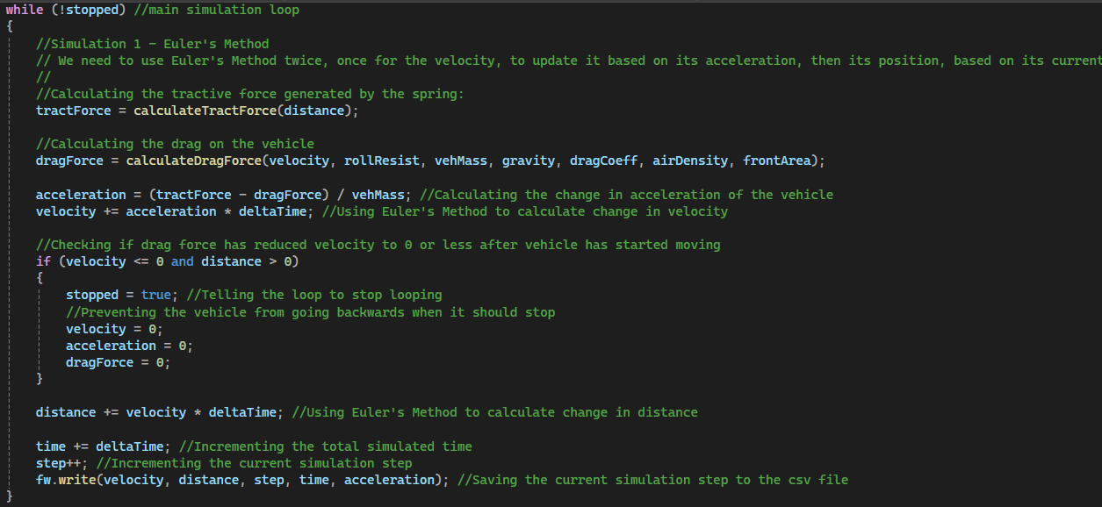
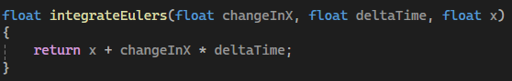

Simulation 2 – The Runge-Kutta Method (RK4)
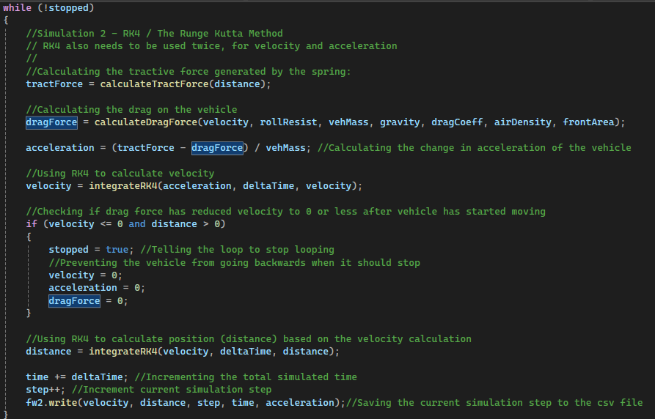
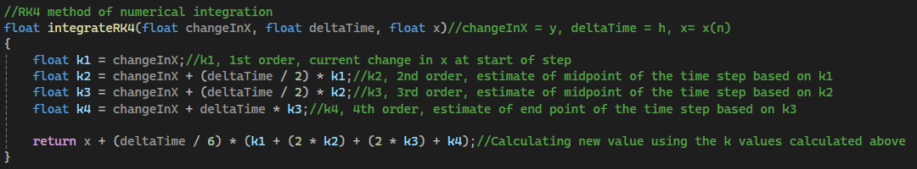

Simulation Results
Both the Euler’s and RK4 method simulations produced similar results, with both their final distances being within .3m of one another and Euler’s only taking one additional step. I did not have time to create a graph demonstrating both of their results

Euler’s
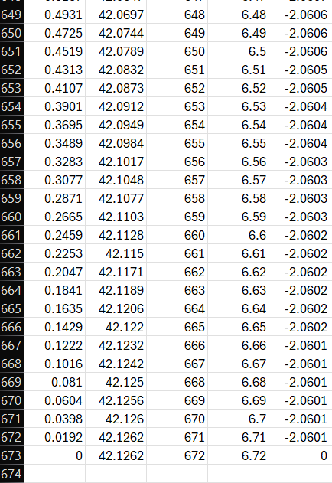

RK4
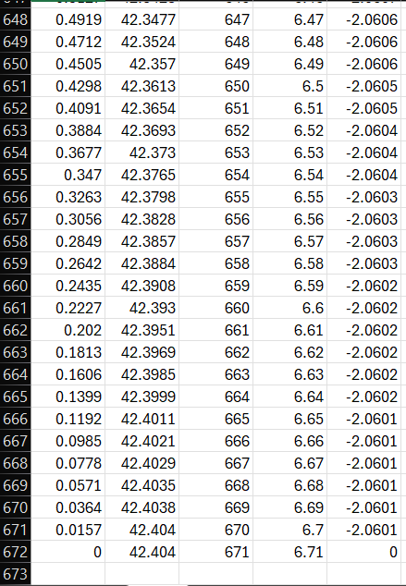

Testing
To ensure my program was working correctly I created a series of tests for each function, to ensure their outputs were correct. I had to decide on test data for each function and come up with an input and calculate what the output should be if the code is working correctly.
I used a calculator to generate the data to test against. I would have liked to use premade programs specifically for numerical integration using Euler’s and RK4 methods, as these would ensure that my functions are implemented correctly, as when manually calculating I could make the same mistakes in my formulas that I could have made in the code. However, I could not find a suitable calculator for either method, as most required significantly more inputs and produced outputs in different formats to mine.
I created a testing harness via a function in a separate header file. It calls each function, sends it test inputs, checks its outputs against the pre-calculated results and prints a string to the console depending on whether it is correct or not. For each test that passed I would increment a value that stored the number of passed tests, so a the end I could show how many of the tests passed.
For the FileWriter function I created a new testing file, wrote some data to it and read the data back. If the read function output the column headings the file writer automatically generated, then the function is working correctly. The file can be manually read by the user through an external program to ensure the values passed were written correctly also.
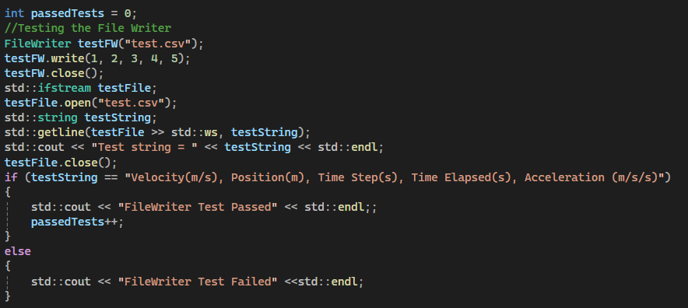
For the tractive force calculation function I ran the function twice with 2 different values for distance. One below 6 that should output a normal tractive force, and one above that should output 0. I checked that both outputs were correct, however I ran into a problem during testing where the function would return 14.4 and 0, the expected values the testing harness was looking for, but it would claim the test failed regardless. I believe this was caused by floating point inaccuracy [1] and was fixed by checking if the value for the first output was in a very small range around 14.4 instead.
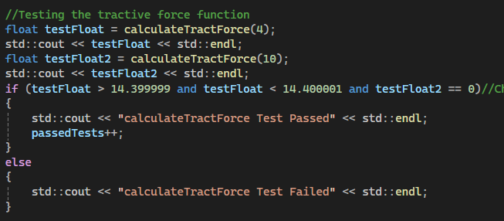
For the drag force calculation I ran the function with a velocity of 10 and set all the other values to what they would be in the program normally. I once again checked that the value was within a small range to account for floating point error.
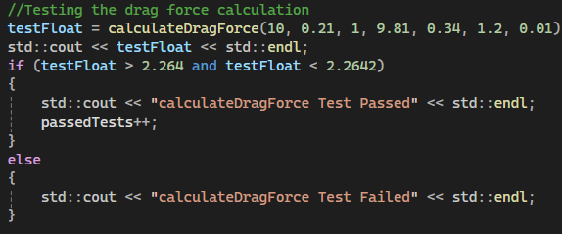
For the Euler’s Method calculation function I simply checked that if x started as 1 and increased by 2 per second for 1 second it would calculate the result as 3.
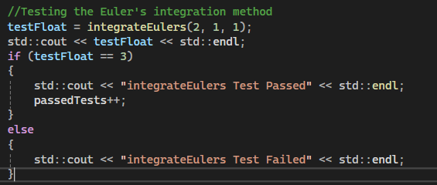
Due to a lack of time, I was unable to test the RK4 calculation function, as its calculations are more complex and would require a more complex testing method than I could have implemented.
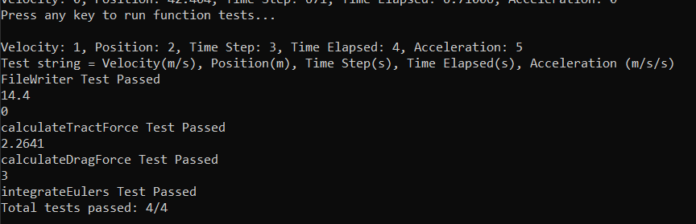
All of the tests I ran produced expected values and therefore all tests were passed. While the RK4 method did not get tested, in practice it appeared close to Euler’s method, suggesting it is likely working correctly.

References

[1] | D. GOLDBERG, “What every computer scientist should know about floating-point arithmetic,” ACM computing surveys, vol. 23, no. 1, p. 5–48, 1991.

