A Basic Physics Engine: Vectors and Collisions

Table of Contents
Introduction 2
Distance Between Two Points 2
Planes 2
Sphere to Sphere Collision 3
Bounding Box 3
Testing 6
Conclusion 10
References 10

Introduction
In this report, I will describe, evaluate and test the different aspects of my physics engine algorithm. I will explain how the different parts of the code work and how they interact with one another. One of the things that I will address is how the code calculates the distance between two points using two 3D vectors. Following the distance between two points, I will explain how the code utilises the two 3D vectors already provided to calculate a plane’s normal and a normalised normal, using a third point provided by the user. Next, I will explain how the physics engine can use the two points provided in the first part of the code, in order to create a sphere around each point using specified volumes, then to detect whether the spheres are colliding based on their position and size. Lastly, I will explain how the engine can create a bounding box using the width, height, depth and a starting point, while also calculating whether a second, arbitrary point, lies within the bounding box created, or if it is anywhere outside of it.

Distance Between Two Points
In the first part of the code, the user is asked for input of two points on a 3D scale. Those two points are important as they are not only used to calculate the distance between two points but also the plane normal and sphere-to-sphere collision, in the next two parts of the code. The distance between two points is calculated by squaring the total of two x values after they have been subtracted from one another, then the same process is carried out for the y and z values. Finally, after the subtraction and squaring, the three numbers are added and square rooted, in order to provide the final, distance between two points. This can be expressed by the following equation, where the ‘d’ is the distance between two points: [1]
$$d=\sqrt{{\left(x_{2}-x_{1}\right)}^{2}+{\left(y_{2}-y_{1}\right)}^{2}+{\left(z_{2}-z_{1}\right)}^{2}}$$
The second part of this code segment involves simply squaring the distance, calculated in the first part. To make this much simpler, the program stores the distance calculated previously in a variable, then it squares the value, instead of writing another equation for the process.

Planes
To make this segment simpler to test, instead of providing the program with fresh coordinates, it will utilise the two points that were provided for calculating the distance between two points. Although using two existing points to calculate a plane normal will make testing much easier, one new set of coordinates is still required, which is why in this code segment, the user is asked to provide a point that is set to be lying on the plane, indefinitely. After the program has acquired said point, the program will calculate two sets of new coordinates which will be used to calculate the cross product of the point on the plane and the two points from the previous code segment. The cross product is what will provide the engine with a normal to the plane. The cross product “n”, calculations are done as follows: [source]
$n_{x}= a_{y}*b_{z}- a_{z}*b_{y}$ $n_{y}= a_{z}*b_{x}- a_{x}*b_{z}$ $n_{z}= a_{x}*b_{y}- a_{y}*b_{x}$
Once the engine calculates the normal by finding the cross product, it will have to normalise the plane normal. For that, it will require the magnitude of the normal, which is calculated as follows: [2]
$$magnitude =\sqrt{{n_{x}}^{2}+ {n_{y}}^{2}+ {n_{z}}^{2}}$$
Next, using the magnitude, each element of the plane normal can be normalised to provide a using the following steps, where the normalised coordinates are represented by “O”:
$o_{x}= n_{x} / magnitude$ $o_{y}= n_{y} / magnitude$ $o_{z}= n_{z} / magnitude$
Finally, after the engine has constructed a plane, found the plane normal and has normalised said normal, the user will be asked to provide the coordinates for an arbitrary point which will be tested on whether it lies on the plane. The engine will return a response, appropriate to whether the arbitrary point is on the plane, or if it is above/below it. The way the program can determine the position of the point with respect to the plane, is by calculating two dot products and subtracting one from the other. The first dot product (represented by “np”) is that of the normalised plane normal, and the point that lies on the plane indefinitely. The second dot product (represented by “nx”) is a product of the arbitrary point created by the user for testing, and the normalised plane normal. Once the program subtracts np from nx, if the answer is 0, the engine can assume that the point lies on the plane, however if the answer is either higher or lower than 0, the engine will know that the point is either above or below the plane.

Sphere to Sphere Collision
The physics engine is also capable of calculating sphere-to-sphere collision. The way it does that is by creating a sphere around both points created in the first part of the code, then determining the radius of each sphere based on the volumes that the user provides. After the radius is calculated for both spheres, the sum of the two is compared to the distance between two points. If the distance is smaller than the sum of the radiuses, the program can conclude that the spheres are indeed colliding. The equation for finding the radius of a sphere using the volume is: [3]
$$radius = {\left(3*\left(volume / \left(4*π\right)\right)\right)}^{\frac{1}{3}}$$

Bounding Box
The final segment of the physics engine is executed in two parts. The first part takes four values and builds a bounding box to work with, using the values provided. The main values are the length, width and depth of the bounding box that will be constructed. Those three will determine the size of the bounding box. The fourth value that the program will require from the user is the x, y and z coordinates, which will serve as a starting point for the construction of the bounding box.
When the starting point and the size parameters are determined, the program creates a second point below the starting point. The distance between those two points in dependant on the depth. Next, the program creates a third point to the right of the starting point. The distance between the third point and the starting point is dependent on the length. Finally, the program will create a fourth point below point three. The point three and point four vector is directly proportional and parallel to the starting point and point two vector, while also staying perpendicular to the point three and starting point vector. Through this method, the engine creates the first of the two planes necessary to define six faces needed to construct a bounding box.
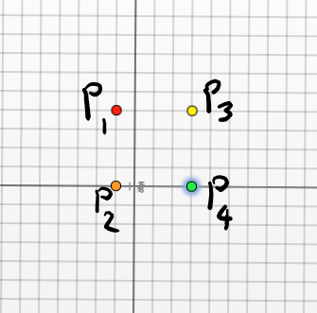
For example, if we assume that the starting point ($P_{1}$) coordinates are (-1, 4, 3), and the width, length and depth values are set to 4, then the engine will create the rest of the first plane like so:

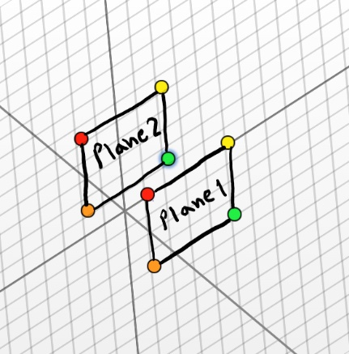
Once the first plane is constructed, the program will essentially copy the first plane, and create a second one just like it, a specific distance away. This distance is dependent on the value provided for the width.

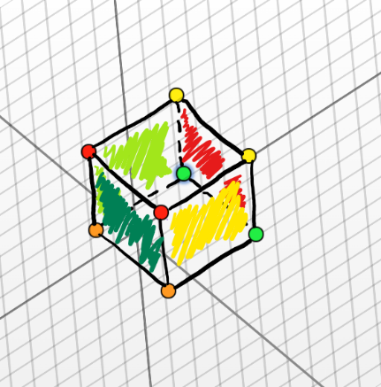
When the two planes are created, the engine can now define all six faces of a bounding box. This is done by referencing and mixing two specific points from each plane. For example, the points that will define the left face of the bounding box are both the starting points in plane one and two, as well as both the second points created in plane one and two. This process is repeated four times after the first two planes are created using the correct, corresponding points, which will in turn, create a full bounding box.

Now that the engine has generated a bounding box, the user is asked to input the coordinates for an arbitrary point which will then be used to test collision with the box. If the point is created within or on the edge of the bounding box, the engine will then return a response which states that the point lies within the bounding box. The user is then asked if they would like to test for another point, until they state that they are done, which allows for extensive testing with an infinite combination of coordinates.
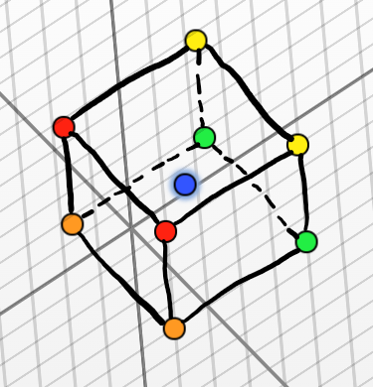
For the sake of demonstration, if the user states that the point used for collision testing is at (1, 2, 1), then the point will be at the very centre of the bounding box, which means that there is a collision, and the physics engine will detect it.

The website used for visualising the bounding box can be found at source [4]

Testing
Test | Output Screenshot | Expected Result | Actual Result | Pass/Fail
Testing Mode | 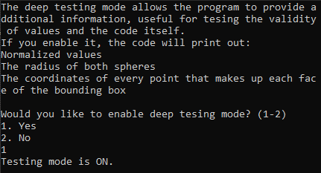 | The engine will output that the testing mode is on/off depending on the user’s choice | The program will now run, in testing mode, and so it will display additional information | Pass
Testing mode invalid answer | 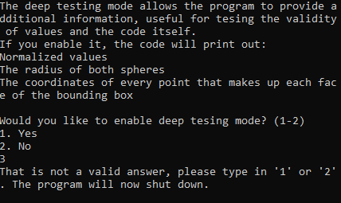 | If the user doesn’t type in 1 or 2, the engine will deem that as an invalid answer | The program shut down | Pass
Storing two vectors for later use | 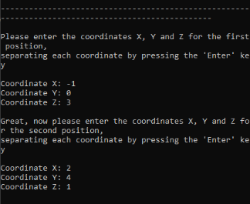 | The user will be asked to type in two sets of coordinates | The program took the input and had the values stored for later use | Pass
Calculating the distance between two points | 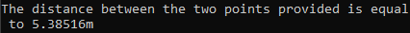 | The program will calculate and output the distance between two points | The program displayed the distance between two points | Pass
Squaring the distance between two points | 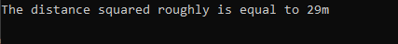 | The program will output the distance between two points after it is squared | The program displayed the distance between two points squared | Pass
User input for a third set of coordinates for calculating planes | 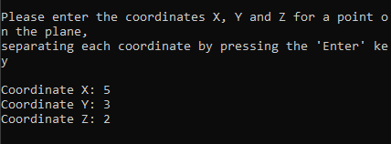 | The program will ask the user for a third set of coordinates to be used for the planes section of the engine | The program has taken the coordinates for a third point on the plane | Pass
Calculating the cross product (plane normal) of the first two points and the third point | 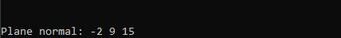 | The engine will output the calculated plane normal | The program displayed the plane normal | Pass
Calculating the normalized plane normal | 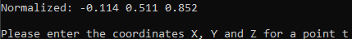 | The engine will output the calculated normalized normal | The program displayed the normalized plane normal | Pass
Testing for position with respect to the plane | 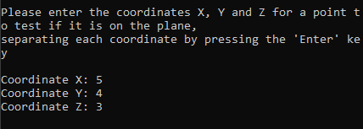 | The user will be prompted to input a set of coordinates for a point that will be used to test its position with respect to the plane | The program took the coordinates of a point which may or may not lie on the plane | Pass
Displaying the dot product of the point on the plane and the normalized normal | 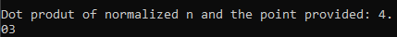 | The engine will print out the dot product of said values  This will only happen if testing mode is ON | The program displayed the dot product of the normalized normal and the point that lies on the plane indefinitely | Pass
Displaying the dot product of the arbitrary point and the normalized normal | 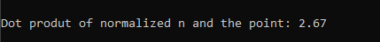 | The engine will print out the dot product of said values  This will only happen if testing mode is ON | The program displayed the dot product of the normalized normal and the point that may or may not lie on the plane | Pass
Displaying the distance of the arbitrary point from the plane | 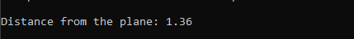 | The engine will print out the distance of the point with respect to the plane  This will only happen if testing mode is ON | The program displayed the distance of the arbitrary point from the plane | Pass
Displaying if a point is on, above or below the plane | 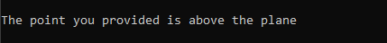 | Based on the distance value, the program will tell if a point is below, above or on the plane | The program displayed that the point was above the plane because the value was positive | Pass

Input of two volumes to construct two spheres around the two points provided at the start | 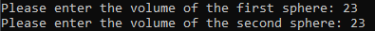 | The user will be prompted to input two volumes for the spheres | The program has taken two volumes and calculated two radiuses | Pass
Calculating and displaying the radius of both spheres | 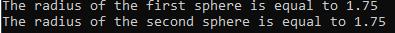 | The program will display the radius of both spheres based on the volume provided  This will only happen if testing mode is ON | The program displayed the two radiuses it calculated | Pass
Collision check | 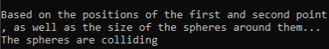 | The program will check for collision of the two spheres based on their size and position, then it will output the result | The program displayed whether the spheres are colliding, based on the sphere sizes and positions | Pass
Bounding box length, width and depth input | 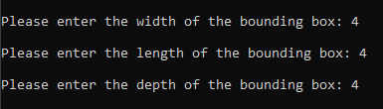 | The user will be prompted to provide the length, width and depth of the bounding box | The program took the values of the length, width and depth of the bounding box for later use | Pass
Bounding box construction | 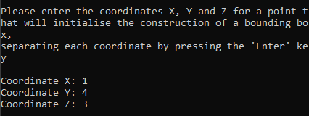 | The user will be prompted to input coordinates for a point that the engine will use to create a bounding box | The program has taken the coordinates of a point that it will use to automatically generate a bounding box with six faces. It did so by creating two planes and combining them. | Pass
Bounding box details output | 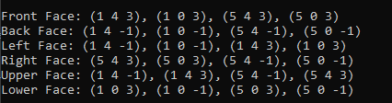 | The engine will output the coordinates for each point that defines the six faces of a bounding box  This will only happen if testing mode is ON | The program displayed the coordinates for the points it has automatically generated for the bounding box. | Pass
Bounding box collision point | 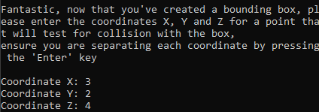 | The user will be prompted to input the coordinates of an arbitrary point to test for collision | The program took the coordinates of an arbitrary point | Pass
Collision doesn’t occur | 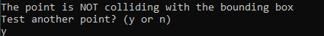 | If the arbitrary point is NOT within or on the edge of the bounding box, the program will state that the point isn’t colliding with the box | The program displayed that the arbitrary point was created outside the bounding box | Pass
Collision occurs | 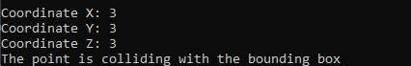 | If the arbitrary point is within or on the edge of the bounding box, the program will state that the point is colliding with the box | The program displayed that the arbitrary point was created within the bounding box | Pass
Collision test repeat | 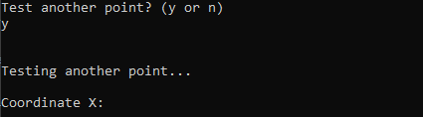 | The program will ask the user if they would like to test for another point. If yes, the user will have to provide a new set of coordinates for a point. If not, the engine will terminate, and the program will shut down | After the collision test, the program has initiated another test, per the users wish to do so | Pass

Conclusion
In conclusion, the physics engine can perform its tasks in a relatively efficient way. It can find the distance between two points; it can create a plane and it can test for sphere-to-sphere collision using the same two points that the user provides at the beginning of the algorithm. The two sets of coordinates, along with additional information provided at each segment of the engine, is what allows it to carry out its tasks, without the need for unnecessary additional values. The fourth and final part of the engine is entirely independent of any previously defined variables and values. This is because of the way the bounding box is constructed and the way the collision with the box is tested, the two points defined at the beginning are essentially useless for the final function of the engine.

References

[1] | E. Furey, “Three Dimensional Distance Calculator,” CalculatorSoup, [Online]. Available: https://www.calculatorsoup.com/calculators/geometry-solids/distance-two-points.php. [Accessed 22 December 2021].
[2] | N. DQ, “Magnitude of a vector definition,” Math Insight, [Online]. Available: https://mathinsight.org/definition/magnitude_vector#:~:text=For%20a%20three-dimensional%20vector,22%2Ba23.. [Accessed 23 December 2021].
[3] | “How to find the radius of a sphere with the volume?,” CUEMATH, [Online]. Available: https://www.cuemath.com/questions/how-to-find-the-radius-of-a-sphere-with-the-volume/. [Accessed 23 December 2021].
[4] | “CPM 3D Plotter,” CPM, [Online]. Available: https://technology.cpm.org/general/3dgraph/. [Accessed 1 January 2022].

