REPORT TEMPLATE
Module: Introduction to Web and Database Concepts (ACCA4023)
Assignment: HTML & CSS Web Development
Student Name: _____Ammar Doudou_____________________
Student ID: ____2439672______________________
Course: ______Introduction to Web and Database Concepts (ACCA4023_LON)
___________________
Submission Date: ____24/04/2026______________________

Table of Contents
(Update this automatically in Word)

1. Introduction (Abstract)
This report explains the development and design of my website, "My Football Journey," described in this report. The website, which was made to demonstrate my own passion in football, has a contact page, a gallery page with my own photos, and details about me and my football experience. The website was created with HTML and CSS and was intended to be straightforward, understandable, and user-friendly.
The website's primary goal was to develop a multi-page, responsive website that conforms to web standards and can be seen on many screen sizes. Home, About, Gallery, and Contact are the four linked pages on the website. Every page has the same navigation menu, style, and layout.
The requirements for the website, the implementation process, testing and validation, and an assessment of the website's usability, accessibility, and search engine optimization (SEO) are all covered in this report. It also considers the website's advantages and potential future enhancements.

2. Requirements
This website’s primary goal was to use HTML and CSS to create a responsive website. The website had to conform to fundamental web standards and have several linked pages.
My personal passion for football was the inspiration for the website I made. The primary goal is to give details about my football trip, such as my experience, pictures, and contact information.
The following are the website's primary requirements:
• There must be a minimum of three pages on the website. Home, About, Gallery, and Contact are the four pages that make up my website.
• The website needs to be responsive and functional on a variety of platforms, including desktop computers, tablets, and mobile phones.
• For users to navigate between pages with ease, all pages must be connected by a navigation menu.
• There must be pictures on the webpage. I updated the gallery page with pictures I took of football.
• Every page on the website needs to have the same layout and design.
3. Implementation
• Include screenshots of all website pages.
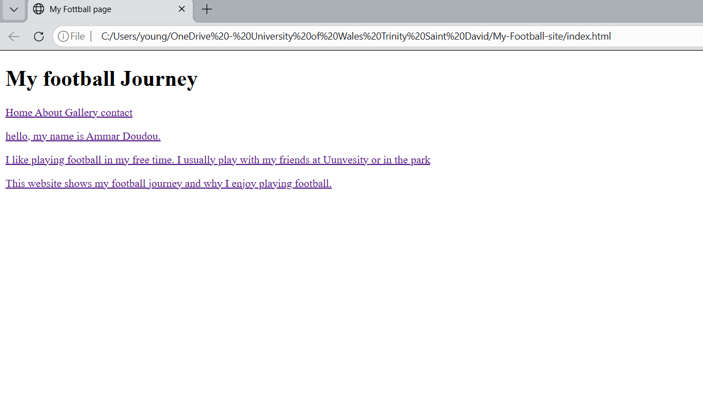
Figure 1: Homepage
My website's home page is this one. It provides a brief overview of my football career and introduces the website. Users can navigate between pages using the navigation bar at the top of the page. The design is straightforward and simple to understand.
The home page has an easy-to-understand design. The website's overall appearance is enhanced by the adoption of a uniform color palette. Users may simply read the text without being distracted because of the layout. Users may easily navigate between pages because the navigation menu is prominently displayed at the top of the site.

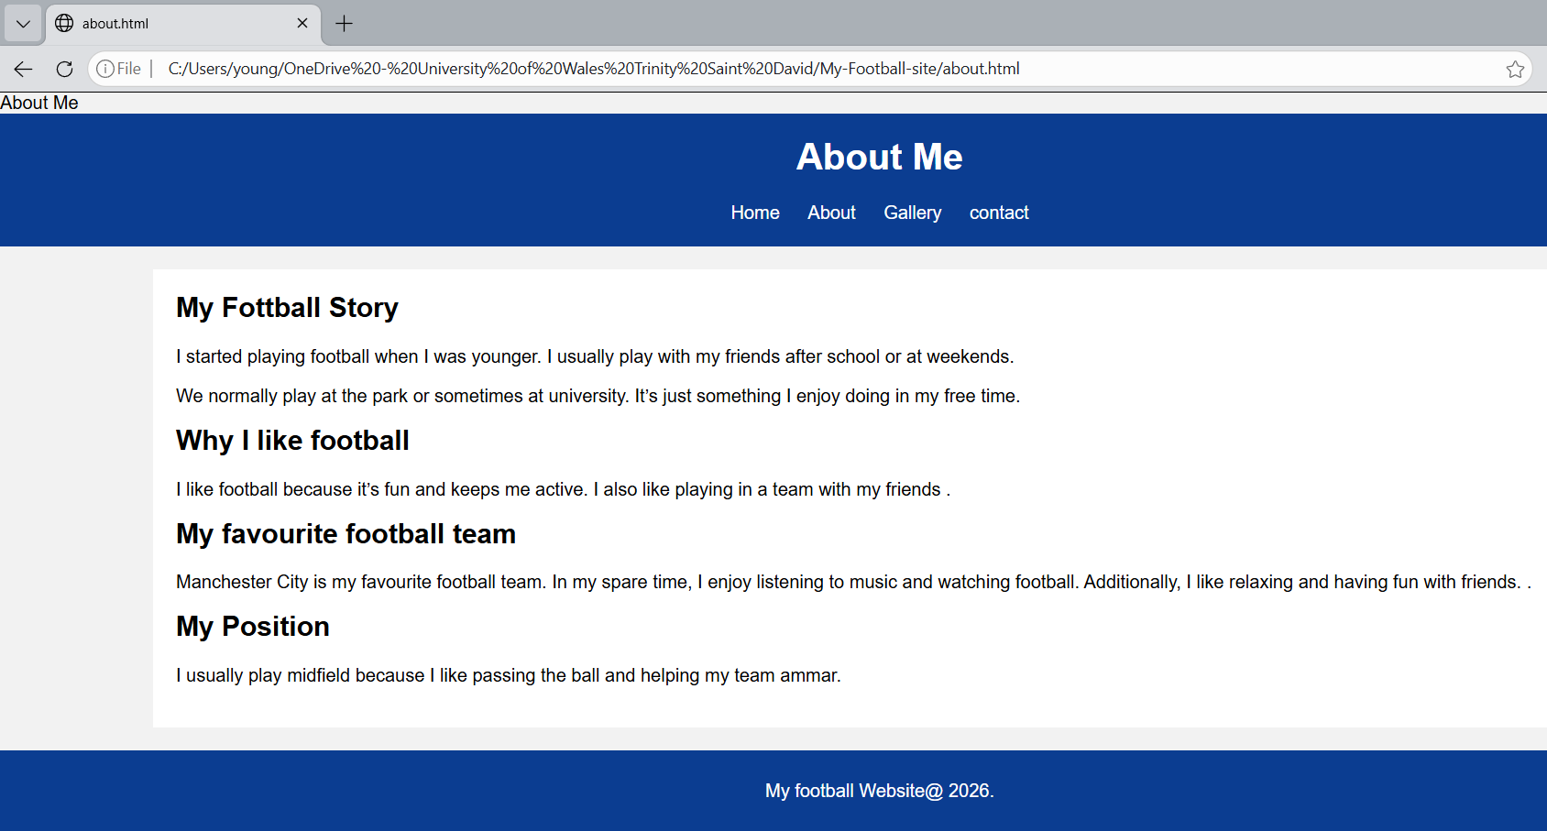
Figure 2: About
More details regarding my football experience are provided on this site. It describes how I got into football, why I like it, and where I stand. To clearly arrange the text, headings and paragraphs are used.

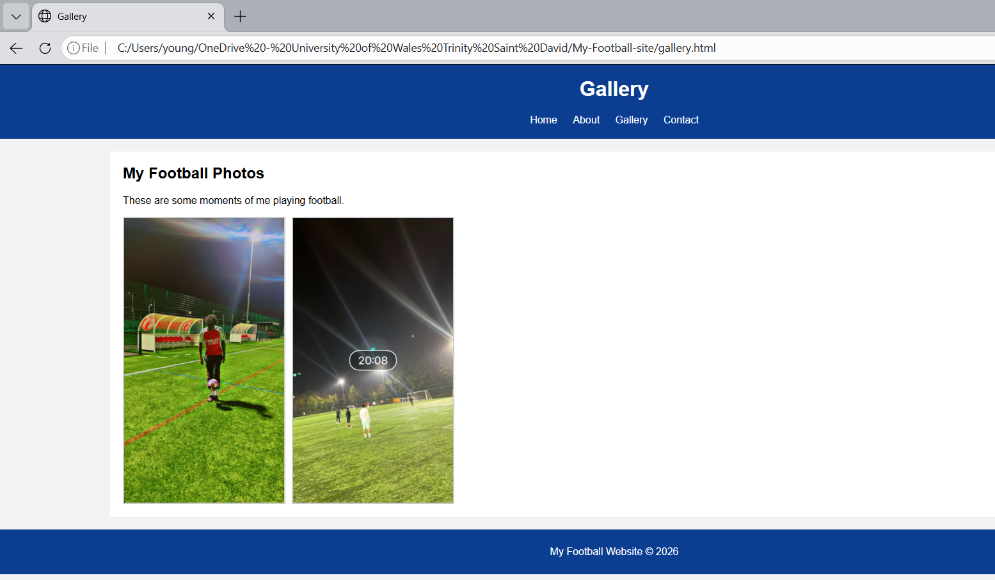
Figure 3: Page of Gallery

Pictures from my football activities are displayed on this site. To add a personal touch to the website, I included my own images. To ensure that the photos are responsive and not overly huge, they are stylish using CSS.

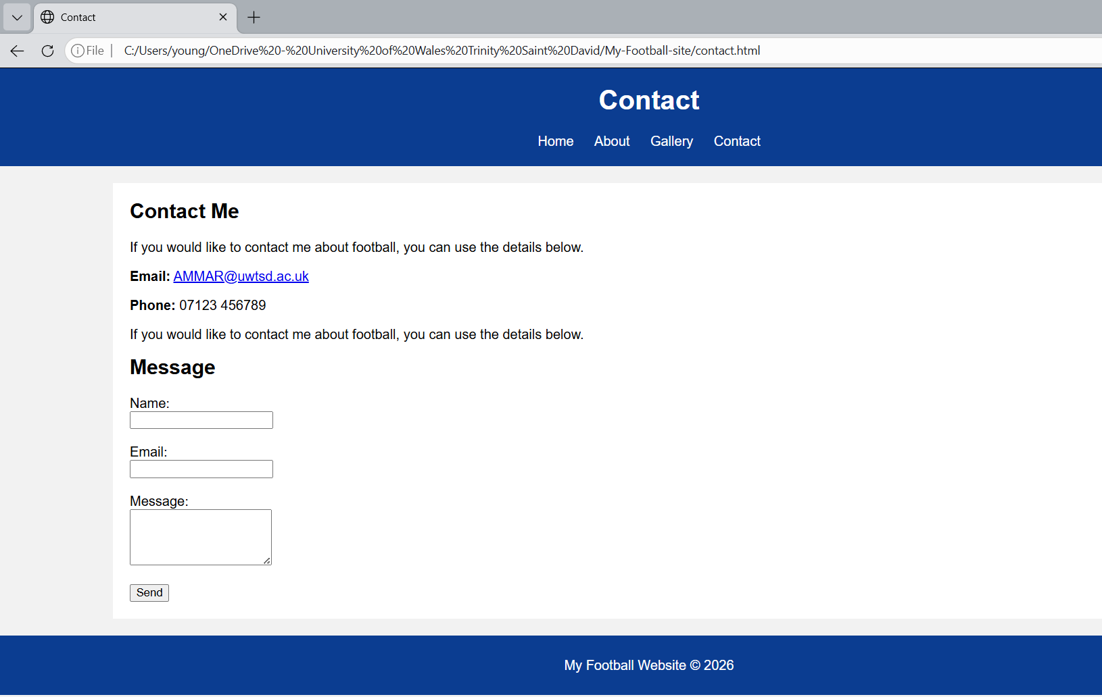
Figure 4: Contact Page
Users can get in touch with me using this page. It has my email address and a straightforward form for users to fill out with their name, email address, and message. The layout is straightforward and user-friendly.

• Provide validation results (HTML & CSS).
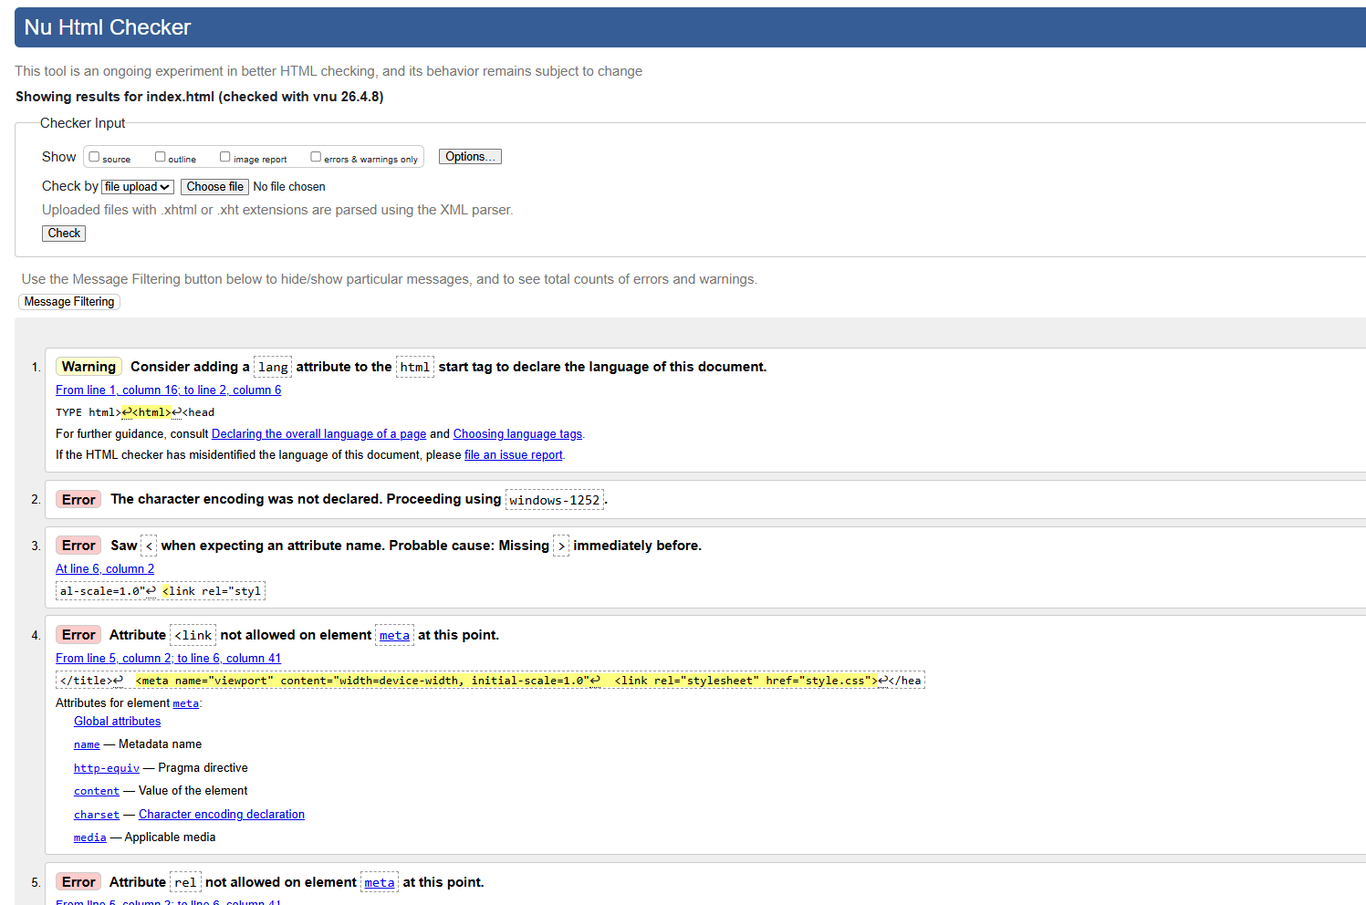

Figure 5: Results of HTML Validation (With Errors)
The first validation result of my HTML code is displayed in this screenshot. The validator found several mistakes, such as missing attributes and improper closing tags. Small faults in the code structure were the source of these issues.

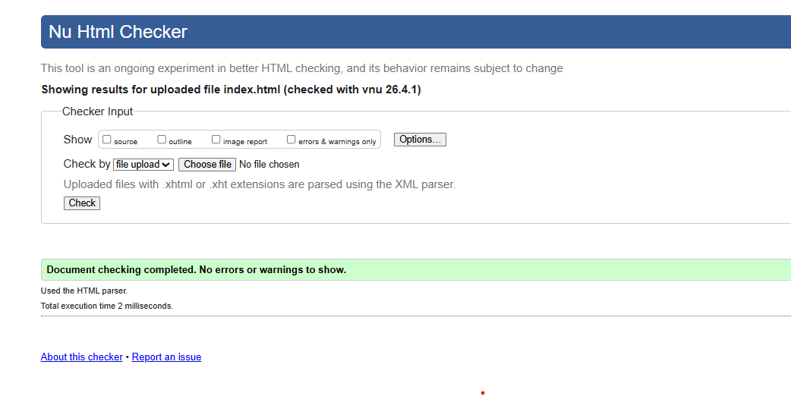Figure 6: HTML Validation Result (After Fixing Errors)
This screenshot shows the final validation result after correcting the errors. The issues identified earlier were fixed by updating the HTML structure and correcting the tags. As a result, the code now follows basic web standards.

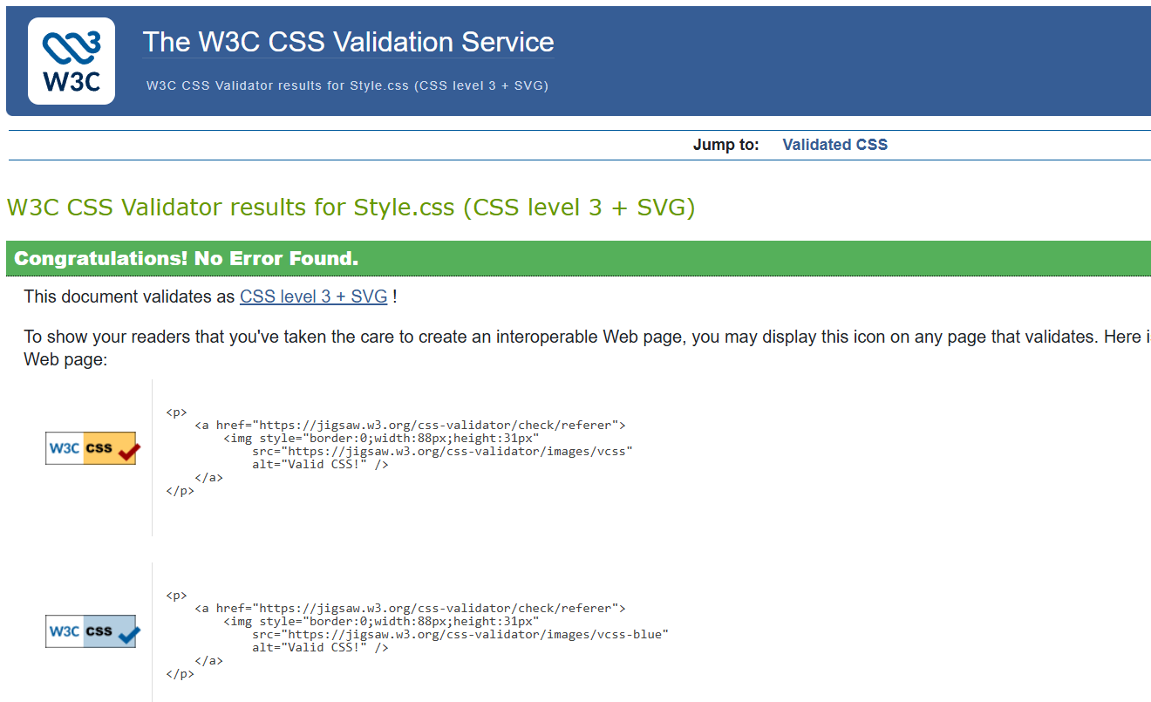
Figure 6: Validation Results for CSS
This screenshot displays the W3C CSS Validator's validation result for my CSS file. The outcome attests to the CSS code's accuracy. This indicates that the stylistic guidelines conform to web standards and are properly prepared. Therefore, every page of the website has an appropriate layout and design.
This validation result enhances the overall quality of the website and verifies that the CSS code is correct.
• Explain errors and fixes.
A few problems were identified and fixed throughout the website's development.
One problem was that the gallery page's pictures weren't showing up. An improper file path was the source of this. By moving the pictures to the appropriate folder and changing the file location in the HTML code, the issue was resolved.
The pictures looked excessively huge on the page, which was another problem. To regulate the image size and make them responsive, CSS styling was included.
Additionally, a few minor HTML mistakes were fixed, including strengthening the structure using semantic elements like header, main, and footer and correcting improper tags.

4. Evaluation

4a) Research
The term "usability" describes how simple and effective it is for people to explore and engage with a website. A well-designed website should have easy navigation, understandable content, and a clear layout. Information should be easily and swiftly found by users. Consistent menus and unambiguous titles are examples of features that enhance usability and contribute to a better user experience.
The capacity of a website to be utilized by a variety of users, including those with disabilities, is known as accessibility. This entails the use of alternative text for images, clear text, and appropriate HTML structure. Websites that are accessible guarantee that visitors with various demands and abilities may comprehend the content. A website becomes more inclusive when it adheres to fundamental accessibility guidelines.
Improving a website to make it easier to find search engines like Google is known as search engine optimization, or SEO. Using pertinent headings, titles, and material that accurately represents the website is part of this. SEO makes the website more visible and makes it easier for users to find it online.
These three ideas are crucial to web development since they guarantee that a website is user-friendly, accessible to a variety of visitors, and search engine visible.

4b) Website Evaluation
My website is straightforward, understandable, and user-friendly. Every page on the website has the same navigation bar at the top. Users may navigate between pages with ease and clarity because of this. The text is arranged in a systematic manner with the use of headings and paragraphs.
Because it lacks complicated features, the website is easy to use. The material is easy to understand and the layout is tidy. Each page's goal is easily understood by users. Additionally, the entire user experience is enhanced by the uniform design.
The website employs a simple HTML structure for accessibility and provides alternative text for images to assist explain their meaning. The design minimizes needless complication, and the content is readable. A greater variety of users will find the website easier to use as a result.
The website has headings and page titles that provide a clear description of the material in terms of search engine optimization. This makes it easier for search engines to comprehend the content of each page. Despite its simplicity, the website uses fundamental SEO strategies including structured content and meaningful titles.
The website also functions on many screen sizes and is responsive. This guarantees that customers won't have any significant problems accessing the website on PCs, tablets, and mobile devices.

4b) Website Evaluation
My website's functionality and style are far simpler than those of professional football websites. Professional websites frequently incorporate cutting-edge features that increase user engagement, like animations, videos, and interactive material.
My website is still useful in terms of usability since it is simple to use and comprehend. However, compared to larger websites, it does not have as many features or interactive elements. My website adheres to basic accessibility guidelines, although professional websites frequently include more sophisticated accessibility features. Professional websites are targeted for search engines and contain more precise content, keywords, and data. Although my website employs fundamental SEO techniques, it could still be enhanced in the future.
Because it makes use of responsive design, my website does well in terms of mobile friendliness. This makes it possible for the pictures and layout to adapt to various screen sizes.

Overall, my website effectively satisfies the fundamental needs and offers a clear and user-friendly experience, even though it is simpler than professional websites.

5. Conclusion
In conclusion, this project gave me the opportunity to use HTML and CSS to design and create a multi-page website. The project's goal was to develop a straightforward, flexible website inspired by my own passion for football. All things considered, I was able to fulfil the assignment's requirements.
Home, About, Gallery, and Contact are the four pages that make up the website. A navigation menu connects each site, making it simple for users to navigate between them. Every page of the website has the same layout, which enhances usability and creates a polished look.
I learned how to use HTML to organize web pages and CSS to style them during the development process. Additionally, I discovered how crucial it is to arrange content using headings, paragraphs, and graphics. The website became more realistic and intimate when I used my own football photos on the gallery page.
Correct image display was one of the main issues I encountered. Initially, improper file paths prevented the photos from appearing. By moving the photos to the appropriate location and changing the image source in the code, I was able to resolve issue. Controlling the photos' size presented another difficulty, which I overcame by using CSS styling to make them responsive.
The website was made to be easy to use and straightforward. Because responsive design approaches like adjustable image sizes and simple media queries are used, it functions on a variety of screen sizes. The user experience is enhanced overall as a result.There are, nevertheless, a few things that could be improved in the future. Videos, animations, and interactive elements are a few examples of additional pages and features that could be included. Using more sophisticated CSS techniques could help enhance the design. More in-depth features and content could also improve accessibility and SEO even more.
All things considered, this project improved my knowledge of how websites are created and improved my web programming abilities. The finished website, in my opinion, satisfies the fundamental requirements and offers an easy-to-use interface.
My ability to solve problems has also improved because of this project. I encountered problems like incorrectly displayed graphics and layout concerns during development. I improved my comprehension of how HTML and CSS interact by resolving these problems.
Additionally, I discovered how crucial it is to prepare and test a website while it is being developed. The final product was improved by making minor adjustments and reviewing the outcomes. My confidence in building basic websites and comprehending web development principles has grown because of this experience.

6. References (IEEE Format)
[1] W3C, "HTML Standard," W3C, 2024. [Online]. Available: https://html.spec.whatwg.org/. [Accessed: 18-Apr-2026].
[2] W3C, "CSS Validator," W3C, 2026. [Online]. Available: https://jigsaw.w3.org/css-validator/. [Accessed: 18-Apr-2026].
[3] W3C, "Markup Validation Service," W3C, 2026. [Online]. Available: https://validator.w3.org/. [Accessed: 18-Apr-2026].
[4] Mozilla Developer Network (MDN), "HTML Basics," 2024. [Online]. Available: https://developer.mozilla.org/en-US/docs/Learn/Getting_started_with_the_web/HTML_basics. [Accessed: 18-Apr-2026].
[5] Mozilla Developer Network (MDN), "CSS Basics," 2024. [Online]. Available: https://developer.mozilla.org/en-US/docs/Learn/Getting_started_with_the_web/CSS_basics. [Accessed: 18-Apr-2026].

7. Appendices

The full HTML and CSS code used to build the website may be seen in the appendices. These code listings offer proof of the implementation and demonstrate how the website was created.

Appendix A: index.html

<!DOCTYPE html>
<html lang="en">
<head>
<meta charset="UTF-8">
<meta name="viewport" content="width=device-width, initial-scale=1.0">
<title>My Football Page</title>
<link rel="stylesheet" href="style.css">
</head>

<body>

<header>
<h1>My Football Journey</h1>

<nav>
<a href="index.html">Home</a>
<a href="about.html">About</a>
<a href="gallery.html">Gallery</a>
<a href="contact.html">Contact</a>
</nav>
</header>

<main>
<p>Hello, my name is Ammar.</p>

<p>I like playing football in my free time. I usually play with my friends at university or in the park.</p>

<p>This website shows my football journey and why I enjoy playing football.</p>
</main>

<footer>
<p>My Football Website © 2026</p>
</footer>

</body>
</html>

Appendix B: about.html
<!DOCTYPE html>
<html lang="en">
<head>
<meta charset=UTF-8>
<meta name="viewport" content="width=device-width, initial-scale=1.0"
<title>About Me</title>
<link rel="stylesheet" href="style.css">
</head>

<body>

<header>
<h1>About Me</h1>

<nav>
<a href="index.html">Home</a>
<a href="about.html">About</a>
<a href="gallery.html">Gallery</a>
<a href="contact.html">contact</a>
</nav>
</header>

<main>

<h2>My Fottball Story</h2>
<p>I started playing football when I was younger. I usually play with my friends after school or at weekends.</p>
<p>We normally play at the park or sometimes at university. It’s just something I enjoy doing in my free time.</p>
<h2>Why I like football</h2>
<p>I like football because it’s fun and keeps me active. I also like playing in a team with my friends .</p>
<h2>My favourite football team</h2>
<p> Manchester City is my favourite football team. In my spare time, I enjoy listening to music and watching football. Additionally, I like relaxing and having fun with friends.
. </p>
<h2>My Position</h2>
<p>I usually play midfield because I like passing the ball and helping my team ammar.</p>

</main>

<footer>
<p>My football Website@ 2026.</p>
</footer>

</body>
</html>

Appendix C: gallery.html
<!DOCTYPE html>
<html lang="en">
<head>
<meta charset="UTF-8">
<title>Gallery</title>
<meta name="viewport" content="width=device-width, initial-scale=1.0">
<link rel="stylesheet" href="style.css">
</head>

<body>

<header>
<h1>Gallery</h1>

<nav>
<a href="index.html">Home</a>
<a href="about.html">About</a>
<a href="gallery.html">Gallery</a>
<a href="contact.html">Contact</a>
</nav>
</header>

<main>
<h2>My Football Photos</h2>

<p>These are some moments of me playing football.</p>

<div class="gallery">
<img src="images/football1.jpg" alt="Me playing football">
<img src="images/football2.jpg" alt="Me playing football">
</div>
</main>

<footer>
<p>My Football Website © 2026</p>
</footer>

</body>
</html>

Appendix D: contact.html
<!DOCTYPE html>
<html lang="en">
<head>
<meta charset="UTF-8">
<title>Contact</title>
<meta name="viewport" content="width=device-width, initial-scale=1.0">
<link rel="stylesheet" href="style.css">
</head>

<body>

<header>
<h1>Contact</h1>

<nav>
<a href="index.html">Home</a>
<a href="about.html">About</a>
<a href="gallery.html">Gallery</a>
<a href="contact.html">Contact</a>
</nav>
</header>

<main>
<h2>Contact Me</h2>

<p>If you would like to contact me about football, you can use the details below.</p>

<p><strong>Email:</strong>
<a href="mailto:AMMA@uwtsd.ac.uk">AMMAR@uwtsd.ac.uk</a>
</p>
<p><strong>Phone:</strong> 07123 456789</p>
<p>If you would like to contact me about football, you can use the details below.</p>

<h2>Message</h2>

<form>
<label>Name:</label><br>
<input type="text" name="name" required><br><br>

<label>Email:</label><br>
<input type="email" name="email" required><br><br>

<label>Message:</label><br>
<textarea name="message" rows="4" required></textarea><br><br>

<button type="submit">Send</button>
</form>
</main>

<footer>
<p>My Football Website © 2026</p>
</footer>

</body>
</html>

Appendix E: style.css

body {
font-family: Arial, sans-serif;
margin: 0;
padding: 0;
background-color: #f2f2f2;
}

header {
background-color: #0b3d91;
color: white;
text-align: center;
padding: 20px;
}

nav {
margin-top: 10px;
}

nav a {
color: white;
text-decoration: none;
margin: 0 10px;
}

main {
background-color: white;
width: 80%;
margin: 20px auto;
padding: 20px;
}

footer {
background-color: #0b3d91;
color: white;
text-align: center;
padding: 10px;
margin-top: 20px;
}

h1, h2 {
margin-top: 0;
}

.gallery {
display: flex;
gap: 10px;
flex-wrap: wrap;
}

.gallery img {
width: 250px;
max-width: 100%;
height: auto;
border: 2px solid #ccc;
}

@media (max-width: 600px) {
main {
width: 90%;
padding: 15px;
}

nav a {
display: block;
margin: 8px 0;
}

.gallery {
flex-direction: column;
align-items: center;
}

.gallery img {
width: 90%;
}
}

