task
by Task Task

Submission date: 23-Jun-2023 03:53AM (UTC-0500)
Submission ID: 2121328417
File name: Fwd-Demir_3196_P_Academic_Skills.docx (24.43K)
Word count: 1553
Character count: 8593
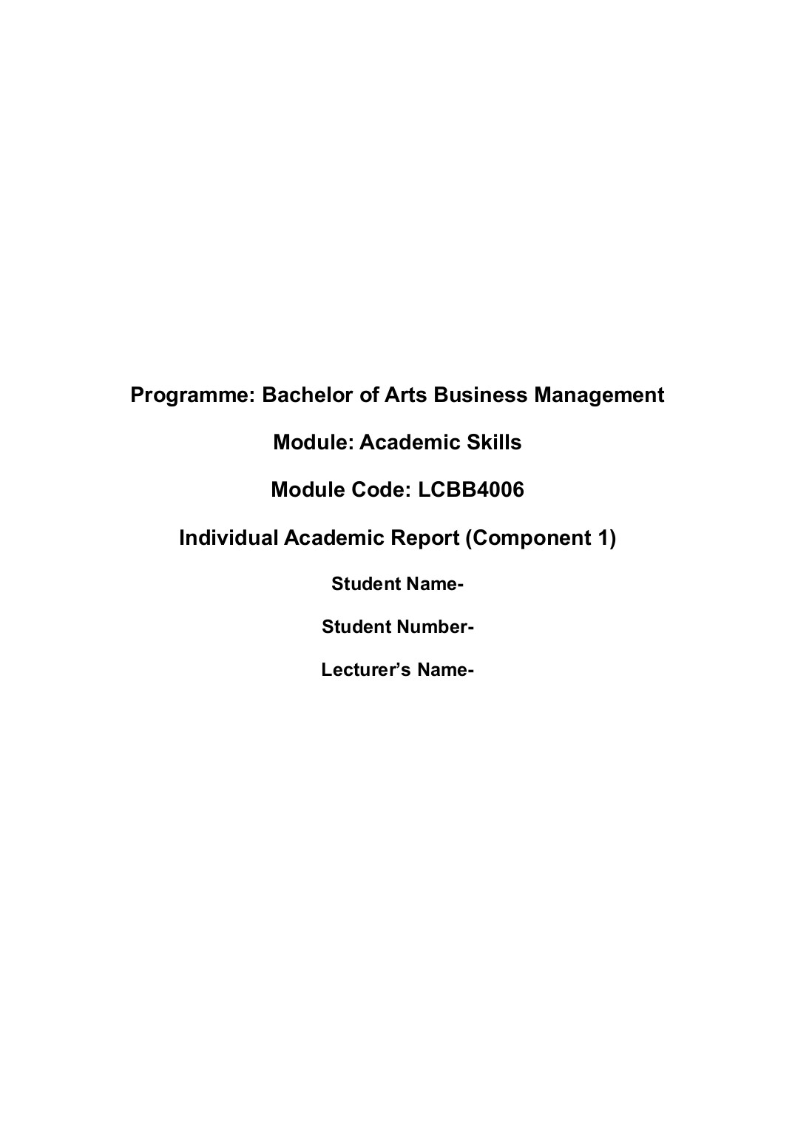
3
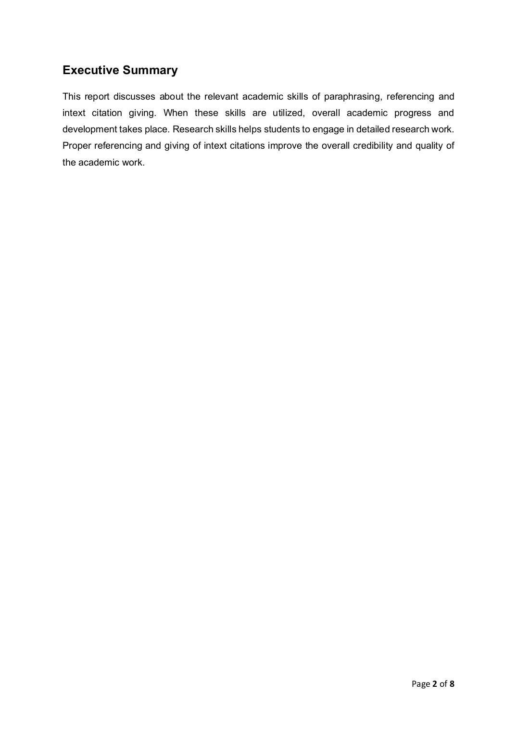
1

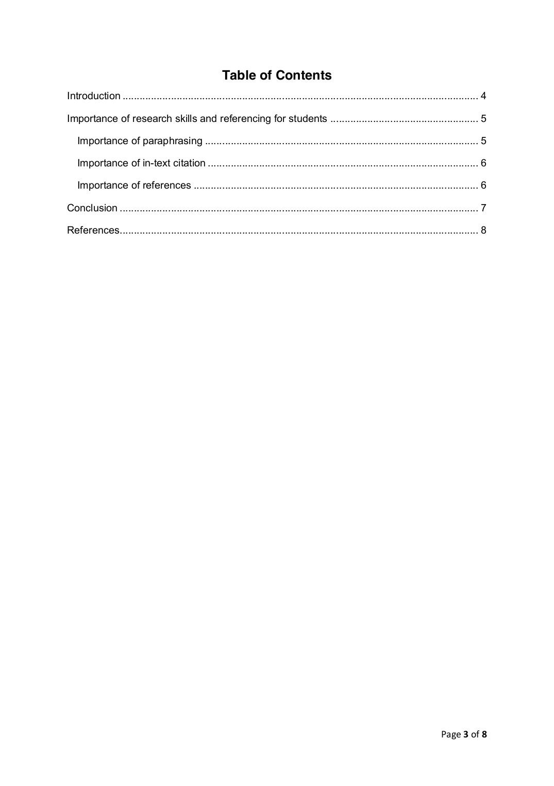
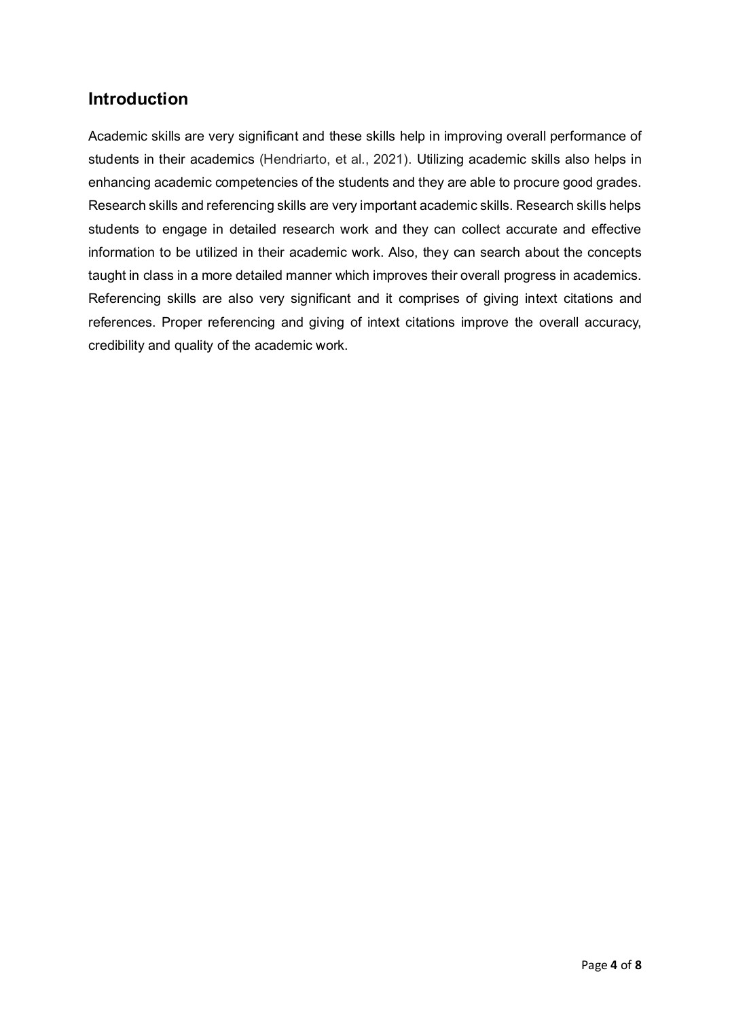
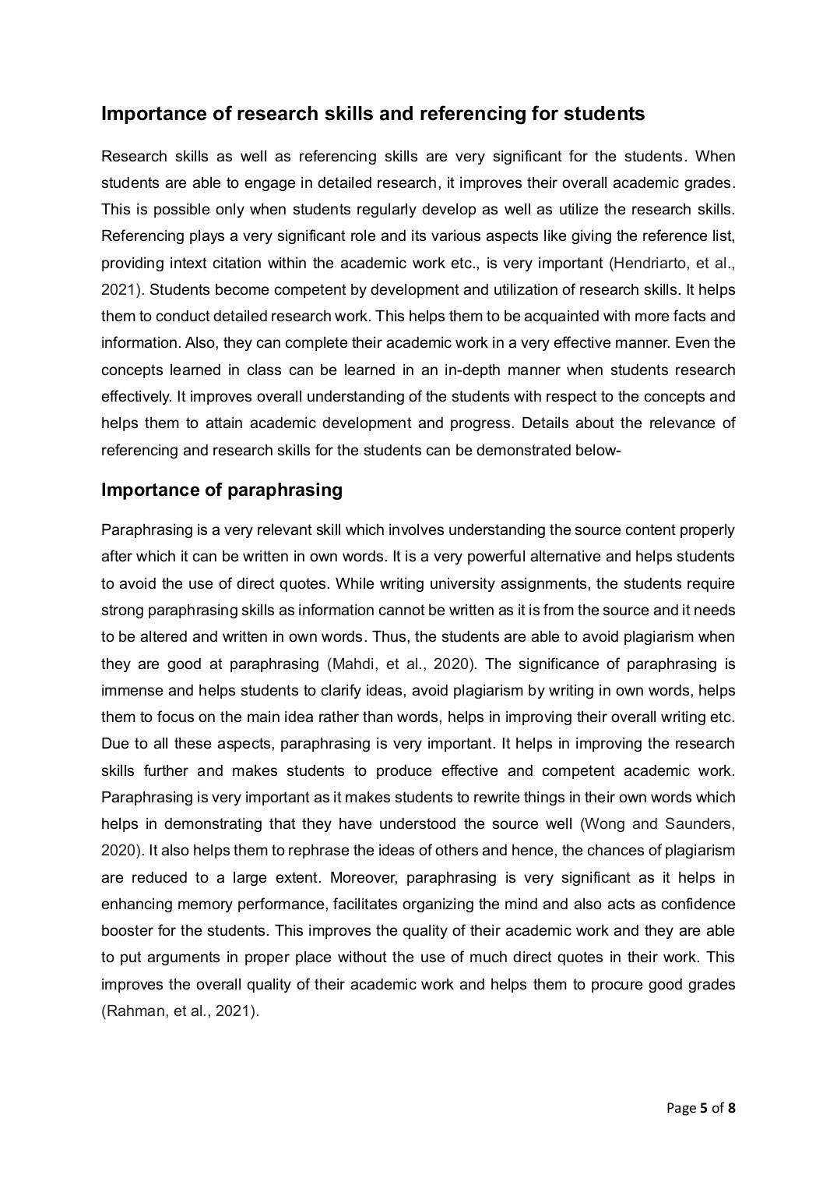

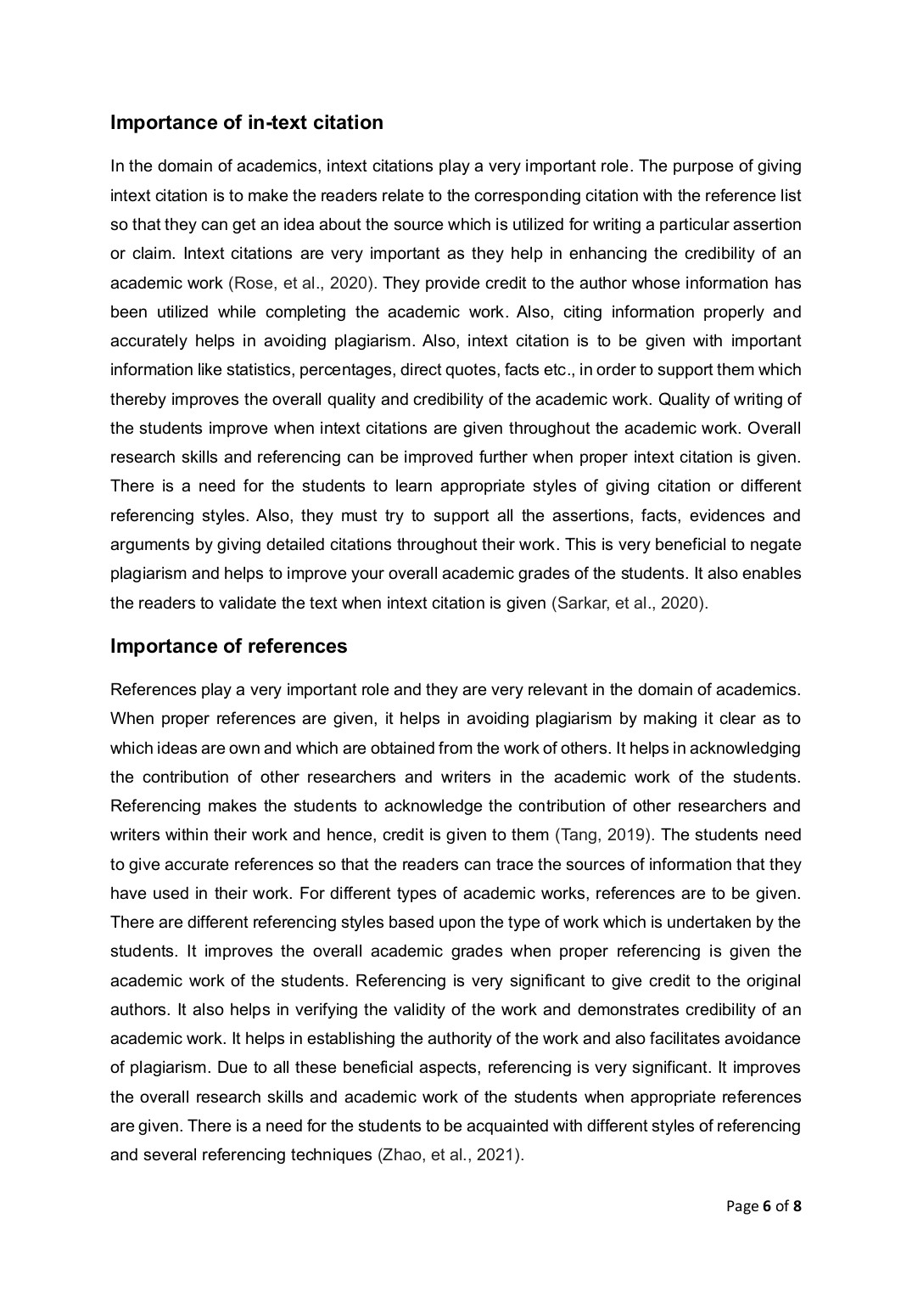
2

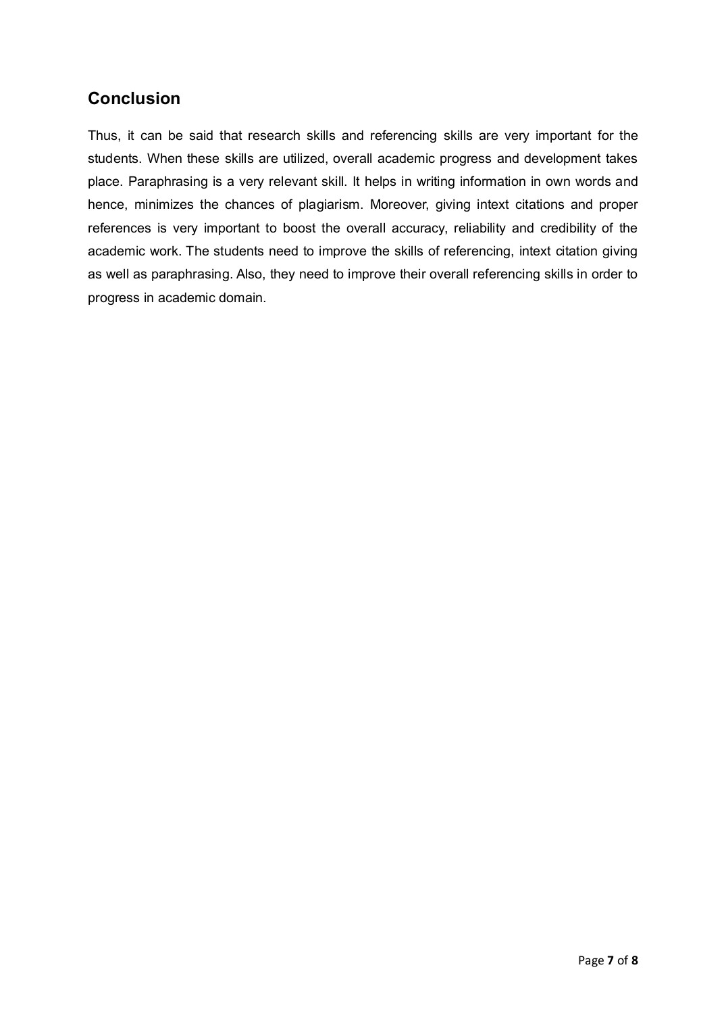
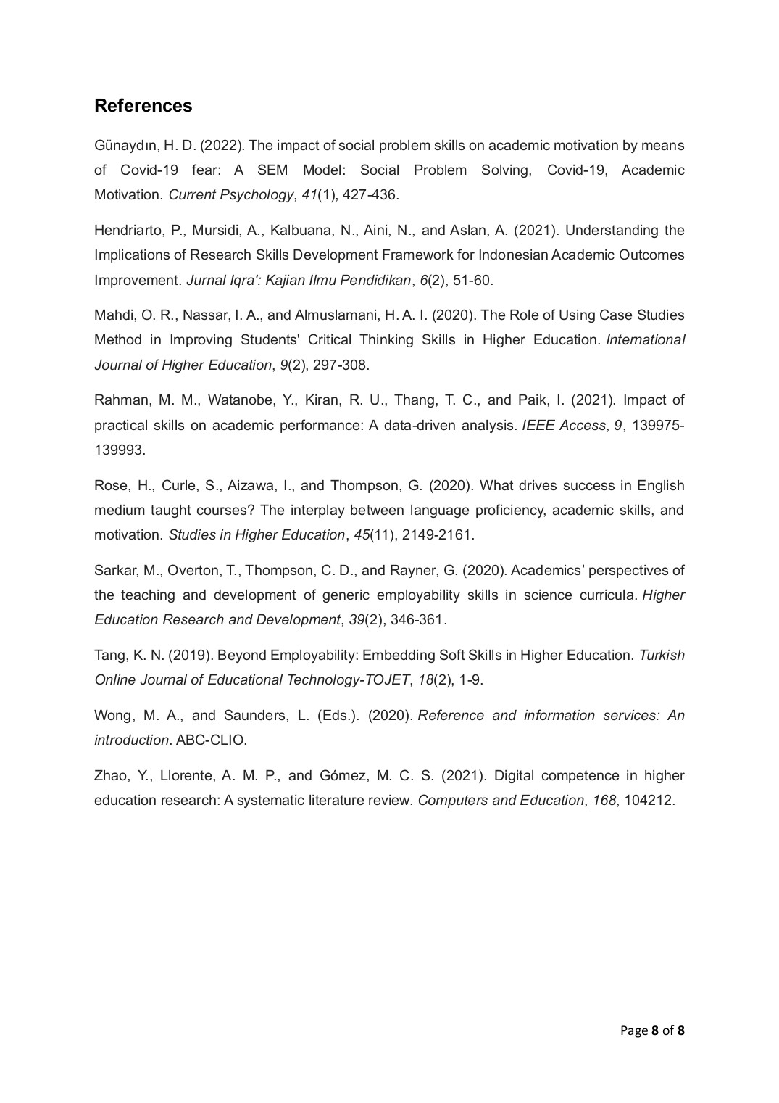

task
ORIGINALITY REPORT
3%  SIMILARITY INDEX | 2% 0%  INTERNET SOURCES PUBLICATIONS | 3%  STUDENT PAPERS
PRIMARY SOURCES
global.oup.com  1 Internet Source |  | 2%
Submitted to Eiffel Corporation  2 Student Paper |  | 1%
www.coursehero.com  3 Internet Source |  | 1%

Exclude quotes Off Exclude matches Off
Exclude bibliography On

task
GRADEMARK REPORT
FINAL GRADE /0 | GENERAL COMMENTS  Instructor
PAGE 1
PAGE 2
PAGE 3
PAGE 4
PAGE 5
PAGE 6
PAGE 7
PAGE 8

