BMHP5014

Changemakers: Creativity and Value Creation

Component 2: Written Assignment (Report)

Care Link Connect: A Digital Integrated Support Hub for Unpaid Carers and Vulnerable Adults in the UK

Student Name:HAJAR ORRITI
ID: 2328101
Lecturer: Precious Igbinigie

Poster

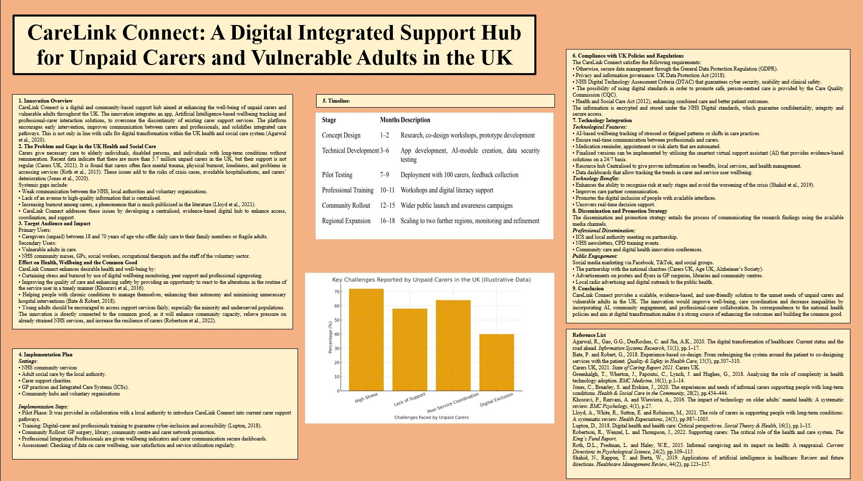

Pitch

1. Introduction
It is an expansion of the key arguments covered in the CareLink Connect poster, and it is a persuasive and comprehensive explanation of how to implement and utilise the innovation to change the UK health and social care sector. The CareLink. Since they know the issues that have always encompassed the unpaid carers, CareLink Connect has been developed as a response to the fact that they are always undermined in favour of the social care sustaining system. Unpaid carers have been shown to have to endure mental and physical stress, lack of resources, and decentralised resources problems (Roth, Fredman & Haley, 2015). Since the health and social care system is becoming overloaded, it is immediately necessary to introduce innovations that may lead to community capacity and care coordination (Robertson, Wenzel & Thompson, 2022).
CareLink Connect will bridge these gaps by serving as a more integrated digital approach to care, through the aid of community and early intervention, and simplified communication between the carers and the professionals. The innovation helps to implement the key goals of integrated care systems (ICSs) in England and aligns with the overarching processes of digitising health and social care (Agarwal et al., 2020).
2. The Problem:
This has been occasioned by the growing need for long-term care, the restriction of statutory health and social care services, which has led to an increase in dependency on unpaid carers. Carers UK (2021) estimated that there are 5.7 million people who give unpaid care in the UK, and this costs the state billions of pounds. Regardless of this contribution, the research is continuously informing that carers are likely to experience much stress, emotional burden, and physical fatigue (Lloyd et al., 2021). Several carers have complained that they find it hard to get help and education, and also to communicate with the professionals and are not respected in their work.
Discontinuous information-sharing and inadequate flow of care are often the results of discontinuous service structures and lead to avoidable crises and emergency interventions (Jones, Brearley & Erskine, 2020). Such gaps can be addressed by filling them with digital health technologies that can improve the communication process, detect the need early, and offer accessible support tools (Greenhalgh et al., 2018).
The CareLink Connect is a short-term solution to these issues within the system since it can offer a one-stop centre of digital solutions, AI-based monitoring, and expert support to improve the health of carers and strengthen the care pathways.
3. The Innovation:
CareLink Connect is an online web and mobile application that will enable unpaid carers with regard to communication, service access and monitoring of their wellbeing. The innovation has four fundamental capabilities:
a) Wellbeing Informatics
The app detects patterns, which may be indicative of stress, fatigue, and risk factors, using safe and non-intrusive data analysis (Shahid, Rappon and Berta, 2019).
b) Communication Tools
Secure messaging helps the carers to liaise with health and social care professionals in a way that enhances quicker response and lessens the management of care that is disjointed.
c) Availability of Support and Verified Resources
A centralised library will give advice to the carers on benefits, self-care, management of the condition, and local services. It has been evidenced that greater access to proper health information enhances decision-making and minimises uncertainty in carers (Khosravi, Rezvani and Wiewiora, 2016).
d) Community Support Networks
Peer support helps decrease social isolation and enhance well-being, which is why it is an essential part of the platform (Bate and Robert, 2018).
Through the combination of these features, CareLink Connect will increase the ability of carers to deliver effective, safe, and sustainable care.
4. Influences on the Target Population
The innovation has a direct benefit to unpaid carers, one of the most vulnerable and unnoticed groups in the UK health and social care system. Studies indicate that mental health challenges, chronic stress, and decreased quality of life are closely associated with the extended and unsupported caring responsibilities (Roth et al., 2015). The application of digital tools that facilitate self-management and emotional well-being has become more accepted as one of the effective strategies to enhance better outcomes (Lupton, 2018).
CareLink Connect is beneficial to vulnerable adults, enabling them to have a better continuity of care, faster intervention, and more effective connectivity between services. The innovation will facilitate the resilience of communities and the decrease of any unnecessary burden on NHS emergency and acute services in the context of the common good, resulting in a more sustainable national care system (Robertson et al., 2022).
5. Policy, Legislation, and Professional Alignment
CareLink Connect is consistent with a variety of national policies and professional frameworks:
- Health and Social Care Act 2012- stresses that there must be integrated care and patient-centred service delivery.
- NHS Long Term Plan - puts digital change and community-led care at the top of its list.
- Care Act 2014 - imposes an obligation on local authorities to satisfy the well-being of carers.
- Data Protection Act 2018 / GDPR - provides the legal, safe process of handling user data.
The innovation complies with the NHS Digital Technology Assessment Criteria (DTAC) as well, meaning it follows the standards of cybersecurity, usability, and clinical safety.
The professional engagement of community nurses, social workers, GPs, occupational therapists, and voluntary organisations will positively facilitate the capacity of CareLink Connect to promote the multi-disciplinary working approach, which has been extensively proven to enhance health outcomes (Greenhalgh et al., 2018).

6. Community Involvement and Public Engagement
One of the main aspects of this pitch is showing how the population and local communities will be made to participate in the initiative. CareLink Connect is inclusive of:
- Digital literacy free community training.
- The strategy should include collaboration with such charities as Age UK and Carers UK.
- Advertisement via local GP practices, libraries and social media.
Involvement of the community also enhances adoption, as carers feel acknowledged, supported and valued in society.
7. The rationale behind the adoption of CareLink Connect
CareLink Connect is not just a digital tool; it is an all-inclusive system of support integrating carers, professionals, and communities. Its strengths include:
- Fills a national gap in carer support.
- Lessens the carer burnout and wellbeing.
- Enhances communications within disintegrated services.
- Enables the agenda of the government on digital health transformation.
- Conformity with integrated care system goals.
CareLink Connect is a timely, scalable and cost-effective solution to the pressure that the NHS and the social care systems are facing.
Conclusion
This pitch has demonstrated that CareLink Connect is a game-changer, an evidence-based and ethical answer to the issue of unpaid carers and vulnerable adults in the UK. The initiative with solid academic underpinning, policy congruence and quantifiable social effectiveness steps is a monumental stride to a growingly unified, caring and sustainable health and social care framework. ￼

Reference
- Agarwal, R., Gao, G.G., DesRoches, C. and Jha, A.K., 2020. The digital transformation of healthcare: Current status and the road ahead. Information Systems Research, 31(1), pp.1–17.
- Bate, P. and Robert, G., 2018. Experience-based co-design: From redesigning the system around the patient to co-designing services with the patient. Quality & Safety in Health Care, 15(5), pp.307–310.
- Carers UK, 2021. State of Caring Report 2021. Carers UK.
- Greenhalgh, T., Wherton, J., Papoutsi, C., Lynch, J. and Hughes, G., 2018. Analysing the role of complexity in health technology adoption. BMC Medicine, 16(1), p.1–14.
- Jones, C., Brearley, S. and Erskine, J., 2020. The experiences and needs of informal carers supporting people with long-term conditions. Health & Social Care in the Community, 28(2), pp.434–444.
- Khosravi, P., Rezvani, A. and Wiewiora, A., 2016. The impact of technology on older adults’ mental health: A systematic review. BMC Psychology, 4(1), p.27.
- Lloyd, A., White, R., Sutton, E. and Robinson, M., 2021. The role of carers in supporting people with long-term conditions: A systematic review. Health Expectations, 24(3), pp.987–1005.
- Lupton, D., 2018. Digital health and health care: Critical perspectives. Social Theory & Health, 16(1), pp.1–15.
- Robertson, R., Wenzel, L. and Thompson, J., 2022. Supporting carers: The critical role of the health and care system. The King’s Fund Report.
- Roth, D.L., Fredman, L. and Haley, W.E., 2015. Informal caregiving and its impact on health: A reappraisal. Current Directions in Psychological Science, 24(2), pp.109–113.
- Shahid, N., Rappon, T. and Berta, W., 2019. Applications of artificial intelligence in healthcare: Review and future directions. Healthcare Management Review, 44(2), pp.123–137

