Is the Biological Spiritual? : A Scientific Approach to Daoism & Interconnectivity

Kane Alexander

1808611

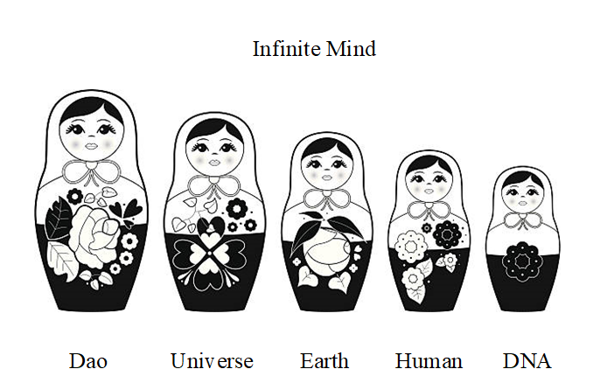

Philosophy Dissertation (HPPH6025)

(Word Count-10,942)

Is the Biological Spiritual? A Scientific Approach to Daoism and Interconnectivity
Introduction
Whilst Daoism is a philosophy, that is often practiced as a religion (Ball, 2004, p. 38). Its ancient roots may make it appear, at face value, less relevant to a modern living. However, the great Dao is considered a principle of life and unchanging source of all things (Ball, 2004, p. 12-17). I argue that Daoism is still important from a modern-day perspective, so to be able to incorporate modern knowledge into the broader ancient holistic framework. Within this essay I will describe my thesis outlining the multiple layers of existence, of which the Dao express itself upon, being DNA, the mind, the human body, the planet itself and the cosmos. Additionally, due to the nature of the tai ji (yin yang), we also find the Dao expressed at a level of the home, society and our personal and global interactions of historical, present day, and future relevance. I will discuss these characteristics of existence, as well as the importance of acknowledging the wholistic eastern perspectives within the current western paradigms, in terms of medicine and environmental concerns.
According to the Dao, the universe is a continuum, dualistic in nature with all in existence being a manifestation, via the virtue of yin and yang (Lynn, 1994, p. 9). Daoist’s claim that there is a great ultimate source which cannot be named (Lynn, 1994, p.65), which generates the two modes of duality (Ball, 2004, p.18). Yin and yang are the polarity or balance between all things, both living and non-living and their cause (Ball, 2004, p.18), due to an interconnection and dependency and paradoxically, that all duality exists in unity (Ball, 2004, p. 18). Everything has in it either yin or yang characteristics and exhibits, or more precisely should exhibit either yin or yang behavior (Lynn, 1994, p.9). Superiors are yang, subordinates are yin; yang is male, yin is female (Lynn, 1994, p. 9). The yin and yang are also classified as negative and positive (Lynn, 1994, p.9). The Dao see all physical, psychological and sociological occurrences as operating in conjunction with natural cycles and continuous patterns (Kohn, 2009, p.71) and see all the plants, animals and humans as the creation of not only earth, but also heaven (Tian) (Kohn, 2009, p.70).
The origins of the concept of yin yang are difficult to trace, with some placing its first appearance within the scriptures of Lao Zi’s; Dao De Jing, (Classics of path and virtue), (Liu and Hua, 1999, p. 38) and others dating it further back, through the I Ching (Ball, 2004, p. 111), of which the most ancient accounts were given carved into bone, metal, shell and stone by an unknown authorship (Lynn, 1994, p. 4). The yin yang symbol, often called the Tai ji tu is often attributed to the hand of Chen Tuan, during the song dynasty and used to represent the uttermost polarity of the cosmos which divides into two sides (Liu and Hua, 1999, p. 47). The names themselves are taken from the sunny and shady side of a mountain, due to the yin yang also representing hot and cold (Ames et al., 2018).
We find duality nearly everywhere: north and south poles; the left and right side of the human body; day and night. We even think dualistically and the language we use reflects our dualistic thinking. There are almost no third concepts, only intermediaries between extremes. The human being is and only is a manifestation of the universal energy that exists, such as masculinity and femininity. There can be no third gender, only a combination of the two, in various proportions or the absence of either. Just as in the way in which afternoon is not a third concept, only an intermediary between day and night. East and west only serves to constitute a second duality between north and south. Even water cannot objectively constitute a third concept, as is only an intermediary point within a continuum between to ice and steam (soft and hard, yin and yang). Steam, water and ice are objectively the same molecule and their solidity we perceive, is only a relative comparison to other masses, which changes due to frequency of vibration. Yet within any form, water is a polar molecule containing bonds between positive and negative ions, of equal and opposite charge (Redmond, 2008). This is the way the physical world exists, due to the tai ji.
Dao and DNA
With all being a manifestation of the Dao, this therefore includes all biological matter on the planet and its DNA. As Lao Zi’s scriptures were written millennia BC, modern science is often viewed as a separate phenomenon to Daoism, yet this cannot be so. It was originally forbidden to look inside the human body as considered sacred. Thus, Daoist practitioners used different techniques to view the inside of the human, including the internal organs and developed traditional Chinese methods of medicine, e.g. acupuncture (Liu and Hua, 1999, p. 11). However, now such biological discoveries have been made, the human body; full of automatic mechanisms and unseen forces, should still operate under the rules of Daoism. Whilst the Dao view the human as a miniature version of the universe, “humans tiny tai ji exists within the boundless great tai ji” (Liu and Hua, 1999, p. 48), biology explains DNA as a miniature version of the human (Redmond, 2008). Therefore, I assert that DNA is a miniature version of the universe regarding interconnectivity.
Each human cell contains the genetic information (DNA) for the whole human body, known as a genome (Redmond, 2008). The DNA is stored within the nucleus classified as the information center of the being (Redmond, 2008). This DNA consists of two strands having a dualistic nature; the double helix (Sinden, 1994, pp. 1-22)(See fig 4). These two strands are named the coding strand and template strand, based on their roles in transcription and translation the copying of genetic information for creating proteins, though perform multiple other duties (Redmond, 2008). We see both strands are equal and opposites, due to the ionic bond formations between individual nucleotides (Sinden, 1994, pp. 1-22). This is described by scientists as complimentary pairing in terms of the roles they play within formations and interactions (Redmond, 2008). These strands consist of four nucleotides: adenine, guanine, cytosine and thymine (Sinden, 1994, pp. 1-22). Cytosine always forms hydrogen bonds with guanine, whilst adenine always forms hydrogen bonds with thymine; due to the structure of the amino acids (Sinden, 1994, pp.1-22). These form the rungs of the ladder of the double helix, which are described as anti-parallel (Redmond, 2008.) Within a hydrogen bond, a positive hydrogen atom is attracted to an atom with an electro negative charge, in this case a nitrogen or an oxygen atom (Redmond, 2008). Thus, DNA exists in a dualistic pairing of equal and opposites; positive and negative, just as the tai ji. As is the chemical nature of the universe.
Anthropologists Jeremy Narby (1999), draws upon the connections between the Caduceus (See Fig 1) and DNA (See fig 4). The caduceus features two snakes wrapped around each other, in a similar fashion to what the two strands of DNA are woven around each other (Narby, 1999). This symbol has been used throughout numerous cultures for natural and modern forms of healing. He then moves to assert that the Caduceus, displaying two snakes coiled together, to form a single androgynous vital principle, is often synonymous with the yin-yang (tai ji) in character (see fig 2) (Narby, 1999). Thus, the two strands of DNA can be viewed as the mythical snakes, dragons and serpents involved in all creation stories, viewing one strand of DNA as the male black anaconda which as the and the other strand as the female rainbow-colored boa constrictor (See fig 5)(Narby, 1999); still synonymous with yin and yang.
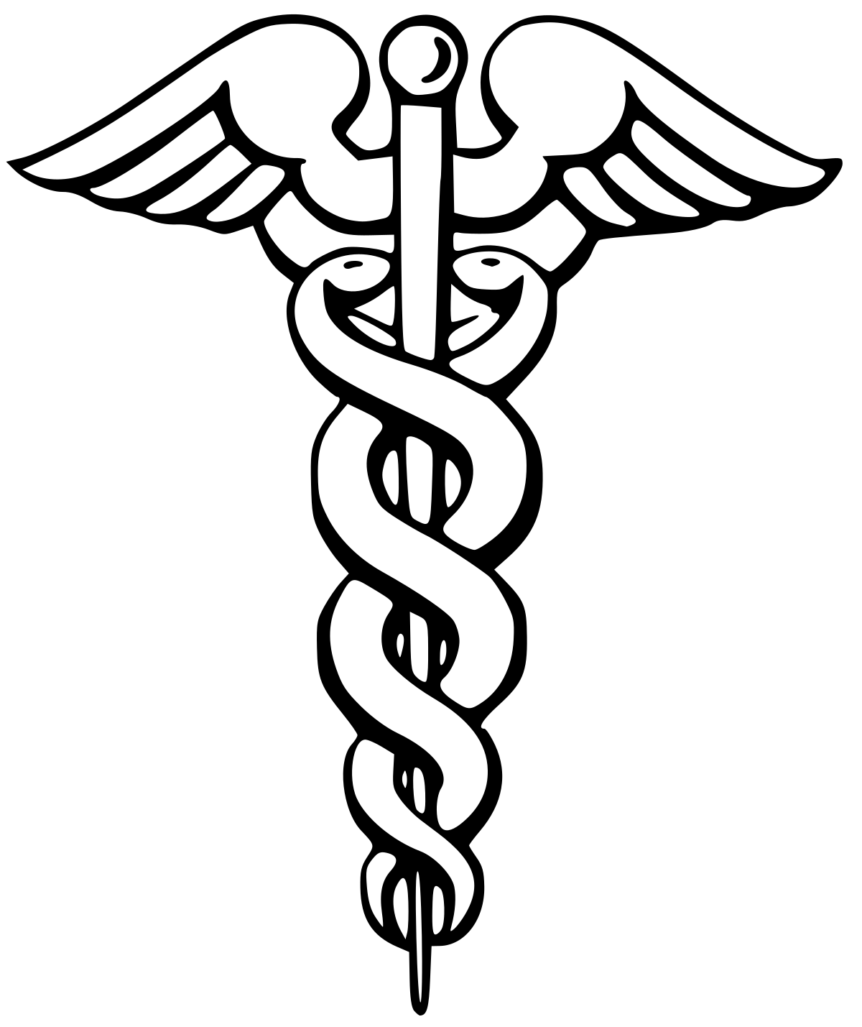 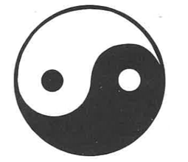 (Figure 1, Caduceus) (Figure 2, Yin-Yang Pictogram)
From an eastern perspective, in terms of Yi duo bu fen (translating to “the indivisible one and many”), there is no heaven divisible from earth and no god other than self (Ames et al., 2018). Therefore, there can be no spirituality separate from the biological self and mind. Narby (1999) believes ancients such as Lao Zi (Chang Tzu), as the founder of Daoism (Taoism) must have had knowledge of DNA as too did various other races, pre-science, through omniscient methods. Whilst I consider this possible, it is likely their comprehension would have not been alike todays comprehension, though of equal sophistication, in term of micro tai ji, a miniature universe within.
The Dragons/serpent as an icon, is revered in China and is dated to approximately 5,000 BC; It was claimed that the Chinese were descended from it (mythologically) and was symbolically revered as a giver of life (Gardener, 2005, p. 141). Within the Dao creation story, the Dao rested in deep chaos, next it evolved into the great ultimate of cosmic unity, becoming the energies of yin and yang from which, all creation came fourth (Kohn, 2009, p.25). The early Daoist scriptures describe this original state of the Dao, as a shapeless sac of cosmic chaos (Hundun), giving rise to all the creatures including humans which populate the earth (Kohn, 2009, pp.116-117). The way runs through and connects everything, in this sense we are all one (Cooper, 2012, p. 47). This creation story refers not only to eons ago when the world came into being, but also the process by which all things come into being in each moment they manifest, from the Dao into reality, as the Dao is always at work. Whilst we only see the physical means in which things are produced, there is also the energy at an unseen level, of the yin and yang interactions, which cause each creation, existing on a higher and more subtle level of frequency; which causes the weather patterns, growth of plants and even the formation of empires.
When we look at the DNA molecule, we find similar behavior to hundun. The formation of DNA alluded to thus far; the double helix structure of chromosomes, only occurs during protein synthesis (transcription and translation) and cell division (mitosis and meiosis)(Redmond, 2008). Whilst DNA, is not undergoing DNA replication during cell division, it exists in the form of chromatin (see fig 3): an unordered, muddled, seemingly random state, its original or resting state, within a round black cell organelle called a nucleus (Redmond, 2008). This is reminiscent of Hundun: unordered chaos, muddled, random, unintelligible mess; a nebulous state: cloudy or ill-defined within a large black egg (Ames et al., 2018). However, when DNA undergoes DNA replication (during the creation of a new cell) (mitosis) it lines up into the double helix formation(yin and yang) (Redmond, 2008). Like when the universe was created, from the primordial chaos of Hundun, it split and divided into the element’s yin and yang. This is reflective of how chaos becomes order, as the function of higher causation, within both a cellular and cosmic sense.
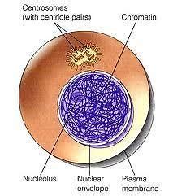
(Figure 3, DNA as Chromatin; pre formation- Comparable to Hundun)

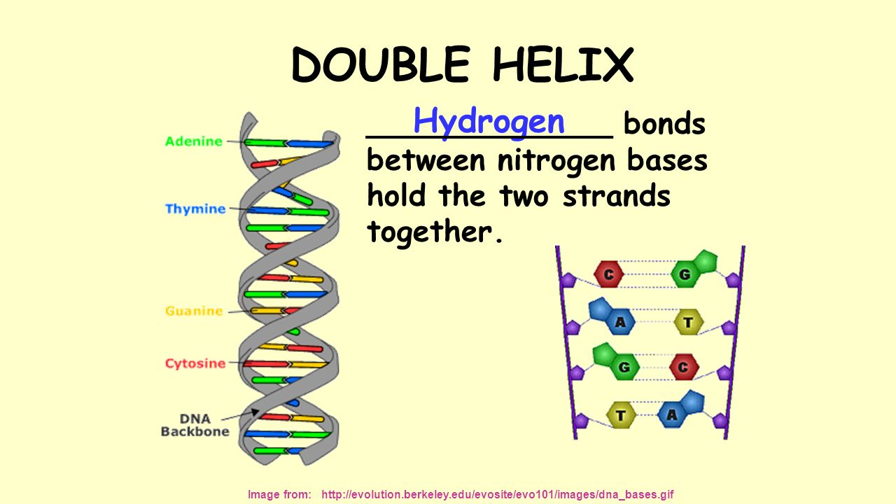
(Figure 4, DNA in Double Helix; post formation-Comparable to YinYang)
The yin yang symbol (tai ji tu) does not exist in real life or nature, only the principle which it represents. DNA does; and we have reasoned the dividing of a muddled nebulous state into a dualistic form of positive and negative pairing, applies to both the tai ji and DNA. An image of the DNA as the Dao and yin yang has begun to emerge. Though before we can further explore the implications of DNA and Dao, we must first comprehend the Dao significance to the human brain, body and the planet.
The Human Brain
As we see the yin yang symbol expressed within the genome, fittingly we also find the duality of yin and yang within the human body and brain, to which we then find the same duality existing within the mind. The Brain is split into two hemispheres, divided by the interhemispheric fissure (Barthelemy, 2019). The left (dominant) hemisphere is often termed the male brain, having the qualities of mathematics, science and logic etc.; with the right (submissive) hemisphere claimed to contain the qualities of art and creativity (Barthelemy, 2019). Art itself may be a result of suppression and pressure (Ranking, 2005); same as many spiritual activities as is generally considered a release of tension, caused by the dominance, allowing the individual to express itself in ways otherwise prevented by marginalization.

For most people the right brain is dominant, however, this is not a clear-cut division, and can be reversed for some people. The last decade has seen dozens of contradictory scientific claims regarding the hemisphere’s qualities and capabilities. However, this is not problematic to my theory, as; yin contains the seed of yang and likewise yang contains the seed of yin, symbolized by the black dot within the white part and the white dot within the black part (Liu and Hua, 1999, p. 47-50). Yin and yang are only relative and only often found out of proportion, they constantly shift balance, whilst remaining the same essence (Liu and Hua, 1999, p. 47-50). An absolutist scientific approach will not yield results, thus rules established for the balance between hemispheres, will be contradicted due to change and flux. However, what is clear and undeniable are the trends of duality and the dominance found within the brain, suggesting the essences of the yin and yang are responsible for the brain’s qualities and structure; with the only fixed rule being the Dao itself, which paradoxically remains in constant change.
Jeremy Narby (1999) forms the same connections between DNA and mythical snakes (cosmic serpents), as between the mythical snakes and the brain; the male and female energy of binary opposition is depicted as two snake occupying either hemisphere of the brain; an image resembling the yin yang symbol, on the brain.
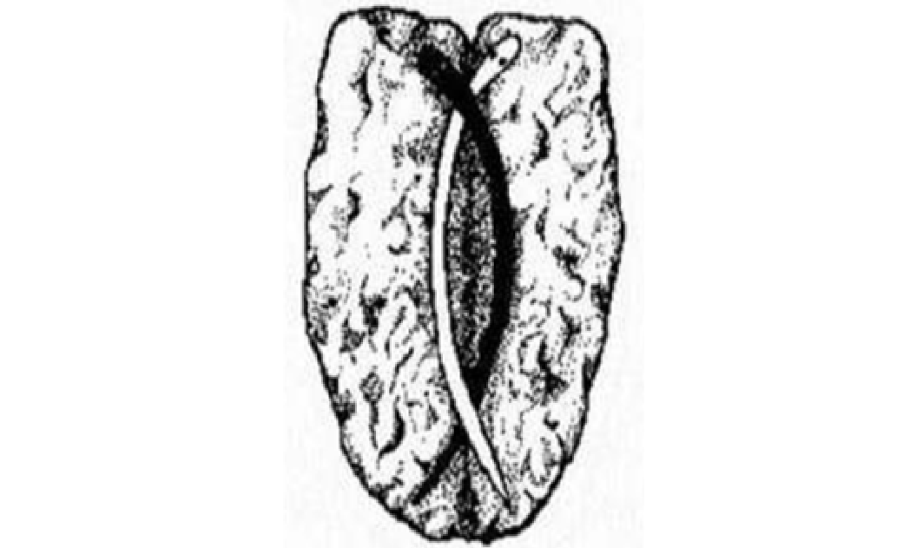
(Figure 5, The Left and Right Hemisphere of the Brain;
with Snakes Representing the Male and Female Qualities of Nature)
The human brain is manifestation of the Dao, evidenced through its duality. Whilst the external world is manifestation of the mind. So, if we check we expect to find further correspondence. How is this relevant to humanity and society? From a psychological perspective on social interaction, we repeatedly encounter the issue of dominance and control. This hemispheric dominance is stereotypical of human social structure. It is no coincidence we find the same occurring in the world and is reflective of our core nature, reminiscent of the dominance and subordination of the yin and yang principle.
Suppression of the Feminine within the Body, Mind and Society
Whilst multiple theories upon the correspondence between the external and internal often exist in abstraction. I will elucidate upon specifics which point to this principle, focusing on three areas being the language dominance of the male brain (internally); dominance (oppression) of a male society in terms of education (externally); and left-handedness, which heralds correspondence to activity within the right hemisphere of the brain. Whilst it has long been believed that the right hemisphere of the brain has minimal to no language capabilities (for both left and right-handed individuals), this is not fact. Whilst all language is contained within the Wernicke’s and Broca’s area of the brain both situated within the left hemisphere, it has now been revealed through case studies that the submissive right hemisphere can acquire language in the absence of the dominating left hemisphere (Danelli et al., 2013). Case study reveals a young boy had his left hemisphere removed at age 2.5; when such an operation has been conducted for adults there have been drastic effects with all language capabilities lost permanently (Danelli et al., 2013). However, this young individual was able to learn and develop language abilities to a normal standard, showing the submissive right hemisphere is perfectly capable of acquiring language (Danelli et al., 2013).
The male of the species throughout prior centuries prevented, suppressed and forbidden formal education for women within their own families and communities all over the globe (Agrawal and Aggarwal, 1992) (Shaw, 1995). Resultantly, it was believed women lacked intelligence which men had; however, it is now considered that women’s situations were the result of their oppression from dominating males (Agrawal and Aggarwal, 1992) (Shaw, 1995). Just as we have found the suppressed hemisphere can acquire language, women can become intellectuals, if allowed to. I use this comparison not as a metaphor, but to show how the external is a mirror of the internal in terms of male dominance and the acquisition of knowledge, as is found within both the brain and society.
Additionally, whilst women have been persecuted by the male, to the degree of even being burnt and accused of witchcraft (Levack, 2013, pp. 1 & 146-156). The left-hand has been stigmatized in western Europe as evil and satanic (Coren, 1993), cack (excrement) handed, clumsy, sinister, impolite, criminal and cursed, however, was not under the same discrimination in China (Coren, 2014, p.75 &. 201). The use of the left hand was forbidden within westernized education systems (Pletsch, 2006), whilst many individuals within the nineteenth and twentieth centuries day have labelled left-handedness pathological (Coren, 2014)(Pletsch, 2006), as too characteristics of the female’s mentality (Shaw, 1995)(Agrawal and Aggarwal, 1992). However, we find emotional troubles and stuttering, occurs due left-handers being forced to use the right-hand (Pletsch, 2006). Same as the imbalanced societal conditions, creating a female’s disadvantaged position, due to discrimination and an imbalanced valuing of qualities (Agrawal and Aggarwal, 1992) (Shaw, 1995).
This is relevant as the human being is cross wired, with the left hand corresponding to activity in the right hemisphere of the brain (yin) and the activity of the left hemisphere of the brain (yang) corresponding with activity of the right hand (Barthelemy, 2019). Therefore, we find suppression of the feminine within society (women) as well as within the human body (left hand), and the female brain (right hemisphere), as all interconnected through interactions of dominance and submission, yin and yang. Even if we blame the dormancy of the right hemisphere on the persecution of left handers, this does not refute the correlation, only alleges a causation, yet Dao consider all causation cosmic, through interconnectivity.
The East and West Ideologically
As the Dao shapes the body and brain internally, we find the same existing externally; socially, historically and culturally. Here I present the east and west as two side of the yin yang duality. We can comprehend the western world as yang, in terms of actions, beliefs, mentalities and systems; and the eastern as yin, in terms of the same criteria (Gardener, 2005, p.23). The concept of duality of the brain is found throughout many ancient cultures, before the recent evidence of neuroscience granting comprehension of the two hemispheres of the brain. When African shamans deal with the male and female duality, they describe westerners; from left hemisphere dominant cultures, as people of the line and represent this by a 1, to indicate masculinity; and describe people from the east; right hemisphere dominated cultures, as people of the dot, represented by the binary symbol 0, denoting femininity (Gardiner, 2005, p. 23). As the right hemisphere is dormant whilst the left hemisphere is active, this aids in the comprehension of the male and female, not only as representing the left and right hemisphere, but also as functions of the conscious mind and the subconscious (unconscious) mind (Gardener, 2005, p. 48).
The Sun is considered masculine, whilst the moon is considered feminine (Gardener, 2005, p. 22). This makes it clear in terms of east and west why the sun forms the basis for the Gregorian calendar in western countries such as the UK and the moon forms the basis for the calendar of China: the Chinese Zodiac, known as Sheng Xiao. Thus, we find the eastern and western mentalities are not only intrinsic to human nature, but also intertwined with the greater cosmos. The east and the west duality are both part of the great Dao. Where dualism exists from a western perspective, from an eastern perspective is all one. Humanities mentality exists, as two different perspectives, which when combined create the whole. Both are expression of the yin-yang.
Whilst previous studies have attempted to use to science to prove religion, this theory differs with the claim that the holistic theory of the east is incomplete without incorporating the western ideals, thus merges science and spirituality. It is not only that I compare the right and left hemisphere to the east and west, but also allege that when a western individual uses science, he speaks of the world from a left brained perspective and when an eastern individual speaks of the Dao, they speak from a right brained perspective. As the mind creates the world, we only speak of our own minds experience, coupled with the paradox of the environment effecting the mind, shaping experience.
The east and the west often have contrasting views, in terms of their consensus systems. For example; whist UK deal with human rights, which are absolute and form the basis of regulations for the treatment of children by parents, as laws imposed for governance; China more so deal with duties, what one should do for one another, i.e. children’s duty to care for the parents (Ames et al., 2018). Both are moral standpoints to be comprehended by any philosophical individual. These viewpoints are reflective of individualistic verse communal societies. Whilst the west asks the question of “who am I”, China deals with the notion of self-cultivation, and does not consider the individual to exist separate from the family structure, nor society generally (Ames et al., 2018); whilst the family constitutes a miniature version of the nation.
Whilst the traditional eastern view is that the heart and mind are one entity (Xin), which function in unity in terms of moral guidance (Ames et al., 2018). The west not only claim the brain and heart as separate entities, but also divide the brain into the left and right hemispheres. The Dao deal with an intuitive form of knowing from within, which is yin. Whilst western science, which is currently the dominant paradigm, deal with an object knowing, externally; an absolute knowing, which is yang. Whilst these two types of knowing or belief of knowing are very different, both are expressions of the Dao. We must comprehend Dao as neither a philosophy or religion (yang), but as an energy source we must connect with and know intuitively (yin). The unconscious believing as opposed to the conscious comprehension.
Whilst many prior western physicians within biomedicine claimed and operated under the premise, that the body and mind are two separate entities. The traditional Chinese approach is that the body and mind are one. We can reason that neither can be correct. E.g., if the body and mind were not one entity, psychosomatic symptom with no biological cause would not occur, such as ulcers; nor would stress lead to disfunction of organs or tension in muscles etc. However, if the body and mind were not separate, when we experience casualty within a dream and suffer due to the mind, the body would also suffer. Conversely, we find these two opposing viewpoints are simultaneously correct. One from a dualistic left brained physical western perspective and the other from a holistic metaphysical eastern right brined perspective. Although the eastern and western perspectives contradict, I claim both are necessary, to achieve the true holistic perspective. It is only through the combination of both can the whole truth of self be found, and ontological questions answered.
Autistics have previously been described as having an extreme male brain, which I will compare to a western mentality. Despite certain savant’s extreme mathematical ability to count the number of trees growing in a patch of land e.g. 286, some of these individuals can never comprehend that this is in fact a forest or wood (Royston and Humphries, 2007). This is like the westerner’s perspective, highly intelligent, can identify all the separate parts of the world; down to the smallest cell in biology, atom in chemistry and electron or quark in physics. Yet are unable to view the heart, mind, internal, external, heaven and earth as one.
The symbol, yin-yang, represents the conflicting facets of humanity and the cosmos, the division and duality, whilst the merging of the two poles represents the interconnectedness, so to depict the ultimate unity of one and many (Ball, 2004, p. 124). Everything in the universe contains two aspects, a basic duality to make one whole, however, within each lies the seed of the opposite, and in due course, as the cycles of life progress, the polarities of one turn into the other (Ball, 2004, p. 124). This includes the east and the west as well as masculine and feminine. These poles will inevitably swap, this is inevitable, however this is a gradual subtle change. Although admittedly, any individual characteristic of either described dichotomously, as I have so done, is reductionist, with poles being multifaced and always within constant shift, thus the identified characteristics remain mere archetypes of behaviors and ideals, which can not be applied to individuals generally, with absolutist claims.
Balance
An eastern perspective considers balance necessary; the ancient Chinese believed that yin and yang must remain within equilibrium, thus practices such as Chi Gung (Qi gong) and mediation were designed to keep the universal aspects of yin and yang within the brain synchronized (Barthelemy, 2019). This carries increased health benefits, cognitive abilities, plus organization and decision-making skills, whilst granting a greater perspective, e.g. the ability to see the interconnectivity of all existence (Barthelemy, 2019). This principle is not exclusive to China or Daoism. All esoteric systems believe in the fusion of the male and female, (yin and yang) (anima or animus) to achieve an enlightened state of consciousness, thus aligning themselves with a higher power or source (Gardener, 2005, p.36).
Other techniques for greater harmonization of the yin yang balance include listening to or playing music, which is a quintessential characteristic of the right brain (Barthelemy, 2019). The drum beat of the African shamans is considered the coming together of the male and female forces (Gardener, 2005 p. 21). With music acting as a stimulus to balance the brain, to induce trance, to perform magic within rituals (Smart, 2014, p.545). It is also believed that mantra (chanting) and meditation can calm the left hemisphere, relieving this mind’s anxiety, freeing the mind from the dominating left hemisphere causing the body to swap over to a right hemispheric mode of activation (Meissner and Pirot, 1983). Kaons are a form of riddle within Buddhism which often create a paradox within the mind. This causes the brain to think in new ways to gain brief enlightened moments. Upon these principles, I suspect kaons, function to stimulate both hemispheres simultaneously, to create an awakening, as only through the unity of both perspectives can one achieve the correct or true perspective, superior to either perspective individually. Thus, we find many benefits of a balanced body, brain and mind.
Royston (Royston and Humphries, 2007) talks about the issues with right handers. Trauma experienced within childhood can accumulate within the right-hemisphere of an individual; causing anger within their unconscious and conscious mind (Royston and Humphries, 2007). They may be unable to alleviate this tension, due to the right-hemispheres dormancy, as they cannot activate certain gyrus to retrieve a memory and digest the anger, reflective of an imbalance (Royston and Humphries, 2007). However, modern theories propose that being ambidextrousness is of no advantage. Ambidextrousness has been placed alongside left-handedness, thus now stigmatized within biological-psychological academic circles under claims of harboring an association with cognitive deficits, neuropathology, schizophrenia, and developmental abnormalities (Vlachos et al., 2013). These claims are reflective of a bias consensus; an imbalanced western left brained mindset, attempting to remain the dominant ideology. It appears the derogatory claims about left handers of later centuries have returned with up to date empirical reproach, to replace the social and religious discrimination.
The problem with modern society is it has become imbalanced. The right hand without the left, resulting in reductionist scientific truths in isolation. Many spiritual individuals may be anti-science and vice versa, again these mind states are reflective of the yin yang nature of mankind collectively. However, each imbalanced perspective will balance out eventually, with mens oppression of women in society resulting in a cosmic backlash, leading to movements such as the suffragettes and modern-day feminism. Whilst previous periods were ruled by the feminine, others have been ruled by the masculine, as we move toward perfect balance through the progression of natural cycles.
Human, Earth & Cosmos
The Dao see human as the same nature as the earth, for this reason claims are made such as the earth having 365 days, whilst the human body has 365 qi(chi) points; the year having 12 months corresponding to the body’s 12 channels or meridians (jing luo); and the earth having four seasons, in connection to the human body’s four limbs. This extends to multiple complex relationships between the star constellations, the earth and the human. (Liu & Hua, 1999, pp. 40-41). Whilst seeing the body as a miniature copy of the universe (Kohn, 2009, pp.142-143). We can now investigate the human as a miniature version of the earth. Therefore, if we check we should expect to find the same things.
Within the human body we find the same duality of the male and female. This is perfectly evidenced through the energy meridians found within the Indian chakra system (Ozaniec, 1996). The channels of Ida and Pingala (named after rivers in India) exist in the dualistic form of the male and female, which the serpentine energy (kundalini) rises through during meditation (Ozaniec, 1996). This directly correspond in appearance to the male and female strands of DNA, when within the double helix formation. Yet also bear the same physical appearance of the male and female energy lines which flow through the earth (see fig 6 & 7).
(Figure 6, The Male and Female Energy Channels of Earth Chakras).
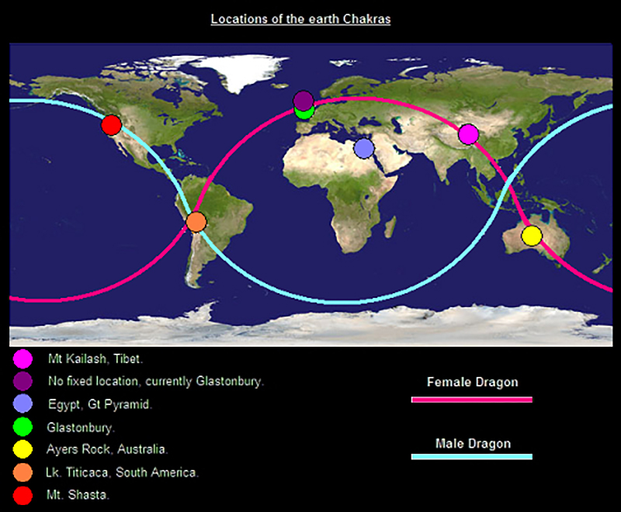
The earths meridians or channels are known within the western world as ley lines, whilst referred to in China as dragon lines (Olsen, 2008, p.13), represented pictorially within Tibetan mythology as a double serpent coiled round the earth, as the female dragon line runs directly through the Tibetan chakra (Olsen, 2008, p. 276). This energy is believed to be responsible for the presence of spiritual reverence with Tibet, as the energy of the earth manifests upon the surface through the thoughts, speech and actions of the people. These lines have been referred to by many names; including dream tracks or song lines by the Aboriginal people of Oceania (Olsen, 2008, p.13). Hence, we find the same male female duality within DNA, the physical body and the earth.
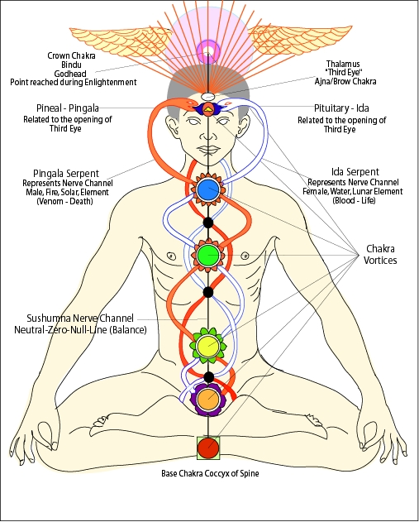
(The Human Body Chakras and Male & Female Energy Meridian) *Notice the Resemblance between DNA (Double helix), the Body Meridians, and Earths Meridians.
Daoist’s (see fig 8) follow a similar bio-spiritual system of astral energy centres and pathways, by which the male and female channels are instead named the governor (yang) and functional (yin) channels (Ball, 2004, p. 204) (Watkins, 2014). Also called the back (tu-mai) and front (jen-mai) channels and transport the same forces and energy. Though many practitioners of meditation do not care for the difference in vessel and focus purely on meditating. The Indian and Chinese schools only slightly differ on the location of the chakras; Indians generally believe the energy is located within the spine, whilst the Chinese generally identify the chi(qi) energy with the more-fleshy parts of the body e.g. the abdomen and loins (Watkins, 2014).
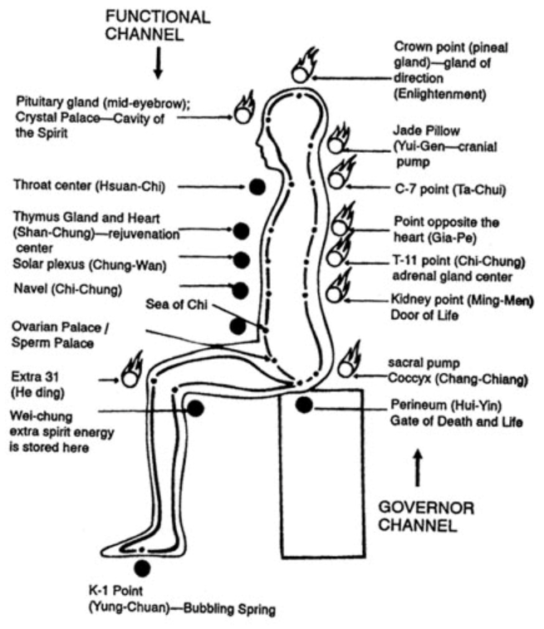
(Figure 8, Conceptual Relationships of the Indian Chakras within Chinese Daoism)
Additionally, each energy center directly corresponds with the biological organs and glands. The organ which the western medical system labels the pineal gland is the equivalent of the Daoist crown point (Watkins, 2014). Whilst the Daoist Shan Chung (rejuvenation center) corresponds the both the heart and the thymus gland (Watkins, 2014). In terms of interconnectivity these are the same, as is no separation. One focusses on the physical matter, whilst the other the finer forms of energy. These are not just two sociological perspectives; they represent truth on two separate levels of energy. An organ or gland cannot be comprehended in terms of either in isolation, thus remains a criticism of much western medicine techniques.
Here I would like to focus on the dual aspects of yin and yang within the planet. When the earth was created the duality of the north and south pole emerged, displaying duality through the magnetic polarity of positive and negative balance, of equal and opposites. Whilst the southern hemisphere experiences winter (yin) the northern hemisphere experiences summer (yang); and whilst the northern hemisphere experiences winter (yin) the southern hemisphere experiences summer (yang) (Ball, 2004, p.113). The Dao believe in cycles; the four seasons: spring, summer autumn and winter; these are interconnected with the four cardinal directions of the earth, east, south, west and north as well as the yin and yang (Ball, 2004, pp.124-125). We find the same universal forces at work within the human and the earth such as the magnetism and electricity. We are now aware that the human brain can detect magnetism, due to an internal compass, which links in with the magnetism of the north and south pole, whilst brain waves (electric frequencies) are detrimentally affected by unnatural magnetic frequencies (Kirschvink, Kobayashi-Kirschvink and Woodford, 1992). Granting scientific motivations to keep in tune with nature.
There is also the cycle of day and night. We must stay in tune with the earth in terms of the yin yang balance, alignment and cycles. The Dao cycles are interconnected with the human’s biological cycles as the human and earth are interconnected as one. This is simultaneously biological and spiritual. The human’s circadian clock (24 hour) is both endogenous (internal) and exogenous (external) and is controlled by what are called clock genes (Sack et al., 2007). Hence why we must align with the Dao by waking in the morning and sleeping at night. In accordance with the changes in light (external); correlating with our hormonal cycles (internal), i.e., melatonin release from the pineal gland (for healing during sleep), core body temperature cycles (which decrease at night), as part of the body’s natural biological rhythm; the sleep wake cycle (Sack et al., 2007). When we travel long distances by airplane, we experience biological and psychological disturbances, whilst our body resynchronizes within its new environments (Sack et al., 2007). Therefore, this biological sleep disorder (jetlag) is the same thing as being out of alignment with the Dao, in terms of body and planet as interconnected. With the cycle of the human and earth then linking in with the cycles of the cosmos (Liu & Hua, 1999, pp. 40-41).

Hierarchy of Interconnectivity
We can greater comprehend the idea of multiple layers of existence through Augustus de Morgan’s poem “the biological order of the flea” which describe the multi layered nature of the universe.
“Big fleas have little fleas,
Upon their backs to bite ‘em, and little fleas have lesser fleas,
And so, ad infinitum.”
And the great fleas, themselves, in turn have greater fleas to go on;
While these again have greater still, And greater still, and so on.” (de Morgan, 2008).
This refers to taxonomic rank and expresses the parasitic nature of existence here on earth. This deals with the conversion of energy from one form to another. This can also be used to refer to hierarchy. Ball (2004, p. 37) uses this poem in reference to the manifestations of the Dao energy within the universe here on earth. The term flea to indicate level of existence and expression of the Dao’s polarity from the micro level to the macro.
To review the levels: The lowest level is the Dao, which is the essence of all things, which divides into duality to bring about the structure of an atom (nano-tai ji), being yang and yin in terms of motion and stillness; and protons and electrons; in equal and opposite balance, granting the polarity of the structure, which contributes to the double helix. DNA: the essence of the human, is the next level up the chain. Which enters its polar formation. DNA is not the only essence of the human. There is also consciousness, which I have addressed in terms of the yin yang balance of the mind. The Human is the next level, in which we find the male and female body meridians, as a miniature version of the earth and meridians. Thus, we can reason, it is likely the earth is a miniature version of the cosmos, by the act this repeating pattern, besides the Daoist claim that the human is a miniature version of the universe.
Though de Morgan’s poem states “to infinitum”. This list contains only six levels. This is insufficient to constitute infinity. So where does this Daoist Russian doll set (see title page) which we are; have within us and are bound within; end. Perhaps external to the three-dimensional universe. Within eastern philosophy there is generally considered to be no beginning of the universe (Ames et al., 2018). If this notion is correct, it would suggest the fifth dimension holds the key to comprehending cosmogony, where there is no concept of time (beginning and end), as time itself, is considered the fourth dimension.
Whilst mathematicians have deduced that the fifth dimension exists, no human mind can perceive it visually nor has the capabilities to even imaging the awesomeness. Though it appears feasible to believe this: Dao-DNA-Man/Mind-Earth-Universe hierarchy, will end where it began, outside of existence again as a form of Dao, which created the Universe; un-subject to the human notions and experience of earthly cycles of time. We when refer to the infinity, we encounter an issue from a left brained perspective. Whilst all modern mathematics and science accept infinity theoretically, they fail to imagine it. This is not cognitively possible. It may be that only in trance like states or right hemisphere, yin modes, can we know the Dao, and the infinity that we are. A power of which only the subconscious (right hemisphere) can anchor.
All is contained within the store house of the Dao; the ultimate and infinite mind. I propose that this is the mind that humanity is progressing towards, round the curve of time and cycles of the earth and cosmos, as we become more aware of ourselves and that it is only through experience that we progress and evolve in terms of mind collectively; to eventually become one with the Dao; a higher state of being and mind. So how can we be progressing towards what already exists?. Because whilst the human mind experiences time; the past, present and future, all exist simultaneously (Wolf, 2014). It is as if higher consciousness has entered a lower form or state; the human condition.
Feng-Shuai
This ontological theory remains simplistic and incomplete. There remain other arenas in which the Dao express itself within infinite immeasurable and un-calculable ways. And of course, humans as individuals upon the earth, are biologically female and male, who pair together in terms of reproduction, completing a dualistic union of yin and yang for the creation of the next cycle of humans. This allows us to view marriage in a non-religious sense, as the combination of two becoming one, in terms of offspring. What I wish to add here is the other intermediary level between the human and earth; the home. Traditionally shared between a partnering male and female, plus their children and within China, even the grandparents; with the children recently emerging from the spirit world and the grandparents about to return to it, completing a cycle. You may think house? This is not universal law, such as science and Dao, from eastern and western perspectives. This appears more akin to Confucianism or western sociology. Yet I will show you that it is universal law.
There is an unseen connection between the human and the house in terms of energy. Feng-shui (translating to wind and water) is an ancient practice from over 5,000 years ago, it deals with the natural flow of energy between the polarities of yin ang yang within our own personal living space; our houses (Ball, 2004, p. 126). A Dao practitioner of the healing art will balance the internal and external energies in conjunction with the body’s aura (our own natural energy field) and the Dao (Ball, 2004, p. 126). This can also be used to achieve a harmonious lifestyle as well as for productive business ventures (Ball, 2004, p. 126).
Just as the actions of the heavens and earth correlate, the positioning of the home and the experience of the human correlate. The layout of the home is responsible for the experiences in our lives which can be beneficial or detrimental (Ball, 2004, p. 127). There are three main schools of feng-shui, the compass school, the form school and the black hat school (Ball, 2004, pp. 126-130). The location of the house is important to feng-shui, the compass school use divination methods from the I Ching and takes astrological sequence into account to decipher if a position is favorable or unfavorable for the construction of a house (Ball, 2004, pp.127-128). The most modern school, the black hat school has roots within Tibet Buddhism as well as Daoism and considers characteristics of the man, such as his date of birth (Ball, 2004, p. 130).
The feng-shui principle of building can be extrapolated beyond the activity of a single building or home to a site, such as the ancient grounds which Peking University was built upon. The form school focus on the features of a surrounding landscape such as hills, contours and other natural features (Ball, 2004, p.127). Thus, once again we see the house, man, earth and cosmos all as one. Nothing exists in isolation and there are relationships and interconnectivity between all things (Ball, 2004, p. 37). I will now extrapolate this principle in terms of the globe.
Interconnectivity of the Phi Ratio; Body, Mind, Planet
The Dao claim that everything in the Universe is a manifestation of the Dao. As we find mathematical patterns occurring within nature (Melchizedek, 2000). According to the Daoist principles, mathematics must therefore be of the Dao. The golden ratio (or mean), is a syllable from the language of the universe. The golden mean is a proportion of spatial ratio’s, relating to the Fibonacci sequence (Melchizedek, 2000), of which each number is the sum of the prior two numbers (0,1,1,2,3,5,8,13,21,34) (See fig 9). This ratio is ascetically pleasing and found within art, architecture and is often termed the divine ratio (Melchizedek, 2000).
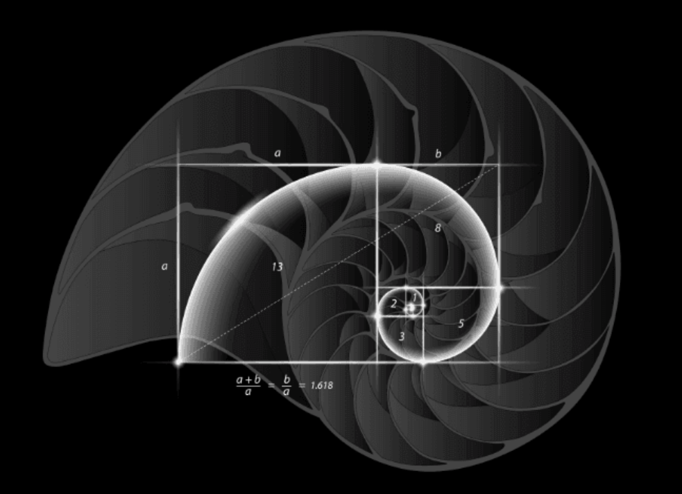
(Figure 9, Spiral Shape Found in Nature which Expands
in the Proportion of the Golden Mean) (Golden Mean=1.618)
Over the last few decades, theories relating to the hidden power of the mind have been popular within the mainstream of science and spirituality. Whilst less attention has been payed to the hidden power within DNA. However, there is evidence for vast amounts of knowledge being contained within the genome. For instance, it has been found that the petals of sunflowers form patterns which correspond to the golden ratio, with the number of spirals relating to the Fibonacci sequence (Posamentier, 2007). Therefore, this pattern, number or sequence is of universal law, showing a higher order or meaning of the living things within nature and is presumably a result of the sunflowers DNA code.
Bacteria multiply at the rate of the Fibonacci sequence and more curiously, spiders have been found to spin webs in accordance with the golden mean (Luwes, 2010). We can hypothesize that the spider is unaware of this and is only an automatic result of either the DNA code; or a mathematical law of nature; by which the properties of the universe shape things. Like water flowing into a mold; the water will automatically take the shape of the mold, yet the shape formed, is not by virtue of the water, but by the mold.
The Phi ratio (the basis of the golden mean) is also appears present in the human genome, determining the ratios and relations of limbs and body sizes (Melchizedek, 2000) as well as facial proportions, with those closest to it and most symmetrical being considered the most attractive (Pallett, Link and Lee, 2010). However, the people who are attracted to these faces, presumably due to their genetic makeup, are not necessarily aware of this phenomenon. The golden mean is also found within statues made by the Egyptinas and Greeks, such as Da Vincis sculture canon (Melchizedek, 2000). It was believed that this could only be acheieved through the use of both sides of the brain symultaneously (Melchizedek, 2000); thus another reason to balance the brain. Therefore, the golden ratio found is within DNA, the human and mind, yet appears a force beyond our ordinary consciousness. Is it coincidence the phi ratio is also found within the buildings we build? Or is it our nature?
Ancient megalithic structures containing the golden ratio (Phi φ) including the Great pyramids of Giza build around (2570 BC) and Stonehenge constructed (3100 BC – 2200 BC)(Olsen, 2008)(amongst numerous other ancient sites). We find, just as the spider constructs its domicile in accordance with the geometry of the golden mean, the humans build their constructions, by the same value. So, what does this allegedly divine mathematics have to do with anything? Many of these constructions coincide with the lay lines (dragon lines), the male and female energy meridians which pass through the earth (Olsen, 2008, p.13) and the earth chakra points. This highlights the connection between, divine mathematics within DNA, the body and the mind in conjunction with the channels of the earth itself. A debate concerning lay lines as to whether ancient civilization who constructed these monuments were purposely erecting these megalithic stone structures on lay lines and chakra points due to knowledge they possessed (yang) or were drawn to them due to the connection between themselves and nature, by their intuitive/subconscious mind (yin). Likely a combination of both.
Divination
As we have discussed, mathematics is a function of the left brain. Modern western systems attempt to map and predict the future. Meteorologists study weather patterns, by taking readings of atmospheric conditions, based on an arbitrary initial state (Howe and Wain, 2005, p.10). Due to the activity of the earth’s atmosphere being chaotic, these predictions are accurate for up to five days, yet unable to predict much further ahead (Howe and Wain, 2005, p.10). Such methods are based upon learning the scientific laws of the earth and universe, then gathering large amounts of data so to make predictions (Howe and Wain, 2005, p.10).
Large amounts of data are quintessential ideals of a left brained ideology. However, individuals soon came across what is termed the butterfly effect, where one small change or error can have a great impact to trends predicted (Howe and Wain, 2005, p. 39-40). For computers to make definite predictions of global trends, natural disasters or the effects of global warming in advance, they would have to take measurements from the beginning of time, account for all of the natural environmental factors, as well as human interventions; between the point of prediction and the date of the predicted event. This is not possible.
Similar feats were attempted, to model and calculate the economy, but again this proved to be beyond the scope of current mathematics. Economists were unable to predict human behavior, in terms of our interactions in conjunction with global commodities (Bookstaber, 2017, pp.3-13). Predictive abilities fell short due to computational reducibility; thus, we could not foresee or prevent economic crisis (Bookstaber, 2017, pp.3-13). Whilst the universe itself may consist of purely mathematical elements (Tegmark, 2015); human-made non-physical constructs cannot be classified, mapped or predicted as simply as orbits of planets.
The I Ching has been used as a book of wisdom, containing the laws of the universe as well as a divination manual (Ball, 2004, p.114)(Lynn, 2004, p. 1). The I Ching contains hexagrams for the purpose of fortune telling. Each hexagram contains two trigrams, each trigram is composed of three lines each; each line is either solid (yang) or broken (yin), creating sixty-four possible combinations of hexagrams, formed from eight possible trigrams ( Lynn, 2004, p. 1)(see fig 10).
Through consorting with the Dao energy source, you can receive guidance to achieve good fortune and avoid misfortune, through acting in accordance with the flow of the Dao and nature (Lynn, 2004, p.1). This is stereotypical of the ancient’s nature, as right-brained eastern individuals. Thus, again we see the east and western methods of calculations are reflection of the yin yang, eastern and western, left and right hemisphere nature of societies, with both having their benefits. Divination of course considers all the information and factors from not only the whole past of the universe but also the future, through the ultimate mind, the storehouse of the eternal Dao.
Current Daoist theorists (Hu and Wu, 2011) claim a connection between the 64 hexagrams of the I Ching and the 64 codons of the DNA code, referring to extensive algebraic theorems to support their hypothesis, in connection with space and time, claiming the divination of the I Ching and the genetic code speak the same language. If correct, not only would this explain how the I Ching speaks the language of nature, yet also support my DNA and Dao hypothesis.
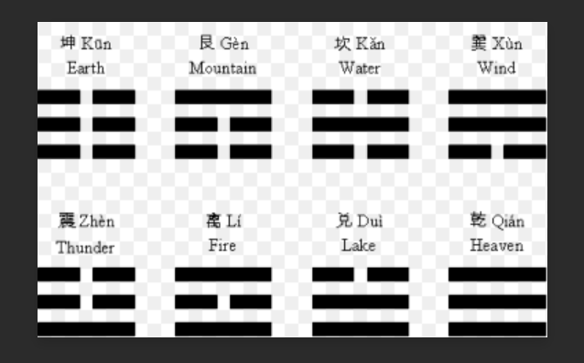
(Figure 10, The Eight Trigrams and their Meanings)
Wu-wei
Another way in which we can investigate interconnectedness is through wu-wei. A central principle of wu-wei being that we are the Dao itself (Ball, 2004, p.14). Wu-wei translates approximately as non-action, as instead of acting, we allow the matter to unfold (Ball, 2004, p.14). All which unfold upon the earth is part of a greater cyclical flow of energy (Ball, 2004, p.44). One should never apply effort, this is because our cognitive thoughts or ideas and actions, cannot compare to the all-knowing source of all thing. During wu-wei we are guided subconsciously.
A Dao practitioner achieves a state of awareness through the interconnectivity between the chi energy of self and the chi energy of all things (Ball, 2004, p. 40). The aim is to bring ourselves in line with the Dao (Ball, 2004, p.44). This is not a physical position or location; it is a frequency of mind and thought. We must tune ourselves in to this frequency to flow with the energy and become part of a greater whole (Ball, 2004, p. 44). As the Dao is cyclical, there is a time for change, thus action, when tian (heaven) dictates. One rests and aligns, until the opportune moment, then the Dao moves the individual, you never move yourself. This is the moment you can be successful. This should never be your own mental planning, only the will of the Dao.
We have shown the Dao exists in the brain and mind, the body (DNA), the earth and cosmos; with interconnectivity between all. This eludes to why the wu-wei is possible. As sophisticated knowledge of science aids in the comprehension of how an action potential, activates a brain neuron, to trigger the contractions of tendons, through electrical impulses; thus, thought can move the hand. An understanding of complete connectedness of the human and cosmos assists in comprehending how the universe can move us. Metaphorically; we become a hand of the Dao’s greater mind.
Modern psychologists investigate an aspect of wu-wei under the title of flow, or in the zone. Wu-wei is a spiritual practice and deals with harmonizing with nature and allowing the forces of the Dao to guide one-self (Ball, 2004, pp.40-44). Whilst flow is only a sample of wu-wei, which deals with part of the phenomena in isolation and not the whole thing. Neuroscientific research has looked at what happens to athletes, when forces (via the right hemisphere) spontaneously take over an individual and act without effort, performing feats beyond their ordinary expected capabilities (Stavrou et al., 2007). Whilst a Daoist purposely bring themselves in line with the forces with the intention of the source guiding them; and may live this way generally. The Athlete achieves alignment inadvertently. Likely due to the breathing techniques designed for stamina, amongst other factors. Though psychologists aim to recreate (model) this phenomenon, without the balance of nature.
Neuroscience from Meck (2005) shows us that the right hemisphere has an inferior sense of time, being predominantly a function of the left hemisphere, whilst reaffirming lateralization of function can change. Time is considered an illusory characteristic which only the physical world is subject to (Wolf, 2014). Both wu-wei and flow deal with the idea of loss of the sensation of time (Ball, 2004, p. 40) (Stavrou et al., 2007). This further draws connections between the right hemisphere, religious or spiritual activity and the subconscious; in association with yin qualities of the universe.
Organs are the Miniature Universe; Implications for Medicine
Daoist’s believe the world is made of five major elements, wood, fire, earth, metal, water; which correspond to the five yin organs: liver, heart, spleen, lungs and kidneys; and the five yang organs: gall bladder, small intestine, stomach, large intestine; the five senses: eyes, ears, mouth, nose and body; yet also the earth, seasons, climate, directions, cosmos, emotions and speech (Ball, 2004, pp.113 & 147-153) (Kohn, 2004, p. 31-32). Any imbalance in one area; e.g. emotions can cause and imbalance an organ, due to interconnectivity of all, existing within the balance of yin and yang (Ball, 2004, pp.113 & 147-153) (Kohn, 2004, p. 31-32). The example given corresponds with many modern schools of psychology and biology, in terms of healthy mind and body. As too does the balance between season and organ, hence Seasonal Affective Disorder (SAD).
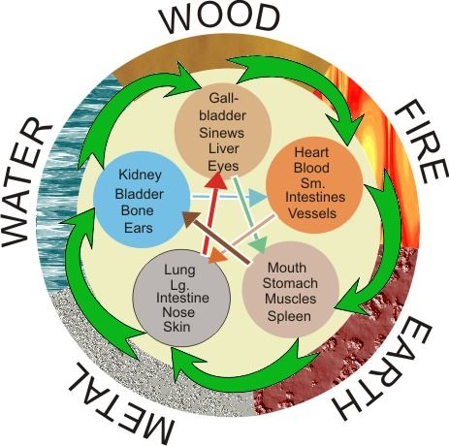
(Figure 11, Interconnection of the Five elements,
the Five Yin Organs, the Five Yang Organs, & the Five Senses)
Relationships between organs as all processes of human biology are expressions of the yin yang energy that can be found in the universe with being interconnected (Ball, 2004, pp.147-148). The same energies which are believed to move and control all the celestial bodies of the heavens or galaxies (Kohn, 2009, pp.141-143). Once we can view the body as a miniature version of the universe, we can see an organ is not merely a bunch of individual cells. The body cannot be considered just a collection of its parts and must be considered whole, one, and at one with all.
The Dao is responsible for the whole of nature and essences of each individual human being (Cooper, 2012, p.47). Therefore, this includes personality traits; however, this does not automatically negate biological personality theories, which attribute innate tendencies to DNA. As once we have attributed the nature of DNA to the Dao, we can also view genetic predispositions as virtue of the Dao. With DNA being the miniature version of the whole man, this is what you are incorporating into your body upon any transplants, as organs contain cells, thus DNA, thus the genome.
Current research suggests that many individuals who have organ transplants report changes within their conscious self which correlate with the personality, emotions, preferences and even memory of the donor; this is especially common for hearts (Joshi, 2011). These include food and music preferences, sexuality, as well as unexplained dreams relating to the donor’s life (Joshi, 2011). Whilst in the west, since the Roman period the brain was declared the center of consciousness. In the east: the heart, is considered the mind and moral guidance system. Western science has only a partial comprehension of its actions, these organs contain more energy than we can currently comprehend scientifically. This is not to insinuate organ transplant is incorrect behavior, but to place this act within the wider context which it belongs. With a greater understanding of what we are; the cosmos. Granting a greater frame of reference form which to make choice.
Gene Therapy
Gene therapy also attempts to manipulate the biology of the human by changing the genes of a cell. A healthy gene is inserted into a host cell using a vector (Toole and Toole, 2002). This gene replaces the malfunctioning or missing gene, which is causing dysfunction of the body, with a functioning gene which codes for beneficial body proteins (Toole and Toole, 2002). Each layer of the universe is just part of a greater whole and are one. We cannot manipulate one layer without affecting another.
This is comparable metaphorically to the butterfly affect within forecasting; how one small change in one place can create larger effects elsewhere later. Thus, gene therapy and greater so genetic modification, acting on only a cellular level, has effects for the whole organism, could have effects on a global or even cosmic level; as we have reasoned that we are the universe at large. Explaining one reason why gene therapy can lead to side effects, causing health problems for individuals as well as other unforeseen consequences (Burley and Harris, 2002). With similar dangers of genetic engineering of plants and animals (Burley and Harris, 2002).
The large-scale effects of genetic modification of plants are more obvious, as plants affect humans directly through the food chain and the environment through physical terms, besides the cosmic terms. As the evolutionary process is geared towards creating mutations which are adaptive in terms of survival (Martincorena, Seshasayee and Luscombe, 2012), genetic modification leads to resistant strains of virus and bacteria which can cause greater a global concern. Adverse consequences occur as we are moving against the flow of the Dao, without a wholistic comprehension, hence side effects are inevitable. We cannot force disease to cease (Mao, 2018), bacteria as all evolve with a natural place and order, this is cyclical and governed by universal laws (Ball, 2004, p. 37). All have a time and place on earth is part of the natural sequence and will only revert when ready (Ball, 2004, p.37). We cannot reduce the level of negative energy or bacteria in the world, only ensure our own immune systems are strong enough to resist (Mao, 2018).
Tian: Causation of Evolution
From a Daoist perspective, all major and minor events are the result of tian, from rulers to natural disasters (Kohn, 2009, pp.78-79). Yet this a two-way causation, with cycles of heaven affecting earth and the actions of individuals; and the actions of individuals affecting earth and heaven. From a modern biological perspective, all life on the planet contains DNA and evolve due to evolution. First a random mutation occurs, often this initially has minimal effect, until an environment changes, at which point a mutation becomes advantageous or disadvantageous, causing life to flourish or in extreme cases can cause extinction (Toole and Toole, 2004).
The issue here is the notion of random. All is of higher order; therefore, action has a cause and effect, which only appears random to those unaware of the cause. Behind the changes in population of humans, plants and animals, and bacteria is the Dao, responsible for not only the changes in DNA structure (random mutation) but also the environmental changes in climate and disease (Ball, 2004, p.37). Science itself is still evolving. Evolution theory was created in 1859, just over one-hundred years prior to the discovery of DNA in 1962. Thus, the concept of random mutations of DNA, was later incorporated into evolution theory.
Recent biological discoveries refute mutation as random, supporting my greater causation hypothesis. From experimentation on Escherichia coli bacteria, we find mutation is not random (Martincorena, Seshasayee and Luscombe, 2012). It appears that the DNA molecule itself is intentionally creating masses of mutations, with a bias towards producing adaptive genes for survival (Martincorena, Seshasayee and Luscombe, 2012), thus is a self-governing molecule. Similar tests have been conducted on other organisms, e.g. maize. It appears previous biologists did not have a complete comprehension of this molecule. Nor the force, mind or consciousness behind the intentional formation of new genetic codes. Whilst many individuals take the biocentric or anthropocentric viewpoints on governance of the planet, others view the planet as a self-governing organism (Attfield, 2013, pp. 2-5 & 31-34). Yet even this viewpoint must be incorporated into the greater cosmic perspective comprehending the self-governance of the planet as a result of the governance of tian. Whilst respecting DNA as self-governing also.
Control Over the Serpent
Neuroscientific research shows that mindfulness alone can affect the gene expression, capable of alleviating a range of conditions for both mental and physical illnesses (Creswell et al., 2012) (Dada et al., 2018); as too can Tai chi and yoga (Qigonginstitute.org, 2019). This is the correct way to move with the Dao by aligning self with the universe and acting in accordance, to bring about changes at a cellular level by the action performed on a cosmic level. In this way we use mind to change DNA, to change body. In the same way which it is difficult to roll a boulder up hill and much easier to roll one downhill. It is much easier to work with the energies of the Dao than against them. Hence mediation can also be dangerous in you can not control the power.
What we find here is that the western techniques of neuroimaging and genetic testing brings greater comprehension to eastern mindfulness, whilst eastern interconnectivity brings greater clarity to biological truths in isolation. However, we must now learn to manipulate the universe, not the biology of cells or the humans within psychology. We must view DNA as spiritual, whilst also acknowledging the biological nature of DNA and the earth. Only through the combination of the science and spirituality can we have a complete comprehension of the biological body in terms of yin and yang.
Daoist’s align themselves with the universal energy (Dao) to create a cosmic sense of self through meditative focus, so to be able to gain control over the body’s biological rhythms, as operating in accordance with the universal forces, which function on a higher level than the ordinary human (Kohn, 2009, pp.142-143). The human body does many things it does without the human knowing consciously it is doing them, such as control of the heartbeat, hormone production and secretion of hormones by glands (RajMohan and Mohandas, 2007). These are termed automatic processes, controlled by the limbic system and often referred to as the reptilian brain (Naumann et al., 2015).
Researchers have shown practicing meditators can speed up or slow down their heart rate at will (Telles et al., 2013). Thus, meaning have over-powered the reptilian brain or limbic system if you prefer, our primordial animalistic nature. Whilst often considered spiritual, due of the Chi channels or otherwise energy meridians. This is both a biologically scientific and spiritual phenomenon. This is what I refer to mythologically as having power over the serpent. Current research is interested in discovering the same phenomenon for glandular function (Telles et al., 2013), due having the same center of control (limbic system).
As meditation can affect gene expression (Creswell et al., 2012) (Dada et al., 2018). With there being DNA, within every living plant, animal and bacteria on the planet. I ask if through meditation; can we affect the earth, and its other living organisms; as well as the planet itself due to its energy channels (Dragon or ley lines) and the interconnectivity between all levels of existence, by tapping into the house of the Dao?
All mythical serpents and dragons are used synonymously with the Dao, on different levels, with different cultural stories expressing the different occurrences (Gardener, 2005). The same serpent which created the universe, is the same symbolic serpent, which runs through the lay lines, the same serpent power that rises through our meridians during meditation, the same serpent contained in our DNA; all being chi. Whilst the term reptilian brain appears at face value only a coincidence, it is still inadvertently the same serpent power, we can master of become one with.

Conclusion
The duality of nature exists on many levels. This paper not only brings an up to date biological perspective on Daoism but also incorporates science into a wholistic perspective, revealing how it can be detrimental to our-selves if performed incorrectly without a greater awareness of interconnectivity. The qualities of the mind are the same as the qualities in the world, male and female, eastern and western, positive and negative; as equal and opposite polarities, just as Daoism and the tai ji symbol suggest. Whilst many philosopher, biologist, physicist and psychologist have searched the internal and the external for the answers to life. This theory presents them as one in the same. Whilst many Eastern philosophies claim interconnectivity, this research elucidates the connections scientifically. With regards to the philosophy of know thy self, this paper provides greater understanding of self, building upon Daoist theories by the addition of scientific and social theory, to greater comprehend the self, planet and universe as one, as claimed within eastern philosophy. This can lead to greater action taken, not only caring for the planet as if one’s self, but also the other people as if oneself, in line with multiple philosophies. Whilst many comprehend interconnectivity on an intuitive (yin) level, this essay explains interconnection in a non-doctrinal or mythological method, whilst explaining the requisite of balance, from a scientific viewpoint as well as the purpose of being ambidextrous in mind and body, for a balanced harmonious planet. Whilst reiterating the benefits of meditation for heath from scientific perspectives, as well as for a better world and universe.

Word count (10, 942)

References
Agrawal, S. and Aggarwal, J. (1992) Women's education in India. New Delhi: Concept Pub Co.
Ames, R., Behunaik, J., Tian, C. and Wang, R. (2018) Nishan Confucian Studies Summer Workshop. Danjang, Jangsu.
Attfield, R. (2003) Environmental ethics. Oxford: Polity.
Ball, P. (2004) The essence of Tao. London: Arcturus.
Barthelemy, J. (2019) Yin Yang Qigong, Brain Balancing – [online] Fiveseasonsmedicine.com. Available at: https://fiveseasonsmedicine.com/yin-yang-qigong-brain-balancing/ [Accessed 27 Apr. 2019].
Bookstaber, R. (2017) The end of theory. Oxford: Princeton University Press.
Burley, J. and Harris, J. (2002) A companion to genethics. Malden, Mass: Blackwell Publishers.
Cooper, D., E. (2012) Convergence with nature: a Daoist perspective. Totnes: Green Books.
Coren, S. (1993) The left-hander syndrome. New York: Vintage Books.
Coren, S. (2014) Left-Handedness. Amsterdam: Elsevier Science.
Creswell, J., Irwin, M., Burklund, L., Lieberman, M., Arevalo, J., Ma, J., Breen, E. and Cole, S. (2012) Mindfulness Based Stress Reduction training reduces loneliness and pro-inflammatory gene expression in older adults: A small randomized controlled trial. Brain, Behavior, and Immunity, 26(7), pp. 1095-1101.
Dada, T., Mittal, D., Mohanty, K., Faiq, M., Bhat, M., Yadav, R., Sihota, R., Sidhu, T., Velpandian, T., Kalaivani, M., Pandey, R., Gao, Y., Sabel, B. and Dada, R. (2018) Mindfulness Meditation Reduces Intraocular Pressure, Lowers Stress Biomarkers and Modulates Gene Expression in Glaucoma. Journal of Glaucoma, 27(12), pp. 1061-1067.
Danelli, L., Cossu, G., Berlingeri, M., Bottini, G., Sberna, M., and Paulesu, E. (2013) Is a lone right hemisphere enough? Neurolinguistic architecture in a case with a very early left hemispherectomy. Neurocase, 224(3), pp. 393-410. Doi: 10.1080/13554794.2011.654226
de Morgan, A. (2008) A Budget of Paradoxes, Volume II. 1st ed. [ebook] Gotenburg: D. Starner & K. Edkins. Available at: http://www.gutenberg.org/files/26408/26408-h/26408-h.htm [Accessed 1 Nov. 2018].
Gardiner, P. (2005) The Serpent Grail. 1st ed. London: Watkins Publishing.
Howe, L. and Wain, A. (2005) Predicting the future. Cambridge: Cambridge University Press.
Hu, H., and Wu, M. (2011) Generation of DNA Codes & the Hexagrams of I Ching from the Principle of Existence. DNA Decipher Journal, pp.1-10. Available at: http://vixra.org/pdf/1101.0087v1.pdf [Accessed 1 May 2019].
Joshi, S. (2011) Memory transference in organ transplant recipients. Namah: Journal of New Approaches to Medicine and Health. 19(1).
Kirschvink, J., Kobayashi-Kirschvink, A. and Woodford, B. (1992) Magnetite biomineralization in the human brain. Proceedings of the National Academy of Sciences, 89(16), pp.7683-7687.
Kohn, L. (2004) Cosmos and Community. St Petersburg: Three Pines Press.
Kohn, L. (2009) Introducing Daoism. Milton Park, Abingodn, Oxon, Routledge.
Levack, B. (2013) Witch-Hunt in Early Modern Europe. New York: Taylor & Francis.
Liu, Z., & Hua, K. (1999) A study of Daoist acupuncture & moxibustion. Boulder: Blue Poppy Press.
Luwes N., J. (2010) Fibonacci numbers and the golden rule applied in neural networks. Interdisciplinary Journal, 9(1), p. 36.
Lynn, R. J. (2004) The classic of changes: a new translation of the I Ching. Irvington: Columbia University Press.
Mao, A (2018) Chinese Gentle Manipulative Technique Workshop. Lampeter, Wales.
Martincorena, I., Seshasayee, A. and Luscombe, N. (2012) Evidence of non-random mutation rates suggests an evolutionary risk management strategy. Nature, 485(7396), pp. 95-98.
Meck, W. (2005) Neuropsychology of timing and time perception. Brain and Cognition, 58(1), pp. 1-8.
Meissner, J. and Pirot, M. (1983) Unbiasing the Brain: the effects of meditation upon the cerebral hemispheres. Social Behavior and Personality: an international journal, 11(1), pp.65-76.
Melchizedek, D. (2000) The Ancient Secret of the Flower of Life. Flagstaff: Light Technology Publishing.
Narby, J. (1999) The cosmic serpent, DNA and the origins of knowledge. London: Phoenix.
Naumann, R., Ondracek, J., Reiter, S., Shein-Idelson, M., Tosches, M., Yamawaki, T. and Laurent, G. (2015) The reptilian brain. Current Biology, 25(8), pp. R317-R321.
Olsen, B. (2008) Sacred places, North America. San Francisco, CA: Consortium of Collective Consciousness.
Ozaniec, N. (1996) The elements of the chakras. Shaftesbury: Element.
Pallett, P., Link, S. and Lee, K. (2010) New golden ratios for facial beauty. Vision Research, 50(2), pp.149-154.
Pletsch, V. (2006) Not just the strap. New York: Universe Inc.
Posamentier, A. S. (2007) The fabulous Fibonacci numbers. Amherst, N.Y.: Prometheus Books.
Qigonginstitute.org. (2019) Qigong Institute - Epigenetics and Psychoneuroimmunology. [online] Available at: https://www.qigonginstitute.org/category/15/epigenetics-and-psychoneuroimmunology [Accessed 16 Apr. 2019].
RajMohan, V. and Mohandas, E. (2007)The limbic system. Indian Journal of Psychiatry, 49(2), p. 132.
Rankin, M. (2005) An introduction to religious experience (3rd Series Occasional Paper, 2) Lampeter Religious Experience Research Centre.
Redmond, K. (2008) Salters-Nuffield advanced biology for Edexcel AS biology. Harlow: Pearson Education.
Royston, R., & Humphries, A. (2007) The hidden power of dreams: an essential guide to interpreting your dreams. London: Bantam.
Sack, R., Auckley, D., Auger, R., Carskadon, M., Wright, K., Vitiello, M. and Zhdanova, I. (2007) Circadian Rhythm Sleep Disorders: Part I, Basic Principles, Shift Work and Jet Lag Disorders. Sleep, 30(11), pp. 1460-1483.
Shaw, J. (1995) Education, gender, and anxiety. Washington, DC: Taylor & Francis.
Sinden, R. (1994) DNA structure and function. Houston, Texas: Academic press.
Smart, N. (1998) Latin America and the Caribbean. The world's religions, Cambridge University Press, pp. 532-548.
Stavrou, N., Jackson, S., Zervas, Y. and Karteroliotis, K. (2007) Flow Experience and Athletes’ Performance with Reference to the Orthogonal Model of Flow. The Sport Psychologist, 21(4), pp. 438-457.
Tegmark, M. (2015) Our mathematical universe: my quest for the ultimate nature of reality. London: Penguin Books.
Telles, S., Subramanya, P., Manjunath, N., Deepak, K., Naveen, K. and Raghavendra, B. (2013) Voluntary heart rate reduction following yoga using different strategies. International Journal of Yoga, 6(1).
Toole, G. and Toole, S. (2002) Essential AS biology. Cheltenham: Nelson Thornes.
Toole, A. and Toole, S. (2004) Essential A2 biology for OCR. Cheltenham: Nelson Thornes.
Vlachos, F., Gaillard, F., Vaitsis, K. and Karapetsas, A. (2013) Developmental Risk: Evidence from Large Nonright-Handed Samples. Child Development Research, 1(1), pp.1-10.
Watkins, K. (2014) Taoist perspective of the Chakras. Elephant Journal. [online] Available at: https://www.elephantjournal.com/2014/04/a-taoist-perspective-of-the-chakras-keith-watkins/ [Accessed 6 May 2019].
Wolf, F., A. (2001) Mind into Matter: A New Alchemy of Science and Spirit. Newburyport: Red Wheel Weiser.

Appendix
References of Figures
[Front Cover] iStock. (2019) Matryoshka Russian Dolls - Illustration. [online] Available at: https://www.istockphoto.com/gb/vector/matryoshka-russian-dolls-gm163838628-13433807 [Accessed 6 May 2019].
[Figure 1.] Rama (2006) Modern depiction of the caduceus as the symbol of commerce. [image] Available at: https://en.wikipedia.org/wiki/Caduceus [Accessed 18 Apr. 2019].
[Figure 2.] Gardiner, P., (2005) The Serpent Grail. 1st ed. London: Watkins Publishing.
[Figure 3.] StudyBlue inc. (2018) Interphase. [image] Available at: https://www.studyblue.com/notes/note/n/unit-06-cell-division-mitosis-meiosis/deck/12793845 [Accessed 18 Apr. 2019].
[Figure 4.] Slideplayer.com. (2019) Figure 12–7 Structure of DNA - ppt download. [online] Available at: http://slideplayer.com/slide/8078926/ [Accessed 28 Apr. 2019].
[Figure 5.] Narby, J. (1999) The cosmic serpent, DNA and the origins of knowledge. London, Phoenix.
[Figure 6.] Fully Aware Mind (2017) These Are The Exact Locations Of The Earth’s Main Chakra Points. [image] Available at: http://fullyawaremind.com/exact-locations-earths-main-chakra-points/ [Accessed 18 Apr. 2019].
[Figure 7.] Theawakendstate (2012) The Universe is Inside of You. [image] Available at: http://theawakenedstate.tumblr.com/post/18388353788/chakra-appreciation-post [Accessed 19 Apr. 2019].
[Figure 8.] Watkins, K. (2014) Taoist perspective of the Chakras. Elephant Journal. [online] Available at: https://www.elephantjournal.com/2014/04/a-taoist-perspective-of-the-chakras-keith-watkins/ [Accessed 6 May 2019].
[Figure 9.] Marshall, J. (2010) What is the Golden Ratio and How is it Related to the Fibonacci Sequence?. [online] Quick and Dirty Tips. Available at: https://www.quickanddirtytips.com/education/math/what-is-the-golden-ratio-and-how-is-it-related-to-the-fibonacci-sequence [Accessed 3 May 2019].
[Figure 10.] ElsaElsa (2010) Trigrams, Dream Syntax and Hexagram. [image] Available at: https://www.elsaelsa.com/astrology/hexagram-61-iching/ [Accessed 5 May 2019].
[Figure 11.] Pinterest. (2019) Crash Course: The Basics of Chinese Medicine. ~ Yara Coelho. [online] Available at: https://www.pinterest.co.uk/pin/497014508853554487/ [Accessed 30 Apr. 2019].

