

Module Name: Financial management

Module Code : LCMB7002

Assessment component : Financial performance and management

Lecturer's Name: Shengfeng Mei

Student Name : Aayushy Patel

Student ID : 2503361

Word count: 5093

Table of Contents
Introduction 3
1. Financial Health Check 3
1.1 Financial Statements Analysis 3
1.2 Ratio Analysis, and Identification of Trends, Strengths, and Threats 4
1.3 Default Risk Assessment using Altman Z-Score Model 6
2. Working Capital Management Analysis 6
2.1. Assessment of Cash Operating Cycle 6
2.2. Recommendations to Improve Liquidity 7
2.3 Short-Term vs Long-Term Financing Options 8
3. Strategic Financial Restructuring Plan 9
3.1. Recommended Options for Financial Restructuring 10
3.2. Assessment of Impact 12
3.3. International and Ethical Considerations 12
4. Investment Appraisal and Capital Budgeting 13
References 18
Appendices 21

Introduction
Analysing financial performance of a company facilitate understanding the core issues, which can be addressed through appropriate improvement strategies. Among different methods to undertake a company’s financial performance, the analysis and interpretation of financial ratio is a key one. Besides, the significance of ‘Altman Z-Score’ cannot be overlooked in assessing the default risk that a business faces. In case of the assessment of different investment projects, large use of various investment appraisal methods can be seen, such as ‘payback period (PBP), ‘accounting rate of return (ARR), ‘net present value (NPV),’ and others. This report is involved in assessing the financial performance of ‘General Electronics (GE).’ Besides, it also assesses three investment projects of the company by using different investment appraisal methods.

1. Financial Health Check

1.1 Financial Statements Analysis
Consolidated Income Statement
GE’s net sales demonstrate a constantly decreasing trend from 2020 to 2024. Owing to increased cost of sales, GE’s gross profit has decreased in 2023 and 2024 compared to the previous years. However, an increase in the gross profit in 2024 has led to an increase in this ratio. Declining net sales and increased operating expenses have contributed to operating losses in 2023 and 2024. This is why the operating profit margin is negative in these years. The company has constantly reported net losses owing to increased interest expenses, operating expenses, and cost of sales, and constantly declined net sales. These aspects have contributed to negative net profit margins in 2023 and 2024. Hence, declined profitability during these years has affected profitability ratios of the company.
Consolidated Financial Position
From 2020 to 2024, GE’s total assets have declined constantly, which is not a positive aspect for its business. Sharp decrease in assets, such as property plant and equipment (PPE), intangible assets, and cash and cash equivalents demonstrates a decline in the scale of the business of GE. However, a recent increase in GE’s asset turnover ratio in 2024 demonstrates its improved efficiency in managing assets to generated sales revenue. A decrease in the company’s total liabilities is due to the decrease in its long-term liabilities and ‘line of credit.’ Total shareholders’ equity has decreased constantly over these years, and constant net losses meaningfully contributes to this. This scenario has affected the gearing ratios of GE. Table 1 shows a constant increase in GE’s debt-to-equity ratio and debt ratio, which indicates a circumstance where debt is increasing and equity is decreasing.
Consolidated Cash Flow Statement
Net cash generated from operating activities decreased in 2024 indicating a deteriorating in the ability of GE’s core business operations to generate cash inflows. Repayments of the lines of credit has contributed to cash outflow in financing activities. Besides, acquisition of PPE and intangible assets has caused major cash outflows in 2024. Table 1 shows deterioration in GE’s cash flow ratios, such as the cash flow coverage ratio, cash flow margin ratio, and cash ratio. Such a deterioration mirrors GE’s constant decrease in cash inflows and increase in cash outflows.

1.2 Ratio Analysis, and Identification of Trends, Strengths, and Threats
Profitability
In the Appendix, Table 1 shows an increase in GE’s gross profit margin in 2024 owing to a sharp decrease in the cost of sales. This ratio increased from 28.06% in 2022 to 23.20% in 2023, and 28.87% in 2024. This is a financial strength as it demonstrates the company’s strength in managing direct costs related to its manufacturing operations. However, trends show that GE has constantly registered negative operating profit margin and net profit margin from 2020 to 2024. For example, GE’s operating profit in 2023 and 2024 is -20.29% and -3.87% respectively. Besides, its net profit margin in 2023 and 2024 are -23.36% and -6.09% respectively. This is because of increasing operating and other expenses (Ahmed and Bhuyan, 2020). For example, GE’s operating expenses increased to £182,861 million in 2023 compared to £137,744 million in 2022. Besides, interest expenses have meaningfully increased in 2022, 2023 and 2024 compared to 2020 and 2021. These demonstrate GE’s deteriorated control over managing key expenses associated with its business (Palepu et al., 2020). This could create a long-term threat of insolvency of GE’s business if this situation continues. Overall, GE’s profitability position cannot be regarded as a business strength.
Liquidity
As per Table 1 and Graph 2, the current and quick ratios of GE have fluctuated from 2020 to 2024. Table 1 shows an increase in the current ratio from 1.56 times in 2022 to 1.61 times in 2023, and a decrease to 1.53 times in 2024. Likewise, the quick ratio decreased from 1.06 times in 2023 to 1.03 times in 2024. Even though both the ratios have decreased in 2024, they are above 1. It implies that GE has the required current and quick assets to pay off its current business obligations. Although it is a key business strength, GE needs to consider the impact of recent declines in these ratios on its liquidity position. For example, a sharp increase in GE’s accounts payable in 2024 is an area of concern, which needs to be actively considered by GE’s management (Ho, Lu and Bai, 2021).
Efficiency
After registering a constant decline from 2020 to 2023, GE’s asset turnover ratio increased in 2024 i.e. 1.16 times in 2024 from 0.98 times in 2023. This is a strength as it denotes a more efficient utilization of GE’s business assets to generate sales revenue. The receivable turnover ratio decreased to 3.48 times in 2024 from 3.74 times in 2023, and receivable days increased from 97.6 days in 2023 to 104.8 days in 2024. A decline in the receivable turnover ratio along with an increase in receivable days is a sign of inefficiency as the business is taking more time to collect dues from its debtors. This creates the threat of a further deterioration in GE’s capability of managing receivables with efficiency. However, its inventory turnover ratio has increased from 2.83 times in 2023 to 3.35 times in 2024 while days sales in inventory have decreased during the same period i.e. 108.91 days in 2024 from 129.12 days in 2023. It is a business strength as the company has cleared its stocks more time in average in 2024 compared to previous years. Overall, GE manages its assets with efficiency, which is a business strength, but there is a need to further strengthen the management of trade receivables (Aduda and Ongoro, 2020).
Gearing
As per Table 1 and Graph 4 in the Appendix, GE’s debt-to-equity ratio has constantly increased from 2020 to 2024 i.e. 0.63 times in 2020 to 1.11 times in 2024. As this ratio is higher than 1 in 2024, it indicates the company’s large dependence on debt capital compared to equity capital. This is a threat as it makes the business risker to investors. The same table also shows that the equity ratio of GE has constantly decreased from 0.61 times in 2020 to 0.47 times in 2024. The fact that this ratio is lower than 0.50 in 2024 implies that GE’s dependence on equity capital has decreased in this year. On the other hand, GE’s debt ratio has constantly increased from 0.39 times in 2020 to 0.53 times in 2024, and it is higher than 0.50 in 2024. It implies that GE’s dependence on debt capital has increased in this year. An increased dependence on debt capital and a decreased dependence on equity capital create the threat of business insolvency if this situation persists (Ahmed and Bhuyan, 2020). This makes the business highly geared. Owing to operating losses in 2023 and 2024, the interest coverage ratio of GE is negative in these years i.e. -19.69 times in 2023 and -4.55 times in 2024. It indicates total incapability of GE in paying interest expenses by using profits from its operations. Overall, GE’s business is highly geared because of its high reliance on debt capital compared to equity capital.
Investment
Graph 5 shows that GE’s EPS is negative in 2023 and 2024 as the company has registered net losses in these years. For example, EPS in 2023 and 2024 is -7.64 and -1.84 respectively. Negative EPS demonstrates business weakness as it presents the business as an unprofitable option to existing shareholders and potential investors. This may meaningfully impact GE’s attractiveness as a suitable investment option to investors (Wulansari, Elwisam and Digdowiseiso, 2023).
Cash Flow
As per Table 1, the cash flow coverage ratio of GE has fluctuated over the years, and it has declined meaningfully in 2024. For example, the cash flow coverage ratio decreased to 0.09 in 2024 to 0.14 in 2023 It implies that GE may lack the required cash flows for paying its short and long-term debt obligations. A similar trend can also be seen for the cash flow margin ratio. This ratio has also decreased in 2024 to 0.04 from 0.06 in 2023 demonstrating GE’s deteriorated capability of generating cash inflows from sales revenue. This cannot be regarded as a strength of the company. Table 1 shows a decrease in the cash ratio from 0.27 in 2023 to 0.17 in 2024, which affects the company’s ability of satisfying current business obligations by using cash and cash equivalents (Palepu et al., 2020). Overall, the cash flow position of the business cannot be regarded as an area of strength.

1.3 Default Risk Assessment using Altman Z-Score Model
‘Altman Z-Score’ can be referred to as a model utilized for forecasting the probability of businesses facing bankruptcy. The presence of three zones can be seen in this model. A ‘safe zone’ is presented by a scope >2.99 representing a low possibility of insolvency. A ‘Grey Zone’ is signified by a score between 1.81 to 2.99 demonstrating a reasonable insolvency risk. A ‘Distress Zone’ is represented by a score <1.81, which represents a high possibility of bankruptcy (Lord et al., 2020). It can be seen in Table 2 in the Appendix that GE’s Z-Score in 2024 is 2.82, which is between 1.81 and 2.99. It implies that the company is currently in the ‘Grey Zone’ where it is facing a reasonable likelihood to become insolvent. The risk of insolvency has increased in 2023 and 2024 as the company has fallen into the ‘Grey Zone’ from a ’Safe Zone’ in 2020, 2021 and 2022.

2. Working Capital Management Analysis

2.1. Assessment of Cash Operating Cycle
The cash operating cycle highlights the number of days consumed to convert resources into cash (Lu et al., 2020). This cycle involves the time taken to sell inventory and gather payments from customers. A longer cycle generally leads to cash flow stress and higher dependence on financing (Laghari, Ahmed and López García, 2023). Next, a shorter cycle mostly leads to better cash flows and enhanced liquidity. Longer cycle even created additional stress on other business segments like procurement, production and distribution.
General Electronics in recent years, has encountered a consistent rise in the number of days consumed to collect receivables. This activity highlights delays in customer payments and showcase inefficient control over credit terms. Furthermore, the time taken to sell inventory has been high. This situation highlights towards slow-moving stocks and the issues related to matching supply with demand. These interruptions in converting assets to cash lead to better working capital needs and decrease the funds available for reinvestment (Jalal and Khaksari, 2020).
Based on the calculations, working capital of General Electronics has remained for locked in operations for a longer period. This scenario impacts liquidity and decreases the flexibility to handle daily business requirements. Furthermore, the cash operating cycle of the business has become less efficient over the years. The demand to enhance internal processes around inventory and receivables has become very important. With the rise in this inefficiency, external financing becomes a more generic solution and this brings in financial risk (Durst, and Gerstlberger, 2020).
The analysis does not disclose the time consumers to pay suppliers but the available financial figures are able to highlight the key problem areas. The capability of the business to generate cash from operations has been restricted. This has led to a gap between inflows and outflows. This gap can be resolved by undertaking precise working capital changes and enhanced management initiatives. A better cash cycle can lead help in long-term financial recovery of the business and decrease reliance on higher-cost capital.

2.2. Recommendations to Improve Liquidity
A better focus on the core areas of working capital is needed to enhance liquidity for General Electronics. There are numerous real-life actions that can help free-up cash and decrease dependence on external funding. The correct strategy balances operational transitions with financial discipline and effective utilization of technology and data.
Furthermore, better management of receivables can lead to enhanced cash collection (Van Deventer, 2023). General Electronics can profit from establishing robust credit regulations and tracking payments timelines more thoroughly. Next, customers may efficiently respond to early payment discounts. Tracking tools and automated reminders can even help minimize overdue payments. Employee training in credit analysis and customer follow-up can enhance collections.
Additionally, better inventory control can enhance liquidity. It is seen that a leaner stock strategy can decrease holding costs and enhance cash position (Akhtar, 2024). Furthermore, proper demand planning can lead to lesser stock build-ups and improved product availability. It is even observed that product review activities can help eliminate outdated or slow-moving items from inventory. The company can even consider direct ship frameworks or vendor-based inventory for selected products.
As per the calculation, a longer supplier payments terms can assist in cash conversion. Establishing better supplier relationships can create room for further flexible arrangements. The timing of internal customer payments can be aligned with outgoing payments to minimize gaps in the cash cycle. This sort of alignment helps the business to maintain operations without overextending overdraft facilities or credit limits.
Digital tools can support day-to-day liquidity decisions. Cash flow dashboards can provide precise insights into anticipated inflows and outflows. Such visibility can help General Electronics to act faster and prevent cash shortfalls. The business can use simple tools that offers features like budgeting, managing bills and monitoring expenses for daily activities (Bintara, 2020).
These actions can establish a further effective working capital cycle. The company over time can reduce its dependencies on financing for daily activities. Furthermore, additional available cash can even enhance the ability of the business to investment and develop. It is therefore seen that stronger liquidity enhances organizational confidence and can even help create better relations with lenders and partners.

2.3 Short-Term vs Long-Term Financing Options
The demand for funds mostly generates from gaps in working capital. Selecting of the correct type of financing can assist General Electronics to handle cash with efficacy. Furthermore, long-term and short-term financing offers risks and advantages. The correct balance can offer organizational stability and development. Matching the financing technique with the nature of cost can enhance financial performance.
The process of short-term financing includes instruments like invoice financing, credit lines and supplier credit. These financing options provide faster access to cash. They are efficient during shortages in cash flows or seasonal peaks. However, such options come with increasing interest rates and shorter repayment durations. Overusing short-term finance can develop pressure on the available limited resources. Such pressures generally rise with delay or volatility in revenue.
Next, long-term financing leads a further stable capital. This sort of funding can help bigger projects like structural alterations, system upgrades or expansion. Repayment generally occurs over a longer period. The interest cost tends to be lower compared to short-term options. However, long-term financing can create commitments in fixed repayments. Such commitments can become an issue to handle without consistent and steady cash flow.
A mixture of both financing types can help the business during its recovery stage. Next, short-term tools can support with urgent cash flow demands. Furthermore, equity funding can even be examined to reinforce the balance sheet and decrease financial risk.
It is seen that proper attention has to be given to the current debt levels. The analysis reveals that interest coverage ratio for General Electronics has become in recent years. This transition showcase that the business is encountering problems in covering financial expenses from operating income. For this factor, extra borrowing needs to be matched with improvements in cash flow. Actions to minimize financial expenses and restructure existing debts can be helpful during this timeframe.

3. Strategic Financial Restructuring Plan
It can be observed from the provided data that GE’s total shareholders’ equity (£153105 million) is lower than total liabilities (£170249 million), which demonstrates GE’s major dependence on debt capital. Total cash and cash equivalents (£26783 million) are lower than GE’s line of credits (£36960 million). Besides, total inventories (£79355 million) are significantly higher than total property, plant, and equipment (£34207 million).
This existing circumstance demands improving GE’s liquidity position immediately. Simultaneously, expenses related to interest is to be condensed by minimizing GE’s dependence on debt capital.

3.1. Recommended Options for Financial Restructuring
Based on GE’s existing condition and provided data and information, three financial restructuring options are recommended. They are instantaneous actions related to liquidity (Option 1), addressing issues in the balance sheet by using careful divestiture and injection of equity (Option 2), and merger and acquisition (M&A) as a tactical business association (Option 3).
Option 1
Purchasing treasury stock should be stopped immediately, and any scheme of buying shares back should be deferred. Since these processes significantly affect GE’s short-term liquidity, deferring them releases ‘cash and cash equivalents’ which facilitates judicious apportionment of capital. This can meaningfully save ‘cash and cash equivalents’ for GE (Aduda and Ongoro, 2020).
Volatilities are involved in ‘lines of credit,’ and borrowings under these facilities have substantially increased from £78,000 million in 2023 to £102,193 million in 2024. Hence, GE is recommended to negotiate delay of debt maturities so that immediate loan payment requirements can be converted into med-term loans. This will ease the pressure on GE to make immediate repayments of loans, and provide GE with the time to raise additional capital (Struwig and Watson, 2023).
Planned actions related to the conversion of cash should be employed to enhance the management of working capital. For example, dues from debtors should be collected at a quicker pace; terms of credit should be tightened for new customers; and additional capital expenditures should be decelerated. Application of these measures can significantly optimize operating cash flows so that GE does not have to substantially rely on capital from external sources.
Option 2
Assets which are not essential in tactical diversity should be sold to realize case. For example, underused ‘property, plant, and equipment’ should be disposed of. The balance of cash and cash equivalent could be substantially increased from cash inflows generated by the sale of these assets. GE could use these cash inflows to settle existing ‘lines of credits’ while the rest could be utilized in the process to rearrange the business. Apart from circumventing immediate weakening of ownership, this strategy can meaningfully contribute to the enhancement of ‘earnings per share.’
Additional equity should be injected in the business in a planned manner. An increase in the existing equity will decrease dependence on debt, which is key to increase investors’ confidence. Besides, rights should be distributed to present shareholders so that aggressive ownership dilution can be avoided. In this manner, GE could meaningfully increase the inflow of cash, decrease its dependence on current debts, and reduce expense related to interest payment (Kiymaz, Haque and Choudhury, 2024).
‘Restructuring debts’ is another option as GE could pay interests at a fixed rate if some of existing ‘lines of credit’ are converted into medium to long-term debts (Dvorkin et al., 2021).
Option 3
M&A is a tactical move which can achieve planned rearrangement of GE’s business. Aspects like incorporation of existing supply chain, scale of business, and quick rotation of product are key in the ‘consumer electronics industry.’ In this circumstance, GE could be significantly beneficial by amalgamating with a balancing competition in the marketplace, or it can also enter into a ‘joint venture’ deal in important areas of the industry. The advantages could be obtained in the form collaborations in research and development, increased spread of delivery, and increased cash inflows. These actions could meaningfully enhance GE’s ‘gross profit margin’ by increasing the scale of business (Shah and Devos, 2021).
GE is also recommended to make significant reinvestments in lines of products and services which can generate high profit margins. This option demands distributing more capital and resources to these products and services. It could meaningfully increase profit margins of the business.
In addition, existing production as well as supply activities should be streamlined so that increased costs associated with them can be minimized. This leads to an overall reduction in GE’s costs and expenses.

3.2. Assessment of Impact
The above discussion shows three recommended options which can be used for strategically restructuring the business of GE. The impacts of these options are discussed below.
Value of Shareholders – Even though ‘earnings per share’ is deteriorated when equity rights are issued, this meaningfully alleviates the risk of default. Cash inflows may be meaningfully enhanced by ‘divestitures.’ In the long-run, ‘earnings per share’ is improved by a reduction in leverage and attentive business processes. Business progression and development may be attained by tactical business associations in the forms of M&A, and other planned options (Gharaibeh et al., 2022).
Structure of Debt – Restructuring a portion of existing debts is a key aspect of the proposed options. By negotiating extensions of existing current debts to turn them into medium/long-term debts could substantially assist GE in repaying debts effectively. As this provides GE with more time to pay off these debts, it reduces the risk of default while facilitating appropriate interest payments. This meaningfully improves GE’s standing to investors.
Flexibility in Operations – GE could release itself from the load on capital expenditure by disposing of non-essential assets, which can no longer create value for the business and its shareholders. Planned investments are facilitated as equity capital is injected in the business, which leads to major business growth and expansion. GE’s management should be attentive about possible commotions which could occur when completing M&A deals.

3.3. International and Ethical Considerations
During the implementation of these strategic options, GE needs to take into account pertinent international as well as ethical considerations.
- It is important for GE to follow laws, rules, and regulations related to taxation. Both domestic and international taxation regulations should be followed when undertaking different restructuring activities, such as divestiture. Application of hostile strategies to minimize tax liabilities could land the business into legal troubles. These activities should be avoided while conducting business and other restructuring operations (Elumilade et al., 2022).
- Both ‘inflation’ and ‘currency risk’ are crucial considerations for GE. Strategies of ‘natural hedging’ and ‘forward contract’ should be used for address risks generated from the exposure of foreign exchange. Movements in inflation should be observed so that appropriate strategies can be implemented to address inflationary pressure. Appropriate policies should be there to address these risks.
- ‘Corporate social responsibility (CSR)’ is another key area which GE should consider. For example, existing policies and procedures related to employment should be appropriately followed, such as policies related to ‘workplace health and safety.’ Besides, it needs to be considered that the business restructuring leads to positive social impacts so that the environment and community people are benefitted (Maroun, 2020).
- GE should focus on developing ethics-based supply chain management. In this process, suppliers must comply with the existing ‘supplier’s code of conduct’ to maintain ethics in every aspect of GE’s supply chain. Besides, it is also crucial to maintain transparency in its supply chain.

4. Investment Appraisal and Capital Budgeting
In the provided scenario, the presence of three proposed investment projects can be seen, which are Project A, Project B, and Project C. Table 5 shows the capital budgeting techniques used for appraising these three proposed projects.
PBP
The PBP can be referred to as the time that a company takes to recover an initial outlay. The payback rule is principally gauging about how long investors have to wait until the initial cost associated with an investment is covered. However, when a company’s management takes the decision of using this method, a suitable cut-off date must be decided, as the method disregards the cash flow generated after that cut-off date. An additional branch of the PBP is the Discounted PBP, which involves discounting future cash flows by using a discount rate. In assessing the proposed investment projects of GE, this method has not been used (Oyetola et al., 2025).
It can be seen from Tables 4 and 5 that these three proposed projects have generated different PBP. Project B has the highest payback period followed by Project C and Project A. As the PBP rule is to accept the project with the lowest PBP, Project A should be selected. This is because Project A has the lowest payback period. It implies that GE will be able to recover the initial investment amount at the lowest period in case of Project A. Hence, based on the PBP, Project A should be selected.
ARR
The ARR can be regarded as a method demonstrating the percentage rate of return that can be anticipated from an investment project. This method is utilized in circumstances where a company is making a decision on whether to proceed with an investment project or not. It is noteworthy to mention that the concept of the ‘time value of money’ is not considered by this method as cash flows are not discounted. There is a particular decision rule which is followed when using this method. As per this rule, in case the ARR is higher than or equal to the ‘required rate of return’ of the company, it is recommended to proceed with the project. It assures that the project will as a minimum attain the ‘required rate of return’ (Mollah, Rouf and Rana, 2023).
In the provided scenario, the ‘required rate of return’ is 10%. As per Table 5, only Project C’s ARR matches the above-mentioned discount rate. Project A’s ARR (7%) is lower than the aforementioned discount rate, and Project B has an ARR of 0%. Hence, when the decision criterion of ARR is considered, Project C should be selected as it’s ARR is equal to the discount rate of the project.
NPV
The NPV signifies the sum of all the future cash flows to ascertain the present value. During the computation of cash flows, a discount rate is used for discounting both cash inflows and cash outflows. The calculation is undertaken through the subtraction of cash inflows from cash outflows or expenditures associated with investments. This method is utilized for ascertaining whether a proposed investment project will generate higher returns compared to the initial investment. This indicates whether the project is meaningful or not. As per the NPV decision rule, a project will be profitable if it has a positive NPV, and a negative NPV indicates future monetary loss associated with the project (Leahy et al., 2021).
It can be seen from Tables 5 that Project B has generated a negative NPV (-£7.26 million), and it implies that the project will not be profitable in future, and it should not be proceeded with. However, both Project A and Project C have a positive NPV, which qualifies them to be selected for investment. Between these projects, Project C has a higher NPV, and hence, it is recommended to proceed with this project for investment purpose.
PI
The PI is involved in measuring the proportion between future cash flows’ present value and the initial outlay. It can be meaningfully used to prioritize proposed capital projects. Three decision criteria are associated with this method. In case PI > 1, the proposed investment project is capable of creating value, and hence, it should be recommended. In case PI < 1, value creation is ruined by the investment project, and thus, it should be proceeded with. In case PI = 1, the investment project is capable of attaining the ‘break-even’ point, which makes the management uninterested between accepting or rejecting the investment project. An investment project becomes more appealing if it has a higher PI (Ali et al., 2021).
Based on this decision criteria, Project B should be rejected because it’s PI is lower than 1 (0.76 < 1). Value creation will be hampered if GE accepts the project. Other two projects fit the criteria as their PIs are higher than 1 (Project A: 1.03 > 1; Project B: 1.08 > 1). Between these two projects, it is recommended to accept Project C because it has a higher PI compared to Project A. It implies that Project C will create more value compared to the other projects.
IRR
The IRR can be referred to as a discount rate which can make a project’s NPV 0. As that for a valued investment project, the rate of return must be greater than the capital’s opportunity cost. The IRR represents the maximum opportunity cost of capital that an investor can accept. In case the discount rate is greater than the IRR, it would make the NPV negative, which implies that the investment project lacks the worthwhileness for investing. This is why a project with IRR which is greater than the discount rate should be accepted as it signifies the profitability of the investment (Arjunan, 2022).
As per Tables 5, Project B should be rejected because it has an IRR of 0%. It can also be seen that both Project A and Project C have IRR of 11.33% and 12.72% respectively, which are higher than the discount rate (10%). Even though both these projects are qualified to be accepted, it is advised to proceed with Project C. This is because Project C has a higher IRR compared to Project A. It implies that Project C increases the potential of higher returns for investors compared to other two projects.
Investment Recommendation
To make the final investment recommendation, it is assumed that a maximum of £60 million can be invested. Initial investments for Project A, Project B, and Project C are £40 million, £30 million, and £50 million respectively.
It is not possible to make investment in all these three projects as it will surpass the threshold of £60 million (£40 million + £30 million + £50 million = £120 million). Hence, the following selections can be considered.
It can be seen from Table 6 that it is also not possible to invest in two projects as it surpasses the threshold of £60 million.
Since it is feasible to invest only in one project, the most optimal option is to proceed with Project C.
- Project C has the highest NPV (£4.23 million) compared to all three projects.
- Project C’s ARR (10%) is equal to the discount rate of the project (10%).
- The IRR of Project C (12.72%) is the highest among all three projects.
- Project C is the highest PI (1.08) among these three projects.
- The initial investment can be recovered at 3.6 years.
Justification
Financial Performance – GE registered operating losses and net losses in 2023 and 2024, which demonstrates its deteriorating financial performance. Besides, its major dependence on ‘lines of credits’ also indicate existing liquidity issues. In this situation, an investment of £50 million in Project C demands cautious arrangement of financing.
Project Risk Characteristics – Cash inflows of Project C constant increased from Year 1 to 4, and then decreased in Year 5. It indicates instability in cash inflows. There could be major risks if the NPV deteriorated substantially in later stage due to a further decrease in this cash inflow. These areas should be appropriately considered by GE’s senior management in investing in Project C.

References
Aduda, J. and Ongoro, M., (2020) Working capital and earnings management among manufacturing firms: A review of literature. Journal of Finance and Investment Analysis, 9(3), pp.1-5.
Ahmed, R. and Bhuyan, R., (2020) Capital structure and firm performance in Australian service sector firms: A panel data analysis. Journal of Risk and Financial Management, 13(9), p.214.
Akhtar, T., (2024). Are the motives of holding cash differing between developed and emerging financial markets?. Kybernetes, 53(5), pp.1653-1681.
Ali, S., Yan, Q., Sajjad Hussain, M., Irfan, M., Ahmad, M., Razzaq, A., Dagar, V. and Işık, C., (2021) Evaluating green technology strategies for the sustainable development of solar power projects: evidence from Pakistan. Sustainability, 13(23), p.12997.
Arjunan, K., (2022) A new method to estimate NPV and IRR from the capital amortization schedule and the advantages of the new method. Australasian Accounting, Business and Finance Journal, 16(6).
Bintara, R., (2020) The effect of working capital, liquidity and leverage on profitability. Saudi Journal of Economics and Finance, 4(01), pp.28-35.
Durst, S. and Gerstlberger, W., (2020). Financing responsible small-and medium-sized enterprises: An international overview of policies and support programmes. Journal of Risk and Financial Management, 14(1), p.10.
Dvorkin, M., Sánchez, J.M., Sapriza, H. and Yurdagul, E., (2021) Sovereign debt restructurings. American Economic Journal: Macroeconomics, 13(2), pp.26-77.
Elumilade, O.O., Ogundeji, I.A., Achumie, G.O., Omokhoa, H.E. and Omowole, B.M., (2022) Optimizing corporate tax strategies and transfer pricing policies to improve financial efficiency and compliance. Journal of Advance Multidisciplinary Research, 1(2), pp.28-38.
Gharaibeh, A.T., Saleh, M.H., Jawabreh, O. and Ali, B.J., (2022) An empirical study of the relationship between earnings per share, net income, and stock price. Appl. Math, 16(5), pp.673-679.
Ho, L., Lu, Y. and Bai, M., (2021) Liquidity and speed of leverage adjustment. Australian Journal of Management, 46(1), pp.76-109.
Jalal, A. and Khaksari, S., (2020) Cash cycle: A cross‐country analysis. Financial Management, 49(3), pp.635-671.
Kiymaz, H., Haque, S. and Choudhury, A.A., (2024) Working capital management and firm performance: A comparative analysis of developed and emerging economies. Borsa Istanbul Review, 24(3), pp.634-642.
Laghari, F., Ahmed, F. and López García, M.D.L.N., (2023) Cash flow management and its effect on firm performance: Empirical evidence on non-financial firms of China. Plos one, 18(6), p.e0287135.
Leahy, P., McKeogh, E., Murphy, J. and Cummins, V., (2021) Development of a viability assessment model for hydrogen production from dedicated offshore wind farms. international journal of hydrogen energy, 46(48), pp.24620-24631.
Lord, J., Landry, A., Savage, G.T. and Weech-Maldonado, R., (2020) Predicting nursing home financial distress using the Altman Z-Score. Inquiry: The Journal of Health Care Organization, Provision, and Financing, 57, p.0046958020934946.
Lu, M., Shan, Y., Wright, S. and Yu, Y., (2020). Operating cash flow asymmetric timeliness in Australia. Accounting & Finance, 60, pp.587-627.
Maroun, W., (2020) A conceptual model for understanding corporate social responsibility assurance practice. Journal of Business Ethics, 161(1), pp.187-209.
Mollah, M.A.S., Rouf, M.A. and Rana, S.S., (2023) A study on capital budgeting practices of some selected companies in Bangladesh. PSU Research Review, 7(2), pp.137-151.
Oyetola, B.O., Aderemi, A.A.A., Oluseyanu, O.O. and Abdul-lateef, A.I., (2025) THE PAYBACK PERIOD (PBP) UNIFIED FORMULA: A SIMPLIFIED PROPOSED METHOD FOR CALCULATING PBP IN CAPITAL BUDGETING DECISION. Advance Journal of Management, Accounting and Finance, 10(2), pp.31-42.
Palepu, K.G., Healy, P.M., Wright, S., Bradbury, M. and Coulton, J., (2020) Business analysis and valuation: Using financial statements. Cengage AU.
Shah, A.T. and Devos, K., (2021) Tax implications arising from mergers and acquisitions-an investigation of Australian firms. Journal of Australian Taxation, 23(1), pp.103-137.
Struwig, M. and Watson, S., (2023) Working capital management and systems disruption during the COVID-19 pandemic: evidence from South Africa. Athens Journal of Business & Economics, 9(1), pp.45-58.
Van Deventer, I.A., (2023) A study of trade credit: Best practices for managing accounts receivable. International Journal of Accounting Research, 8(2), pp.53-58.
Wulansari, N.T., Elwisam, E. and Digdowiseiso, K., (2023) Analysis of the Influence of Price Earning Ratio, Price to Book Value, Earning Per Share, Debt to Equity Ratio and Return on Equity on Share Prices in Lq45 Companies on the Indonesia Stock Exchange 2016-2020. Jurnal Syntax Admiration, 4(2), pp.332-348.

Appendices
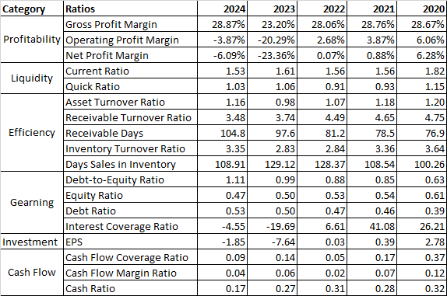
Table 1. Financial Ratios of General Electronics. Source: Case Study
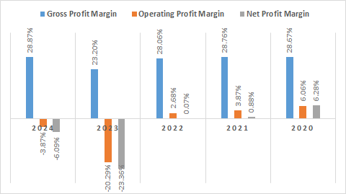
Graph 1. Profitability Ratios of General Electronics. Source: Case Study
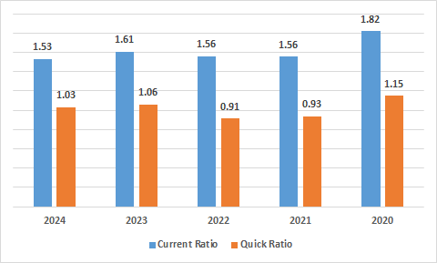
Graph 2. Liquidity Ratios of General Electronics. Source: Case Study
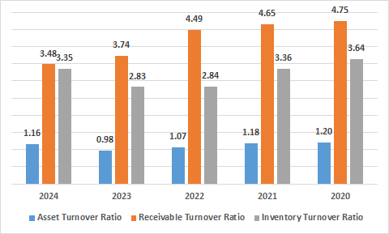
Graph 3. Efficiency Ratios of General Electronics. Source: Case Study

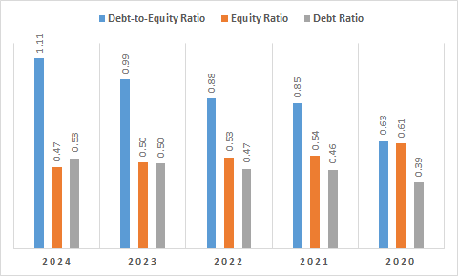
Graph 4. Gearing Ratios of General Electronics. Source: Case Study
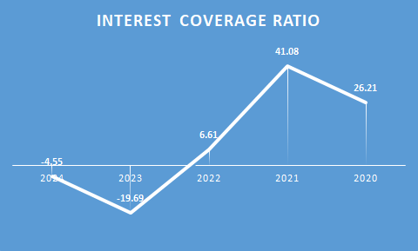
Graph 5. Interest Coverage Ratio of General Electronics. Source: Case Study
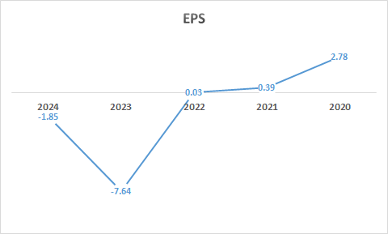
Graph 6. EPS of General Electronics. Source: Case Study
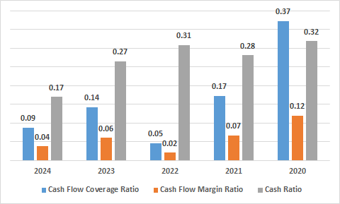
Graph 7. Cash Flow Ratios of General Electronics. Source: Case Study
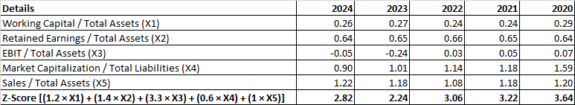
Table 2. Altman Z-Scores of General Electronics. Source: Case Study
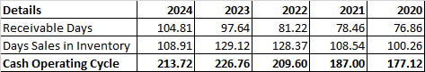
Table 3. Cash Operating Cycle of General Electronics. Source: Case Study
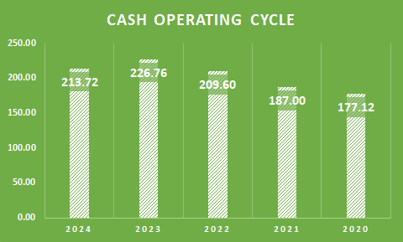
Graph 8. Cash Operating Cycle of General Electronics. Source: Case Study
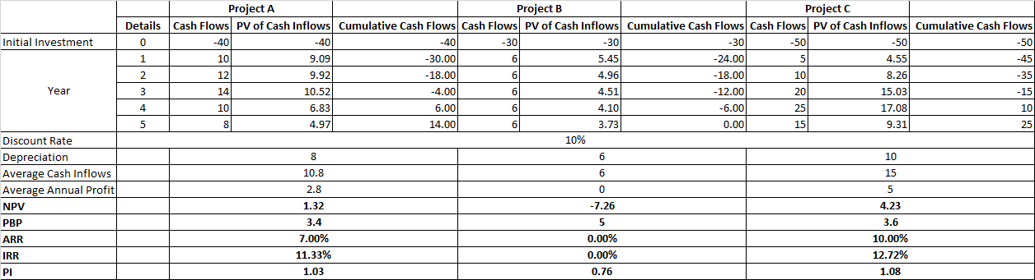
Table 4. Investment Appraisal and Capital Budgeting of General Electronics. Source: Case Study
Investment Appraisal Method | Project A | Project B | Project C
PBP | 3.4 years | 5 years | 3.6 years
ARR | 7% | 0% | 10%
NPV | £1.32 million | -£7.26 million | £4.23 million
PI | 1.03 | 0.76 | 1.08
IRR | 11.33% | 0% | 12.72%
Table 5. PBP, ARR, NPV, PI, and IRR of General Electronics. Source: Case Study
Project A | Project B | £40 million + £30 million = £70 million | Surpasses £60 million
Project A | Project C | £40 million + £50 million = £90 million | Surpasses £60 million
Project B | Project C | £30 million + £50 million = £80 million | Surpasses £60 million

Table 6. Project Comparison. Source: Case Study

