ASSESSMENT
MANAGEMENT ECONOMICS

Stefan Gheorghe-2024473

Management Economics – LCBB 5003
Lecturer Dr. Juan Carlos Braschi Rangel
University of Wales Trinity Saint David
30.08.2022

Table of Contents
1.Introduction 3
2. Market Conditions and Factors that Influence Demand 4
2.1 Price of Substitutes 5
2.2 Price of complements 6
2.3 Consumer Income 7
2.4 Consumers Tastes and Preferences 7
2.5 Expectation of Price Changes 8
3. Factors Affecting Price Elasticity of Demand 8
3.1 Substitutes Effect 9
3.2 Income Effect 10
3.3 Pricing Policy 12
References 13

1.Introduction
Apple Inc. is an American company that designs, manufactures and markets, on a global level, personal computers, smartphones, tablets, wearables, and accessories, but also sells various related services. It was the first successful personal computer company and the popular creator of graphical user interface, or GUI. The company was founded in 1976 in Cupertino, California, and is the dream and creation of Stephen Wozniak, Steven Jobs and Ronald Wayne. It started as a personal computer focused company selling the famous Macintosh and had many successful years. From 1990 though there was a decline in sales mostly due to the lower priced duopoly between Microsoft’s Windows operating system and Intel’s hardware competition. In 1997 the company was near bankruptcy, but Steven Jobs returned it to profitability by systematically introducing new innovative products to the market. The iMac, iPod, iPad, and later iPhone broadened the company’s product portfolio and by 2018 it was valuated at over $1 trillion, further increasing at $2 trillion in august 2020.
Today, Apple offers a wide range of products and services worldwide. Apart from the well-known iPhone, which is a line of smartphones, the company offers the Mac, a line of personal computers, the iPad, a line of multi-purpose tablets, Air Pods Max, an over-ear wireless headphone, and several wearables, home, and accessories comprising of Air Pods, Apple TV, Apple Watch, Beats products, Home Pod, and iPod touch. Furthermore, it provides AppleCare support and a platform like App Store, where customers can download digital content. The company is heavily invested in the technological revolution, and this has led Apple to report an annual revenue of $365.82 billion in 2021, and increase of 33.25% from previous year, as shown in the figure below.
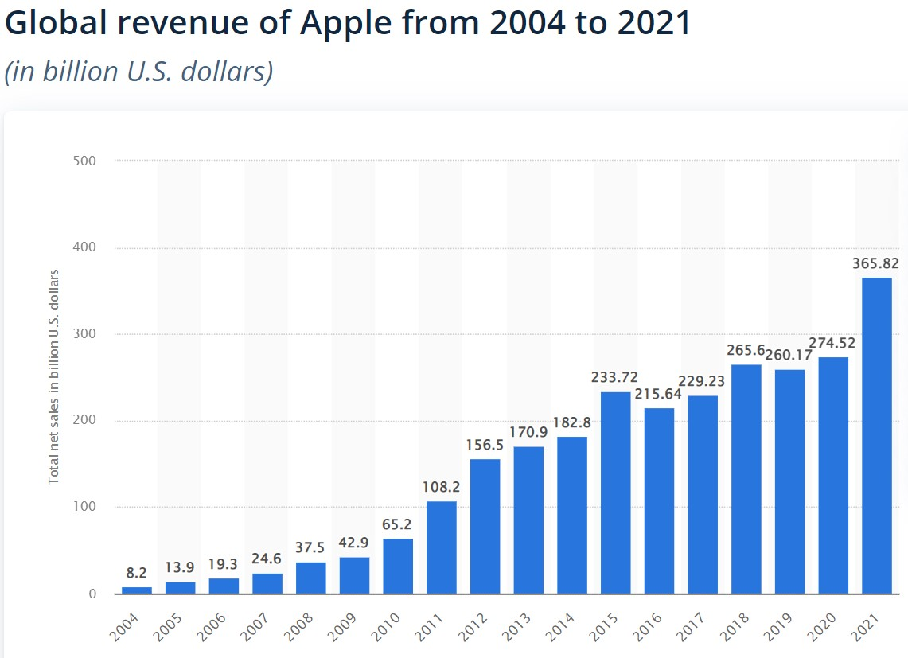
Fig.1 Source: (Statista, 2022)
The main reason for this rise in revenue is represented by the new iPhone products launched in the first quarter and fourth quarter of 2021, and the increasing demand for these products. In the figure below, we can observe the products and services performance of Apple for the last 3 years.
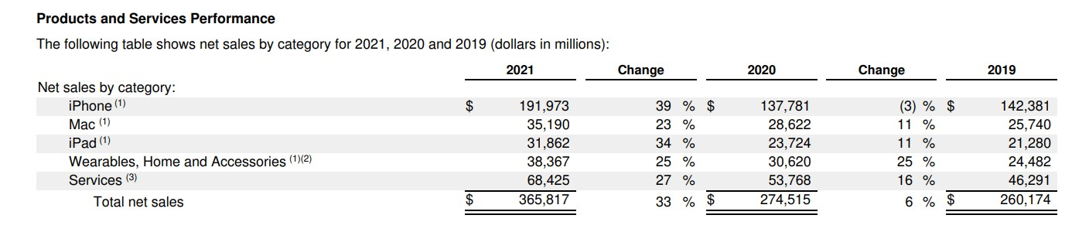
Fig.2 Source: (AnnualReports.com, 2021)
These figures have led us to choose the iPhone product and perform an analysis on the factors that influences the demand and the price elasticity of demand for this product.

2. Market Conditions and Factors that Influence Demand
The iPhone has been in high demand ever since the first model was released in 2007, mainly because it didn’t have much competition and the closest substitute at that time was Blackberry, which could not compete with the features of an iPhone. In the past years though, there was a decline in the market share of the product as more competitors entered the smartphone market. In figure 3, we can observe the sales by region of iPhone between 2015 and 2021. United States still represents the biggest market for iPhone sales, followed by Europe. After the constant decline in China’s market sales from 2015, mostly due to competitors introducing more substitute products, this market has seen its customers taste and preferences chance in 2021, increasing its demand by 23% versus 2020, most likely due to the features of the new iPhone 12.
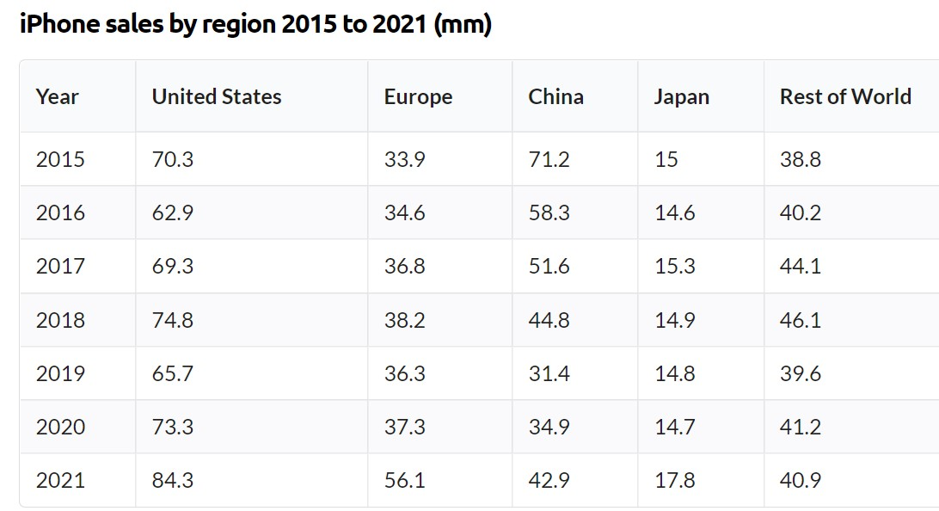
Fig.3 Source: (Curry, 2022)
Looking at figure 4 below, we can observe the market share of smartphone shipments from different companies. In 2021, there were only 5 major companies that supplied over 70% of the total market demand, making this structure a perfect example of an oligopoly. By using the Herfindahl-Hirschman Index to measure the market concentration we obtain a result of 1940.65, which indicates a moderately concentrated market (Hayes, 2022).
HHI index = 20.1² + 17.4² + 14.1² + 9.9² + 9.5² + 29.1²
HHI index = 404.01 + 302.76 + 198.81 + 98.01 + 90.25 + 846.81 = 1940.65
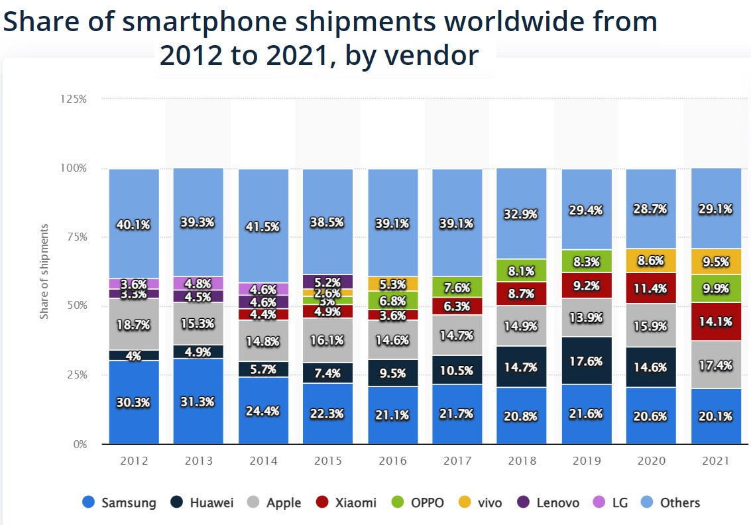
Fig.4 Source: (Statista , 2022)
By operating in an oligopoly, we can assume that the firms involved will be affected directly by how the other firms in direct competition set their products prices and output. In oligopolies firms usually are engaged in non-price competition and focuses more on product quality and advertising.

2.1 Price of Substitutes
A substitute good is a product that satisfies a common want of a consumer, and which are in direct competitive demand. One of the determinant factors that influences demand and bring a shift in the demand curve is the price of a related good. For iPhone a close substitute is represented by the Samsung smartphone products, or by Xiaomi and Oppo products. Any smartphone producer that releases a similar product as the Apple’s iPhone is a substitute for our product.
Cross price elasticity of demand (XED) measures the percentage change in demand of a product that occurs as a response of a percentage change in the price of another product. If the XED value is positive, then the products are substitute, and if the value is negative then the products are complements. The formula to calculate the XED value is:
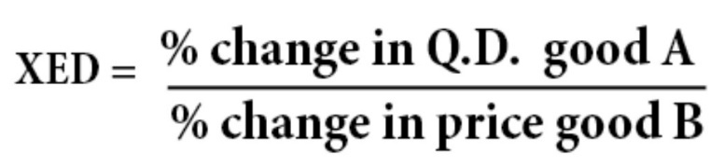
Source: (Pettinger, 2017)
In our case, in 2020, there was a change in price on all Samsung smartphone releases. The Samsung S10, released in 2019 was starting at $899, while the new Samsung S20 was prices starting at $999, an 11.12% increase in price due mostly to the fact that Samsung was the only smartphone company that was selling 5G compatible devices (Kelly, 2020). In October 2020, Apple launched its iPhone 12 range, that was also capable of 5G connectivity, but was priced starting at $849, which led to a strong performance in Q4 of 2020 from Apple, compared to 2019 and shown in figure 5 below.
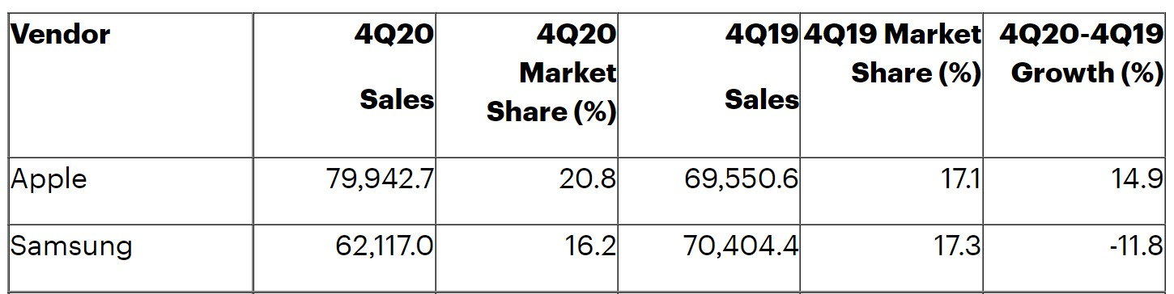
Fig.5 Source: (Gartner Inc., 2021)
We can now calculate the XED value:
$XED= ∆Demand Apple÷∆Price Samsung=14.9\%÷11.12\%$
$XED=1.34$ means they are substitutes.
The price of substitutes is going to influence the demand for the iPhone, but ultimately the consumer taste, preferences and product differentiation are going to play an important role in the demand for the product. Through advertising Apple is increasing its brand loyalty and makes consumers to be less willing to switch to another brand even if the prices for their products rise.

2.2 Price of complements
A complement is a product that is used together with another product, in joint demand. The XED can be used here as well but the value is going to be negative. As examples for the iPhone product, we have phone cases, screen protectors, power cables, wireless charging station, 3rd party apps and many accessories that can be used with the iPhone. All these complementary goods have seen an increase in number and variety so today we have hundreds or thousands of choices when purchasing them. This increase in competition has led to the decrease in price of most of the complementary goods, making them more affordable. Also, the rise in demand for iPhone products has prompted the increase in supply for these products.

2.3 Consumer Income
The disposable income of consumers its an important factor when determining the demand for any product. To help making decisions, businesses use an indicator called income elasticity of demand (YED), which shows how responsive the demand for a product is to a change in real income. If YED is negative, the good is considered an inferior good, while a positive value indicates a normal good. This is further divided in two more categories according to the value of YED. For values higher than 0 but lower than 1 the good is considered a normal necessity good, while values higher than 1 are considered luxury goods. The formula to calculate YED value is:
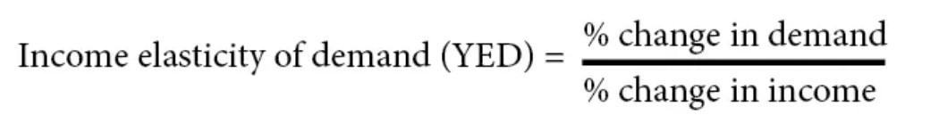
Source: (Pettinger, 2019)
According to US Census Bureau, the median real income in United States in 2020 was $67.521 per year, an increase of 9.35% from the 2015 value of $61.748 (US Census Bureau, 2021). At the same time, Apple reported sales in the US of 73.3 million units in 2020, an increase of 4.26% from the 70.3 million units sold in 2015. Based on these figures we can calculate the YED for iPhone in relation to the real income of US citizens.
$$YED=∆ Demand ÷∆ Income =4.26\% ÷9.35\%$$
$$YED =0.45$$
According to this value of YED, the iPhone would be considered a normal necessary good rather than a luxury as the price of it suggests. We could argue that the availability of flexible payments for the gadgets as well as the increase in real income has pushed the YED values from luxury good to necessity good, making the iPhone more accessible to lower income classes, thus increasing the demand for the good.

2.4 Consumers Tastes and Preferences
Consumers tastes and preferences refer to the tendency to favour one product over other alternatives. If the consumer buys an iPhone instead of any other rival smartphone, then they prefer this choice which reflects consumer and brand loyalty, and successful marketing strategies. The changes in preferences always affect the level of demand for that good. Apple should understand better the consumer tastes and preferences as it is vital for marketing success. The company should anticipate consumer behaviour changes and adapt the products to build a stronger consumer experience.
The personal, social and psychological factors influence the consumer decision to purchase a product. Any change in these factors will influence the demand curve by either increasing the demand for our product, if the consumer beliefs that the benefits brought by the product are enough to satisfy him, or by decreasing the demand if the consumer believes that he can find better alternatives. An example of the change in consumer taste is the iPhone sales in China, which saw a volume decrease from 71.2 million units in 2015 to 34.9 million units in 2020 (Curry, 2022). This is a significant decrease of 51% in 5 years and is mostly due to the increase in competition by the Asian smartphone producers and to the fact that consumer shifted to the competitors’ products because these were more affordable and supported national businesses.

2.5 Expectation of Price Changes
A study made by Simon-Kucher & Partners in 2019 in US, revealed the willingness of consumers to pay higher prices for future new iPhone devices with 10% of respondents saying they would pay over $2.000, and a further 15% agreeing to pay more than $1.800 for new iPhone devices (MacDailyNews, 2019). This is primarily driven by the fact that consumers can now opt for 24-month free interest purchase options that would spread the cost of the good and have little influence on the consumers disposable income. Demand for the iPhone has remained strong despite the year-on-year price increases and consumers have shown no signs of decreasing their demand because of the price of the product.

3. Factors Affecting Price Elasticity of Demand
Price elasticity of demand (PED) measures the responsiveness of demand after a change in the goods own price. The formula to calculate PED is:
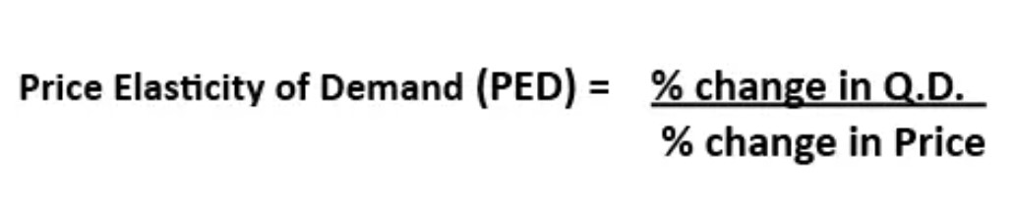
Source: (Pettinger, 2019)
The value of PED shows us how elastic is the demand following a change in price. The return values can be:
- Less than 1, which means PED is inelastic
- Greater than 1, which means PED is elastic
- Zero, means that PED is perfectly inelastic
- Infinite, which means PED is perfectly elastic
There are several reasons why companies would gather information about the PED of its products. A company will have more control over internal operations and production costs while the external environment needs to be studied and forecasts to be made regarding the effects on demand followed by a change in price. By gathering data on how consumers respond to changes in price firms can help reduce risks and uncertainties. The PED for iPhone is highly dependant on the time factor, as each model launched has a short product life cycle. As newer models of the iPhone are released to the market, its PED is deemed as inelastic as a change in price for the new model will not affect the demand for it significantly. At the same time, the older model(s) of iPhone will have a PED value that is seen as elastic, simply because of the availability of more similar smartphones in the market. Apple will reduce the price on these older models to attract a new pool of consumers and increase demand and subsequently the revenue obtained.

3.1 Substitutes Effect
Regarding substitute products, it can be said that for iPhone a substitute good is considered any competitive smartphone product that can satisfy a similar need of the target consumers. We can consider Samsung, Oppo, Xiaomi or Huawei products as direct competitors in the market of smartphones. Even though all the other competitors provide a similar physical product, Apple is differentiating its iPhone product by supplying its own operating system, the iOS. In this regard, the iPhone is unique from the rest of smartphone producers.
As stated above, we found that on the long term the YED value suggests that the iPhone is considered a normal necessity good. With the technological advances in the past years, owing a mobile device has become more of a necessity that a luxury, fact proven by the consumers who now own and use at least one mobile device, as seen in figure 6 below.
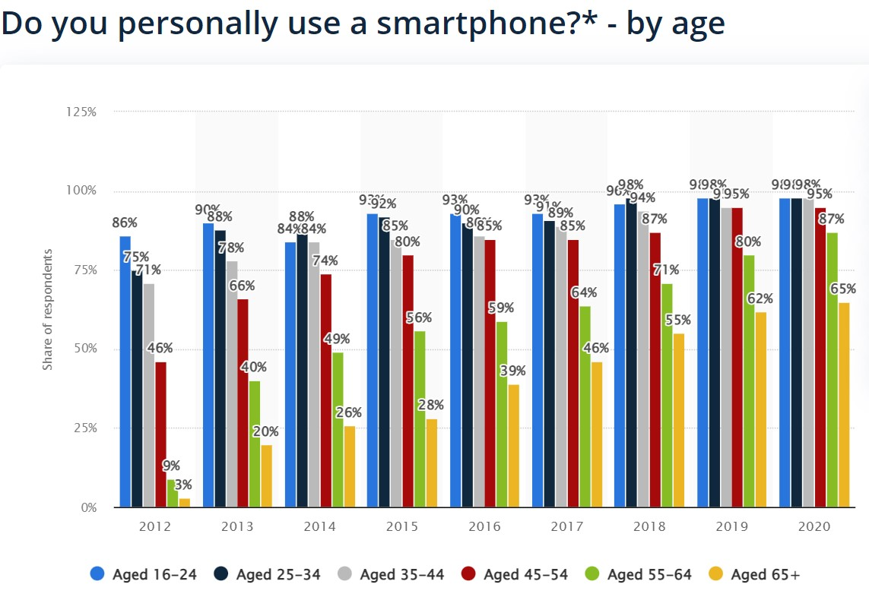
Fig.6 Source: (Statista, 2022)
The degree of necessity for smartphone devices and the tastes of consumers, influenced by the marketing campaigns is leading to a demand that is price inelastic. In the case of iPhone, the substitutes can be considered as weak, because of the difference in product offered by the operating system of Apple makes the iPhone not easily replaced and more inelastic in demand. The other competitors offer similar, undifferentiated products, all based on the Android operating system, and because of this their demand is more price elastic.

3.2 Income Effect
Society is divided into different classes that are based on income levels and other factors. For a company like Apple, that serves multiple global markets, the percentage of consumer income that is spent on their goods is important in determining the pricing policies that will influence how much revenue and profit the company will make.
According to a survey conducted by Slickdeals in 2018 in US, the iPhone owners tend to have a higher income than those who use an Android device. Those who use iPhones have an average salary of $53.251, while the Android users have an average salary of $37.040. In figure 7 below, we can observe a summary of the survey data which indicates that the iPhone users not only have a higher income level but also spend more on other commodities. This information is helpful for marketers who need to decide the target market they want to attract and the promotional mix to use.
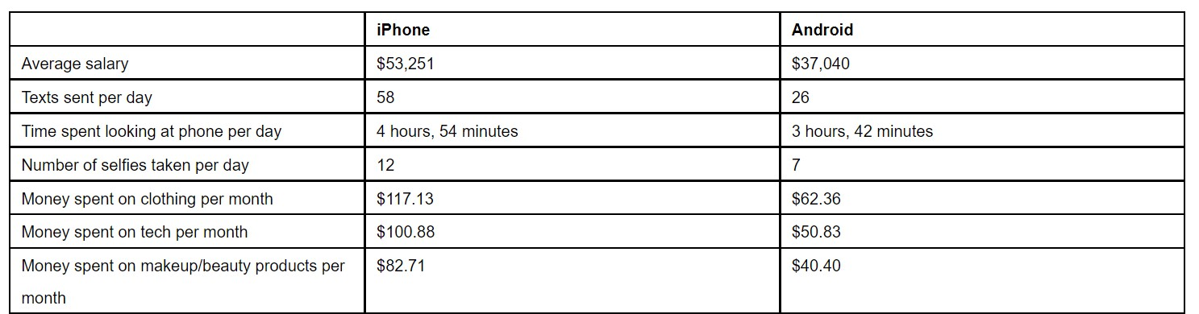
Fig.7 Source: (Slickdeals, 2018)
In 2020, in US the median household income was $67.521 (US Census Bureau, 2021). Based on this information and an article published in Statista and shown in the figure below, we can calculate how much of the yearly income consumers spend on the iPhone released that year.
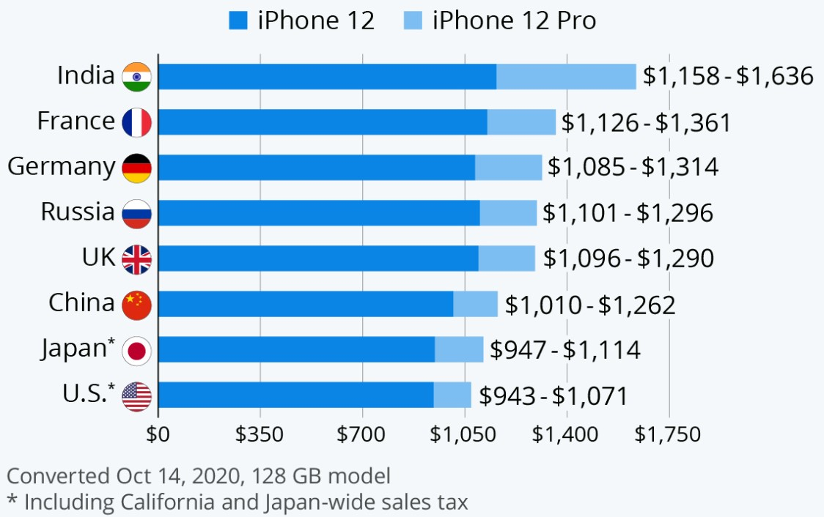
Fig.8 Source: (Buchholz, 2020)
 | Median income | Cost of iPhone 12 | Percentage of income | Cost of iPhone 12 PRO | Percentage of income
United States | $67.521 | $943 | 1.396% | $1.071 | 1.586%

As we can see, the percentage of income spent when buying an iPhone in US is low and has little influence over the demand for the product. The PED in this case would be inelastic as higher prices could be charged by Apple with insignificant change on demand.
In the case of countries where the median income is low, and the percentage of income spend to acquire an iPhone is high the PED value would indicate a price elastic demand. In figure 8, India has a listed price well above the other countries, mostly due to high taxation, intermediaries and the fact that Apple has no assembly factory in the country. Considering the price reported to the disparities in income would suggest a PED value in which the demand is more price elastic.

3.3 Pricing Policy
The pricing policy we suggest would depend very much on the country where we sell the iPhone products. If PED is higher than 1, meaning that the demand is price elastic, we could slightly decrease the price of the product to increase demand and revenue while maintain a good profit margin and introduce more flexible monthly payments, that would encourage new customers to purchase the product. If PED value shows that demand is price inelastic, we could increase the price of the product to increase revenue, considering also the profit margin.

References
AnnualReports.com, 2021. Apple Annual Report 2021. [Online]
Available at: https://www.annualreports.com/Company/apple-inc
[Accessed 25 08 2022].
Buchholz, K., 2020. The Price of the iPhone 12 Around the World. [Online]
Available at: https://www.statista.com/chart/19336/the-price-of-the-iphone-around-the-world/
[Accessed 29 08 2022].
Curry, D., 2022. Apple Statistics. [Online]
Available at: https://www.businessofapps.com/data/apple-statistics/
[Accessed 26 08 2022].
Gartner Inc., 2021. Newsroom. [Online]
Available at: https://www.gartner.com/en/newsroom/press-releases/2021-02-22-4q20-smartphone-market-share-release
[Accessed 26 08 2022].
Hayes, A., 2022. Herfindahl-Hirschman Index (HHI). [Online]
Available at: https://www.investopedia.com/terms/h/hhi.asp
[Accessed 26 08 2022].
Kelly, G., 2020. Samsung Shock Warning For Millions Of Galaxy S20, S20 Ultra Buyers. [Online]
Available at: https://www.forbes.com/sites/gordonkelly/2020/03/03/samsung-galaxy-s20-ultra-support-two-years-update-price-upgrade-galaxy-s10-note10-upgrade/?sh=1ed5f87b2ee1
[Accessed 26 08 2022].
MacDailyNews, 2019. Study reveals consumers willing to pay up to $2,400 for new iPhone. [Online]
Available at: https://macdailynews.com/2019/09/09/study-reveals-consumers-willing-to-pay-up-to-2400-for-new-iphone/
[Accessed 27 08 2022].
ONS, 2022. Average household income, UK: financial year ending 2021. [Online]
Available at: https://www.ons.gov.uk/peoplepopulationandcommunity/personalandhouseholdfinances/incomeandwealth/bulletins/householddisposableincomeandinequality/financialyearending2021
[Accessed 27 08 2022].
Pettinger, T., 2017. Cross Elasticity of Demand. [Online]
Available at: https://www.economicshelp.org/microessays/equilibrium/cross-elasticity-demand/#:~:text=It%20will%20have%20a%20negative%20cross%20elasticity%20of,there%20will%20be%20less%20demand%20for%20Android%20Apps.
[Accessed 26 08 2022].
Pettinger, T., 2019. Income Elasticity of Demand (YED). [Online]
Available at: https://www.economicshelp.org/microessays/equilibrium/income-elasticity-demand/
[Accessed 26 08 2022].
Pettinger, T., 2019. Price Elasticity of Demand (PED). [Online]
Available at: https://www.economicshelp.org/microessays/equilibrium/price-elasticity-demand/
[Accessed 28 08 2022].
Slickdeals, 2018. PR Newswire. [Online]
Available at: https://www.prnewswire.com/news-releases/iphone-users-spend-101-every-month-on-tech-purchases-nearly-double-of-android-users-according-to-a-survey-conducted-by-slickdeals-300739582.html?c=n
[Accessed 29 08 2022].
Statista , 2022. Global Market Share of Smartphones Vendors. [Online]
Available at: https://www.statista.com/statistics/271492/global-market-share-held-by-leading-smartphone-vendors/
[Accessed 26 08 2022].
Statista, 2022. Statista. [Online]
Available at: https://www.statista.com/statistics/265125/total-net-sales-of-apple-since-2004/
[Accessed 25 08 2022].
Statista, 2022. Statista. [Online]
Available at: https://www.statista.com/statistics/300402/smartphone-usage-in-the-uk-by-age/
[Accessed 28 08 2022].
US Census Bureau, 2021. Income, Poverty and Health Insurance Coverage in the United States: 2020. [Online]
Available at: https://www.census.gov/newsroom/press-releases/2021/income-poverty-health-insurance-coverage.html
[Accessed 27 08 2022].

