

Applying a Procedural Texture to a 3D object
By
Rhiannon Thomas

Supervisor: Andrew Baker
Second Marker: Gordon Dickers

Project submitted as part of the requirements for the award of BSc (Hons) Computer Games Development

April 2019

Declaration FORM AND FORM OF CONSENT
DECLARATION

I, Rhiannon Marie Thomas declare that I am the sole author of this Project; that all references cited have been consulted; that I have conducted all work of which this is a record, and that the finished work lies within the prescribed word limits.

This work has not previously been accepted as part of any other degree submission.

Signed: R Thomas

Date: 30/04/2019

FORM OF CONSENT

I Rhiannon Marie Thomas hereby consent that my Project, submitted in candidature for the B.Sc. Computer Games Development degree, if successful, may be made available for inter-library loan or photocopying (subject to the law of copyright), and that the title and abstract may be made available to outside organisations.

Signed: R Thomas

Date: 30/04/2019

ABSTRACT
In modern day society, the main complication with gaming is to create visually realistic objects. To tackle this obstacle, Procedural textures have been implemented which gives gamers the effect that objects look realistic. The concept of Procedural texturing originated back in 1983 by Ken Perlin. This project has been created to tackle the problem with “machine-like” objects and instead create a procedural texture and apply it to a 3D object.
This project contains seven chapters which includes an Introduction, Research and Review of Literature, Research and Development Methodology, Design and Implementation, Evaluation, Conclusions and Recommendations and Reflection.
The main methods that have been used in this project includes the Development techniques, implementation and Research Methodology. These three processes is what creates the project and makes it a success.
Also, a critical Evaluation and Conclusions are included at the bottom of the report which analysis the data that has been implemented and a summary of the report.

Contents
Declaration FORM AND FORM OF CONSENT i
ABSTRACT iii
Contents iv
Table of figures v
2 Introduction 6
2.1.1 Aim 6
2.1.2 Objectives 6
2.1.3 Structure of Report 6
3 Research and Review of Literature 7
3.1 Procedural Techniques 7
3.1.1 Abstraction 8
3.1.2 Parametric Control 8
3.1.3 Flexibility 8
3.1.4 Procedural Generation 8
3.2 Building Procedural Textures 8
3.2.1 Texture 8
3.2.2 Texture Mapping 9
3.2.3 Procedural Texture 9
3.2.4 Procedural versus Non-Procedural 9
3.2.5 Implicit and Explicit Procedures 10
3.2.6 Advantages of Procedural Texturing 10
3.2.7 Disadvantages of Procedural Texturing 11
3.3 Fractals 11
3.3.1 Monofractals 11
3.3.2 Multifractals 12
3.3.3 Conclusion 12
3.4 L-Systems 12
3.4.1 Rewriting 12
3.4.2 Turtle Commands 12
3.4.3 D0L-System 13
3.4.4 Conclusion 13
3.5 Perlin Noise 13
3.5.1 Lattice Noise 14
3.5.2 Value Noise 14
3.5.3 Gradient Noise 15
3.5.4 Value-Gradient Noise 15
3.5.5 Lattice Convolution Noise 16
3.5.6 Sparse Convolution Noise 16
3.5.7 Explicit Noise Algorithms 16
3.5.8 Wavelet Noise 17
3.5.9 Anisotropic Noise 17
3.5.10 Fourier Spectral Synthesis 17
3.5.11 Interpolation Function 18
3.5.12 Conclusion 19
3.6 OpenGL Shading Language 19
3.7 Conclusion 20
4 Research and Development Methodology 21
4.1 Research Overview 21
4.1.1 Positivism 22
4.1.2 Deductive 22
4.1.3 Document Review, Software Development and Experiment 22
4.2 Research Methodologies 23
4.2.1 Develop an Overall Model 23
4.2.2 Build a Features List 24
4.2.3 Plan by Feature 24
4.2.4 Design by Feature 25
4.2.5 Build by Feature 25
4.3 Development Methodology 25
4.4 Research Deliverables 25
4.5 Conclusion 26
5 Design and Implementation 27
5.1 Requirements 27
5.2 Problem Formulation 28
5.3 Design 28
5.3.1 Step-By-Step Process 28
5.4 Implementation 29
5.5 Testing 31
5.5.1 Unit testing 31
5.5.2 System testing 35
5.5.3 Acceptance Testing 36
5.6 Storyboard 36
5.7 Conclusion 37
6 Evaluation 38
6.1.1 Conclusion of Data 38
6.1.2 Meeting the Aim and Objectives 38
6.1.3 Finalized Design 39
7 Conclusions and Recommendations 40
7.1 Summary 40
7.1.1 Introduction 40
7.1.2 Research and Review of Literature 40
7.1.3 Research and Development Methodology 40
7.1.4 Design and Implementation 41
7.1.5 Evaluation 41
7.2 Conclusion 41
7.3 Recommendations for Further Research 42
8 Reflection 43
9 References 44
10 Bibliography 48
11 Appendicies 51
11.1.1 Appendix 1 – Predicted Outcome 51
11.1.2 Appendix 2 – Original Design 51
11.1.3 Appendix 3 – Actual Outcome 52
11.1.4 Appendix 4 – Fragment Shader 52
11.1.5 Appendix 3 – Vertex Shader 53

Table of figures
Figure 1: Examples of Procedural Textures 9
Figure 2: The Koch Snowflake 13
Figure 3: Diagram of Turtle creating letter “L” 15
Figure 4: Example of D0L-system 15
Figure 5: Lattice Noise 16
Figure 6: Value Noise 17
Figure 7: Sparse Convolution Noise 18
Figure 8 (A):2D Wavalet Noise 19
Figure 8 (B): 2D sliced through 3D wavalet noise 19
Figure 9: Anisotropic Noise 19
Figure 10 (A): Linear Interpolation 21
Figure 10 (B):Cubic Interpolation 21

Introduction
A project will be undertaken to solve a common problem in gaming industries these days. Graphics is an ongoing evolution and so far, programmers can create realistic objects using procedural textures. In this project, a procedural texture will be created and rendered onto a 3D object by using multiple mathematical algorithms.

Aim
The main aim of this project is to successfully develop a procedural texture and apply it to a 3D object.

Objectives
There are multiple objectives which are achievable by creating this project. The objective are to:
- Establish the understanding of the different types of procedural textures which have been used in the past and discuss different procedural techniques that can be used for this project;
- Establish the requirements needed to develop this project;
- Provide a critical literature review providing information about procedural texturing and what types of different procedural textures have been used before;
- Develop a programme which applies a procedural texture to a 3D object
- Evaluate, discussing the implementation, the effectiveness of the code that has been written and discuss other ways which could have been used
- Expose the finalised programme and use the evaluation to make appropriate modifications to future development

Structure of Report
This project has been created into three parts including critical research and methodology in the first part of the project, design, implementation and evaluation in the second part of the project and conclusions and reflection in the third part of the project. Below is a short summery of what is discussed in each chapter:

Chapter One – This chapter illustrates an overview of the overall project, it details the aim and objectives and once achieved will bring success to this research.
Chapter Two – This chapter is based on Research and Review of Literature. It thoroughly details the information of procedural texturing and specifies the different types of procedural textures that have been used before.
Chapter Three – This chapter is based on Research and Development Methodology. It details the approach taken to carry out this project.
Chapter Four – This chapter is based on Design and Implementation. It details the design and the implementation used whilst developing the project.
Chapter Five – This chapter is based on the Evaluation. It details the conclusions of the result and whether the objectives have been met.
Chapter Six – This chapter is based on the Conclusions and Recommendations. It details a summary of the overall project and recommendations on future development.
Chapter Seven – This chapter is based on Reflection. It details what has been learnt during the implementation of the project.

Research and Review of Literature
Computer Graphics are images created using computers. There is a crucial element needed to create an effective graphical image which are textures. Textures exist in nearly every naturally occurring object and texturing can be viewed as a process of adding textures to synthesized images [1]. There are ways in which users can create a procedural approach of texturing by applying mathematical algorithms to the texture.

Procedural Techniques
Procedural Techniques are used to create realistic textures, such as marble, wood, stone and other natural materials shown in figure 1. These techniques were then extended to procedural modelling which includes models of water, smoke, steam, fire, planets and dribbles [2]. Usually, the natural output of the rendered result is achieved by using fractal noise and turbulence functions [3].

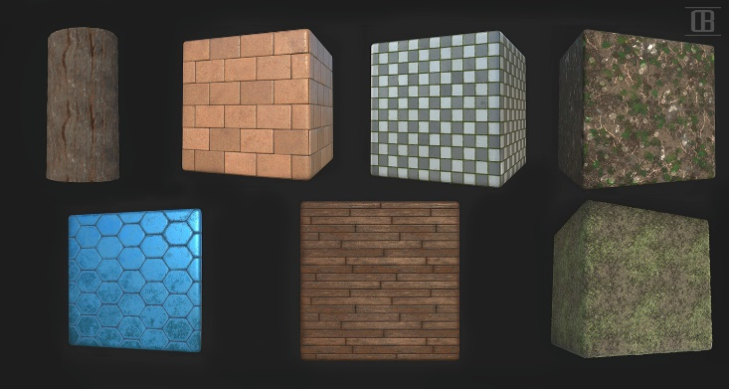

`
Figure 1: Examples of Procedural Textures

Procedural techniques have been created and applied successfully in the generation of numerous complex phenomena in computer graphics especially within the games industry. One of the most time-consuming aspects of developing games is the creation of game geometry, the virtual world which players inhabit [4]. Procedural techniques are code segments or algorithms that specify some characteristic or computer-generated model or effect [5]. Basically, in order to create this technique, the user must apply a set of algorithms to the texture to make it procedural. For example, a procedural texture for a marble surface does not use a scanned-in image from the internet to define the colour values [2]. Instead, it uses algorithms and mathematical equations to determine the colour [2]. There are many procedural techniques used which are Fractals, L-systems and Perlin Noise.

Abstraction
One of the most important features of a procedural technique is abstraction [2]. Procedural Abstraction is a mechanism for separating use from implementation [6]. It ties the idea each individual method performs in a well-specified function [6]. Abstraction allows the user to create inherent multiresolution models and textures that we can evaluate to the resolution required [2].

Parametric Control
Another feature of a procedural technique is parametric control [2]. This feature allows the user to assign to a parameter a meaningful concept, meaning that it enables users to assign a number that makes mountains rougher or smoother [2]. This feature gains useful components such as Database Amplification which provides amplification of the modeller/animator’s efforts [2]. Also, this feature has the serendipity inherent in procedural techniques [2].

Flexibility
Procedural models also include flexibility [2]. The designer of the procedures can abduct the essence of the object, phenomenon or motion without being constrained by the complexity of the laws of physics [2].

Procedural Generation
Procedural Generation differs from Texturing because it describes the entity, geometry, texture or effect, in terms of a sequence of generation instructions rather than as a static block of data [4]. In computer graphics, it is also called random generation, it is used to automatically create large amounts of content in a game [7].

Building Procedural Textures
Throughout the history of computer graphics, many researchers have desired to enhance the realism of their synthetic images by finding exceptional ways to render the appearance of surfaces [2]. This can work by using shading and texturing, this allows users to apply shading and texturing to an object this includes changing colour, changing appearance of the object, darkening certain parts of an object, changing the light source of an object and many more. Shading is the process of calculating colour of a pixel or shading sample from user-specified surface properties and the shading model [2]. Texturing is the process of varying the surface properties from point to point so that it can give the appearance of surface detail that is not usually present in the geometry of the surface [2]. Both methods are used to make objects visually appealing to the eye.

Texture
In computer graphics, a texture is the digital representation of the surface of an object [8]. Textures have two-dimensional qualities such as colour and brightness, it is also encoded with three-dimensional properties such as how transparent and reflective the object is [8]. Well-defined textures are very important for rendering realistic 3D images [8]. However, textures require large amounts of memory, so they’re not used as often as they should be [8].
Edwin Catmull generated the first textured computer graphics image [2]. Catmull’s surfaces were represented as parametric patches [2]. Each point on the 3D surface of a parametric patch corresponds to a parametric 2D point $(u,v)$in parameter space [2]. These 2D-to-3D correspondences implies that a two-dimensional texture image can easily be mapped onto the 3D surface [2]. The (u,v) parameters of any point on the patch can be used to compute a corresponding pixel located in the texture image [2].

Texture Mapping
Texture mapping is a two-dimensional surface which is wrapped around a three-dimensional object [9]. It can apply colour, texture or any other surface detail like glossiness, reflectivity and transparency to the 3D object [10]. Texture maps are developed to directly correspond to the UV coordinates of an unwrapped 3D object and are either devised from real-life images or hand painted in a graphical application like Photoshop [10].

Procedural Texture
A procedural texture is an algorithmic way of constructing a texture [11]. Compared to bitmapped textures, in which the texture is represented as a bitmap, a procedural texture includes mathematical algorithms [11]. Robert L. Cook (1984) constructed the “Shade Trees” system, which was one of the first systems in which it was acceptable to generate procedural textures during rendering [2]. Shade Trees is a flexible tree-structured shading model that can represent a wide range of shading characteristics [12]. The model provides an easy way for specifying complex shading characteristics [12]. This method is also efficient because it can tailor the shading calculations to each type of surface [12]. Ken Perlin (1985) constructed a complete procedural texture generation language and laid the foundation for most popular class of procedural textures which is in use today, these procedural textures are commonly known as “noise” a stochastic texture generation is primitive [2].

Procedural versus Non-Procedural
Theoretically, a procedural texture is a better technique to use because it has infinite resolution, increased editability and can be applied to nearly any model without repetition or resolution issues [13]. One major defining characteristic of a procedural texture is that it is synthetic generated from a program or model rather than a digitized or painted image [2]. However, image textures can be included between procedural textures in a procedural texture language that combines image-based texture mapping as one of its primitive operations [2]. Some admirable procedural textures can be based on the procedural combination, modification or distortion of image textures [2]. Also, image textures can be swiftly made unlike procedural textures which can be time consuming due to challenging and complexed mathematical algorithms.

Implicit and Explicit Procedures
There are two major types of procedural texturing or modelling methods which are explicit and implicit methods [2]. In explicit methods, the procedure directly generates the points that make up a shape [2]. In implicit methods, the procedure answers a query about a point [2]. The most common form of implicit method is the isocurve (in 2D) or isosurface (in 3D) [2]. This method is a texture pattern which is characterized as a function F of points P in the texture space, and the patterns consists of a level set of F, that is, the set of all points at which the function has a particular value $C: \{P| F (P) = C\}$ [2].

In the texturing aspect, implicit procedural methods are recommended to be used for textures that are evaluated during rendering [2]. In both ray tracers and depth buffer renderers, texture samples are usually required to be evaluated in order that is determined by the renderer, not by the procedural texture [2]. An implicit procedure fits perfectly in this situation because this procedure is designed to answer a query about any point in the texture at any given time [2]. An explicit procedure desires to generate its texture pattern in some fixed order, which likely doesn’t match the requirements of the rendering algorithm [2]. In most renderers, using an explicit texture routine would require running the procedural texture as a prepass and having the procedure generate the texture image into an image buffer, where it could be looked up as essential for texture application during rendering [2].

In principle the explicit and implicit methods can be used to produce the same type of texture patterns or geometric models, but in routine each approach has its own type of models that are convenient or feasible [2]. Explicit models are convenient for polygons and parametric curves and patches [2]. Implicit models are convenient for quadrics and patterns that result from potential or force fields [2]. Since implicit models are usually continuous throughout a region of the modelling space, the models are appropriate for continuous density and flow phenomena such as natural stone textures, fog and clouds [2]. Other methods like Fourier Spectral Synthesis fit well into an implicit procedural system [2].

Advantages of Procedural Texturing
Procedural textures have major advantages over an image texture which includes:
- Procedural textures are more natural looking because there are no seams caused by texture wrapping [14].
- A procedural texture is extremely compact, the size of a procedural texture is usually measured if kilobytes, compared to a texture image which is usually measured in megabytes [2].
- A procedural texture has no fixed area. Most of the time it can provide a fully detailed texture no matter how closely the user looks at it [2].
- A procedural texture covers no fixed area. Meaning, it is unlimited in extent and can cover an arbitrarily large area without seams and unwanted repetition of the texture pattern [2].
- A procedural texture can be parameterized, so it can generate a class of related textures rather than being limited to one fixed texture image [2].

Disadvantages of Procedural Texturing
The disadvantages of a procedural texture compared to an image texture includes:
- A procedural texture can be complexed and hard to build and debug. Programming is often difficult and programming an implicit pattern is especially hard in nontrivial cases [2].
- A procedural texture can be a surprise. It is usually easier to predict the outcome when the user scans or paints a texture image [2].
- Evaluating a procedural texture can be slower than accessing a stored texture image, this is the classic time versus space trade-off [2].
- Aliasing can be a major problem in procedural textures. Antialiasing can be problematic and is less likely to be taken care of automatically than is in image-based texturing.

Fractals
Fractal Geometry is used to create visual complexity in synthetic imagery, it is a potent language of complex visual form [2]. The most common fractal used are Mountains, people can create convincing synthetic mountains with some simple fractal computer programs [2]. Benoit Mandelbrot, was largely responsible for fractal geometry, showing how fractals can occur in many different aspects both mathematics and elsewhere in nature [15].

The Basic concept of fractals is that they contain large degrees of self-similarity, this means that they usually contain little copies of themselves buried within the original copy like the stars embedded in the Koch Snowflake as shown in Figure 2 [4].

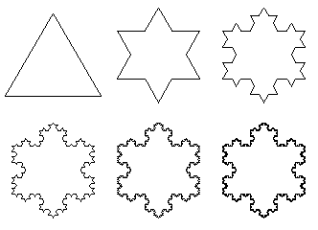

Figure 2: The Koch Snowflake

Monofractals
Monofractals can get boring quickly because they’re the same everywhere, all the time [2]. Monofractals are commonly used for clouds and textures because the procedure would be repeating the same method repeatedly, the same length, same smoothness and roughness. However, Multifractals are more interesting because they’re not the same everywhere. They’re smoother in some places and rougher in other places [2].

Multifractals
Multifractal systems are common in nature, including the length of coastlines, fully developed turbulence, real world scenes, heartbeat dynamics, human gait and activity and human brain activity [16]. F. Kenton Musgrave packaged up the two best behaved multifractals which was used in his creation of MojoWorld which are The Heterofractal Function and The Multifractal Function [2].

Conclusion
Many scientists have found fractal geometry a powerful tool for uncovering secrets from a wide variety of systems and solving critical problems within the Computer Graphics sector. Fractals have improved user’s precision in describing and classifying “random” or organic objects however, they are not all perfect, some scientists still believe that true randomness exist and no mathematical equation will ever be described to perfection [17].

L-Systems
L-systems also known as Lindenmayer-systems named after Astrid Lindenmayer, allow definition of complex shapes using iteration [18]. L-systems are used as a foundation for an axiomatic theory of biological development [19]. An L-system is a grammar on an alphabet of symbols, such as “F”, “+” and “-“. The development of an L-system model is enclosed in a set of productions which are rules that describe the replacement of a nonterminal symbol with a string of zero or more symbols [2].

Rewriting
The main concept of L-systems is rewriting. In general, rewriting is a technique for defining complex objects by successfully replacing parts of a simple initial object using a set of rewriting rules or productions [4].

Turtle Commands
L-systems can be used to visualise structures by integrating graphical symbols within the string that can then be used later to render it [4]. Turtle commands can be used to describe and visualize a wide range of L-systems including plants and branching structures. The approach behind Turtle Graphics is that the ‘turtle’ is given instructions manually by the user to control where the turtle goes, this could be by move forwards, rotate 90 degrees left and 90 degrees right and move forward without drawing on the application. For example, with those simple rules the user can easily develop a string that causes the turtle to draw a shape such as the letter “L”, assuming the turtle is facing upwards, the user would use the following string to create the letter “L” [18].

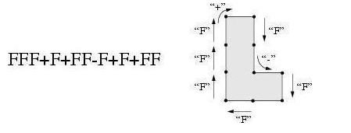

Figure 3: Diagram of Turtle creating letter “L”

D0L-System
The easiest form of an L-system is called D0L-systems which stands for deterministic and 0-context or context-free. This is used to provide an intuitive understanding of the main idea behind D0L-systems [19]. For example, consider having two letters a and b. For each letter that is specified a rewriting rule is used. The rule a -> ab means that the letter a will be replaced by the string ab, and then the rule b -> a means that the letter b will be replaced by a. The rewriting process starts from a distinguished string called axiom, in this case this string will be called b. In the first step of rewriting the axiom b is replaced by a using production b -> a. In the second step a is replaced by ab using the production a -> ab. The word ab consists of two letters, both which are simultaneously replaced in the next step. Lastly, a is replaced by ab, b is replaced by a and the string aba ends as a result [19]. The result of this method is shown in Figure 3.
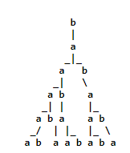

Figure 4: Example of D0L-system

Conclusion
L-systems are a good example of procedural techniques for a number of reasons. They allow complex models and organic structures to be characterized, modelled and visualised using clear sets of productions [4]. In contrast, models expressed in generalized purpose programming languages may require multi-page program listings. However, the essence of the models is often similar in spite of different software implementations [20].

Perlin Noise
Perlin Noise, created by Ken Perlin was initially developed to help create more natural looking textures [4]. To generate irregular procedural textures an irregular primitive function is needed, which is called Noise [2]. The noise function is commonly known for being stochastic and will break up the monotony patterns that would be too regular [2]. Perlin Noise can be used to toughen up the smooth edges and make a generated surface look more natural and realistic [21]. Noise is created by using a pseudo random function to generate multiple of values which will then be interpolated into coherent noise [4].
The obvious stochastic texture primitive is white noise, which uses a source of random numbers, uniformly distributed with no connection between successive numbers [2]. White noise can be generated by a random physical process, such as the thermal noise that occurs within many analogue electronic systems [2]. In distinct time, white noise is a discrete signal whose samples are regarded as a sequence of serially uncorrelated random variables with zero mean and finite variance [22].

The properties of an ideal noise function are [2]:
- Noise is a repeatable pseudorandom function of its inputs
- Noise had a known range from -1 to 1
- Noise is band-limited with a maximum frequency of 1
- Noise doesn’t exhibit obvious periodic or regular patterns. Pseudorandom functions will continuously be periodic, however the period can be made extremely long and therefore the periodicity is not clearly visible.
- Noise is stationary, meaning that its statistical character should be translationally invariant
- Noise is isotropic, meaning that its statistical character should be rotationally invariant.

Lattice Noise
Lattice noise is a type of algorithms which is intended to procedurally generate noise. The common element in lattice noises is a lattice or grid which subdivided the area in smaller sections, the algorithm will then travel through the grid generating the noise function inside each individual square [23]. Lattice Noises are based on the integer lattice meaning the integer lattice is formed from the creation of evenly distributed pseudorandom numbers [24]. These numbers are mapped into the texture space that each coordinate occurs at an integer value [24].
The generation of a lattice noise begins with one or more uniformly distributed PRNs at every point in the texture space whose coordinates are integers [2]. These points form the integer lattice. These crucial low-pass filtering of the noise is succeeded by a smoot interpolation between the RPNs [2]. Examples of what Lattice Noise looks like visually is shown in figure 5.
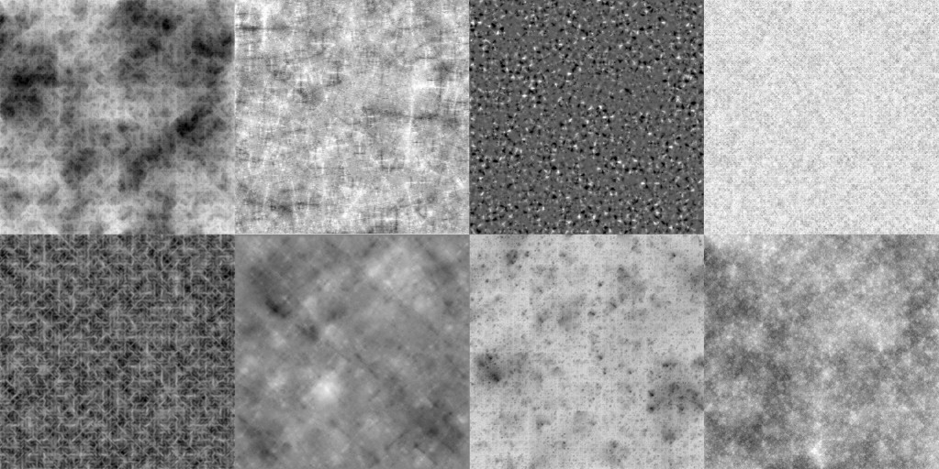

Figure 5: Lattice Noise

Value Noise
Value Noise is a method which consists of the creation of a lattice of points which are assigned random values, the noise function will then return the interpolated number based on the values that are surrounding the lattice points [25].

The key decision which is required to be made in implementing value noise is how to interpolate among the lattice RPNs [2]. Many methods have been used to tackle this problem, ranging from linear interpolation to a variety of cubic interpolation techniques. However, linear interpolation is insufficient for a smooth-looking noise because the derivate of a linearly interpolated value is not continuous and the sharp changes are clearly visible to the eye [2]. It is suggested that cubic interpolation is the better option to make so both the derivative and the second derivative are continuous [2]. There are other methods which are possible for value noise such as Quadratic and cubic B-splines. These splines do not interpolate the lattice PRN values, they approximate the values instead, which could possibly lead to a narrower oscillation range for the B-spline noise [2]. Example of what a Value Noise looks like visually is shown in figure 6.

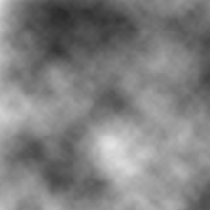

Figure 6: Value Noise

Gradient Noise
Gradient Noise is similar to Value Noise however, instead of creating lattice points Gradient Noise creates a lattice of random gradients, dot products which are then interpolated to obtain values in between the lattices [26]. Gradient Noise offer a different method of generating low-pass filtered stochastic function by using the PRN’s at each lattice point to come up with gradient vectors which will be used instead of the values themselves [21].
The value of a gradient noise is 0 at all integer lattice points. The pseudorandom gradients resolve its behaviour between lattice points [2]. The gradient method uses an interpolation based on the gradients at the eight corners of a single lattice cell, rather than a 64-vertex neighbourhood used in a cubic interpolation method [2]. Most of the energy of gradient noise comes from frequencies between 0.3 and 0.7. There is more high-frequency energy in gradient noise compared to value noise and less low-frequency energy [2]. These are consequences because gradient noise has zeros at each lattice point and therefore is forced to change direction at least once per lattice step [2].

Value-Gradient Noise
One problem that can arise with gradient noises is the noticeable grid pattern as a result of a gradient being zero at each lattice point [24]. To solve this issue, both value and gradient noises are combined. One implementation of value-gradient noise is simple, due to combining the value and gradient methods to produce a value-gradient noise function [2]. A more sophisticated form of value-gradient noise is based on cubic Hermite interpolation. The Hermite spline is stated by its values and tangent at each of its end points [2]. To make that a value-gradient noise, the tangents of the spline can be taken from the gradients.

Lattice Convolution Noise
One challenge to the lattice noises is that they exhibit axis-aligned artefacts. Many of the artefacts can be traced to the anisotropic nature of the interpolation schemes used to blend the lattice RPN values [2]. Lattice Convolution Noise attempts to avoid anisotropy by using a discrete convolution technique to do the interpolation. The RPNs at the lattice points are treated as the values of random impulses and are convolved with a radically symmetrical filter [2].

Sparse Convolution Noise
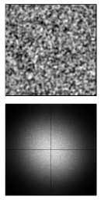
In 1989, Lewis introduced sparse convolution noise which is a procedural noise that offers enhanced control over the power spectrum [5]. Sparse convolution involves building up a noise function by convolving a filter function with a collection of randomly located random impulses [2]. The scattered random impulses are considered to be a “sparse” form of white noise, which explains the term “sparse convolution” [2]. The low-pass filtering of the white noise is consummated by the filter function [2]. The power spectrum of the sparse convolution noise is copied from the power spectrum of the filter kernel, so some control of the noise spectrum is achievable by modifying the filter [2]. Lewis procedurally evaluates sparse convolution noise by introducing a grid and generation the positions and weights of the kernels in each cell on the fly [5]. Example of sparse convolution is shown in Figure 7.

Figure 7: Sparse Convolution Noise

Explicit Noise Algorithms
Explicit noises are different from noise functions because they generate their noise in advance and then store it for later retrieval [24]. Explicit Noise methods generate a large batch of noise values all at once in an explicit fashion [2]. To use then in an implicit procedural texture during rendering, the noise function would need to be generated before rendering and stored in a table of texture images [2]. Two well-known types of explicit noise are wavelet noise and anisotropic noise [24].

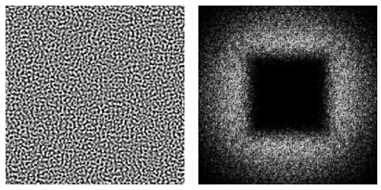

Wavelet Noise
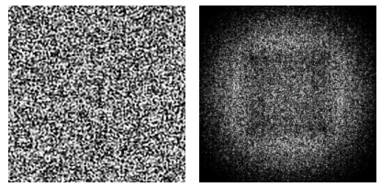
A major benefit to Wavelet Noise compared to Perlin noise is the band-limit is nearly perfect due to the up-down sampling iterative filtering operations [24]. With this method being almost perfectly band-limited, this provides good detail with minimal aliasing [27]. Also, 3D wavelet noise can be used to texture a 2D surface in a way that maintains its band-limited character and this technique is also simple and fast to implement [27]. An example of what Wavelet Noise looks like is shown in Figure 8. To create the algorithm firstly construct the multiresolution noise M(x) in a way which is like Perlin by summing scaled and attenuated versions of a noise band N(x). Below is a mathematical equation showing what the algorithm looks like [27].
Figure 8 (a): 2D wavelet noise
Figure 8 (b): 2D sliced through 3D wavelet noise
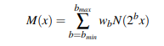

Where b indexes the band and where the weights $wb$ are free variables used to control the spectral character M(x). Wavelet noise differs from Perlin in the definition and construction of $N(x)$ [27].

Anisotropic Noise
Anisotropic Noise offers a solution to the inherent trade-off found in isotropic filtering between losing detail and artefacts from aliasing [24]. This technique generates noise textures by tiling the frequency domain into oriented sub-bands [28]. This approach is like wavelet noise by precomputing texture tiles instead of sampling noise procedurally [28]. However, the frequency content of our tiles is strongly of the tiles is strongly oriented and anisotropic [28]. This method allows users to perform anisotropic filtering during rendering which leads to higher image quality [28]. An example of anisotropic noise is shown in Figure 9.
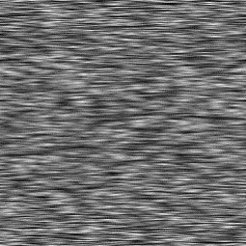

Figure 9: Anisotropic Noise

Fourier Spectral Synthesis
Fourier Spectral Synthesis is a method which is particularly useful when a specific powerful spectrum is desired [24]. Then the various inverse Fourier transform id performed on the frequency domain representation to get a spatial domain representation of the noise [2]. Lattice convolution and sparse convolution are other methods which offer a promising detail spectral control of noise [2]. There is a trade-off between the attempt of generating all desired spectral characteristics is a single call to the noise function by using an expensive method such as Fourier Synthesis or sparse convolution versus the strategy of building up spectral characteristics using weighted sum of several cheaper gradient noise components [2]. This method has been used in explicit noise methods as well as the generation of random fractals for recreating natural phenomenon [24].

Interpolation Function
Interpolation is a method of constructing new data points within the range of a discrete set of known data points [29]. Interpolation is a process of curve fitting in which a function is constructed that intersects exactly through the data points [4]. There are two interpolation functions which are linear and cubic. Linear interpolation is one of the simplest methods used and usually selected when speed is important and quality is secondary importance, this method only takes two points and the interpolant is calculated using the weighted mean [4], an example of linear interpolation shown in Figure 10(a). However, Cubic interpolation is used when quality is more important than speed and its outputs a continuous curve unlike linear interpolation [4], an example of cubic interpolation shown in Figure 10(b).

Linear interpolation between two points:
If the two known points are giver by the coordinates $(x0,yo)$ and the$(x1, y1)$, the linear interpolant is the straight line between these points. For a value x in the interval$(x0,x1)$, the value y along the straight line is given from the equation slopes which can be derived geometrically [30].

$$\frac{y-y0}{x-x0}= \frac{y1-y0}{x1-x0}$$

It is a special case of polynomial interpolation with $n = 1$. Solving this equation for $y$, which is the unknown value that $x$, this gives [30]:

$$y=y0+\left(x-x0\right)\frac{y1-y0}{x1-x0}= \frac{y0 \left(x1-x\right)+y1 (x-x0)}{x1-x0}$$

Which is the formula for linear interpolation in the interval $(x0,x1)$.
This formula can also be understood as a weighted average. The weighs are inversely related to the distance from the end points to the unknown point, meaning the closer point has more influence that the furthest point [30]. The weights are $\frac{x-x0}{x1-x0}$ and $\frac{x1-x}{x1-x0}$ which are normalized distances between the unknown point and each of the end points because these sum to 1 [30].

Cubic Interpolation algorithm definition:
Cubic spline interpolation is a special case for Spline Interpolation that is often used to avoid the problem of Runge’s phenomenon, which is the problem of oscillation at the edges of an interval that occurs when using polynomial interpolation [31]. This method gives an interpolating polynomial that is smoother and has a smaller error than other interpolating polynomials, such as Lagrange polynomial and Newton polynomial [32].
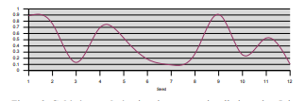
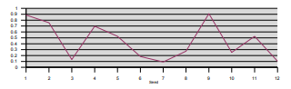

Figure 10 (a): Linear Interpolation Figure 10 (b): Cubic Interpolation

Conclusion
Noise does not use a lot of memory compares to texture mapping and implementing a noise function does not necessarily need to be complexed [33]. A basic noise function can also create large variety of textures and using noise to add texture to an object does not require any parametrisation of the surface which is usually required for texture mapping [33]. However, there is definitely a lot to cover when it comes to noise, some functions can become mathematically complex and noise is usually slower compared to texture mapping.

OpenGL Shading Language
OpenGL Shading Language also known as GLSL. This language has been included in the OpenGL standard as of OpenGL 2.0 and has since been further evolved through OpenGL 3.0 [34].

The recent trend in graphical hardware has been to replace established functionality with programmability in certain areas which have grown excessively complexed, this includes the two areas which are vertex processing and fragment processing [34]. Vertex processing contains the operations that occur at each vertex, usually transformation and lighting [34]. Fragments are per-pixel data structures that are created by rasterization of graphic primitives, a single fragment contains all the data required to update a single location in the framebuffer [34]. Fragment processing contains the operations that occur on a per-fragment basis, usually the fragment process reads from the texture’s memory and applies the texture values at each fragment [34].

A procedural texture can be implemented using GLSL, this is due to the fact that GLSL is a full-featured, high-level programming language to express the processing at each fragment meaning that users are able to algorithmically compute a pattern on an object’s surface, GLSL can be used to create a wide variety of rendering effects [34].

Conclusion
Looking at all the different procedural techniques that can be used, the most appropriate technique which will be used for this project is Noise Cubic Interpolation Function which was created originally by Perlin Noise. This technique has been chosen because looking at the research it is better suited to what the major project is about. In order to create a curved line then the cubic interpolation algorithm must be used. However, there are other ways to create a line such as Linear Interpolation. The reason why this option has not been chosen is because visually it looks messy and unattractive to the eye. Cubic Interpolation algorithm will be created using OpenGL Shading Language, the procedural texture will then be attached the 3D object.

Research and/or Development Methodology
The aim of this chapter is to justify the research design in relation to the objectives of the research. The procedures that will be used for this project will also be identified in this chapter. Also, the method that has been chosen will be described in detail.

Research Overview
A top down view of the three phases of the Research Process has been created which is shown in Figure 1 provided below. The three phase’s segregation: Research Philosophy, Approach and Research Strategies, collectively helps to provide a clearer
understanding of the research design.
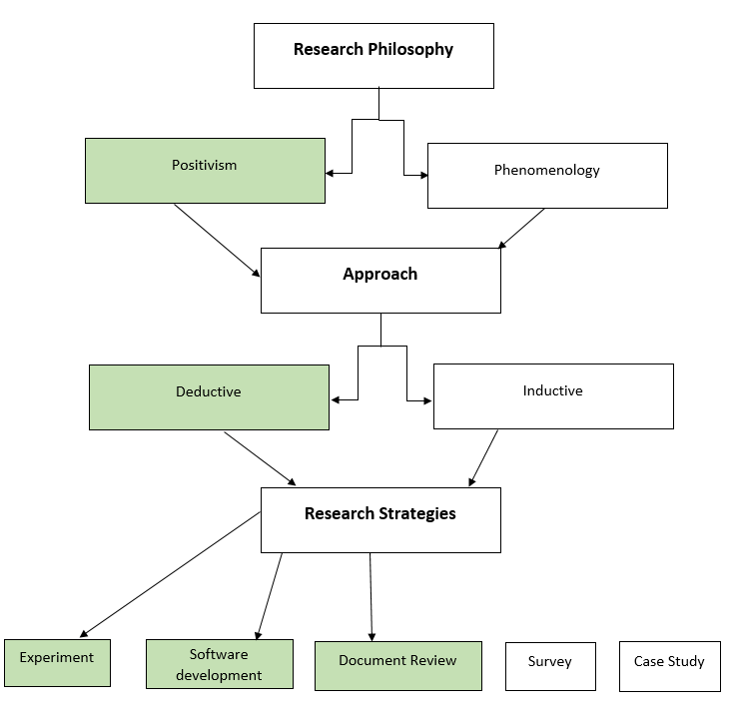

Positivism
As shown in Figure 1, Positivism has been used as a Research Philosophy. The positivism approach uses knowledge which is based on the observation or experience of real phenomena in an objective and real world. Also, objective experiments are performed to observe these phenomena. For this project, a procedural texture will be implemented, and experiments will be performed to ensure that the procedural texture works successfully.

The features of the Positivistic approach are Reliability is high, Validity is low, usually produces quantitative data, uses large samples, Data is highly specific & precise, the location is artificial and Generalises from sample to population.
The methods which is mainly used using the Positivistic approach includes Experiments and Software Development.

Deductive
Deductive has been used as am Approach. This involves developing a theory and hypothesis and designing a research strategy to test that hypothesis. For this project, a theory and hypothesis will be made by evaluating whether the method that was chosen (Cubic Interpolation) was either better or worse than other possible methods and analysing the different outcomes.

Deduction emphasises scientific principles, moving from theory to data, the need to explain casual relationships between variables, the collection of quantitative data, a highly structured approach, researcher independence of what is being researched and large sample size to allow generalisation.

Deduction is suitable when the research topic has a wealth of literature which can be defined as a theoretical framework and a hypothesis and also using theory to identify what data needs to be collected. For this project, a literature review will be created to show different procedural techniques which has been used in previous work.

Document Review, Software Development and Experiment
A document review will be written to identify the main theories in procedural texturing, identify the prominent researchers in procedural texturing, identify the advantages and disadvantages of different procedural textures, confirm that the project is practical and provide an example of a procedural texture which could have been used compared to the one that has been chosen.
The software development strategy will be used which involves developing multiple testing strategies to show that the project works effectively. This project will focus on the implementation of a procedural texture and applying it to an object and when the implementation is complete, an analysis will be written to show the end results.
The experiment strategy will also be used by examining the overall project. An experiment will be created to show users that a procedural texture can be implemented onto a car. Procedural textures are usually used to make graphical objects realistic, however this can also be used to create lines and curves.

Research Methodologies
To be able to create this project a software development model will need to be created to critically analyse the different processes of the project. The software development model which has been chosen is the feature driven agile approach, shown in figure 2 is a prototype. This approach has 5 processes which are develop an overall model, build a features list, plan by feature, design by feature and build by feature.
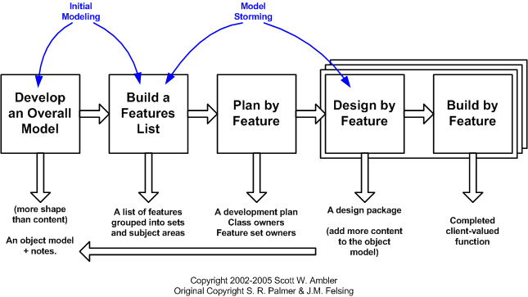

Develop an Overall Model
In this process the requirements must be known, and student documents must have been created. The requirements needed for this project are:
- The car must be loaded in C++ successfully
- A procedural texture must be applied to the car
- The project must build successfully without any errors

A student document has been created which is the literature review that has been written at the start of this report.

Build a Features List
In this part of the process the key features will be identified. There has been a table of features created below specifying the title and level of importance in this project.

Feature Number | Feature Title | Level of Importance
1 | Create a 3D object | 1
2 | Apply a procedural texture to a 3D object | 1
3 | Create object loader in C++ | 2
4 | Ensure that the object is moving around | 3

Create a 3D Object
Firstly, a 3D object will be created so the procedural texture can apply itself to the object. There are different ways of approaching this method. Firstly, there are glut functions which is useable and can be accessed on C++ which will create a basic 3D object. Also, an object can be created in Maya from scratch and then export the object as an object file which will then be accessible to C++, however, in order to do this method, an object loader in C++ must be implemented.

Apply a procedural texture to a 3D object
Secondly, in order to apply a procedural texture to a 3D object, a procedural texture will need to be implemented in GLSL. The vertex shader will allow the shader to wrap around the object and the fragment shader will create the appearance of the object. The result will be a procedural texture wrapped around a 3D object.

Create object loader in C++
Thirdly, this part of the project will only be necessary when creating an object from Maya. In order to show the object on the C++ interface then an object loader will be required. The object loader will find the object file in the project file explorer and then output the object file onto the C++ interface.

Ensure that the object is moving around
Lastly, even though the object doesn’t need to necessarily be moving around the C++ interface, it would look better and more presentable if the object would be rotating at different angles to show users what the procedural texture looks like in different angles.

Plan by Feature
In this process a development plan will be created and the predictions of what the product will look like. A Gantt chart will be implemented to show the plan of when each sections of the project will be implemented.
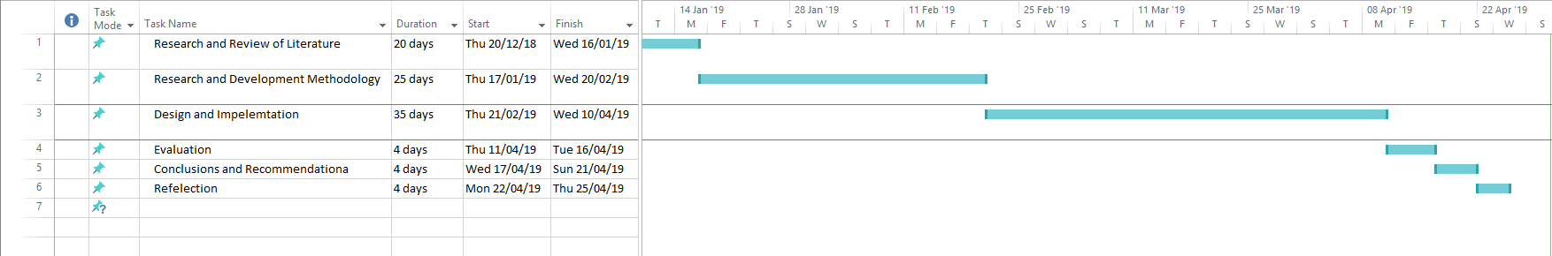

Design by Feature
In this section a sequence diagram will be created. Shown in Figure 3 is a Unified Modelling Language diagram (UML) which visually represents the system and its main roles, actions and classes.
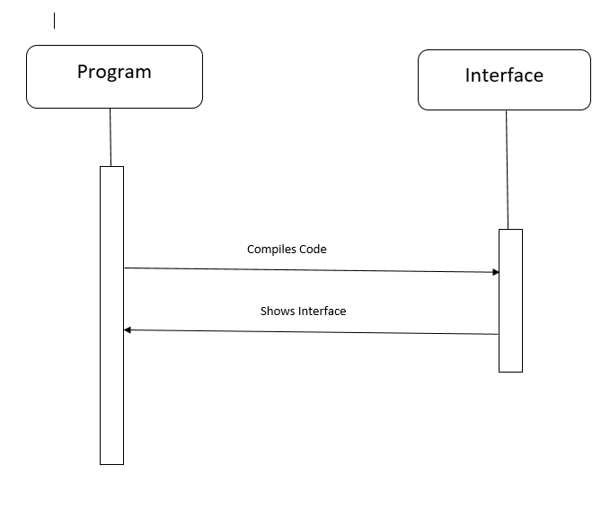

Build by Feature
This is the last process to be made which is implementing the code. After successfully planning and designing the code the implementation can begin.

Development Methodology
Feature driven development is an iterative and incremental software development process which is an agile method for developing software [35]. This development has been chosen because it is a lightweight model meaning that it is an easy and efficient process also this development method is effective and suitable for small projects which fits in perfectly which this project.

Advantages of using Feature driven development are all aspects of the project are tracked by a feature, good for single person or a small group project and offers well defined progress tracking and reporting capabilities [36]. However, using feature driven development can be a problematic such as, iterations are not well defined by the process compared to other agile methodologies and the model-centric aspects can have huge impacts when working on existing systems that have no models [36].

The software which is going to be used in this project is Maya and C++. Maya will be needed to create the car object and then export it as an OBJ file which will make it accessible for C++. C++ will then be used to create a renderer which renders the procedural texture onto the car object.

The hardware which will be needed for this project will be Computer systems which will allow access to the software needed for implementation. The package which will be used in Visual Studio will be Win32 which supports C++ and OpenGL. C++ and OpenGL languages will be used to develop the project, C++ will help with specific functions such as creating the actual renderer and OpenGL will allow access to shaders to implement the procedural texture onto the object.

Research Deliverables
The main outputs of this project will include the software, the test report and a training report. The test report will deliver a report which shows whether the requirements have been meet and all functions in the program works correctly or not. The testing report will provide a table this will have an expected column, actual outcome column, test passed (yes/no) column and reason (if function does not work) column, to show users whether each function has passed or not, and if the function fails then the reason can then be explained in the last column. Also, a training report will be written to evaluate whether the aim and objectives for the overall project has been met. Also, the outputs of the project will be critically discussed in the implementation and evaluation sections.

Conclusion
To conclude, the main factors which have been identified in this section of the project are Research Overview where an analytic hierarchy was created to show which research processes were selected, Research Methodology where the Feature Driven Agile model was chosen as an approach to take for the software development and also Development Methodology which explains why the feature driven development approach was chosen and identification of the software, hardware and tools required to successfully implement this project.

Design and Implementation
The aim of this chapter is to describe the deliverable from what has been achieved in the implementation. Firstly, a requirements section will be created to show what Evathe requirements are and how they were discovered. Secondly, design section will be created to show how to overcome the problem of the project and other ways that procedural texturing could be used, also the processes which has been used will be discussed and how they contributed to ensure that the project was correct. Thirdly, an implementation section will be created to show what tools and techniques that has been used and what difficulties that has been encountered. Lastly, the software will be tested using Unit testing, System testing, Usability testing and Acceptance testing techniques.

Requirements
Firstly, the requirements must be detected before creating the design of the product. Below are the requirements which is needed for this project:

- Create a programme using a Passing system – A passing system will be needed in order to create this project because in order to create a procedural texture in a shader, the shader must be accessible. In order to do this, the programme must call the shader using the passing system.

- Create a shader – Two shaders will be created which are the vertex shader and the fragment shader. Both shaders will be required to apply a procedural texture to an object. The two shaders will be named “texture” and because there will only be one shader implemented, in the pass system, shader 1 will be called (which is the texture shader).

- Create an object loader – An object loader will be used to get the car object from the file explorer and then output the car onto the C++ interface.

- Create a 3D object – In this project a car will be created. The car will be created in Maya and then exported as an object file. The object file will then be accessible in C++, so the object will be able to load onto the C++ interface.

- Create a Procedural Texture – The procedural texture will be created in the Vertex shader and the Fragment shader. Both shaders will communicate with each other to create a successful procedural texture.

- Apply Procedural Texture onto the 3D object – In order to apply a procedural texture on a 3D object, then there must be a Vertex shader with the correct implementation, this will then allow the texture to wrap itself around the object.

Problem Formulation
In order to successfully create a procedural texture and apply it to an object, how to solve the problem must be discussed first. The path which has been chosen is GLSL, which is a shading language in C++ which allows textures to be implemented onto a 3D object. This path has been chosen because, throughout the year shader techniques have been used elsewhere and have been familiarised with other shading techniques, using GLSL was the most confident and comfortable option. However, there are other techniques which could have been used such as different software like Blender which allows the user to create a procedural object and apply it to an object using the Blended Box Mapping technique. The reason this technique was not chosen was because Blender is an unfamiliar software and box mapping seemed to be a technique which was too simple to implement.

Design
Looking back at the Literature Review, the Cubic Interpolation algorithm will be used to implement the procedural texture. The cubic interpolation algorithm will be implemented into the fragment shader. The car will be coloured red with a white line going across the body of the car, a prediction of the result is shown in Appendix 1.

Step-By-Step Process
In order to successfully create a procedural texture, many processes must be taken out. Looking at the requirements needed, this will help create a step-by-step process.

Firstly, A pass system must be implemented. There is a Graphics Template on Moodle which has been used to achieve this goal. The Graphics Template contains five Source files which are firstly, “cRenderClass.cpp”, this source file creates an interface so the object can be shown onto the screen and a multi-pass system which renders the 3D object and renders the shader by calling it. Secondly, “cShader.cpp”, this source file defines how many shaders there are, the user can name the vertex and fragment shaders and a vertex shader and fragment shader path has been implemented so the programme is able to find the shaders in the file explorer. Thirdly, “GraphicsTemplate.cpp”, this source file renders the entire scene and where the main is located. Also, “stdafx.cpp”, this source file includes the standard includes which is needed for the project. Lastly, “textfile.cpp”, this source file includes functions which allows the programme to read and write from a text file, this is useful when reading from a shader from a text file. The Graphics Template also includes five header files, these files mainly consist of calling functions from the source files because they are created into classes.

Secondly, once the main foundation is completed the object loader can then be integrated into the Graphics Template. The object loader has been placed into the cRenderClass.cpp so the car will then be able to render and outputted onto the C++ interface.

Thirdly, once the car is successfully implemented onto the code and can output onto the C++ interface, the shaders will then be implemented. Since the Graphics Template has already been provided with a Vertex and Fragment shader there is no need to create two new shaders. The Vertex shader will mainly consist of the position of the texture and the position of the camera and the Fragment shader will consist of the actual algorithm, below provides pseudocode of what the structure of the algorithm is going to look like in the fragment shader:

if(p.y > 10.0) && (p.y < 12.0)
{
White = gl_FragColor(1.0, 1.0, 1.0)
Else
Red = gl_FragColor(1.0, 0.0, 0.0)
}

This if statement will be able to access the pixels in the y axis and then find the pixels which are higher than 10 and lower than 12, which will then colour the all the pixels into white and then the rest of the pixels will be coloured red. This algorithm will then create a red car with a white line going through the body of the car.

Lastly, once the shaders have been successfully implemented there will be controls so the user can look at the car from different angles. The keyboard controls will be implemented into the GraphicsTemplate.cpp, the user will be able to go left, right, up, down, rotate left and rotate right.

Implementation
During the implementation of the code there were several encounters where there were errors involved. This was mainly due to the shaders not being able to attach to the car. Firstly, the main problem that occurred was the shaders unable to work with the car, this is due to a file issue, and Visual Studio required a certain file to be used for the shader to work. However, to overcome this issue, the idea of having a car object was discarded and used a Torus instead to represent the procedural texture, this was implemented by using the glutSolidTorus function. This function creates a Torus onto the C++ interface, and a rotation function has been created so the user is able to look at the Torus from different angles. Secondly, another issue that has been encountered is when the object is moving it occasionally flickers, however the user can easily visually see the procedural texture rendered onto the object. Unfortunately, this problem has not been solved, however, according to research there is a possibility that the problem could be to do with the buffering. There could be something wrong with the buffering, which makes the object to flicker occasionally.

A change to the code has also been implemented, instead of creating a red torus with a white line going through the middle the code has been changed to a striped effect where the some segments of the torus will be white and other segments of the torus will be red and then this function will then repeat itself.

The main techniques that has been used in this project is creating light, linear blend and Hermite interpolation. In the vertex shader the light algorithm has been created to change the lighting effect in the C++ interface. Below is a snippet of the code used in the project:

DiffuseColor = LightColour * vec3(Kd * dot(lightVec, tnorm));
DiffuseColor = clamp(AmbientLight + DiffuseColor, 0.0, 1.0);
SpecularColor = clamp((LightColour * SpecularLight * spec), 0.0, 1.0);

Firstly, the diffuse colour has been specified by using LightColour * kd * dot product of lightVec and tnorm. LightColour has been initialized as white, Kd needs to be a value between 0 and 1 so 0.8 has been chosen to initialize the value, lightVec is a vector which has been specified by normalizing LightPosition – ecPosition (ecPosition is the position of the camera) and tnorm is a normalized vector of the normal. Secondly, the diffuse colour has been defined overall by adding the AmbientLight which is white by the diffuse colour which has been created in the line above. Lastly, the specular light has been created which times the lightcolour which is white with specular light which is also white and times by spec which is a variable created which includes the dot product of hvec a tnorm, which is basically the dot product of the halfway vector and the normal vector. Above is an example of both the diffuse light and specular light equation written in code.

In the fragment shader a linear blend between the background colour and the stripe colour has been created. Below is a snippet of the code used in the project:

float frac1 = clamp(scaledT / Fuzz, 0.0, 1.0);
float frac2 = clamp((scaledT - Width) / Fuzz, 0.0, 1.0);
frac1 = frac1 * (1.0 - frac2);

In the first line fraction one has been created which is the variable scaledT divided by the Fuzz. ScaledT has been initialized as TexCoord * Scale, the TexCoord has been passed through from the vertex shader and the Scale variable is equal to 10.0. Then the Fuzz variable has been initialized at the top of the shader as 0.1, the variable defines how smooth the transition from the background colour to the stripe colour will be. In the second line, fraction two has been implemented which is scaledT – Width divided by Fuzz, the Width has been declared as 5.0, which is defining the width of the stripes. Lastly, the linear blend has been created in the third line, this is fraction one * fraction two to get a linear blend. The linear blend equation is a type of blend used to combine the Background and Stripe colour together, this can be used to transition from one colour to another smoothly.

In the fragment shader the Hermite interpolation algorithm has been created. Below is a snippet of the code used in the project:

frac1 = frac1 * frac1 * (3.0 - (2.0 * frac1));

In this line of code, the Hermite interpolation algorithm has been implemented. Using fraction one which is the linear blend algorithm and then timing the variable by itself. The Hermite interpolation algorithm is a method if interpolating data points as a polynomial function, this will then allow the background colour and stripe colour to change at different data points.

Testing
In this section a multiple of tests will be carried out to ensure that all the code is working correctly. The tests that will be used in this project will be Unit testing, System testing and Acceptance testing.

Unit testing
This type of testing ensures that individual segments of the code work. The purpose of this test is to validate each unit of the software performs as designed. In GLSL it is complicated to test each line of code, however, to work around this, a manual unit test was created. To ensure that every line works the end result colour was changed to red, commented every line of the code out of the programme and then uncommented the code line by line, if the shader works the torus will output red onto the screen. This is a manual way of setting up unit testing using shaders, this is because shaders are created in Notepad++, and it can be challenging to find an error within the code. However, if there is an error within the code then the Torus will have no colour applied to it. Below is a table that includes the test number, used in the vertex or fragment shader, name of test, did the test work and a screenshot providing evidence whether the code worked or not.

If the lines of the code compiles successfully then the torus will be coloured red, if not then the torus will be uncoloured (grey).

Test Number | Vertex/Fragment | Test Name | Work? (Yes/No) | Screenshot
1 | Vertex | Creating vectors, matrices  and floats | Yes | Code:  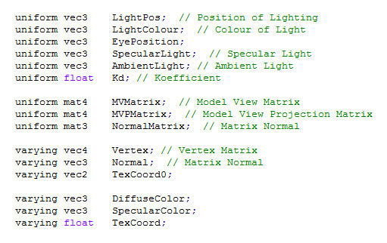  Interface:  
2 | Vertex | Declaring variables and creating the camera position | Yes | Code:  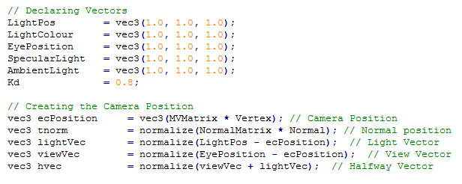  Interface:  
3 | Vertex | Creating Light | Yes | 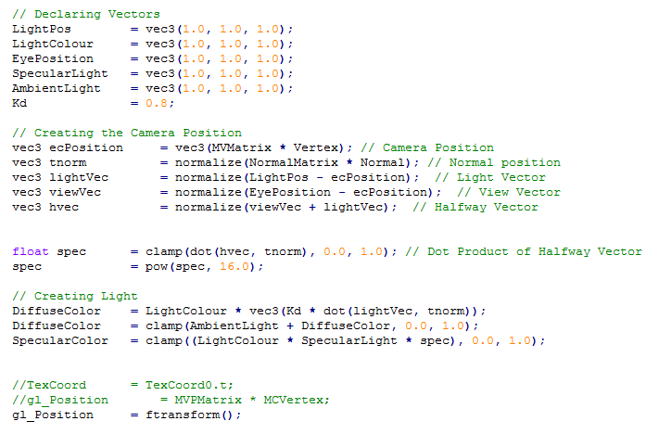  Code:    Interface:
4 | Fragment | Creating vectors and floats | yes | Code:  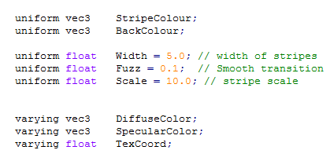    Interface:
5 | Fragment | Creating Positions between the stripe pattern | yes | Code:  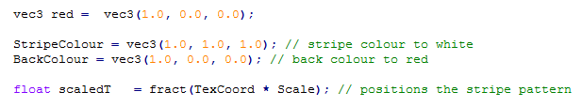  Interface:  
6 | Fragment | Creating a linear blend and Hermite interpolation | yes | Code:  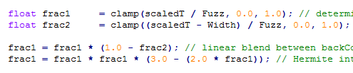  Interface:  
7 | Fragment | Creating the final colour | yes | 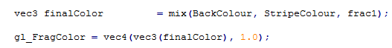  Code:  Interface:  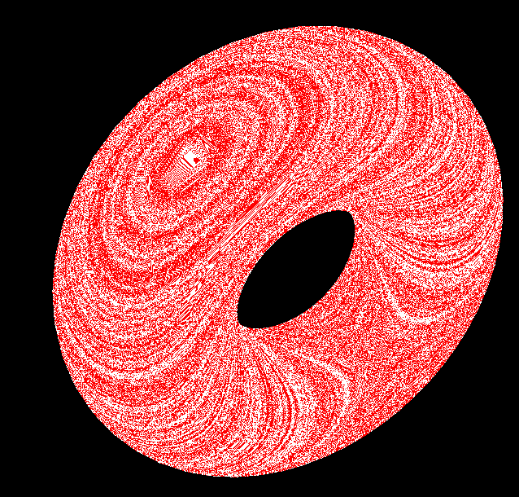

System testing
This type of testing is used to test whether the programme can work as a whole. The purpose of this test is to evaluate the system’s compliance with the specified requirements. The requirements specified are Create a programme using a Passing system, create a shader, Create an object loader, Create a 3D object, Create a Procedural Texture and Apply Procedural Texture onto the 3D object. Below is a table that includes the test number, requirement name, did the test work and screenshots.

Test Number | Requirement Name | Did it work? (Yes/No) | Screenshots
1 | Create a programme using a Passing system | Yes | 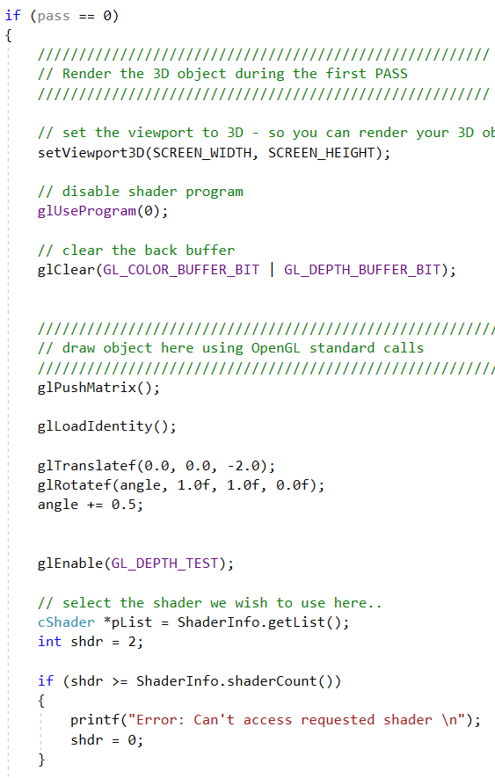  Code:
2 | Create a shader | Yes | 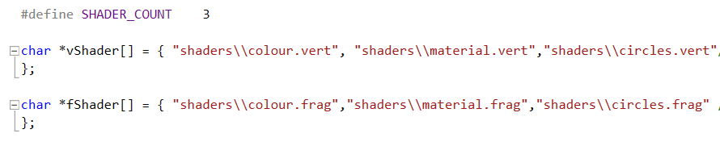  Code:
3 | Create an object loader | No, an object was not created as it was not needed | N/A
4 | Create a 3D object | Yes | Code:  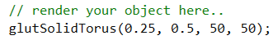  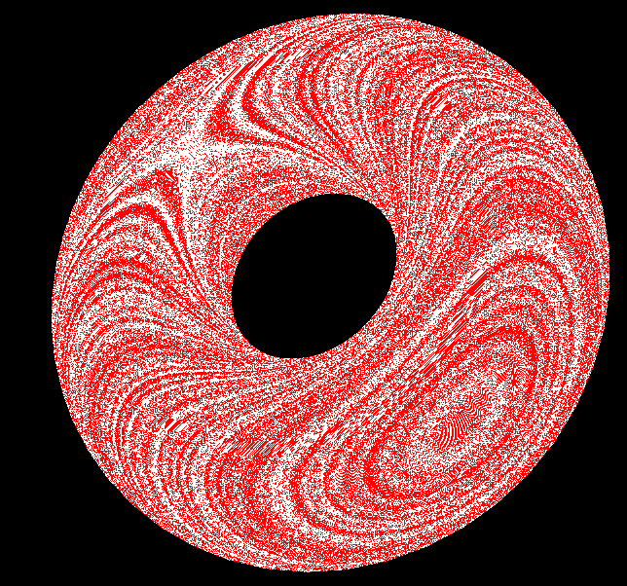  Interface:
5 | Create a Procedural Texture | Yes | As shown above
6 | Apply Procedural Texture onto the 3D object | Yes | As shown above

Acceptance Testing
This type of testing is used to accept whether the programme has met the standards of objective. The purpose of this test id to evaluate the system’s compliance with the user requirements and access whether it is acceptable for delivery. As the developer of the project, having looked at all the different tests used this project has been successful. However, there have been minor errors which occurred in the project, for users the flickering is noticeable but not bold enough to be a major error in the project. As a whole, the project is acceptable for delivery.

Storyboard
In this section a storyboard has been created to show the user what the end product looks like. The object will be rotating around so a storyboard will be implemented to show the user the procedural texture from different viewpoints. The storyboard is shown below:
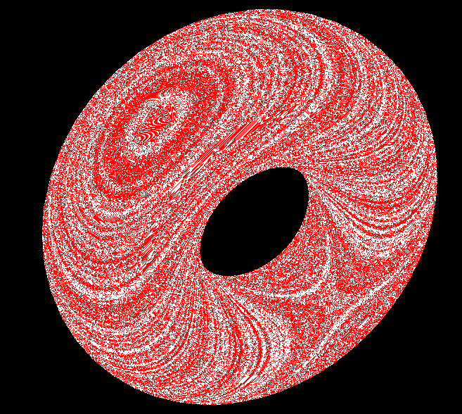
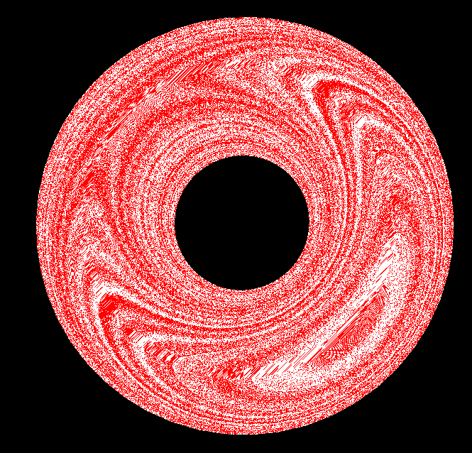
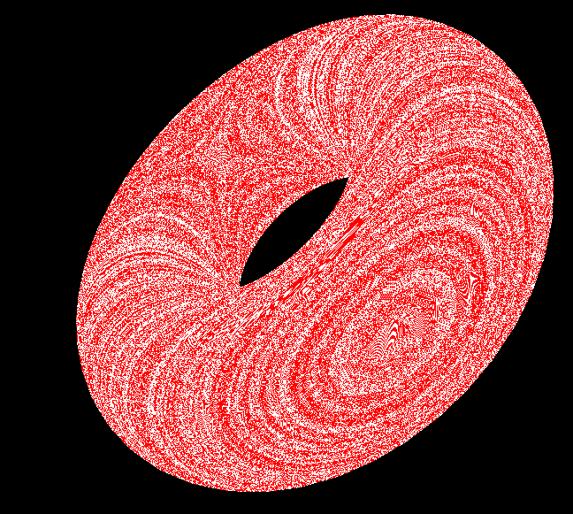

Conclusion
To conclude, the main aspects of this section was the Step-by-Step process which explained in detail the process which will be taken out to implement the programme and also the Implementation stage which includes techniques that have been carried out in the code and snippets of code explaining what the code does and how it effects the outcome of this project. Lastly, many tests have been created to ensure that all segments of the code compiles and the system as a whole, this also comes with table which includes screenshots so users can visually see what segment of code has been tested and what has been shown in the C++ interface.

Evaluation
In this section, an evaluation will be carried out by reflecting on the major project as a whole and whether the aim and objectives made in the introduction has been met. Also, an evaluation will be made with the implementation and whether the code was predictable and if any changes could have been made.

Conclusion of Data
Looking back at the implementation stage the outcome was completely different to the original design. This is because many errors occurred during the implementation which concluded with a striped effect object rather than colouring the entire object red and colouring parts of the object white to create a one stripe effect, in the appendix includes the original shading design as appendix 2 and the actual shading design to show how different the outcome actually is in appendix 3. The development of the shaders changed because using the original design used, it caused an error in the program. The error mentioned that a file could not be reached therefore the programme would not compile, unfortunately this error could not be fixed so another strategy was used to overcome this problem and that is changing the design, so the object has a striped effect. This strategy was created because rather than one line going through the object, multiple lines are going through the object instead. Also, the actual object itself has been changed, initially a car was going to be used but due to time constraints a torus was used instead. The car visually looked poor and the quality of the car also looked poor, using a torus from a glut file seemed like a more appropriate approach as it looks visually acceptable and users can clearly see the procedural texture rendered onto the object, also this object is rotating so users can see the procedural texture from different angles.

Initially, looking back at the Literature Review an algorithm called Cubic Interpolation was going to be implemented onto the object, but this algorithm was not implemented, instead a type of Linear Interpolation was used instead. The algorithm is called Hermite Interpolation, this algorithm was used to create a stripped effect. The Hermite function was used to create a smooth transition from one colour to the other, another way of coding this algorithm is using the “smoothstep” function, this function was not used simply because the function would calculate the code automatically. Using lines to create a procedural texture can be implemented on GLSL, therefore the literature review backed up the implementation correctly.

Meeting the Aim and Objectives
Looking back at the Introduction the aim was to successfully develop a procedural texture and apply it to a 3D object, this has been accomplished during the implementation stage. Many tests have been carried out to ensure that the project works and there are no errors in the code, also a storyboard has been created to show users what the object looks like at different viewpoints.

Looking back at the introduction the objectives were to Firstly, Establish the understanding of the different types of procedural textures which have been used in the past and discuss different procedural techniques that can be used for this project, this has been successfully accomplished by creating a literature review which shows the users the different types of procedural textures which have been used, different types of procedural techniques and a generalized overview of what a procedural texture is. Secondly, Establish the requirements needed to develop this project, this has been successfully accomplished by creating a requirements specification in the design stage and why they are needed to make this project successful. Thirdly, provide a critical literature review providing information about procedural texturing and what types of different procedural textures have been used before, this has been successfully accomplished by creating a Literature Review which procedural texturing is discussed in detail. Another objective is, develop a programme which applies a procedural texture to a 3D object, this has been successfully accomplished because a 3D object with procedural texturing applied to it has been implemented correctly. Also, another objective is, Evaluate, discussing the implementation, the effectiveness of the code that has been written and discuss other ways which could have been used, this has been successfully accomplished by showing snippets of the code and how effective it is and other ways in which the code could have been developed using Blender, this is included in the implantation section. Lastly, Expose the finalised programme and use the evaluation to make appropriate modifications to future development, this has been successfully accomplished by showing what the finalized design looks like on a storyboard provided in the implementation section and future development has been discussed in the conclusion section.

Finalized Design
At the start of the project a prediction of what the final outcome of the development is completely different to the actual outcome. This is due to the many necessary changes in the implementation of the code, mostly the entirety of the design has been completely changed. At the start of the project a car was initially going to be developed and a procedural texture was going to be applied to it, however a torus was used instead of a car. Also, the original shaders were changed to be multiple stripes instead of just one stripe. Overall, the final outcome was not expected based on the initial concept at the start of this project.

The only change that would have been made to this project is to change the software from Visual Studio to Unity. This is because Unity supports shaders and the outcome looks visually better when using Unity compared to using Visual Studio and the procedural texture would look nicer when applied to an object.

Conclusions and Recommendations
In this section a summary of the entire project will be written, this includes all the sections that have been created. Also, suggestions for further work on this project will also be included.

Summary
All the sections that have been included in the report are Introduction, Research and Review of Literature, Research and Development Methodology, Design and Implementation and Evaluation.

Introduction
To summarise this section, this is a short overview of what is to come in the next sections and tells the user briefly what the project is about. Also, the introduction includes an Aim and Objectives which is required so after implementation a comparison can be used whether the Aim and Objectives have been met.

Research and Review of Literature
To summarise this section, this is where users can read about procedural textures. The literature review covers different types of techniques, what a procedural texture is, advantages of procedural texturing, disadvantages of procedural texturing, different types of procedural textures used in the past and a section about OpenGL shading Language explaining what it is and how it can be used to create different types of shading effects. Also, there is a conclusion at the end of the review explaining what technique has been chosen and why this technique is going to be implemented for this project.

Research and Development Methodology
To summarise this section, this is where the methodology has been explained and which type of research methodology has been chosen to create this project. This section has been broken down into two parts, this includes the Research Overview, Research Methodology and the Development Methodology. The research review includes three phases of the research process and a diagram showing which process has been taken for this project, below the diagram shows descriptions of the different types of strategies chosen and how they will help to create this project. The research methodology explains which software development model has been chosen for this project and each segment of the model will include what the process does, and a plan will be carried out. Lastly, Development Methodology includes an explanation on why the model has been chosen and how it can benefit this project and the different types of hardware and software needed in order to create this project. Also, a conclusion at the end of the section has been created to discuss that the main factors have been identified.

Design and Implementation
To summarise this section, this is where the design for the code has been created and a discussion of what the code and result looks like after implementation. This section has been broken down into four parts, this includes the Requirements, Design, Implementation and Testing. The requirements section includes all the requirements needed for the overall project and why they are needed in order to successfully complete this project. The design section gives a description to what the final product should look like and a step by step process on how this project is going to work, including pseudocode as a structure of the algorithm. The implementation includes techniques used by showing snippets of code and explaining how it was used and why these techniques have been chosen. Lastly, the testing section includes Unit testing which tests whether the code is working, system testing which tests whether the whole system works correctly and acceptance testing which discusses whether the programme has met the objectives which was created in the introduction. Also, a conclusion at the end of the section has been created which includes an overall summary of the section.

Evaluation
To summarise this section, this is where an overall reflection of the project has been created. This section has been broken down into three sections, this includes Conclusion of Data, Meeting the Aim and Objectives and Finalized Design. The conclusion of data section includes a finalized conclusion of the implementation and an explanation why the outcome was completely different from the original plan and whether the literature review backed up the implementation created. Meeting the aim and objectives includes a discussion whether the aim and objectives created in the introduction has been met and explanations why they have or have not been achieved. Lastly, the finalized design section includes whether the outcome was what was predicted at the start of the project and a discussion that includes any changes that could have been made during the project and why those changes would have been made.

Conclusion
To conclude, throughout the research of this project there have been multiple resources that have been looked at, these resources include Journal Articles, websites and Books, all resources are shown in the References and Bibliography section. The main area of research is what types of Procedural textures have been used and how they have been used, this research helped chose the overall type of procedural texture chosen for the project. Also, research in OpenGL shading language have been carried out due to creating the procedural texture in GLSL.
Also, the main criteria of this report have been the development and implementation, this is due to main part of the research. The main part of the research has been to create a procedural texture and show users that an implementation was carried out to create a procedural texture and apply it to an 3D object. To finalize, the project required aims and objectives which needed to be met, for them to be met then a research and development must be carried out which includes procedural texturing. Fortunately, the implementation was successful, and users can now see what a procedural texture looks like when applied to a 3D object.

Recommendations for Further Research
Considering that the implementation of the project had to be severely alternated, further work would include changing the object back to the initial idea. This includes changing the torus object back to a car object and applying a striped procedural texture to that object instead. Also, a challenge could be set to change the implantation of the shaders to a singular line instead of multiple lines, so the shader would look like the initial idea, a red car with a white line going through the body.

Reflection
The initial idea of this project was to apply a procedural texture to a 3D object, which has been successfully implemented and tested. The most challenging part of this project was the development of the procedural texture, due to the lack of knowledge in area. However, by overcoming the problem a literature review was created which has provided knowledge in the subject area. Also, many skills have been developed which includes better time management, improved knowledge of the OpenGL shading language and improved literature. Also, developing this project has generated different types of feelings including, anger due to certain aspects of code unable to work but overcame the problem using debugging tools and methods, success due to finishing this project on time and after struggling to develop the code, also happiness due to figuring out the errors that were encountered during the implementation process. Overall, reflecting back at the project the main aspect that has been learnt that making differences to the project can make an overall a better outcome.

References

[1] | X. Q. a. Y.-H. Yang, “Estimating Parameters for Procedural Texturing by Genetic Algorithms,” 2002.
[2] | F. K. M. D. P. K. P. S. W. David S. Elbert, Texturing & Modeling: A Procedural Approach.
[3] | P. C. M. A. O. R. S. Nico Pietroni, “A survey on Solid Texture Synthesis,” vol. 6, 2007.
[4] | H. M. George Kelly, “A Survey of Procedural Techniques for City Generation”.
[5] | S. L. G. D. P. D. Ares Lagae, “Procedural Noise using Sparse Gabor Convolution∗,”  Radial Power Spectrum.
[6] | L. A. Stein, “Encapsulation,” 2003. [Online]. Available: http://www.cs101.org/ipij/procedures.html.
[7] | R. Moss, “7 Uses of Procedural Generation that all Developers should study,”  Wikipedia, 1 January2016. [Online]. Available: http://www.gamasutra.com/view/news/262869/7_uses_of_procedural_generation_that_all_  developers_should_study.php.
[8] | Webopedia, “Texture,” Webopedia, [Online].  Available: https://www.webopedia.com/TERM/T/texture.html.
[9] | M. Rouse, “texture mapping,” Tech Target, [Online].  Available: https://whatis.techtarget.com/definition/texture-mapping.
[10] | J. Slick, “Surfacing 101: The Basics of Texture Mapping,” Lifewire, 13 January 2019.  [Online]. Available: https://www.lifewire.com/texture-mapping-1956.
[11] | The Free Dictionary, “procedural texture,” The Free Dictionary,  [Online]. Available: https://encyclopedia2.thefreedictionary.com/Procedural+textures.
[12] | R. L. Cook, “Shade Trees,” Computer Graphics, vol. 18, 1984.
[13] | Stack Exchange, “What are the benefits to using procedural textures VS image textures?,” Stack  Exchange, 10 June 2018. [Online]. Available: https://blender.stackexchange.com/questions/33131  /what-are-the-benefits-to-using-procedural-textures-vs-image-textures.
[14] | AECOsim Building Designer Help, “Advantages of Procedural Textures,”  AECOsim Building Designer Help, [Online]. Available: https://docs.bentley.com/LiveContent/web/AECOsim%20Building%20Designer%20Help-v5/en  /GUID-F050FDC1-3648-7311-46B7-0C1E874D9177.html.
[15] | S. o. M. a. Statistics, “Benoit Mandelbrot,” University of St. Andrews, [Online].  Available: http://www-groups.dcs.st-and.ac.uk/history/Biographies/Mandelbrot.html.
[16] | P. M. H. Eugene Stanley, “Multifractal Phenomena in Physics and Chemistry,” Nature, vol. 335, 1988.
[17] | E. Patrzalek, “Fractals: Useful Beauty (General Introduction to Fractal Geometry),” [Online]. Available: http://www.fractal.org/Bewustzijns-Besturings-Model/Fractals-Useful-Beauty.htm.
[18] | Houdini, “L-System geometry node,” Houdini, [Online]. Available: http://www.sidefx.com/docs/houdini/nodes/sop/lsystem.html.
[19] | B. Ochoa, “An Introduction to Lindenmayer Systems,” School of Cognitive and Computing Sciences,  [Online]. Available: https://ldc.usb.ve/~gabro/lsys/lsys.html.
[20] | P. Prusinkiewicz, “A look at the visual modeling of plants using L-systems,” 1 January 1999.  [Online]. Available: https://hal.archives-ouvertes.fr/hal-00885925/document.
[21] | H. Moore, “Procedural Noise/Perlin Noise,” 29 03 2011. [Online]. Available: http://physbam.stanford.edu/cs448x/old/Procedural_Noise(2f)Perlin_Noise.html.
[22] | M. L. Stein, Interpolation of Spatial Data: Some Theory for Kriging.
[23] | J. I. Tel, “A generic lattice noise algorithm, an evolution of Perlin noise.,”  Code Project, 20 November 2014. [Online]. Available: https://www.codeproject.com/Articles/785084/%2FArticles%2F785084%2FA-generic-  lattice-noise-algorithm-an-evolution-of.
[24] | K. Hyatt, “Procedural Noise Categories,” 29 03 2011. [Online]. Available: http://physbam.stanford.edu/cs448x/old/Procedural_Noise(2f)Categories.html.
[25] | H. Elias, “Perlin Noise,” [Online]. Available: https://web.archive.org/web/20080724063449/http://freespace.virgin.net/hugo.elias/models  /m_perlin.htm.
[26] | F. N. Jean Combaz, “Painting Folds using Expansion Textures,” [Online]. Available: http://www-ljk.imag.fr/Publications/Basilic/com.lmc.publi.PUBLI_Inproceedings@117681e94b6_be40ac/pg.pdf.
[27] | T. D. Robert L. Cook, “Wavelet Noise”.
[28] | M. Z. F. D. Alexander Goldberg, “Anisotropic Noise”.
[29] | R. S. Colin Bennett, Interpolation of Operators, Columbia, South Carolina: Academix Press, Inc..
[30] | G. Verovkina, “The Interpolation Representations of StochasticProcesses With Non-Equidistance  Interpolation Knots,” Physics and Mathematics, vol. 1, 2018.
[31] | G. Muntingh, “Topics in Polynomial Interpolation Theory,” [Online]. Available: file:///C:/Users/rhian/Downloads/Topics_in_Polynomial_Interpolation_Theory.pdf.
[32] | Wikiversity, “Cubic Spline Interpolation,” Wikiversity, [Online]. Available: https://en.wikiversity.org/wiki/Cubic_Spline_Interpolation.
[33] | S. 2.0, “Value Noise and Procedural Patterns: Part 1,” [Online].  Available: https://www.scratchapixel.com/lessons/procedural-generation-virtual-worlds  /procedural-patterns-noise-part-1.
[34] | B. L.-K. Randi J. Rost, OpenGL Shading Language - Third Edition.
[35] | E. L. J. D. Peter Coad, Java Models in color with UML, 1999.
[36] | R. Izmeth, “Background and Overview of the Feature Driven Development Model,” SlideShare, 2014.

Bibliography

[1] | X. Q. a. Y.-H. Yang, “Estimating Parameters for Procedural Texturing by Genetic Algorithms,” 2002.
[2] | F. K. M. D. P. K. P. S. W. David S. Elbert, Texturing & Modeling: A Procedural Approach.
[3] | P. C. M. A. O. R. S. Nico Pietroni, “A survey on Solid Texture Synthesis,” vol. 6, 2007.
[4] | H. M. George Kelly, “A Survey of Procedural Techniques for City Generation”.
[5] | S. L. G. D. P. D. Ares Lagae, “Procedural Noise using Sparse Gabor Convolution∗,”  Radial Power Spectrum.
[6] | L. A. Stein, “Encapsulation,” 2003. [Online]. Available: http://www.cs101.org/ipij/procedures.html.
[7] | R. Moss, “7 Uses of Procedural Generation that all Developers should study,”  Wikipedia, 1 January2016. [Online]. Available: http://www.gamasutra.com/view/news/262869/7_uses_of_procedural_generation_that_all_  developers_should_study.php.
[8] | Webopedia, “Texture,” Webopedia, [Online].  Available: https://www.webopedia.com/TERM/T/texture.html.
[9] | M. Rouse, “texture mapping,” Tech Target, [Online].  Available: https://whatis.techtarget.com/definition/texture-mapping.
[10] | J. Slick, “Surfacing 101: The Basics of Texture Mapping,” Lifewire, 13 January 2019.  [Online]. Available: https://www.lifewire.com/texture-mapping-1956.
[11] | The Free Dictionary, “procedural texture,” The Free Dictionary,  [Online]. Available: https://encyclopedia2.thefreedictionary.com/Procedural+textures.
[12] | R. L. Cook, “Shade Trees,” Computer Graphics, vol. 18, 1984.
[13] | Stack Exchange, “What are the benefits to using procedural textures VS image textures?,” Stack  Exchange, 10 June 2018. [Online]. Available: https://blender.stackexchange.com/questions/33131  /what-are-the-benefits-to-using-procedural-textures-vs-image-textures.
[14] | AECOsim Building Designer Help, “Advantages of Procedural Textures,”  AECOsim Building Designer Help, [Online]. Available: https://docs.bentley.com/LiveContent/web/AECOsim%20Building%20Designer%20Help-v5/en  /GUID-F050FDC1-3648-7311-46B7-0C1E874D9177.html.
[15] | S. o. M. a. Statistics, “Benoit Mandelbrot,” University of St. Andrews, [Online].  Available: http://www-groups.dcs.st-and.ac.uk/history/Biographies/Mandelbrot.html.
[16] | P. M. H. Eugene Stanley, “Multifractal Phenomena in Physics and Chemistry,” Nature, vol. 335, 1988.
[17] | E. Patrzalek, “Fractals: Useful Beauty (General Introduction to Fractal Geometry),” [Online]. Available: http://www.fractal.org/Bewustzijns-Besturings-Model/Fractals-Useful-Beauty.htm.
[18] | Houdini, “L-System geometry node,” Houdini, [Online]. Available: http://www.sidefx.com/docs/houdini/nodes/sop/lsystem.html.
[19] | B. Ochoa, “An Introduction to Lindenmayer Systems,” School of Cognitive and Computing Sciences,  [Online]. Available: https://ldc.usb.ve/~gabro/lsys/lsys.html.
[20] | P. Prusinkiewicz, “A look at the visual modeling of plants using L-systems,” 1 January 1999.  [Online]. Available: https://hal.archives-ouvertes.fr/hal-00885925/document.
[21] | H. Moore, “Procedural Noise/Perlin Noise,” 29 03 2011. [Online]. Available: http://physbam.stanford.edu/cs448x/old/Procedural_Noise(2f)Perlin_Noise.html.
[22] | M. L. Stein, Interpolation of Spatial Data: Some Theory for Kriging.
[23] | J. I. Tel, “A generic lattice noise algorithm, an evolution of Perlin noise.,”  Code Project, 20 November 2014. [Online]. Available: https://www.codeproject.com/Articles/785084/%2FArticles%2F785084%2FA-generic-  lattice-noise-algorithm-an-evolution-of.
[24] | K. Hyatt, “Procedural Noise Categories,” 29 03 2011. [Online]. Available: http://physbam.stanford.edu/cs448x/old/Procedural_Noise(2f)Categories.html.
[25] | H. Elias, “Perlin Noise,” [Online]. Available: https://web.archive.org/web/20080724063449/http://freespace.virgin.net/hugo.elias/models  /m_perlin.htm.
[26] | F. N. Jean Combaz, “Painting Folds using Expansion Textures,” [Online]. Available: http://www-ljk.imag.fr/Publications/Basilic/com.lmc.publi.PUBLI_Inproceedings@117681e94b6_be40ac/pg.pdf.
[27] | T. D. Robert L. Cook, “Wavelet Noise”.
[28] | M. Z. F. D. Alexander Goldberg, “Anisotropic Noise”.
[29] | R. S. Colin Bennett, Interpolation of Operators, Columbia, South Carolina: Academix Press, Inc..
[30] | G. Verovkina, “The Interpolation Representations of StochasticProcesses With Non-Equidistance  Interpolation Knots,” Physics and Mathematics, vol. 1, 2018.
[31] | G. Muntingh, “Topics in Polynomial Interpolation Theory,” [Online]. Available: file:///C:/Users/rhian/Downloads/Topics_in_Polynomial_Interpolation_Theory.pdf.
[32] | Wikiversity, “Cubic Spline Interpolation,” Wikiversity, [Online]. Available: https://en.wikiversity.org/wiki/Cubic_Spline_Interpolation.
[33] | S. 2.0, “Value Noise and Procedural Patterns: Part 1,” [Online].  Available: https://www.scratchapixel.com/lessons/procedural-generation-virtual-worlds  /procedural-patterns-noise-part-1.
[34] | B. L.-K. Randi J. Rost, OpenGL Shading Language - Third Edition.
[35] | E. L. J. D. Peter Coad, Java Models in color with UML, 1999.
[36] | R. Izmeth, “Background and Overview of the Feature Driven Development Model,” SlideShare, 2014.

Appendicies

Appendix 1 – Predicted Outcome
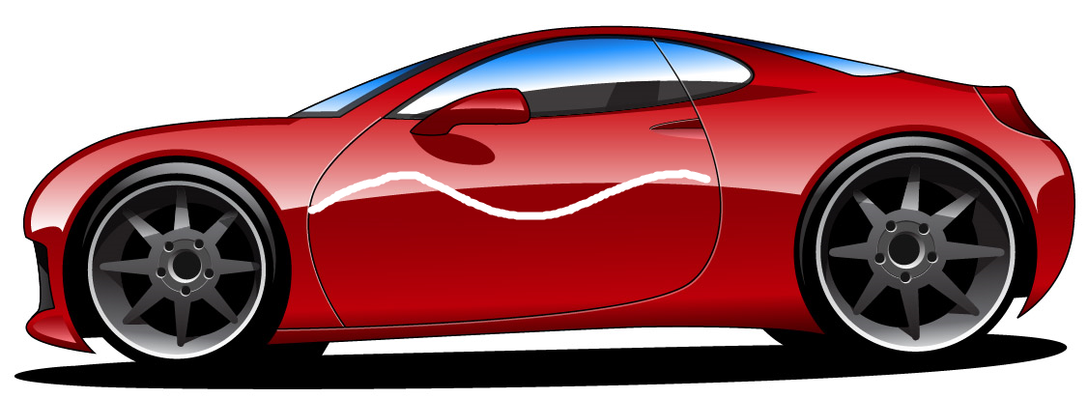

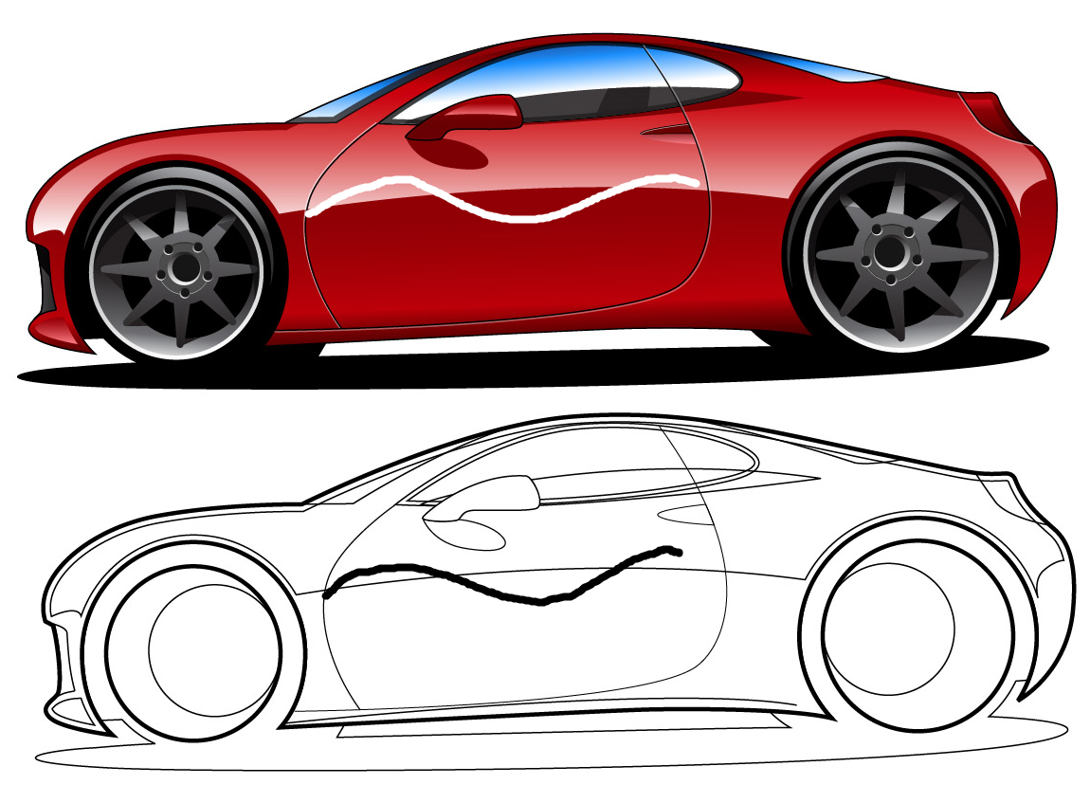
Appendix 2 – Original Design

Appendix 3 – Actual Outcome

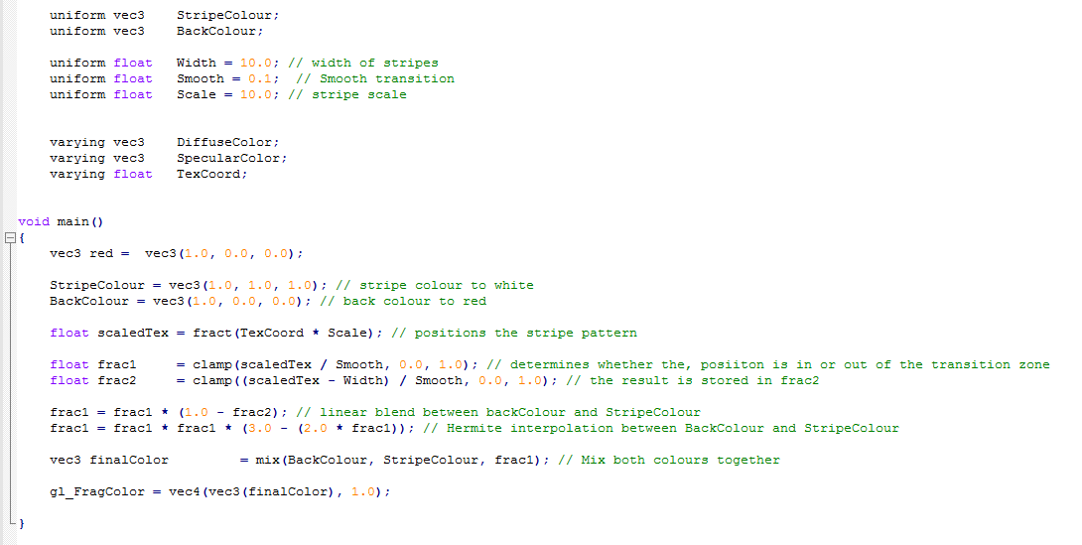
Appendix 4 – Fragment Shader

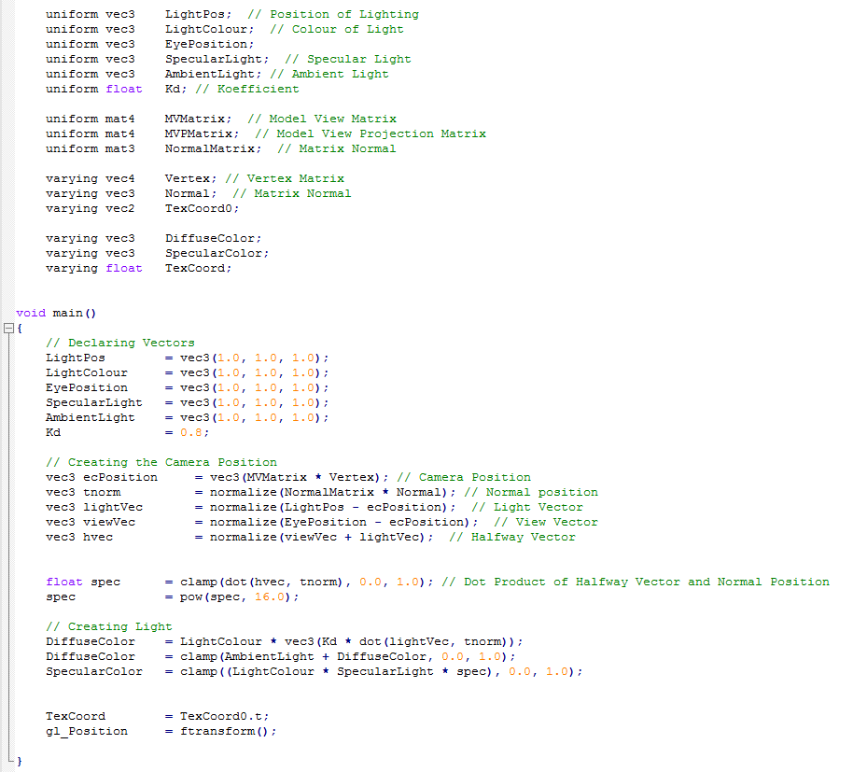
Appendix 3 – Vertex Shader

