LCBB4004 Marketing Fundamentals Assessment 1 BLOG

Student Name: Daniela Jicmon
Student ID: 2119900
Date: 01/09/2022
Module Code: LCBB4004
Module Name: Marketing Fundamentals
Module Lecturer: Sadeque Shaikh

BACKGROUND: UNILEVER

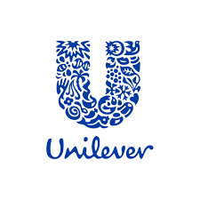
Unilever is one of the largest consumer goods companies in the world, with a presence in over 190 countries and a workforce of over 172,000 employees. Unilever is a British-Dutch multinational consumer goods company headquartered in London, England. Its products include food, beverages, cleaning agents, and personal care products. The company has over 400 brands spanning across 170 countries. Unilever was formed in 1930 by the merger of British soap maker Lever Brothers and Dutch margarine producer Margarine Unie. (Tien, 2019). During the Second World War, the company's factories were turned over to the war effort. After the war, Unilever experienced rapid growth, with its products becoming increasingly popular around the world. Unilever has its origins in two separate companies, one in the Netherlands and one in the United Kingdom. Both companies have a long history dating back to the 19th century. The Dutch company, NV Van den Bergh's Margarine Unie (later Unilever N.V.), was established in 1885 by Gerard Adriaan van den Bergh. The British company, Lever Brothers, was established in 1885 by William Hesketh Lever and his brother James. (Henderson and Nellemann, 2018).
The two companies initially competed against each other, but in 1927 they merged to form Unilever. The merger was partly driven by the need to compete with the US company Procter & Gamble, which had started to produce its own margarine.
Unilever has a dual structure, with two holding companies: Unilever NV in the Netherlands and Unilever plc in the United Kingdom. Each company has its own shareholders, board of directors and management team. By the 1960s, Unilever had become one of the world's leading consumer goods companies. (Reza, 2020). Today, it remains a major force in the global marketplace, with its products enjoyed by billions of people every day.

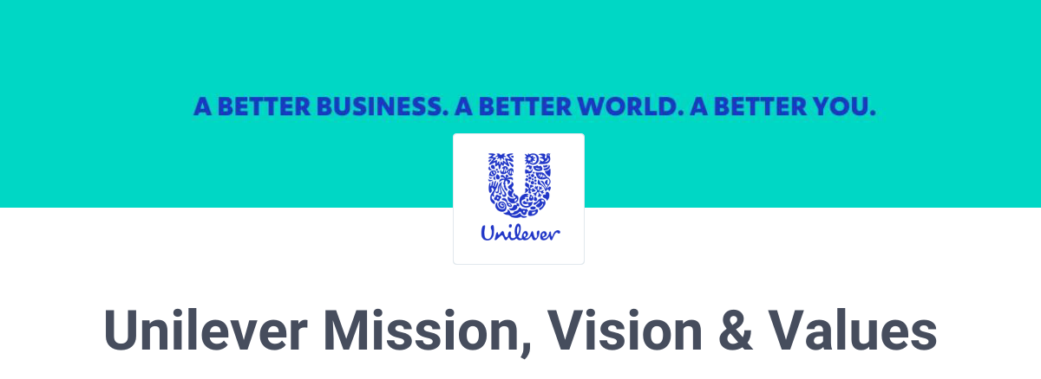
“To add vitality to life. We meet every day needs for nutrition, hygiene and personal care with brands that help people feel good, look good and get more out of life.”
This mission statement summarizes the company's dedication to improving the quality of life for people around the world. Unilever has a long history of creating innovative products that make a real difference in people's lives. From soap and toothpaste to laundry detergent and ice cream, Unilever's brands have become household names in countries all over the world. (Henderson and Nellemann, 2018). The company's products are designed to meet the needs of consumers, no matter where they live or what their budget is. Unilever is committed to providing quality products at an affordable price, and to making a positive impact on the communities where it does business.
“To make sustainable living commonplace. We believe this is the best long-term way for our business to grow.”
Unilever's Vision is to make sustainable living commonplace. The company tackles some of the world's biggest social and environmental issues through its Sustainable Living Plan. This plan has three goals: to help more than a billion people improve their health and well-being, to halve the environmental impact of our products, and to enhance livelihoods for millions of people. To achieve these goals, Unilever has set ambitious targets and is working with partners across the value chain. (Tien, 2019).

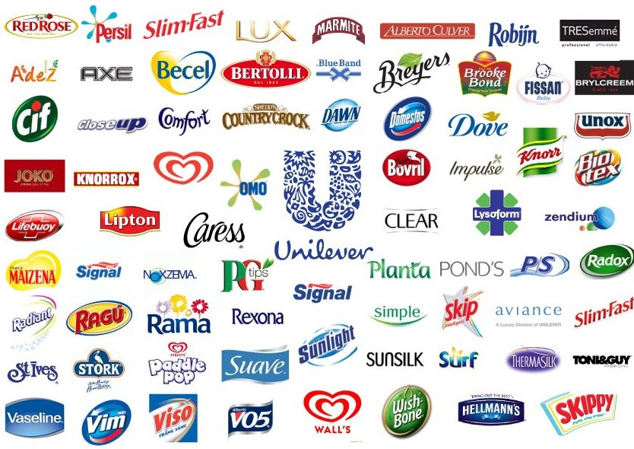
PRODUCTS
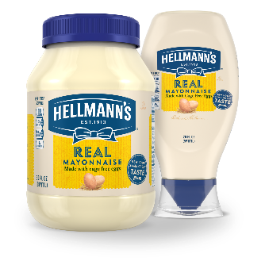
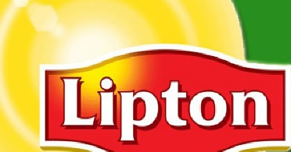
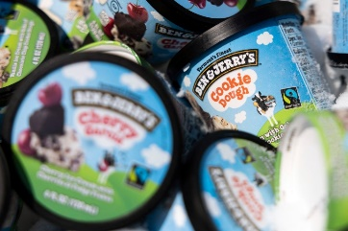
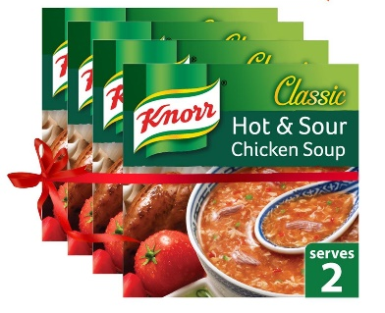

Food: Unilever is one of the world's largest food companies, with a portfolio that includes some of the best-known and most beloved brands. Unilever's food brands include Knorr, Hellmann's, Lipton, Ben & Jerry's, and Magnum. Each brand has its own unique history and range of products, but all share a commitment to quality and taste. Unilever's food brands are enjoyed by people all over the world, and the company is continually innovating to bring new and exciting products to market. (Steenkamp, 2017). With such a strong portfolio of food brands, Unilever is a trusted partner for retailers and foodservice providers looking to offer their customers the best possible selection.
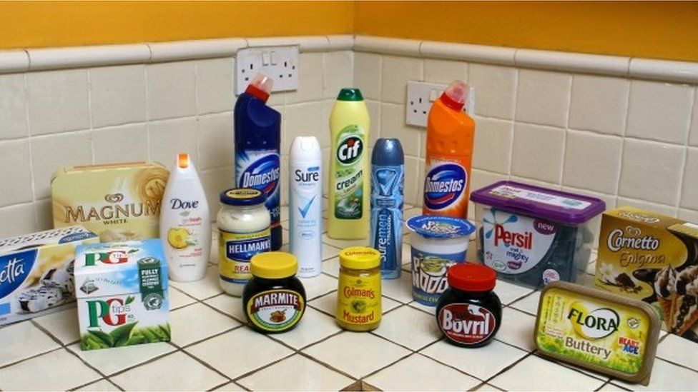
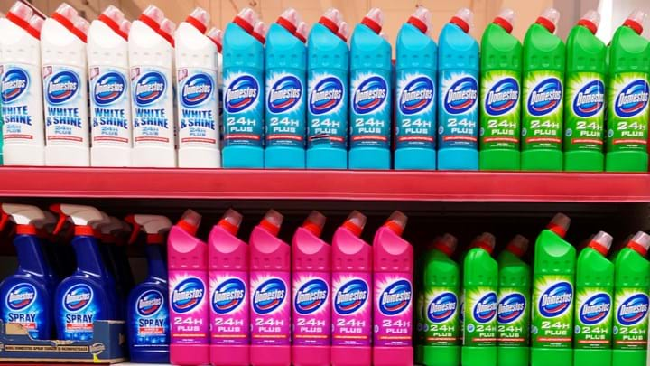

Cleaning: Unilever is one of the world's largest consumer goods companies with a portfolio that includes some of the best-known and most-loved brands. The company's cleaning brands include Magic, Vim, Woolite, Cif, Domestos, Omo/Persil, Sunlight and Surf. Unilever has a long history of responsible business practices and is committed to sustainable living. The company's purpose is to make sustainable living commonplace and it seeks to reduce its environmental impact through the efficient use of resources, including water and energy. In addition, Unilever aims to source all its agricultural raw materials sustainably by 2030. (Reza, 2020). Thanks to its strong portfolio of cleaning brands, Unilever is well-positioned to help consumers around the world to live more sustainable lives.
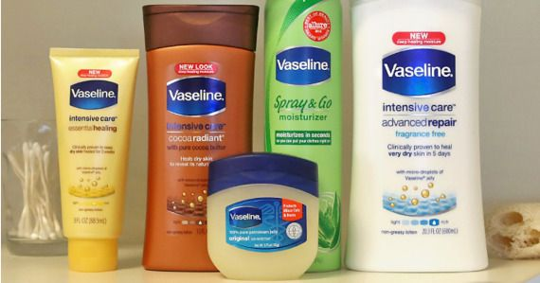
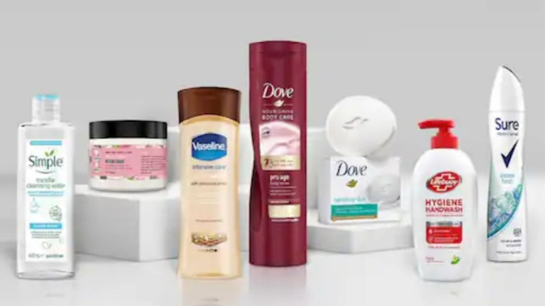
Personal care: There are many personal care brands under the Unilever umbrella, including Dove, Pond's, Vaseline, Axe, and more. Each brand has its own unique formulations and products that cater to different needs. (Reza, 2020). For example, Dove is known for its gentle cleansers and moisturizers that are ideal for sensitive skin, while Axe is known for its men's grooming products. Whatever your personal care needs may be, chances are there's a Unilever brand that can help.

In terms of packaging design, Unilever strives to create packaging that is both functional and stylish. For example, the company's detergent containers are designed to be easy to pour, while also being eye-catching and attractive. In terms of product quality, Unilever puts a great deal of emphasis on safety and efficacy. All of the company's products undergo rigorous safety testing before they are released onto the market. In addition, Unilever employs a team of experienced researchers who are constantly looking for ways to improve the quality of the company's products. (Tien, 2019). As a result of this commitment to quality, Unilever has built a reputation for being a trusted supplier of consumer goods.
In terms of quality, Unilever’s extensive research and development efforts ensure that its products meet the highest standards of quality. The company rigorously tests all of its products before they are released to the market, and it continually strives to improve the quality of its existing product lines. In addition, Unilever offers a money-back satisfaction guarantee on all of its products. (Tien, 2019). This commitment to quality has helped make Unilever one of the world’s most trusted brands.

PRICE

Low-priced products:
Lipton, Knorr, Hellmann's, Best Foods, Bertolli, Ben & Jerry's
Mid-priced products:
Dove, Axe, Signal, Sunsilk
High-priced products:
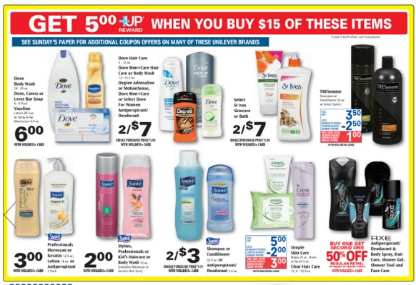
Pond's, TRESemmé, Lux, Garnier
Unilever has a long history of using price to increase sales and market share. The company often uses price discounts and promotions to attract buyers and keep existing customers loyal. (Hasan, 2015). For example, Unilever offers coupons on its website and runs regular sales on popular items. In addition, the company offers loyalty programs that give customers points or discounts on future purchases.
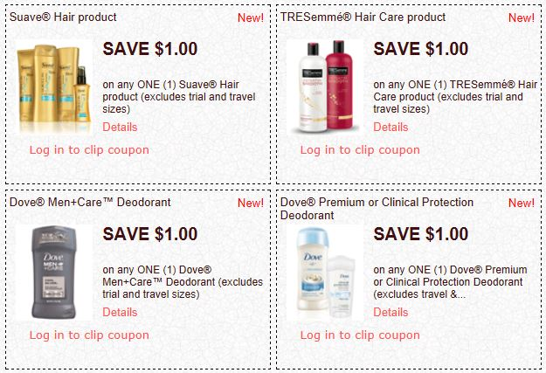
Unilever's pricing strategy is based on a combination of premium pricing for its flagship brands and competitive pricing for its mass-market products. The company capitalizes on the strength of its brands to charge higher prices, while its mass-market products are priced to compete with budget alternatives. In terms of promotions, Unilever relies heavily on discounts and coupons to drive sales. (Reza, 2020). The company also invests heavily in advertising, with a particular focus on television and online advertising. Overall, Unilever's pricing and promotional strategy is designed to maximize sales and profits across its wide range of products.
PLACE
Unilever has a direct presence in many markets, with a network of more than 400,000 outlets selling its products. Unilever has a large network of distributors, wholesalers and retailers that helps it to reach its customers around the world. Unilever operates its own distribution centers and warehouses, and it also uses the services of third-party logistics providers. The company has a well-established supply chain that helps it to deliver its products to consumers in a timely and efficient manner. Unilever has a strong commitment to responsible sourcing and has been working to improve the sustainability of its supply chain. (Bahadir et al., 2015). The company is also working to reduce its environmental impact by increasing the use of renewable energy and by reducing waste.

The sales representatives who visit Unilever stores are an important part of the company's success. Unilever has a team of more than 2,000 field sales representatives who visit stores and provide training to staff on how to best sell the company's products. (Reza, 2020). They are the ones who inform store owners about the latest products and promotions, and they also provide valuable feedback about customer needs and preferences. In addition, the sales reps help to keep Unilever's products stocked on shelves and ensure that store shelves are properly merchandised. As a result, they play a key role in ensuring that Unilever's products are available and visible to customers. Without the sales reps, Unilever would not be able to maintain its presence in retail stores.

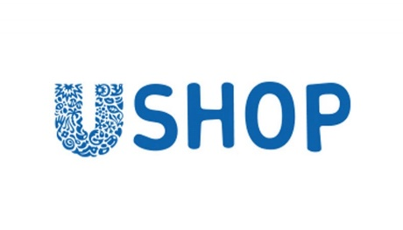
The company's online shopping service offers a convenient way for customers to purchase Unilever products from the comfort of their own homes. The website is easy to navigate, and customers can search for items by category or brand. In addition, the site offers a variety of payment options, including credit cards, debit cards, and PayPal. Shipping is typically free for orders over $50, and customers can often find coupon codes for additional savings.
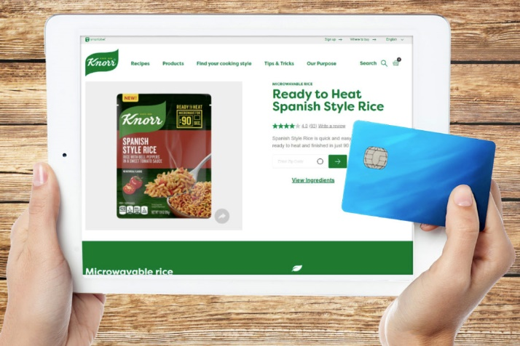
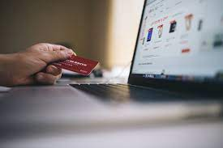

In recent years, Unilever has been increasing its presence in the e-commerce sphere, with a focus on selling its products through online retailers such as Amazon. This shift has been driven by changes in consumer behavior, as more and more people are doing their shopping online. Unilever has responded by investing heavily in e-commerce infrastructure and partnerships, as well as developing new marketing strategies to reach online shoppers. (Mortanges, and Rad, 2018).

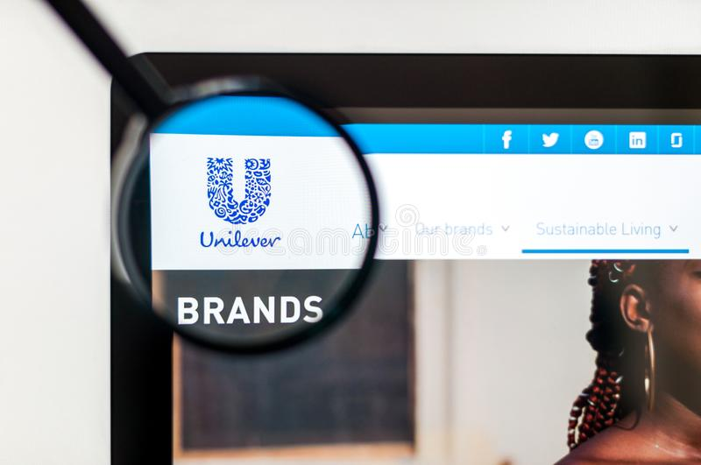

Unilever Global: Making sustainable living commonplace | Unilever

PROMOTION
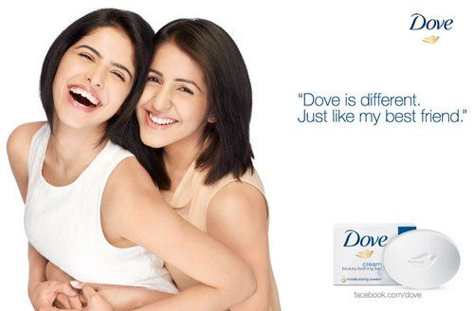
Unilever has a long history of successful marketing, and its advertising campaigns have helped to make its products some of the most recognizable in the world. Today, Unilever continues to be a leader in advertising, with campaigns that reach consumers across multiple platforms. (Bahadir et al., 2015). Television commercials, radio ads, print ads, and online ads all feature Unilever products, making it one of the most ubiquitous brands in the world. Whether it's a mother bonding with her daughter over Dove soap or a family enjoying a picnic with Hellman's mayonnaise, Unilever ads have a way of resonating with consumers on a personal level. Fairy

HELLMANN'S NEW LINEBACKER SACK FOOD WASTERS IN SUPER BOWL COMMERCIAL

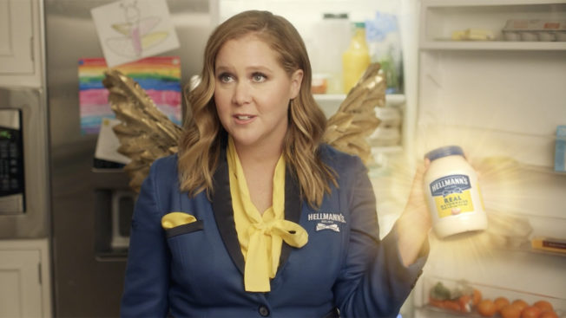
GODMAYO AMY SCHUMER REVIVES LEFTOVERS IN HELLMANN'S SUPER BOWL AD

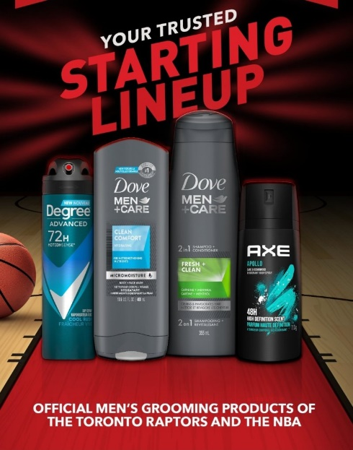
Unilever also uses sales promotions to reach its target market. Common sales promotion techniques used by Unilever include coupons, contests, and sweepstakes.
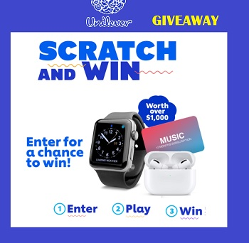


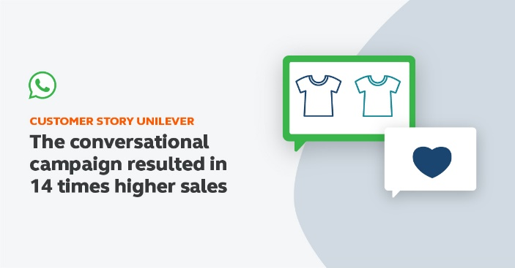
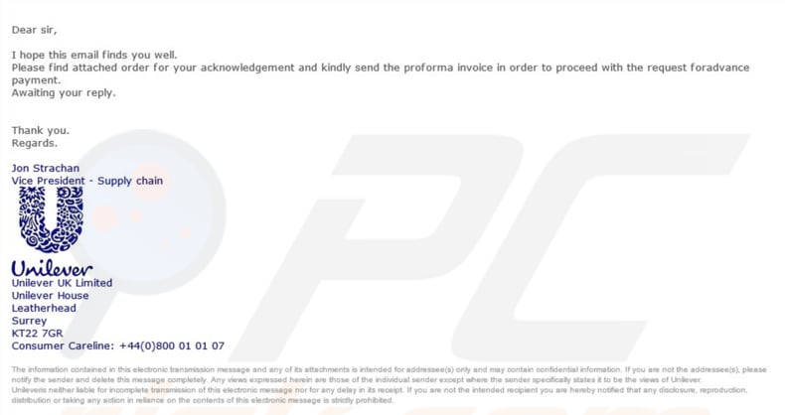
Unilever also uses direct marketing to reach its target market. This can be done through mail, email, telemarketing, or text messages

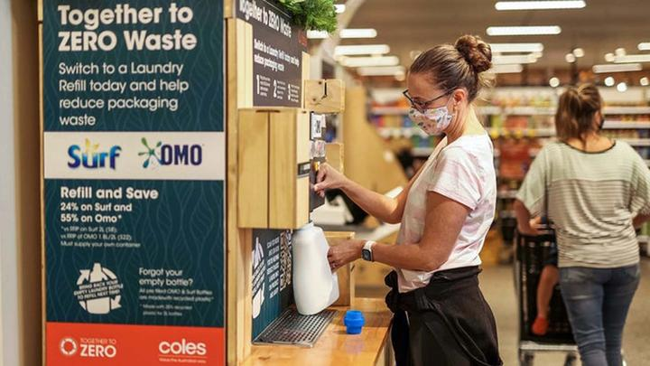
Unilever also uses personal selling and social media marketing to reach its target market. Personal selling involves face-to-face interactions with customers. This can be done through in-store demonstrations or presentations. (Jones and Miskell, 2015)

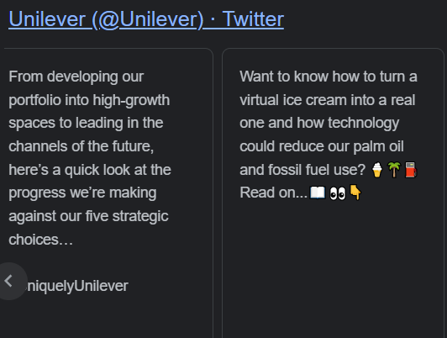
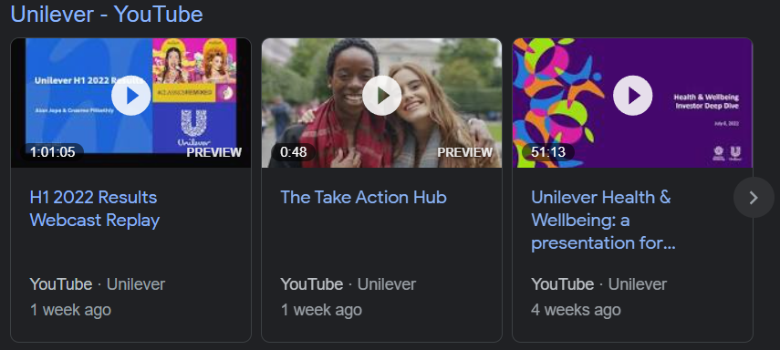
On its website, Unilever provides numerous examples of how it has utilized social media platforms such as Facebook and Twitter to reach out to consumers and promote its products. (Jones and Miskell, 2015). In one campaign, Unilever created a series of short videos featuring real people talking about their experiences with the company's products. (Henderson and Nelleman, 2020). The videos were then posted on the Facebook pages of various Unilever brands, resulting in over four million views. In another campaign, Unilever used Twitter to connect with consumers on a more personal level. The company encouraged users to tweet about their favorite Unilever products using the hashtag #myun Golemi. These tweets were then compiled into a video that was posted on the company's YouTube channel. (Tien, 2019). As these examples illustrate, social media marketing can be an effective way for businesses to connect with consumers and promote their products.
Word count: 1961
REFERENCES
- Bahadir, S.C., Bharadwaj, S.G. and Srivastava, R.K., 2015. Marketing mix and brand sales in global markets: Examining the contingent role of country-market characteristics. Journal of International Business Studies, 46(5), pp.596-619.
- Baines, P., Fill C., Page, K., (2014) Marketing, Oxford, 2nd edition.
- Blythe, J., (2014), Principles and Practice of Marketing, 3rd edition, Sage.
- Clow, K., Baack, D., (2013), Integrated Advertising, Promotion and Marketing Communications 6e, Pearson.
- Hasan, M.M., 2015. Marketing Analysis of Unilever. Total Quality Management, 11(1), pp.13-24.
- Henderson, R.M. and Nellemann, F., 2020. Sustainable tea at Unilever. Harvard Business School Case, (712-438). Maljers, F.A., 1992. Inside Unilever: The evolving transnational company. Harvard Business Review, 70(5), pp.46-52.
- Housden, M., (2010), Marketing Information and Research, Butterworth Heinemann.
- Jobber, D., (2016) Principles and Practice of Marketing, McGraw Hill 8th edition.
- Jones, G. and Miskell, P., 2015. European integration and corporate restructuring: the strategy of Unilever, c. 1957–c. 1990 1. The Economic History Review, 58(1), pp.113-139.
- Kotler P, Armstrong G, Harris, L, Piercy, N., (2017), Principles of Marketing, 7th Edition, Pearson.
- Mortanges, C.P. and Rad, A.T., 2018. Marketing strategy and market value:: An event-study analysis. European Management Journal, 16(3), pp.365-371.
- Reza, M.H., 2020. Marketing Strategy and Sustainable Plan of Unilever.
- Steenkamp, J.B., 2017. Global marketing mix decisions: global integration, not standardization. In Global Brand Strategy (pp. 75-109). Palgrave Macmillan, London.
- Tien, N.H., 2019. Comparative analysis of multidomestic strategy of P&G and Unilever Corporation. International journal of foreign trade and international business, 1(1), pp.5-8.

