Health and safety in Construction

Presented By Joanna Weedon 2414801
  - ACBA4023

Contents
Building Safety Act 2022 2
High Risk Building 2
Building Control 3
Inspector Competency 3
Administrative Requirements 4
Impacts 4
Health and Safety Legislation 5
Working at Height Regulations 2005 5
Lifting Operations and Lighting Equipment Regulations 1998 (LOLER) 6
The Control of Noise at Work Regulations 2005 6
Control of Substances Hazardous to Health Regulations (COSHH) 7
The Health and Safety at Work Act (HASAWA) 1974 7
The Management of Health and Safety at Work Regulations 1999 8
Personal protective equipment (PPE) 8
Excavation Safety 9
Barriers to effective health and safety management 10
Construction (Design and Management) Regulations 2015 – also known as CDM Regulations 11
Client Duties 11
Principal Designer (PD) 11
Principal Contractor (PC) 11
Appendix 13
Excavations 13
Glossary 16
Figure List 17
References 18

Building Safety Act 2022
The Building Safety Act 2022 was introduced following the Grenfell Tower tragedy, this major incident exposed crucial flaws in building safety (CIOB, no date). The act will improve safety standards across the county to give residents and homeowners more rights, powers, and protections. While the act has now been implemented across the country, the Welsh Government made the decision to implement the regulations in phases, beginning with the design and construction phase (Welsh Government, 2023). The brief shown below outlines the primary legislation that will affect the proposed development of the affordable flats in situated in Swansea.

High Risk Building
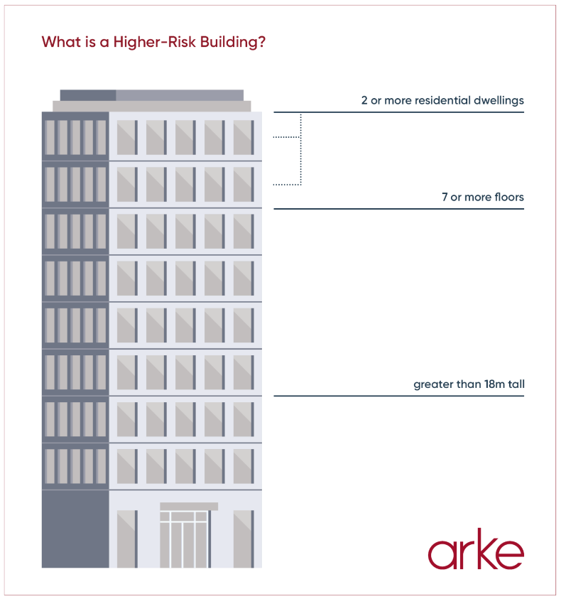
One of the Acts key focuses was the regulation of higher risk-buildings also knows as HRB (The Welsh Ministers, 2023). Buildings with the following details would fall into this category
Figure 1- Example of HRB (Fuell, 2024)

1) at least 18 metres in height, or has at least 7 storeys, and contains
1
a. at least one residential unit,
b. a hospital that has at least one bed intended for use by a person admitted to the
premises for an overnight stay,
c. a care home, or
d. a children's home, and
2) is not an excluded building -such as military use which would include barracks, or accommodation provided by the MoD.

Due to the specification of the development, we can assume that the building will fall under the HRB regulation. This will significantly affect the planning and delivery of the project in its entirety.
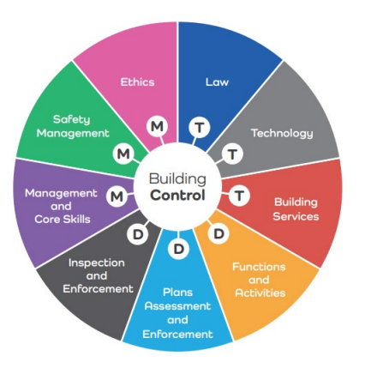

Building Control
The Act has determined that only local authorities such as Swansea County Council can now only oversee building control services. This means that the council will inspect to ascertain if the building complies with the Building Regulations 2010, review all plans and specifications, carry out on-site inspections with or without notice and have legal powers to enforce or prosecute noncompliance matters (Welsh Government, 2023b).
Figure2 – Building Control Functions (Welsh Government, 2025b)

Inspector Competency
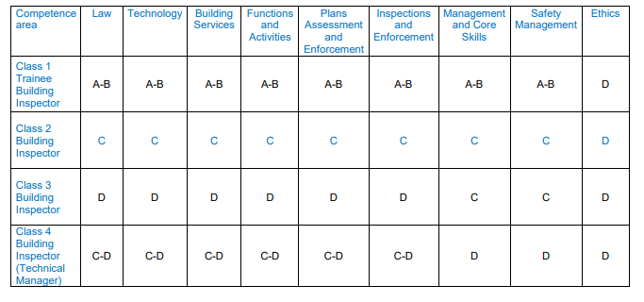
The inspectors working on the HRB must meet new competency standards. These are overseen by the Building Safety Regulator (BSR), which sits under HSE. For HRBs, registered Building Inspectors will either need to be in the following Classes, 2 – less complex HRBs or Class 3 more complex HRBs (Welsh Government, 2025)
Figure 3 – Building Inspection competence framework (Welsh Government, 2025c)

Administrative Requirements
Additionally, the proposed development must follow the Welsh specific using forms such as Form 2(W) – Start notice, Form 3(W) – Plans certificate application and 5(W) – completion. These forms mean that the Swansea County Council has complete visibility over the project and a traceable record of each stage (Welsh Government, 2023b).

Impacts
Area of Regulation | Requirement | Project Impact
Building Control | Only Swansea County Council can oversee building control for HRB projects | Due to capacity within the Building Control team, possible delays in approvals or inspection could occur. This impacts the programme, added prelim costs and potential cashflow issues if work has to pause
Start & Design Approval | All plans must be approved via the Welsh specific forms - Plans must be approved via Form 2(W) – Start notice, Form 3(W) – Plans certificate application | Any changes post submission will require revised paperwork resulting in delays to construction, which will directly affect the project timeline
Final Certification | Form 5(W) must be submitted to confirm full compliance at completion. | Sign off may be delayed if documentation is incorrect or missing, causing impact on time and money
Inspector Competency | Only Registered Building Inspectors Class 2 or 3 may oversee HRBs. | Due to the limited availability of Inspectors due competency requirements, we could see delays to schedule.
Administrative Requirements | Must use Welsh-specific forms (e.g., Form 2(W), 3(W), 5(W)); Golden Thread data must be maintained. | Increased administrative skills may be required, resulting in additional project support, which will be an added cost. Failure to keep accurate documents could result in regulatory non- compliance or legal challenges
Enforcement & Legal Risk | Building Control has powers to issue stop notices, prosecute breaches, and enforce standards without time limitation. | Breaches can result in costs delays.

The Building Safety Act 2022 introduces tighter regulatory oversight, higher proficiency requirements, increased administrative processes, and greater enforcement powers for HRBs in Wales. For this Swansea project, the legislation affects design timelines, inspections, resource planning, and legal exposure. The project team must prioritise early coordination with the local authority, verify the competence of duty holders, and maintain a clear audit trail throughout construction.
These impacts are not just procedural — they affect key project outcomes such as cost certainty, programme delivery, handover timelines, and regulatory risk. A failure to manage any of these areas could result in a delay in completion, increase costs, or result in enforcement action.

Health and Safety Legislation
There are several core pieces of Health and Safety Legislation that are applicable to the Kings Road SA1 proposed development site

Working at Height Regulations 2005
The Working at Height legislation applies to a task when there is a danger from falling from one level to another and resulting in injury. In relation to the proposed development, working on scaffolding, carrying out roof work, installing cladding are all deemed high risk height activities and therefore would sit under The Working at Height Regulations 2025 (The law - HSE, no date). The legislation requires three steps to help prevent injuries.
- Avoid working at height where it is reasonably practicable to do so – ground level assembly, use extendable tools
- Prevent falls from occurring - MEWPs, fixed edge protection on flats roofs, guard rails, properly erected scaffolds.
- Minimise the Consequences of a Fall - safety nets, airbags, harnesses and industrial rope access techniques
(Health and Safety Executive, 2014)

Lifting Operations and Lighting Equipment Regulations 1998 (LOLER)
People and businesses who own, operate or have control over lifting equipment would need to comply under the LOLER regulations. There are several lifting equipment’s that would fall under this category, for the development on Kings Road SA1, we would expect to see the following
- Hoists
- Cranes
- Forklifts & Telehandlers
- Material lifts
- Davits or pulley systems

The equipment should be examined by a competent person at the required intervals. For lifting accessories and equipment used to lift people, we would expect the equipment to be inspected every 6 months, and 12 months for all other equipment (Health and Safety Executive, 1999).
Provision and Use of Work Equipment Regulations (PUWER) works along side with LOLER. This regulation requires that the equipment is maintained, suitable and operated by trained individuals.
While intervals checks are required, pre checks and regular inspections are crucial to identify wear or defects, we would expect a competent person to under this before every use.
All inspections should be recorded for each examination and available upon request.
Both LOER and PUWER will reduce the risk of injury, fatality or misused equipment which will be critical when carry out the work at Kings Road.

The Control of Noise at Work Regulations 2005
Noise regulations are in place to protect workers hearing from any excessive disturbance in the workplace. The definition of extreme noise is that which could cause loss of hearing or to suffer from tinnitus. The regulation pertaining to dangerous levels is 80dB and employers must assess the risk to their employees’ health if they are carrying out tasks associated with high noise levels. Provision of information and training is a statutory requirement at levels of 85dB with noise protection a legal obligation to prevent damage. Levels at 87dB – taking into account hearing protection measures – are considered highly dangerous and workers must not be exposed to these levels (King’s Printer of Acts of Parliament, no date).

Control of Substances Hazardous to Health Regulations (COSHH)
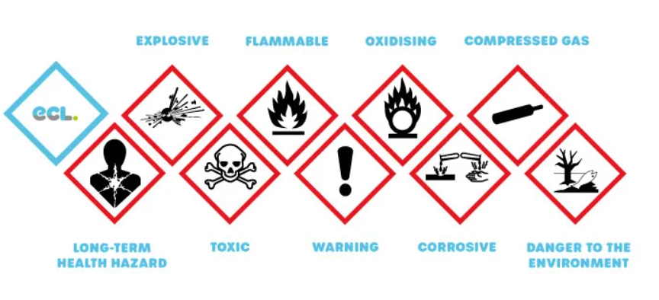
The law controlling the COSHH regulations requires the employers to ensure that any exposure to detrimental materials in the workplace that might cause ill health for their workers must be managed. These materials include dusts, gasses or fumes (breathable) or liquids, gels or powders that could come into contact with eyes or skin. Paints, solder fume, cleaners are likely to contact hazardous chemicals (COSHH Basics – COSHH, n.d.)
Figure 4 - Substances hazardous to health (ECLadmin, 2025)

The Health and Safety at Work Act (HASAWA) 1974
The Health and Safety at Work Act – Act 1974 is the foremost legal code addressing health and safety in the United Kingdom. The Act imposes a duty on companies to ensure that as far as is reasonably practicable, the health, safety and welfare of their employees, contractors, visitors and members of the public is paramount (Health and Safety Executive, 2013.
The Act requires that employees must take reasonable care of their own safety and that of others. Full cooperation is required from an employee’s perspective on health and safety matters.

The Management of Health and Safety at Work Regulations 1999
Also known as Management Regs, this legislation builds onto the responsibilities in the Health and Safety at Work Act 1974. For the proposed development the following key duties would be carried out to assess and manager risks for those carrying out the specific activities and for anyone else that could be affected

Health and Safety Key Duties | Who Carries This Out (Kings Road SA1)
Carrying out suitable and sufficient risk assessments | Each subcontractors site supervisor for specific tasks; reviewed by Principal Contractors H&S team
Appointing competent persons to manage health and safety | Principal Contractor appoints a site Health and Safety Manager; subcontractors appoint competent supervisors
Providing employees with information, instruction, and training | Principal Contractor provides site inductions and toolbox talks; subcontractors train their own operatives
Having emergency procedures in place | Principal Contractor develops emergency plans (led by Site Manager); subcontractors follow and support procedures

Personal protective equipment (PPE)
On the proposed development, PPE is fundamental to protect workers from a wide range of risks. Responsible steps should be taken to reduce any risk of activities before relying on PPE, however when hazards remain, appropriate work specific PPE should be worn as a safety measure (TSO (The Stationery Office), 1992). We would expect to see the following worn at Kings Road SA1 development
- Safety Boots (Steel Caps) – Certain Contractors enforce laced boots for added support around the ankles
- Hard Hats
- High-Visibility vests
- Gloves
- Safety Glasses
- Hearing Protection
- Weather resistant clothing for outdoor tasks.
The employer is legally responsible for proving PPE at no cost to the employee.

Excavation Safety
To carry out substructure and service installation works on the project, excavating will be required. To control any associated risks with these, such as banks collapsing or falls, procedures must be planned and supervised by a competent person in line with construction safety standards. Safety measures such signage; restricted access areas and edge protection must be used to mitigate risks (Excavations - HSE, no date). These controls sit under the following regulations
- Construction (Design and Management) Regulations 2015
- Work at Height Regulations
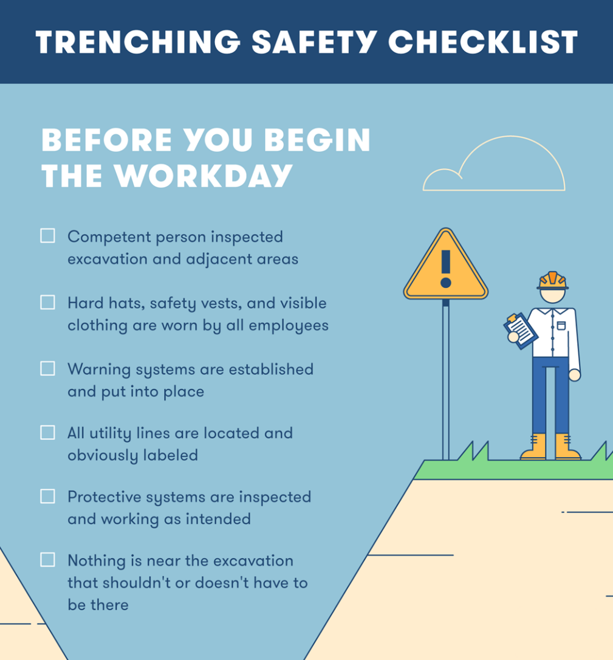
- Health and Safety at Work Act 1974
Figure 5 – Trenching safety tips - (Ismail, 2021)

Barriers to effective health and safety management
Barrier | Impacts on Site | Methods to Overcome Barriers
Poor Communication | Confusion about safety measures and/ or emergency procedures | Toolbox talks and briefs can be carried out daily (Participation, no date, sec. 15) and accompanied with clear signage and diagrams
Poor Workforce Engagement | Resistance to safety procedures and inferior hazard recording | Include workers in RAMS presentation; carry out programmed toolbox talks (HSE Books, 2006); encourage feedback at all times
Inadequate Supervision | Risky activities go unchecked | Appointment of competent supervisors key(Participation, no date, sec.8) carry out regular inspections and enforcement of the rules. Encourage near miss reporting.
Language and Literacy Barriers | Safety instructions mistaken by non-native speakers | Use translated materials and simple pictograms, double-check understanding; procure bilingual managers
Incomplete or Ineffective RAMS | Can result in hazardous working methods due to vague or generic forms | Ensure RAMS are task-specific RAMS supported by visual aids; programme in-person briefings and sign-off
Time Pressure and Programme Focus | Undue pressure to meet target dates may flout safe practices | Set genuine programme durations (Participation, no date, sec.4-5) allowing additional capacity in the programme for the high-risk tasks.
Complacency and Routine Risk | Commonplace risks become tolerated (e.g., trips, slips, poor manual handling) | Rotate tasks: review incident trend statistics; managers to reinforcement safety considerations
Subcontractor Variability | Erratic standards across the trades | Interrogate subcontractor pre-qualification – due diligence; training and RAMS; carry out coordination meetings throughout the project
Poor Welfare Provision | Worker weariness and discontent reduce the focus on safety | Provide clean welfare amenities; programme regular inspections with reporting schedule
Underreporting of Incidents | Missed chances to learn from near misses or unsafe conditions | Positively encourage near-miss reporting; communicate with the workforce the lessons learned; keep updated formal incident records

Construction (Design and Management) Regulations 2015 – also known as CDM Regulations
These regulations are there to ensure that thought is given at the outset for Health and Safety measures during the construction phase of the project.
The regulation was driven by the need to reduce injuries, work-related illnesses and fatalities on building sites.
Client Duties – a Client is defined as the commissioning agent and can be an individual or an organisation. It is the Client who must appoint the necessary competent duty holders and ensure that they carry out their obligations under the regulations. The Client must ensure that adequate time and resource is allocated, pre-construction information is provided and that the Construction Phase Plan has been formulated and agreed before work commences. (Commercial clients: roles and responsibilities - HSE, no date).
.
Principal Designer (PD) – this will be the lead role during the design phase of a construction project. The role will undoubtedly continue throughout the construction phase as changes to the design are likely to occur as the build commences. The role can be carried out by an organisation and/or and individual. The PD is accountable for coordinating H&S information from all designers and ensuring hazards are eliminated or reduced through design (Designers: roles and responsibilities - HSE, no date).

Principal Contractor (PC) – the basic function of this role is responsibility for Health and Safety during the construction phase of a project. One of the functions falling within this obligation is the production of a Construction Phase Plan. This document must be shared with any subcontractor associated with the project and the Principal Contractor needs to plan and manage the work so that it can be carried out safely. They must ensure that suitable site inductions are delivered across site, welfare units are maintained and up to standard and that subcontractors cooperate (Principal contractors: roles and responsibilities - HSE, no date).

There may be some overlap during pre-construction and construction phases if the design work continues throughout the construction phase and if planning aspects of this phase have to be done in advance of site works. Effective coordination between the PD and PC is essential to avoid safety gaps and Principal Contractor is essential to prevent safety breaches.
The Kings Road Project located at SA1 will be subject to CMD Regulations. The Client will have to follow the regulatory procedure making sure that they have proficient professionals for the roles of Principal Designer and Principal Contractor.

Appendix
Risk Assessment – 1

Excavations
Doc No: | RA - 001
Created: | 15/05/2025
Last Review: | N/A
Next Review: | Following any incident/near miss or change of methods
Owner: | Joanna Weedon
Project: | Development of affordable flats
Task: | Excavation for Foundations and Utility Services
Location: | Kings Road SA1
Activity | Hazard | Who Might be Harmed | Controls in Place | Potential Severity (PSR) | Probable Likelihood (PLR) | Risk Rating Number (PSR X PLR)
Excavation | Collapse or subsidence of trench sides | Groundworkers, Inspectors | Implement trench supports, inspect daily, no unauthorised people inside trenches, trained operatives only | 5 | 3 | 15
Excavation | Contact with services underground | Groundworkers | CAT scan area before use, Utility drawings assed before works are carried out, mark areas where services lay, hand-dig near services if possible | 5 | 2 | 10
Excavation | Falls into trench | Ground workers, site operatives, general public that have egressed onto site | Barries around trenches, signage trench covers, controlled access | 4 | 2 | 8
Excavation | Ingress of water | Site operatives in trench | Weather monitoring and assessing area before entering, removing water with pumps | 3 | 2 | 6
Excavation | Handling of top soil | Operatives | Use of lifting equipment rather than manual handling such as diggers and dumpers | 2 | 2 | 4
Excavation | Moving Vehicles | Site operatives in trench | Zoned areas of working assisted with trained banksman, traffic management plan, segregated walkways | 4 | 2 | 8
Excavation | Contaminated Gound - such as asbestos | Site Operatives | Soiling testing, site investigations, appropriate PPE and RAMS in place to dispose of contaminated materials | 5 | 1 | 5
Excavation | Collapse of Adjacent Structures | Site Operatives, General Public | Engage with civil engineer, protective barriers, underpinning of buildings | 5 | 2 | 10
Excavation | Confined Space Entry | Site Operatives | Permit to work, gas monitoring, emergency plans in place | 4 | 2 | 8
Existing controls in place
Training | Operatives trained to work in trenches
Signage | Adequate signage around site
Supervision | Daily checks by competent operatives
Equipment | Lifting Equipment, tech boxes, CAT scan
Reassessment Of Activity Hazards |  |  |  | Likelihood | Severity | Risk Level
1
2
3
4
5
Name Position: Joanna Weedon |  | Signed: J. Weedon |  | Date of Completion:15/05/2025
KEY |  | 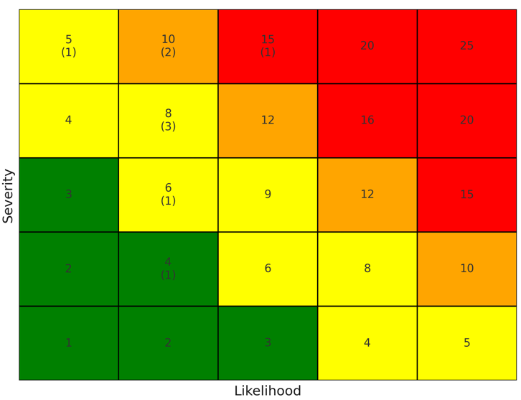
Likelihood | Severity
1.Very Unlikely | 1. Nuisance
2. Unlikely | 2. Minor
3.Likely | 3. Medical treatment
4. Very Likely | 4. Major
5. Certainty | 5. Fatal

Glossary
Building Safety Act 2022 - Uk legislation which was introduced to improve building safety standards
Building Safety regulator (BSR) - A organisation that sits within the HSE. Responsible for implementing building safety regulations and supervising inspectors competence and building control
CDM Regulations 2015 - Construction (Design Management) Regulations. A legislation that requires clients, designer and contractors to manage and oversee health and safety throughout a construction project
Client - A organisation or person for who the construction project is carried out for
COSHH - Control of Substances Hazardous to Health Regulations. This regulation ensures employees to control substances that can harm employees health.
High- Risk Building (HRB) - A residential or institutional building that meets the requirements, subject to stringent regulations under the Building Safety Act
HSE (Health, Safety & Environment) – A body that regulates and implements health and safety laws within the UK
LOLER - Lifting Operations and Lifting Equipment Regulations. This legislation implements safer use of lighting equipment such as cranes and hoists
MEWP - Mobile Elevated Work Platform. This machine is used to safely lift workers to elevated areas
PPE - Personal Protective Equipment – such as helmets, safety boots (steel caps) and gloves. Worn to reduce safety hazards.
Principal Contractor – A contractor who has overall control over the construction phase of a site. Responsible for health and safety and managing of scheduled work whilst complying with regulations
Principal Designer – Responsible for planning and co-ordinating design work, ensuring that is complies with regulations
RAMS - Risk Assessment and Method Statement. Documents which outline hazards of tasks and methods of safely carrying out tasks.
Working at Height Regulations - A regulation to prevent injury from falls, from one level to another.

Figure List
Figure 1 – Example of a HRB - Fuell, C. (2024) Higher-Risk buildings. https://www.arkecreative.co.uk/higher-risk-buildings/.
Figure 2 – Building Control Functions Welsh Government (2025b) Building Inspector Competence Framework (BICOF) (Wales), pp. 2–45. https://www.gov.wales/sites/default/files/publications/2025-05/building-inspector-competence-framework-bicof-wales.pdf.
Figure 3 – Building Inspector Competence Framework - Welsh Government (2025c) Building Inspector Competence Framework (BICOF) (Wales), pp. 2–45. https://www.gov.wales/sites/default/files/publications/2025-05/building-inspector-competence-framework-bicof-wales.pdf.
Figure 5 – Substances hazardous to health - ECLadmin (2025) What is COSHH? The complete guide to COSHH compliance. https://www.ecl.world/what-is-coshh/.
Figure 6 – Trenching safety tip - Ismail, K. (2021) Photo of the day: Trenching Safety Tips That Can Save a Life. https://hsseworld.com/photo-of-the-day-trenching-safety-tips-that-can-save-a-life/.

References
CIOB (no date). https://www.ciob.org/industry/policy-research/resources/Building-Safety-Act-Advice-and-Guidance.
Commercial clients: roles and responsibilities - HSE (no date). https://www.hse.gov.uk/construction/cdm/2015/commercial-clients.htm.
Designers: roles and responsibilities - HSE (no date). https://www.hse.gov.uk/construction/cdm/2015/designers.htm.
Excavations - HSE (no date). https://www.hse.gov.uk/construction/safetytopics/excavations.htm.
Health and Safety Executive (1999) Lifting Operations and Lifting Equipment Regulations (LOLER) 1998: Open learning guidance. HSE Books, pp. 1–84. https://www.hsebooks.co.uk.
Health and Safety Executive (2013) Workplace health, safety and welfare. HSE Books, pp. 2–60.
Health and Safety Executive (2014) Working at height, Health and Safety Executive. https://www.hse.gov.uk/pubns/indg401.pdf.
HSE Books (2006) Health and safety in construction. Third, HSG150. Third, pp. 1–141. https://www.hse.gov.uk/pubns/priced/hsg150.pdf.
King’s Printer of Acts of Parliament (no date) The Control of Noise at Work Regulations 2005. https://www.legislation.gov.uk/uksi/2005/1643/contents/made.
Participation, E. (no date a) The Construction (Design and Management) Regulations 2015. https://www.legislation.gov.uk/uksi/2015/51/regulation/15.
Participation, E. (no date b) The Construction (Design and Management) Regulations 2015. https://www.legislation.gov.uk/uksi/2015/51/regulation/4.
Participation, E. (no date c) The Construction (Design and Management) Regulations 2015. https://www.legislation.gov.uk/uksi/2015/51/regulation/8.
Participation, E. (no date d) The Construction (Design and Management) Regulations 2015. https://www.legislation.gov.uk/uksi/2015/51/regulation/15.
Principal contractors: roles and responsibilities - HSE (no date). https://www.hse.gov.uk/construction/cdm/2015/principal-contractors.htm.
The law - HSE (no date). https://www.hse.gov.uk/work-at-height/the-law.htm.
The Welsh Ministers (2023) The Building Safety (Definition of Higher-Risk Building) (Design and Construction Phase) (Wales) Regulations 2023, D R a F T W E L S H S T a T U T O R Y I N S T R U M E N T S. https://www.gov.wales/sites/default/files/consultations/2023-02/the-building-safety-definition-of-higher-risk-building-design-and-construction-phase-regulations-2023.pdf.
TSO (The Stationery Office) (1992) Personal protective equipment at work. TSO. https://www.hse.gov.uk/pubns/priced/l25.pdf.
Welsh Government (2023a) Building Safety Act 2022 Handbook for Wales, pp. 2–23. https://www.gov.wales/sites/default/files/publications/2024-06/building-safety-act-2022-handbook-for-wales-design-and-construction-phase.pdf.
Welsh Government (2023b) Building Safety Act 2022 Handbook for Wales, pp. 2–23. https://www.gov.wales/sites/default/files/publications/2024-06/building-safety-act-2022-handbook-for-wales-design-and-construction-phase.pdf.
Welsh Government (2025) Building Inspector Competence Framework (BICOF) (Wales), pp. 2–45. https://www.gov.wales/sites/default/files/publications/2025-05/building-inspector-competence-framework-bicof-wales.pdf.

