

Databases and Application Development

Student Name | Dharar Ahmad Ahmad Morshid
Student ID | 2411713
Programme: | BSc Applied Computing
Module: | Databases and Application Development
Module code: | ACCA5026
Lecturer: | Mohd Syafiq Bin Zolkeply
Assignment Title: | Database Design & Implementation  Part B
Submission deadline: | Friday 31st July 2026

1. Introduction
TasteBite is a database-driven recipe website developed as part of the Databases and Application Development module. The project was designed to demonstrate the practical application of PHP programming and database integration by creating a dynamic website that stores and retrieves information from a MySQL database.
The TasteBite recipe website allows users to browse recipes, search for recipes, and view detailed recipe information, including ingredients, cooking instructions, cooking time, and recipe images.
The website was developed using PHP for server-side programming, MySQL for database management, and HTML, CSS, and JavaScript to create a responsive and user-friendly interface. The database consists of three related tables: recipes, categories, and admin, allowing the website to display dynamic content and support administrator functions including adding, editing, and deleting recipes.
As the website interacts directly with a database, security is a significant consideration. Basic security measures were implemented, including user authentication and the use of prepared statements to reduce the risk of SQL Injection attacks. These measures help protect user input and maintain the integrity of the database while ensuring that the website operates securely and efficiently.
2. Overview of SQL Injection
The TasteBite website is a database-driven web application developed using PHP and MySQL. While the website stores recipe information in a MySQL database and allows users and administrators to interact with the data, it is important to protect the application against security threats. One of the most significant threats to database-driven websites is SQL Injection (SQLi).
SQL Injection is a web security vulnerability that occurs when an attacker inserts malicious SQL code into an application's input fields. These input fields may include login forms, search boxes, or data entry forms. If the application does not securely process user input, the malicious data can become part of the SQL query sent to the database. This may allow attackers to access, modify, or delete information stored in the database without authorisation.
In the TasteBite website, users can search for recipes, while administrators can log in and manage recipe records by adding, editing, or deleting information. Because these features require interaction with the database, they could become potential targets for SQL Injection if they were not developed using secure coding practices.
For example, the administrator login page could be vulnerable if user input were inserted directly into an SQL query without protection. An attacker might attempt to enter malicious text instead of a valid username or password to bypass authentication and gain access to the admin panel. If successful, the attacker could modify recipe information or delete records stored in the database.
Another possible target is the recipe search function. Since users enter keywords that are used to search the database, an attacker may attempt to submit malicious input instead of a normal search term. If the application is not properly protected, the SQL query could be manipulated to return unintended results or expose confidential database information. In a secure application such as TasteBite, the search feature should only return recipes that match the user's search term and should never execute malicious SQL commands.
SQL Injection attacks can have serious consequences for websites. Attackers may steal confidential information, modify existing records, delete important data, or gain unauthorised access to administrator accounts. These attacks can result in financial losses, reputational damage, and reduced trust from users. Therefore, protecting database-driven applications against SQL Injection is an essential part of secure web development.
To reduce this risk, developers should implement secure coding techniques such as prepared statements, parameterised queries, and input validation. Prepared statements separate SQL commands from user input, ensuring that any information entered by users is treated as data rather than executable SQL code. Input validation further reduces security risks by checking that only valid and expected data is accepted by the application.
In the TasteBite website, these security methods were considered during development to help protect database operations and reduce the risk of SQL Injection attacks. The following section discusses how these security measures were implemented within the project and demonstrates their effectiveness using examples from the website's source code.
3. SQL Injection Protection in the TasteBite Website
The TasteBite website was developed using PHP and MySQL, allowing users to browse recipes and administrators to manage recipe information through the admin panel. Because the website interacts directly with a MySQL database, protecting it against SQL Injection attacks was an important part of the development process.
The main areas that interact with the database are the administrator login page, the recipe search function, and the CRUD operations (Create, Read, Update and Delete).
The TasteBite website also implements CRUD (Create, Read, Update, and Delete) functionality through the administrator panel. After successful authentication, administrators can add new recipes, view existing recipe records, update recipe information, and delete recipes when required. These functions allow the website content to be managed efficiently while maintaining the accuracy and consistency of the database. These features receive user input before sending SQL queries to the database. If the input were processed without proper security measures, an attacker could attempt to manipulate the SQL queries by entering malicious SQL statements.
To prevent this risk, the TasteBite website uses prepared statements together with parameter binding when processing user input. Functions such as mysqli_prepare() and mysqli_stmt_bind_param() were implemented to ensure that all user input is treated as data rather than executable SQL commands. This prevents attackers from modifying the structure of SQL queries, even if malicious input is submitted.
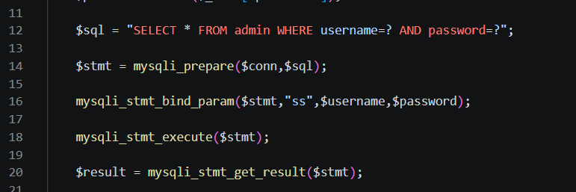
Figure 3.1: Prepared statement implemented in the administrator login page (login.php).
shows the prepared statement used in the administrator login page. The username and password are securely processed using parameter binding before the SQL query is executed.
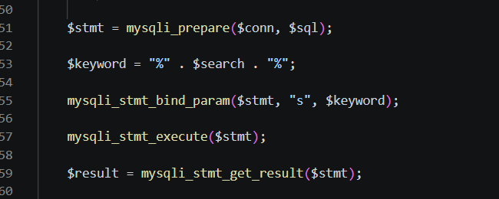
Figure 3.2: Prepared statement implemented in the recipe search function (search.php).
shows the prepared statement used in the recipe search page. The search keyword is securely bound to the SQL query before execution, preventing SQL Injection attacks.

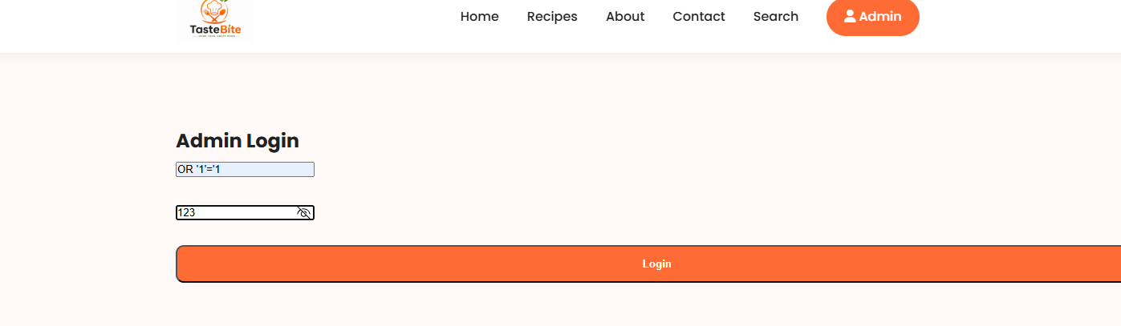
Figure 3.3: SQL Injection attempt entered into the administrator login page.
shows an SQL Injection attempt using the input ' OR '1'='1 in the username field. This common attack is used to test whether the login page is vulnerable to SQL Injection by attempting to bypass the authentication process.

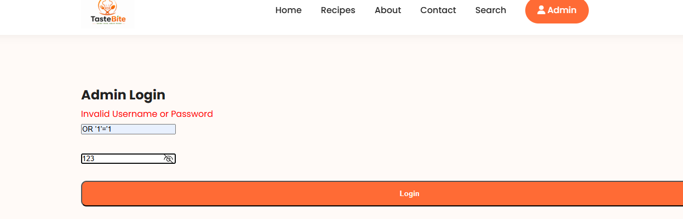
Figure 3.4: Result of the SQL Injection attack showing failed administrator login.
shows the result of the SQL Injection attempt. The malicious input (' OR '1'='1) was rejected, and the application displayed the message "Invalid Username or Password" instead of allowing access to the administrator dashboard. This confirms that the prepared statements successfully protect the login page against SQL Injection attacks.
The testing confirmed that the implemented security measures effectively protected the database against common SQL Injection attacks. Although the current implementation provides a good level of protection, future improvements could include password hashing using PHP's password_hash() function, stronger server-side input validation, and limiting repeated login attempts to further enhance the security of the website.

Conclusion
The TasteBite website successfully demonstrates the development of a secure database-driven web application using PHP and MySQL. The project provides users with the ability to browse, search, and view recipes, while administrators can manage recipe records through a secure administration panel. The integration of HTML, CSS, JavaScript, PHP, and MySQL allowed the website to deliver dynamic content and a user-friendly experience.
Security was an important consideration throughout the development process. The implementation of prepared statements and parameter binding helped protect the website against SQL Injection attacks by ensuring that user input is treated as data rather than executable SQL commands. Testing confirmed that SQL Injection attempts were rejected successfully, demonstrating the effectiveness of the security measures implemented.
Overall, the project met the objectives of developing a functional database-driven website while applying secure programming practices. Although the website provides a good level of protection, future improvements could include password hashing, stronger server-side validation, and additional security features such as login attempt limitations. These enhancements would further improve the reliability, security, and overall quality of the TasteBite website.
References
[1]. Paul, A., Sharma, V., & Olukoya, O. (2024). SQL injection attack: Detection, prioritization & prevention. Journal of Information Security and Applications, 85, Article 103871. https://doi.org/10.1016/j.jisa.2024.103871
[2]. Qin, Q., Li, Y., Mi, Y., Shen, J., Wu, K., & Wang, Z. (2025). Sql injection detection algorithm based on Bi-LSTM and integrated feature selection: SQL injection detection algorithm based on Bi-LSTM. The Journal of Supercomputing, 81(4). https://doi.org/10.1007/s11227-025-07109-w
[3]. Liu, Y., & Dai, Y. (2024). Deep Learning in Cybersecurity: A Hybrid BERT–LSTM Network for SQL Injection Attack Detection. IET Information Security, 2024(1). https://doi.org/10.1049/2024/5565950
[4] Chen, Y., Li, Z., & Zhang, H. (2025). Research on SQL Injection Detection Technology Based on Content Matching. Computers, Materials & Continua. https://doi.org/10.32604/cmc.2025.063319
[5]. Garn, B., Zivanovic, J., Leithner, M., & Simos, D. E. (2022). Combinatorial methods for dynamic gray‐box SQL injection testing. Software Testing, Verification & Reliability, 32(6). https://doi.org/10.1002/stvr.1826
[6]. Wadisman, C., Nozomi, I., & Rahmawati, S. (2021). Implementation of Cryptography Merkle-Hellman Knapsack Combination, Discrete Algorithm and ASCII Table Modification for PHP Source Code Security. IOP Conference Series. Earth and Environmental Science, 704(1), 12044. https://doi.org/10.1088/1755-1315/704/1/012044
[7]. Choi, J. (2025). Comparative Analysis of SQL Injection Defense Techniques: Focusing on Union Select Attacks. Applied Sciences, 15(23), 12351. https://doi.org/10.3390/app152312351
[8]. Andrijević, N., Lovreković, Z., Salkić, H., Šarčević, Đ., & Perišić, J. (2026). Benchmarking PHP–MySQL Communication: A Comparative Study of MySQLi and PDO Under Varying Query Complexity. Electronics (Basel), 15(1), 21. https://doi.org/10.3390/electronics15010021

