Accounting Fundamentals

Student ID: 2129047
Lecturer: Thomas Adeyemi
Name : Ancuta Ambrus
Date: 7.05.2023
Course: Accounting Fundamentals

Contents
Question 1 3
Question 2 3
Reference 9

Question 1
- Given below is the Income statement of the Wales PLC for the year ended 2022. According to the Income Statement, net income for the year is 58,350.
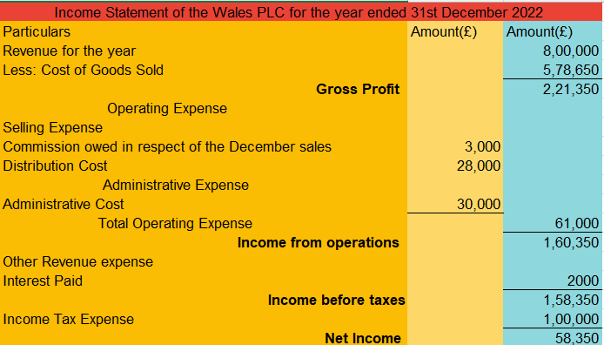
b) Balance sheet shows the financial position of the company. It provides transparency by showing the list of assets, liabilities and equity. The balance sheet shows that all the financial transactions are recorded accurately when both sides balance. If there is any mistake in recording the transaction then the balance sheet will never balance. The major reason that the balance sheet will balance is because of the double entry system of accounting. This means every transaction in the accounting system has a dual effect, for example, if the company decides to sell its car then in that case assets will decrease by the car's amount and cash from the proceeds will be recorded in the assets. Sometimes the balance sheet does not match because of the typical errors, forgetting to make a double entry, inputting a positive number in place of a negative number, typing errors or placing an entry in the wrong section. It is possible in some cases that the balance sheet slips an occasional error like an error of omission, misposting this indicates that relevant debit and credit are in the correct place(CFI, 2023).

Question 2
A)
1) Return on Capital Employed- This ratio is to be used to calculate return on capital. This shows how much the company is profitable in terms of its invested capital or how the company is using its capital to generate profit. It measures how the company is performing in the industry. This ratio is majorly used by the investor to decide on investment in the company(CFI TEAM, 2023).
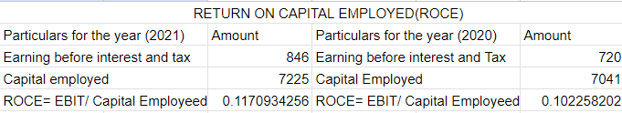
In the above table Return on Capital employed Increases from 2020 to 2021, this makes the company more attractive in the eyes of investors. A higher return is favourable, using this single matrix is not useful.

2) Return on Equity- Return on Equity measures the rate of return on the equity share capital, how much each equity of the company gives a return to the shareholder. This can be calculated by dividing net income by shareholders' equity. Higher return on equity is favourable and it depicts how companies perform in the industry. It should be equal to or above the earnings per share of the company's competitors(ECONOMICS TIMES, 2023).
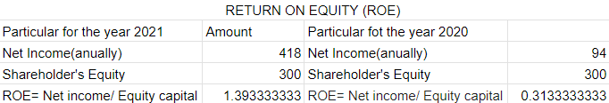
In the above-mentioned table, we can see that the Return on equity significantly increased from the year 2020 to 2021 which is a good sign concerning the investor. This means that the company is good at generating shareholder value because the company knows how to utilise the profit of the company efficiently.
3) Earnings Per Share- This is calculated by earnings available to shareholders divided by the total number of shares available to the equity shareholder. This shows the ability of the company to produce a net profit for the common shareholder. Higher EPS is favourable to the company for investment. This is the major ratio in the profitability ratios section. Given below is the image in which the earning per share increased significantly which makes the company investable and it is good and earns profit for the shareholder(GARTNER, 2023)
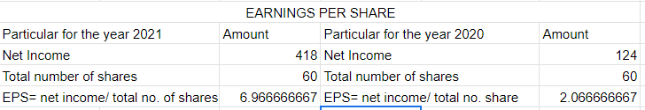
4) Net Profit Margin- It is an important indicator of the company's financial health. It shows whether the company's plans are working according to the plan or any deviation from it. It shows how much income is generated from every dollar of the revenue invested in the company. It is represented as a percentage which makes the business with all other businesses. Sometimes it temporarily boosts up because of the sale of assets. The formula of the same is Net income/revenue*100.
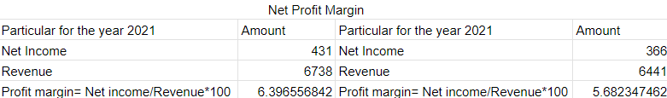
In the given figure profit margin slightly increased from 2020 to 2021 but in the overall profitability index the company performs very well. All the companies' plans regarding the future are working according to them. The company manages its finances nicely which is proved from the above parameter.
5)Assets Turnover - This ratio measures how a company manages its assets to generate revenue or sales. It compares the revenue to the assets of the company and depicts how the company manages its assets to earn profit. A higher turnover ratio is favourable because it shows that the company is efficient in terms of generating revenue. A lower ratio shows that the company is not good in terms of sales. Turnover ratio boosts up at the time of sale of assets, this is to be kept in mind at the time of calculation.
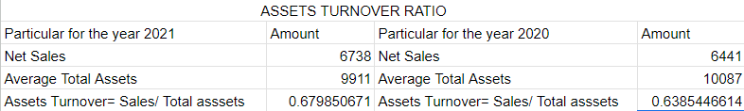
In the above image assets turnover slightly increased this is only because of the 299 million sale of the assets. So, this is not a good sign from the investor's point of view

6) Stock Holding Days- It states the days during which an organisation holds inventory before the sale. If inventory holding days are low this means that the organisation is efficient to convert the inventory into finished goods and there is a demand for it in the market. This can be calculated by dividing the cost of average inventory by the cost of goods sold multiplied by 365 days(CLEARTAX, 2022).
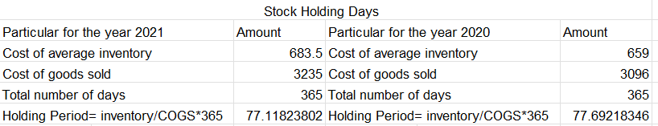
Stock holding days were reduced slightly by company policy to manage the inventory as the previous year.
7) Debtor Collection Period- It is a time within which a company converts its credit into cash sales. It depicts the company's ability to meet the short-term cash requirement and the only reason to maintain liquidity in the company. The average time taken by the purchaser of the company to make the payment of its credit sales, which company has a low collection period means that the company has loyal customers. This can be calculated by dividing 365 days by the accounts receivable turnover ratio.
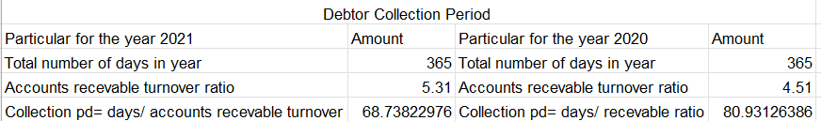
The debtor collection period improved from 80 days to 68 days which means that the company can recover back the money 2 days earlier. Customer loyalty improved from the previous year.
8) Current ratio- It measures the ability of a business to meet the short-term obligations that are due in the year, this can be paid by using the capital liabilities. The favourable current ratio is to be greater than 1. The higher the current ratio is the more reliable the company becomes in the long term because the risk of insolvency is very low. This shows whether the company can survive in the long term or not. The formula of the same is current assets divided by current liability(CFI TEAM (2023).
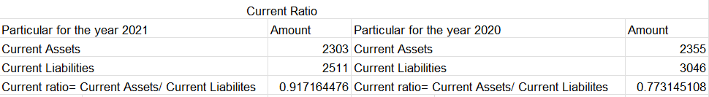
The company's current ratio improved from last year but this is lower than 1. The risk of insolvency is reduced from the previous year but there is some risk, if all the current liability holders will ask for the money at the same time then the company might have to face insolvency. According to the current ratio, liquidity increases significantly.
9) Gearing Ratio- This ratio depicts what proportion of capital acquired by way of debt in the company's capital structure. A higher gearing ratio means that the company will use a loan to pay for operational costs, this could lead to the insolvency of the company. With a low gearing ratio companies can easily survive the economic ups and down, and use the shareholder equity to pay for the major cost. The formula for the same is debt divided by equity(IG, 2023)
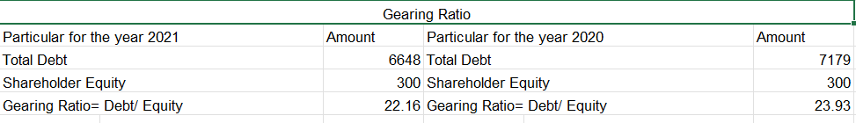
The favourable gearing ratio is between 25-50. The company has a low gearing ratio as compared to the favourable one which means that the majority of the money invested in the company is from the route of equity shareholders.
10) Interest coverage ratio- It is a metric that calculates how many times a company can pay its interest on the debt by using its earnings before its interest and taxes. This shows the capability of the firm in the payment of debt and depicts the chance that the company will survive in the long term or not. This ratio should always be more than 1 or there will be a high chance of being insolvent. The formula of this ratio is EBIT and tax plus non-cash expense divided by the interest expense(GROWW (2023).
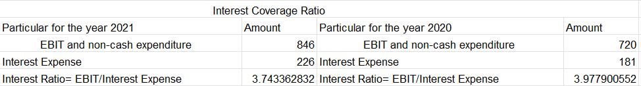
The company has a good interest coverage ratio but from the previous year, it slightly decreased because the rate of increase in the interest expense is more than the rate of increase in the earning before interest and tax.

b) As the profitability index improved significantly from 2020 to 2021, this means that the company is working on improving the earnings the company and its plans are proved to be successful. The company can give a good return to the shareholders, Return on equity is increased from 1 unit which means that the company is good at managing the fund as well as the profit generated from the company. Investors will feel that their money is in safe hands and growing significantly. Earnings per share increased by 6 units which is also a good point for investors. The profit margin also increased which makes the company suitable from the profitability index point of view. The assets turnover ratio increased and the only reason for the same is that the company sold 299 million assets which represent that the company is inefficient in managing the assets and in making good return from the assets. This is a negative point from the investor's point of view. The stock holding period is the same as the previous year and the company is not improving its policy to manage the inventory in such a way that the holding period should be minimum. The debtor collection period improved by 2 days but the current ratio is less than 1, which means that the liquidity from the collection period improved slightly but due to the low current ratio its effect become negligible. The gearing ratio is low and the interest coverage ratio is of 3 times which represents that the creditor cannot interfere in the company's matter because they will get their interest timely, Company will not face insolvency. After analysing various ratios there is a chance that companies' performance will improve in the future. Investors may have bright prospects through this company.

Reference
CFI (2023) Balance sheet, Corporate Finance Institute. Available at: https://corporatefinanceinstitute.com/resources/accounting/balance-sheet/ (Accessed : May 5, 2023).
CFI TEAM (2023) Current ratio formula, Corporate Finance Institute. Available at: https://corporatefinanceinstitute.com/resources/accounting/current-ratio-formula/ (Accessed: May 5, 2023).
CFI TEAM (2023) Return on capital employed (ROCE), Corporate Finance Institute. Available at: https://corporatefinanceinstitute.com/resources/accounting/return-on-capital-employed-roce/ (Accessed: May 5, 2023).
CLEARTAX (2022) Inventory holding period, cleartax. Available at: https://www.clear.in/s/inventory-holding-period (Accessed: May 5, 2023).
ECONOMICS TIMES (2023) What is return on equity? definition of return on equity, return on equity meaning, The Economic Times. Available at: https://economictimes.indiatimes.com/definition/return-on-equity (Accessed: May 5, 2023).
GARTNER (2023) Definition of earnings per share (EPS) - gartner finance glossary, Gartner. Available at: https://www.gartner.com/en/finance/glossary/earnings-per-share-eps-#:~:text=Earnings%20per%20share%20(EPS)%20is,and%20value%20perceived%20by%20investors. (Accessed: May 5, 2023).
GROWW (2023) Interest coverage ratio(icr) - meaning, calculation and examples, Groww. Groww. Available at: https://groww.in/p/interest-coverage-ratio (Accessed: May 5, 2023).
IG (2023) Gearing ratio definition, IG. Available at: https://www.ig.com/en/glossary-trading-terms/gearing-ratio-definition (Accessed: May 5, 2023).

