
Problem Analysis and Solution Development
Module Name: Analysing and Solving Problems
Module Code: ACCA 4019
Student Name: Yevhen Mateta
Student ID: 2512714
Lecturer Name: DR Abida Perveen

Submission date: 21/03/2026

Contents
Introduction 1
MoSCoW - 1
Must 1
Should 1
Could 1
Will not be 1
Decomposition 1
IPO 1
IPO Variables 1
Pseudocode 1
START 1
END 1
Flowchart 1
MAIN 1
Sub Process 1
Reflection 1
Conclusion 1
References 1

Introduction
In this paper, I will consider a scenario where a local college needs help organising. I will use the MoSCoW method to identify key solutions to the college's problem, and then completely decompose the problem and create a solution.

MoSCoW -
MoSCoW (Must-Should-Could-Will not be) is a technique used to indicate the importance and necessity of certain requirements for a given task or goal. In my case, I will use this technique to categorise the important components of my college problem into those that are important, can be done, or won't be done now [1].

Must
Creating a student database – since the main problem is that students are often placed in classes that are not designed for such a large number of students, it would be advisable to create a database of all students and teachers at the educational institution and assign each a unique identifier. The program should also indicate which group the student belongs to, which teacher will be assigned to that group, and how many students are in that group.
Creating a room database - to distribute groups into the correct rooms; a database of all rooms is required. Each room will have its own unique ID number, which will indicate the number of people this room can accommodate.
Assignment Program - A program must be developed that will assign the group to appropriately sized rooms and assign teachers to groups based on their subject so that two groups or more than one teacher are not in the same room at the same time.

Should
The program should consider the location of the previous room where a group of students studied, so that the students can get to the next room as quickly as possible.
The program should provide the ability to change the lecture schedule or the composition of the group or the teacher.
It should be possible to download the table in different formats, such as PDF or Excel.

Could
There could be a database containing data on classroom equipment to assign groups of students to the appropriate lecture room for their subject.
There could be an analysis of how comfortable it is for students to get to their classrooms between lectures.

Will not be
A system for registering student arrival times to analyse the time spent by students moving between rooms.
Expanding classrooms to address overcrowded rooms.
Purchasing new classroom equipment to increase the versatility of classrooms for different student groups.

MUST | SHOULD | COULD | WILL NOT BE
Database for all audiences and their locations | The software considers the location of students and pupils to distribute them among classrooms located in proximity, from the previous audience. | Database including the equipment of the class | System with registration of student arrival time.
Software for matching classroom sizes to student group sizes. | Possibility to change the schedule or audience manually. | Distribution of students into classrooms with equipment appropriate to the subject. | Audience expansion
Database of all student groups and teachers associated with them. | Ability to export a schedule table (for example, to Excel) | Analytics on overloaded audiences. | Improving classroom equipment.
Software that verifies "one audience per group" compliance
Assigning teachers to groups on specific days and times on a "one teacher per group" basis

Decomposition
1. Assigning Classes to Lecture Rooms
1.1 Ask the user about the number of classes
1.2 Obtain and save input data
1.3 Cycle checking for suitable rooms for classes
2.Ask about the room
2.1 Identify the room number
2.2 Ask the user about the room size
2.3 Obtain and save input data
3. Checking the room for suitability for the class
3.1 Selecting a lecture room for testing
3.2 Checking the capacity of the lecture room
3.3 Checking if the lecture room is available according to the schedule
3.4 Checking the next lecture room if the current one is unsuitable
4.Final Assignment
4.1 Assign the most suitable lecture room to the class based on all criteria
4.2 Display a message confirming that the lecture room has been assigned
4.3 Displaying all data, including information about the class and lecture room.

IPO
IPO (Input Process Output) is a model for dividing a problem into three stages: Input is the input data, or what the problem requires, Process is the part of the stage that explains what and how the data should be processed, and the last stage is output, which indicates the solution to the problem or the data that should be obtained after the process [2].

INPUT | Process | Output
Total number of classes  Class size  Check room capacity  Check room schedule | Collect the total number of scheduled classes.  Collect the class size for the current class.  Check if the room is suitable for the number of students and their schedule.  Assign a suitable room to the class.  Update the schedule for all classes. | Total number of classes registered  Class size registered  Space suitability determined.

IPO Variables
Variables act as temporary or permanent storage for information a program needs during execution. Essentially, a variable is like coordinates on a map, pointing to a specific location that stores specific data. Variables are created in a specific style so that other developers can understand the variable's nature and meaning [3]. There are many ways to write variables, but the most common are PascalCase(FullNameStudent) or CamelCase(fullNameStudent), or the same methods but with underscores. However, in my work, I will only use PascalCase, as it is the most convenient for me.
INPUT | Process | Output
TotalClasses  ClassSize  CapacityCheck  ScheduleCheck | Start a loop for each class (ClassIndex).  Set initial values: RoomAssigned = 0,  CurrentRoom = 1.  Check the current room for capacity and schedule.  If CapacityCheck = 1 and ScheduleCheck = 1, then allocate the room (AllocatedRoom = CurrentRoom) and end the search (RoomAssigned = 1).  Otherwise, move on to the next room (CurrentRoom = CurrentRoom + 1). | DISPLAY "Class " + ClassIndex + " allocated to room " + AllocatedRoom  DISPLAY "All classes are successfully scheduled!"

Pseudocode
Pseudocode is a convenient and unambiguous way to describe the logic of a script or program for future use in writing real code. Although pseudocode is structured like a programming language, as it is typically used, it lacks strict and restrictive rules, so instead, it serves as a universal, language-independent blueprint. Pseudocode is much easier to read and can easily describe complex processes. Ultimately, this blueprint makes complex programs easier to read for any developer, regardless of their programming language [4].

START

- DISPLAY "Enter the total number of classes:"
- INPUT TotalClasses
- FOR ClassIndex FROM 1 TO TotalClasses DO
- CALL AllocateRoom()
- END FOR
- DISPLAY "All classes are successfully scheduled!"
- END

- SUBPROCESS AllocateRoom()
- DISPLAY "Enter class size for class " ClassIndex ":"
- INPUT ClassSize
- SET RoomAssigned = 0
- SET CurrentRoom = 1
- WHILE RoomAssigned = 0 DO
- DISPLAY "Checking room " CurrentRoom " for capacity, time, and distance"
- DISPLAY "Is the room suitable for that number of students? (1 for Yes, 0 for No):"
- INPUT CapacityCheck
- DISPLAY "Is the room suitable for student schedule? (1 for Yes, 0 for No):"
- INPUT ScheduleCheck
- IF CapacityCheck = 1 AND ScheduleCheck = 1 THEN
- SET AllocatedRoom = CurrentRoom
- SET RoomAssigned = 1
- ELSE
- SET CurrentRoom = CurrentRoom + 1
- END WHILE
- DISPLAY "Class " ClassIndex " allocated to room " AllocatedRoom
- RETURN

END

Flowchart
A flowchart is a diagram that visualizes the sequence of scripts needed to solve a specific problem. Since a flowchart is a structural plan, it uses specific symbols for specific data types and commands: a rectangle for a process, a parallelogram for input/output, a diamond for a decision (for example, "IF"), a rectangle with two additional rectangles on each side for a sub-process, an oval/terminal to indicate the beginning and end of a program, and, of course, arrows to indicate sequencing. Instead of reading text, a developer can immediately understand how a system works by looking at a flowchart.

MAIN
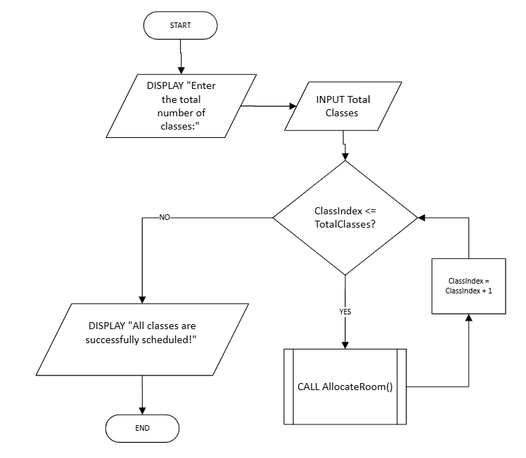

Sub Process
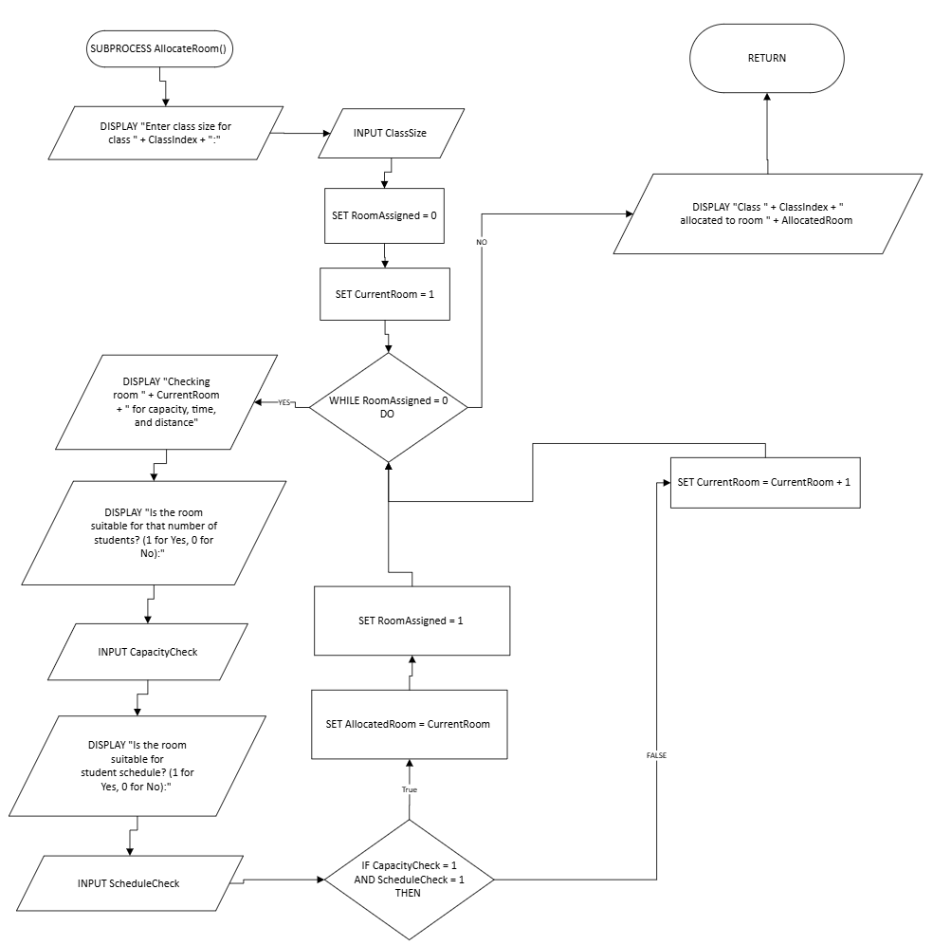

Reflection
I've accomplished quite a lot in this report, but I know I could have done more. For example, I could have expanded the pseudocode a bit or made it more professional, such as having the program calculate all the information itself instead of asking the user. I could also have added more features, such as allowing the teacher or staff to intervene in the room selection process. For MoSCoW, I could have written more requirements in the "should" or "could" clauses.

Conclusion
So, I've come a long way, starting with the introduction and ending with this summary. In this report, as planned, I analysed the scenario using the MoSCoW technique to identify the main problems and how to solve them. I can't help but mention the Decomposition section, in which I step-by-step analysed how the program should work, considering the main problems I'd already identified. Next, I extracted the main data from the scenario into the IPO table—that is, what the program is asking us to calculate, as well as the expected output—then created variables from this and placed them in the IPO variables table. After fully analyzing the scenario, I began creating pseudocodes for all parameters, and then also created a flowchart for easier understanding of the program flow. Finally, I wrote a Reflection function to identify areas for improvement.

References
[1] I. Putu Ramayasa, I. Gede, and A. Candrawibawa, “Usability Evaluation of Lecturer Information Systems Using Sirius Framework and Moscow Technique,” Scientific Journal of Informatics, vol. 8, no. 1, 2021, doi: https://doi.org/10.15294/sji.v8i1.25356.
[2] J. Deng, S. Huang, L. Wang, W. Deng, and T. Yang, “Conceptual Framework for Smart Health: A Multi-Dimensional Model Using IPO Logic to Link Drivers and Outcomes,” International Journal of Environmental Research and Public Health, vol. 19, no. 24, pp. 16742–16742, Dec. 2022, doi: https://doi.org/10.3390/ijerph192416742.
[3] D. Panjuta and J. Jabbarzadeh, “C# Data Types and Variables,” Learning C# Through Small Projects, pp. 23–43, 2024, doi: https://doi.org/10.1007/978-3-031-51914-7_2.
[4] N. Bennett, "Introduction to Algorithms and Pseudocode," Project "Exploring Modelling and Computation," Working paper, Jan. 2025.
[5] “Algorithm & Flowchart,” Google Books, 2022. https://books.google.co.uk/books?hl=ru&lr=&id=FA2KEAAAQBAJ&oi=fnd&pg=PA2&dq=flowchart+pseudocode&ots=QrwHoTMt2c&sig=Ink8QXdHwp4a97GMfinSJupbLQ&redir_esc=y#v=onepage&q=flowchart%20pseudocode&f=false
‌

‌

‌

