

BA BUSINESS MANAGEMENT
Marketing Fundamentals Assessment 1

Module: Marketing Fundamentals

Code: LCBB4004

Lecturer: Nadeem Mirza

Name: Dimitar Stefanov Cherganski

Student ID: 2133011

SUBMITTED ON THE 25th November 2022
Assessment

Table of Contents
Blogging to communicate 3
Overview of Hermès 4
The Mission of Hermès 5
Marketing Mix of Hermès 6
Hermès Customers at the core of the Network 9
Hermès Contemporary Artisans Since 1837 10
References 12

Blogging to communicate

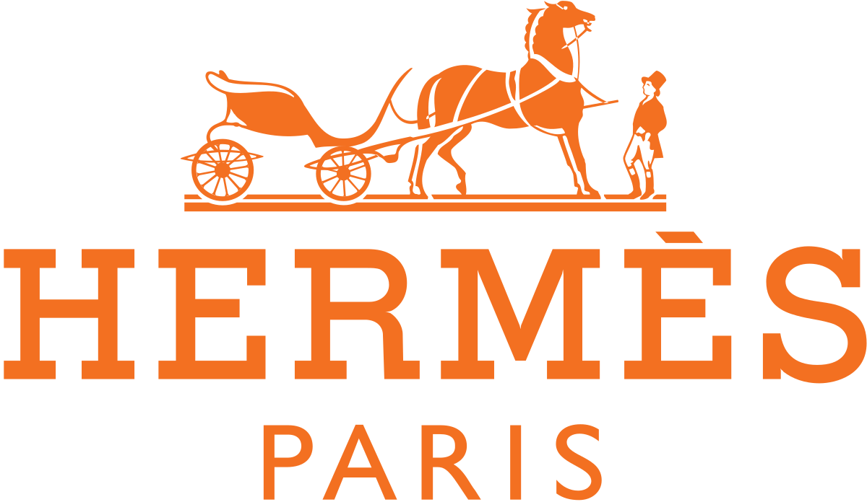

Overview of Hermès

Hermès International SCA is in the business of providing textiles and apparel. It manufactures, sells, and distributes apparel products, including leather goods and saddlery, ready-to-wear clothing, footwear, belts, gloves, hats, silk and textiles, jewellery, furniture, wallpaper, interior fabrics, tableware, perfumes, and watches (The history of Hermès, 2022). Thierry Hermès founded the company on 1st June 1938, headquartered in Paris, France. The fashion house Hermes is steeped in history and tradition. The brand, family-owned for five generations, is a global symbol of distinction (SEGRAN, 2021). From its origins in saddlery and fine equestrian leather goods, Hermes is now best known for its handbags and other high-quality items. In the last two centuries, they have certainly come a long way, and today we will delve deeper into the history of this iconic brand (A timeline of the Hermès brand, 2022).
Hermes conjures up a storey that many other fashion houses cannot even begin to compete with because it has many wondrous tales and illustrious history. The enduring desirability of their exquisite handbags is a testament to the fashion house's design brilliance and opulent craftsmanship (Martin Roll, 2021).

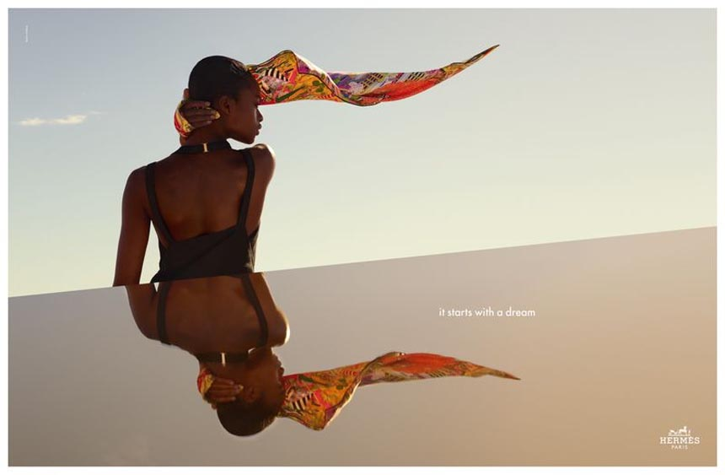

The Mission of Hermès

The Hermès brand philosophy could be summed up in a single sentence from former CEO Jean-Louis Dumas: "We do not have an image policy; we have a product policy."

The brand's ethos is deeply rooted in "quality" and "refinement." For these reasons, the brand has always avoided mass production, assembly lines, and outsourcing. According to Hermès, every product bearing the brand's name should reflect the craftsmanship of the artisan who created it. Creative Director Pierre-Alexis Dumas continues to sign off on every Hermès product before it leaves the workshop, demonstrating the company's unwavering dedication to the highest quality. According to current CEO Axel Dumas, the greatest asset
of the Hermès brand is its dedication to craftsmanship. Pierre-Alexis Dumas said, "I believe Hermès objects are desirable because they re-humanise individuals... Our customer senses the presence of the person who crafted the object, while the object's sensory gratification brings him back to his sensibility."

The most important aspect is that these brand principles have remained consistent throughout the company's nearly 183-year evolution. Multiple generations of the Hermès family have been responsible for the company's ownership, management, and leadership, but the Hermès brand's core values have never been compromised. Hermès products are manufactured almost entirely in France by Ateliers Hermès, which places a premium on quality. In addition, Hermès' claims, which are consistent with those of its CEO and Creative Director, that each product is entirely handcrafted by a single craftsman demonstrate the superior craftsmanship and uniqueness of its products. For example, only silk from Hermès farms in Brazil is used to create its silk scarves.

Hermès, as a company, has a strong desire to maintain its exclusivity, which is the driving force behind its quality and exclusivity pillars. The company values an aura of exclusivity because it does not intend to portray its brand and products as mass-market or even premium luxury. The philosophy and goal have always been to remain an "ultra-premium luxury" that only a select few can afford and is not easily accessible (The history of Hermès, 2022).

Consistent with these brand philosophies, the company lacks a marketing division. Intuition and originality are the two primary forces propelling the company's business engine. Allegedly, every employee at Hermès is responsible for marketing.

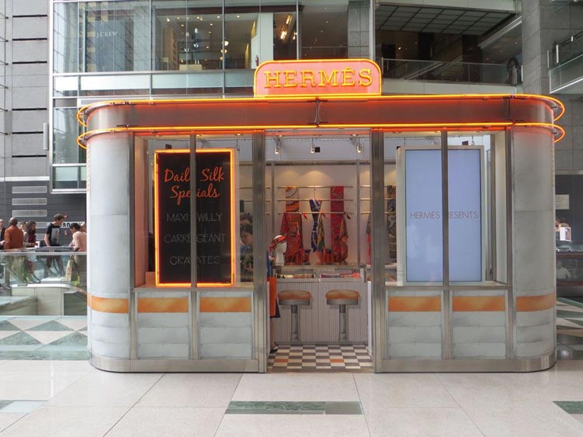

Marketing Mix of Hermès

For any business, the product line is crucial. According to their capabilities and marketing strategies, firms organise their product lines. There are companies with small product lines and companies with extensive product lines. A company's ability to diversify its product portfolio and increase sales is aided by a broad product offering. Hermès' diversified portfolio of products enables them to maintain a healthy sales volume among the affluent and thrive in a competitive market by employing customisation and innovation. Hermès' product lines include men's wear, Women's fashion, Perfume, Watches, Stationery, Footwear, Gloves, Enamel, Decorative arts, Tableware, Jewellery, Saddles, Belts, Scarves, Hats, and Furniture.
Every organisation has its pricing strategies. Some companies set prices based on market supply and demand, while others consider the brand's worth. The price of Hermès products reflects the brand's prestige and superior quality. Hermès's prices are incredibly high. It has made a value inaccessible. In other words, these products are not available to everyone. It is not available to the general public and is created exclusively for a specific audience. The product's prices are perceived. Hermès utilises the limited edition product strategy to determine the price of a product. Their market offers a limited number of product editions. This establishes an aura of exclusivity. Hermès products are never discounted, so their prices are always the same. Their pricing strategy is based on psychological principles. Additionally, they employ a geographical pricing strategy, which allows us to purchase an identical products from different locations at varying costs (SEGRAN, 2021).
Hermès has adopted a strategy for premium pricing in its marketing mix to imbue its products with a sense of exclusivity, which is precisely what luxury consumers seek. It does not offer discounts for any events, occasions, or individuals. Launching limited edition series also helps to ensure exclusivity. The handmade nature of Hermès products is a primary factor in their high price.
Hermes operates in global fashion hubs such as Japan, Europe, the United States, and Asia-Pacific to increase sales and expand its customer base. Especially in China, the largest luxury market in the world. To reinforce its brand image, Hermès distributes its products through 300 exclusive stores worldwide and online. The majority of the revenue is generated by Hermès-owned stores. Hermès has expanded its online business in tandem with the rise of e-commerce due to the widespread use of the internet. Its products are available exclusively on its website and some of the world's most prominent e-commerce platforms.
The company does not promote its brand using conventional advertising techniques. It is significantly dissimilar to others. They lack any brand ambassadors to market their products. Individuals who utilise the product promote it. These individuals are notable celebrities, ultra-wealthy individuals, and royal families. The strategy is unique and facilitates the company's development of a competitive advantage over other companies (Xaif, 2022).
Hermes prioritises a comprehensive advertising and promotional strategy as a premium brand of durable consumer goods. Waiting list strategy - Hermes's strategists use the economic principle that "scarcity increases value" to create exclusive demand for its products among high-end consumers by maintaining a one-year waitlist.
In contrast to other brands, Hermès maintains its core values by avoiding mass advertising to increase sales volume, which enables the brand to communicate effectively with its specific target groups.
Hermès primarily advertises in print media, which can intelligently provide appealing colours, themes, and images. Such as the luxury and high fashion magazine Vogue.
Hermès utilises celebrity endorsement to create global brand awareness, add value, and strengthen its market position.
Hermès uses celebrity names to increase the value of its products. For instance, "Kelly and Berkin bags" are named after Grace Kelly and Jane Birkin. Outdoor advertising Fashion show - to promote new products and solicit customer feedback, Hermès solicits well-known actors to use its products in a film to enhance the brand's reputation. Sandra Bullock carries a Hermès Birkin bag in the film "The Proposal."
Website- supports multiple languages for various countries to promote its newest products and services and answer customer inquiries (Martin Roll, 2021).

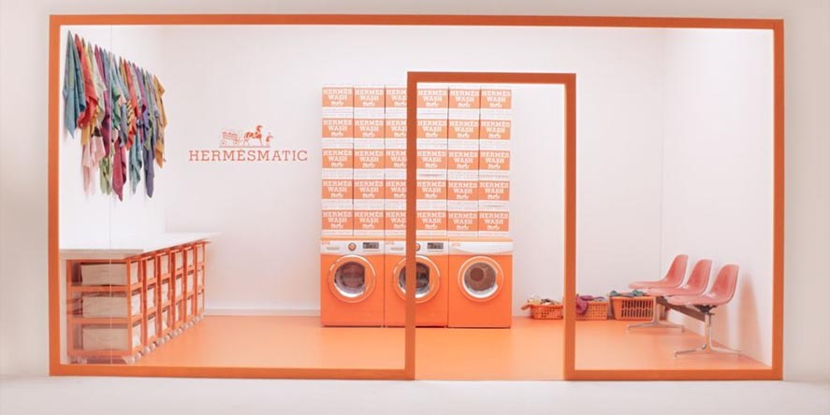

Hermès Customers at the core of the Network

Customers of Hermès are a community that transcends borders. For this devoted and expanding clientele, the house has created online and in its international Network of stores "houses for objects" that are distinguished by their distinctive offerings.
Rich in content, hermes.com provides internet users with a one-of-a-kind experience nourished by the house's stories and heritage as well as the events that colour Hermès' daily life.
Hermès continues to expand its global presence by opening new stores. Due to the purchasing freedom enjoyed by each director, each "house of objects" is unique.
By subtly combining the house's identity with local culture, each address has a unique resonance that contributes to the individualised experience offered to its clients.
Similarly, there are no identical window displays, which reflects the uniqueness of each store in the world.
The house exports its exceptional expertise to 45 countries via 303 stores, each of which embodies the same resolutely elegant spirit, which is both artisanal and innovative, modern and timeless (Hermès UK, n.d.).
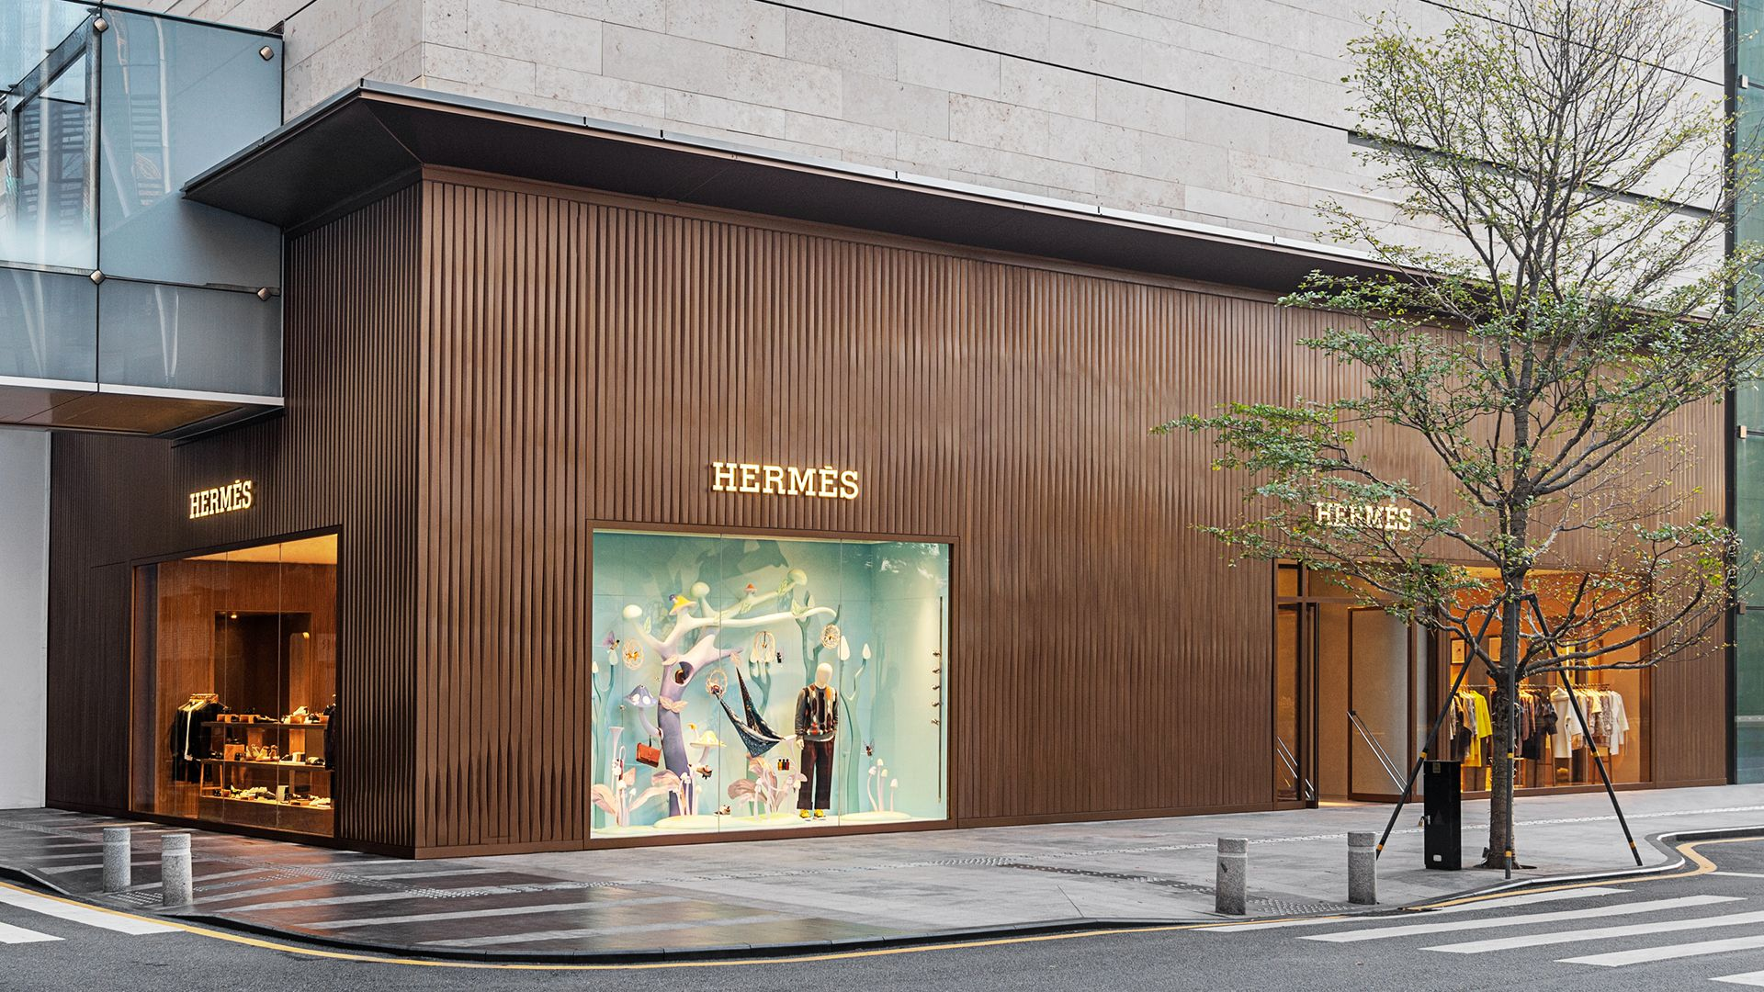

Hermès Contemporary Artisans Since 1837

As of 31st December 2021, Hermès employed 17,595 individuals, including 7,634 artisans. 62% of employees are employed in France. One thousand people have joined the Hermès community in the past year. Most Hermès products are produced in France, at 52 production sites in 11 regions. Hermès is optimistic about the future and will continue to expand its production capacity by opening new sites, each of which will create an average of 250 jobs.
Hermès contributes significantly to the revitalisation of regions where it establishes production facilities. As a result of the resulting socioeconomic development, it is possible to provide employees with convenient working conditions that combine proximity with stable employment (Hermès, n.d.).



There are 52 production sites in France, organised into regional hubs. This Network is comprised of twelve manufacturers located in Switzerland, Italy, the United Kingdom, the United States, Vietnam, and Australia.
Hermès is dedicated to its suppliers and collaborates with them to address the numerous challenges they face, including ethical, social, economic, and environmental issues. The company ensures that its entire value chain is involved in the most important issues pertaining to sustainable development. The system's robustness is enhanced by the quality and longevity of supplier relationships, which are based on trust developed over time (19 years on average for the principal partners).
In his "Footprints Across the World" series, documentary filmmaker Frédéric Laffont depicts the house's numerous obligations.

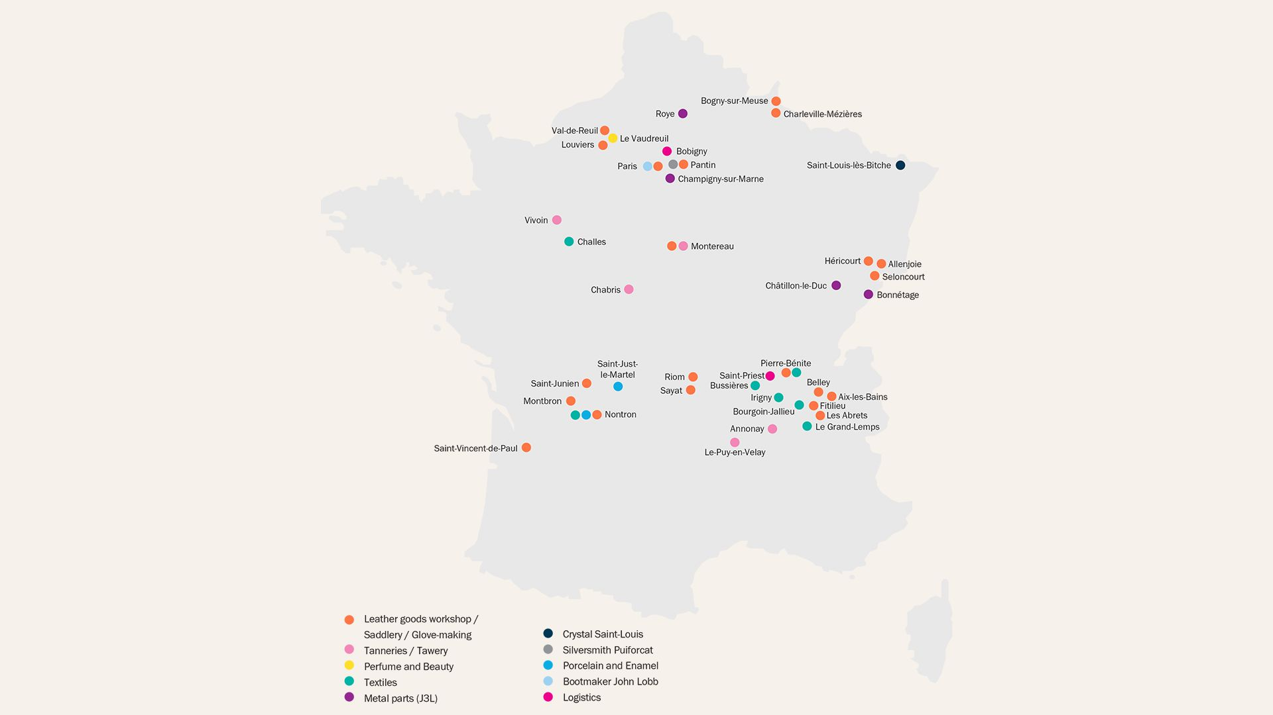

References

A House of artisans and human values | Hermès UK (no date) Hermės UK. Available at: https://www.hermes.com/uk/en/story/271246-responsible-and-sustainable-development/ (Accessed: November, 2022).
A timeline of the Hermès brand (no date) Baghunter. Available at: https://baghunter.com/blogs/insights/hermes-brand-history-timeline(Accessed: November, 2022).
Customers at the core of an omnichannel network | Hermès UK (no date). Available at: https://www.hermes.com/uk/en/story/271204-hermes-around-the-world/ (Accessed: November, 2022).
Hermès - the strategy insights behind the iconic luxury brand (2021) Martin Roll. Available at: https://martinroll.com/resources/articles/strategy/hermes-the-strategy-behind-the-global-luxury-success/ (Accessed: November, 2022).
SEGRAN, ELIZABETH (2021) How hermès conquered the luxury industry - fast company. Available at: https://www.fastcompany.com/90605195/hermes-most-innovative-companies-2021 (Accessed: November, 2022).
The history of Hermès (no date) Bags of Luxury - Authentic Hermes Bags. Available at: https://bagsofluxury.com/guides/the-history-of-hermes/ (Accessed: November, 2022).
Xaif (2022) Intensive case study on marketing strategy of Hermes - 2022 update, IIDE. Available at: https://iide.co/case-studies/marketing-strategy-of-hermes/ (Accessed: November, 2022).

Top of the Document

