ISHA SONI
Student ID. 2315396
Supervisor: Dr Jia Miao
dISSERTATION
MBA-LCMB7020_LON
TOPIC: INVESTIGATING THE IMPACT AND EFFECTIVENESS OF STORYTELLING ON DIGITAL PLATFORMS FROM TRAVELLERS PERSPECTIVE – CASE STUDY OF AIRBNB

Acknowledgments:
First and foremost, I would like to express my deepest gratitude to my supervisor, Dr Jia Miao for his invaluable guidance, support, and encouragement throughout this research journey. His insights, constructive feedback, and unwavering belief in this project have been instrumental in shaping the direction and success of this work.
I would also like to extend my thanks to the faculty and staff at University of wales TSD for providing the necessary resources and creating an environment conducive to academic growth. I am grateful to all the participants who took the time to contribute to my survey and share their experiences. Their input was crucial in helping me gather the primary data needed to complete this research. To my family and friends, your unwavering love, encouragement, and patience have been my constant source of motivation. Thank you for believing in me and providing emotional support throughout this journey. Lastly, I would like to thank the authors and researchers whose work laid the foundation for this research. Without their valuable contributions to the field, this study would not have been possible.
Thank you all for being a part of this journey.

Table of Contents:
Acknowledgements ……………………………………………………. 1
Table of Contents …………………………………………….………... 2
Chapter 1: Introduction
1.1 Introduction ………………………………………………………… 3
1.2 Research Aims, Objectives, and Questions …………………….…... 4
1.2.1 Research Aim ………………………………………………….. 4
1.2.2 Research Objectives ………………………………………….... 4
1.2.3 Research Questions ………………………………………..…... 5
1.3 Methodology ……………………………………….………….…… 5
1.4 Data Collection ……………………………………………….…… 5
1.5 Data Analysis ……………………………………………………… 6
1.6 Limitations ………………………………………………….……… 6
1.7 Structure of the Dissertation ……………………………………….. 6
Chapter 2: Literature Review
2.1 The Role of Storytelling in Shaping Traveler Expectations ……….. 7
2.2 Storytelling and Sustainable Travel Practices ………………….…... 7
2.3 Customer Satisfaction and Perceived Value …………………….…. 8
2.4 Emerging Technologies in Storytelling ……………………….…… 9
2.5 Storytelling for Business Optimization ………………………….… 9
2.6 Frameworks and Models ………………………………………….. 10
2.7 Brand Storytelling Framework ………………………………….… 12
2.8 Elaboration Likelihood Model of Persuasion (ELM) ………….….. 13
2.9 Impact of Social Media …………………………………………… 15
2.9.1 Diet ……………………………………………………….…... 16
2.9.2 Politics …………………………………………………….….. 16
2.9.3 Lifestyle ……………………………………………………..... 17
2.9.4 Airbnb ……………………………………………….………... 18
2.9.5 TripAdvisor …………………………….………………..……. 19
2.9.6 Trust pilot ……………………………………………………… 20
Chapter 3: Methodology
3.1 Research Philosophy …………………………………………….... 23
3.2 Research Approach ……………………………………………..…. 23
3.3 Data Collection Method: Questionnaire Survey ……………….….. 24
3.4.1 Questionnaire Design ………………………….……….…….. 24
3.4.2 Sampling Strategy …………………………………………….. 25
3.4.3 Data Analysis ……………………………………….………... 25
3.4.4 Ethical Considerations …………………………..……..…….. 26
3.5 Limitations of the Research ………………………………..……… 26
Chapter 4: Findings and Analysis
4.1 Introduction to Analysis of the Questionnaire …………….………… 28
4.1.1 Demographics and Travel Patterns ……………………………... 28
4.2 Use of Digital Platforms and Storytelling Preferences ………………. 29
4.2.1 Host Descriptions and Decision-Making ………………………... 30
4.3 Impact of Storytelling on Booking Decisions ………………..…….... 30
4.3.1 Emotional Connection and Value Perception …………....……… 31
4.4 Influence on Sustainable and Responsible Travel …………………… 32
4.4.1 Storytelling as a Driver for Responsible Choices ……………….. 33
4.5 Technological Innovations in Enhancing Storytelling ………..……... 33
4.5.1 Enhancing Guest Experience ……………………………………. 33
4.5.2 AI and Personalization and Virtual Reality (VR) …………….… 34
4.6 Satisfaction, Loyalty, and Revisit Intentions ………………………… 35
4.6.1 Narrative Types and Guest Satisfaction ……………………....… 36
4.7 Recommendations for Improving Storytelling ………………..…..… 36
4.8 Future Implications ……………………………………..………….... 37
Chapter 5: Conclusion
5.1 Storytelling as a Decision-Making Tool ……………………..….…... 39
5.2 The Role of Visual and Immersive Storytelling ………………..…… 40
5.2.1 Personalization through Technology ………………….…….…. 41
5.3 Impact on Sustainable Travel …………………………………..…… 41
5.4 Enhancing Guest Satisfaction and Loyalty ………………………….. 42
5.5 Secondary Connection and Examples ……………….……..……….. 43
Chapter 6: Recommendations
6.1 Future Research Directions ………………………………………….. 45
6.2 Personalized Storytelling and Technology Integration ……………… 46
6.3 Business Implications and Customer Engagement …………………... 47

List of Figures:
Figure 1: The Sharing Economy Model …………………………….. 11
Figure 2: Brand Storytelling Framework ………………………….. 12
Figure 3: Elaboration Likelihood Model (ELM) …………………. 13
Figure 4: ELM Model in Storytelling …………………………….. 14
Figure 5: Research Onion Model (Saunders, 2019) …………………..…….. 22

CHAPTER 1
Introduction:
Storytelling has long been a central aspect of human communication, dating back to ancient times when narratives were used to pass down traditions, values, and knowledge. In the modern era, storytelling has evolved beyond oral and written traditions to become a powerful tool in marketing and digital communication. The rise of digital platforms, particularly in the travel and hospitality industry, has transformed how stories are created, shared, and consumed. Companies like Airbnb have capitalized on the power of storytelling to engage consumers, differentiate their offerings, and build loyalty.
Airbnb, founded in 2008, revolutionized the travel industry by providing a platform that connects travelers with unique accommodations worldwide. What sets Airbnb apart from traditional hospitality providers is its emphasis on personal stories. Hosts on Airbnb are encouraged to share narratives about their properties, neighborhoods, and personal experiences, thereby creating a more intimate and engaging experience for guests. This focus on storytelling has been instrumental in shaping travelers' perceptions and decisions, making it a critical area of study.
{AI: “Artificial Intelligence is technology that behaves intelligently using skills associated with human intelligence, including the ability to perceive, learn, reason and act autonomously.”- (Marsden, 2017)
AR: Augmented reality (AR) is a technology that enhances the real-world environment with digital information and objects, creating a more immersive and interactive experience. - (M and Ramos, 2023)
VR: VR can be described as the use of computer technology to create the effect of an interactive three-dimensional world in which the objects have a sense of spatial presence- (Bryson, 2013)}
Recent developments in digital storytelling have been fueled by advancements in technology, such as Artificial Intelligence (AI)*, Augmented Reality (AR)*, and Virtual Reality (VR)*. These technologies enable more immersive and personalized storytelling experiences, which have the potential to further influence traveler behavior and expectations. However, the effectiveness and impact of these storytelling practices, particularly from the traveler’s perspective, remain underexplored.
We often become engrossed in a good story to the point where we become unaware of the time and place, this feeling is regarded as "narrative transportation." It is a hallmark of a fantastic narrative and an effective means of influencing people's attitudes. When people get engrossed in a story, whether it be genuine or fiction, the character and their world becomes a way for their own belief. There are stories that surround us, from the more complex tales presented in books or movies to the commercials on television or in music videos. Everything has a backstory, and the techniques used to weave the story are just as significant as the plot. (Mihăeş, Andreescu and Dimitriu, 2021)
New Age travelers are transforming the travel landscape by sharing their stories through Airbnb. These travelers are not just tourists, but storytellers, sharing personal growth, cultural understanding, and societal change. They are not just tourists, but storytellers who challenge traditional travel narratives and create lasting connections with local hosts. Their stories inspire others to seek unconventional paths to self-discovery, challenging societal norms and expectations. The New Age travel movement is centered on empowering travelers to redefine their identities through storytelling, paving the way for a more inclusive and diverse travel culture. These narratives foster empathy, community, and cross-cultural dialogue, breaking down stereotypes and promoting a more compassionate and interconnected world. By sharing their experiences, these travelers become agents of change, catalyzing a more compassionate and interconnected world.
Key pieces of research have highlighted the importance of storytelling in creating memorable experiences and fostering customer loyalty. (Pine and Gilmore's 1998) "Experience Economy" concept emphasizes the value of experiences over products, with storytelling being a key driver of these experiences. Moreover, the work of (Kim, Ritchie, and McCormick 2012) on memorable tourism experiences underscores the role of narratives in enhancing the perceived value of travel. Despite this, there is still a need for more focused research on how storytelling influences travelers' expectations, decision-making, and sustainable travel practices, particularly in the context of digital platforms like Airbnb.

1.2 Research Aims, Objectives, and Questions
1.2.1 Research aim:
The primary aim of this dissertation is to investigate the impact and effectiveness of storytelling on digital platforms from a traveler’s perspective, with a specific focus on Airbnb.

1.2.2 Research Objectives:
- To examine the role of storytelling in shaping urban explorers' (the guests) expectations and perspectives on decision-making for the overall experience.
- To explore how perceived storytelling can influence sustainable and responsible travel practices, guest satisfaction, perceived value, and their intention to revisit in terms of loyalty.
- To identify and understand different elements of storytelling that contribute to its virility and effectiveness in shaping customer experience, including the use of emerging technologies like AI, AR, and VR for enhanced and tailored content.
- To evaluate and make suggestions to businesses on optimizing digital platforms for consumer engagement and loyalty, helping them reach new and sustainable benchmarks.
1.2.3 Research Questions:
- How does storytelling on digital platforms like Airbnb influence the expectations and decision-making processes of urban explorers?
- In what ways does storytelling impact sustainable travel practices, guest satisfaction, and loyalty in the context of Airbnb?
- Which elements of storytelling are most effective in creating compelling customer experiences, and how can emerging technologies enhance these narratives?
- What strategies can businesses adopt to optimize their use of storytelling on digital platforms to enhance consumer engagement and achieve long-term loyalty?
1.3 Methodology
This research will employ a mixed-method approach, combining both quantitative and qualitative data collection methods however the main focus will be on primary data and it’s analysis but because of taking support evidence from other established authors and their work, we will consider this a mix approach.
1.4 Data Collection:
A structured survey is created for the purpose of this paper which is tailored to users of Airbnb and will be distributed to a sample of Airbnb users to collect quantitative data on their experiences with storytelling on the platform. The survey will include closed-ended questions, allowing for clear interpretation and statistical analysis of the data and also some open ended questions or journals pertaining to this paper might be interpreted.
1.5 Data Analysis:
Both quantitative and qualitative data will be used but on a 80/20 or 90/10 basis majority being on primary data and the survey data will be analyzed using statistical software to identify patterns, correlations, and trends, while thematic analysis will identify key themes and insights related to the research objectives.

1.6 Limitations:
The study may be limited by the sample size, as it may not fully represent the diverse population of Airbnb users as well as from the ones we have, also have technological aspect being that everyone might not have had access to or experiences with these technologies like AI, leading to variability in responses and The reliance on self-reported data from surveys and interviews may introduce bias, as participants may not always accurately recall or report their experiences.
1.7 Structure of the Dissertation
Chapter 1-Introduction: This chapter will introduce the research topic, outline the research aims, objectives, and questions, and provide an overview of the dissertation structure.
Chapter 2-Literature Review: This chapter will review the existing literature on storytelling in the digital age, with a focus on its impact on consumer behavior, the role of emerging technologies, and its application in the travel and hospitality industry mainly Airbnb.
Chapter 3-Methodology: On this chapter, the research design, data collection methods, and analysis techniques used in the study will be discussed, also the limitations of the research and the ethical considerations involved will be discussed.
Chapter 4-Findings and Analysis: This chapter is going to present the results of the survey and will analyze the data in relation to the research questions. Both quantitative and qualitative findings will be discussed focusing more on primary data.
Chapter 5-Conclusion: Conclusion will interpret the findings in the context of the literature review, exploring their implications for theory and practice. It will also address the research objectives and provide answers to the research questions and will summarize the key findings, discuss their implications for digital platforms and the travel industry.
Chapter 6- Recommendation: This last but not least one will provide recommendations for businesses, it will also suggest areas for future research.
CHAPTER 2:
Storytelling is a powerful tool that transcends traditional marketing methods, especially in the digital age. Its ability to evoke emotions, create memorable experiences, and influence consumer behavior has made it an essential component of digital platforms, particularly within the travel and hospitality industry. This literature review explores the impact and effectiveness of storytelling from a traveler’s perspective, focusing on its role in shaping expectations, influencing sustainable practices, enhancing customer satisfaction, and fostering loyalty. The review draws on a wide range of academic sources, including seminal works, contemporary research, and emerging models, to provide a comprehensive understanding of storytelling’s role in the digital age, specifically in the context of platforms like Airbnb.
2.1 The Role of Storytelling in Shaping Traveler Expectations
Storytelling has long been recognized as a crucial element in shaping consumer expectations. (Bruner, 1990) argued that narratives are central to how individuals make sense of the world, suggesting that storytelling can significantly influence how travelers perceive potential experiences. In the context of digital platforms like Airbnb, the stories shared by hosts play a pivotal role in setting expectations for the travel experience. According to (Pine and Gilmore, 2013) the "Experience Economy" emphasizes the creation of memorable experiences over mere transactions, with storytelling serving as a key mechanism in delivering these experiences. One of the study have further expanded on this idea, examining the specific elements of storytelling that most effectively shape traveler expectations. For example, (Magasic, 2016) found that visual storytelling, including the use of high-quality images and videos, significantly enhances the perceived authenticity and appeal of a destination. Moreover, (Tussyadiah, Zach and Wang, 2020) highlighted the importance of user-generated content in travel decision-making, with peer-to-peer stories often perceived as more trustworthy and relatable than traditional advertising.
2.2 Storytelling and Sustainable Travel Practices

The influence of storytelling on sustainable and responsible travel practices is an emerging area of research. The concept of sustainability in tourism has been studied (Bramwell and Lane, 2011), but the role of storytelling in promoting these practices is a relatively new focus. Storytelling can be an effective tool in communicating the importance of sustainability, particularly when stories emphasize the environmental and cultural impact of tourism. (Storr, 2021) The BPS article discusses how storytelling is a highly effective tool for persuasion because it engages emotions, making information more relatable and memorable. For example, using stories in sustainability campaigns helps create emotional connections with environmental issues, leading to better public engagement.
On the other hand, some argue that storytelling can oversimplify complex sustainability challenges. A study by (Dahlstrom, 2014) suggests that while narratives are persuasive, they may prioritize emotional appeal over accuracy, leading to misinformation or a lack of critical engagement with facts that the article highlights that storytelling taps into the psychology of humans by influencing emotions and cognitive processes, making it easier to persuade people. It can be used positively, like in sustainability campaigns where emotional stories about climate change ignite action. It can also be manipulative if used to distort facts or create biased views, such as when brands overly romanticize eco-friendly practices without full transparency (greenwashing) shows how storytelling can sway opinions but also risks being misleading depending on the intention behind its use. (Storr, 2021)

(Tred, 2023) The article from Tred lists notable examples of greenwashing in 2022, focusing on how companies misleadingly market themselves as environmentally friendly: HSBC: Highlighted climate-friendly projects while omitting their fossil fuel investments. Innocent: Marketed eco-friendliness despite being owned by Coca-Cola, a major plastic polluter. Persil: Vaguely claimed their detergent is "kinder to the planet" without clear comparisons. Oatly: Misleadingly compared carbon emissions of dairy and plant milk. Coca-Cola: Sponsored COP27 despite being the top plastic polluter globally and these are just a few examples.

It is also explored how digital storytelling on platforms like Airbnb can encourage sustainable behavior among travelers. Their findings suggest that when hosts incorporate narratives about local culture, history, and environmental stewardship, travelers are more likely to engage in responsible travel practices. This aligns with the concept of "pro-environmental behavior" (Steg and Vlek, 2009), where the effectiveness of such behavior can be significantly enhanced through compelling narratives that resonate with the audience's values. Airbnb itself promotes this by sharing various tips and tricks and guides on the how-to for the hosts. (Airbnb, 2021)

2.3 Customer Satisfaction and Perceived Value through Storytelling
Customer satisfaction and perceived value are critical outcomes of effective storytelling. Kotler and Keller (2016) in (Mensah, Oppong and Addae, 2022) article argue that customer satisfaction is not just about meeting functional needs but also about fulfilling emotional and experiential desires. In the context of Airbnb, the stories shared by hosts contribute to creating an emotional connection between the guest and the destination, thereby enhancing satisfaction. A study by Kim, Ritchie, and McCormick (2012) introduced the concept of "memorable tourism experiences" (MTEs), emphasizing that stories significantly contribute to the memorability of travel experiences. This memorability is directly linked to perceived value, as travelers are more likely to perceive higher value in experiences that leave a lasting emotional impact. Furthermore, (Wang et al., 2014) found that perceived value is a crucial determinant of customer loyalty, indicating that storytelling not only enhances satisfaction but also fosters repeat visits and positive word-of-mouth. The role of storytelling in creating perceived value is also supported by the work of (Fog, 2005), who argue that stories are instrumental in creating brand value. They posit that brands, including platforms like Airbnb, can leverage storytelling to differentiate themselves from competitors by offering unique, narrative-driven experiences that resonate with consumers on a deeper level.
2.4 The Effectiveness of Emerging Technologies in Enhancing Storytelling
The integration of emerging technologies such as Artificial Intelligence (AI), Augmented Reality (AR), and Virtual Reality (VR) in storytelling is reshaping how stories are told and experienced. These technologies allow for more immersive and personalized storytelling, which can significantly enhance the traveler’s experience. According to (Yung, 2019), AR and VR offer new ways to engage travelers by providing them with virtual tours, augmented narratives, and interactive experiences that can influence their decision-making processes. (Moorhouse et al., 2017) conducted a study on the use of VR in the tourism industry, highlighting its potential to create immersive pre-travel experiences that can influence traveler expectations and satisfaction. Similarly, (Tussyadiah, Zach and Wang, 2020) explored the role of AI in personalized storytelling, finding that AI-driven narratives can enhance the relevance and appeal of the content, leading to higher engagement and satisfaction among travelers.
These technologies not only enhance the storytelling experience but also contribute to the virility of the content. The work of (Berger and Milkman, 2012) on the concept of "contagious content" suggests that emotionally charged, technologically enhanced stories are more likely to be shared across digital platforms, thereby increasing their reach and impact.

2.5 Storytelling as a tool for business optimization and consumer engagement
The strategic use of storytelling for business optimization and consumer engagement has been widely discussed in the literature. (Prahalad and Ramaswamy, 2004) introduced the concept of "co-creation," where consumers are actively involved in creating value through their interactions with the brand. In the context of Airbnb, this co-creation often occurs through the stories that travelers and hosts share on the platform.
(Pera, Viglia and Furlan, 2016) argue that digital storytelling is a key driver of consumer engagement, particularly in the sharing economy. Their research suggests that the interactive nature of storytelling on platforms like Airbnb encourages consumers to participate more actively, whether by sharing their own stories or engaging with those of others. This engagement, in turn, fosters loyalty and strengthens the relationship between the consumer and the brand. Additionally, (Hennig-Thurau, Hofacker and Bloching, 2013) discuss the importance of storytelling in the context of digital marketing, emphasizing that stories are more effective than traditional marketing messages in creating emotional connections with consumers. This emotional connection is crucial for building long-term loyalty, as consumers are more likely to return to a brand that resonates with their personal values and experiences.
The literature on the impact and effectiveness of storytelling on digital platforms, particularly from a traveler’s perspective, underscores the multifaceted role that storytelling plays in the travel industry. From shaping expectations and promoting sustainable practices to enhancing customer satisfaction and fostering loyalty, storytelling is a powerful tool that digital platforms like Airbnb can leverage to create meaningful and memorable experiences for their users. As emerging technologies continue to evolve, the potential for even more immersive and personalized storytelling experiences will likely grow, further solidifying the importance of storytelling in the digital age. Future research should continue to explore the intersection of technology and storytelling, particularly how new innovations can enhance the effectiveness of narratives in influencing traveler behavior and decision-making.
2.6 Frameworks and Models

(Sharing Economy: Brief peer-to-peer exchanges are a feature of the sharing economy, wherein idle resources and services are shared or cooperative efforts are facilitated. Today in sharing economy, buyers and sellers are commonly connected through internet platforms. The sharing economy is expanding and changing quickly, but it still has a lot of obstacles to overcome, including ambiguous regulations and worries about misuse. Other names for the contemporary sharing economy include the share economy, peer economy, collaborative economy, and collaborative consumption).

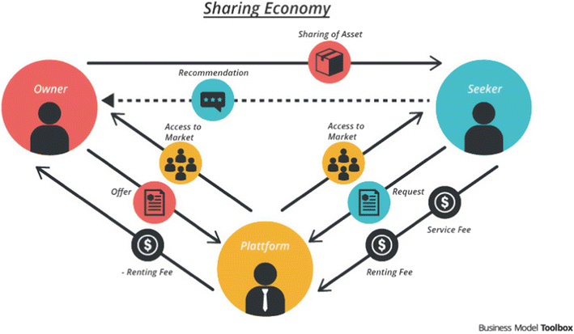

(Figure: 1) (Olaya, 2016)

(MacDonald, 2018) Arun Sundararajan’s book, The Sharing Economy: The End of Employment and the Rise of Crowd-Based Capitalism, explores how platforms like Airbnb have transformed traditional economic models, particularly in the tourism and hotel industries. Due to its peer-to-peer approach that uses people's homes as existing assets rather than depending on expensive infrastructure like hotels, Airbnb has upended the traditional hotel industry by providing adaptable, economical, and diverse accommodations. By decentralizing hospitality services, this change has allowed visitors to have more customized and localized experiences. This has increased the size of the tourism industry and spread its advantages over more areas, including those without the usual tourist infrastructure. Furthermore, the model of Airbnb has made it possible for people to operate as micro-entrepreneurs, generating new revenue streams and fostering the development of a crowd-based the economy of the nation, on the other hand this transformation has also raised concerns about unfair competition, as traditional hotels are subject to strict regulations, safety standards, and taxes that may not always apply to Airbnb hosts. With its ability to support local economies, draw more customers to establishments in the vicinity of listing hubs, and provide a variety of lodging options to suit a wide range of tastes and price points, Airbnb's expansion has brought about positive economic effects. However, it has also brought about issues like gentrification, increased real estate costs, and disturbances to nearby communities. According to Sundararajan, in order for traditional hotels to remain relevant, they need incorporate more individualized and locally focused services, much like what Airbnb offers, and perhaps consider hybrid models or joint ventures. Although the sharing economy has given customers more freedom and options, it has also sparked ethical and legal discussions, forcing cities all over the world to weigh the advantages of services like Airbnb against the need to safeguard local communities effectively turning stays into stories that people
want to share.

2.7 Brand storytelling Framework:

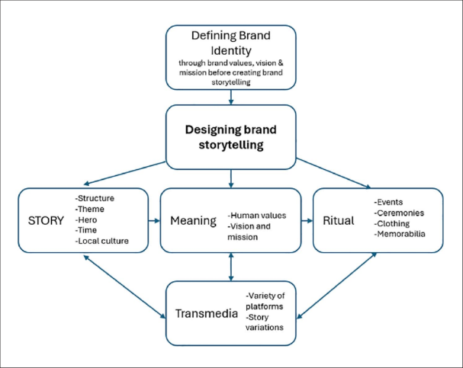

(Figure 2) (Sheiner, 2024)
(Zorfas and Leemon, 2016) Businesses can create engaging narratives that evoke strong feelings in their audience by using the Brand Storytelling Framework, a strategic approach. In contrast to conventional marketing, which frequently highlights features and advantages, brand storytelling concentrates on delivering relatable tales that speak to the values, needs, and experiences of the target audience. The framework's main components are establishing a distinct brand purpose and mission, making the consumer the protagonist of the narrative, and identifying an issue or conflict that the brand can assist in resolving. Businesses use compelling stories to position their goods and services as solutions, utilizing storytelling to make their brand an important facilitator of the consumer journey. This approach is effective because it drives emotional engagement which, makes consumers 3 times more likely to choose a brand they feel an emotional connection with over others.
(Content Marketing Institution, 2022) Retail, tech, and tourism are just a few of the industries that demonstrate the value of the Brand Storytelling Framework. For instance, Airbnb has effectively used narrative to foster authenticity and trust by showcasing real-life experiences of both hosts and visitors. Airbnb has distinguished itself from conventional hotels that depend on conventional amenities and services by demonstrating how their platform facilitates relationships between visitors and locals. The framework works especially well for firms trying to stand out in crowded markets because of its emphasis on accessible storytelling, emotion, and consistency. A Content Marketing Institute report indicates that 92% of consumers want brands to make ads that feel like a story, further underscoring the effectiveness of this approach. Companies that can embed their values and purpose into stories will not only engage their audience but also foster long-term loyalty, turning customers into advocates who spread the brand’s message organically.

One example of a company perfect to use here is Nike, with their slogan “Just do it” and utilizing the USP for being self-empowerment, motivation, and achievement it focuses on empowering consumers by tapping into their aspirations, determination, and personal goals. In addition to showcasing how businesses may use their staff as real brand ambassadors, the Britopian essay explores the significance of employee advocacy in brand storytelling. It offers instances of effective marketing efforts where companies leveraged the voices of their staff to produce approachable and authentic material, increasing brand recognition and trust. The article highlights how employees can contribute their distinct viewpoints and personal narratives to strengthen the brand narrative. Examples of how authentic storytelling can strengthen consumer relationships and brand loyalty include Starbucks' initiative to share stories about employee community involvement and IBM's use of employee expertise to highlight innovation. (Brito, 2018)

2.8 Elaboration Likelihood Model of Persuation (ELM)
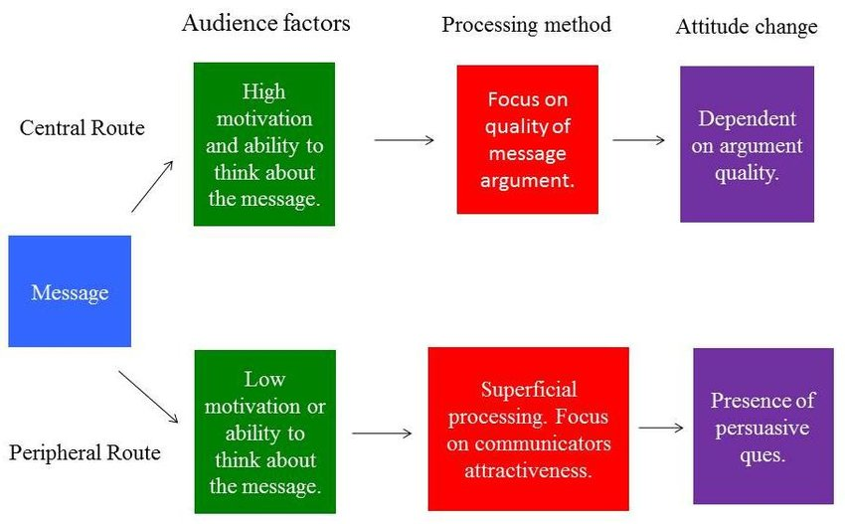

(Figure: 3) (Challenor, 2013)

This model is being used here in support of the BSF model to further elaborate how these models are linked and used for brands. It is a communication theory that explains how people process persuasive messages and make decisions. Developed by (Petty and Cacioppo, 1986), ELM suggests that the central route and the peripheral route are the two main pathways via which information is processed. The audience attentively considers and assesses the arguments made in the content when following the central route. When people are strongly driven and able to comprehend the information, they absorb it in this way, which results in long-lasting changes in attitude. Conversely, the peripheral method depends less on the material itself and more on surface-level indicators like feelings, images, or endorsements. This approach is more likely to be utilized in situations where the audience lacks motivation or is unable to fully comprehend the information, which could result in more transient shifts in attitude.
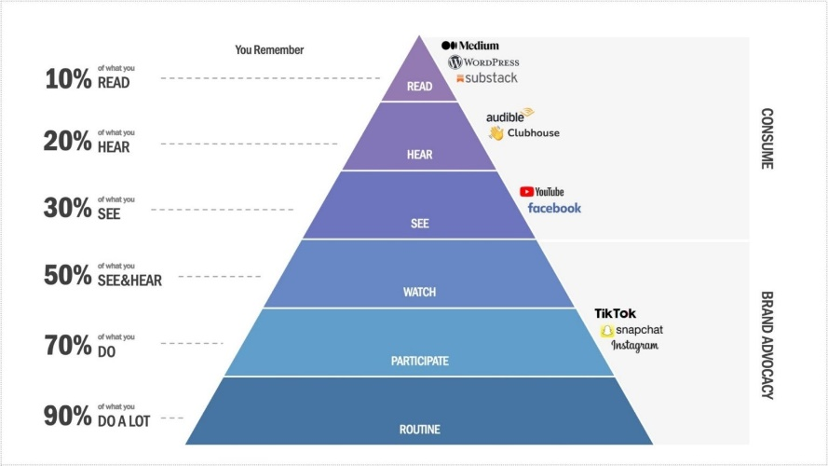

(Figure: 4) (Brito, 2018)

By employing stories that arouse feelings, provide unforgettable moments, and appeal to ideals without necessitating a thorough analysis of the content, effective storytelling can operate through the peripheral pathway. This is crucial for companies like Airbnb, who utilize narratives to showcase real, localized experiences that emotionally connect with their target market. Airbnb engages potential consumers emotionally by sharing experiences of hosts and guests, which helps them relate to and trust the platform. This strategy makes use of the peripheral processing pathway, where persuasive cues such as images, emotional appeal, and personal stories influence the purchasing decisions of consumers. Empirical evidence demonstrates that emotionally charged storylines can foster a more robust and long-lasting bond between the company and its customers making ELM a vital framework for understanding how storytelling influences purchasing decisions.
(El Hedhli and Zourrig, 2022) On the other hand However, it is also discussed how it can lead to manipulation and potential consumer backlash if not executed authentically. It highlights that while storytelling can enhance emotional engagement, it also poses risks if the narratives are perceived as insincere or misleading. This aligns with the Elaboration Likelihood Model (ELM), which outlines two routes of persuasion: the central route, which involves thoughtful consideration of the message, and the peripheral route, which relies on superficial cues, such as storytelling.
This article specifically points out the deficiency in ELM model in the context of storytelling, suggesting that when consumers are exposed to persuasive narratives without sufficient critical thinking, they may be less likely to scrutinize the message's authenticity. This can result in consumers being easily swayed by emotionally charged stories without fully understanding the brand's actual values or intentions. Therefore, it emphasizes the need for brands to balance storytelling with transparency and authenticity to avoid alienating consumers and maintain trust. (El Hedhli and Zourrig, 2022)

2.9 Impact of social media in today’s world
Social networking is becoming more of a way of life and less of a means of communication in today's hyper connected world. Social media sites like Instagram, Tik-Tok, and YouTube have an almost hypnotic influence over people's life, whether it be through controlling our political opinions, determining our diets, or affecting our fashion choices. We no longer only follow influencers—those online celebrities with impeccably manicured lives—we want to be like them. These platforms have more power than just passing fads; they create new perspectives on culture, with influencers playing the role of tastemakers in the modern day. As one might say, if it didn’t happen on Instagram, it didn’t really happen at all.

2.9.1 Diet: The phenomenon of diet culture for example on Instagram, where wellness influencers promote clean eating, intermittent fasting, and plant-based diets, many health and fitness promoters turned to social media influencers to promote their products (Durau, Diehl and Terlutter, 2022). However, the real-world impact can be a double-edged sword. On one hand, followers are exposed to healthier food choices and lifestyle tips, but on the other hand, there is the risk of promoting unattainable beauty standards or unhealthy habits like restrictive diets, ultimately leading to issues such as orthorexia (Leathers, 2024). Take the explosion of #KetoLife on social media (DeAngelis, 2023) Thousands of influencers, armed with smoothie bowls and keto brownies, have transformed the ketogenic diet into a cultural movement. Followers devour these posts sometimes literally seeking to emulate the lean bodies and radiant smiles of their wellness idols and as much of a good for our dietary ketogenic food is, it can be proven to be not filling and complete for everyone. Many of the marketers in the health and wellness space use influencers to promote their products (Durau, Diehl and Terlutter, 2022) Yet, while influencers may inspire healthier eating, they can also lead their followers down rabbit holes of fad diets and obsessive eating behaviors. You might be thinking that you only follow for the recipes, but the influence sneaks in, shaping decisions more than we realize.
2.9.2 Politics: Similarly, social media plays an enormous role in politics. During the 2016 U.S. election, Twitter became a political battleground, with viral tweets swaying public opinion faster than a well-produced political ad. The saying of pen being mightier than the sword now seems like child’s play compared to the power of a viral meme. With the opinion comes the democratization of misinformation, and suddenly, you find yourself in an echo chamber, where every scroll reinforces what you already believe. As (Alcott and Gentzkow, 2017) revealed, social media's power to polarize is as strong as its ability to inform.
2.9.3 Lifestyle: On a broader level, influencers affect how people travel, dress, and live. (Monroe, 2017) Who hasn’t seen the #VanLife trend on Instagram and thought that they could totally live out of a van and just travel the world! Well, hold your horses, before you swap your rent payments for a life on wheels, it’s important to remember that these influencers aren’t posting about breakdowns in the middle of nowhere or the lack of indoor plumbing. Social media has this funny way of making everything look effortless and desirable, turning even the most rugged of lifestyles into something "aspirational." The hashtag #VanLife, for instance, has glamorized minimalist living, with influencers depicting the nomadic lifestyle as aspirational. While these curated glimpses into van living inspire people to break away from conventional living, it can also give a misleading view of a lifestyle that comes with its own set of challenges like isolation or financial insecurity. As a double-edged sword, social media offers both inspiration and illusion, leaving users to discern between the two.
To more understand the point being made here that how important storytelling is becoming through social media, when it comes to online reviews, platforms like Airbnb, Trust pilot, and TripAdvisor have become the gospel for travelers and consumers alike. But which platform reigns supreme? Let’s dive into the nitty-gritty with a bit of banter of these digital review giants.
2.9.4 Airbnb: The Experience Curator
Airbnb is like the cool kid in the room when it comes to unique, personalized experiences. Unlike traditional hotels, Airbnb offers you the chance to stay in quirky homes, like a treehouse in Costa Rica or a cozy igloo in Finland. It’s like having a friend with a spare room in every corner of the world. And the storytelling? Well, that’s where Airbnb truly shines. Hosts weave tales about their properties and neighborhoods that entice travelers to book based not just on location but on the feeling of the place. As Frederick R. Barnard, an advertising executive said, "A picture is worth a thousand words," but with Airbnb, that’s not the case all the time, sometimes it’s the story that seals the deal. Airbnb has completely changed the tourism business by providing distinctive, locally-inspired lodging that frequently incorporates the hosts' personal narratives. Its ability to create a sense of community while providing guests with experiences that make them feel more personalized and intimate than those of regular hotels is one of its advantages. Peer reviews are possible on the platform, allowing hosts and guests to assess one another and building trust.
However, this personalized charm can come with some quirky surprises. Ever stay in an Airbnb with a "rustic" feel, only to find out that "rustic" really means no Wi-Fi and questionable plumbing? As the saying by Ferdinand August Bebel goes, "One person’s treasure is another person’s trash," and nowhere is this more true than on a platform where reviews are subjective. The five-star experience for one traveler may be a disaster for another. Reviews can sometimes be biased, as both parties are incentivized to maintain positive relationships for future bookings.
2.9.5 TripAdvisor: The Traveler’s Bible
Then we have TripAdvisor, the seasoned traveler’s best friend. With millions of reviews for everything under the sun—hotels, restaurants, excursions—it’s like a trusty guidebook that never goes out of style. You get tips, photos, rankings, and that warm, fuzzy feeling of knowing exactly what you’re getting into.
There’s also a dark side to TripAdvisor’s throne. Sometimes the most highly rated places don’t live up to the hype, and you wonder, if these reviews written by real people or marketing bots. The story of "The Shed at Dulwich" is a brilliant satirical take on the gullibility of TripAdvisor’s algorithm, where a non-existent restaurant became London’s top-rated spot. (Wiseman, 2017)The Guardian article tells the story of a fake restaurant that rose to become TripAdvisor's top-rated eatery in London, despite never serving a single meal. Using fabricated reviews and photos, the restaurant's creator, Oobah Butler, highlighted how easily the platform could be manipulated through fake reviews and cleverly staged photos, it highlights the flaws of relying solely on online ratings. It's a reminder that storytelling can easily distort reality if not fact-checked. Meanwhile, Airbnb’s focus on verified stays and real user experiences offers a safeguard against such absurdity. Because, after all, it’s hard to fake a bed you’ve actually slept in! This example shows the potential misuse of storytelling in digital platforms for deceptive purposes, highlighting the importance of trust. Airbnb’s verification processes, user-generated content, and reliance on authentic experiences make it a more trustworthy platform than TripAdvisor.

2.9.6 Trust pilot: The Truth-Teller (or Not?)
Trust pilot, on the other hand, is the democratic hero of the review world. Anyone can review anything like hotels, restaurants, tech gadgets, or even airlines. It’s like the all-you-can-eat buffet of reviews. The open format provides in-depth, honest reviews, or at least that’s the goal. It’s like sitting at a dinner party where everyone has an opinion, but you're not quite sure who you should trust. But, as with any open forum, it’s easy for things to spiral. Businesses can manipulate their reviews, and fake reviews sneak in like uninvited guests. It’s a bit like navigating through a crowd at a concert, you’ve got to push through the noise to get to the good stuff. Finding genuine, helpful feedback on Trust pilot sometimes feels like finding a diamond in the rough, or to find a needle in a haystack.
The distinction between reality and fiction is hazier than ever in the digital era, particularly in relation to social media, bloggers, and review sites. Every site has advantages and disadvantages, whether it's TripAdvisor serving as the traveler's oracle, Trust pilot providing a plethora of perspectives, or Airbnb creating customized experiences. The secret you might ask is to keep an open mind and a dash of skepticism as you approach things. As the saying floats around in media with no accurate record who said it, Read everything carefully, but don't believe everything you read. But those developments have increased the significance and potency of real-world examples and narratives accompanied by videos or other graphical representations of proof.

Let’s talk about some amazing examples in detail to even get more understanding of what storytelling used through an advert looks like. First example that comes to my mind is a stunning piece I saw few days back randomly searching through websites-
It is an Advertisement for Leroy Merlin. If not familiar what Leroy merlin is, because I wasn’t either, it is a home improvement and renovation company. Now why this particular stood out to me was because it is an award winning masterpiece with no dialogue to convey the message but melodious music and the comparison with sailing. They created a lovely little film named "Life's Adventure" and it figuratively equated remodeling a house to sailing. The movie follows a couple as they overcome storms, which stand in for the difficulties encountered during renovations, to reach a peaceful, completed home. The Impact was that strong that Homeowners were moved to tears by this artistically magnificent advertisement. The idea that life is like a journey struck a deep chord with people, and Leroy Merlin became known not only as a home renovation store but also as a company that assisted people in completing their largest life undertakings. After the advertisement ran, it resulted in higher brand engagement and a noticeable rise in sales. (BETC and Merlin, 2022)
Another one of the geniuses is Tata Tea – Jaago re! Tata Tea’s "Jaago Re" (Wake Up) campaign launched in 2007, marked a significant shift from just selling tea to creating social awareness. The campaign encouraged citizens to "wake up" to issues like corruption, voting apathy, and gender equality and Global warming. The ads used everyday scenarios to call for action, positioning Tata Tea as not just a product but a catalyst for change. This socially conscious campaign struck a deep chord with Indian consumers, transforming Tata Tea from a household tea brand into a thought leader in social reform. Tata Tea saw a double-digit increase in sales, and the campaign evolved into multiple phases over several years, continuing to focus on pressing societal issues. Now Tata tea is known for its creative ability to reach audiences through promotive campaigns and from many I chose to take this one in particular to express here because of the issue itself which is Global warming. The ads feature children singing catchy rhymes that highlight the urgency of taking action against climate change. By employing children as the messengers, Tata Tea taps into the innocence and authenticity of youth, making the message more relatable and poignant. This choice resonates with viewers on an emotional level, prompting them to reflect on the future of the planet for the younger generation. This innovative approach exemplifies how brands can effectively use creative messaging to drive social change while simultaneously enhancing their brand identity. The success of the campaign illustrates the power of storytelling in marketing, particularly when it addresses important global issues in an accessible and emotionally resonant way. (Jaago re, 2024)

Another type of storytelling with visual element and using ELM framework with psychological manipulation is Rolls-Royce.
They use something called the Anchoring effect- One of the most reliable cognitive heuristics is the anchoring effect, which describes the process by which people are swayed by particular information provided prior to making a decision. Anchoring judgments is somewhat influenced by ability, personality, processing methods, and mood. (Furnham and Boo, 2011) Rolls-Royce has opted to seek an audience that is not only exclusive but possibly more willing to invest on a car that costs more than most homes, but less than the Airplanes, while many luxury car brands are still fighting for attention at automotive shows. (Boss, 2024)

In Next page there are some video accumulation for better context.

Number | Link to the video | Small Description
1 | https://www.youtube.com/watch?v=L3qc6QjfJyc | Perfect example by Dove how social media stories can impact inversely and in parallel can help from various real life situations emotionally- by Dove UK
2 | https://youtu.be/Ur_ihUZLmdI | Few amazing examples by a You tuber on storytelling for better understanding
3 | https://www.instagram.com/ashton.shanks/reel/C_yKSLPtMO_/ | Instagram reel by Ashton shanks explaining Go-Pro genius
 | https://www.ispot.tv/ad/1r_R/gopro-official-camera-of-fun | Other Go-Pro small insights with only visual Inputs for
 | https://www.youtube.com/watch?v=Zk7gs9Iu2hk | both videos
4 | https://www.youtube.com/watch?v=ZUG9qYTJMsI | Amazing Brand introduction, marketing and confidence showing power of storytelling by Dollar shave club.
5 | https://www.youtube.com/watch?v=9rx7-ec0p0A | As he bid adieu to his remarkable career, rival German automaker BMW chose to pay him a special and surprising tribute- By Mercedes Benz
6 | https://youtu.be/88_TfiR5hrg | Jaago re- campaign by Tata Tea, an attempt at awareness for global warming
7 | https://youtu.be/IJNR2EpS0jw | Released by Metro trains Melbourne for promoting Railway Safety and Security in a lighter way
8 | https://youtu.be/w65k0yDsnW0 | The behind scenes and creation of the above video for better understanding
9 | https://www.youtube.com/watch?v=mgLLbCY9L4o | Created by Leroy Merlin symbolizing sailing as home renovation, a beautiful award winning advert with no dialogues
10 | https://www.thedrum.com/news/2024/01/08/ad-the-day-cadbury-remakes-mum-s-birthday-mark-200th-anniversary | Created by Cadbury, a remake of original ad from 2018 with same script for its Generosity campaign

Chapter 3:
Research Methods for Business Students by Saunders, Lewis, and Thornhill is a comprehensive guide for students conducting research-led projects or dissertations. It covers observation research, data collection, and academic poster preparation. Saunders' research onion outlines the decisions required for developing a research methodology, ranging from philosophical to tactical and practical, for dissertations, thesis, or other formal projects. (Saunders, Lewis and Thornhill, 2019)
We will be working off the research onion model for design. The methodology for this research has been carefully designed to investigate the impact and effectiveness of storytelling on digital platforms from the perspective of travelers, specifically focusing on Airbnb as a case study. This section outlines the research philosophy, approach, methods of data collection, sampling strategy, and the techniques used to analyze the data. It will also address the limitations of the study, ethical considerations, and the rationale behind each methodological decision.

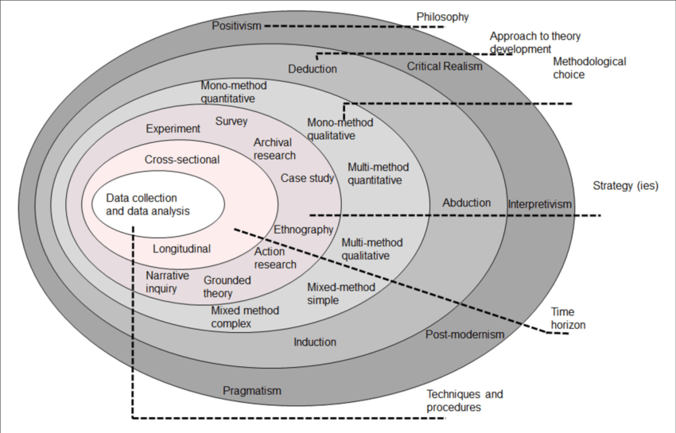

(Figure 5: Research onion, Saunders 2019)

3.1. Research Philosophy
The interpretivist research theory underpins this study, which is consistent with the goal of comprehending subjective human experiences, especially as it relates to how digital storytelling affects visitors' perceptions and choices. Interpretivist is the best approach to investigate how Airbnb guests view storytelling and how it affects their behavior, including decision-making, satisfaction, and loyalty, since it centers on the subjective meanings and lived experiences of individuals. (Saunders, Lewis and Thornhill, 2019).
3.2. Research Approach
For this investigation, an inductive methodology has been followed. This approach facilitates the gathering of data that will enable the formulation of more comprehensive ideas regarding the influence of digital storytelling on traveler behavior, as opposed to testing pre-existing hypotheses. The inductive approach makes sense since it places a strong emphasis on drawing conclusions from data, which facilitates the investigation of how narrative affects user experiences and environmentally friendly travel strategies on websites such as Airbnb.
3.4. Data Collection Method: Questionnaire Survey
A structured questionnaire survey will be used to obtain quantitative data in order to gain insights into the impact of storytelling on digital platforms. Since the goal of the study is to extrapolate results from a certain traveler group, a quantitative technique makes it possible to gather quantifiable data, which can then be statistically analyzed to detect patterns and correlations.
3.4.1. Questionnaire Design
The questionnaire will consist of 25 closed-ended questions, designed to capture both descriptive and inferential data. The majority of the questions will be multiple-choice, enabling respondents to select options that best reflect their experiences, expectations, and opinions on digital storytelling. In addition, a few key questions will use ranking scales (0-5) 0 being least likely and 5 being most or 5 being the positive side and vice-versa to better understand participants' perceptions of storytelling elements, such as the level of influence storytelling has on their decision-making or the perceived value of AI-enhanced content.
The questionnaire will cover several thematic areas: Demographics for travel habits, Experience with Airbnb for frequency of use, satisfaction levels, Perception of Storytelling for importance of storytelling in choosing accommodation, role in decision-making, Impact of Storytelling on Travel Behavior for influence on sustainability, loyalty, and future travel intentions, Ranking of Storytelling Elements effectiveness of AI, AR, VR, personalized narratives, and user-generated content. There will also be some open ended questions for elaboration on participants thoughts which will include some suggestive or recommending revert from them. All of them will help determine the outcome to answer our research questions like effectiveness on decision making or sustainability, any technological aspects and their outcomes and overall how all this combine can impact a brand.
3.4.2. Sampling Strategy
The target population for this study includes urban travelers and explorers who have used Airbnb within the past two years which includes my friends and family friends as well as acquaintances as a researcher. This population is appropriate as they are likely to have encountered digital storytelling during their booking and travel experiences and could spare 2 minutes to give feedback on this survey. The study will use a non-probability sampling method, specifically convenience sampling, due to time and resource constraints. The goal is to gather responses from approximately 40-45 participants to ensure sufficient data for statistical analysis.
3.4.3. Data Analysis
Using both descriptive and inferential statistics, the data gathered from the questionnaire will be examined. An overview of the respondents' demographic traits and their interaction with Airbnb storytelling will be given using descriptive data. The replies to the ranking questions will be analyzed using metrics like mean, median, and mode, which will reveal how much various storytelling aspects affect decision-making, satisfaction, and loyalty. Correlation analyses are carried out for inferential analysis in order to investigate links between variables. Examples of these relationships include those between customer happiness and AR/VR technology utilization, or between the perceived effectiveness of narrative and visitor loyalty. Regression analysis can also be used to forecast the relationship between the independent variables like storytelling aspects and the dependent variables like total satisfaction and intention to return.
3.4.4. Ethical Considerations
Ethical considerations are crucial for any research involving human participants. In line with all the guidelines, the following principles will be upheld throughout the study- Informed Consent as in all participants will be informed of the study’s purpose, procedures, and their right to withdraw at any time without consequence. Consent will be obtained prior to participation through participant consent form and Confidentiality- Participants’ responses will remain anonymous, and personal data will be kept confidential. The data will only be used for academic purposes.
3.5. Limitations of the Research
While the research methodology has been carefully designed, several limitations must be acknowledged. Based on participant’s self-reported experiences and perceptions, the data collected may be impacted by recall and social desirability predispositions, also the survey looks at cutting edge technology like virtual reality, augmented reality, and artificial intelligence, it's likely that some respondents didn't have direct experience with these advancements, which could lead to different findings. Time constraint is also a major limitation as this being a vast area of research, few weeks on survey will have its impact on the study. This methodology section offers a clear and detailed roadmap for conducting research on how storytelling impacts travelers' decision-making, satisfaction, and loyalty on digital platforms like Airbnb. It highlights the importance of sound data collection and ethical research practices, ensuring that the study contributes meaningful insights into the field of digital marketing and consumer behavior.

CHAPTER 4
4.1 INTRODUCTION TO ANALYSIS OF THE QUESTIONAIRE:
This research focuses on the impact and effectiveness of storytelling on digital platforms from the viewpoint of travelers. Specifically, it looks at how storytelling influences travelers’ decisions, emotions, and overall experiences when using platforms like Airbnb. The goal is to explore how digital storytelling such as hosts sharing personal stories or narratives about their homes affects the choices and satisfaction of travelers.
To gather firsthand information, a questionnaire was created and distributed to people who have used digital travel platforms, especially Airbnb. The survey included a range of questions that aimed to discover how travelers interact with the stories told on these platforms. These questions covered basic information about the respondents, as well as more detailed questions about their thoughts, experiences, and emotional reactions to the storytelling elements they encountered during their use of Airbnb.
This analysis will focus on several key areas based on the responses- Engagement with Storytelling like How travelers respond to and engage with the stories that hosts share on the Airbnb platform, Influence on Travel Decisions like Whether the stories told by hosts impact travelers' decisions when choosing accommodations or experiences, Emotional Connection like The role that storytelling plays in creating an emotional connection between the traveler and the host or the platform, Travel Experience Satisfaction like How stories influence travelers’ satisfaction with their overall travel experience. Analyzing these responses is important because it can reveal patterns in how travelers engage with digital stories. For instance, if travelers feel more emotionally connected to a host or a destination through storytelling, they may be more likely to choose that accommodation and have a more satisfying experience. These insights can help digital platforms like Airbnb improve the way they present stories to attract more users and increase customer loyalty. By looking closely at the data from the questionnaire, we aim to better understand whether storytelling is effective in influencing traveler behavior and improving their overall experience on the platform. This analysis also has practical value for businesses using storytelling as a marketing tool. If storytelling helps travelers feel more trust or loyalty towards a platform, this could lead to better brand perception and more repeated use of services like Airbnb.
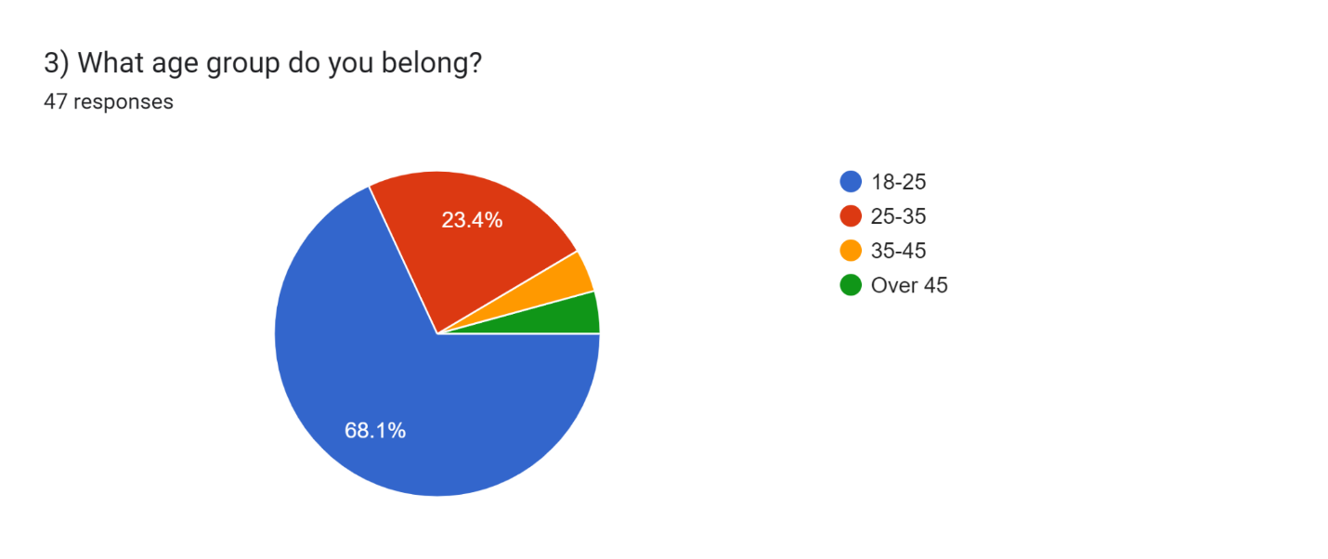
4.1.1 Demographics and Travel Patterns
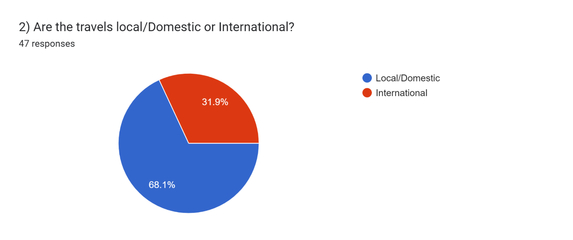

The survey begins by identifying the demographics of respondents and their travel habits. The majority of participants fell within the 25-35 age group, indicating a significant interest from young to mid-career professionals. This demographic often prioritizes experiential travel, making them prime candidates for storytelling impact analysis which is why I felt the need to include it. Most respondents reported traveling between 2-4 times annually, with a nearly Double preference for local/domestic over international travel yet a big number is taken for international as well so these findings suggest that digital platforms must cater to diverse traveler needs, ranging from local experiences to global explorations. Participants' travel frequency varied, with most respondents traveling 2-4 times per year, followed by those traveling 1-2 times annually. A smaller group travels more than 6 times, indicating a mix of frequent and casual travelers. The diversity in travel frequency suggests that Airbnb’s storytelling needs to cater to both regular and occasional travelers, focusing on creating compelling narratives for both categories. As a large number of respondents engage in both local and international travel the trend here highlights the necessity for Airbnb to offer narratives that resonate with diverse cultural and geographical backgrounds. Airbnb hosts should also incorporate more elements that appeal to both domestic and international travelers, such as highlighting unique local attractions or providing stories that emphasize global experiences.
4.1.2 Frequency and Nature of Travel
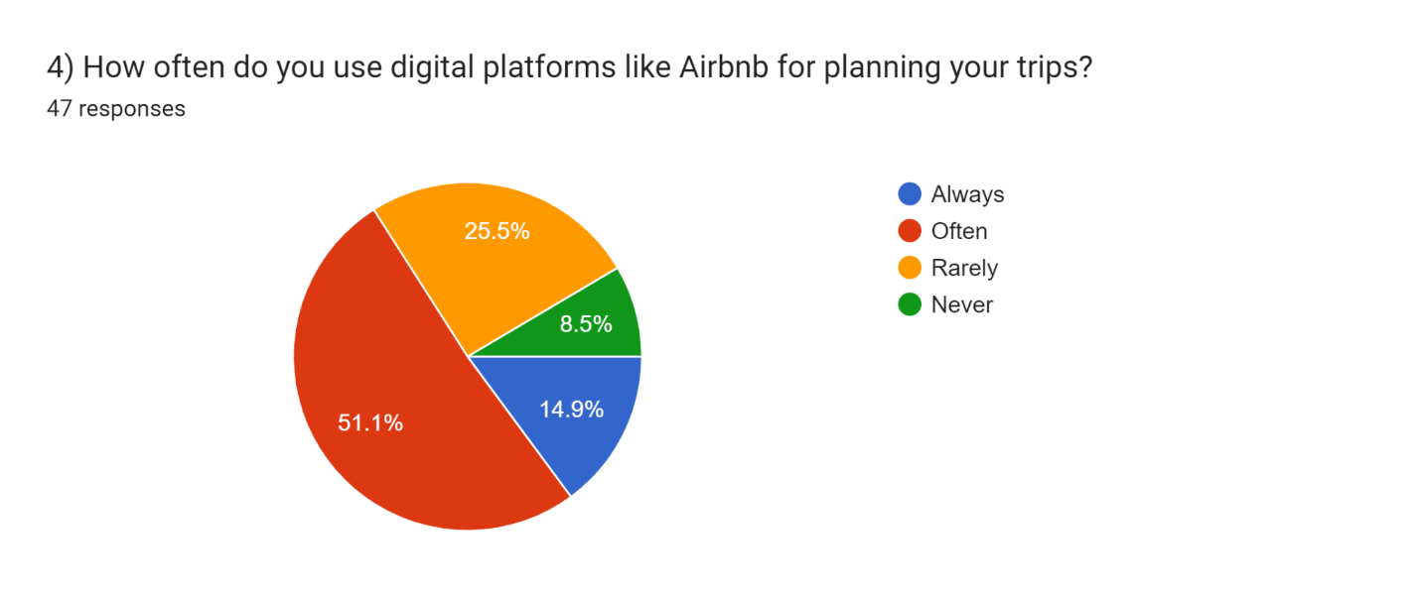

The survey suggests that those who travel frequently are more likely to base their lodging decisions on narrative. A greater dependence on Airbnb's host stories, visual storytelling, and customized experiences was observed among those who travel more than six times year. Given that frequent travelers seek experiences that connect with their personal narratives rather than just a place to stay, it is possible that the frequency of travel and the value placed on storytelling components are related.

4.2 Use of Digital Platforms and Storytelling Preferences
Participants were asked about their use of digital platforms for planning trips. Results show a dominant preference for platforms like Airbnb, with some respondents mentioning alternatives when not using Airbnb like TripAdvisor, Booking.com, and Expedia. However, Airbnb stood out due to its integration of storytelling elements with 51% from 47 sample data, which respondents found compelling in host descriptions, visual narratives, and guest testimonials. As storytelling becomes a key differentiator, platforms need to ensure that the narratives shared by hosts stand out. Effective use of visuals, guest testimonials, and detailed descriptions can enhance user engagement.

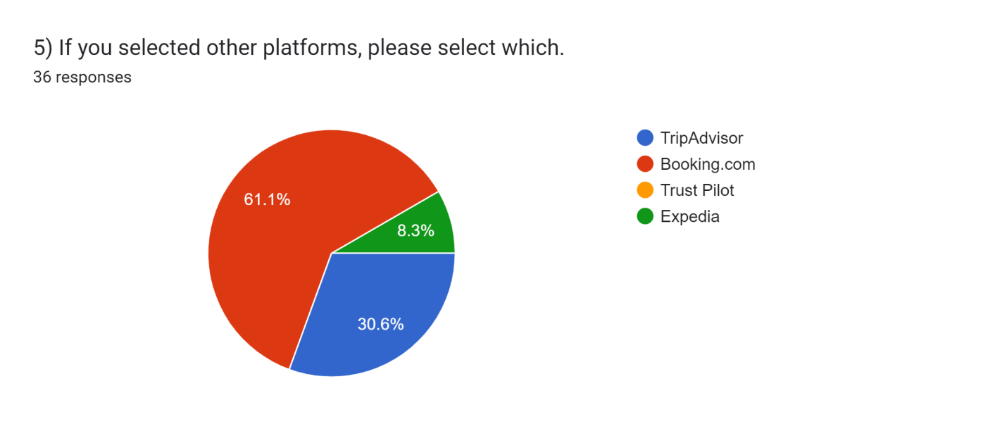
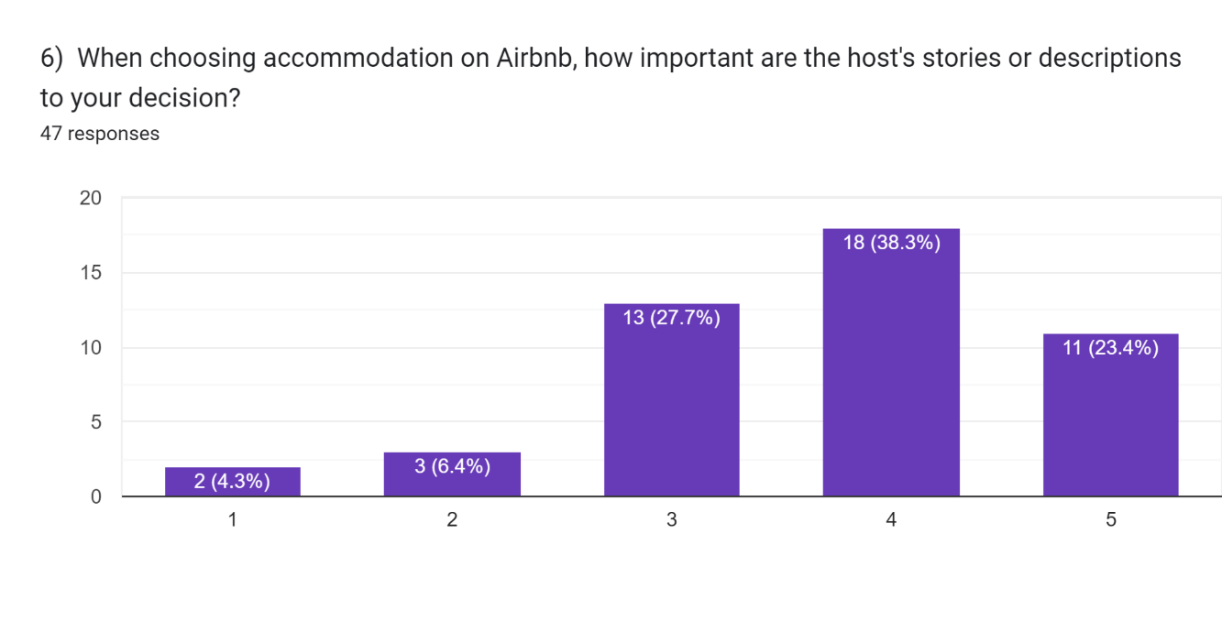
4.2.1 Host Descriptions and Decision-Making

Decisions on accommodations were found to be significantly influenced by the host's tales or descriptions. Numerous participants highlighted that their assessment of a property's value is greatly influenced by the host narratives, which encompass personal accounts, cultural insights from the area, and distinctive features of the property. As they provide prospective guests with a sympathetic and interesting experience, story components that portray genuineness, host problems, or victories tend to resonate more powerfully.
4.3 Impact of Storytelling on Booking Decisions
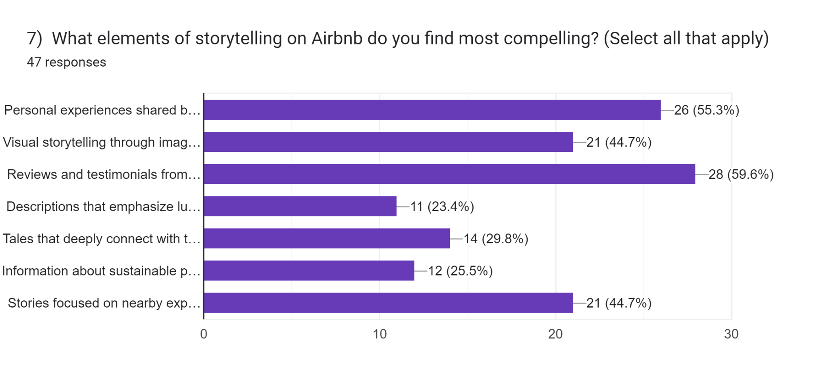
The survey explored specific storytelling elements that influence participants’ decisions to book accommodations. Visual storytelling, such as images, videos, and virtual tours, ranked highest in terms of impact. Respondents expressed that images and videos that showcased local attractions, room aesthetics, and lifestyle experiences played a decisive role in forming an emotional connection with the property. Narratives that reflect local culture and tradition also scored high, emphasizing the importance of contextual storytelling that goes beyond functional descriptions. To talk in more detail, the bar graph displays the poll findings and highlights the most interesting aspects of Airbnb's storytelling, according to the respondents. The most well-liked storytelling component among the 47 participants was "Reviews and testimonials from previous guests," selected by 28 participants 59.6%. This suggests that since they foster a sense of credibility and authenticity, personal testimonials and testimonies have a big impact on swaying prospective buyers. The element that garnered the second most attention was "Personal experiences shared by hosts," which was chosen by 26 participants 55.3%. This indicates that the stories hosts share about their listings and local knowledge are extremely important in building an emotional bond with visitors. Twenty-one respondents 44.7% found "Visual storytelling through images and videos" and "Stories focused on nearby experiences or local attractions" to be appealing. This suggests that emphasizing nearby experiences and visually representing environments are effective ways to draw consumers in. There is a moderate interest in cultural and environmentally friendly elements, as evidenced by the selection of "Tales that deeply connect with the local culture," by 14 respondents 29.8%, and "Information about sustainable practices of the listing," by 12 respondents 25.5%, which are less compelling but still noteworthy. Lastly, with 11 responses 23.4%, "Descriptions that emphasize luxury or exclusivity" drew the least attention, indicating that many Airbnb users place less value on luxury than on authenticity and local experiences.
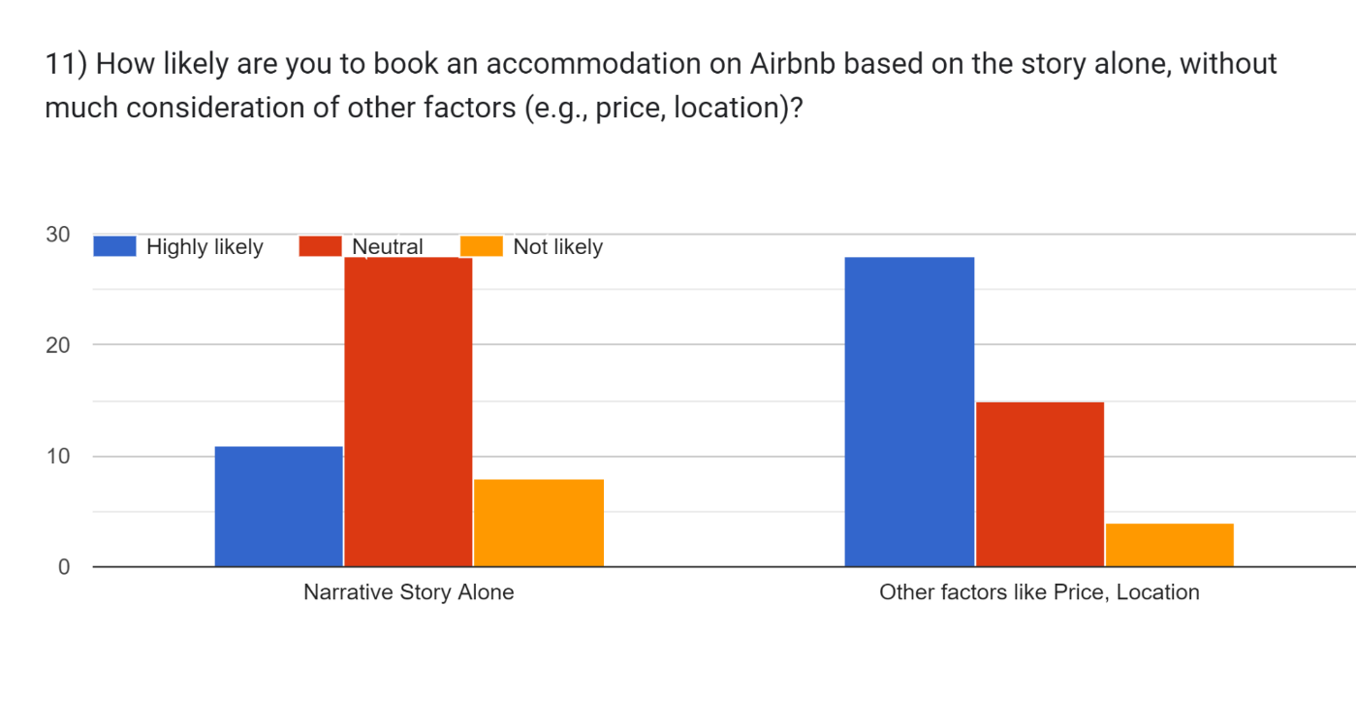
4.3.1 Emotional Connection and Value Perception
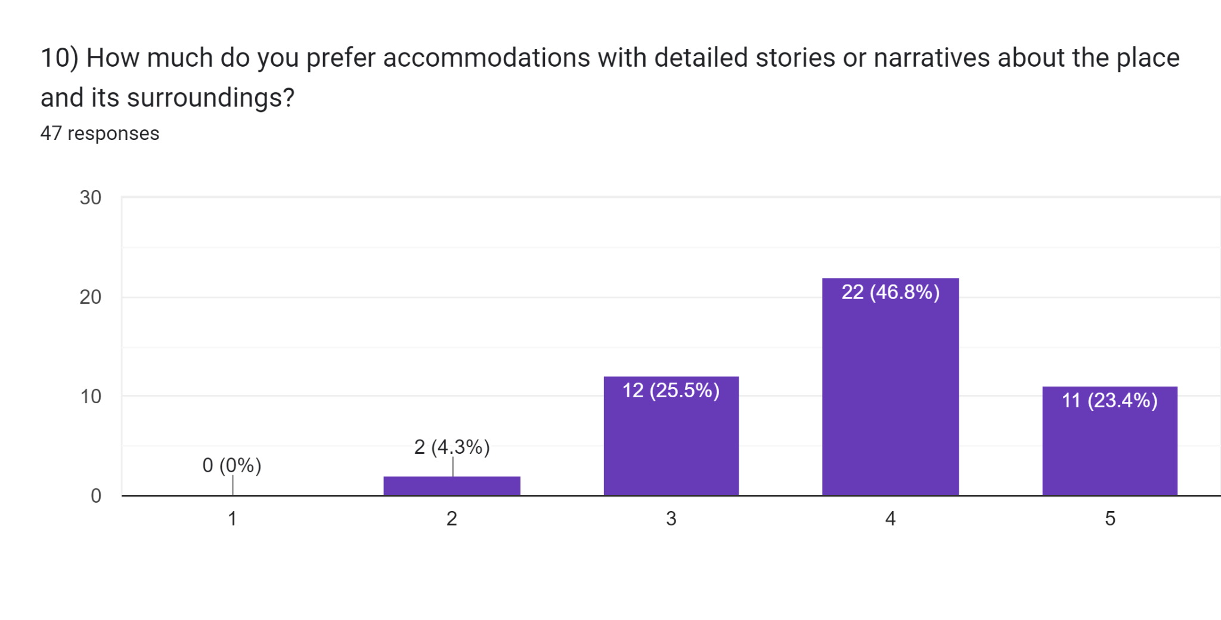
One important component of perceived value was found to be the emotional bond that storytelling fosters. Even though they cost more than comparable options, participants reported that accommodations with compelling narratives were more likely to be seen as distinctive and appealing. In addition to differentiating qualities, this emotional branding raises their perceived value, which increases customer happiness and brand loyalty. The graph demonstrates that even while pragmatic considerations like cost and location are significant, storytelling can still have a significant influence. Even in situations where other factors are similar, a listing that has an engaging narrative will stand out from the competition, evoke strong feelings in the reader, and stimulate their imagination, increasing the likelihood that a possible guest will choose it. This emphasizes how special it is to incorporate an engaging narrative into a listing.

Many and most respondents were classified as Neutral when asked about their reservations based only on the narrative story, indicating that they had no strong feelings in any direction. Even fewer people said they were not likely to base their decision only on the narrative, while a smaller group said they were highly likely to do so. However, the majority of respondents indicated that they are extremely likely to base their lodging decisions on price and location, two other practical variables, indicating a clear preference. Less people indicated that they were Neutral, and very few said that they were not likely to be impacted by these circumstances. But we also discovered that, although compelling tales do sway some people, factors like cost and location are significantly more important in influencing a person's decision to book an Airbnb. This implies that, even if narrative might be valuable, it is not enough to generate most bookings on its own without taking other specific aspects into account. But we also discovered that, although compelling tales do sway some people, factors like cost and location are significantly more important in influencing a person's decision to book an Airbnb. This implies that, even if narrative might be valuable, it is not enough to generate most bookings on its own without taking other specific aspects into consideration.
4.4 Influence on Sustainable and Responsible Travel
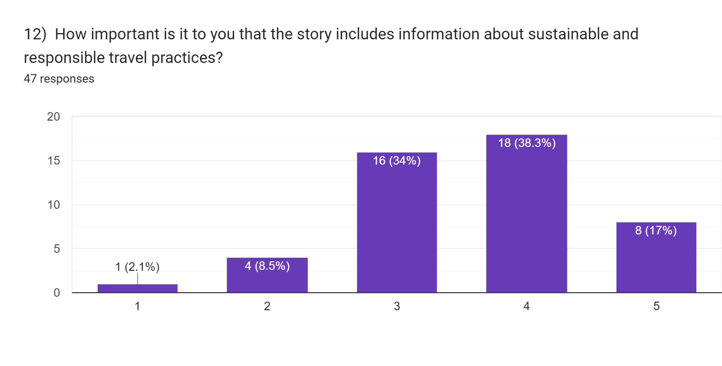
An essential section of the survey examined the role of storytelling in promoting sustainable travel behaviors. Many respondents showed a preference for properties that include narratives about sustainable practices. This preference was particularly strong among the younger demographic (18-35), suggesting that sustainability is an emerging priority for millennial and Gen-Z travelers.
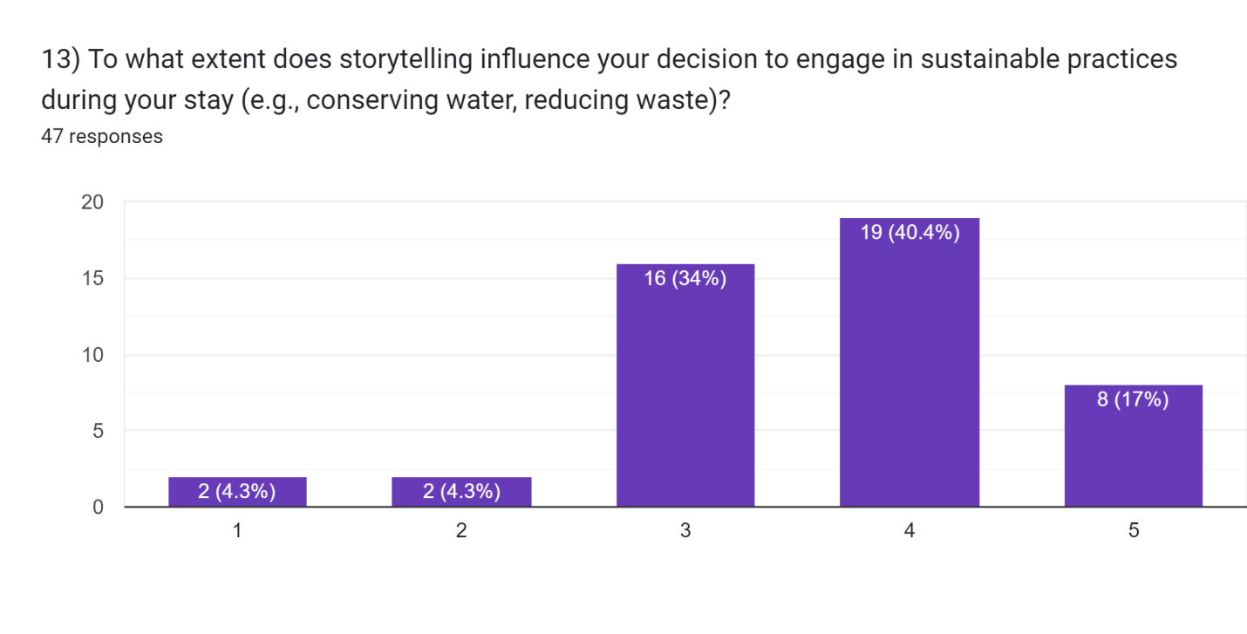
4.4.1 Storytelling as a Driver for Responsible Choices
The incorporation of sustainability elements into narratives, such as details on waste minimization, water conservation, and environmentally friendly facilities, had a major impact on participants' inclination to follow suit while visiting. Stories with an emphasis on social or environmental impact were evaluated as very compelling by respondents, suggesting that well-written narratives can both draw eco-aware tourists and promote more conscientious behavior.
4.5 Technological Innovations in Enhancing Storytelling
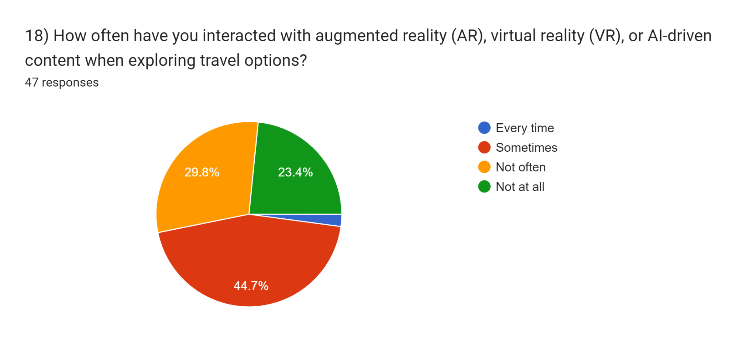
Respondents were asked to evaluate the potential of emerging technologies like artificial intelligence (AI), augmented reality (AR), and virtual reality (VR) in enhancing storytelling. Most participants felt that integrating these technologies would enrich their experience by providing immersive previews of the properties and interactive content.
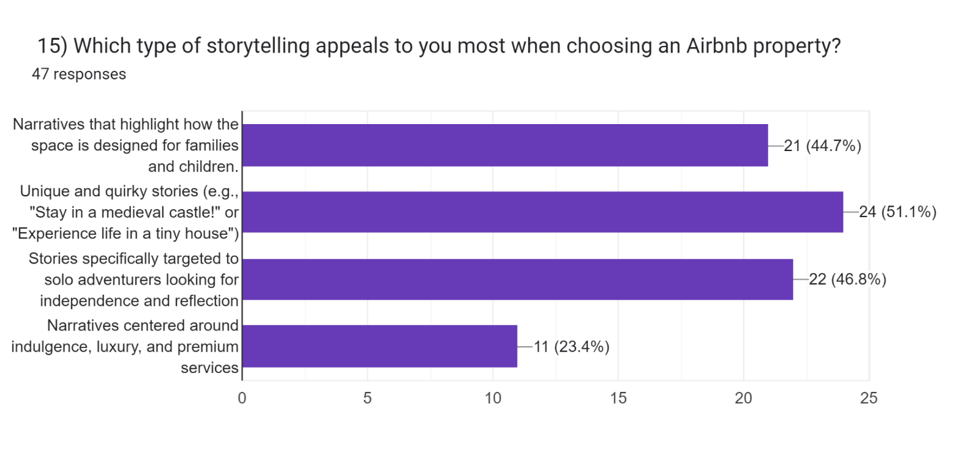
4.5.1 Enhancing guest experience
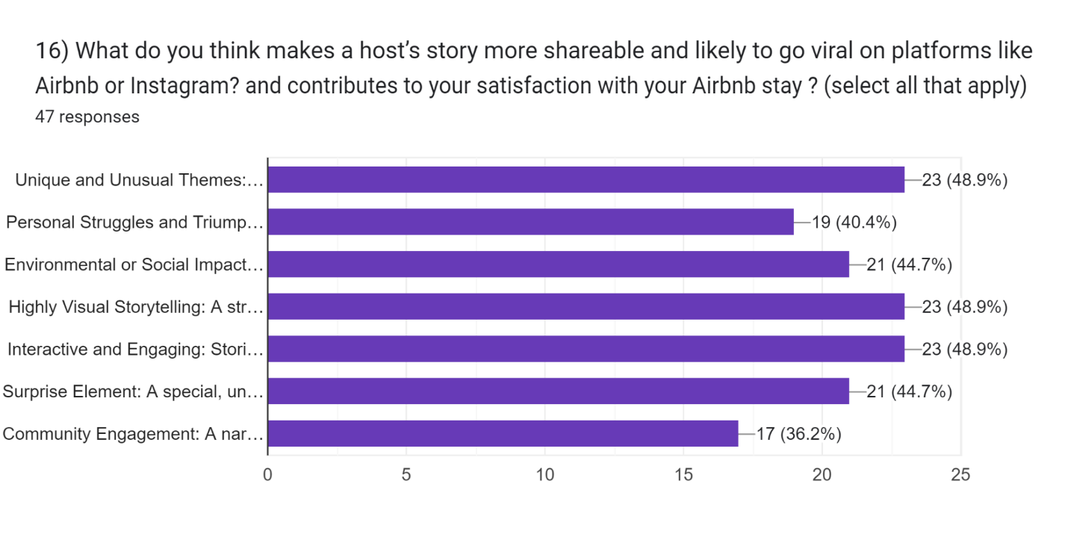
The first chart illustrates the types of storytelling that respondents find most appealing when choosing an Airbnb property. Out of 47 respondents, the most preferred type, chosen by 51.1%, is "Unique and quirky stories" that offer distinct experiences such as staying in a medieval castle or a tiny house or similar to that but on edgy side according to current trends on social media. Right behind is 46.8% of respondents that are drawn to narratives specifically targeting solo adventurers seeking independence and reflection. Additionally, 44.7% of respondents prefer stories that highlight how the space is designed for families and children, indicating a focus on shared family experiences. Meanwhile, "Narratives centered on indulgence, luxury, and premium services" are the least appealing, selected by only 23.4% backing the current trends again of minimalistic and carefree esthetic style living.
The second one focuses on what makes a host's story more shareable and likely to go viral on platforms like Airbnb or Instagram, also at the same time contributing to the guest’s satisfaction. The most popular themes include "Unique and Unusual Themes," "Highly Visual Storytelling," and "Interactive and Engaging Stories," each chosen by 48.9% of respondents. This suggests that guests are attracted to storytelling that not only stands out but also provides an immersive and visually engaging experience. Other impactful elements include a "Surprise Element" 44.7% and stories focusing on "Environmental or Social Impact" 44.7%. Additionally, "Personal Struggles and Triumphs" 40.4% and "Community Engagement" 36.2% are also valued, indicating that stories that resonate on an emotional or community level can leave a strong impression.

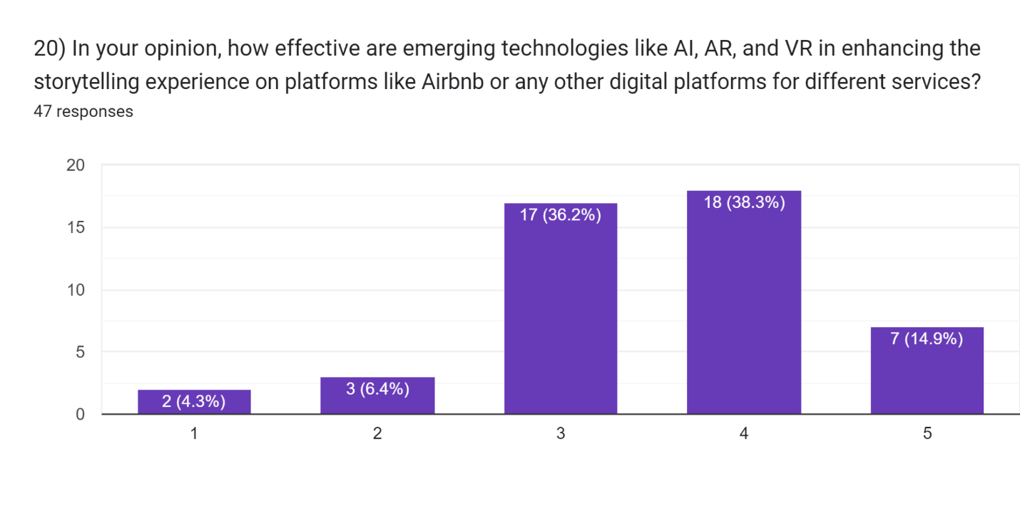
4.5.2 AI and Personalization and Virtual Reality (VR) and Immersive Storytelling

The bar graph illustrates respondents' opinions on the effectiveness of emerging technologies like AI, AR, and VR in enhancing storytelling experiences on platforms such as Airbnb. Among 47 participants, the majority rated these technologies as moderately to highly effective, with 18 respondents 38.3%giving a rating of 4 and 17 respondents 36.2% rating it 3. A smaller group, 7 respondents 14.9%, rated it as very effective 5, while fewer participants rated it lower, with 3 respondents 6.4% at 2. Overall, the feedback indicates a generally positive outlook on the role of these technologies in enhancing storytelling.
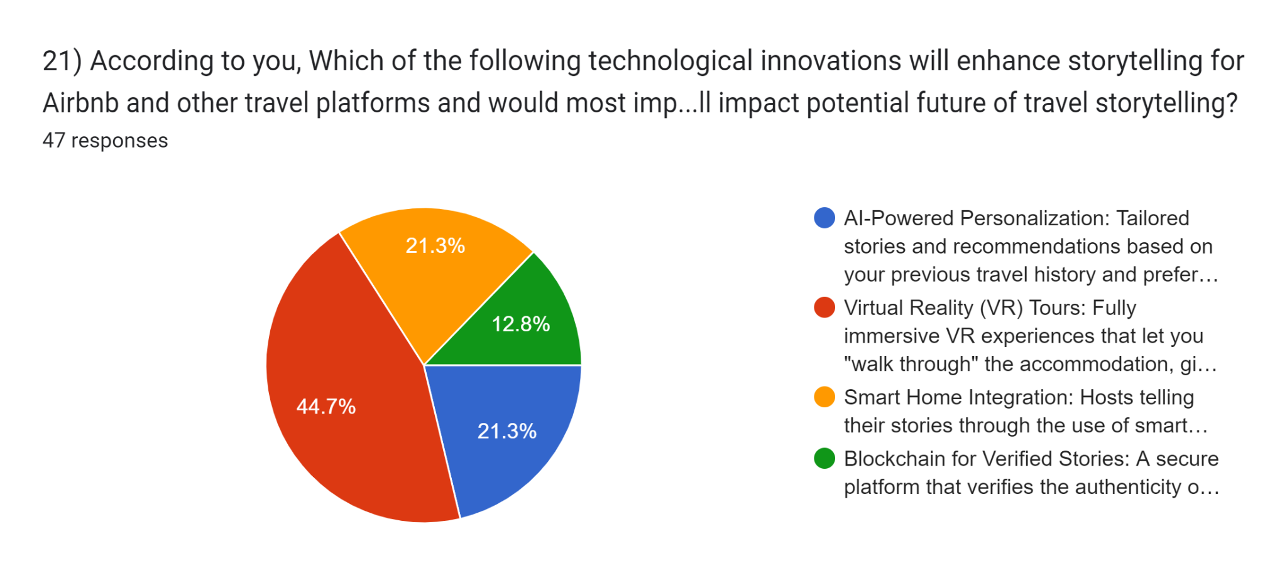
AI-based personalization was particularly favored for its ability to tailor recommendations and narratives based on past travel preferences. Respondents suggested that AI-driven content could create customized storylines that align with individual interests, enhancing the sense of personalization and relevance. VR tours emerged as another significant factor, with many participants indicating that immersive previews of a property would make them more likely to book. This preference was consistent across all age groups, highlighting the broad appeal of VR technology in digital marketing.
4.6 Satisfaction, Loyalty, and Revisit Intentions
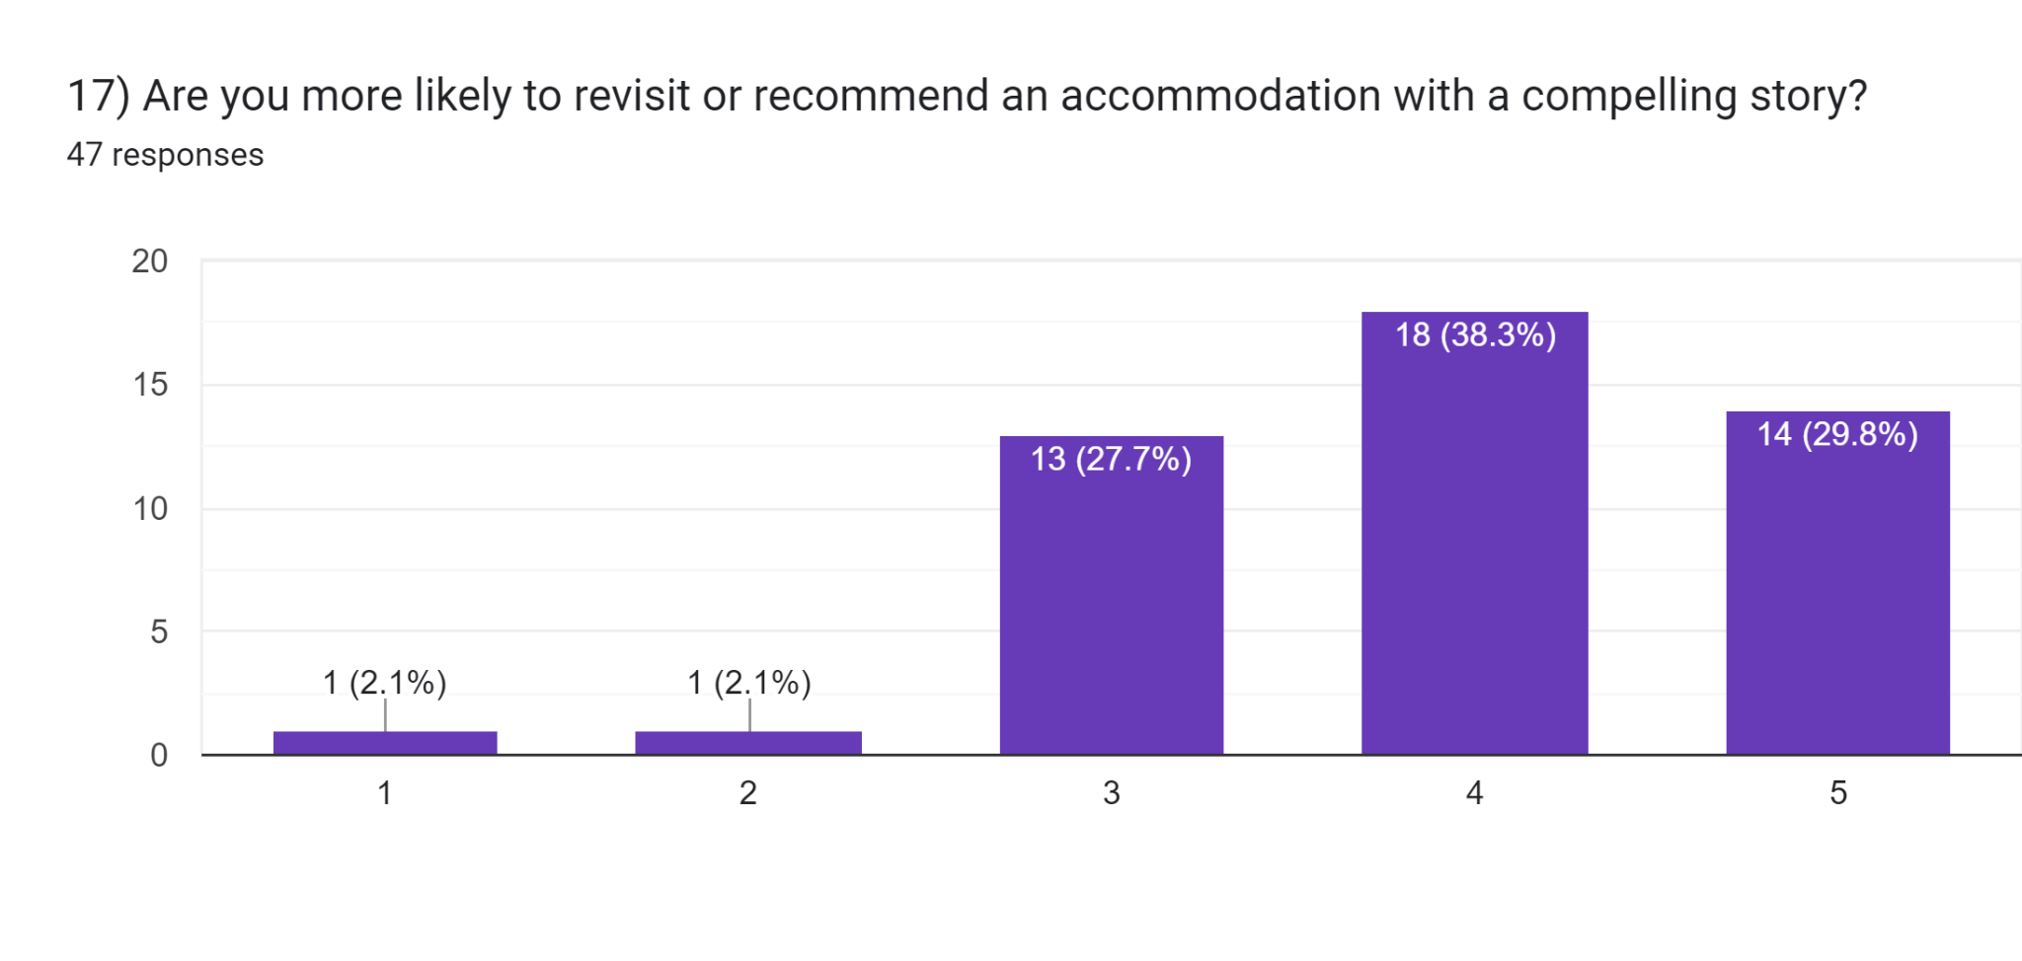
The survey further assessed the role of storytelling in driving satisfaction and loyalty. Respondents who engaged with compelling host narratives reported higher levels of satisfaction and were more likely to revisit or recommend the property. This reinforces the notion that storytelling does not merely influence initial booking decisions but also contributes to long-term brand loyalty.
4.6.1 Narrative Types and Guest Satisfaction
It was discovered that different story kinds had varying effects on how satisfied guests were at the end. Guest experiences were especially improved by narratives that highlighted the difficulties faced by hosts, the involvement of the community, and distinctive thematic experiences such as lodging in a medieval castle. Conversely, stories that were too generic or marketed were seen as less genuine and negatively affected the opinions of the visitors.

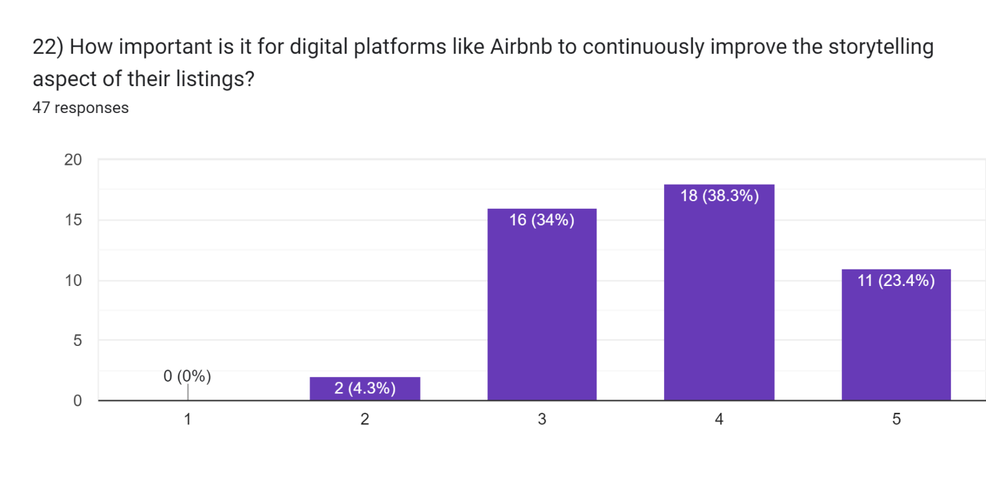
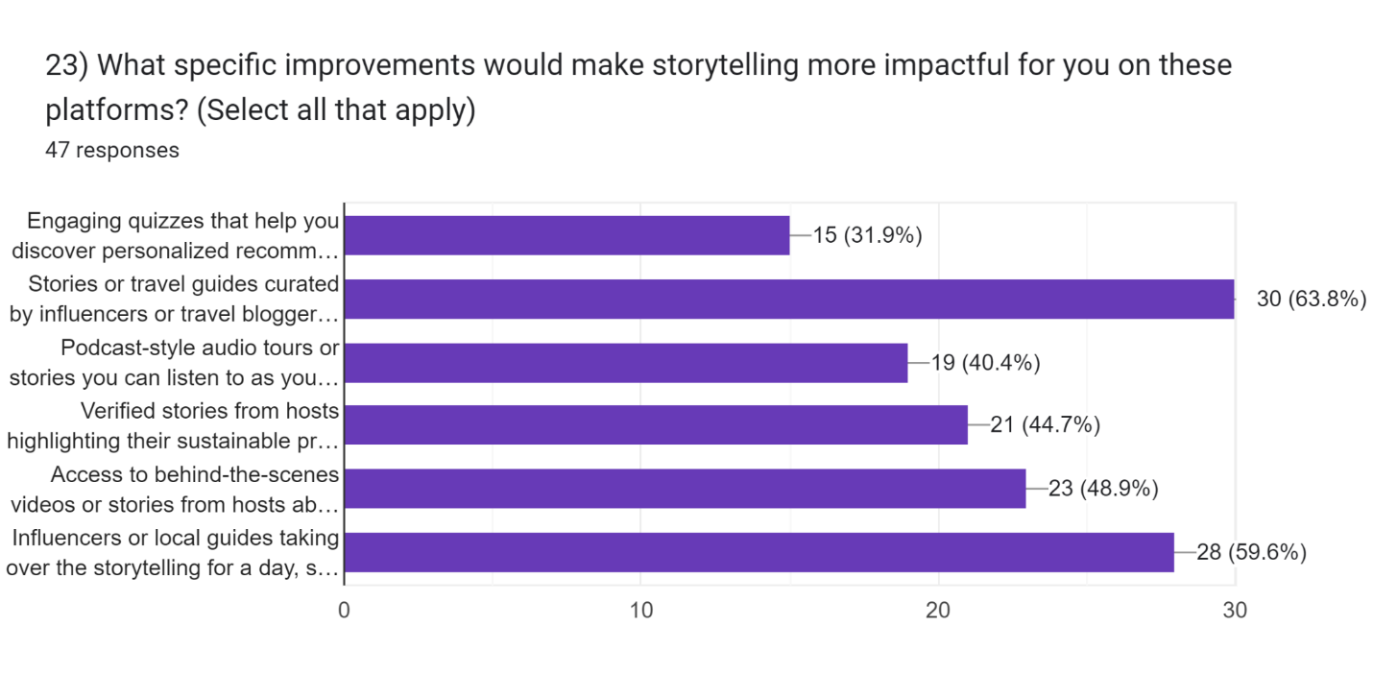
4.7 Recommendations for Improving Storytelling on Digital Platforms

All the surveyors dictated that they have not seen much of storytelling content but if it were to use technological elements like AR/VR and continue improving, not only they would be more engaged but more likely to make decisions from it, they also provided several recommendations through open ended questions which will be summarized below, for enhancing storytelling on digital platforms like Airbnb.
- Workshop Integration: Respondents suggested organizing workshops that focus on local legends, historical narratives, and cultural immersion. This would provide guests with a deeper understanding of the area and create a stronger connection to the destination as well as create a long lasting mark on their trip which can contribute to unique experiences..
- Partnerships with Local Organizations: Collaborating with local cultural and environmental organizations can help hosts develop stories that emphasize community impact, social awareness or fun activities and fairs promoting both the property and the local culture at the same time spreading knowledge which could be most fun for people with kids as their knowledge expands while on holiday helping future decisions in life.
- Incorporating Interactive Elements: Many participants showed interest in interactive storytelling experiences, such as cooking classes or craft workshops, which could be integrated into the host’s narrative, also can be made fun like game night with all the facts gathered during day about locations or learn local or specialty cuisine.

4.8 Future Implications
According to the survey's overall results, digital platforms like as Airbnb can effectively use narrative to set themselves apart from the competition and emotionally connect with tourists. When done well, storytelling has the power to influence attitudes, influence decisions about what to book, and encourage environmentally friendly travel practices. In the future, digital platforms ought to think about making investments in cutting-edge technologies to produce immersive storytelling experiences and concentrate on developing stories that speak to the changing tastes of contemporary tourists.
Using Airbnb as a case study, the goal of this survey is to acquire a greater knowledge of the influence and efficacy of storytelling on digital platforms from the viewpoint of travelers. The importance of narrative in a time where individualized experiences and digital interaction are becoming crucial factors in customer choice cannot be overstated. The purpose of this study is to assess how stories affect visitors' decisions, how they see properties, and how satisfied they are with their overall experience. The poll delves into the parts of storytelling that have the most influence on diverse traveler types, including visual content, personal experiences, and cultural narratives. This is because digital platforms such as Airbnb mainly depend on visual content, user ratings, and host descriptions. The ultimate goal is to identify effective storytelling strategies that align with travelers’ preferences and expectations. Understanding these dynamics will not only help hosts create more compelling and engaging narratives but will also inform Airbnb’s broader strategy in terms of content management and presentation.
The expected outcome of this research is a comprehensive set of insights into the role of storytelling in the digital travel experience. By examining responses from a diverse set of travelers, this survey was to identify which storytelling components are most valued and what kind of narratives contribute to a stronger connection between hosts and guests. The development of suggestions for Airbnb and related sites to improve the caliber of their listings depends heavily on these findings. For example, Airbnb may think about giving hosts additional resources to enhance their photo and video material if the data demonstrates that visual storytelling significantly influences decision-making. In order to give listings greater authenticity and relatability, Airbnb may encourage hosts to share more of their own journeys and experiences that are connected to their properties if it finds that these types of anecdotes and host stories are very interesting. In a similar vein, Airbnb may offer hosts advice on how to include eco-friendly methods in their stories so that they conform to the ideals of customers who care about the environment if sustainability is emphasized as a significant consideration in visitors' decision-making. The survey will also highlight any gaps or areas where current storytelling strategies might be falling short, thereby guiding Airbnb on where to focus its efforts to improve guest engagement and satisfaction.
When the survey responses are examined as a whole, a number of important themes and trends show up that give a thorough picture of the expectations and preferences of passengers. First, it is abundantly evident that responders like storylines that are in-depth, real, and emotionally relatable. When questioned about what makes a tale most interesting, a lot of participants highlighted the value of the presenters' personal experiences, stories that relate to the community, and descriptions that evoke strong feelings. According to these results, tourists are searching for narratives that help them imagine their stay by providing them with a feeling of location and context, rather than just a transactional experience. For example, a host who shares the history of their property, the story behind its design, or insights into the local community is more likely to capture the attention and interest of potential guests. This emphasis on authenticity and depth is consistent with broader consumer trends, where modern travelers prioritize experiences over material goods and are increasingly drawn to unique, story-rich environments that offer them something beyond a standard hotel stay.
The survey also revealed a noteworthy trend: people place a high importance on visual storytelling. High-quality photos, engrossing movies, and other visual components were often ranked by participants as essential components in their decision-making process. This conclusion is especially pertinent to websites such as Airbnb, where a traveler's decision to book is frequently influenced by the listing's aesthetic attractiveness. In a congested market, properties that can effectively highlight their distinctive qualities through eye-catching images and videos stand out and help prospective guests picture themselves staying there. Furthermore, the survey found that consumers are becoming more interested in new technologies like augmented reality (AR) and virtual reality (VR). Those who had engaged with VR/AR content said that these tools improved their knowledge of the property and gave them more assurance when it came time to make a reservation. According to this, there is a good chance that websites like Airbnb will incorporate more immersive storytelling technology, giving visitors the opportunity to engage with the neighborhood or take a virtual tour of the house.
In the poll results, personalization also surfaced as a major subject. Travelers indicated a preference for advice and stories catered to their individual interests and needs. Stories that emphasize possibilities for introspection and independence, for example, can pique the curiosity of a lone traveler more than a family, who might react more favorably to stories that highlight kid-friendly services and activities. This emphasizes how crucial it is to use AI and machine learning to produce material that is tailored to the interests of various traveler profiles. AI-driven narrative technologies that automatically create or recommend material based on a guest's past reservations, specified preferences, and browsing activity could be beneficial for platforms such as Airbnb. By using this strategy, the content becomes more interesting and relevant and also helps build a sense of connection between the guest and the property even before the stay begins.
Sustainability was another area where storytelling proved to be impactful. Many respondents indicated that they prefer accommodations that incorporate sustainable practices and that highlight these aspects in their narratives. Stories about eco-friendly construction, energy saving and water saving measures, and community engagement were particularly compelling for respondents who identified as environmentally conscious. Not only that but they also indicated that they are more likely to make a decision or contribute to the cause if such interactive information is to be presented regarding sustainability. This finding aligns with the growing trend of responsible tourism, where travelers are not just looking for a place to stay but are also considering the environmental and social impact of their choices. For Airbnb, this presents an opportunity to further differentiate itself by encouraging hosts to share their sustainability stories like other stories and by creating dedicated sections on listings that focus on green practices which was also one of the recommendation by a participant. For example if the hosts does recycling programs, use renewable energy, or engage in local conservation efforts and make a point to also explain about it to the guest, it could highlight these initiatives as part of their narrative, thereby attracting like-minded travelers.
Also, a substantial correlation between guest happiness and narrative was seen in the survey replies. Effective storytelling can improve the guest experience beyond the physical features of the facility, as seen by the better ratings for overall satisfaction given to accommodations with captivating stories. Positive reviews and requests to return were more common among guests who related to the host's story or found the narrative to be well-thought-out. This discovery holds special significance for websites such as Airbnb, which depend on customer loyalty and favorable referrals to propel their expansion. Airbnb can enhance its value offer and cultivate a devoted user base that has an emotional bond with the company by prioritizing storytelling as a fundamental aspect of the visitor experience.
CHAPTER 5
Conclusion:
The findings of this survey, which explored the impact and effectiveness of storytelling on digital platforms from the traveler’s perspective, provide significant insights into how storytelling shapes travel decisions, guest satisfaction, and sustainable behaviors. The data collected sheds light on the preferences, motivations, and attitudes of travelers using digital platforms like Airbnb, revealing the critical role that engaging narratives play in creating compelling experiences and influencing consumer behavior. First we will focus onto the research questions derived from the research objectives and discuss on that, after which we can compare and combine primary data as well secondary to form conclusion. Questions will be divided in sections below.
5.1 Storytelling as Decision making tool
The survey findings unequivocally show that travelers use storytelling as an important element or tool when making decisions. According to the majority of respondents, narratives shared by hosts such as firsthand accounts, cultural insights, and thorough descriptions of the property and its surroundings have a significant impact on their decisions. These components give the listing more substance and turn it from a straightforward lodging option into something unique and unforgettable. The host's personal tales, narratives that highlight distinctive facets of the local culture and community, and visual storytelling through pictures and videos are the storytelling elements that most resonated with the audience.
As a fundamental part of their marketing and consumer interaction strategy, digital platforms such as Airbnb must continue to invest in storytelling. When a hotel tells a narrative well, it may stand out from the competition and attract potential guests who are searching for more than simply a place to stay—they want to be part of the story. Because they can emotionally connect with guests, hosts who are skilled at telling compelling stories have a greater chance of seeing increased booking rates and happy guests.
5.2 The Role of Visual and Immersive Storytelling
In the questionnaire, visual storytelling was recognized as having a particularly powerful effect. This consists of vivid pictures, interesting films, and user-generated material that accurately depicts the lodging and its surrounds. Numerous participants mentioned that visual components aid in creating a mental picture of their visit, which lowers uncertainty and boosts confidence while making reservations. This result is in line with more extensive studies on consumer behavior, which indicate that visual information can greatly affect perception and choice, particularly when traveling and taking into account a destination's ambience and aesthetics.
It has also been discovered that the increasing use of cutting-edge technology like augmented reality (AR) and virtual reality (VR) improves storytelling. After using these technologies, respondents said they could get a deeper, more immersive preview of lodgings, allowing them to feel as though they were "being there" before deciding to make a reservation. This means that websites like Airbnb might make greater use of these technologies to offer prospective visitors interactive experiences or virtual tours that showcase a property's special features.
5.2.1 Personalization through Technology
Personalized storytelling experiences are also strongly preferred, according to the report. The use of AI to personalize tales and recommendations according to a participant's interests, preferences, and past travel experiences piqued the curiosity of the participants. Platforms may now provide users more interesting and relevant content, which seems customized and in line with their expectations thanks to this technology. This methodology not only enhances user pleasure but also cultivates a sense of platform loyalty and connection. Airbnb can enhance its storytelling methods to better suit individual profiles and increase conversion and repeat business by incorporating AI and machine learning to assess customer behavior and preferences. Personalization can include suggesting things to do in the area or emphasizing features of a hotel that suit a guest's interests or itinerary.
5.3 Impact on Sustainable Travel
One of the most interesting findings from the survey is the impact of storytelling on promoting sustainable and responsible travel practices. Respondents showed a strong inclination toward choosing accommodations that emphasize sustainable practices in their narratives. Stories that highlight the environmental and social impact of a property, such as eco-friendly construction, local community engagement, and green initiatives, were rated as particularly compelling. This suggests that digital platforms and hosts can play a significant role in encouraging sustainable behaviors by weaving these themes into their storytelling. For example, hosts could share stories about their efforts to reduce waste, conserve resources, or support local communities, thereby appealing to the growing demographic of environmentally conscious travelers. Such narratives not only influence booking decisions but also inspire guests to adopt sustainable practices during their stay.

5.4 Enhancing Guest Satisfaction and Loyalty
The association between guest pleasure and excellent storytelling is further shown by the survey results. High ratings for overall satisfaction were found in accommodations with strong storytelling components, suggesting that visitors appreciate places with an engaging tale. Several respondents said they would be more inclined to return or suggest a property with an interesting story, demonstrating how this contentment frequently transfers into loyalty. Consequently, narrative should be seen by online platforms such as Airbnb as an integral component of the guest experience rather than merely a promotional tool. To foster stronger emotional ties which are essential for fostering enduring loyalty hosts should be encouraged to concentrate on crafting tales that showcase the special qualities of their property, the surrounding area, and personal experiences.
5.5 Secondary connection and examples
The primary aim of this research was to explore the impact of storytelling on digital platforms like Airbnb, focusing on how it shapes traveler expectations, influences decision-making, and fosters sustainable travel practices. The results from the survey and literature analysis strongly affirm that storytelling plays a crucial role in influencing the behavior and decisions of modern travelers now let’s look at some secondary data gathered to form a conclusion.
Analyzing the effects of storytelling on expectations and decision-making was one of the main goals. According to the literature (Pine and Gilmore, 2013; Magasic, 2016), narrative creates immersive experiences that influence travelers' expectations. This is supported by the survey's findings, which show that 51% of participants thought host narratives had a big impact on their decision to book, with visual storytelling—that is, images and videos—having a crucial significance. This demonstrates how tales told by hosts not only give guests details about the establishment but also arouse feelings of empathy, enabling them to visualize their stay. This is corroborated by research by (Kim, Ritchie, and McCormick 2012), which shows that emotionally charged travel experiences are frequently the driving cause behind memorable traveler experiences. Airbnb's emphasis on user-generated content (Tussyadiah, Zach, and Wang, 2020).
According to Bramwell and Lane (2011), the research findings are consistent with the second objective of investigating the impact of storytelling on sustainable travel practices. Specifically, the narratives centered on sustainability were found to have a particularly strong resonance with younger travelers, indicating a growing trend towards responsible tourism. According to research, tales that highlight a place's culture, environmental protection, and social impact can be effective in promoting responsible travel (Steg and Vlek, 2009). This opinion was supported by the survey participants, many of whom said that they would prefer to book lodgings that included sustainable aspects in their descriptions. This has a direct bearing on the conclusions of (Storr, 2021), which emphasize the storytelling's emotional power in encouraging ecologically responsible behavior.
Finding the most powerful components of storytelling was the focus of another goal. The main statistics demonstrated that visual storytelling and personal host stories work very well in crafting an engaging experience. The secondary literature suggests that real storytelling (Bruner, 1990) and immersive experiences (Yung, 2019) made possible by technologies like AI and VR can improve customer happiness and engagement. As responders pointed out, AI-based personalization can adjust recommendations based on user preferences, which would increase the stories that are shared to its relevancy.
Lastly, the study shows that storytelling is a powerful technique for building client loyalty in terms of business optimization. Strong storylines establish an enduring connection between the visitor and the platform in addition to fostering emotional involvement. Engaging with captivating host narratives increased respondents' happiness and increased their likelihood of returning or recommending the resort. This is in line with (Zorfas and Leemon's 2016) research on brand storytelling frameworks, which highlights the significance of accessible, value-driven tales in fostering enduring loyalty.
To sum up, this study highlights the critical influence that storytelling has on the development of contemporary travel experiences, especially on online platforms such as Airbnb. The results of the literature analysis and poll demonstrate that storytelling is a means of fostering sustainable business practices and enduring customer loyalty in addition to being an instrument for producing memorable experiences. Airbnb hosts may greatly increase guest satisfaction and promote repeat business by crafting stories that emphasize authenticity, cultural immersion, and ethical travel. It is also possible to build even more customized and engaging narrative experiences by integrating cutting-edge technology like AI and VR. Organizations that leverage the power of narrative are likely to experience long-term gains in consumer loyalty, satisfaction, and engagement, which will eventually contribute to a more sustainable and connected travel industry.

CHAPTER 6
RECOMMENDATIONS:
Before we begin to dwell in future insights, this is to clarify that the recommendations will be based on the researcher that is mine and surveyors that are the participants ideas and or something already being done but to enhance for better results.
This study's conclusions provided insight into how customer views and judgments about Airbnb rentals are influenced by stories. Although this study has limitations like any other, filling in these gaps could greatly enhance the future research and its consequences for businesses who employ narrative in their marketing initiatives. The study's two main shortcomings are the sample size and the demographics it looks like it and Even though the survey received a wide range of responses, it's possible that the sample doesn't accurately reflect all Airbnb users or prospective visitors from different age, gender, and geographical considerations or cultural aspects for it to be completely accurate, also as stated above, personal bias could reflect to some points.
Future studies ought to concentrate on broadening the sample to encompass a more globally diversified audience, since storytelling preferences are frequently impacted by cultural conventions and individual backgrounds. Insights that are more useful for businesses operating in international markets would result from a greater comprehension of how various narratives resound across geographies and cultural contexts. An additional barrier related to making use of narrative in context. The study mostly looked at story components by themselves, including unusual encounters or tales that appeal to families, without taking into account how they interacted with other important criteria for choosing, like cost, location, and facilities. Subsequent studies ought to take a more comprehensive approach, examining the combined effects of narrative storytelling and these practical factors in order to determine how they together affect the decisions made about reservations. The best mix between sentimental value and effectiveness could be found through experimental studies in which people are shown many Airbnb ads with varying narrative styles, prices, and visual presentations.

If we think about it, while the research is pertinent, it may not fully capture the subtleties of the impact of storytelling on other comparable platforms or the hospitality industry, such as small hotel chains or vacation rental websites, because it primarily focuses on Airbnb. A more comprehensive understanding of how storytelling affects customer behavior in the hotel and tourism sector would result from expanding the research to cover these scenarios. With this extension, businesses would be able to apply research beyond Airbnb and develop customized narrative techniques that might raise customer pleasure and engagement at a range of service points in return.
Going forward, businesses might want to think about making investments in customized storytelling strategies. According to this research, respondents exhibit a preference for narratives that are either extremely distinctive or customized to meet certain needs, including those of lone travelers or families. This points to an increasing tendency toward hyper-personalization, in which narrative is tailored to meet the specific needs and tastes of various customer categories. To improve the emotional resonance and relevance of their stories, businesses might use AI technologies and data-driven insights to produce dynamic storytelling content that changes depending on the audience. Also, the study's emphasis on the value of interactive and visual storytelling indicates that businesses must invest in more engaging content formats rather than just static descriptions. Subsequent investigations may examine the influence of nascent technologies such as virtual reality (VR) and augmented reality (AR) on narrative, specifically with regard to their capacity to facilitate prospective visitors' "experience" of a resort prior to making a reservation. The incorporation of immersive technologies has the potential to revolutionize the storytelling approach and enhance the customer decision-making process, rendering it more captivating and instinctive. For businesses to use storytelling effectively, it is important to make sure that the stories they tell are both shareable and have the potential to create attention on social media. Results indicate that specific story elements like original themes and interactive content have a higher chance of going viral. This is important information for businesses hoping to gain greater exposure and draw in new clients through natural social media sharing. Future studies should examine how to integrate these components into more
Comprehensive digital marketing strategies as well as which particular narrative structures along with content styles optimize popularity. The study also emphasizes how important it is that narratives reflect real-world events. The power of narratives that are too well-crafted or general may be diminished by coming across as false. Subsequent research endeavors may concentrate on comprehending the limits of genuineness in narrative and the appropriate ways in which businesses can align innovation and openness. This is especially important in a time when people are less receptive to overt marketing strategies and are more likely to interact with companies that share real, personal tales.
Invest in Visual and Immersive Content: Platforms should prioritize high-quality visual content, including images, videos, and VR/AR experiences, to provide a richer, more engaging portrayal of properties. Promote Personalized Storytelling: AI and machine learning can be used to tailor narratives based on individual user profiles, making the experience feel more relevant and personal. Emphasize Sustainability: Digital platforms should encourage hosts to incorporate sustainability themes into their stories, highlighting eco-friendly practices and community impact. Provide Host Training: Platforms could offer workshops or resources for hosts to improve their storytelling skills, focusing on authenticity, emotional connection, and effective use of multimedia. Leverage User-Generated Content: Encouraging guests to share their experiences and integrating these stories into the platform’s content strategy can enhance authenticity and create a sense of community.

The data illustrates the profound impact that storytelling has on the travel decision-making process, guest satisfaction, and sustainable travel practices. As digital platforms like Airbnb continue to evolve, the role of storytelling will become even more central to their strategies. By leveraging emerging technologies, embracing personalization, and promoting sustainable narratives, these platforms can enhance their value proposition, create memorable experiences for guests, and foster long-term loyalty. Through the careful integration of compelling stories, digital platforms can transform simple travel bookings into rich, immersive experiences that resonate deeply with guests. The future of travel storytelling lies in the seamless blend of technology, personalization, and authentic narratives that speak to the desires and values of modern travelers.
In the end, this study has highlighted the important influence that storytelling has on visitor preferences on Airbnb, however, further research and improvement of the technique will be necessary to produce more comprehensive and useful findings. Future research can help businesses realize the full potential of storytelling by utilizing cutting-edge technologies, investigating novel contexts, and emphasizing authenticity. This will eventually improve customer engagement and propel commercial success in the dynamic digital landscape.

