BMSW 4005
Poppy wagstaffe
2026246

Look at this job on Indeed:
GBNFC
Family Support Worker, Hours Vary
Birmingham B13
https://uk.indeed.com/m/viewjob?jk=540a5844a66c3699&from=native

Cover letter:
Dear Mr/Miss

I am writing to express my interest in the role of the job being advertised. As you can see from my attached CV, I have a years’ experience as a successful care provider, lead volunteer, retail based environment alongside a bartender/front of house.

Currently I am not employed but attending University, I wish to start a new career within this spectrum. My motivation to become successful in the care providing industry and continue volunteering is my main goals. I can offer great intentive service skills and become a valid member of the team. I work well under pressure and maintain high standards.

In my previous jobs as a care provider and student partaking in a health and social course I have achieved a number of new relevant skills, including: customer service, working under pressure to provide the best customer service and to be able to use my initiative to provide the appropriate care that’s needed. In addition to this I became a valid a member at my volunteering post for the charity British Red Cross and wish to carry on volunteering as I have a great passion for it I was made lead volunteer because of my exceptional ability to organize, use initiative and good social communication skills. The aspect I enjoyed most about my work was working within a team, I ensured that the customers always felt welcome and as helpful as possible.
I am confident I have the attributes that your company is looking for and I am available for an immediate start. I would very much welcome the opportunity to discuss my application in person.
Yours sincerely,

Miss Poppy Wagstaffe

Mob no: 07398 494374
Home: 0121-6089897

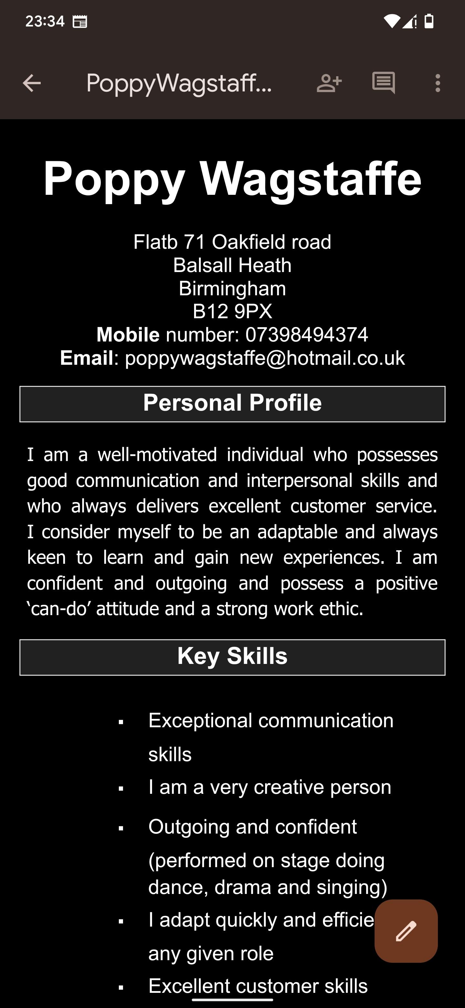
Cv:


