

Assessment 1 – Reading Task Template
Upload your photo of your mind map here:
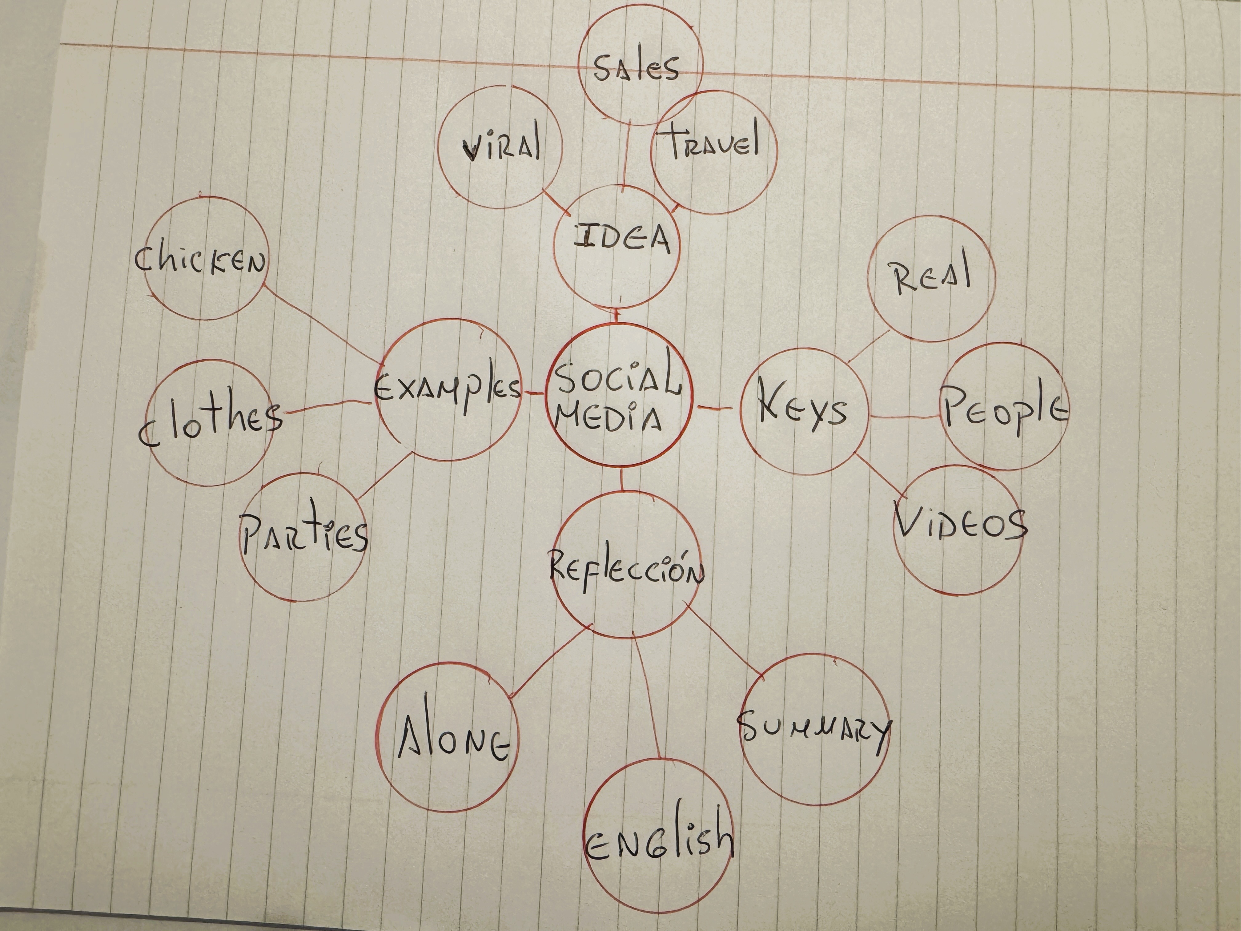

1. Answer these questions using the sentence starters below
a. What is the main idea of the text?
The main idea is that several small businesses are using social media like TikTok and Instagram to get noticed and bring in more customers. What they all have in common is that posting videos or going viral helped them get discovered, leading people to buy from them, even travelling long distances to do so
b. What are two key points?
One key point is that people prefer seeing real content rather than typical ads. One example is Linda Hunter, who owns an online clothing shop. She started posting simple videos showing her clothes from home, and now she sells across the country and even to Australia.
Another key point is that social media brings in customers from far away. One example is Hony wood sandwich shop. A customers posted a video of its chicken burger, and thanks to that, people started traveling up to three hours just to eat there.

c. What part of the text did you find most important? Why?
The most important part is the idea that people prefer seeing real content rather than formal ads. I chose it because it clearly explains why social media works so well nowadays. You connect better when you see the real person behind the business.
d. Was anything unclear or difficult to understand?
I was not sure about the English phrase “weekend side hustle” when referring to the children’s party business. Later, I understood that it meant an extra weekend job, but at first the phrase was not entirely clear to me.
e. How did your group help you understand the text better? I did the work on my own, so I read the article carefully by myself to answer each question.
My group helped me by
2. One sentence reflection
Question: What did you find challenging about this task?
The hardest part was summarizing each business story in my own words without leaving out crucial details.

