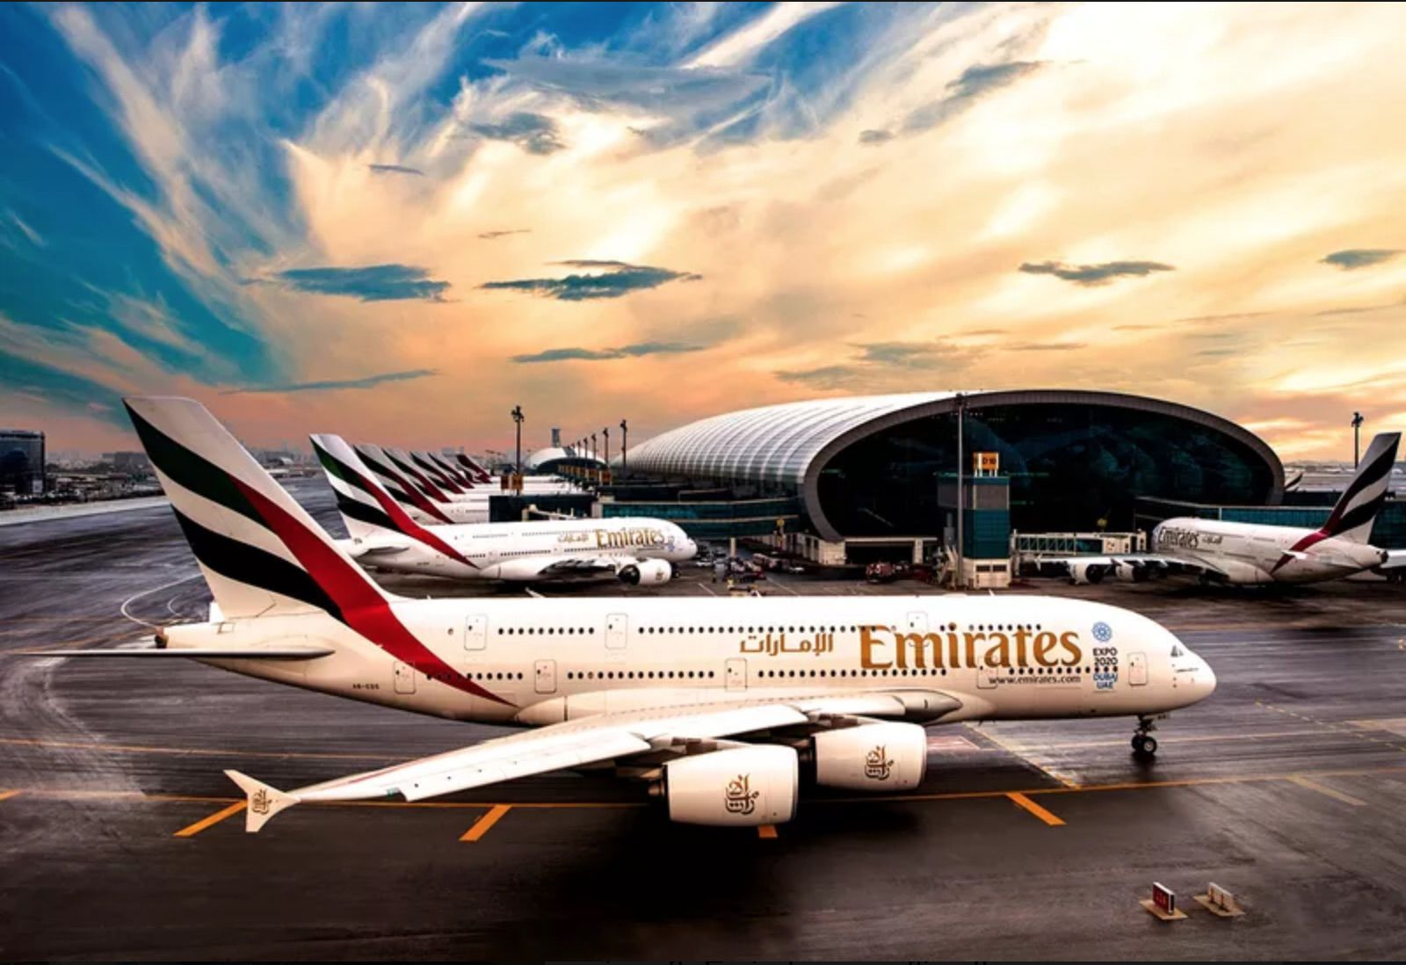  Organizational Structure and Culture in Emirate Airlines  Assessment 1 | University of Wales  Trinity Saint David  Introducing the Modern Workplace -LCBB4003  Teodora Georgieva  Student ID: 2111818  Date of submission:  23th August 2022  Word Count: 1943 words  Tutor’s Name:  Md Sadeque Imam Shaikh

Table of Contents

1. Introduction ……………………………………………………………………………..2
2. Organizational Structure of Emirates Airline and performance………………………....2
2.1 Structure of the company……………………………………………………………….2
2.2 Company Performance…………………………………………………………………4
3. Impact of Organizational Culture………….…………………………………………….5
4. Approaches and factors, influencing group and team behaviour……………………...…6
5. Conclusion………………………………………………………………………………..7
6. References………………………………………………………………………………...8

- Introduction
Already at the creation of an organization, questions about what will be its goals, what position we want for it in the market among the competition, its vision, and its mission, are decisive for the potential and for the future. The goal we strive for is always a maximum performance, so factors such as structure, organizational processes, relationships, technological development, leadership, business etiquette and social responsibility must be taken into account. We will mention the role of all of them in this report. We have taken Emirates Airlines as an example. First looking will be at it the organizational structure and its impact on the company's performance and move on to the organizational culture, as well as the management methods that Emirates Airlines uses to deal with situations with the aim of satisfied staff, customers and profits for the company.

2. Organizational structure of Emirate Airlines and performance
2.1 Structure of the company
In order to achieve success in business, companies need to follow successful organizational structures. Scholars in this field seek new approaches to effective productivity through technology, innovation, and cultural knowledge (Hao, et al., 2012). Emirates takes all these factors into account and tries to implement them successfully in its management.
The definition of organizational structure can be interpreted as the distribution of mechanisms in the administration and roles influencing control and activities in the work process (Child, 1972).
After disagreements arose over the vision for open flights between the Dubai government and Gulf Air, the main carrier of the United Arab Emirates, and the reduced number of flights to and from Dubai with the agreement of Sheikh Maktoum bin Rashid Al-Maktoum, the then ruler of Dubai, experts were convened in this area headed by Sir Maurice Flanagan, then managing director of dnata and established their own carrier on 26 June 1985. The company is owned by the Dubai Investment Corporation, a sovereign legal entity of Dubai, and Emirates was established as a limited liability company (Al-Aali & Nataraja, 2011). The strategy is for this airline to have no capital investment from the government, apart from the initial US$10 million, and to meet extremely high standard requirements.
The Emirate Airline's structure is flat – Fig.1. It enables quick and easy decision-making, thanks to communication that is clear and simplified (Nataraja & Al-Aali 2011). The entire aviation business is under the direction of the president, who in turn delegates duties to the executive vice president. All airport services, freight transport, and holiday and hotel business are also part of the President's responsibility.
Team works and the possibility of direct communication along the vertical and horizontal hierarchies help both for effective leadership and for the direct communication of the team with the management and with each other at the same time. Management forms teams, with responsible managers who monitor the processes and take care of their teams, as well as the fulfilment of company requirements. In a constantly changing environment and conditions, "timeliness", an essential factor for company success, is the result of adequate management perception (Svensson & Wood 2010).

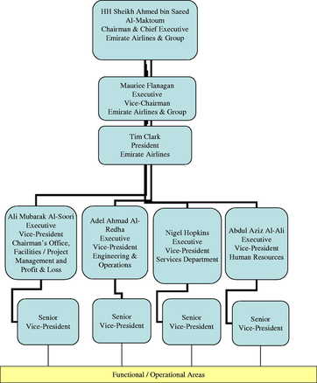

Fig1: Organizational chart Emirate Airlines
2.2 Company performance
A company's performance is undoubtedly due to operational and innovative diversification strategies and to a well-chosen management team that is part of the organizational structure. The values ​​and vision of Emirates Airlines, consisting of a strong team, tactically considered decisions, and implementation of new ideas and technologies, contribute to the stability and progress of the company. Adding to that, the focus on customer service and care for employees and every single stakeholder completes the created image of the airline.
The results, despite the negative circumstances that have arisen in recent years such as Covid, increased oil prices, lack qualified staff and inflation, are visible in the company's statistical analysis. Losses for the company have been reduced dramatically since the crisis period from 65.6% to 6.6% (Emirates, 2022). Despite the difficulties in the aviation business, President Tim Clark interviewed by CNBC International TV mentioned an increase in the company's profits (Clarck, 2021).
Also, through its successful business model and flexible policy, the airline is benefiting from increased demand after the Covid-19 pandemic and increased its destinations to over 140. The growth in the number of passengers by 199% for 2021-2022, compared to the previous year, is eloquent. According to statistics, the number of passengers is 19.6 million, and cargo volume has increased by 47% (Emirates, 2022).
Additionally, the belief in the success of their business model is so great that the management spare no effort and funds for future development. They invest in every single area they consider important - marketing, staff, services and sponsorship (Thanh, 2016). In 2020-21, for the safety of passengers, 14 of the aircraft were grounded due to their long-term use and replaced by 3 new Airbus A380s. Also, 120 of the company's planes have been reupholstered with new seats and a more modern cabin for the Premium Economy class (Emirates, 2022).
Emirates' vision is to be among the best airlines in the world. Its aspiration is to cover all the quality criteria by which it wishes to be recognized. Customer care in terms of comfort and satisfaction is also proven with other services such as the Wi-Fi on board, numerous TV channels for adults and children, and last but not least the beverages and food that can satisfy every single customer. For Emirates Airlines, travel is not just about transporting people from one point to another, but an experience that it strives to make in the most memorable way.
In addition to comfort and entertainment, the management has also considered all hygiene requirements - HEPA filters for air purification, disinfection of all planes after each flight and many new technologies for quick data control and check-in (Emirates, 2022). For their trade partners in the tourism sector, the new Emirates Gateway and Emirates Partner Portal have been created for faster access and greater awareness (The Emirates Group, 2021).
To strengthen the emotional connection with customers and its global image, the company sponsors sports clubs and events such as sailing regattas, tennis tournaments, golf, football, horse racing and F1 races.

- Impact of Organizational culture
Organizational culture is commonly thought of as a set of values ​​and beliefs shared by the collective in an organization (Sun, 2008). For Ogbonna (1992), as a result of organizational culture, there is a fusion of individual attitudes with collective thinking and sharing of norms, values, customs and views. On the other hand, organizational culture can also be seen as "shared meaning held by members" (Robbins 2001, p. 508).
There are usually two main functions of organizational culture, namely to create a sense of belonging and commitment to one's duties and to create a sense of privilege and stability in the system (Martins, 2000).
On the other hand, part of the organizational culture of Emirates Airlines was formed at the very beginning of the company. The value of the customers and the people employed are put at the forefront. Emirates is proud of its employees, which is why their selection is very strict and careful. The workforce is made up of skilled and forward-thinking people who work with desire. Good organizational results are also achieved through low staff turnover. A good organizational culture is a factor in the development of effective leadership, and vice versa through leadership we can reach an effective organizational culture.
Furthermore, good management skills are fundamental to building and maintaining an organization's culture. Achievement of goals, tolerance of staff and cooperation in the service should be adequately recognized and appreciated. Competitive effectiveness is increased by promoting communication between team members, as well as through organizational training. This has been successfully implemented in Emirates Airline's policy, as each worker goes through a training course on the company's accepted norms and standards. To its numerous, multicultural human capital, the company provides regular training through the Plateau Learning Management System, giving employees additional motivation and confidence in their work.

4. Approaches and factors, influencing group and team behaviour
Clear goals guide an organization. Part of the factors that lead to the good performance of the companies, as well as to its workforce, is building a strong organizational relationship, a good working environment, diversity, motivation, development and satisfaction. In order to achieve them, it goes through the careful selection of the main resources and analysis of all actions and stages to achieve the final result (Mullins, 2019).
A sense of belonging to a team or organization is one of the leading factors achieved in a positive working environment, with good management of team relationships and a strong leadership position and example. With its successful results in teamwork, Emirates proves that cohesion is embraced by the company and that this practice is maintained. Positivism in relationships leads to a collective inclined to share common interests, as well as to help a group member who needs support. Without timely communication, exchange of knowledge, experience and collaboration, the creation of a quality product or service is unthinkable (Aveling et al., 2018).
The introduction of new ideas and technologies is admired by the company's management. Various services such as in-flight internet, safe control systems, luxurious accommodation and a complete passenger experience from the first step to the last are the work of not only the leadership team but also the staff. Working in an environment of innovative thinking and free to express their clear opinion, employees appreciate their importance and feel satisfied, both with their activity and with the way they are treated. Taking care of one of its main assets - the staff - is expressed in systematic programs for the development and training of the teams.
It is essential in managerial work to be able to show understanding and to ensure that justice is observed in the workplace so that each worker can feel integrated and equal (Torres & Brussels, 1992). Compliance with this factor, in addition to many positives for the company, also helps to increase the company's competitiveness.
In our example, the people who work for Emirates Airlines are representatives of 160 nations (Emirates, 2022). The company is an example of how multiculturalism should be used. It is indisputable that the cultural diversity of a company leads to positive results, due to the fact that it brings together cultural assets such as feelings, languages, and principles of different people, creating an opportunity for them to learn from each other (Sultana et al. 2013).
Managing such diversity requires a certain organizational culture. Employees should feel equal, no matter what religion, gender, nationality or racial group they belong to because these differences do not in any way affect their participation in the work process (Bryan, 1999).The selection process is one of the most important stages through which the company reduces the loss of its personnel to a minimum. Screening the most qualified and reliable personnel, from the very beginning, contributes to the company's outstanding results. Multicultural heritage gives the advantage of speaking different languages and knowing all the idiosyncrasies of cultures around the world, which in turn is beneficial in communicating both in the company and with passengers.

5. Conclusion
In this report, we looked at Emirate Airlines’ organizational structure, the airline's performance through its remarkable organizational culture and unique multicultural diversity in its employees. By maintaining this stable policy, in which there is the support of the company, the motivation of all parties and the impeccable leadership team, the success and healthy positions of the airline are easily achieved. The focus on brand recognition, business ethics, and care for the environment, customers and employees in the company is what successfully leads the company to future stability and development.

6. References

Aveling, E. L., Stone, J., Sundt, T., Wright, C., Gino, F., & Singer, S. (2018). Factors influencing team behaviours in surgery: a qualitative study to inform teamwork interventions. The Annals of thoracic surgery, 106(1), 115-120.
Al-Aali, A. & Nataraja, S., 2011. The exceptional performance strategies of Emirate Airlines. An International Business Journal, 21(5), p. 472.
Bryan, J. H. (1999). The diversity imperative. Executive Excellence, p. 6.
Child, J., 1972. Organizational Structure, Environment and Performance: The Role of Strategic Choice. Sociology, p. 2.
Clarck, T., 2021. Full Interview: Emirates President Tim Clark (Interview) (15 11 2021).
Emirates, 2022. About us Emirates United Kingdom. (Online)
Available at: https://www.emirates.com/uk/english/about-us/
(Accessed 17 07 2022).
Emirates, 2022. Emirates Group Announces 2021-22 Results. (Online)
Available at: https://www.emirates.com/media-centre/emirates-group-announces-2021-22
results/#:~:text=Emirates%20reports%20significantly%20improved%20financial,to%20the
20previous%20financial%20year.&text=dnata%20reports%20a%20profit%20of,its%20202
%2D22%20financial%20
(Accessed 26 07 2022).
Hao, Q., Kasper, H. & Muehlbacher, J., 2012. How does organizational structure influence performance through learning and innovation in Austria and China. Chinese Management Studies, 6(1), p. 37.
Martins, E.C., 2000. The influence of organizational culture on creativity and innovation in a university library. MLnf dissertation, University of South Africa, Pretoria.
Nataraja, S & Al-Aali, A., 2011. The exceptional performance strategies of Emirate Airlines. Competitiveness Review: An International Business Journal, vol. 21, no. 5, pp. 471-486.
Mullins, L, & McLean, JE 2019, Mullins: Organisational Behaviour in the Workplace, Pearson Education, Limited, Harlow.
Available from: ProQuest Ebook Central
(Accessed 22 08 2022).

Ogbonna, E., 1992. Managing Organisational Culture: Fantasy or Reality. Journal of Human Resource Management, Volume 3, Number 2, pp. 42-54.

Robbins, S 2001, Organizational behaviour, 9th edn, Prentice-Hall Inc., Upper Saddle River, New Jersey.
Sultana, M, Rashid, M, Mohiuddin, M, & Mazumder, M 2013, ‘Cross-cultural management and organizational performance: a content analysis perspective’, International Journal of Business and Management, vol. 8, no. 8, pp. 133-146, via ProQuest database.
Sun, S., 2008. Organizational Culture and Its Themes. International Journal of Business and Management, December, 3(12), p. 137.
Svensson, G & Wood, G., 2010. The serendipity of leadership effectiveness in management and business practices, Management Decision, vol. 43, no. 7/8, pp. 1001-1009.
Thanh, T. H. T., 2016. EMIRATES AIRLINE CASE STUDY REPORT: Brand Identity, Image,
and Personality, London: Academia.edu.
Torres, C., & Bruxelles, M. (1992). Capitalizing on global diversity. HR Magazine, pp. 30-39.
The Emirates Group, 2021. The Emirates Group Annual Report | 2020-2021. (Online)
Available at: https://cdn.ek.aero/downloads/ek/pdfs/report/annual_report_2021.pdf
(Accessed 15 08 2022).

