
Title: Sustaining Advantage in a Regulated Market: A Strategic Analysis of Coca-Cola Zero Sugar in the United States (2025–2026)

Student Name: Shahbuddin aliahmad shah
Student ID: 2519349

Module code: LCMB7003
Module Name: Strategic Management

Lecturer’s Name: Ghulam Mujtaba

Word Count: 5393

Table of Contents
Sustaining Advantage in a Regulated Market: A Strategic Analysis of Coca-Cola Zero Sugar in the United States (2025–2026) 1
Table of Contents 2
Introduction 3
Section 1: Strategic Analysis & Choices 3
1.1 Organisational Context and Overview 3
1.1.2 Company Profile & History 3
1.1.3 Strategic Intent 4
2. External and Internal Analysis 6
2.1 Macro-Environmental External Analysis (PESTEL Framework) 6
2.2 Resource-Based Internal Analysis (VRIO Framework) 10
2.3 SWOT Analysis 11
3. Comprehensive and Holistic View 15
3.1 Corporate Social Responsibility (CSR) Audit 15
3.2 The Balanced Scorecard 16
4. Strategic Choices and Implementation 20
4.1 Business-Level Strategy Mapping 20
4.2 Framework Validation 21
4.3 Competitive Advantage & Execution 23
4.4 Implementation Risk Management 24
Section 2: Reflective Account 26
Reference List 29

Introduction
This report focuses on the competitive stance of Coca-Cola Zero Sugar in the non-alcoholic drinks market in the United States. Now it is the most growing brand in the Coca-Cola Company with an increase in the global volume by 14% in 2025 and an additional 16% in the second quarter of 2026. Based on PESTEL, VRIO, SWOT, a corporate responsibility audit, Balanced Scorecard, Porters Five forces and the SAFe test, this report reviews the external environment, internal capability and strategic choices available. The main analysis is then followed by a first person reflective account (Britannica, 2024).

Section 1: Strategic Analysis & Choices

1.1 Organisational Context and Overview

1.1.2 Company Profile & History
The Coca-Cola Company was incorporated in Atlanta in the year 1886 and today it sells its products in over 200 countries. Coca-Cola Zero was introduced in 2005 and it was later reformulated into Coca-Cola Zero Sugar in 2017. The net operating revenues in full year 2025 amounted to $47.9 billion, operating income to $13.8 billion, non-diluted earnings per share to 3.04 (The Coca-Cola Company, 2026a). On 31 March 2026, James Quincy's replacement as Chief Executive was by Henrique Braun. The bottling partners of the system use over 700, 000 employees together ( The Coca-Cola Company, 2025a).
Justification of scope — Coca-Cola Zero Sugar, United States market
It will be restricted to Coca-Cola Zero Sugar in the United States. The United States is the fastest moving market on sweetener regulation, tariffs and health politics, and North America brought in the highest revenue of 2025, at $19.6 billion, which is the largest single market. There was a 16% increase in zero-sugar volume around the world in the second quarter of 2026 (Study Corgi, 2026).

1.1.3 Strategic Intent

Mission Statement
The firm looks to refresh the globe and create a difference.

Vision Statement
The mission is to create brands and beverages that people are fond of, and develop a sustainable company.

Core Business Model — concentrate/franchise bottling system
Coca-Cola produces concentrate and distributes it to approximately 200 independent bottling companies that have approximately 1,000 facilities. The bottlers will add water, packaging and sweeteners and locally distribute. A comparable operating margin of 31.2% was provided by this system of asset-light franchising in 2025 (The Coca-Cola Company, 2025).

Industry — US non-alcoholic ready-to-drink / carbonated soft drinks
The competition that Coca-Cola Zero Sugar faces in the United States is in the non-alcoholic ready-to-drink category, which is the carbonated soft drink category, with a value of 55.8 billion in 2025 (Beverage Industry, 2026).

Key Competitors
Major competitors include PepsiCo, producer of Pepsi Zero Sugar and poppi, Keurig Dr Pepper, producer of Diet Dr Pepper and functional competitors Celsius and Alani Nu (Volodymyr Nikolenko, 2024).

Market Position
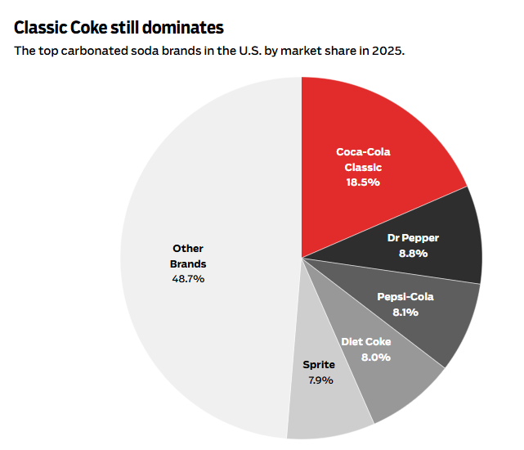
Figure 1: Coca Cola Market Share
(Source: Wenk, 2026)
In 2025, Coca-Cola was the market leader of the retail volume of carbonated soft drinks in 36 out of 41 major markets across the United States. The brand share of Coca-Cola Classic stood at 18.5, and Diet Coke at 8.0 and Coca-Cola Zero Sugar was seventh in the country, which means that there is long-term potential in the trademark with zero sugar, which is currently in the experimentation stage (Wenk, 2026).

2. External and Internal Analysis

2.1 Macro-Environmental External Analysis (PESTEL Framework)
Political
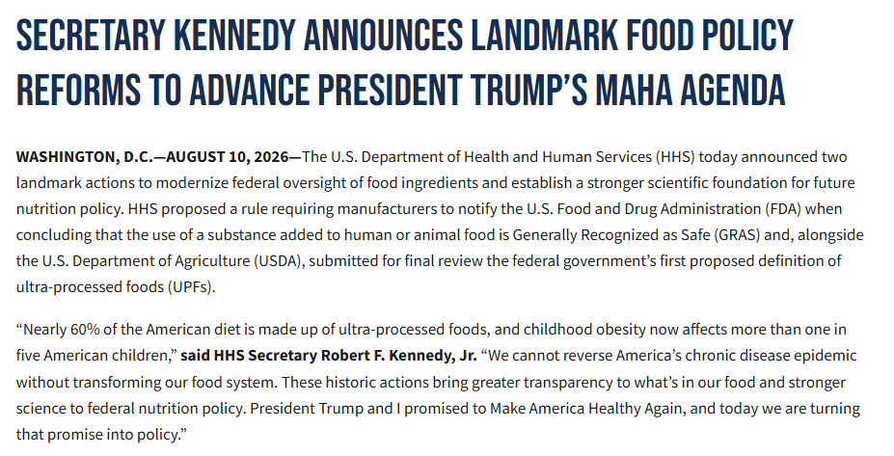
Figure 2: Secretary Kennedy’s Announcement
(Source: ASPA, 2026)
The sweetener choice is now directly influenced by United States politics. In July 2025 President Trump announced publicly that Coca-Cola had concluded to use cane sugar at home, and the company verified a cane sugar variant days later in its second quarter launch (Helmore, 2025). It was rolled out in October 2025 in some chosen cities, and Chief Financial Officer John Murphy said it was a gradual process as there is limited supply of domestic cane sugar. Health Secretary Robert F. Kennedy Jr. headed the Make America Healthy Again agenda that has urged governors to ban sweetened beverages. Politically speaking, Coca-Cola Zero Sugar is exposed both ways: on the one hand, not sugar criticized, on the other hand, no sugar is harmful, artificial sweeteners criticized, and the brand is a victim of two antagonistic federal health messaging endorsed by the president in an election-sensitive time (ASPA, 2026).
Economic
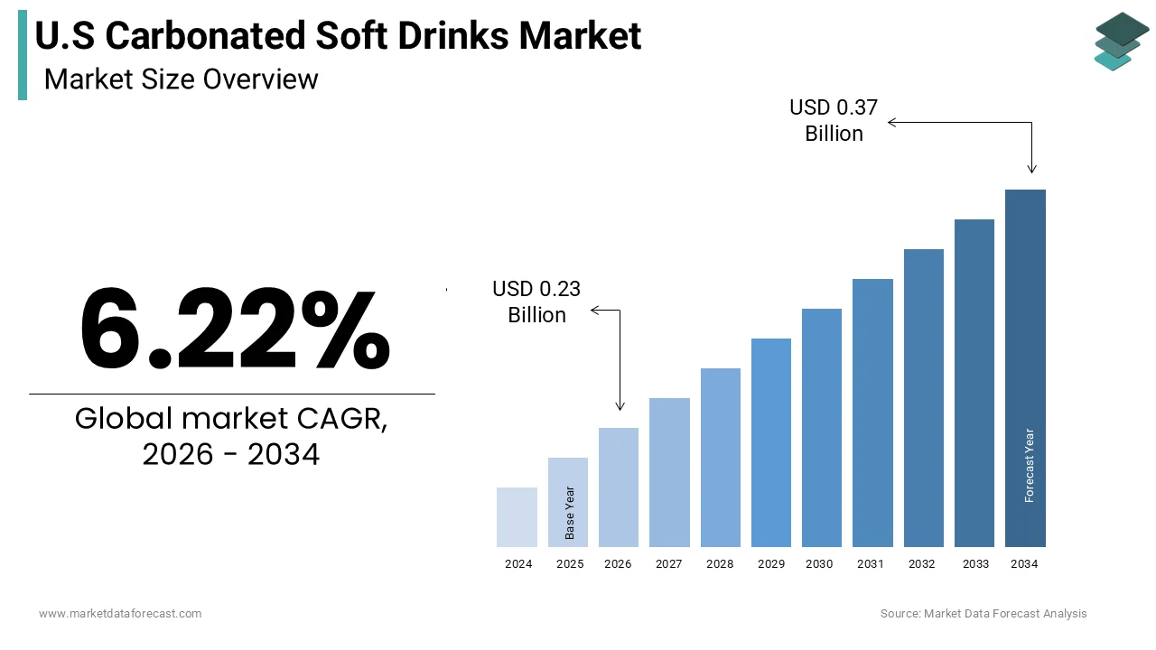
Figure 3: US Carbonated Drinks Market
(SourcE: Market Data Forecast, 2026)
In 2025, the United States carbonated soft drinks market had reached a whopping 55.8 billion, and had increased 6.2 percent annually. The numbers of regular and diet drinks stood at 36.5 billion and 19.3 billion respectively, yet diet has increased 11.8% in 2025, narrowing the margin (Market Data Forecast, 2026). In North America, Coca-Cola will provide revenue of 19.6 billion in 2025, an enhancement of four percentage points, with price/mix providing five percentage points compared to a 1% decline in volume (The Coca-Cola Company, 2026a). The point of pressure is input costs. On 4 June 2025 the Section 232 tariffs on foreign-made aluminium and steel increased to 50, which increased the costs of cans. James Quincy observed that the company can divert their focus to PET bottles in the event cans become costly (Kiplinger, 2025). Since that, growth has since been better, as the North America volume has increased 3% and price/mix 4% in the second quarter 2026.

Social
There are changes in consumer preference that favour reduced-calorie beverages. In 2025, the Coca-Cola Zero Sugar volume increased by 14 percent and 13 percent in the fourth quarter globally and in the Trademark Coca-Cola sector, respectively, and in 2025, all four geographic units experienced growth (The Coca-Cola Company, 2026a). Diet Coke, which targets older consumers, was growing 6% in the first quarter of 2026, indicating the possibility of a revival of a broad category, in place of cannibalisation. Consumers of younger ages are also shifting towards functional beverages. In 2025, PepsiCo acquired prebiotic soda brand poppi to the tune of $1.95 billion and Coca-Cola released Simply Pop in February 2025 (Theodore, 2026). There is also an increasing mistrust in the non-sweeteners and this poses a social threat that zero-sugary cola might be considered processed food but not healthy.
Technological
In late 2025, Coca-Cola established the Chief digital officer position to bring together digital, data and operational excellence (The Coca-Cola Company, 2026a). The company also employed connected packaging to engage over 80 million consumers and gather over 25 million first-party data records during the 2026 FIFA World Cup, which can be leveraged to target future campaigns (The Coca-Cola Company, 2026b). Science of sweeteners will continue to be the topic of interest: Coca-Cola Zero Sugar has aspartame, acesulfame potassium and stevia extract and the company extends Coca-Cola Zero Zero, which is sugar-free and calorie-free and caffeine-free, to Europe to Asia Pacific and Latin America. Each operating unit is being set up with innovation hubs to accelerate local product development (Sec.gov, 2026).

Environmental
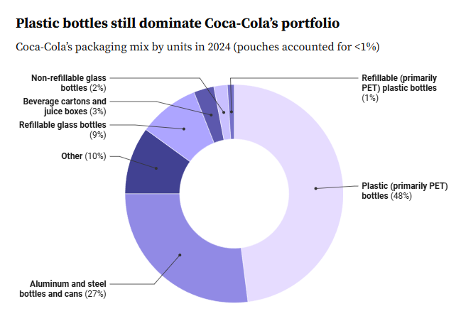
Figure 4: Plastic bottles still dominate Coca-Cola’s portfolio
(Source: Rachal, 2025)
The main environmental exposure of the brand is the packaging. In 2025, 99 percent of the major consumer packaging of Coca-Cola was recycled, recycled content has grown to 28 percent and recycled PET has grown to 18 percent, yet the usage of virgin plastic increased at 2.94 million metric tonnes (Rachal, 2025). Corrected 2035 targets are 35-40 percent recycled material and collection 70-75 percent of bottles and cans to replace more ambitious 2030 promises. In 2025, water replenishment was reported to be 157% globally following a decrease in January 2026. Aluminium tariffs cause a contradiction, as the redesign of cans to PET would increase amounts of plastic at the time of maximum inspections (ESG News, 2024).

Legal
Senate Bill 379 in Texas resulted in a federal waiver, which took effect 1 April 2026, prohibiting Supplemental Nutrition Assistance Program beneficiaries against purchasing any beverage with artificial sweetener or five grams of added sugar (Texas.gov, 2026). This locks out Coca-Cola Zero Sugar to about 3.5 million Texans. Similar waivers have become a part of 22 states. In June 2025, Louisiana passed Senate Bill 14, which gave a ban on aspartame-containing meals in public schools starting in 2028-29. Aspartame is still considered to be Group 2B by the International Agency on Research on Cancer and the Food and Drug Administration has announced a broader evaluation of low-calorie sweeteners. There are still no cases of separate plastic pollution lawsuits filed by the Los Angeles County and Baltimore (Gartner et al., 2025).

2.2 Resource-Based Internal Analysis (VRIO Framework)
Resource / Capability | Valuable | Rare | Inimitable | Organised to Exploit | Competitive Implication
Zero-sugar taste profile (aspartame, Ace-K, stevia blend) | Yes | Yes | Yes | Yes | Sustained competitive advantage
Coca-Cola trademark equity (since 1886) | Yes | Yes | Yes | Yes | Sustained competitive advantage
Bottling network (~200 partners, ~1,000 plants) | Yes | Yes | Yes | Yes | Sustained competitive advantage
Marketing scale (FIFA World Cup 2026, 180+ markets) | Yes | Yes | No | Yes | Temporary competitive advantage
First-party data capability (25m+ records) | Yes | No | No | Yes | Competitive parity

Table 1: VRIO Analysis — Coca-Cola Zero Sugar (United States)
(Source: Self-developed)
Using the framework uniformly, Coca-Cola Zero Sugar meets all four of the conditions in the VRIO model and can thus be considered as a long-term competitive advantage and not a short-term one. The decision is based on facts as opposed to statement: volume growth in digits, compared to stalemate trademark results, is evidence of worth, seventh national brand ranking with share increases depicts growth possibilities, and margin expansion represents organisational entrapment. The sole downside is that the inimitability does not safeguard regulatory standing but taste and distribution. The Texas constraints in April 2026 indicate that one resource might be powerful internally, but susceptible to a policy which cannot be effectively represented in the standard version of VRIO (Ohiomah, 2026).

2.3 SWOT Analysis
Strengths
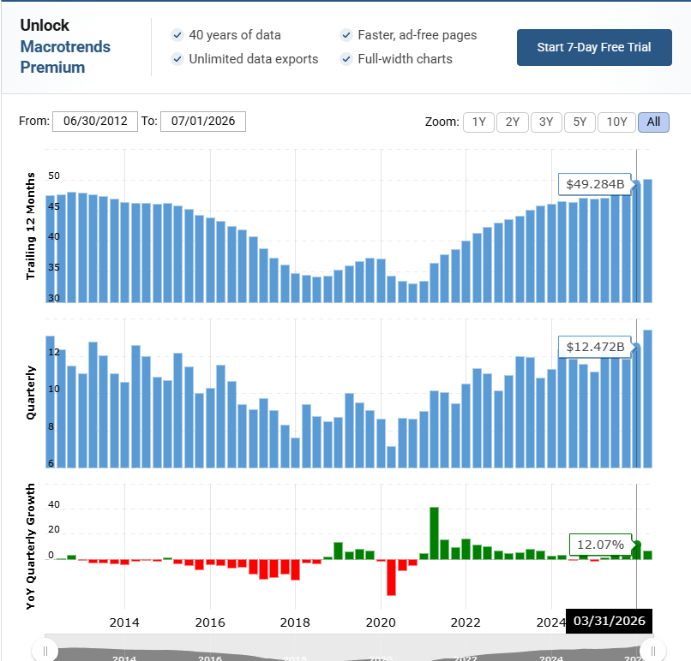
Figure 5: Coca Cola Revenue
(Source: Macrotrends, 2025)
The growth potential of the trademark is Coca-Cola Zero Sugar. The volume increased by 14% in 2025, 13% in the first quarter of 2026 and 16% in the second quarter, three times all geographic operating segments have registered increases (The Coca-Cola Company, 2026a; 2026b). It is located within a franchise system generating 2025 revenue of 47.9 billion and comparable operating margin of 31.2 percent with North America generating 19.6 billions of revenue. The distribution coverage is outstanding: In 36 out of 41 main markets in the United States, Coca-Cola dominated the market of the retail volume of carbonated soft drinks in 2025 (Beverage Digest, 2026). Financial health facilitates the ability to continue to invest in marketing, as seen by 64 years of consecutive annual dividend growth in February 2026 and payment of $8.8 billion to shareowners through the course of 2025.
Weaknesses
The product relies solely on unhealthy sweeteners, just when such fitting is subject to the most vigorous inspection in decades. Aspartame is still a Group 2B haemorrhage of the International Agency on Research on Cancer, and it was named so in a May 2025 report entitled Make Our Children Healthy Again. Another weakness is brand share: among the carbonated soft drinks brands in the U.S., Coca-Cola Zero sugar was ranked at 7th in 2025 with Diet Coke holding 8.0, thus the company itself is split in 2 propositions of its diet portfolio (Beverage Digest, 2026). The asset-light model also inhibits control, as ultimately, fraternally-broken bottlers dictate prices, packaging strategies, and advertising in respective local areas. The performance on packaging has fallen behind the aspiration, and the recycled content was 28 per cent; the use of virgin plastic increased to 2.94 million metric tonnes in 2024 (Rachal, 2025b).

Opportunities
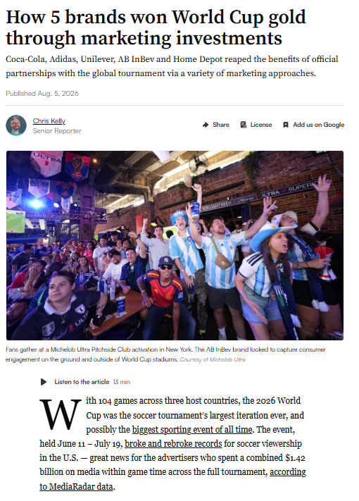
Figure 6: Brand Benefitted by FIFA World Cup
(Source: Kelly, 2026)
The diet segment is expanding at a much greater rate than the broader category. In 2025 United States diet carbonated soft drinks were to hit 19.3 billion, projected to increase by 11.8 percent, as compared to 6.2 percent of the total industry (Beverage Industry, 2026). The conversion of the current trademark drinkers is a big and free growth pool since Coca-Cola Zero Sugar is only number seven in its country whereas, Coca-Cola Classic tops at 18.5. This format innovation is already paying off: North America mini-can volume increased in high single digits at the beginning of 2026 following convenience store rollouts. An additional chance is presented by data capability where over 25 million first-party data have been gathered via connected packaging in the course of the 2026 FIFA World Cup so that more accurate targeting of zero-sugar messages is possible (Kelly, 2026).

Threats
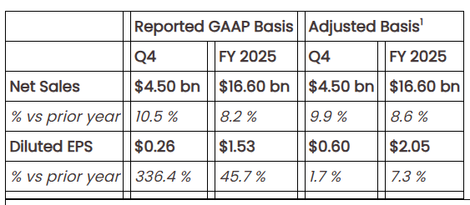
Figure 7: Keurig Dr Pepper
(Source: Keurig Dr Pepper, 2026)
By far the most acute threat is regulation. Since 1 April 2026 Texas will not allow purchase of a drink with an artificial sweetener and puts about 3.5 million potential customers out of business, and twenty-two states are now known to have similar waivers (Texas HHS, 2026). Outside competitors are increasing their intensity: At the first quarter of 2026, Celsius Holdings had taken over the Alani Nu and Rockstar companies, and reached the 20.9 percent dollar share of the energy category in the United States, recently (Celsius Holdings, 2026). In 2025, Keurig Dr Pepper increased the sales of United States refreshment drinks 11.9% to $10.4 billion (Keurig Dr Pepper, 2026). The volatile cost of inputs remains, and there are 50 percent tariffs on aluminium, enforced since June 2025. Lastly, if any negative regulatory development occurred on aspartame it would hurt consumer faith in the product virtually overnight, and they would take long to reformulate.

3. Comprehensive and Holistic View

3.1 Corporate Social Responsibility (CSR) Audit

Water Stewardship, Packaging, Sugar Reduction and Community Investment
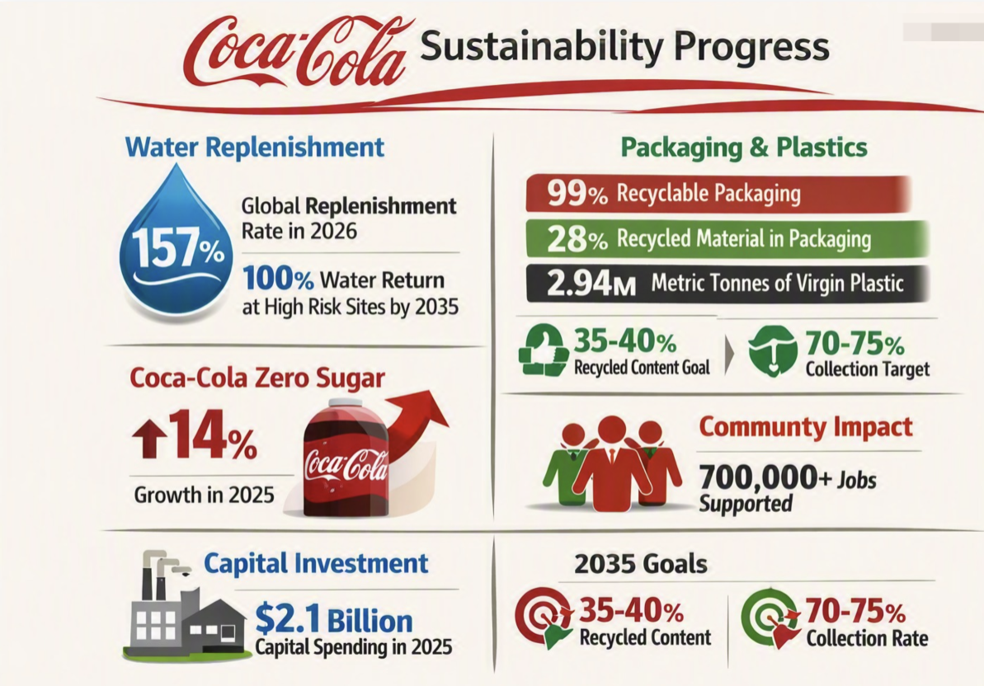
Figure 8: CSR Sustainability Progress
(Source: self-developed)
Since 2015, coca-cola has been reporting redirected over 100% of the water it used in its finished products annually, but as of 2024, it reported a global replenishment of 157% and reduces its report to 157% when published in January 2026 (The Coca-Cola Company, 2024). The company has a goal of returning 100 percent of the water consumed at all its 200 or more high risk sites by 2035 (The Coca-Cola Company, 2026). Rapid Plastics On packaging, in 2024, 99% of primary consumer packaging is recyclable, recycled material is 28% of primary packaging and recycled PET is 18%, but total virgin plastic increased to 2.94 million metric tonnes (Packaging Dive, 2025). Revised 2035 goals seek 35% to 40% recycled material and collection of 70% to 75% of containers introduced.
The most apparent one is sugar reduction, with Coca-Cola Zero Sugar being its flagship, and increasing 14 percent in 2025. Through The Coca-Cola Foundation and local bottler programmes, community investment works, in addition to the over 700,000 jobs in the system. In 2025, capital spending of 2.1 billion assisted in supporting local industries through efficiency in plants and water infrastructure (Coca-Cola, 2026).

Analysis of Alignment with Business Objectives
Coherence is best where the area of responsibility matches the revenue. The virus of sugar reduction is not cost-centre, the part of the portfolio that grows quickest, therefore the health commitment is self-financing. Defensive yet reasonable is safeguarding of the basic raw material by water stewardship and obtaining of operating licences in stressed watersheds. The least alignment is on packaging. Moving the target of recyclability and collection to 2035 and a target of 50% of recycled content to a 35% to 40% range relieved the margin pressure, but was met with criticism and came at a time when virgin plastic was on the increase. This implies that responsibility is real when it promotes growth and when it is negotiated when it limits cost (The Coca-Cola Company, 2026b). In the case of Coca-Cola Zero Sugar, the alignment argument is valid, with all cases sold promoting the goal of reducing sugar directly.

3.2 The Balanced Scorecard

Financial Perspective
Objective: Multiply Coca-Cola Zero Sugar volume increase to profitable growth in North America with preserving margin against tariff-impacted input cost inflation and inappropriate channel mix, such that zero-sugar growth increases (instead of eroding) segment profitability.
Key Performance Indicators (KPIs): North America net revenue growth, price/mix contribution, similar operating margin, free cash flow conversion, share of segment revenue on zero sugar and the payback on marketing investment spend.
Targets: North America organic revenue increase of at least 7, to maintain the growth rate in the first half of 2026 and a group comparable operating margin held above 35, identical to the 35.6% comparable operating margin shown in the second quarter of 2026.
Strategic Initiatives: Management of revenue growth, both pack and channel, and hedging involving selective PET replacement, as well as strict reinvestment of the projected free cash flow of 12.4 billion by 2026, which will go to marketing, other than the spend on a broad portfolio (Rajani Lohia, 2026).

Customer Perspective
Objective: Attract the transparently new zero-sugar drinkers, especially younger drinkers, not merely by rebranded heavy Coca-Cola Classic customers in the same household, increasing overall category consumption in new drinking environments.
Key Performance Indicators (KPIs): Brand volume growth, national share ranking of carbonated soft drinks sold in households, repeat purchase, and share value in total non-alcoholic ready to drink beverage category.
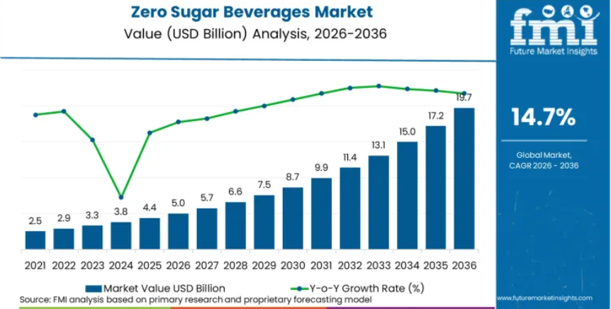
Figure 9: Zero Sugar Beverage Market
(Source: Futuremarketinsights, 2026)
Targets: Move Coca-Cola Zero Sugar to more than the 8.0% Diet Coke brand share in the United States in 2025 and grow our volume by double digits annually in the United States up to 2028.
Strategic Initiatives The growth of single-serve mini-cans in the convenience retail, linked packaging, campaigns based on 25 million first-party data we gathered in the course of the 2026 FIFA world cup, and group-specific digital activation directed at Generation Z events like gaming and live sport (Futuremarketinsights, 2026).

Internal Business Processes
Objective: Accelerate zero-sugar innovation to market faster and lower the cost and carbon intensity of the packaging through the bottling system, as packaging is the lowest sustainability indicator of the brand.
Key Performance Indicators (KPIs): Concept to shelf duration, percentage of recycled content, collection rate of containers, ratio of water usage, cost per case to manufacture the items and the percentage ratio of packaging that can be recycled.
Targets: Recycling of 35 percent to 40 percent of material used and gathering of 70 percent to 75 percent of containers brought into market by 2035 and global reforging of water at least 100 percent and returned in full at all high-risk sites (Rachal, 2024).
Strategic Initiatives: The innovation hubs in operating-unit initiatives, bottle rollout (ultra light-weight), advocacy of extended producer responsibility, and expansion of Coca-Cola Zero Zero in Europe to additional markets where the proposal is supported by consumer testing.

Learning and Growth
Objective: Develop digital, data and sweetener science capacity so that the brand is able to react swiftly to regulatory changes and evolving taste preferences without sacrificing the unique cola flavor which makes them buy repeatedly.
Key Performance Indicators (KPIs): Digital capability maturity, the number of first-party data records held, reformulation lead time, and retention of employees to the broader Coca-Cola system, including all significant independent bottling partners.
Targets: Change in 2026 create innovation hubs in every operating unit; Have a validated reformulation option available within a year of an adverse regulatory decision on aspartame in one of the larger state jurisdictions.
Strategic Initiatives: Institute the new Chief Digital Officer role developed in 2025, and increase natural sweetener research, stevia and monk fruit, and establish commercial centres of excellence in major markets to spread successful practice more quickly across the operating units (Christofi, 2023).

4. Strategic Choices and Implementation

4.1 Business-Level Strategy Mapping
Cost Leadership Strategy
Coca-Cola does not undertake pure cost leadership at the brand level but cost discipline supports affordability. The concentrate model passes the manufacturing cost to the bottlers and revenue growth management entails the pack architecture, such as mini-cans and multi-serve PET to retain entry price points. Upon the implementation of 50% tariffs on aluminium in June 2025, James Quincy assured that the system will have the ability to focus on PET bottles rather than cans to safeguard the affordability (Kiplinger, 2025).
Differentiation
Coca-Cola Zero Sugar relies on differentiation as the most popular approach. It is a calorie-free beverage that is similar to the original and no other competing brand has been able to make the same statement with the same validity. Marketing scale supports differentiation as reflected by a 2026 FIFA world cup campaign reaching more than 180 markets with over 60 billion digital impressions and over nine billion views, and distribution depth that resulted in 2025 making the Coca-Cola trademark the first brand of its type in volume sale in 36 out of 41 market units (The Coca-Cola Company, 2026b; Beverage Digest, 2026).

4.2 Framework Validation

Porter's Five Forces
Threat of New Entrants – Low
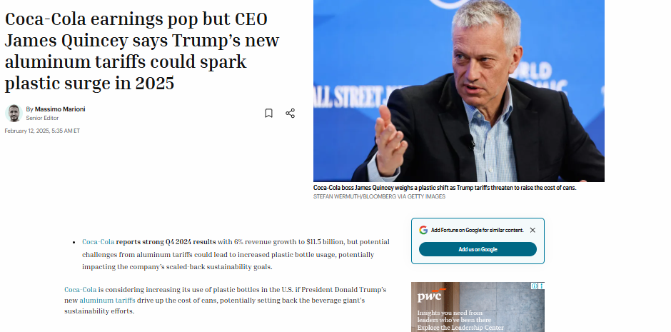
Figure 10: Coca Cola Earnings Rise
(Source: Marioni, 2025)
Barriers are high. The trademark, the concentrate formula and a system of about 200 bottlers and approximately 1000 plants would cost an immeasurable sum of capital to copy the grand formula (Aequitas Victoria, 2025). The retail shelf-space is competitive and national advertising is expensive, thus new cola entries are few, but niche functional brands are readily added into the broader category.
Bargaining Power of Suppliers – Low to Moderate
Most commoditised and multi-sourced materials include Sweeteners, carbon dioxide and packaging inputs. Power has been increasing at a moderate rate compared to June 2025 because the 50 percent on aluminium tariffs on readymade cans increased PET costs, but the willingness to substitute the material with alternatives to the packaged item in general restrains the leverage of suppliers (OECD, 2025).
Bargaining Power of Buyers – High
Big grocers, club chains and quick-service restaurants focus the purchasing power and bargain on price and promotion. Consumers can switch at a low cost. Even regulatory buyers have something to take into consideration, as twenty-two states have limitations on the waiver purchase of sweetened beverages under the nutrition programs (Martichoux, 2026).
Threat of Substitute Products – High
Substitutes are proliferating. Competitors of the same occasion are prebiotic sodas, energy drinks, sparkling water and functional hydration (Business Wire, 2025). In 2025, PepsiCo acquired poppi at a price of 1.95 billion, and Celsius Holdings attained an approximate 20.9 percent share of dollar share in the category of energy drinks in the United States by early 2026 (PepsiCo, 2025).
Industry Rivalry – High
Competition is stiff in regard to price, innovation and shelf space. Keurig Dr Pepper has achieved 11.9% growth in sales, rising to United States as the biggest seller of refreshment beverage, achieving sales of 10.4 billion in 2025 and Pepsi had regained third place among the American carbonated brands, proving that a leading position could still be challenged (Mishra, 2026).

Feasibility Check via SAFe Framework

Suitability
The variation strategy is appropriate in the environment. In the periods datums 2025, diet carbonated soft drinks increased by an estimated 11.8% as compared to 6.2% on the segment, and Coca-Cola Zero Sugar increased by 14% therefore, the strategy targets the most important consumer trend and takes advantage of the existing strength of the trademark, as compared to having to create an unfamiliar new position (Jacobsen, 2026b).

Acceptability
Returns are acceptable. In 2025, North America operating income had increased up to $5.07 billion and group similar operating margin had increased to 31.2. Concentration of risk is in the area of sweetener regulation. In 2025, expectations of shareholders are fulfilled by a 64th consecutive dividend increase declared in February 2026, as well as an amount of dividends of 8.8 billion paid (Mohanty, 2026).

Feasibility
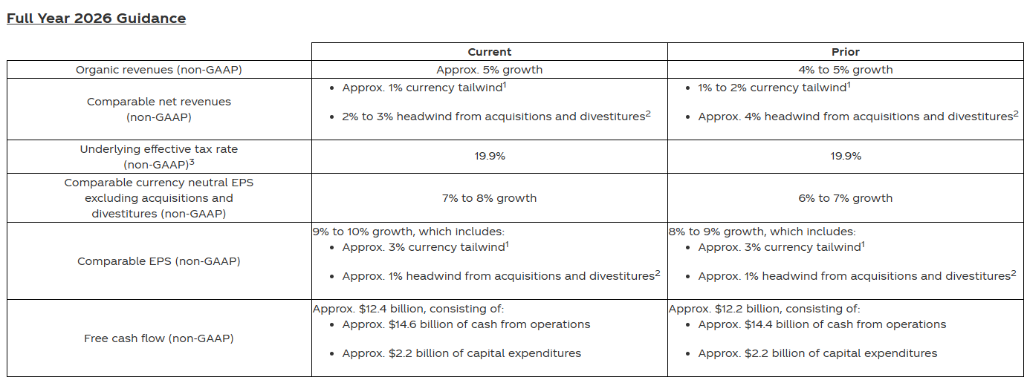
Figure 11: Full Year 2026 Guidance
(Source: The Coca-Cola Company, 2026c)
Strong feasibility evidently exists. In 2025, the system gave rise to the generation of free cash flow of $11.4 billion and forecasts the generation to $12.4 billion in 2026, without the fairlife payment. Bottling capacities, marketing abilities and the new centers of innovation already lie in the system, hence no whole new resource base is needed (The Coca-Cola Company, 2026c).

4.3 Competitive Advantage & Execution

Porter's Generic Strategy (Differentiation)
Coca-Cola Zero Sugar engages wide differentiation. The fuel behind the leadership is the flavor equality to the original at zero calories that are secured through the proprietary sweetener mix and 140 years of trademark goodwill. Implementation is based on marketing magnitude and distribution profundity instead of price, hence the reason the price/mix added four percentage points of growth in North America during the second quarter of 2026 whereas volume, as well, grew 3%. Differentiation thus achieves the pricing power without compromising on the volume which is the hallmark test of such a strategy. (Coca-colacompany, 2026)

Triple Bottom Line
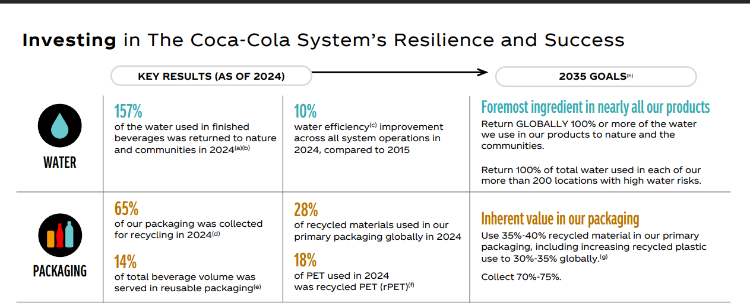
Figure 12: Coca Cola Sustainability highlights
(Source: Coca Cola, 2025)
Profit is reflected in the 47.9 billion of net operating revenue in 2025, with good margin and good shareowner returns. Individuals are contacted via sugar reduction throughout the portfolio and over 700,000 positions are supported throughout the entire system. The planet score is mediocre: in 2024, water replenishment was at 157 percent, and recycled material was at 28 percent share and virgin plastic ranged at 72 percent, averaged out indicating that today, the environment is not performing as well as social or economic results (Coca Cola, 2025).

4.4 Implementation Risk Management
Challenge 1: Sweetener Regulation and Consumer Perception Risk
Justification: Texas prohibits the purchase of artificially sweetened drinks under the nutrition assistance, April 2026, and aspartame is deemed Group 2B by the International Agency of Research on Cancer.
Mitigation: The brand should hasten stevia and monk fruit development, have a wholly validated reformulation at the ready and communicate ingredients transparency on pack and in advertising.

Challenge 2: Input Cost Volatility and Bottler Margin Pressure
Justification: Section 232 50 per cent aluminium tariffs since June 2025 increase can offset costs and bottlers pay the packaging cost as direct expense (The White House, 2025).
Mitigation: hedge aluminium exposure forward, change the preferred volume towards PET, increase ultra-lightweight bottle size, and adopt revenue growth management to defend low-end entry price points in all retail channels.
Challenge 3: Category Shift Toward Functional and Energy Beverages
Justification: It was justified by the fact that by early 2026, Celsius Holdings (2026) controlled about 20.9% of the energy category of the United States and the prebiotic brand poppi was purchased by PepsiCo (Celsius Holdings, 2026).
Mitigation: The brand should size BODYARMor FIT sparkling sports drink, take the Coca-Cola Zero Zero to additional markets, and leverage the new operating-unit innovation hubs to reduce the launch cycles (The Coca-Cola Company, 2026).

Section 2: Reflective Account
Gibbs Reflection Model

Description
I was requested to come up with a strategic analysis of Coca-Cola Zero Sugar within the United States market, using PESTEL, VRIO, SWOT, a corporate responsibility audit, the Balanced Scorecard, Porter's five forces and the SAFe test. I started with primary financial information on the fourth quarter and full year 2025 results of the company, released in February 2026 and its second quarter 2026 results, released in July 2026. My next search was in the market data regarding the United States category of carbonated soft beverages, the regulatory trends concerning sweeteners and competition (Datta, 2024). I then constructed the analysis bit by bit, striving to a given word count per framework. The most agonizing was determining which evidence really fitted in each structure, instead of cloning the same figures throughout all the structures and coming up with an analysis that appeared deep but said little.

Feelings
I started feeling confident, as Coca-Cola is a household company, and I expected it to not be that hard to locate the material. That trust never lasted long. I had been very uncomfortable, beginning to read about the regulation of sweeteners, since I had expected the picture to be a little smoother than it is (Öncel and Sökmen, 2026). It was also frustrating to me since I discovered that market figures could look all over in different sources and I feared to show something wrong. The discovery of the Texas waiver that explicitly discriminates against the nutrition assistance purchases of artificially sweetened beverages turned out to be a turning point, and I was immediately interested in it. Towards the end of it I was pleased, but a little afraid that word-constraints had compelled me to omit evidence which I felt was significant, especially on the competitor activity in the functional beverage sector (Praveena et al., 2025).

Evaluation
My use of primary sources was a success. To be able to work directly out of published earnings releases was to have trustworthy financial figures and I could quote segment level detail not generic claims. The analysis arranged in terms of one product was also effective, as it helped to maintain the scope of the argument rather than shift to the profile of the company in general (Benková et al., 2020). The aspect that was not so good was my first research strategy. I collected material generally and then chose what the argument would be, resulting in much information then not being used. I also under-estimated the time it will take to get the conflicting market size estimates to be reconciled, an aspect that cost me time that would have been necessary in the process of coming up with the strategic evaluation (Elsaid et al., 2025). My third weakness was that my first draft was more of a description of the company than of the product.

Analysis
In examining the reasons why this occurred, my initial influential belief was based on familiarity with the brands and not a familiarity with the market. Knowledge is not experience and it prompted me to forego the planning process altogether. After I had imposed a structure, my work became much better. The challenge of market data is an actual characteristic of business research existing out there and not a failure of mine: the categories used by market research companies are not identical and thus the numbers cannot be directly correlated (Mukhanova, and Seitimova, 2025). The understanding of this altered my approach to secondary sources during the rest of the work. I started to instead focus on filings of the company and those of the government, rather than on aggregate market publications, and I indicated the source along with each figure to allow the reader to determine the reliability of the source. The very structures also informed me. VRIO implied that the brand enjoyed a sustained advantage as it could, the Texas restriction demonstrated that even an internally strong resource can be neutralised by policy. Such a contradiction was awkward and helpful, as it demonstrated to me that frameworks explain a position, not predetermine it, and that no single model as a whole can explain a complete situation.

Conclusion
I find that my analytical skill is better as compared to my research planning. I am also able to process evidence and build an argumentative structure but I waste time sifting through stuff before I realize what I require. It also makes me conclude that now I tend to be more judgmental towards the sources than I was initially, especially when I deal with estimates of commercial market size (Bassot, 2024). Another lesson learned is that it is more rewarding to employ multiple frameworks simultaneously as compared to relying on them independently since the imbalance of the two like the VRIO which showed strength and the PESTEL which showed vulnerability illustrated the best insight of the entire report. Lastly, I realise that writing within word limits enhanced my writing skills, as it compelled me to cut down on the description and leave the evidence that directly proved my point. I think that made the report easier to read.

Action Plan
In my next assignment I have four ways I will alter the approach. To start with, I will prepare a one page research plan to get the questions answered before the start of the search so that the search is not exploratory. Second, I shall create a comprehensive table of sources noting each figure, its source, date and reliability that will eliminate the reconciliation issue that arose in this case (Afifi, Stryhn and Sánchez, 2023). Third, I will write the argument in outline and then write one full paragraph per section. That will mean I will allocate words to each section at the beginning and not to readjust the words. Fourth, I will intentionally seek inconsistency within frameworks as opposed to viewing each of them as distinct exercises, as it clearly was my strongest analysis in this piece of work. I will also ensure that there is a prior internal time of doing research, leaving a clear period of time to evaluate and edit as opposed to lumping the two in the final phase of the work.

Reference List
Mukhanova, A. and Seitimova, A., (2025). Reimagining Differentiation: A Reflective Inquiry Using Gibbs’ Model. https://library.camtree.org/entities/publication/ba66a815-270a-4cd2-86de-dad9f2d1b44c
Praveena, K.S., Juslin, F., Patil, C.M. and Bhargavi, K., (2025). Using gibb's reflective model approach for enhancing project-based learning among students through reflective assessment. Journal of Engineering Education Transformations, pp.148-155. https://journaleet.in/index.php/jeet/article/view/2071
Bassot, B., (2024). The reflective journal. Bloomsbury Publishing. https://books.google.com/books?hl=en&lr=&id=GAIZEQAAQBAJ&oi=fnd&pg=PP1&dq=gibbs+reflective+cycle+for+strategic+management&ots=ayzjqC5SVD&sig=mz4gUMvUg1MwUhBN4E0FZN-Jx8Y
Benková, E., Gallo, P., Balogová, B. and Nemec, J. (2020) “Factors Affecting the Use of Balanced Scorecard in Measuring Company Performance,” Sustainability, 12(3), p. 1178. Available at: https://www.mdpi.com/2071-1050/12/3/1178
ASPA (2026) Secretary Kennedy announces landmark food policy reforms to advance president Trump’s MAHA agenda, HHS.gov. US Department of Health and Human Services. Available at: https://www.hhs.gov/press-room/hhs-announces-ultra-processed-foods-gras-reforms.html
Britannica (2024) The Coca-Cola Company, Britannica. Available at: https://www.britannica.com/money/The-Coca-Cola-Company
Christofi, M. (2023) “The role of chief digital officer: Critical insights into an emerging field and road map for future research,” Journal of Business Research, 172, p. 114390. Available at: https://doi.org/10.1016/j.jbusres.2023.114390.
Coca Cola (2025) Sustainability Update. Available at: https://investors.coca-colacompany.com/_assets/_014b8b8f047681531f8b5adc4eb10f2d/cocacolacompany/db/1015/11072/file/The+Coca-Cola+Company+-+Sustainability+Update.pdf.
Coca-Cola (2026) Nutrition, cch Group Website. Available at: https://www.coca-colahellenic.com/en/a-more-sustainable-future/mission-2025/nutrition
Coca-colacompany (2025) Coca-Cola reports second quarter 2025 results and updates full year guidance, Coca-colacompany.com. Available at: https://www.coca-colacompany.com/media-center/coca-cola-reports-second-quarter-2025-results
Coca-colacompany (2026) The Coca-Cola Company, Coca-colacompany.com. Available at: https://www.coca-colacompany.com/media-center/coca-cola-reports-second-quarter-2026-results
ESG News (2024) Coca-Cola exceeds 100% global water replenishment since 2015, ESG News. Available at: https://esgnews.com/coca-cola-exceeds-100-global-water-replenishment-since-2015/
Futuremarketinsights (2026) Zero sugar beverages market, www.futuremarketinsights.com. Available at: https://www.futuremarketinsights.com/reports/zero-sugar-beverages-market
Gartner, R., Hembree, M.C., Werner, M.J., Klock, S.M., Freedhoff, M.I. and Goodrich, K. (2025) (More) food for thought: Louisiana enacts food product warning labels for 44 chemicals | insights | holland & knight, Hklaw.com. Available at: https://www.hklaw.com/en/insights/publications/2025/07/more-food-for-thought-louisiana-enacts-food-product
Helmore, E. (2025) Coca-Cola to launch coke with cane sugar in the US after Trump Post, the Guardian. The Guardian. Available at: https://www.theguardian.com/business/2025/jul/22/coke-cane-sugar-trump
Jacobsen, J. (2026a) Zero, diet extensions keep carbonated soft drink market fresh, Bevindustry.com. Available at: https://www.bevindustry.com/articles/98263-zero-diet-extensions-keep-carbonated-soft-drink-market-fresh
Jacobsen, J. (2026b) Zero, diet extensions keep carbonated soft drink market fresh, Bevindustry.com. Available at: https://www.bevindustry.com/articles/98263-zero-diet-extensions-keep-carbonated-soft-drink-market-fresh
Kelly, C. (2026) How 5 brands won world cup gold through marketing investments, Marketing Dive. Available at: https://www.marketingdive.com/news/how-5-brands-won-world-cup-gold-through-marketing-investments/826954/
Macrotrends (2025) CocaCola revenue 2006-2020 | KO, www.macrotrends.net. Available at: https://www.macrotrends.net/stocks/charts/KO/cocacola/revenue
Marioni, M. (2025) Coca-cola earnings pop but CEO James Quincey says Trump’s new aluminum tariffs could spark plastic surge in 2025, Fortune. Available at: https://fortune.com/2025/02/12/coca-cola-earnings-q4-james-quincey-trump-aluminum-tariff-plastic/
Market Data Forecast (2026) U.S carbonated soft drinks market report, Market Data Forecast. Available at: https://www.marketdataforecast.com/market-reports/united-states-carbonated-soft-drinks-market
Mishra, S. (2026) “Keurig dr pepper reaffirms forecast on strong soda, energy drink demand,” Reuters, 6 August. Available at: https://www.reuters.com/business/keurig-dr-pepper-beats-quarterly-sales-estimates-2026-08-06/
Ohiomah, I. (2026) “Disruptive technology adoption for sustainable digital transformation in South Africa’s manufacturing sector,” Sustainability, 18(8), p. 3894. Available at: https://doi.org/10.3390/su18083894.
PepsiCo (2025) PepsiCo completes acquisition of poppi, accelerating strategic portfolio transformation, Pepsico.com. Available at: https://www.pepsico.com/newsroom/press-releases/2025/pepsico-completes-acquisition-of-poppi-accelerating-strategic-portfolio-transformation
Rachal, M. (2024) Coca-Cola lowers ambition with new 2035 packaging sustainability targets, Food Dive. Available at: https://www.fooddive.com/news/coca-cola-new-packaging-sustainability-goals-2035/734832/
Rachal, M. (2025a) Coca-Cola reports jump in packaging deemed recyclable, Food Dive. Available at: https://www.fooddive.com/news/coca-cola-environmental-recycled-packaging/760942/
Rachal, M. (2025b) Coca-Cola reports jump in packaging deemed recyclable, Yahoo Finance. Yahoo! Finance. Available at: https://finance.yahoo.com/news/coca-cola-reports-jump-packaging-120000409.html?guccounter=1&guce_referrer=aHR0cHM6Ly93d3cuZ29vZ2xlLmNvbS8&guce_referrer_sig=AQAAAKNI1hRnqfNezLJ8wYq4TxjPreu2NP4FOaYZcNhuCRjjAZl3Kyivuo4VlUjacqjHgLBGjE6yvFAmttuMdfGD-HiVdq4UC29L8pb4vlGbXLu76n4ZAK7nAJRlV1cxS4kwURAjSziAdcqc8tncJNUwFyu05F5LEZqCmY_eWX7hKZCo
Rajani Lohia (2026) Coca-Cola’s revenue growth: Organic strength or pricing-led?, Yahoo Finance. Yahoo! Finance Canada. Available at: https://ca.finance.yahoo.com/news/coca-colas-revenue-growth-organic-144500230.html
Sec.gov (2026) Document, Sec.gov. Available at: https://www.sec.gov/Archives/edgar/data/21344/000162828026049922/a2026q2earningsreleaseex-9.htm
Study Corgi (2026) Coca-Cola Company Analysis and success story | free essay example, StudyCorgi.com. Available at: https://studycorgi.com/coco-cola-company-analysis/
Texas.gov (2026) SNAP purchase restrictions | Texas Health and Human Services, Texas.gov. Available at: https://www.hhs.texas.gov/services/food/snap-food-benefits/snap-purchase-restrictions
The Coca-Cola Company (2025) The coca-cola system, www.coca-colacompany.com. Available at: https://www.coca-colacompany.com/about-us/coca-cola-system
The Coca-Cola Company (2026a) Coca-colacompany.com. Available at: https://www.coca-colacompany.com/about-us/environment/water
The Coca-Cola Company (2026b) Coca-colacompany.com. Available at: https://www.coca-colacompany.com/about-us/environment/packaging
The Coca-Cola Company (2026c) The Coca-Cola Company. Available at: https://investors.coca-colacompany.com/news-events/press-releases/detail/1168/coca-cola-reports-second-quarter-2026-results-and-raises-full-year-guidance
The White House (2025) Fact sheet: President Donald J. Trump increases section 232 tariffs on steel and aluminum, The White House. Available at: https://www.whitehouse.gov/fact-sheets/2025/06/fact-sheet-president-donald-j-trump-increases-section-232-tariffs-on-steel-and-aluminum/
Theodore, S. (2026) Diet coke enters a new decade: The carbonated soft drink brand has come a long way | Mintel, www.mintel.com. Available at: https://www.mintel.com/insights/food-and-drink/diet-coke-enters-new-decade-carbonated-soft-drink-brand-has-come-long-way/
Volodymyr Nikolenko (2024) “International experience in the functioning of the soft drinks market,” Biological Systems Theory and Innovation, 15(3), pp. 58–71. Available at: https://doi.org/10.31548/economics/3.2024.58.
Wenk, A. (2026) Coke rival Pepsi climbs up among top U.S. soda brands, ajc. Available at: https://www.ajc.com/business/2026/04/coke-rival-pepsi-climbs-up-among-top-us-soda-brands-besting-sprite/
Beverage Digest (2026) Soda Wars: Coca-Cola Held CSD Lead in 36 of 41 Major U.S. Markets in 2025. Available at: https://www.beverage-digest.com/articles/1426-soda-wars-coca-cola-held-csd-lead-in-36-of-41-major-us-markets-in-2025
Beverage Industry (2026) Zero, diet extensions keep carbonated soft drink market fresh. Available at: https://www.bevindustry.com/articles/98263-zero-diet-extensions-keep-carbonated-soft-drink-market-fresh
Celsius Holdings (2026) Celsius dominates the US energy drink market while setting its sights on Europe. Available at: https://www.foodnavigator-usa.com/Article/2026/05/08/celsius-dominates-the-us-energy-drink-market-while-setting-its-sights-on-europe/
CNBC (2025) Coca-Cola will roll out cane sugar version of namesake soda in the U.S. this fall. Available at: https://www.cnbc.com/2025/07/22/coca-cola-to-roll-out-cane-sugar-soda-in-us.html
Fox Business (2025) Coca-Cola officially rolls out cane sugar soda across US markets following Trump's urging. Available at: https://www.foxbusiness.com/retail/coca-cola-officially-rolls-cane-sugar-soda-us-markets-following-trumps-urging-report
Gibbs, G. (1988) Learning by Doing: A Guide to Teaching and Learning Methods. Oxford: Further Education Unit, Oxford Polytechnic.
Keurig Dr Pepper (2026) Keurig Dr Pepper Reports Q4 and Full Year 2025 Results and Provides 2026 Outlook. Available at: https://www.keurigdrpepper.com/keurig-dr-pepper-reports-q4-and-full-year-2025-results-and-provides-2026-outlook/
Kiplinger (2025) Steel Tariffs Double: What Trump's 50% Hike Means for Soda, Housing Prices. Available at: https://www.kiplinger.com/taxes/trump-tariffs-on-metals-to-slam-soda-housing-prices
Packaging Dive (2025) Coca-Cola reports jump in packaging deemed recyclable. Available at: https://www.packagingdive.com/news/coca-cola-2024-environmental-update-packaging/760832/
PepsiCo (2025) PepsiCo Completes Acquisition of poppi, Accelerating Strategic Portfolio Transformation. Available at: https://www.pepsico.com/newsroom/press-releases/2025/pepsico-completes-acquisition-of-poppi-accelerating-strategic-portfolio-transformation
Texas Health and Human Services (2026) SNAP Purchase Restrictions. Available at: https://www.hhs.texas.gov/services/food/snap-food-benefits/snap-purchase-restrictions
The Coca-Cola Company (2024) The Coca-Cola Company Evolves Voluntary Environmental Goals. Available at: https://investors.coca-colacompany.com/news-events/press-releases/detail/1124/the-coca-cola-company-evolves-voluntary-environmental-goals
The Coca-Cola Company (2025a) The Coca-Cola Company Announces CEO Succession Plan; Chief Operating Officer Henrique Braun to Succeed James Quincey as CEO in 2026. Available at: https://investors.coca-colacompany.com/news-events/press-releases/detail/1147/the-coca-cola-company-announces-ceo-succession-plan-chief-operating-officer-henrique-braun-to-succeed-james-quincey-as-ceo-in-2026
The Coca-Cola Company (2026a) Coca-Cola Reports Fourth Quarter and Full Year 2025 Results. Available at: https://investors.coca-colacompany.com/news-events/press-releases/detail/1151/coca-cola-reports-fourth-quarter-and-full-year-2025-results
The Coca-Cola Company (2026b) Coca-Cola Reports Second Quarter 2026 Results and Raises Full Year Guidance. Available at: https://www.sec.gov/Archives/edgar/data/0000021344/000162828026049922/a2026q2earningsreleaseex-9.htm
Aequitas Victoria (2025) PATENT V/s trade secret: Detailed study on coca- cola brand, Aequitas Victoria. Available at: https://www.aequivic.in/post/patent-vs-trade-secret-detailed-study-on-coca-cola-brand
Afifi, M., Stryhn, H. and Sánchez, J. (2023) ‘Data extraction and comparison for complex systematic reviews: A step-by-step guideline and an implementation example using open-source software’, Systematic Reviews, 12(1). Available at: https://doi.org/10.1186/s13643-023-02322-1.
Business Wire (2025) Celsius Holdings Reports Full-Year 2025 and Fourth Quarter Financial Results. Available at: https://www.businesswire.com/news/home/20260226726066/en/Celsius-Holdings-Reports-Full-Year-2025-and-Fourth-Quarter-Financial-Results
Celsius Holdings (2026) Celsius holdings reports second quarter 2026 financial results, Celsiusholdingsinc.com. Available at: https://ir.celsiusholdingsinc.com/news/news-details/2026/Celsius-Holdings-Reports-Second-Quarter-2026-Financial-Results/default.aspx
Datta, Y. (2024) ‘The U.S. carbonated beverages market: A competitive profile’, Journal of Economics and Public Finance, 10(4), p. p102. Available at: https://doi.org/10.22158/jepf.v10n4p102.
Elsaid, M., Nassar, K., Alqahtani, F.K. and Ibrahim Abotaleb (2025) ‘Comparative analysis of earned value management techniques in construction projects’, Scientific Reports, 15(1). Available at: https://doi.org/10.1038/s41598-025-05834-z.
Martichoux, A. (2026) 4 More states will add restrictions on SNAP purchases in april, The Hill. Available at: https://thehill.com/homenews/nexstar_media_wire/5796610-4-more-states-will-add-restrictions-on-snap-purchases-in-april/
Mohanty, S. (2026) This dividend king with a 64-Year streak is beating the market, Yahoo Finance. Yahoo! Finance. Available at: https://finance.yahoo.com/markets/stocks/articles/dividend-king-64-streak-beating-233002886.html
OECD (2025) ‘Promoting Energy Efficiency Investments (EN)’. Available at: https://www.oecd.org/content/dam/oecd/en/publications/reports/2008/03/promoting-energy-efficiency-investments_g1gh8c11/9789264042155-en.pdf
The Coca-Cola Company (2026) BODYARMOR Sports Drink Expands Portfolio with BODYARMOR FIT, It’s First‑Ever Sparkling Sports Drink, Coca-colacompany.com. Available at: https://www.coca-colacompany.com/media-center/bodyarmor-fit-sparkling-sports-drink-launch
Öncel, H.U. and Sökmen, Z. (2026) ‘The safety profile of aspartame: A review of regulatory standards and emerging health concerns’, Journal of Nutrition and Metabolism. Edited by S. Saleem, 2026(1). Available at: https://doi.org/10.1155/jnme/4727546.

