University of Wales, Trinity St. David
Bible and Theology BA (Hons)
Year 1
David Bullock
Student Number: 2313567
Email: 2313567@student.uwtsd.ac.uk
Introduction to The Hebrew Bible
Assignment 2
Tutor: Dr Jessica Kennedy
Word count: 2000
Final word count:1945
Date: 07/05/2024

The importance of King David in the Hebrew Bible

King David is an extremely important and prominent Biblical and historical figure; The accounts of his victories, from his early life as a boy fighting and easily defeating the mighty Palestinian Goliath with a single stone, to his rule of Israel. Known as a man "after God's own heart" (Acts 13:22 King James Version (KJV)) he is known for his victories and also his downfalls, for example committing adultery and having his mistresses husband murdered during battle. He is a great example of being human, making mistakes, suffering consequences of sinning against God yet still praising and pursuing Him in spite of Kind Davids suffering. However King David causes controversy amongst scholars and historians.

The evidence of King David and his history his achievements and failures are mainly documented in the first two books of Samuel in the Old Testament, with the book of Psalms being a collection largely consisting of numerous poems and hymns from King David offered to God, displaying the gifts God gave him.

The account of 1 Samuel in the Old Testament explains that a man from Bethlehem, named Jesse, was the father of David, where David grew up as a boy working as a shepherd; Paul Borgman (David, Saul, and God. Oxford University Press, 2008.) explains how the 'succession narrative' is questioned by many, mainly on the basis that there is little documented history, little insight on whom the authors may be or the specific time period, meaning it could potentially be a historical account or entirely for literary purposes. However there are very areas of the bible that aren't debated and challenged by scholars.

It is within 1 Samuel 17:50-53 where the account of the famous, life changing event took place of when a young David killed the Philistine evil giant is documented; This was a momentous moment for David as a young man, being a humble armour barer yet taking down the most feared enemy at the time. It was this that made David a national hero, where he then married King Saul's youngest daughter, Michal, in exchange for 100 Philistine foreskins "Give me back my wife, Michal, whom I betrothed to myself for a hundred Philistine foreskins." (1 Samuel 18:27 Holy Bible NIV), thus making David the son-in law of the most powerful man in the land.

However it was the combination of the gifts, talents and victories God gave David that brought him into the cross hairs of dangerous jealousy; David even acknowledges this in Psalms 69:13 when he refers to the drunkards mocking him. Unfortunately David experienced the majority of his suffering from his father-in-law Saul; Saul became jealous of David and eventually threatened by him and saw David as the root of his problems, despite the fact David was actually the solution to his problems and his salvation and even his government and loved ones.
King David, as outlined in the book of Samuel, actually took advantage of several opportunities to prove to Saul that he meant no harm and could be trusted, and is present choices by God in deciding to kill Saul or not; In 1 Samuel 26, David is advised by Abishai of an opportunity to kill Saul in his sleep, and declines and instead choses to "not extend (his) arm against the Lord's anointed" however, after the two reconciled, David grew suspicious of the sincerity of Saul and expected him to make another attempt on his life.

It is viewed by many of those in the Jewish faith that without King David, there would be no Jewish people, but despite this he faced many hardships, especially in a personal sense, for example two of his own children turned on him as well as Saul and his men, David's own advisors even turned on him.

Historical archaeology: Daniel Pioske (David’s Jerusalem. Routledge, 2015.) highlights how what is known as the 'Tel Dan Stele', which was discovered in 1993. This important piece of evidence is an inscribed stone that was erected by Hazael, a Demascus king king set in the 9th and 8th centuries BCE. The 'Tel Dan Stele' commemorates king David's victory over two enemy kings, and holds the phrase "𐤁𐤉𐤕𐤃𐤅𐤃, bytdwd," which many scholars and historians have translated as meaning "House of David"

David's ascension to rule started in the book of Samuel when God placed him as King over the tribes of Judah and Benjamin and establishing the capital in Hebron, "The tribe of Judah, however, remained loyal to David. The length of time David was king in Hebron over Judah was seven years and six months. (Samuel 2:11, 5:5, Holy Bible, New International Version)

It is documented in 1 Samuel 16:1-13 that the consequences of God's anger from King Saul's illegal sacrifice offering and disobeying of God's command to kill all the Amalekites and destroy their property resulted in Him sending the prophet Samuel to anoint David to be king instead of Saul. King David tactically purchased areas of Jerusalem, inhabited by the Jebusites and later took the rest by force (Samuel 5:7 Holy Bible NIV) where later, a prophet arrived and told David that this was to be established as the city of God and David then made it the capital of Israel.

One of the most recognised achievements of David is considered to be the book of Psalms; Psalms are essentially a partial record of his life and his experiences, a testimony so to speak, but is also a record of hymns and poems written by David (amongst 9 other authors). The great thing about Psalms is, the feelings and thoughts David shares, are relatable to people even today. An example of how David accounts his experiences in Psalms is in Psalm 18 (NIV) when King Saul is pursuing David to have him killed out of jealousy.

King David is considered such an important figure for the Jewish people as they see it as him who helped usher them to their strongest point in history, particularly at his latter days and early days of his son, Solomon's reign. the Jews believe that the euphoric times of David and Solomon are essentially a foreshadow of when they believe the Messiah and expect those days to reflect in present day upon his coming.

Professor Jacob Immanuel Schochet (The Great Maggid. Brooklyn, 1974.)explains that in Judaism, the 'Davidic Line' is what is referred to to explain the bloodline which will produce the Hebrew Messiah. Schochet explains how it is belief in Jewish eschatology that they Messiah will be a Jewish king in the future, coming from the Davidic line and will rule over the Jewish people during the 'Messianic age' and the 'world to come'.

A great deal of the importance of King David is the blood line that carries on through him; it is important to note that Jesus actually comes from the line of King David, essentially being a forefather of the Messiah, Jesus was born in Bethlehem, also where King David was born to his father, Jesse and so this is highly important in understanding the status King Davids holds still today in the Jewish and Christian Faiths, and even Islam. Rylaarsdam, J. Coert (“David...Reign, & Facts.” Encyclopedia Britannica, 2019) outlines the family history and explains how he was responsible for founding the Judaean dynasty, thus uniting all of the tribes of Israel under one sole monarch. It is undisputable that King David had a major influence on the Jewish people, the Christian faith, history and even Islam; each event involving him was significant, he was very much under the spot light with God watching him closely.

Below is an image demonstrating the genealogy of the Kings of ancient Israel and Judah

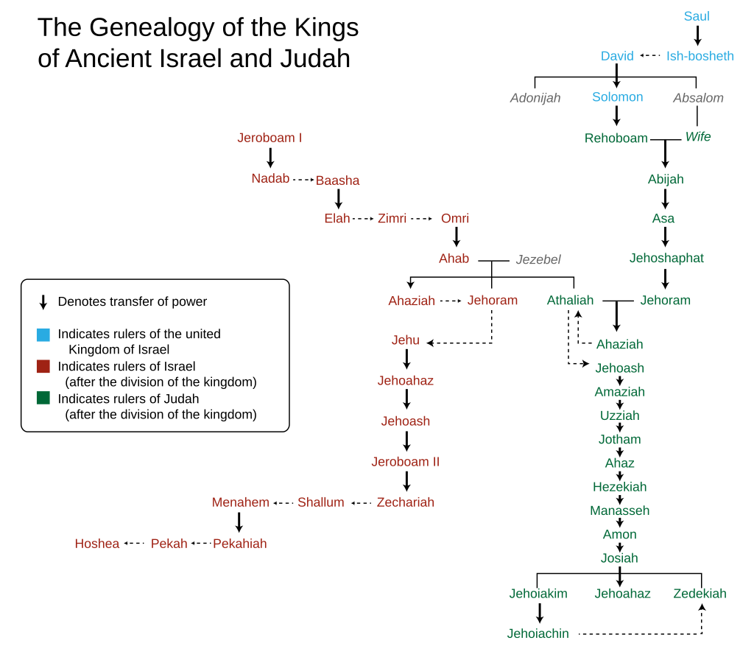

Image: Mr. Absurd derivative work Jon C (https://en.wikipedia.org/wiki/Davidic_line#/media/File:Genealogy_of_the_kings_of_Israel_and_Judah.svg)

However, as outlined by David Zucker (The Bible’s Prophets: An Introduction for Christians and Jews 2013), for Judaism, they do not believe that Jesus Christ was the Messiah; they are still waiting for him to come to bring peace to Israel and so prophets in the Bible bring different things to both the Christian Faith and the Jewish faith; Zucker explains how the Hebrew scriptures predict that through an ascendant of King David, God will send an anointed messiah and will last forever, and he highlights how the book of Samuel provides an evident contrast between David and Saul.

Zucker also reinforces the idea that David was essentially Saul's downfall and explains how the Bible, refers to Saul being tormented by evil spirits, particularly at his later stages, as he was riddled with depression and paranoia and suggests that Saul had lost God's favour and had sent the evil spirits, however regardless, his downfall in his personality and rule paved the way for David to fulfil the prophesies as King.
Another important submission from Zucker is how David, again, was presented with options, for example when he was on the run from Saul with his band of 600 loyal warriors; Zucker explains he had the option to join the Philistines and fight back and defend himself, or he had the choice to trust God and not betray his people, thus fulfilling the prophesy of him gaining the monarchy, which as we know is what happens when Saul and Jonathan are killed in battle where David is then anointed King of Judah, "Then the people of Judah came, and there they anointed David king over the house of Judah." (2 Samuel 2:1-4 Holy Bible, NIV) and David having became King and unifying the tribes of Israel he brings the Ark of the Covenant, a sacred chest that holds the original 10 commandments and is considered important holy to the Jewish people as they believe with it comes Yahweh's presence.

It was when David took Jerusalem that he decided he wanted to try and build a Temple to honour God (Samuel 7:4-17) however this didn't happen as he was prevented on account of the fact he was considered a great warrior, defending his people, and the temple was supposed to represent peace, it was deemed he was not appropriate to begin the construction and so King Solomon built the temple, giving credit to David.; Chronicles 6:42 highlights this when the temple doors wouldn't open and Solomon says "Remember the goodness of my father, David", the doors then opening. David was given credit as he had laid the essential foundations of the temple in many senses, he set aside finances to fund the construction, assembled parts of the materials that were used and also put in the spiritual graft for it's eventual construction. King Solomon's 'first temple' replaced the temple tabernacle, which Moses had supervised previously and which originally housed the Ark of the Covenant. Jewishhistory.org explains how the temple brought God's presence to the Jewish people in a way not seen before, and as a result also came a raise in prophets and wise men who brought the Jewish people to a new level of their faith.

Yair Davidiy (2020) wrote that "David represents the future restoration of the Jewish People and their re-unification with the Lost Ten Tribes." which for the Jewish faith is majorly significant, he adds that David was also promised that his future blood line would rule over the Hebrews forever and he uses scripture from the book of Kings to demonstrate how the blessing was confirmed to Solomon, "But King Solomon shall be blessed, and the throne of David shall be established before the LORD forever." (1 Kings 2:45 (KJB)) And so with the significant historical and spiritual contributions he made, the tremendous faith he maintained in God, it is clear why he is referred to as a "man after God's own heart".

Bibliography:
“1 Samuel 17:50-53 David Defeated Goliath with a Sling and a Rock. He Killed Him without Even Using a Sword. David Ran over and Pulled out Goliath’s Sword. Then He Used It to Cut off Goliath’s Head. When the Philistines | Contemporary English Version (CEV) | Download the Bible App Now.” Www.bible.com, www.bible.com/bible/392/1SA.17.50-53.CEV.
Ann Jensen Adams. Rembrandt’s “Bathsheba Reading King David’s Letter.” Cambridge University Press, 13 Nov. 1998.
Borgman, Paul. David, Saul, and God. Oxford University Press, 16 Apr. 2008.
“David.” Wikipedia, 1 Sept. 2023, en.wikipedia.org/wiki/David#:~:text=After%20Saul%20and%20his%20son.
“David.” Www.jewishhistory.org, 31 Jan. 2010, www.jewishhistory.org/david/.
“Davidic Line.” Wikipedia, 15 Apr. 2024, en.wikipedia.org/wiki/Davidic_line#/media/File:Genealogy_of_the_kings_of_Israel_and_Judah.svg. Accessed 6 May 2024.
Gunn, David M. The Story of King David. A&C Black, 1 Jan. 1978.
J Cheryl Exum. The Historical Books. Sheffield, England, Sheffield Academic Press, 1997.
Jacob Immanuel Schochet. The Great Maggid. Brooklyn, N.Y. : Kehot Publication Society, 1974.
Pioske, Daniel. David’s Jerusalem. Routledge, 11 Feb. 2015.
“Righteous Jehu and His Evil Heirs : The Deuteronomist’s Negative Perspective on Dynastic Succession | WorldCat.org.” Search.worldcat.org, search.worldcat.org/title/166625005. Accessed 29 Apr. 2024.
Rylaarsdam, J. Coert . “David | Summary, Reign, & Facts.” Encyclopædia Britannica, 2019, www.britannica.com/biography/David.
Zucker, David J. The Bible’s Prophets: An Introduction for Christians and Jews. Google Books, Wipf and Stock Publishers, 10 Dec. 2013, books.google.com/books?id=nTtJAwAAQBAJ&pg=PA51#v=onepage&q&f=false. Accessed 6 May 2024.

