PCEE 4007 – Design of Electrical Installations



Practical Assignment
HNC Electrical and Electronic Engineering
James Stevens

Contents
Section A
Work Plan/Method Statement
Tools List
Materials List
Test Results
Circuit Diagram
Wiring Diagram
Section B
Question 1
Question 2
Bibliography

Cover image courtesy of Orbis Engineering (2022), Electrical Installations in Stafford [Online] available at https://www.orbis-es.co.uk/orbis-engineering-guides/electrical-installation-stafford/ [Viewed 04 June 2022]
Section A
Work Plan/Method Statement
Having received the brief from the client, the latest edition of the wiring regulations (BS 7671:2018) should be consulted when drawing up the planned installation. Due regard must be given to the intended uses and likely loads placed on the installation prior to settling on the final design.
A complete survey of the intended location for the installation must be undertaken. This will inform decisions made regarding the likely routing of the installation within the existing fabric of the building; possible hazards that may be encountered during the installation process; load carrying capacity of components; quantities of materials required; the labour required to complete the installation; and, the total cost of completion.
If the client is content to continue with the task on the basis of the costings quoted, the quoted materials must be obtained. It is also prudent to ensure that all of the tools required to complete the task have been obtained and are known to be in good working order.
Prior to work commencing, appropriate control measures should be put into place to protect life and property from harm against the possible hazards identified in the initial survey. A further survey may also be required if sufficient time has elapsed since the initial survey or if the material circumstances of the task have changed. Hazards that might be considered might include working near or upon live conductors, working at height, working near other utilities (mains water or gas), working in proximity to other trades or persons, working within confined spaces, working in an area with poor ventilation or dusty environments, working in noisy environments, and risk of damage to electrical equipment and services in the event of power outages. If a hazard is considered too serious or severe then work should be suspended until the hazard can be reduced or removed.
Control measures might include the use of appropriate personal protective equipment and clothing, working with another competent person, specialised access equipment (for example, if the work area includes a stairwell), effective lock-out procedures to live utility supplies, temporary warning placards set out in the work area listing specific hazards likely to be encountered nearby, and proper lines of communications to other individuals concerned.
It is critical that all those engaged in the commissioning of the installation understand the nature and extent of the hazards involved in the task and have been made aware of the controls in place to minimise these hazards. To this end, a toolbox talk is recommended between the individuals involved in the installation. If other people or trades are likely to be at risk of some of the hazards identified, the hazards and control methods must be disseminated to those others.
A work plan scheduling the tasks to undertaken and the time allocated for each task should be established. This will allow for progress of the installation to be monitored and to ensure a timely and cost-effective completion of the installation process. Throughout the task, this plan should be kept up to date and amended if required.

Tools List
The tools required for the completion of this task include:
- Step ladder
- Side cutter pliers
- Electrically insulated conventional pliers
- Electrically insulated wire strippers
- Electrically insulated screwdrivers
- Small hammer
- Tape measure
- Straight edge
- Spirit level
- Electrical installation tester
All of the above electrically insulated hand tools must comply with the latest standards (BS EN 60900:2018).

Materials List
Materials required for the completion of this installation should include the following:
Item | Quantity
Single Gang Back Box | 8
32 Amp Rated Junction Box | 1
3 Unit Consumer Unit | 1
16 Amp 2 Pole RCD | 1
16 Amp Class B MCB | 1
Single Socket Outlet | 4
Ceiling Rose | 2
Ceiling Rose Backing Plate | 2
Baton Holder | 2
Single Gang 13 Amp Switched Fused Spur | 1
Single Gang Two Way Light Switch | 2
Single Gang Intermediate Light Switch | 1
2.5mm² Flat Twin and Earth Conductor | 5 Meters
1.0mm2 Flat Twin and Earth Conductor | 1 Meter
1.0mm2 Four Core Conductor | 1 Meter
2.5mm2 Cable Clips | 15
1.0mm2 Cable Clips | 6
CPC Colour Coded Insulation Sheath | 0.5 Meter
Line Colour Coded Insulation Sheath | 0.1 Meter

Test Results

Visual Inspection |  | Pass
Continuity of CPC | Test Lead Resistance | 0Ω
 | (R₁+R₂) | 0Ω
Insulation Resistance | Test Voltage Applied | 500V
 | Min. Acceptable Value | 1mΩ
Line to Neutral Value |  | >500mΩ
Line to CPC Value |  | >500mΩ
Neutral to CPC Value |  | >500mΩ
30mA RCD Test | X 0.5 | Fail
 | X 1.0 | 19.7ms
 | X 5 | 18.5ms
Polarity Test |  | Pass

Circuit Diagram
The following diagram is a depiction of a circuit diagram of a ring final circuit with spurs and a switched fused spur controlling a 3-way switched lighting circuit (complete with legend):
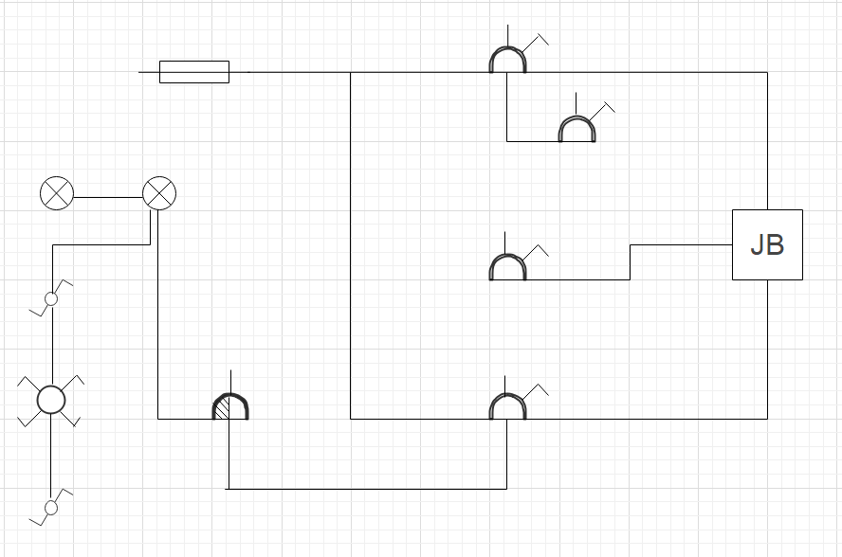

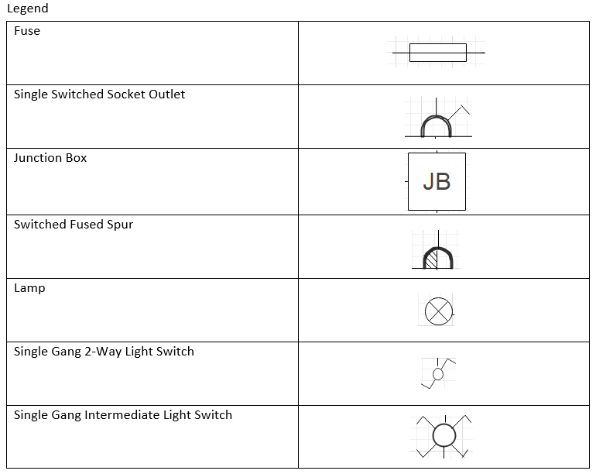

Wiring Diagram
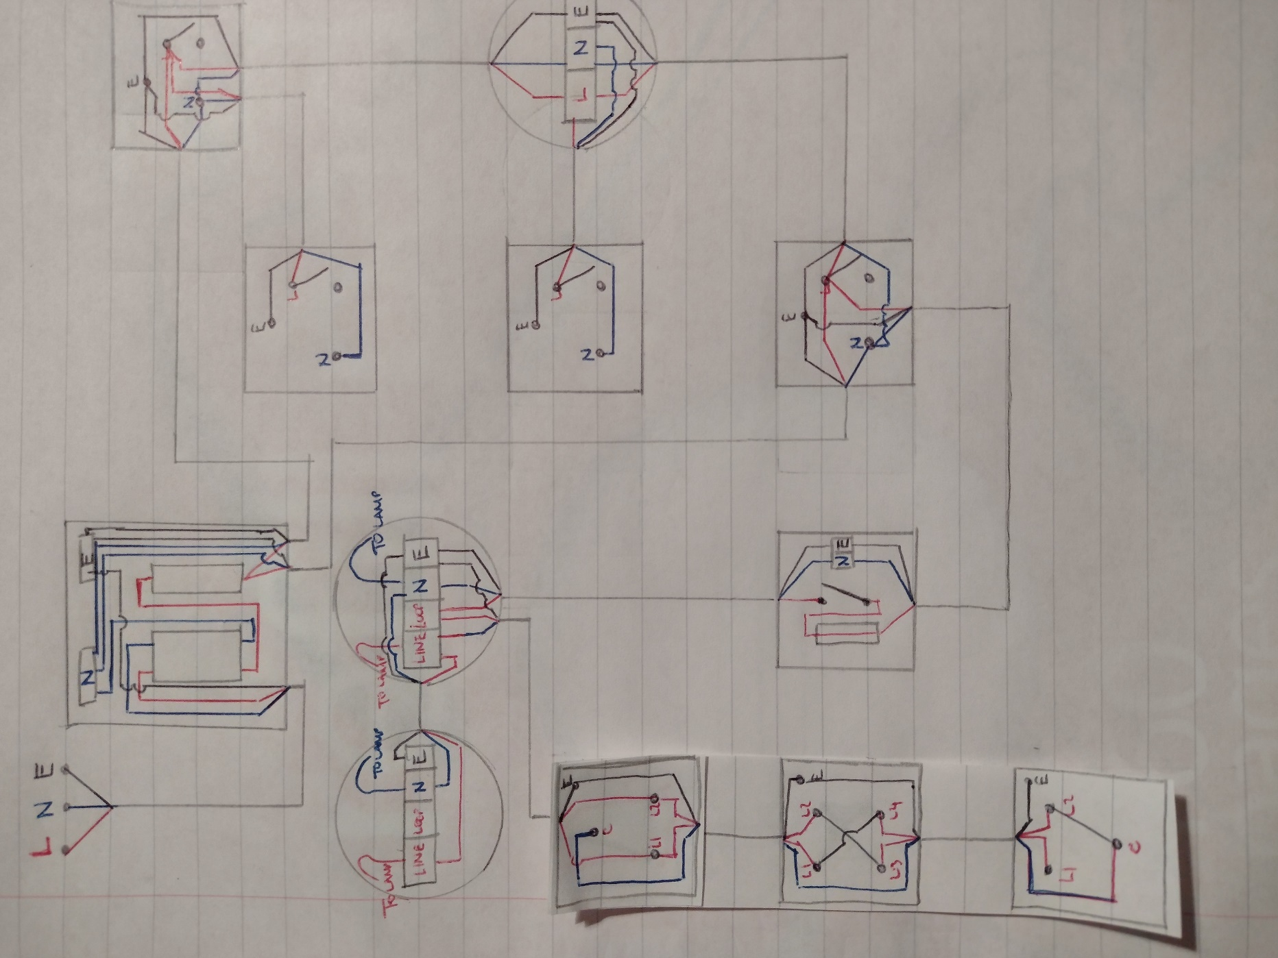
The image below is of a wiring diagram detailing all of the electrical connection required for the construction of a ring final circuit with spurs and a switched fused spur controlling a 3-way switched lighting circuit.
Section B
a) i)
Discrimination is the term used to describe an electrical installation which contains circuit protective devices designed and operated in such a way as to minimise total interruption of electrical supply in the event of an overload current being present. That is to say, in the case of an installation containing two or more circuit protective devices, that the overload current operates the protective device nearest to the final operation so as to limit the interruption of supply to the other final circuits (Scaddan (2019), p76).

ii)
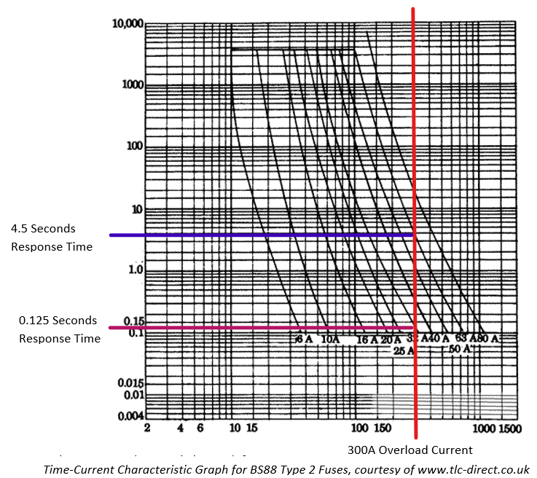

Using the time-current characteristic graph of a BS88 Type 2 fuse above, it is possible to identify that a 300A overload current will cause the following fuses to disconnect in the following times:
Fuse A (63A) - 0.125 seconds
Fuse B (32A) – 4.5 seconds

b)
A circuit protective device that utilises thermal tripping properties is constructed around a bimetallic strip which, in turn, is connected to a set of electrical contacts. The bimetallic strip will distort at a predetermined level of current (due to the current heating the bimetallic strip), which in turn will disconnect the electrical contacts. This form of device is relatively slow to react but is useful in protecting against overload faults.
A circuit protective device that utilises magnetic tripping properties is constructed around a coil of wire wrapped around a ferrous core. This core is in turn connected to a set of electrical contacts. The coil becomes energised to a sufficient level at a predetermined current to move the ferrous core so as to disconnect the electrical contacts. The response time of this device is very quick and is useful in protecting against short circuit faults.

2
a)

Line diagram of lighting point controlled by two-way light switching

b)

Line diagram of two lighting points switched together and controlled by two-way intermediate switching

c)

Line diagram of six multiples of one-gang 13A BS1363 switched socket outlets wired as a radial final circuit

d)

Line diagram of thermostatically controlled heater wired from a double-pole switch

Reference List
Institute of Engineering and Technology and the British Standards Institute, 2018. BS 7671: Requirements for Electrical Installations. London, British Standards Institute
British Standards Institute, 2018. BS EN 60900: Live Working - Hand Tools. London, British Standards Institute
Scaddan, B. (2019) 18th Edition IET Wiring Regulations – Electric Wiring for Domestic Installers (16th Edition) Oxford, Routledge
TLC Electrical Supplies (2022) Circuit Breakers [Online] available at https://www.tlc-direct.co.uk/Book/3.6.4.htm [Accessed 04 June 2022]
Orbis Engineering (2022), Electrical Installations in Stafford [Online] available at https://www.orbis-es.co.uk/orbis-engineering-guides/electrical-installation-stafford/ [Accessed 04 June 2022]

Marking Comments
A very well-presented and detailed assignment, James.
Your practical work was very neat and precise demonstrating a sound knowledge of installation methods and good practical skills.
Well done.

