Name: Keval sureshbhai Miyani
Student Number: 2426154
Module Code : LCHS7009
Lecturer: Dr. Ping Wu
Programme: MSc Public Health and Social Care in Practice
Module: Population Health and Digital Health Promotion
Blogs

Table of Contents
Blog 1: Evaluating Mobile Health Apps in Combating Global Obesity 2
The Public Health Challenge 2
Digital Technology in Health Promotion 2
Evidence of Health Promotion Impact 3
Strengths and Weaknesses 4
Addressing Shortfalls 4
Conclusion 4
References 6
Blog 2: Critically Discussing the Impact of a Designed Digital Technology for Obesity Health Promotion 7
References 10

Blog 1:Evaluating Mobile Health Apps in Combating Global Obesity

The Public Health Challenge
Obesity has proved to be a serious worldwide public health problem that cuts across both low and high-income countries. Obesity may be defined as body mass index (BMI) ≥30 kg/m² and occurs at the expense of comorbidities, including type 2 diabetes, cardiovascular disease, and some cancers (World Obesity Federation, 2023).
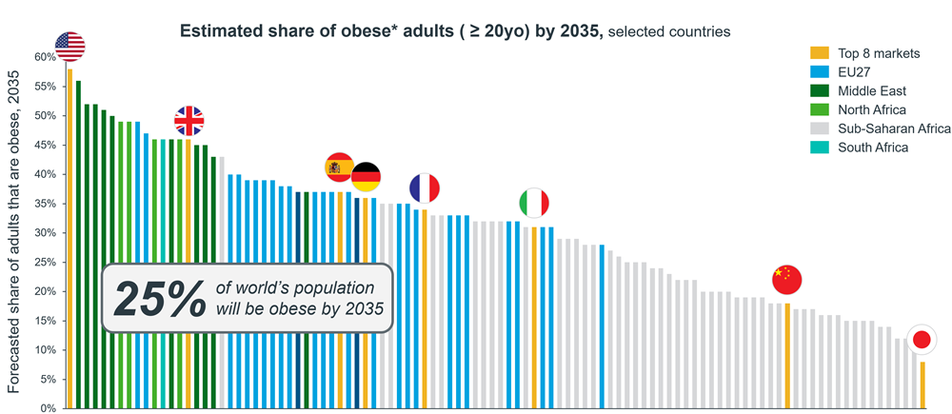
Figure 1: The global prevalence of obesity (IQVIA, 2024)
As shown in Figure 1 above, global prevalence is projected to rise from 14% in 2020 to 25% by 2035, affecting nearly 1.9 billion individuals (IQVIA, 2024). The expected cost of obesity related costs will exceed 4 trillion in 2035, or 2.9% of world GDP, against healthcare and productivity costs (World Obesity Federation, 2023).

Digital Technology in Health Promotion
Mobile health (mHealth) applications play the pivotal role of ensuring that people lead healthier lives, particularly when it comes to preventing obesity. These apps provide self-tracking, nutrition monitoring, physical exercise motivation and behaviour suggestions. They will have such features as custom goals, reminders, social support forums, and rewards based on gamification to support positive behaviours (Fedele et al., 2017). In the delivery of real-time feedback, mHealth promotes bridging knowledge gaps and motivation issues that are essential to permanent weight control. Applications like Noom and MyFitnessPal help users record and monitor what they eat, how often they exercise, and the kind of coaching they receive to lose weight and make beneficial decisions, as shown in Figure 2 below.
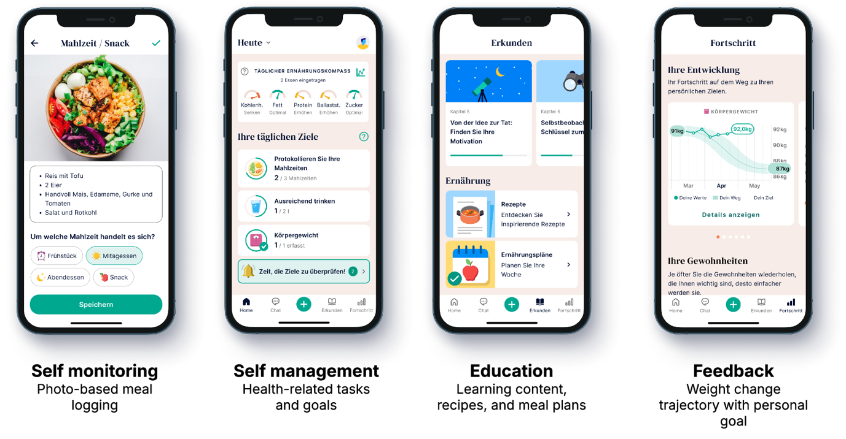
Figure 2: Behaviour change pathway in mobile health applications for weight management (Lautenbach et al., 2025).

Evidence of Health Promotion Impact
An overview by Halpern et al. (2021) showed that the diet and activity of app-based interventions have significant improvements compared to the 12 weeks, resulting in a mean weight reduction of 2.5-3.5 kg. Patient-reported outcomes and real-world information can also be collected through digital tracking to help informthedevelopmentof personalised care and system-wide interventions (IQVIA, 2024).

Strengths and Weaknesses
mHealth apps are easy to access, scalable, personalised, and based on data. It is possible to have continuous out-of-clinic engagement to cut healthcare burdens. Disadvantages are a decreasing number of users, the issue of digital illiteracy, lack of privacy, and low effectiveness in case of severe obesity (Fedele et al., 2017).
Table 1: Advantages and limitations of mobile health applications in obesity prevention.
Advantages | Limitations/Shortfalls
Personalized goal-setting and feedback | User attrition
Scalable and cost-effective | Digital literacy/access barriers
Real-time monitoring and self-tracking | Privacy and data security concerns
Integration with healthcare systems | Less effective for severe obesity

Addressing Shortfalls
The shortfalls may be reduced through hybrid programs that use digital coaching with clinician supervision, design applications to improve sustained engagement, and strong data security. Association of app display with health insurance pathways and payment would enhance uptake and efficacy.

Conclusion
mHealth apps have massive potential in facing obesity. These provide personalised, scalable interventions based on real-world data. Multi-modal strategies ought to be addressed to tackle the issue of engagement, equity, and security to have a maximum impact on global health promotion.

References
Fedele, D. A., Cushing, C. C., Fritz, A., Amaro, C. M., & Ortega, A. (2017). Mobile health interventions for improving health outcomes in youth: a meta-analysis. JAMA pediatrics, 171(5), 461-469. https://jamanetwork.com/journals/jamapediatrics/article-abstract/2611946
Halpern, B., Louzada, M. L. D. C., Aschner, P., Gerchman, F., Brajkovich, I., Faria‐Neto, J. R., ... & Franco, O. H. (2021). Obesity and COVID‐19 in Latin America: A tragedy of two pandemics—Official document of the Latin American Federation of Obesity Societies. Obesity Reviews, 22(3), e13165. https://onlinelibrary.wiley.com/doi/abs/10.1111/obr.13165?casa_token=3yAy9yauA2YAAAAA:HPOVe0iMKr0hmfFrPvS1mMWhB99AY737yNZDorzoDxRnsPQQwWJTOtz67SrnGV9cllgTdQmn2Nu6RulJ
IQVIA Institute. Global Use of Medicines 2024: Outlook to 2028. IQVIA Institute for Human Data Science, (2024). https://www.iqvia.com/locations/emea/blogs/2024/10/2024-the-obesity-markets-inflection-point
Lautenbach, A., Blüher, M., Mijuskovic, A., Jones, L., & Schirmann, F. (2025). Efficacy of a digital health application for weight management in people with obesity: 6-months results from a randomized controlled trial: Clinical Research. International Journal of Obesity, 1-8. https://www.nature.com/articles/s41366-025-01967-3
World Obesity Federation (2023).Economic impact of overweight and obesity to surpass $4 trillion by 2035. Available at: https://www.worldobesity.org/news/economic-impact-of-overweight-and-obesity-to-surpass-4-trillion-by-2035

Blog 2: Critically Discussing the Impact of a Designed Digital Technology for Obesity Health Promotion
One of the major public health issues worldwide is physical inactivity. More than 28% of adults do not exercise in accordance with recommended physical activity, which leads to 5 million people being killed each year by exposing them to higher risks of chronic diseases (WHO, 2024). In developed nations, sedentary living is increasing due to work behind screens, the use of personal transport, and governments that do not encourage people to build their lives on active lifestyles (Thomas et al., 2016). Cardiovascular disease, type 2 diabetes, and musculoskeletal complications are closely associated with obesity, and thus prevention and long-term management of weight are of utmost priority in the realm of public health.
To overcome this issue, I propose FitMind+Body, a unified online health application that would encourage weight loss by using personalised, evidence-based programs. The application is a combination of behavioural support, nutrition education, wearable device support, telehealth coaching, and pharmacotherapy monitoring of patients who are prescribed GLP-1 receptor agonists (e.g., Wegovy or Tirzepatide). It aims at providing a multifaceted intervention that would address both lifestyle habits and adherence to medication as the key to effective weight loss and better health results.
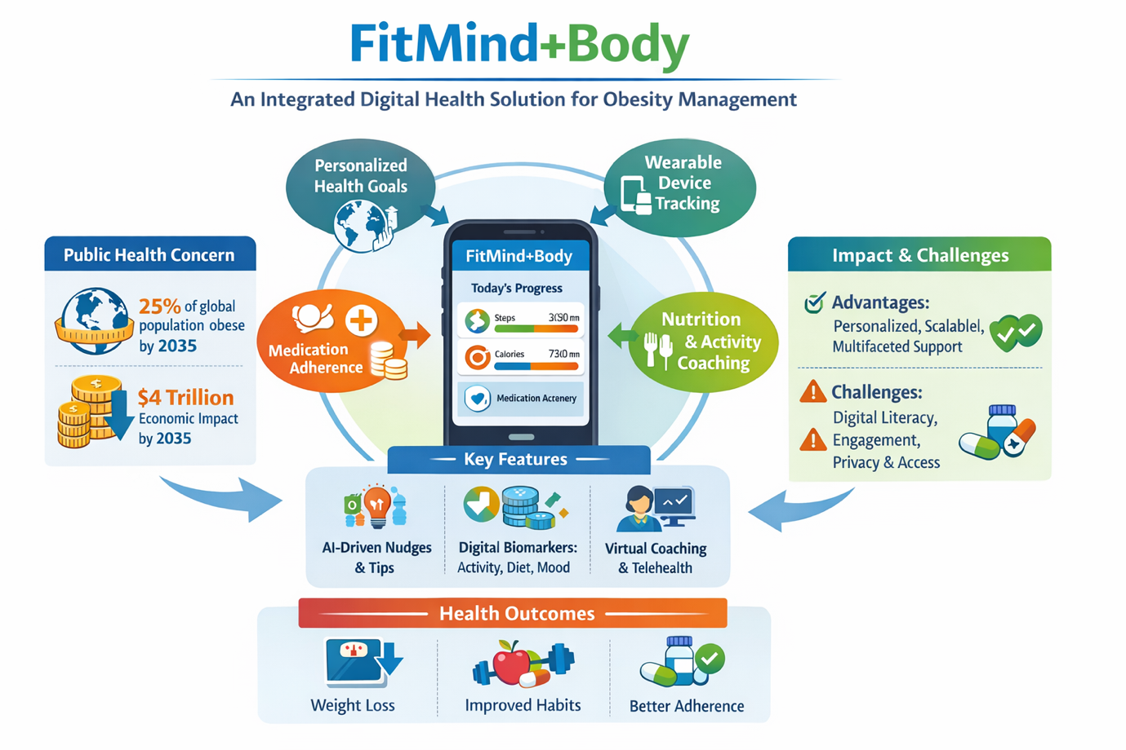
Figure 1: FitMind+Body - Personalised weight management and health tracking (Author, 2026).
FitMind+Body would use a number of essential features to capture the users. Nudges in behaviour and AI-based suggestions promote daily physical exercise, goal setting, and observing healthy eating habits. Nutrition and activity coaching offer customised diets, physical activity instructions, and patterns of developing habits. Digital prescriptions are combined with medication adherence tracking to assist in scheduling proper dosing and patient outcomes. Integration of wearable devices enables real-time monitoring of sleep patterns, heart rate and steps. The telehealth consultations connect the users to consultations with dietitians and health coaches.
It has been proven that digital technology can be very effective when used in combination with obesity management. Digital interventions involving structured methods result in significant weight loss, a better diet, and better medication adherence (Wharton et al., 2020; IQVIA, 2024). The average weight loss per trial in GLP-1 receptor agonists ranges between 10 and 15%, and cardiovascular benefits have been proven in the SELECT trial, which indicates that pharmacotherapy and behaviour change are compatible with use on digital platforms (Klasa et al., 2025).
Although FitMind+Body provides scalability, customisation, and multidimensional service, there are some difficulties. It can reduce engagement levels due to the lack of ongoing motivation, screening out access by lack of digital literacy, and privacy-related issues can influence uptake. The reliance on the use of wearables and apps can sideline poorer groups or locations with poor access to technology.
They can be solved with the help of gamified interaction, multilingual support, low-bandwidth applications, community digital literacy classes, and safe data management systems based on the cloud. By providing fair access and proving cost-effectiveness in clinical research, this will facilitate further adoption by patients and health care systems.
To sum up, FitMind+Body shows the possibility of digital health technologies to solve the problem of obesity through the integration of behaviour change, medication adherence, and individual coaching. Its interdisciplinary and evidence-based nature provides a model of varying size to address an immediate health issue in the population, and hopefully lead to better health and a decrease in economic burdens.

References
IQVIA Institute. Global Use of Medicines 2024: Outlook to 2028. IQVIA Institute for Human Data Science, (2024). https://www.iqvia.com/locations/emea/blogs/2024/10/2024-the-obesity-markets-inflection-point
Klasa, A., Sobas, A., Biedka, K., Ziobro, O., Blaszczyk, K., Bulski, J. M., ... & Estreicher, A. (2025). Semaglutide effects on cardiovascular outcomes in overweight or obese individuals who do not have diabetes: A literature review. Medical Science Pulse, 19(1). https://www.ceeol.com/content-files/document-1391850.pdf
Thomas, C. E., Mauer, E. A., Shukla, A. P., Rathi, S., & Aronne, L. J. (2016). Low adoption of weight loss medications: A comparison of prescribing patterns of antiobesity pharmacotherapies and SGLT 2s. Obesity, 24(9), 1955-1961. https://onlinelibrary.wiley.com/doi/abs/10.1002/oby.21533
Wharton, S., Haase, C. L., Kamran, E., Liu, A., Mancini, J., Neish, D., ... & Christensen, R. A. (2020). Real‐world persistence with liraglutide 3.0 mg for weight management and the World Obesity Federation. World Obesity Atlas. (2023). https://www.worldobesity.org/resources/resource-library/world-obesity-atlas-2023
World Health Organisation (2024).Physical activity. Available at: https://www.who.int/news-room/fact-sheets/detail/physical-activity

